Module: Professional and Career development

Task 1 – Open Book Assessment
BMSW 4005
Sergiu Marian Cot
1911765

Table of Contents
Introduction……………………………………………………………………………………………………2
Social impaction of mental illness……………………………………………………………………….….3
1.Social and Discrimination……………………………………………………………………………………3
1.1 Peril………………………………………………………………………………………………………3
1.2 Origin…………………………………………………………………………………………………………4
1.3 Concealability………………………………………………………………………………………………….4
2.Financial cost…………………………………………………………………………………………………………….5
3.Social exclusion and relationship………………………………………………………………………………………………….5
4.Psychical and mental health……………………………………………………………………………………………………….5
References ………………………………………………………………………………………………………………….6

Social impacts of mental illness
Five social impacts of mental illness are:
1.Stigma and discrimination
The most established definition regarding stigma is written by Erving Goffman (1963) in his seminal work: Stigma: Notes on the Management of Spoiled Identity. Goffman (1963) states that stigma is “an attribute that is deeply discrediting” that reduces someone “from a whole and usual person to a tainted, discounted one” (p. 3). The stigmatized, thus, are perceived as having a “spoiled identity” (Goffman, 1963, p. 3).
According to, David Crepaz-Keay people with mental health problems say that the social stigma attached to mental ill health and the discrimination they experience can make their difficulties worse and make it harder to recover.
1.1. Peril
The first dimension of stigma is peril – otherwise known as dangerousness. Peril is often considered an important aspect in stigma development, and it is frequently cited in the research literature (Corrigan, et al, 2001; Feldman & Crandall, 2007; Angermeyer & Matschinger, 1996).
When society attributes, upon a person or group of people, perceived behaviors that do not adhere to the expected social norms, discomfort can be created.
1.2. Origin
Another dimension of stigma that is often discussed in the research on stigma is origin. As in the definition provided earlier, mental and behavioral disorders are often believed to, at least in-part; develop from biological and genetic factors – i.e., origin (APA, 2000).
1.3. Concealability, or visibility of the illness, is a dimension of stigma that parallels controllability, but also provides other insight into the stigmatization of mental and behavioural disorders.

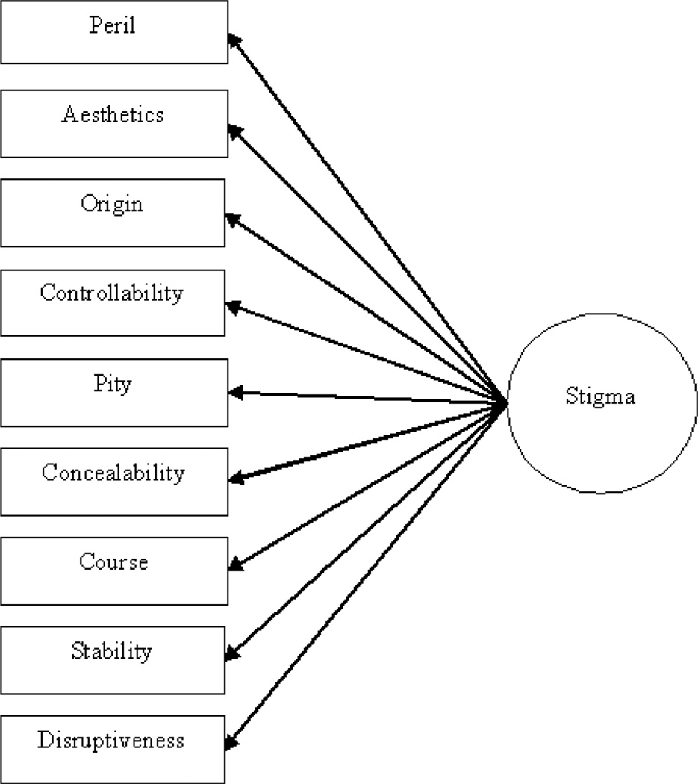

2. Financial costs
Many face extra financial costs when caring for a loved one that can put a strain on family relationships and mental health - this is one of the major social influences affecting mental health for carers. Carers UK discovered that those who are of working age who care for their partner or disabled children have higher utility bills to pay, which reflects the likelihood of them sharing the same home.

3. Social exclusion and relationships
75% of carers found it difficult to maintain social relationships because many don’t understand what impact caring has¹⁰.
Due to the sheer amount of responsibilities a carer takes on, they often report feelings of isolation. The primary reasons behind this include people not understanding their role, the need to leave paid work and being unable to take time off - all of which results in losing touch with colleagues, friends and even family members. According to the State of Caring 2014 survey, 57% said they had lost touch with their friends, and nearly half of them believe that this was because they do not have access to practical support that enables them to socialise.

4. Physical and mental health
The pressures that carers face can have an impact on their mental and physical health. 92% said that caring has taken its toll on their mental health, including depression and stress⁷. This impact is worsened due to carers not being able to find the time for check-ups or treatment or not being able to find adequate and affordable replacement care. Two in five carers say they have been forced to delay treatment due to their responsibilities⁸. Carers UK also discovered that some carers were even discharging themselves from hospital early to care for the person they look after.

References
Ahmedani, B., 2020. Mental Health Stigma: Society, Individuals, And The Profession. [online] PubMed Central (PMC). Available at: <https://www.ncbi.nlm.nih.gov/pmc/articles/PMC3248273/> [Accessed 8 October 2020].
Cdc.gov. 2020. Frequently Asked Questions | Social Determinants Of Health | NCHHSTP | CDC. [online] Available at: <https://www.cdc.gov/nchhstp/socialdeterminants/faq.html#what-are-social-determinants> [Accessed 8 October 2020].
Counselling-directory.org.uk. 2020. Social Influences Affecting Mental Health - Counselling Directory. [online] Available at: <https://www.counselling-directory.org.uk/social-influence-stats.html#caringforalovedone> [Accessed 8 October 2020].
SAGE Journals. 2020. Social Work And Managed Care: Measuring Competence, Burnout, And Role Stress Of Workers Providing Mental Health Services In A Managed Care Era - Gila M. Acker, Dorothea Lawrence, 2009. [online] Available at: <https://journals.sagepub.com/doi/abs/10.1177/1468017309334902> [Accessed 8 October 2020].
PA, B., 2020. Monitoring Equity In Health And Healthcare: A Conceptual Framework. [online] PubMed. Available at: <https://www.ncbi.nlm.nih.gov/pubmed/14717564> [Accessed 8 October 2020].
Mental Health Foundation. 2020. Stigma And Discrimination. [online] Available at: <https://www.mentalhealth.org.uk/a-to-z/s/stigma-and-discrimination> [Accessed 8 October 2020].

