



Kinetic Energy Recovery
Alternative Propulsion Systems (ACHA5010)
Name: Evan Craig
Student ID: 2012643
Date: December 2023

Name: Evan Craig
Student ID: 2012643
Date: 10/2022

Table of Contents
1. Introduction 1
2. Vehicle Selection 2
2.1 Vehicle Specification 2
2.2 WLTP Testing Procedure 2
3. Worldwide Harmonised Light Vehicle Test Procedure 3
4. Tractive Forces 5
5. Tractive & Braking Power 7
6. KERS System 8
7. KERS Power Potential 9
8. KERS Components & Sizing’s 10
8.1 Efficiency for Components 11
9. KER Returned to Wheel 12
10. Conclusion 13
10.1 Final Remarks 14
11. References 15

Introduction

The field of alternative propulsion systems is fuelled by the growing concern for environmental sustainability and the pursuit for efficient transportation solutions has forced the automotive industry to explore innovative technologies. Among these is a Kinetic Energy Recovery System (KERS) which has already been shown to be a promising avenue for reducing fuel consumption. This report is a comprehensive analysis of the effects of introducing a KERS into a Ford Fiesta with a focus on reducing fuel consumption while maintaining performance.
The first step is to select an appropriate vehicle, a decision which sets the foundation for the analysis. The research for the vehicle entails finding the dynamic characteristics of the vehicle, understanding these characteristics is fundamental to gauging the potential impact of the KERS on the vehicle’s performance. The size of each of the KERS components and efficiency values for each component can be found in the report.
Once a vehicle is chosen the appropriate Worldwide harmonised Light Vehicle Test Procedure (WLTP) is selected which allows the tractive and braking moments of the car to be recorded. From the WLTP cycle, multiple graphs can be created, these visualisations serve as benchmarks for understanding the energy demands and potential for recovery.

Vehicle Selection

To analyse the effects of introducing a kinetic energy recovery system to reduce fuel consumption to its maximum potential, a commonly found car would be the best suited to the role. For this paper, the vehicle selected was A Ford Fiesta, specifically the Mk6 Fiesta made from 2008 to 2019 with over 22 million sold it is the perfect test subject.

2.1 Vehicle Specification

To properly analyse these effects some dynamic characteristics of the Fiesta are needed, the following is the required data;
- Test Mass – 1525 KG (Car Info, 2015)
- Engine Power – 60 BHP (Car Info, 2015)
- Frontal Area – 2.13 M² (Ecomodder, 2018)
- Rolling Resistance Coefficient – 0.02 (Energia Zero, n.d.)
- Coefficient of Aerodynamic Drag – 0.33 (Ecomodder, 2018)

2.2 WLTP Testing Procedure

With the required dynamic characteristics of the vehicle above, the worldwide harmonized light vehicle testing procedure (WLTP) can be selected. There are four classes within the WLTP which can be seen in Figure 1 below:
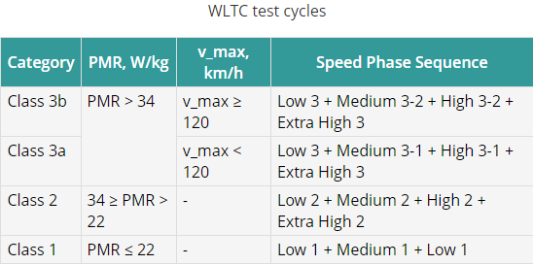

Figure 1 - A Figure to Show the Different WLTP Test Classes (Emission Test Cycles, 2020)

The different classes apply to the power-to-mass ratio for the vehicle, for example, class 3 vehicles are the European and Japanese style of vehicles tested, with class 3 being the class the Ford Fiesta fits into.

Worldwide Harmonised Light Vehicle Test Procedure

Below you will see the WLTP test done for a vehicle in class 3b. The graphs are split into 3 different figures as the test runs for 1800 seconds so each figure will cover 600 seconds of the test.
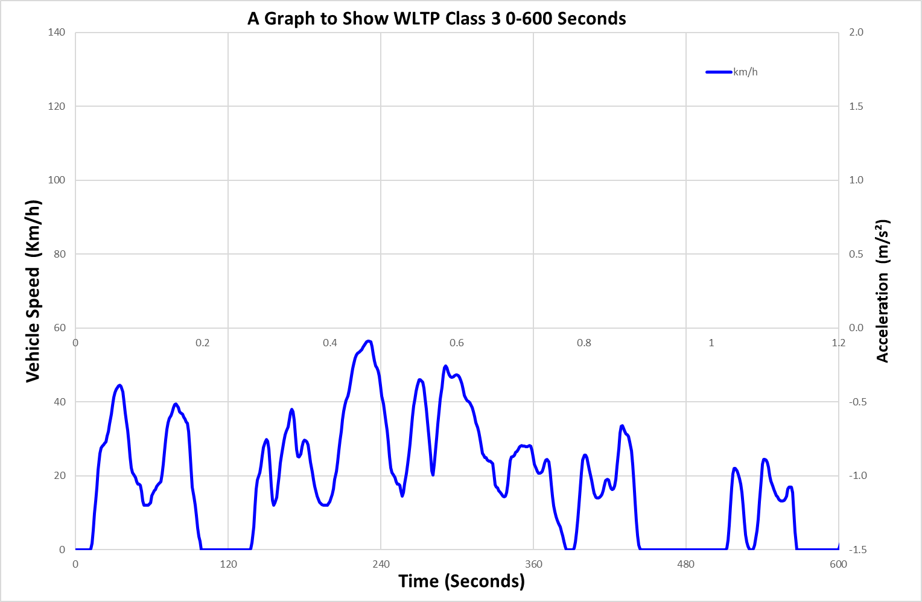

Figure 2 -A Graph to Show WLTP Class 3 0-600 Seconds

As you can see in Figure 2 this is the first 600 seconds of the test, which is known as the low range of the test, hence why the speeds are all so low because this part of this test is used to replicate slow, start-stop style driving you would usually see in busy towns and such.
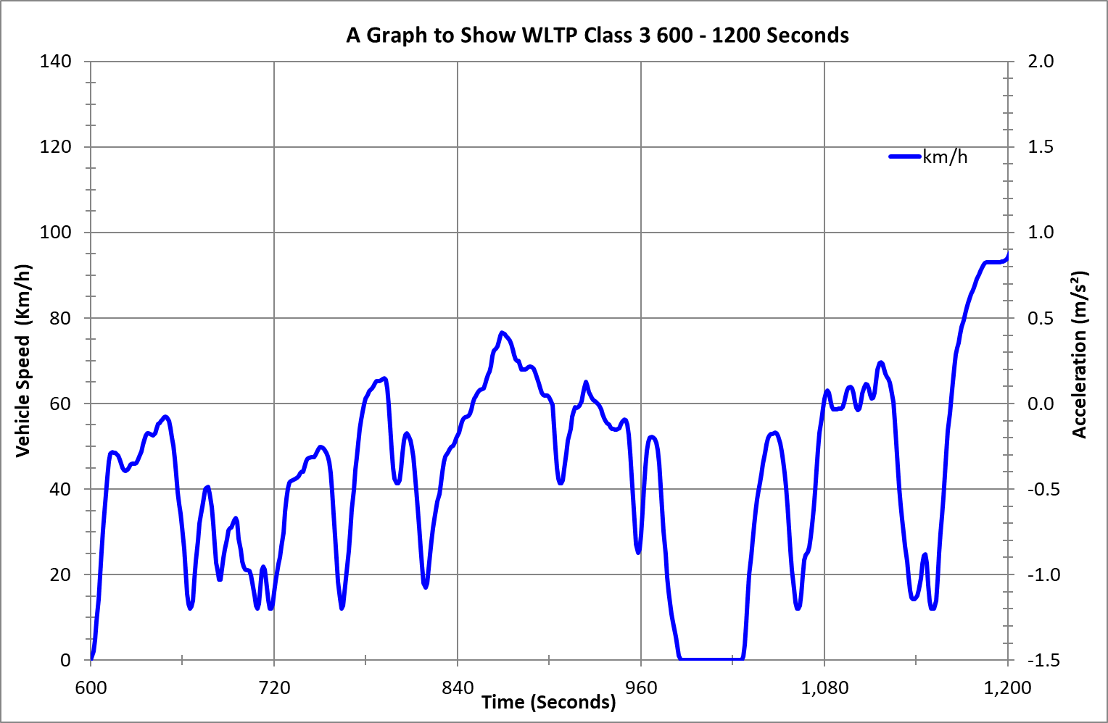
Figure 3 - A Graph to Show WLTP Class 3 600 - 1200 Seconds

Figure 3, above, is similar to Figure 2 however this part of the test is known in the medium range, the whole section of the medium range is conducted in Figure 3, however, from 1022 seconds the test goes into the high range which is why it starts to increase more rapidly at the end of the graph.
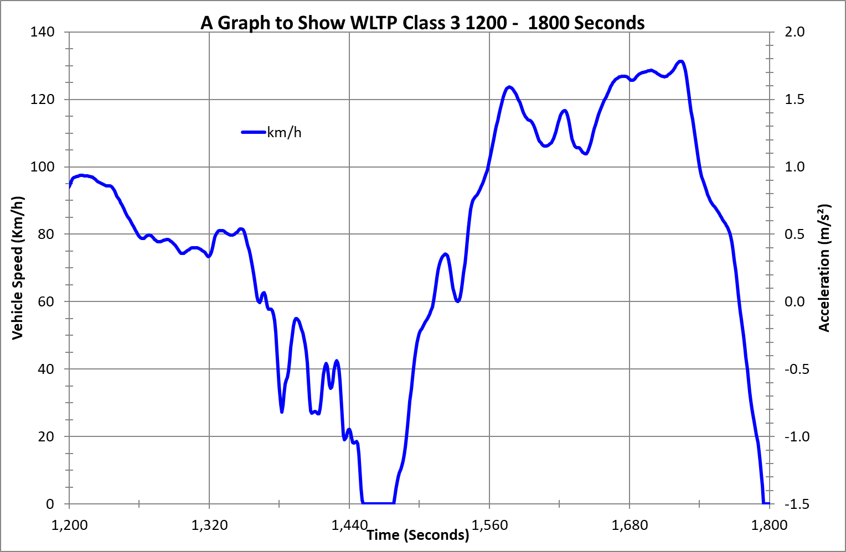

Figure 4 - A Graph to Show WLTP Class 3 1200 - 1800 Seconds
The final part of the testing procedure can be seen in Figure 4, with this graph showing the test going through the high and very high ranges. This is the part of the test used to simulate motorway driving as the speeds achieved in the test are only applicable to the motorway/dual carriageway.

Tractive Forces

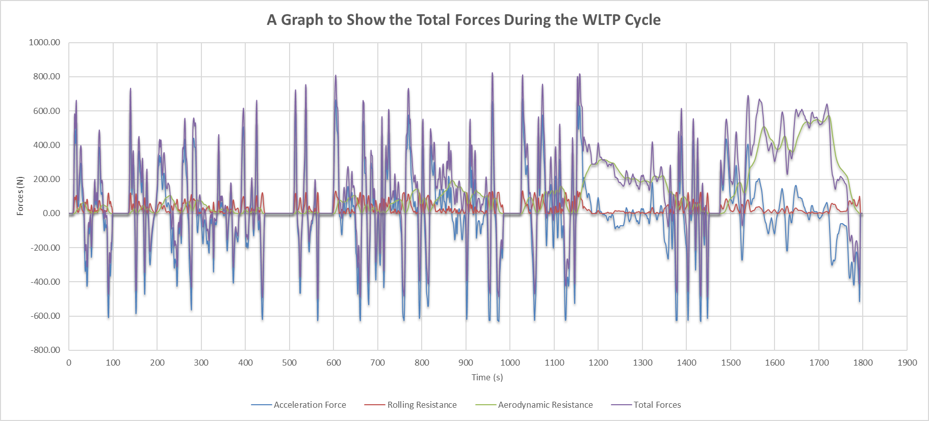
Using the Figures above the different forces generated and acting on the vehicle throughout all 1800 seconds can be calculated. The different forces calculated were the acceleration, rolling and aerodynamic resistance all in Newtons.
Figure 5 - A Graph to Show the Total Forces During the WLTP Cycle

Figure 5 shows the total forces produced by the Fiesta during the test. As you can see the most contributing force would be aerodynamic resistance as it closely follows the trace for the total forces. There are periods on the graph where the forces become negative, this is mainly down to the acceleration force going negative at periods when the vehicle is braking. The points at which the total amount of forces go into the negative numbers are the points where energy can be recovered as more is available than is being used.
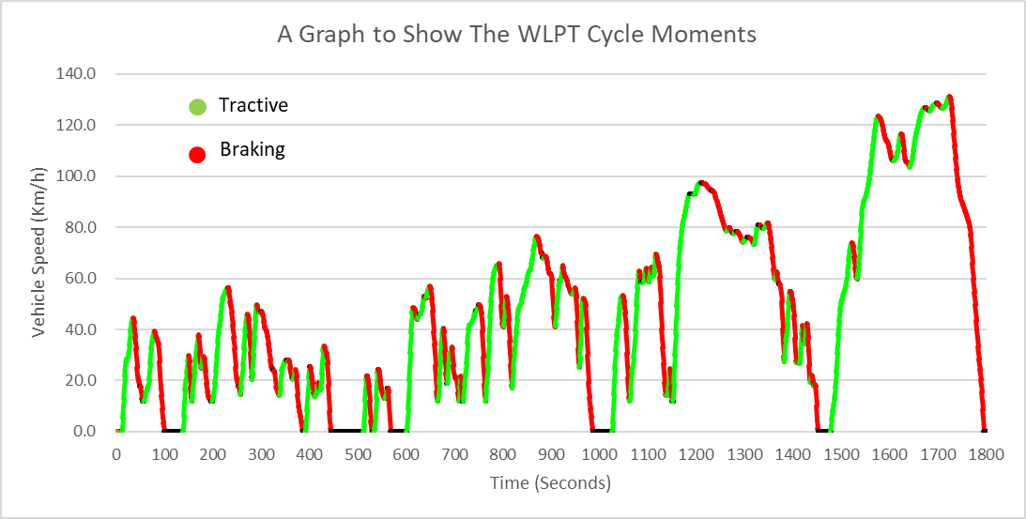
Figure 6 - A Graph to Show the Tractive & Braking Moments Over the WLTP Cycle
Using Excel it is possible to create the Figure above it is the whole 1800 seconds of the WLTP cycle, with the green depicting the tractive moments and red the braking moments. The red lines are the potential times when energy can be recovered, and then similarly the green lines are when the recovered energy can be deployed.
There is a slight assumption made as not every red line may be a braking moment, this is due to the driving style used in the test being unknown. There are types of drivers which would use the brake to reduce speed by even a slight amount like some segments of the graph may be. On the other hand, it is also possible that some of the reductions in speed are due to gear changes or more likely the reduction of acceleration pedal depression, which can reduce the speed.

Tractive & Braking Power
Over the whole WLTP cycle, it is possible to calculate the amount of tractive and braking energy that is required to complete the cycle. Using the previously calculated total forces, and then identifying the tractive and braking moments a graph like Figure 7 below can be created.
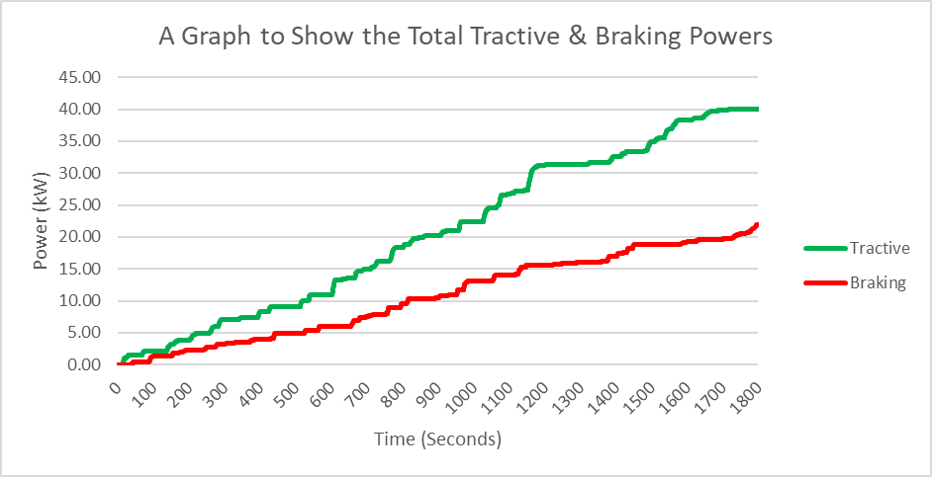
Figure 7 - A Graph to Show the Total Tractive & Braking Powers
As expected, there is a lot of power being lost between the required tractive power and the braking power. The difference between the two powers would be the potential energy that could be used in a kinetic energy recovery system. With a maximum difference of 18.19 kW, there is a lot of energy to be recovered.

KERS System

Integrating a kinetic energy recovery system into a Ford Fiesta would be a promising avenue to achieve an enhanced fuel efficiency of the vehicle. The main role of a KERS system is to capture and store kinetic energy that is generated during braking, and then to deploy the energy while accelerating which is a better optimisation of the vehicle compared to its current form.
The appropriate selection for an energy store system is a vital step for the system, for a vehicle such as the Fiesta a higher capacity and lightweight solution would be crucial to not overstress the vehicle. A commonly used solution is a lithium-ion battery or for a different use case a supercapacitor, as they each offer different solutions to the same problem. A key component in any KERS system would be the regenerative braking system, this could be achieved in different ways with the selected system being the most common.
Another contributing factor related to the success of the system would be the power electronics and control systems. The power electronics rely on things such as inverters and control systems to efficiently transfer energy allowing for an optimised process. The control systems are responsible for the recovery and deployment strategy the KERS system will be working by.
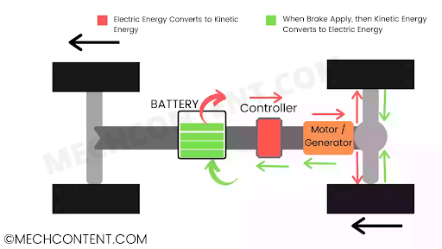
Optimisation of these processes and components would allow for an efficient KERS system, which is capable of reducing fuel consumption and improving performance.
Figure 8 - A Detailed Overview of a Regenerative Braking System (Pratik, 2021)
Knowing this the system would work similarly to Figure 8 with the electric motor being located in a different place in the Fiesta. However, the flow of energy shown in Figure 8 is the same plan as intended for the Fiesta.

KERS Power Potential

In the context of the WLTP testing scenario, where the tractive and braking moments are closely monitored over a set amount of time. This provides data which is helpful when analysing the potential energy for recovery.
Figures 6 and 7 both represent this by showing the cumulative tractive and braking power. The maximum difference was identified as 18.19kW this number serves as an estimation for the maximum amount of power that potentially can be recovered during the time the vehicle is braking. The regenerative braking system can capture and store this energy with the efficiency mentioned later in the report.
With 18.19kW there is a lot of potential the two common methods of storage are a supercapacitor and a battery both have different methods of using this potential. Supercapacitors are known for their quick charge and release capabilities. The ability to quickly capture the energy in braking events and release it in a powerful burst during acceleration. Despite their prowess in charging and power delivery, a supercapacitor exhibits lower energy density which limits their capacity to store energy for a longer period of time thus being more useful to achieve more performance than for optimising fuel consumption.
Meaning that a battery is a better choice to handle the potential energy specifically a lithium-ion battery storage system. This style of system would allow a higher density of energy enabling the vehicle to store more energy which can be better utilised and more capable for longer journeys while also possessing the adaptability to more diverse driving conditions. Lithium-ion battery systems have been used heavily in the industry already (Dai., et al., 2019)

KERS Components & Sizing’s

The components for this project are:
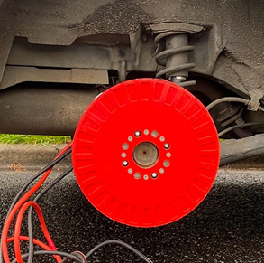
This is the axial flux motor which is mounted onto the hub fitting directly over the disk brake allowing for a seamless integration. The motor would power the wheels when needed which would help to reduce fuel consumption as it would reduce the total amount of tractive forces the engine would need to produce alone. A motor can output 50kW meaning they are working well within their range. (Blain, 2023)
With a setup like this, the motor would run in reverse when the throttle pedal is lifted, this acts as the regenerative braking system.
Figure 9 - A Picture of The Selected Motor (Burton, 2023)

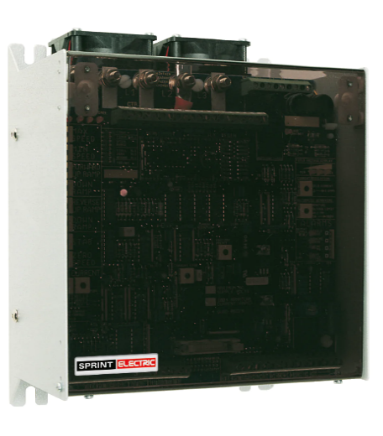
For the control unit, a three-phase sprint SL50 inverter drive controller has been selected. According to the supplier the controller can work from 5kW to 50kW meaning it will work for the vehicle.
The dimensions for the controller are 14.3cm Height, 25cm Length and 20.4cm Width. The spare-wheel well has a height of around 14cm given that the spare wheel tread width is 125mm, the controller would fit in the spare wheel without taking up any used space as there is no spare tyre from the factory. (Tyremen, 2023).
Figure 10- A Picture of The Selected Control Unit (Sprint Electric, n.d.)

The LGChem battery module is a great candidate for the battery system. By running 2 of the 8.1kWh batteries in a series circuit it is possible to achieve the requirements the rest of the system needs.
The battery pack dimensions are 11.2cm Height, 64.5cm Length and 41.5 cm Width, but running them in series would double the height to 22.4cm with all other dimensions staying the same. The only space in the vehicle for something this size would be the boot, with a space of 397.5cm length and 197.8cm width there is plenty of space left even with it placed here. (Aucock, 2023)
Figure 11 - A Picture of The Selected Battery System (EVShop, 2022)

8.1 Efficiency for Components

The components' efficiency ratings would be:
- Motor – The efficiency of an axial flux motor, is typically over 90% (Oh & Emadi, 2004)

- Controller - According to the user manual the conversion energy is “approximately 99%, very little is wasted”. (SL Analog Drive Product Manual, 2017)

- Battery - The efficiency of the battery is not public data, however, similar LGChem products boast an efficiency of 96% so an estimation of at least 90% is assumed. (Brui, 2023)

- Overall – The equation for the overall efficiency would be:

$$ηtotal=0.90*0.99*0.96$$
Giving a total efficiency rating of: 85.54%

KER Returned to Wheel
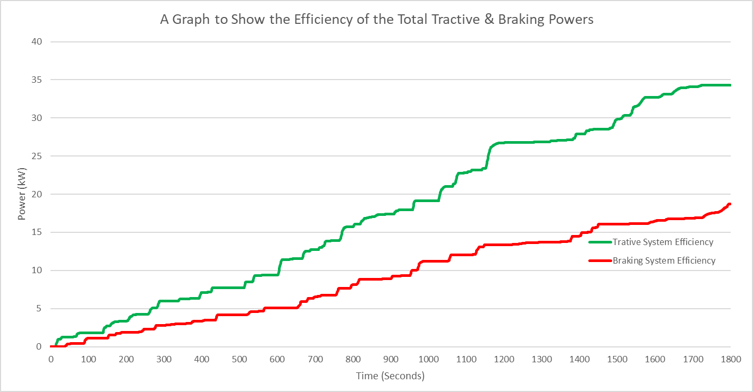
With the efficiency value of 85.54% per cent, the potential energy returned to the wheel can be calculated.
Looking at Figure 12 the efficiency of the system can be seen, the new maximum is 34.27kW and the maximum power loss is down to 15.56kW. Even with the power loss of 2.63kW from the initial figure the system would still be able to reduce the fuel consumption of the vehicle.
Figure 12 - A Graph to Show the Efficiency of the Total Tractive & Braking Powers

Conclusion

When introducing a kinetic energy recovery system into a vehicle several assumptions are typically made to simplify the analysis and to be able to model the system effectively. Also, there are variations that the driver may experience when compared to the stock vehicle with just friction brakes. The assumptions made during the report and the variations the driver may experience are as follows;
Assumptions:
- Efficiency - The Efficiency value is only an educated estimation as there are other losses incurred while the energy is being transferred around the system.
- Energy Transfer – The assumption that all energy transfer is instant and seamless between the KERS and the vehicle's kinetic energy. There are delays and losses when transferring energy
- Constant Parameters – Vehicle parameters such as the rolling and aerodynamic resistance may be assumed as constant over the WLTP cycle when in reality these parameters vary based on the driving conditions and terrain.
- WLTP Cycle Representation – The WLPT cycle is a uniform and ideal test-driving scenario when, in practice, actual driving conditions can vary significantly which could affect energy
recovery and consumption.
Variations Experienced:
- Braking Sensation – The driver may experience a variation in the braking sensation when compared to conventional friction brakes. A different feel may be present which could be described as a smoother braking feel.
- Acceleration Response – The response from the vehicle during acceleration may vary with the KER system integrated, the additional power from the recovered energy could have a more dynamic and responsive acceleration pedal.
- System Engagement & Disengagement – Drivers may feel a slight variation while driving, due to the KER system engaging and disengaging. This would mostly affect driving when the charge of energy storage is low or the driver has a more aggressive driving style.
- Energy Management Strategies – Overall the driving experience may be influenced by the energy management strategy chosen by the driver, such as aggressive drivers compared to conservative drivers, which can have massive effects on how the system works.

10.1 Final Remarks

The integration of the specified kinetic energy recovery system would reduce the fuel consumption of the Ford Fiesta. In 2009 technicians from the Mercedes F1 team demonstrated their KERS to the company’s road car division. The conclusion there was “The technology has almost no direct relevance to road car applications”. (Autocar, 2009)
The data proves that all the lost power during driving the implementation of the system is relevant and it is possible to reduce the fuel consumption.

References

Car Info (2015) Specifications for Ford Fiesta 3-door. Available at: https://www.car.info/en-se/ford/fiesta/fiesta-3-door-125-m5-2015-24162980/specs (Accessed 14th December 2023)
Ecomodder (2018) Vehicle Coefficient of Drag List. Available at: https://ecomodder.com/wiki/Vehicle_Coefficient_of_Drag_List (Accessed 15th December 2023)
Energia Zero (n.d.) Rolling friction and rolling resistance. Available at: http://www.energiazero.org/risparmio_energetico/rolling%20friction%20and%20rolling%20resistance.pdf (Accessed 15th December 2023)
Emission Test Cycles (2020) Worldwide Harmonized Light Vehicles Test Cycle (WLTC). Available at: https://dieselnet.com/standards/cycles/wltp.php (Accessed 16th December 2023)
Pratik. (2021) Regenerative braking system: Working, Diagram, Principle. Available at: https://mechcontent.com/regenerative-braking-system/ (Accessed 18th December 2023)
Dai, Q., Kelly, J.C., Gaines, L., Wang, M. (2019) Life Cycle Analysis of Lithium-Ion Batteries for Automotive Applications. MDPI.
Burton, A. (2023) REVR. Available at: https://www.revr.tech/ (Accessed 19th December 2023)
Blain, L (2023) REVR plans to turn your ICE car into a plug-in hybrid for US$3,200. Available at: https://newatlas.com/automotive/revr-ev-conversion-kit/ (Accessed 19th December 2023)
Sprint Electric (n.d.) SL Series. Available at: https://www.sprint-electric.com/product-category/sl-series/ (Accessed 21st December 2023)
Tyremen (2023) 15" Ford Fiesta 2012 > 2019 - Space saver Spare Wheel Kit. Available at: https://tyremen.co.uk/products/15-ford-fiesta-2012-2019-space-saver-spare-wheel-kit#:~:text=The%20wheel%20will%20have%20a,as%20seen%20in%20the%20images. (Accessed 29th December 2023)
EVShop (2022) 24S 8.1kWh LGChem Battery Module. Available at: https://evshop.eu/fr/batteries/351-module-de-batterie-lgchem-24s-81-kwh.html (Accessed 30th December 2023)
Aucock, R. (2023) Ford Fiesta ST boot space, practicality and safety. Available at: https://www.parkers.co.uk/ford/fiesta/st-2012/used-review/practicality/ (Accessed 3rd January 2024)
Oh, S.C., Emadi, A. (2004) Design and Research of Axial Flux Permanent Magnet Motor for Electric Vehicle. IEEE.
SL Analog Drive Product Manual (2017) SL Series Three Phase DC Motor Controller (1st ed.). Sussex: Sprint Electric Limited.
Brui, A (2023) LG Chem Battery: Prices, Specs, Reviews & More. Available at: https://www.greenmatch.co.uk/solar-energy/solar-panels/lg-chem-battery (Accessed 5th January 2024))

Autocar (2009) KERS 'not relevant to road cars'. Available at: https://www.autocar.co.uk/car-news/industry/kers-not-relevant-road-cars (Accessed 8th January 2024)

