

Postgraduate/Distance Learning
Assignment coversheet & feedback form

THIS SHEET MUST BE THE FIRST PAGE OF THE ASSIGNMENT YOU ARE SUBMITTING (DO NOT SEND AS A SEPARATE FILE)

For completion by the student:
Student Name: STEFANO STRACUZZI

Student University Email: 2218809@student.uwtsd.ac.uk
Module code: HPCA7028  Module title: Sacred Skies | Student ID number: 2218809 |  |  | Educational support needs:  No
Assignment title: A Critical Examination of the Sky in Relation to Material Culture – Image Based

Assignment due date: 4th May 2023
This assignment is for the 1st 2nd 3rd 4th 5th 6th module of the degree
I confirm that this is my original work and that I have adhered to the University policy on plagiarism.
Signed ……………………………………………………………
Email submission: if you are submitting this form via email, please tick this box [X]
(as a substitute for your signature) to confirm that you agree to the above declaration.
Assignment Mark
1st Marker’s Provisional mark
2nd Marker’s/Moderator’s provisional mark
External Examiner’s mark (if relevant)
Final Mark

NB. All marks are provisional until confirmed by the Final Examination Board.

ALL COMMENTS ARE ON THE PDF OF YOUR PAPER IN TURNITIN

For completion by Marker 1 :
Comments:

Marker’s signature: |  |  | Date:
For completion by Marker 2/Moderator:

Comments:

Marker’s Signature: |  | Date:
External Examiner’s comments (if relevant)

External Examiner’s Signature: |  | Date:

A Critical Examination of the Sky in Relation to Material Culture – Image Based

The Sun and its Light in Michelangelo’s ‘The Last Judgement’ and ‘Creation of the Sun, Moon and Plants’

Introduction
This essay will focus on the cosmological significance of two frescoes painted by Michelangelo Buonarroti (1475-1574) in the Vatican’s Sistine Chapel. The aim is to identify the meaning and roots of the Sun-symbolism which is visible in the artist’s work, as well as the differences in expression between the ceiling frescoes (1508-12) and the altar wall painting (1536-41). The first primary source is a fresco called Creation of the Sun, Moon and Plants. It constitutes the second scene of the ceiling sequence and relates to the third and fourth days of Creation, as expressed in the Bible. The image is an interpretation of the section of Genesis in which the Lord created the two cosmic Lights as well as vegetation on Earth. The Last Judgement will be used as the second primary source. It occupies the altar wall of the Sistine Chapel and it constitutes an extensive interpretation of Matthew 25, which referred to Christ’s second coming, and the utterance of the final verdict. Michelangelo’s work shows a connection between the physical and mystical worlds; in fact, Saint Pope John Paul II referred to the Chapel as ‘the shrine of the theology of the human body’, commemorating Michelangelo’s artistic contribution and the way he attempted to represent the ethereal nature of God via human-related imagery. This essay will address the cosmological meaning of the Sun and its light in both frescoes, through the following themes: cosmic symbols involved in the frescoes, the historical setting and commission, the links with Dante and Copernicus, the theological implications of light and darkness, and the significance of the Sun in Christianity.

Creation of the Sun, Moon and Plants
In 1508, Pope Julius II requested that the chapel’s ceiling be repainted. He entrusted the project to Michelangelo, who later painted a sequence of scenes from Genesis on the upper vault (Figure 1). Paul Barolsky specified that the artist started the project near the chapel’s entrance, working towards the altar. The last scene of the central ceiling sequence is the Separation of Light from Darkness, and it is preceded by Creation of the Sun, Moon and Plants (Figure 2). Intuitively, if one considers the journey from the entrance towards the altar as a journey towards God, the ceiling sequence goes backwards, ending at the Separation of Light from Darkness, which refers to an early stage of Genesis. Barolsky identified some form of duality in this sequence, specifying that Michelangelo was quite original in creating ‘a story that simultaneously unfolds both from and toward the beginning’. Barolsky’s analysis also referred to St John’s Gospel, in which the very same act of separation between light and darkness is repeated at the end of time. His study suggested that the blend of direct and inverse chronologies across the Sistine Chapel’s frescoes recalls the transcendence of time.
Michelangelo was inspired by the following biblical passages, taken from Genesis:
And God said, Let the earth bring forth grass, the herb yielding feed, and the fruit-tree yielding fruit after his kind, whole feed is in itself, upon the earth: and it was so.
And God made two great lights; the greater light to rule the day, and the lesser light to rule the night: he made the stars also.
The fresco (Figure 2) is dominated by a strong sense of duality, with a double representation of God, as well as the presence of the two great Lights, the Sun and the Moon. On the left, God shows his back to the observer, while on the right he faces the observer, standing in between the Sun and the Moon. With an imperious gesture, he separates the two great Lights, one representative of the day and the other of the night. The sense of duality which pervades the whole fresco differs from the absolute centrality of the luminous Christ which dominates The Last Judgement. The solar disc is placed roughly in the middle-upper part of Creation of Sun, Moon, and Plants, while the Moon occupies a peripheral position. This perhaps highlights the importance that Michelangelo gave to the Sun and its light, associating them with centrality, glory and divinity.
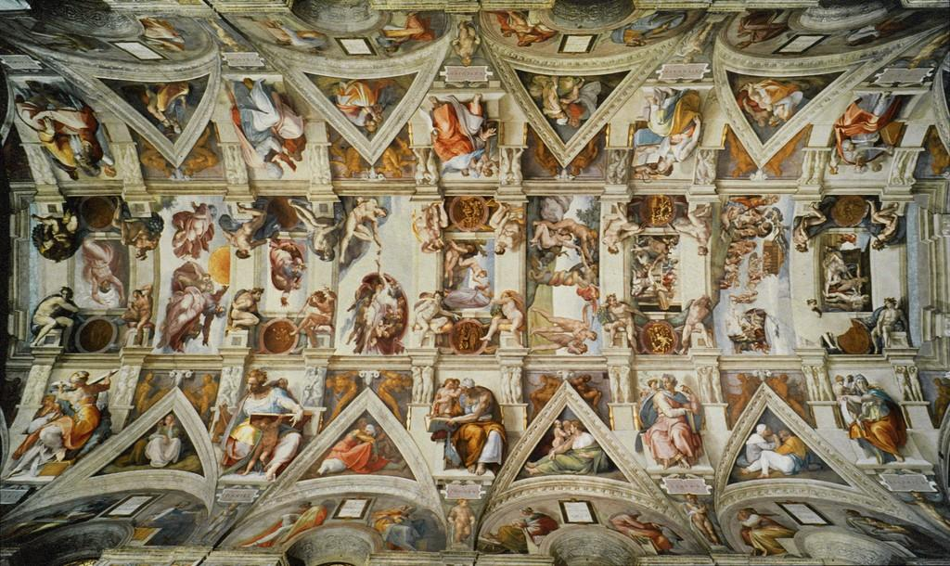
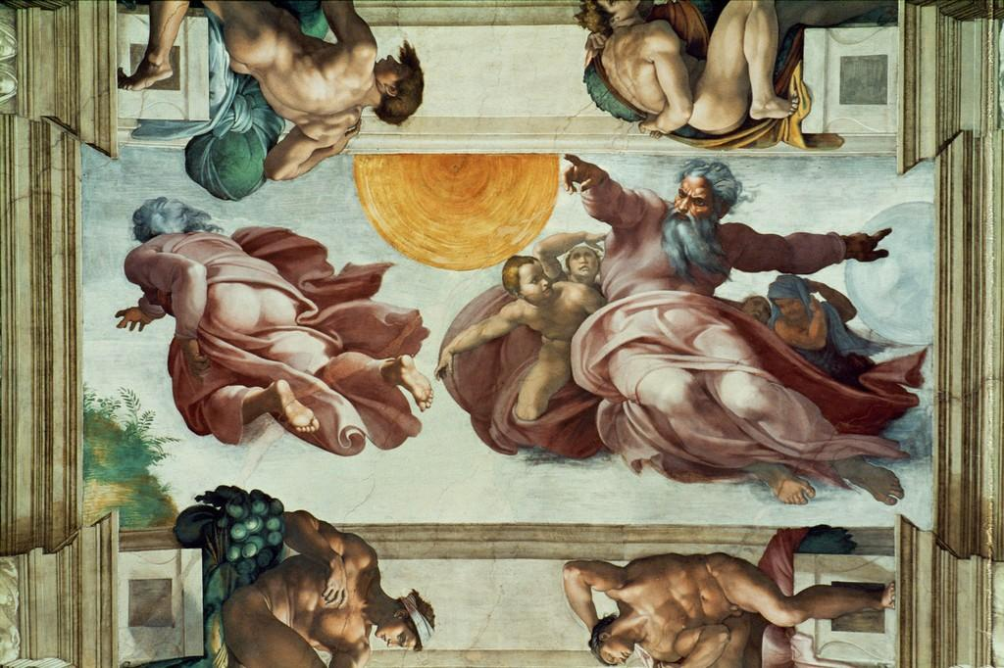
Figure 1
Michelangelo Buonarroti, Sistine Chapel: Ceiling Frescoes, 1508-12, fresco, Sistine Chapel, Vatican
Photo Credit: Erich Lessing/ART RESOURCE, N.Y., JSTOR

Figure 2
Michelangelo Buonarroti, Creation of the Sun, Moon and Plants, 1508-12, fresco, Sistine Chapel, Vatican.
Photo Credit: Erich Lessing/ART RESOURCE, N.Y., JSTOR.

The Last Judgement
The Last Judgement (Figure 3), which occupies the altar wall of the Sistine Chapel, was painted between 1536 and 1541. Christ is central within the fresco and appears as a dominant figure. The scene shows the moment before the Messiah is meant to utter his verdict during his second descent to Earth, according to the biblical narrative.

Then shall the King say unto them on his right hand, Come ye blessed of my Father, inherit the kingdom prepared for you from the foundation of the world.

Then shall he say also unto them on the left hand, Depart from me ye cursed, into everlasting fire, prepared for the devil and his angels.

These biblical passages, taken from the gospel of St. Matthew, describe Christ’s act of final judgement, during which the destinies of the sinners and the faithful will separate. One of the most striking features of Michelangelo’s The Last Judgement is the circular motion which appears to be focused upon Christ and his luminous aura. According to Valerie Shrimplin, the centre of this radial composition seems to be Jesus’ right thigh. She connected this fact with Revelation 19:16, where it is written that Christ carried an inscription on his vesture and thigh. The message was ‘King of Kings and Lord of Lords’. This Biblical passage is followed by a reference to an angel which stands in the Sun. In Michelangelo’s The Last Judgement, the connections with solar centrality are multiple, and they can be quite subtle. As Anne Leader specified, The Last Judgement was intended to reach a refined theological audience. Previous artistic renditions of the parable of the Last Judgement traditionally represented the Earth, Heaven and Hell within the same piece. Michelangelo introduced a fresh conception of the usual cosmology, giving Christ’s image absolute centrality and creating a blend of the three realms around the Messiah. In ancient representations, the flat surface of the Earth would be dominated by the dome of Heaven above, with Hell represented below. Michelangelo’s fresco appears to incorporate a grand circular dynamic, with an ascending movement on the right of both Jesus and Mary, and a descending motion on their left. Mother and Son face the viewer, so the motion appears clockwise across the whole fresco. The distinction between the blessed and the damned souls, which appear to magically float across Michelangelo’s sky, occurs in a climate of commotion, which has left historians debating the overall meaning of the fresco.
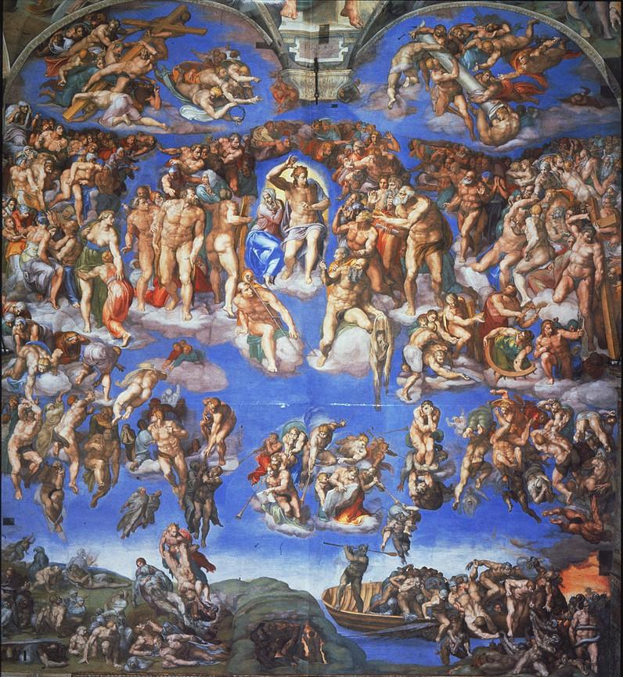
Figure 3
Michelangelo Buonarroti, The Last Judgement, 1534-41, fresco, Sistine Chapel, Vatican
Data from: University of California, San Diego, JSTOR.

Commission and Execution
The idea of painting the chapel’s vault went through some evolution. As noted by Kathleen Weil and Garris Brandt, the first commission only referred to the painting of twelve apostle images in the lunettes, which are the semicircles above the windows. During the planning stage, Michelangelo realized that the original project would not have been rich enough; therefore, he asked Pope Julius II for a larger commission and more freedom of choice. Weil and Brandt suggested that Michelangelo was animated by a competitive spirit and that he challenged himself by accepting the ceiling project. The difficulties of painting at height on a curved surface were great; this was one of the reasons which pushed Michelangelo to compete against the expert architect Donato Bramante. The ceiling work was finalized in 1512. In 1533, Pope Clement VII de’ Medici commissioned the new fresco, but he died the following year. Michelangelo started The Last Judgement in 1536, under the pontificate of Paul III. Leader highlighted the fact that Pope Paul III was elected under the threat of spreading Protestantism. She suggested that The Last Judgement, with its strong statement, was also aimed at counteracting the rupture which was severely affecting the Church. Leader added that there are theories which connect the horrors of the Sack of Rome with the commission of Michelangelo’s apocalyptic fresco. According to such theories, the events of 1927 may have caused Clement VII to order a painting that could provide a response to the injustice of the sack. Nevertheless, Leader cited both von Heinem and Shearman, writing that they both questioned this idea. They suggested that The Last Judgement had already been envisioned during the first decade of the sixteenth century, when Julius II requested that the original design of the ceiling should be altered. According to Leader, the narratives present on the vault and walls find their culmination in The Last Judgement. A similar viewpoint was expressed by John Dixon, who stated that The Last Judgement could only be comprehended if seen as a culmination of the ceiling narrative. He added that the altar fresco represents part of the journey towards salvation, and that its position on the altar wall connects it with the salvational sacrifice of the Holy Mass. Dixon pointed out that Michelangelo had changed, both physically and intellectually, between the creation of the ceiling frescoes and The Last Judgement. Even though there is no pattern continuation between the two sections, they are all deeply connected. Amidst the noticeable dynamism of The Last Judgement, Christ is shown as a luminous central point of reference. Leader wrote that ‘Michelangelo’s Christ appears not angry but calm and dignified’. Therefore, representing the existence of a central divine, transcendental and redemptive core seems to have been one of Michelangelo’s objectives.

Dante and Copernicus as Literary and Scientific Influences
Michelangelo’s approach has been observed in connection with Dante Alighieri’s (1265-1321) works. Armour noted that the link between Dante and Michelangelo can be found in the writings of Donato Giannotti, Benedetto Varchi, Giorgio Vasari and Ascanio Condivi. Armour cited Giannotti, who wrote of Michelangelo as a ‘gran dantista’, despite Michelangelo’s rejection of the claim.
Michelagnolo hauete uoi ragione à dire, che egli sia gran Dantista. Percioche io non conosca alcuno, che meglio di lui lo intenda et possegga ; Non auete già ragione à dir di me, che io sia Dantista ; Et mi fate grandissima ingiuria attribuendomi quello che non è mio.
Michelangelo you are right to say, that he is a great Dantista. This is because I do not know anyone, who knows and possesses him (Dante) better than him (Michelangelo); you have no reason to say about me, that I am a Dantista; and you do great harm to me by attributing what is not mine (my translation).
Both Armour and Barolsky noted that Dante-related iconography can be found in Michelangelo’s The Last Judgement. For this reason, he pointed out the presence of images which resonate with The Divine Comedy, such as Haman on the cross, as well as the presence of both Charon and Minos. Barolsky saw Michelangelo as a visionary, especially with regard to his representation of Dante’s narrative. Through his rendering of the human body, Michelangelo contributed to bringing the worshiper closer to the supernatural. In The Last Judgement, Saint Bartholomew, defined as Michelangelo’s ‘saintly persona’, gazes towards the central Sun-Christ whilst holding his own skin. Barolsky saw in this detail an allusion to Dante’s prayer to Apollo in the first Canto of Paradiso. Pietro Toesca wondered why Dante had attracted artists such as Michelangelo and Botticelli, who could fully express themselves through their abilities in the plastic arts. Toesca found an explanation in the notion that Dante’s work could overcome any theoretical boundaries which were traced between the arts. The connections between the refined theology and allegorical vision of Dante, therefore, appear to have left their mark for generations to come. Michelangelo, as he contemplated divinity within the Sistine Chapel, may have found inspiration also in the words of Dante, who had lived two centuries earlier.
Michelangelo’s entire project spanned between the initial commission of the ceiling work in 1508 and the completion of The Last Judgement in 1541. The artist was a contemporary of Nicolaus Copernicus (1473-1543), whose book De Revolutionibus Orbium Coelestium was published in 1543. The heliocentric theory reached the press in the same year of Copernicus’ death and two years after Michelangelo completed The Last Judgement. In a study about the origins of heliocentrism, Bernard Goldstein explained that heliocentric ideas had been circulating a long time before Copernicus. In fact, in the Book IX of the Almagest, Ptolemy (c.100 – c.170 AD) had written about the possibility that the Sun occupied a median position within the Solar System, stating that ‘the order assumed by the older [astronomers] appears the more plausible’. In the sixteenth century, Copernicus had to deal with the fact that calculations of the period-distance relationship for each planet would not make sense for the orbits of the Sun, Mercury and Venus. Therefore, by addressing incompatibilities with the distance-period relationship of the planets and the Sun, he came to the conclusion that only with the introduction of a heliocentric theory the calculations would make sense for all the observable bodies. Shrimplin argued that Michelangelo could have had access to such knowledge during the years in which he was working on the chapel’s frescoes. Copernicus studied in Italy for seven years and was part of intellectual communities similar to those of Michelangelo. Additionally, the Polish astronomer dedicated his De Revolutionibus to Pope Paul III, who commissioned Michelangelo’s The Last Judgement. With his enterprise, Michelangelo attempted to explore humanity’s relationship with the cosmos and the sacred, and his knowledge of the scriptures may have also been supported by the nascent scientific theory of heliocentrism.

Light and Darkness
Michelangelo’s representation of light within the two frescoes examined in this essay may have drawn on ancient roots. The theological importance of light can be traced to Biblical scripture, as specified by Shrimplin. Both the Old and New Testaments referred to Sun-symbolism in relation to Christ, giving importance to light as a sign of consciousness. The centrality of a luminous Christ in The Last Judgement, as well as the presence of the two ‘Lights’ of Genesis 1:16 in Creation of the Sun, Moon and Plants, constitute two examples of Michelangelo’s attention toward the theological importance of light. In an article about The Last Judgement, Shrimplin analysed alternative sources for the design of Michelangelo’s fresco. She considered the possible connections with Platonic Sun-symbolism, the Catholic revival of the ancient Solar Christ image, Dante’s literary approach, and Copernicus’ scientific theory of heliocentrism. She added that the Christ of The Last Judgement can be seen as an Apollonian Sun-Christ. Dixon wrote that ‘the chapel is profoundly Christocentric’, and that its comprehension requires participation like ‘an act of worship and proclamation’. According to Shrimplin, the symbolic importance given to the Sun and its light within The Last Judgement is connected with the fact that Michelangelo was influenced by Ficino’s Neoplatonism and Dante’s works. It can be noted that also Copernicus, who was a fervent Catholic and accepted the action of God in the creation of the universe, was influenced by Ficino’s Neoplatonism. Michelangelo worked on the Sistine Chapel’s frescoes during a time in which a revival of early Christian symbolism and ideology was occurring. The Solar Christ was among the concepts which were circulating again. This symbolic association constituted a traditional link between light, the cosmos and divinity. As Raymond Kilduff explained, the roots of the word ‘deity’ are Indo-European, and are connected with the act of shining. This was reflected in Latin, in which the word ‘deis’ and ‘Deus’ were used to indicate ‘day’ and ‘God’ respectively. The idea that light represents divinity can be traced back to ancient times. Both the Old and New Testaments referred to light as a manifestation of the divine. As noted by Kilduff, Christianity’s focus on light, especially in the New Testament, differs from the Eastern traditions as well as the duality of Gnosticism. Links between the divinity of Christ and the power of light are present within the New Testament, as the Messiah is often seen as the light himself. Kilduff cited John 1 6-9, where John the Baptist was described as God’s messenger. The passage explained that John’s mission was to tell the people about the light. Kilduff also referred to John 8 12, in which Christ said he was ‘the light of the world’.
An exploration of the symbolic association between darkness and evil can reveal additional details about the meaning of light in Christianity. In an article on the mythology of darkness, Morton T. Kelsey explored three different historical views about evil, trying to identify its roots. First, he described the modern approach: the purposelessness of the universe is disconnected from the power of the Ego, which tends to identify both positive and negative significance in the experience of change. In the second point of view, he referred to the Aristotelian image of the universe as a neutral system which is opposed to human reason. Through the use of reason, humans are considered able to choose rationally between good and evil. Kelsey’s third approach related to the ancient religious worldview, which identified a superior creative power that needs to bring forth both good and evil in order to let reality unfold. As noted by Barbara A. Weightman, life’s cyclicity is related to the alternation of light and darkness. Light is associated with life, whereas darkness brings death. She added that the combination of light and darkness helps evoke divinity within sacred spaces. Judith L. Corey cited Saint Symeon, a Greek Christian mystic of the Eastern tradition, who wrote about light as an agent that transforms the soul. God manifests as light, which acts as a bridge between the visible and invisible realms. Corey also highlighted Symeon’s understanding of light as the agent of inner transformation and purification. Kelsey explained that by turning towards what he called ‘the experiencing center’, one is able to identify the coexistence of good and evil. There is an equally destructive power within the inner core, which depth psychologists refer to as the ‘unconscious’. He subsequently mentioned Jung’s view, according to which mythology explains ‘encounters with the inner psychic world’. The coexistence of light and darkness can therefore be seen as the dualism between divinity and evil.

Solar Symbolism in Liturgy
Helen Dunbar pointed out that, in the past, the celebration of the Mass connected the faithful with the Sun. Because of the typical Eastward orientation of churches, all eyes would be directed toward the sunlight, the cross or the monstrance. Solar symbolism would be visible to the faithful in the form of a glorious Sun on the ostensorium or an eclipsed Sun on the cross. The presence of both Lights, the Sun and Moon, on the cross was sometimes a symbolic statement about the Sun being eclipsed. As noted by Charles Warren, the Eastern sky was traditionally seen as the place from which God connects with the Earth. In dealing with the sacred orientation of churches, both Warren and Gordon referred to Ezekiel 43:2, where the prophet mentioned the coming of God from the East.
‘And behold, the glory of the God of Israel came from the way of the east’
Citing T.D. Atkinson, Gordon pointed out that in Hebrew etymology, East means ‘the front’, and West ‘the back’. The symbolic importance associated specifically with the East highlighted the importance of the nascent Sun, which was seen as glorious and divine during its rising. In a study about the sacred orientation of churches and synagogues, Franz Landsberger pointed out that the etymology of ‘orientation’ indicates ‘a turning toward the east’. He added that the sacred direction of non-Christian and non-Jewish temples used to give prominence to the deity, rather than the worshiper. Therefore, the deity would look through the portal, which was oriented towards the East. This description referred to a practice opposite to that indicated by Dunbar, in which the worshipers faced the direction of the rising Sun. Landsberger specified that the Greeks and Romans, more recently, arranged the portals of temples toward the east. In his view, Christians subsequently chose to pray toward the East, despite the ambivalent previous traditions. Landsberger justified this with the idea that Christians saw prayer as an act that guided them towards the Savior. Dunbar also specified that the four sections of the Holy Mass, which are associated with different seasons of the liturgical year, summarise the solar year. The Advent corresponds to the darkness of winter, followed by Christmas and the Epiphany, right after the Solstitial rebirth of the Sun. The third season corresponds to Lent and Easter, and the fourth is the harvesting period ruled by the action of the Holy Spirit after the Pentecost. This constitutes a connection between the four astronomical seasons and the four mystical seasons of the liturgical year. On a similar note, in Pope Paulus VI’s Sacrosanctum Concilium (1963), it was stated that ‘Within the cycle of a year, moreover, she (Holy Mother Church) unfolds the whole mystery of Christ’. The work of Saint Francis constitutes another major contribution rich in solar symbolism. He composed the Canticle of the Brother Sun in 1225, a year before he died. Ilia Delio defined the work as a ‘hymn of light’ that reflected Saint Francis’ experience of the divine.
Praised be my Lord God with all His creatures, and especially for our brother, the Sun, who brings us the day and who brings us the Light. Fair is he and shines with a very great splendor. O Lord, he signifies to us, Thee.
Saint Francis wrote of the Sun as Christ, showing a link between the two. The centrality of Christ is here connected with the luminosity and grandiosity of the ‘Brother Sun’.

The Birthday of the Sun
This paragraph will explore the roots of Christmas as a Solar date, as a further symbolic connection which may aid the interpretation of Michelangelo’s work. Nothaft noted that, alongside the possible Christianization of ancient religious dates, the date of Christmas may have derived from an ancient calculation done by Christian scholars. Nothaft referred to Thomas J. Talley, one of the proponents of such ideas, who held that the December date of Christmas had been obtained from a calculation that considered several factors. The assigned dates for both the Annunciation to Mary and Christ’s death were both associated with March 25. Nothaft explained that, according to Talley, Christian scholars added a rounded number of nine months to the date of the Annunciation in order to calculate the date of Christmas. Julius Evola, discussing Altheim’s work, pointed out that Christmas originated from the Roman festival Natalis Solis Invicti, celebrated on December 25th. The Romans used the term ‘Invictus’ also to refer to Mithra, indicating the sunlight which overcomes darkness. The infusion of Solar symbolism in early Christianity could also be seen on Roman crucifixes. Evola also cited Altheim, specifying that the Roman Sun, supreme and central, eventually became the servant of a higher God, that of the Christians. The contrast between two different epochs and worldviews characterized what Evola referred to as ‘the Romanisation of early Christianity’. It is from this connection of ideologies and symbolism that references to Solar centrality in Christianity emerged. The symbolic relationship between Christ and the Sun was reflected in both scripture and tradition. Louise Burkhart noted that Christ’s birth was traditionally associated with midnight and the epoch of the winter solstice; furthermore, Christ’s body was linked with brilliance at birth, during the transfiguration and after his resurrection. In John 8:12, Christ spoke to the people and self-identified as the ‘light of the world’, granting the ‘light of life’ to those who followed him and stayed out of the darkness. Jack Greenstein referred to the association between Michelangelo’s Christ and the ‘Sol Iustitiae’, or Sun of Righteousness. He added that the head of the Christ of The Last Judgement resembles that of the Apollo Belvedere, a sculpture of the Greek Sun-God, which can be found in the Vatican Palace. The refined features of Apollo can be observed in the head of Michelangelo’s Christ; nevertheless, the latter’s body does not match the thinner Apollonian body. In both medieval and Renaissance traditions, Christ was often shown as bearded. However, Michelangelo departed from such tradition, blending an Apollonian head with a sturdy body. Therefore, according to Greenstein, the Apollonian appearance carried the solar magnificence of the transfigured Christ.

Conclusion
The Sistine Chapel frescoes created by Michelangelo are filled with symbolism of high theological sophistication. In Creation of the Sun, Moon and Plants, Michelangelo provided a dualistic image, in which God is personified and seen from different perspectives during the act of creating the great Lights of the sky, as well as vegetation on Earth. The almost absolute centrality of the Sun constitutes a prominent feature of this particular fresco. Both the Sun and Moon symbolically participate in God’s act of Creation, representing two aspects of life and nature. The dualism of Creation of the Sun, Moon and Plants contrasts with the concentricity of The Last Judgement. In the latter, Christ is at the centre and, with his luminous halo, appears to direct the dynamic scene of the fresco. Though the Sun is not explicitly represented in The Last Judgement, studies have shown connections between Michelangelo’s work and Christ-Sun symbolism. Michelangelo changed a lot between the first and second commissions. During the latter part of his work, the Church was starting to face the repercussions of the Protestant Reformation. In that climate, he worked on the major project of The Last Judgement, and he was also more mature, experienced and thoughtful. Whilst the ceiling contains scenes related to Creation, the altar wall shows an Apocalyptic act. Within the Sistine Chapel, both the beginning and the end of the world are portrayed. The Last Judgement has attracted scholarly attention, and doubts have been raised as to whether the scene should be interpreted as an intimidating or liberating one. One of the main characteristics which seem to transpire from an analysis of the fresco is that some sort of general commotion rules the scene. The centrality of Christ, who is illumined like the Sun, represents a fulcrum within a general motion of ascending blessed and descending damned souls. In Creation of the Sun, Moon and Plants, which is significantly smaller than the other fresco analysed in this essay, the Sun participates in an imperious divine act. Related to the third and fourth days of Genesis, the image brings together the supreme image of God and two major elements of the cosmos, the Sun and the Moon. Michelangelo worked on his frescoes during a revival of ancient Christian symbolism, possibly knowledgeable about Dante’s literature, and perhaps aware of heliocentric ideas. The frescoes analysed in this essay emphasize the connection between numinous and cosmic elements, yet the various narratives are centred around the image of God. Celestial elements are prominent in some of the scenes, and light appears to participate in humanity’s journey towards salvation. Therefore, light represents a subtler aspect of the Solar symbolism which transpires across the two frescoes. Michelangelo may have imagined the Sun as a cosmic element which accompanied the Lord and responded to His demands. On the other hand, he may have envisioned God and the Sun as the embodiment of each other.

BIBLIOGRAPHY

Primary Sources
Anonymous, The Holy Bible Containing the Old Testament and the New. (Oxford, 1680-1682).
Giannotti, Donato, Dialogi di Donato Giannotti: De' giorni che Dante consumò nel cercare l'inferno e 'l purgatorio, (Firenze: Tip. Galileana,1859).
Ptolemy, ‘Book IX’, in G. J. Toomer, Ptolemy’s Almagest. (Princeton: Princeton University Press, 1998), 419–468.
Saint Francis of Assisi, ‘Canticle of the Sun’ (translated by Matthew Arnold), World Affairs, 107.2 (1944), 118.

Secondary Sources
Armour, Peter, ‘A Ciascun Artista L’Ultimo Suo: Dante and Michelangelo’, Lectura Dantis 22/23 (1998), 141–180.
Barolsky, Paul, ‘The Visionary Art of Michelangelo in the Light of Dante’, Dante Studies, with the Annual Report of the Dante Society 114 (1996), 1-14.
Barolsky, Paul, ‘Beginning and End in the Sistine Chapel’, Notes in the History of Art 23.1 (2003), 31-33.
Brandt, Kathleen and Weil, Garris, ‘Michelangelo’s Early Projects for the Sistine Ceiling: Their Practical and Artistic Consequences’, Studies in the History of Art 33 (1992), 56–87.
Burkhart, Louise M., ‘The Solar Christ in Nahuatl Doctrinal Texts of Early Colonial Mexico’, Ethnohistory 35.3 (1988), 234–256.
Corey, Judith L., ‘Cosmologies of Divine Light and Logos in the Christian Era’, in Light from Light: Cosmology and the Theology of the Logos (1517 Media, 2016), (pp. 55–72).
Delio, Ilia, ‘The Canticle of Brother Sun: A Song of Christ Mysticism’, Franciscan Studies 52 (1992), 1–22.
Dixon, John W., ‘The Christology of Michelangelo: The Sistine Chapel’, Journal of the American Academy of Religion 55.3 (1987), 503-533.
Dunbar, Helen Flanders, Symbolism in medieval thought and its consummation in the Divine Comedy, (Yale University Press, 1929).
Evola, Julius, ‘Sol Invictus: Encounters Between East and West in The Ancient World’, East and West 8.3 (1957), 303–306.
Goldstein, B. R., ‘Copernicus and the Origin of his Heliocentric System’, Journal for the History of Astronomy (2002), 219-235.
Gordon, B. L., ‘Sacred Directions, Orientation, and the Top of the Map’, History of Religions 10.3 (1971), 211-227.
Greenstein, Jack M., ‘How Glorious the Second Coming of Christ: Michelangelo’s “Last Judgment” and the Transfiguration’, Artibus et Historiae 10.20 (1989), 33–57.
Kilduff, Raymond, ‘The Christian Tradition: The Birthday of the Sun’, The San Francisco Jung Institute Library Journal 6.2 (1986), 34-37.
Landsberger, Franz, ‘The Sacred Direction in Synagogue and Church’, Hebrew Union College Annual 28 (1957), 181–203.
Leader, Anne, ‘Michelangelo’s ‘Last Judgment’: The Culmination of Papal Propaganda in the Sistine Chapel’, Studies in Iconography 27 (2006), 103-156.
Musei Vaticani, Creation of the sun, moon and plants <https://m.museivaticani.va/content/museivaticani-mobile/en/collezioni/musei/cappella-sistina/volta/storie-centrali/creazione-degli-astri-e-delle-piante.html> [accessed April 24 2023].
Musei Vaticani, The Last Judgement
<https://m.museivaticani.va/content/museivaticani-mobile/en/collezioni/musei/cappella-sistina/giudizio-universale.html> [accessed April 24 2023].
Musei Vaticani, Sistine Chapel <https://www.museivaticani.va/content/museivaticani/en/collezioni/musei/cappella-sistina/storia-cappella-sistina.html > [accessed April 24 2023].
Vatican, Celebrazione Eucaristica per l'inaugurazione dei Restauri degli Affreschi di Michelangelo - Omelia di Giovanni Paolo II (1994) <https://www.vatican.va/content/john-paul-ii/it/homilies/1994/documents/hf_jp-ii_hom_19940408_restauri-sistina.html> [accessed April 24 2023].
Nothaft, C. P. E., ‘The Origins of the Christmas Date: Some Recent Trends in Historical Research’, Church History 81.4 (2012), 903–911.
Shrimplin-Evangelidis, Valerie, ‘Sun-Symbolism and Cosmology in Michelangelo’s Last Judgment’, The Sixteenth Century Journal 21.4 (1990), 607-644.
Toesca, Pietro, ‘Sandro Botticelli e Dante’ La Bibliofilía 24.1/3 (1922), 1–19.
Warren, Charles, ‘Orientation of Ancient Temples and Places of Worship’, Transactions of the Royal Historical Society 4 (1876), 188–230.
Weightman, Barbara A., ‘Sacred Landscapes and the Phenomenon of Light’, Geographical Review 86.1 (1996), 59–71.

Musei Vaticani, Creation of the sun, moon and plants <https://m.museivaticani.va/content/museivaticani-mobile/en/collezioni/musei/cappella-sistina/volta/storie-centrali/creazione-degli-astri-e-delle-piante.html> [accessed April 24 2023].
Musei Vaticani, The Last Judgement <https://m.museivaticani.va/content/museivaticani-mobile/en/collezioni/musei/cappella-sistina/giudizio-universale.html> [accessed April 24 2023].
Vatican, Celebrazione Eucaristica per l'inaugurazione dei Restauri degli Affreschi di Michelangelo - Omelia di Giovanni Paolo II (1994) <https://www.vatican.va/content/john-paul-ii/it/homilies/1994/documents/hf_jp-ii_hom_19940408_restauri-sistina.html> [accessed April 24 2023].
Paul Barolsky, ‘Beginning and End in the Sistine Chapel’, Notes in the History of Art, 23.1 (2003), 31-33 (p. 31).
Musei Vaticani, Creation of the sun, moon and plants <https://m.museivaticani.va/content/museivaticani-mobile/en/collezioni/musei/cappella-sistina/volta/storie-centrali/creazione-degli-astri-e-delle-piante.html> [accessed April 24 2023].
Barolsky, ‘Beginning and End in the Sistine Chapel’, p. 31.
Barolsky, ‘Beginning and End in the Sistine Chapel’, p. 33.
Musei Vaticani, Creation of the sun, moon and plants <https://m.museivaticani.va/content/museivaticani-mobile/en/collezioni/musei/cappella-sistina/volta/storie-centrali/creazione-degli-astri-e-delle-piante.html> [accessed April 24 2023].
‘Genesis 1:11’ in The Holy Bible.
‘Genesis 1:16’ in The Holy Bible.
Musei Vaticani, The Last Judgement <https://m.museivaticani.va/content/museivaticani-mobile/en/collezioni/musei/cappella-sistina/giudizio-universale.html> [accessed April 24 2023].
‘Matthew 25:34’ in The Holy Bible Containing the Old Testament and the New (Oxford: At the Theater in Oxford, 1680-1682).
‘Matthew 25:41’ in The Holy Bible.
Valerie Shrimplin-Evangelidis, ‘Sun-Symbolism and Cosmology in Michelangelo’s Last Judgment’, The Sixteenth Century Journal, 21.4 (1990), 607-644 (pp. 642-643).
‘Revelation 19:16’ in The Holy Bible.
Anne Leader, ‘Michelangelo’s ‘Last Judgment’: The Culmination of Papal Propaganda in the Sistine Chapel’, Studies in Iconography, 27 (2006), 103-156 (p. 103).
Shrimplin, ‘Sun-Symbolism and Cosmology in Michelangelo’s Last Judgment’, pp. 612-613.
Shrimplin, ‘Sun-Symbolism and Cosmology in Michelangelo’s Last Judgment’, p. 612.
Shrimplin, ‘Sun-Symbolism and Cosmology in Michelangelo’s Last Judgment’, pp. 618-621.
Kathleen Weil and Garris Brandt, ‘Michelangelo’s Early Projects for the Sistine Ceiling: Their Practical and Artistic Consequences’, Studies in the History of Art, 33 (1992), 56–87 (p.58).
Weil and Brandt, ‘Michelangelo’s Early Projects for the Sistine Ceiling: Their Practical and Artistic Consequences’, p.59.
Musei Vaticani, Sistine Chapel <https://www.museivaticani.va/content/museivaticani/en/collezioni/musei/cappella-sistina/storia-cappella-sistina.html > [accessed April 24 2023].
Leader, ‘Michelangelo’s ‘Last Judgment’’, p. 139.
Leader, ‘Michelangelo’s ‘Last Judgment’’, p. 107.
Leader, ‘Michelangelo’s ‘Last Judgment’’, p. 107-108.
John W. Dixon, ‘The Christology of Michelangelo: The Sistine Chapel’, Journal of the American Academy of Religion, 55.3 (1987), 503-533 (p. 504).
Dixon, ‘The Christology of Michelangelo’, p. 515.
Leader, ‘Michelangelo’s ‘Last Judgment’’, p. 108.
Peter Armour, ‘A Ciascun Artista L’Ultimo Suo: Dante and Michelangelo’, Lectura Dantis, 22/23 (1998), 141–180 (pp. 141-143).
Donato Giannotti, Dialogi di Donato Giannotti: De' giorni che Dante consumò nel cercare l'inferno e 'l purgatorio, (Firenze: Tip. Galileana, 1859), p. 4.
Armour, ‘A Ciascun Artista L’Ultimo Suo: Dante and Michelangelo’, p. 143.
Paul Barolsky, ‘The Visionary Art of Michelangelo in the Light of Dante’, Dante Studies, with the Annual Report of the Dante Society, 114 (1996), 1-14 (p. 2-3).
Armour, ‘A Ciascun Artista L’Ultimo Suo: Dante and Michelangelo’, pp. 143-144.
Barolsky, ‘The Visionary Art of Michelangelo in the Light of Dante’, p. 7.
Barolsky, ‘The Visionary Art of Michelangelo in the Light of Dante’, p. 7.
Pietro Toesca, ‘Sandro Botticelli e Dante’, La Bibliofilía, 24.1/3 (1922), 1–19 (p. 2).
Musei Vaticani, Sistine Chapel <https://www.museivaticani.va/content/museivaticani/en/collezioni/musei/cappella-sistina/storia-cappella-sistina.html > [accessed April 24 2023].
Bernard R. Goldstein, ‘Copernicus and the Origin of his Heliocentric System’, Journal for the History of Astronomy, 33.3 (2002), 219-235 (p. 220).
Ptolemy, et al. ‘Book IX’, Ptolemy’s Almagest, (Princeton: Princeton University Press), 1998, p. 419.
Goldstein, ‘Copernicus and the Origin of his Heliocentric System’, p. 220.
Goldstein, ‘Copernicus and the Origin of his Heliocentric System’, p. 231.
Shrimplin, ‘Sun-Symbolism and Cosmology in Michelangelo’s Last Judgment’, p. 612.
Shrimplin, ‘Sun-Symbolism and Cosmology in Michelangelo’s Last Judgment’, p. 635.
Shrimplin, ‘Sun-Symbolism and Cosmology in Michelangelo’s Last Judgment’, p. 624.
Shrimplin, ‘Sun-Symbolism and Cosmology in Michelangelo’s Last Judgment’, p. 611.
Dixon, ‘The Christology of Michelangelo’, p. 503.
Shrimplin, ‘Sun-Symbolism and Cosmology in Michelangelo’s Last Judgment’, p. 612.
Shrimplin, ‘Sun-Symbolism and Cosmology in Michelangelo’s Last Judgment’, pp. 635-636.
Raymond Kilduff, ‘The Christian Tradition: The Birthday of the Sun’ The San Francisco Jung Institute Library Journal, 6.2 (1986), 34-37 (p. 34).
Kilduff, ‘The Christian Tradition: The Birthday of the Sun’, p. 36.
Kilduff, ‘The Christian Tradition: The Birthday of the Sun’, p. 34.
Morton T. Kelsey, ‘The Mythology of Evil’, Journal of Religion and Health, 13.1 (1974), 7-18 (p. 8).
Barbara A. Weightman, ‘Sacred Landscapes and the Phenomenon of Light’, Geographical Review, 86.1 (1996), 59–71 (p. 67).
Weightman, ‘Sacred Landscapes and the Phenomenon of Light’, p. 67.
Judith L. Corey, ‘Cosmologies of Divine Light and Logos in the Christian Era’, in Light from Light: Cosmology and the Theology of the Logos (1517 Media, 2016), 55–72 (p. 69).
Kelsey, ‘The Mythology of Evil’, p. 9.
Helen Flanders Dunbar, Symbolism in medieval thought and its consummation in the Divine comedy. (Yale University Press, 1929), p. 400.
Charles Warren, ‘Orientation of Ancient Temples and Places of Worship’, Transactions of the Royal Historical Society, 4 (1876), 188–230 (p. 191).
Warren, ‘Orientation of Ancient Temples and Places of Worship’, p. 191.
B. L. Gordon, ‘Sacred Directions, Orientation, and the Top of the Map’. History of Religions, 10.3 (1971), 211-227 (p. 212).
‘Ezekiel 43:2’, in The Holy Bible.
T. D. Atkinson, Points of the Compass, Encyclopaedia of Religion and Ethics. New York, 1955, 10:85, cited in Gordon, ‘Sacred Directions, Orientation, and the Top of the Map’, p. 212.
Franz Landsberger, ‘The Sacred Direction in Synagogue and Church’, Hebrew Union College Annual, 28 (1957), 181–203 (p. 181).
Dunbar, Symbolism in medieval thought, p. 400.
Franz Landsberger, ‘The Sacred Direction in Synagogue and Church’, p. 181.
Dunbar, Symbolism in medieval thought, pp. 407-408.
Vatican, Sacrosanctum Concilium (1963), <https://www.vatican.va/archive/hist_councils/ii_vatican_council/documents/vat-ii_const_19631204_sacrosanctum-concilium_en.html> [accessed April 24 2023].
Ilia Delio, ‘The Canticle of Brother Sun: A Song of Christ Mysticism’, Franciscan Studies, 52 (1992), 1–22 (p. 1).
Saint Francis of Assisi, ‘Canticle of the Sun’ (translated by Matthew Arnold), World Affairs, 107.2 (1944), p. 118.
C. P. E. Nothaft, ‘The Origins of the Christmas Date: Some Recent Trends in Historical Research’, Church History, 81.4 (2012), 903–911 (pp. 903-904).
Julius Evola, ‘Sol Invictus: Encounters Between East and West in The Ancient World’, East and West, 8.3 (1957), 303–306 (p. 304).
Evola, ‘Sol Invictus’, p. 305–306.
Louise M. Burkhart, ‘The Solar Christ in Nahuatl Doctrinal Texts of Early Colonial Mexico’, Ethnohistory, 35.3 (1988), 234–256 (p. 236).
‘John 8:12’ in The Holy Bible.
Jack M. Greenstein, ‘“How Glorious the Second Coming of Christ”: Michelangelo’s “Last Judgment” and the Transfiguration’, Artibus et Historiae, 10.20 (1989), 33–57 (p. 49).
Greenstein, ‘“How Glorious the Second Coming of Christ”: Michelangelo’s “Last Judgment” and the Transfiguration’, p. 49.

