

University of Wales Trinity Saint David

School of Engineering

Probability of Detection and Probability of Sizing
Structural Integrity and Materials Evaluation

ACEA7013

Christian Parry

1808165

4/1/2022

Contents
1 Abstract iv
1.1 Abbreviations iv
2 Introduction 1
2.1 Aims 1
2.2 Objectives 1
3 Literature Review 2
3.1 Probability of Detection (PoD) 2
3.2 Hit/Miss PoD Analysis 3
3.2.1 Hit/Miss PoFA Analysis 3
3.3 Sizing Accuracy PoD Analysis 4
3.4 Human effects on PoD/NDT 5
3.5 Durability and Damage Tolerance (Scheduling Service Inspections) 5
4 Methodology 7
4.1 Calculating Error 7
4.2 Mean Error 7
4.3 Standard Deviation 8
4.4 95% Probability 8
4.5 Gaussian Distribution (Normal Distribution) 8
4.6 “Â vs A” Analysis 9
4.7 Overall System Hit/Miss (PoD) 9
5 Analysis of Operators 11
5.1 Operator 1 11
5.1.1 Operator 1 Comments 11
5.2 Operator 2 12
5.2.1 Operator 2 Comments 12
5.3 Operator 3 13
5.3.1 Operator 3 Comments 13
5.4 Operator 4 14
5.4.1 Operator 4 Comments 14
5.5 Operator 5 15
5.5.1 Operator 5 Comments 15
5.6 Operator 6 16
5.6.1 Operator 6 Comments 16
5.7 Operator 7 17
5.7.1 Operator 7 Comments 17
5.8 Operator 8 18
5.8.1 Operator 8 Comments 18
5.9 Operator 9 19
5.9.1 Operator 9 Comments 19
5.10 Operator 10 20
5.10.1 Operator 10 Comments 20
5.11 Numerical Graph Comparison 21
6 Conclusions 22
7 References 23

Abstract

This report will analyse, using various statistical processes, the effectiveness and sizing accuracy of ten NDT technician’s results using an ultrasonic thickness gauging NDT process. It will also cover the background and development of PoD and sizing methods processes.

Abbreviations
NASA – National Aeronautics and Space Administration
NDE – Non-Destructive Evaluation
NDT – Non-Destructive Testing
PoFA – Probability of False Alarm/Indication
PoD – Probability of Detection
PoS – Probability of Sizing
RADAR – RAdio Detection And Ranging
USAF – United States Air Force

Introduction

Aims
This report aims to provide a detailed background of the development of PoD in NDT, as well as analysing the results of the ten operators using the NDT process to determine which operator is the most successful at testing for defects.

Objectives
Objectives are to:
- Research the history and development of PoD and sizing methods in NDT
- Create an Excel spreadsheet to analyse each operator
- Evaluate and compare structural integrity assessment methods using relevant statistical models

Literature Review

Probability of Detection (PoD)
The PoD in layman terms is the assessment of the capability/effectiveness of the inspection process using NDT (Air Force Research Laboratory, 2019). The result of the NDT must be verified by the use of destructive testing to see if the results correlate well to the true values. This increases the confidence in the testing procedure and increases the likelihood of the testing method to be used in-service, as opposed to having to retire a component to destructively test it (Paul Zabbal, 2021). This area of engineering has been increasing rapidly in recent years, with the number of PoD specific publications published being seen in Figure 1.
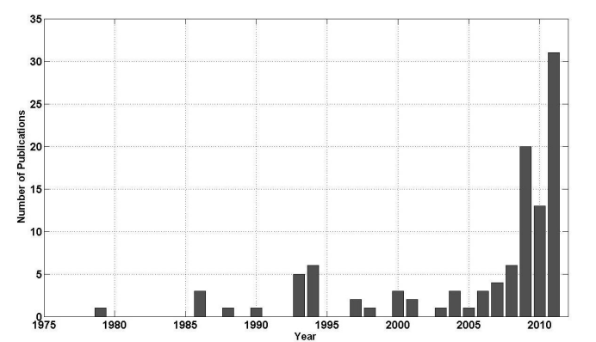
Figure 1 – Number of Publications on PoD in the field of NDT (Juengert, 2012)
This increase is due to the process being adopted in most industries, from the aircraft industry to the Oil and Gas industry. With the amount of older man-made structures such as bridges and buildings still in use, the NDT industry is taking off, as these structures must always ensure safety is maintained. Therefore, NDT is the most suitable process at determining their structural integrity without removing them from service. For example, the Golden Gate Bridge is non-destructively tested/evaluated daily to ensure no dangerous cracks form. This involves engineers traversing the bridge itself as well as SCUBA divers in the water testing the bridge piers (Divers Institute of Technology, 2022).
The PoD process was initially used during World War 2 (Ponsford, 2014) to charaterise whether RADAR, which had recently been invented, was successful in detecting objects, similar to the hit/miss analysis used today.

Hit/Miss PoD Analysis
The simplest form of PoD is the hit/miss detection contingency table as seen below.
 | Defect | No Defect
Detected | True Positive (TP) | False Positive (FP)
Un-Detected | False Negative (FN) | True Negative (TN)
Table 1 – Probability of Detection Contingency Table
The PoD is then worked out based off the total amount of defects that were available to detect (“hit”) within a batch of tests, as seen in Equation 1.
$$PoD=\frac{TP}{TP+FN}= \frac{Total Number of Positive Detections}{Total Opportunities for Rejection}$$
Equation 1 – PoD Equation
When considering the detection contingency table, it is important to note that the worst scenario is a false negative, where a defect in the component has been incorrectly missed either through a fault in the equipment or the testing procedure. If this occurred in a safety critical component it could result in catastrophic consequences. Therefore, it is imperative that false negatives are either completely eradicated or at the minimum, severely reduced.
According to the USA Department of Defence MIL-HDBK-1823A handbook, when analysing the capability of an NDT tester or testing system, it is important to have at least three times as many test pieces with no-defects/unflawed than test pieces with defects/flaws. This is to allow for an estimation of the number of false positives detected (Department of Defence, 2009).

Hit/Miss PoFA Analysis
The probability of false alarms is worked out in much the same way as the PoD was previously, the equation can be seen below,
$$PoFA= \frac{FP}{TN+FP }= \frac{Total Number of False Positives}{Total Opportunities for Acceptance}$$
Equation 2 – PoFA Equation

Sizing Accuracy PoD Analysis
The use of PoD in the NDT sector was developed by NASA and the USAF in the 1970’s, where it was required to analyse the structural integrity of safety components whilst in service. Due to the critical nature of the components being tested, the 90/95 rule was created which means there is a 90% chance of detection with 95% confidence. This can be visualised best in Figure 2 which also shows the effects of sample size on the distribution of results, whereby the larger your sample size, the more sure you can be the test results will truly reflect the distribution of defects.
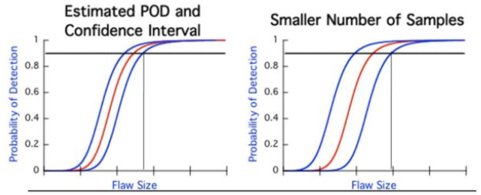
Figure 2 – 90/95 PoD Curves ( (NASA, 2021)
In Figure 2, 90% PoD means that 90% of defects over a certain size will be detected otherwise known as the A90 rule. As previously mentioned, the USAF and NASA work to the de facto A90/95 rule where the 90% PoD must meet the 95% Confidence bound meaning there is a safety margin in place. This information is then used in industry to inform the scheduling of inspection intervals. Due to the preciseness of the 95% confidence bound, the number of defects tested by an operator must be high to provide confidence in the process. It is suggested that a minimum of 60 defects should be tested (Iikka Virkkunen, 2021) with more confidence and higher precision being achieved after 100 tests according to the British Health and Safety Executive (Health and Safety Executive, 2002), or 120 tests according to the USA Department of Defence (Department of Defence, 2009).
Today NDT and PoD is used in almost all engineering industries. Currently, the nuclear industry is developing PoD techniques using round robin tests to assess the reliability of NDT at detecting flaws in components during in-service inspections. One particular example of the round robin test, where multiple NDT inspection teams test the same defects to analyse and compare their results internationally, uses artificial defects to reduce the costs of testing (Iikka Virkkunen, 2021). Previously when completing these comparisons, the process was expensive due to the transportation of test pieces to various companies/testers.

Human effects on PoD/NDT
When conducting NDT analysis, it has been said that the tester themselves is the most significant variable in the process, as the variance between testers is the biggest influence in affecting testing results, more so than the equipment used (Department of Defence, 2009). This can be seen in a test conducted by Nordtest where operators of different certification levels were compared which can be seen in Figure 3, where non-certified testers had a vastly reduced PoD.
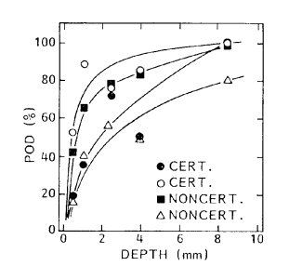
Figure 3 – Effects of Inspectors Certification/Competence on the PoD (Forli, 1990)
To combat this the British Health and Safety Executive mandated that if something was to be tested accurately with complete confidence it must be tested by three different inspectors from three different organisations (Austin, 1996).

Durability and Damage Tolerance (Scheduling Service Inspections)
Following on from the variability in inspectors previously mentioned, one dangerous aspect of an inspector getting a wrong call is that it could result in a component failure. This is because the NDT inspectors will compare a defect size to a chart listing the allowable defect size that wont result in component failure. These allowable defect sizes are calculated using material properties and destructive testing to determine the maximum allowable defect size before the structural integrity of the component is compromised. This then dictates when a component will be tested in service based off the calculated rate of growth of a defect. This is the approach utilised by the USAF in their Aircraft Structural Integrity Program (Air Force Research Laboratory, 2019) as seen in Figure 4.
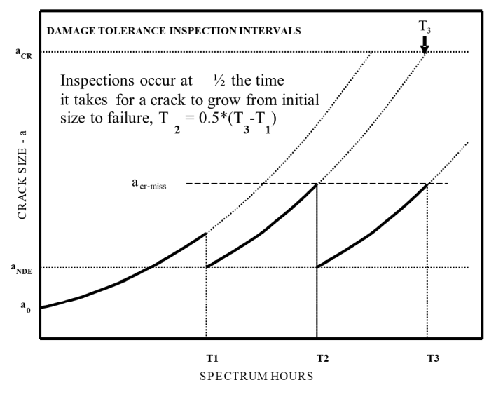
Figure 4 – USAF Inspection Intervals for NDT (Air Force Research Laboratory, 2019)

Methodology
The task at hand was to analyse a new through wall ultrasonic thickness gauging procedure, and then to analyse the sizing accuracy of the ten individual technicians who had used the equipment and procedure to perform the measurements.

Calculating Error
The first step that was taken when analysing each technician was to work out the error between the true size of the defects and the technicians estimate. This process can be seen for Operator 1 in Table 2, the error is calculated by taking away the true size from the estimated size.
Table 2 – Calculating Error for Each Defect
With the error calculated the next step was to calculate the mean error, standard deviation of the errors, and the 95% probability error.

Mean Error
The mean error was calculated by taking the average of all the errors. For operator 1 this came out to be 0.14mm, which means on average, operator 1 overestimates the defect by 0.14mm.

Standard Deviation
When calculating the standard deviation of the operators errors the std.dev-s function was used due to the small sample size of 21 defects. For operator 1 this came out to be 0.46mm, the lower the standard deviation the smaller the spread of values around the mean. This value was then used to calculate the 95% probability.

95% Probability
The 95% probability is calculated to show that there is a 95% chance of plus or minus the standard deviation/range. To calculate it the standard deviation was multiplied by 1.95 to give a value of 0.89mm for operator 1. This means that if a measurement of 3 was recorded by operator 1 then there is a 95% chance of it being 2.11mm or 3.89mm.

Gaussian Distribution (Normal Distribution)
To showcase the range of results more clearly, a Gaussian distribution “bell curve” was produced using the norm.dist function on Excel. A range of -2mm to 2mm was chosen as this could be applied for every tester to keep the x-axis constant. Operator 1 Gaussian distribution can be seen in Figure 5.
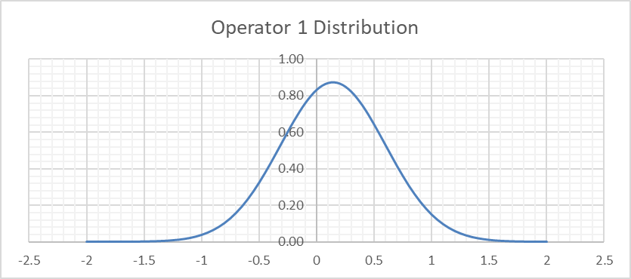
Figure 5 – Operator 1 Gaussian Distribution
As can be seen in the graph the mean value occurs at 0.14mm with a reasonably large distribution of results scattered around the mean.

“Â vs A” Analysis
The next form of analysis used was to create an Â vs A scatter graph which is used extensively in industry (Juengert, 2012), where Â (Estimated Size) is compared to A (True Size) with further analysis tools applied in the form of a trend line and a true size line to show how much the estimated size correlates with the true size, this can be seen in Figure 6.
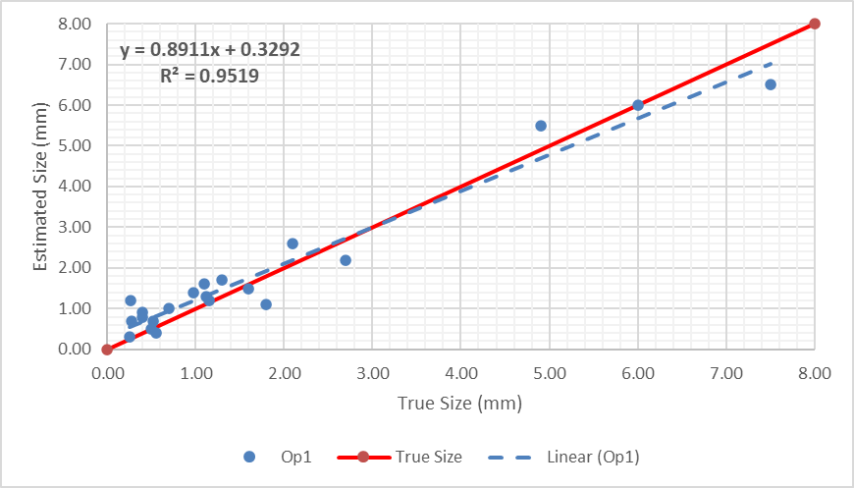
Figure 6 – Operator 1 Â vs A Scatter Graph
As seen in the graph, the equation of the dotted trend line is also included. This is in the Y = Mx + C form and can be used to analyse the technician’s effectiveness. The first number in the equation is the gradient of the line and the second is the system offset. There is also the R^2 function displayed, this value is used to display how much the estimated value and true values correlate, so the more they correlate, the closer to 1 the value will be.

Overall System Hit/Miss (PoD)
To assess the effectiveness of the through wall ultrasound NDT system itself, a hit/miss (detect) column was added to the initial assignment supplement. This can be seen in Table 3. This was added for every operator so it could then be used to calculate an average of the number of correct detections to calculate the system PoD. This can be seen in Figure 7. When looking at the graph, it is clear that there is an outlier that doesn’t follow the natural trend of the PoD graph, the outlier occurs on defect F, where operator 5 misses a defect which is 0.5mm. This affects the testing system’s overall reliability, which therefore means it can only be confidently said that the system will detect defects above 0.5mm.

Table 3 – Hit/Miss Column with POD for System

Figure 7 – Through Wall Ultrasound PoD

Analysis of Operators

Operator 1
Figure 8 – Operator 1 Normal Distribution
Figure 9 – Operator 1 Â vs A

Operator 1 Comments
Normal distribution has a reasonable range of values compared to other operators with mean occurring at around 0.14mm overestimating.
However, the trend line compares well to the true line with a reasonable correlation, the only issue being the underestimating of defect sizes as the defects get larger.

Operator 2
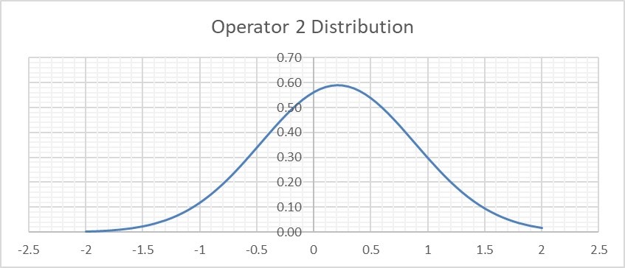
Figure 10 – Operator 2 Normal Distribution

Figure 11 - Operator 2 Â vs A

Operator 2 Comments
Normal distribution looks to be the largest range of values for any operator, so there would be doubt cast as to whether they would size correctly if they continued. The mean occurs at 0.2mm overestimating.
The trend line is also at a significantly different gradient to the true line, with a low correlation. This means operator 3 severely underestimates large defects and overestimates small defect sizes. However, due to the scatter of values recorded, many of the small defects are underestimated too.

Operator 3
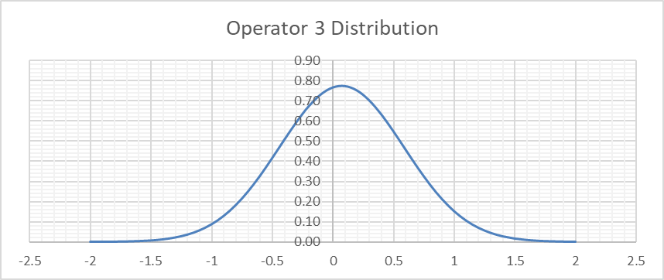
Figure 12 – Operator 3 Normal Distribution
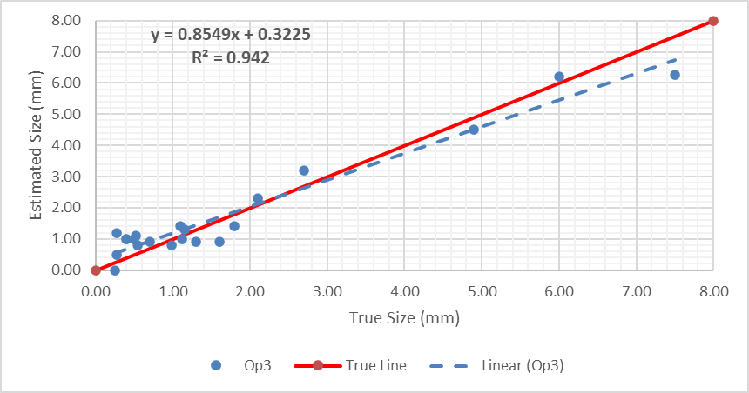
Figure 13 - Operator 3 Â vs A

Operator 3 Comments
Normal distribution range falls in between operator 1 and 2, however the mean improves coming in at 0.07mm overestimating.
Gradient of trend line is again in between operator 1 and 2 with a reasonable correlation, resulting in larger defects being underestimated and small defects overestimated.

Operator 4
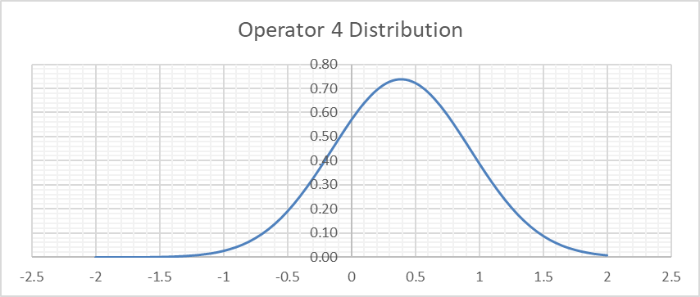
Figure 14 – Operator 4 Normal Distribution
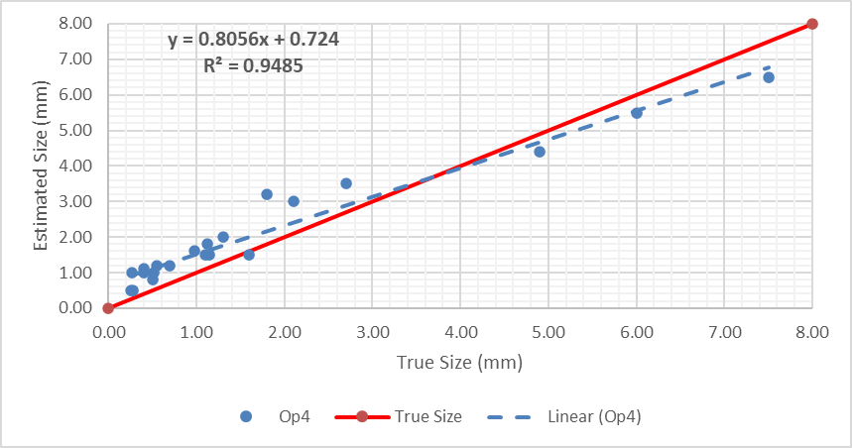
Figure 15 - Operator 4 Â vs A

Operator 4 Comments
Normal distribution has a similar range to the previous operators; however, this operator has a much higher mean value of 0.4mm overestimating.
The trend line has a low correlation to the true size, with the offset meaning it significantly overestimates small defects and underestimates large defects.

Operator 5
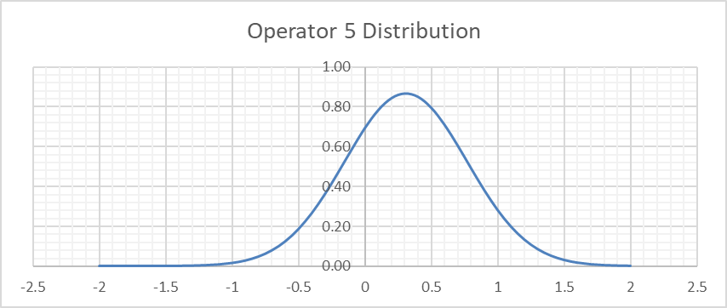
Figure 16 – Operator 5 Normal Distribution
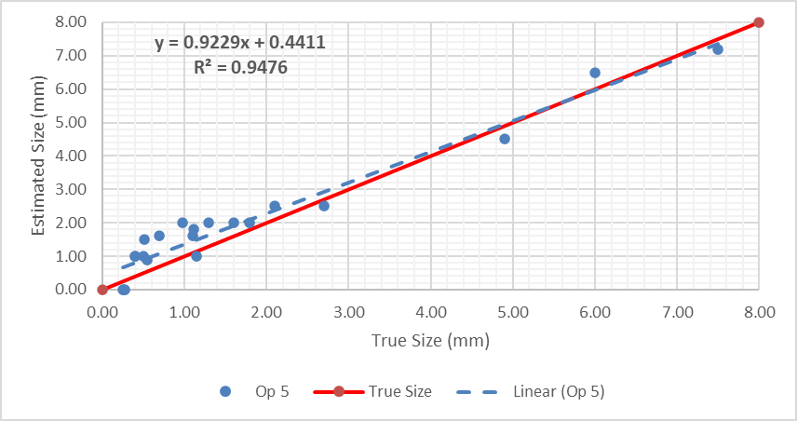
Figure 17 - Operator 5 Â vs A

Operator 5 Comments
Normal distribution range has less spread than previous operators, similar to operator 1, with a mean value of 0.3mm overestimating.
The correlation between the trend line and true line is very high which is positive.

Operator 6
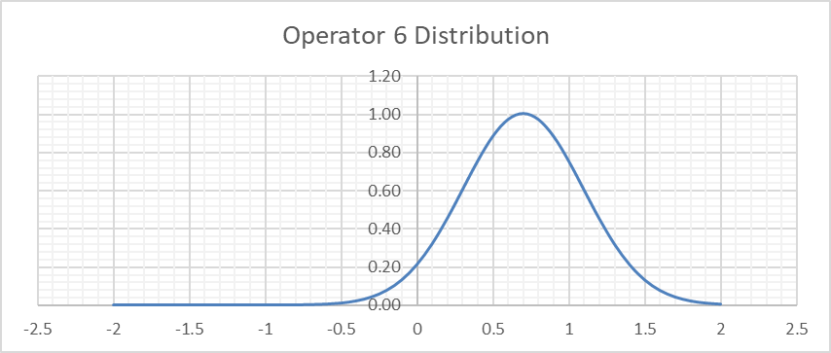
Figure 18 – Operator 6 Normal Distribution
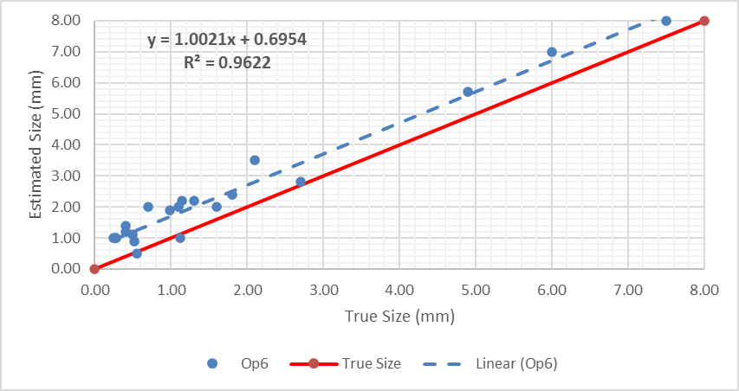
Figure 19 - Operator 6 Â vs A

Operator 6 Comments
The normal distribution values for operator 6 are predominantly all overestimating with the mean value being one of the highest at 0.7mm overestimating.
However, the gradient of the trend line matches almost perfectly with the true line showing very high correlation, apart from the system offset of 0.7mm.

Operator 7
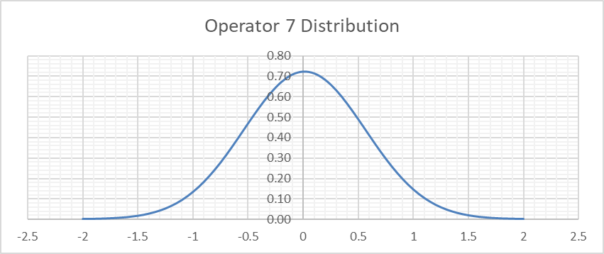
Figure 20 – Operator 7 Normal Distribution
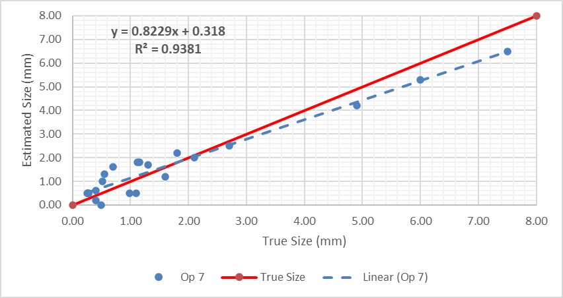
Figure 21 - Operator 7 Â vs A

Operator 7 Comments
Normal distribution range is one of the highest for all operators, with a large scatter both undersized and oversized, which means the mean value ends up being very close to sizing perfectly at 0.01mm overestimating.
The trendline shows a low correlation to the true line. This is due to the large amount of scatter and system offset resulting in consistent underestimating of large defects and scattered results with low confidence for small defects.

Operator 8
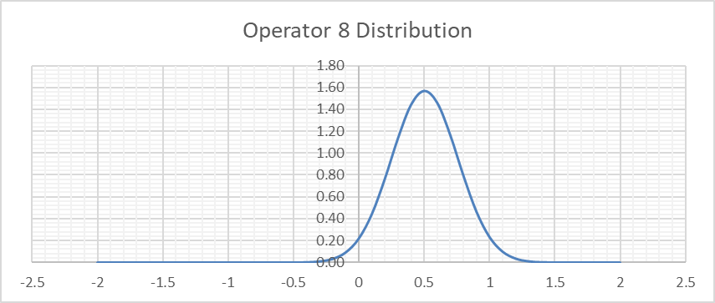
Figure 22 – Operator 8 Normal Distribution
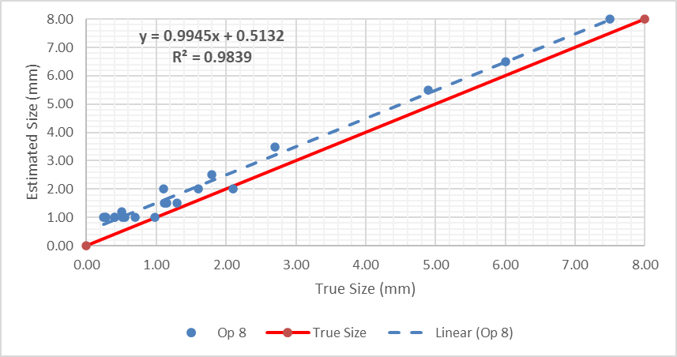
Figure 23 - Operator 8 Â vs A

Operator 8 Comments
Operator 8 appears to have the smallest normal distribution range of all the operators, with most of the sizing errors being overestimated with a mean on 0.5mm.
The correlation between the gradient of the trendline and the true line is excellent with the estimations being extremely consistent, either equal to the true size or higher, for defects of all sizes.
Despite the large system offset for this operator, they are the most consistent in their results, so the knowledge that this operator will overestimate not underestimate increases confidence in their results.

Operator 9
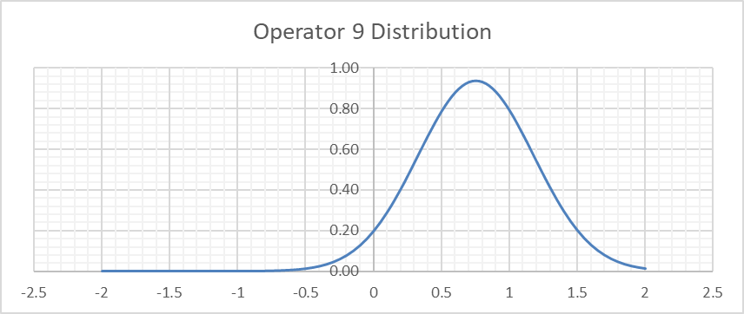
Figure 24 - Operator 9 Normal Distribution
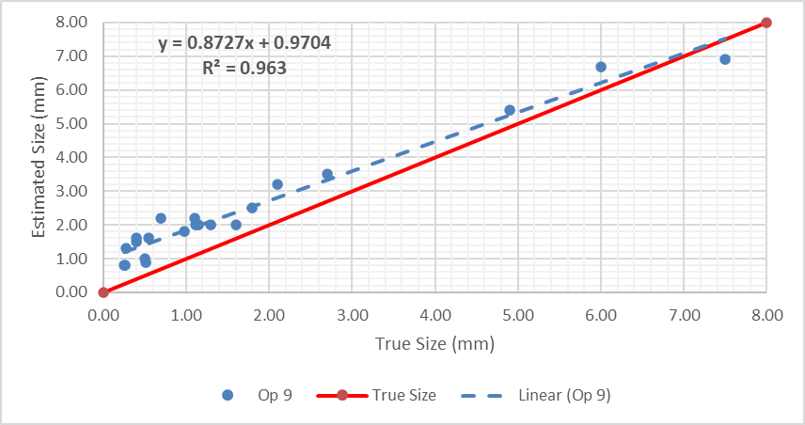
Figure 25 - Operator 9 Â vs A

Operator 9 Comments
Normal distribution range is reasonably good for operator 9 with a tight spread of values, however the mean value is the highest for all operators at 0.75mm overestimating.
The correlation between the trendline and true line is low for this operator due to the large system offset as they overestimate small defects significantly and it looks as if this trend was to continue with larger defects, they would begin to undersize them.

Operator 10
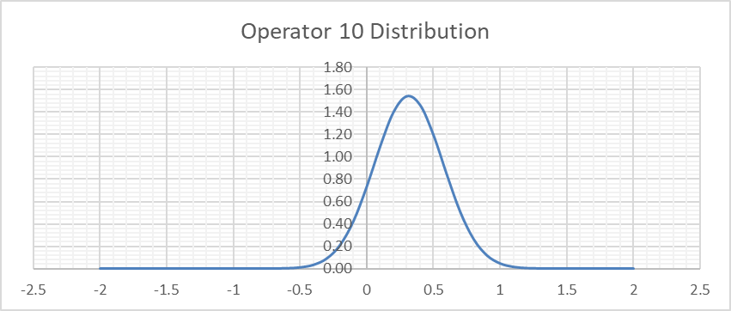
Figure 26 – Operator 10 Normal Distribution
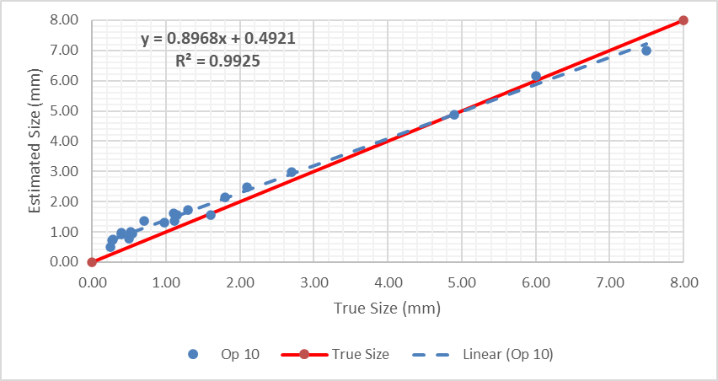
Figure 27 - Operator 10 Â vs A

Operator 10 Comments
Normal distribution is very similar to operator 8 with a very low spread of values, albeit the mean value of 0.31mm is lower which is better.
The correlation between the trendline and the true line is the highest for any operator with most of the values being almost directly on the true line itself. One thing to note about the trend of this operators’ results is that they switch to underestimating at around 7mm defect size, which means this operator would start to underestimate defects if larger defects were tested.

Numerical Graph Comparison
To analyse the operators more accurately than just based off observing the gradients of lines and the scatter of measurements. It was decided to produce a colour map table mapping every parameter the operators could be analysed on, this can be seen in Table 4.
Table 4 – Numerical Comparison of Operators
As seen in the table, for each parameter green is the best and red is the worst. Therefore, the operators with more green cells in their row are the better operators. From observing the graphs and the numerical table above, there are three operators who stand out for their consistency/correlation to the true values. They are:
- Operator 6
- Operator 8
- Operator 10
Of these three operators’, operator 10 detects defects closest to their true size and therefore has the highest R^2 value, whilst operator 8 has the lowest standard deviation so you can be confident in the values they estimate. In addition, operators 6 and 8 have a gradient most like the true line which shows that if the trends were to continue for larger defects, they are most likely to continue overestimating which gives confidence in their results due to consistency.

Conclusions
In conclusion, the through wall ultrasonic thickness gauging NDT procedure worked well, as seen in the PoD graph produced in Figure 7 giving confidence that the system would consistently detect flaws above 0.5mm. When analysing the effectiveness of the operators performing the procedure there is a lot to consider. For example, the procedure has the potential to consistently detect defects that are 0.4mm big, the reason the PoD curve drops on defect F is due to operator 7 missing the defect, which is most likely down to operator error. This could be due to tiredness or a lack of experience in calibrating the ultrasound probe which are listed in the Health and Safety Executives document as high causes of human error (Health and Safety Executive, 2002).
Regarding the operators, the difference between the accuracies could be due to a multitude of aspects, from the experience levels and tiredness previously mentioned to bad work environments, or perhaps some testers were rushing; these could all have massive effects on the accuracy of their results. For example, if an operator had a low experience level and was rushing, they might not apply the coupling agent correctly between the probe and the test piece which would have an adverse effect on their results.
The two operators who stand out as the best are operator 8 and 10. With operator 8 they consistently overestimate defect sizes which is an additional safety factor, whilst also having the tightest spread of values. Perhaps they are overestimating due to a calibration error which could be resolved with extra practice/training. Operator 10 has the most correlation to the true values which makes them the best operator of the group, producing the most accurate results to the true defect size, whilst also having a low standard deviation.

References
Air Force Research Laboratory. (2019). Nondestructive Evaluation: USAF Perspectives on PoD, Imaging and Characterization. Air Force Research Laboratory.
Austin, J. R. (1996). Topside Inspection Project: Phase II Final Report. Offshore Technology Report.
Department of Defence. (2009). NONDESTRUCTIVE EVALUATION SYSTEM RELIABILITY ASSESMENT. USA: Department of Defence USA.
Divers Institute of Technology. (2022, January 3). Non-Destructive Testing: Answering The Call To Underwater Inspection. Retrieved from Divers Institute of Technology: https://www.diversinstitute.edu/non-destructive-testing-answering-the-call-to-underwater-inspection/
Forli, O. (1990). Development and optimisation of NDT for practical use. Finland: IIW.
Health and Safety Executive. (2002). POD/POS curves for non-destructive examination. Weybridge: Visser.
Iikka Virkkunen, T. O.-J. (2021). Virtual round robin – A new opportunity to study NDT reliability. Finland: Nuclear Engineering and Design.
Juengert, A. (2012). Probability of Detection (POD) determination using ultrasound phased array for considering NDT in probabilistic damage assessments. Durban, South Africa: World Conference on Nondestructive Testing.
NASA. (2021). Introduction to Probability of Detection (POD) for Nondestructive Evaluation (NDE). Langley: NASA Engineering and Safety Centre.
Paul Zabbal, G. R. (2021). Evaluation of metallic bonded plates with nonlinear ultrasound and comparison with destructive testing. NDT & E International, Volume 123.
Ponsford, A. (2014). Introduction to Radar. Ottowa: Raytheon.

