Feasibility Plan for an International Meeting

Student name: Irina Roxana Birladeanu
Student ID number: 2121941
Module code: BMIH6007
Lecturers name: Kathryn Flynn

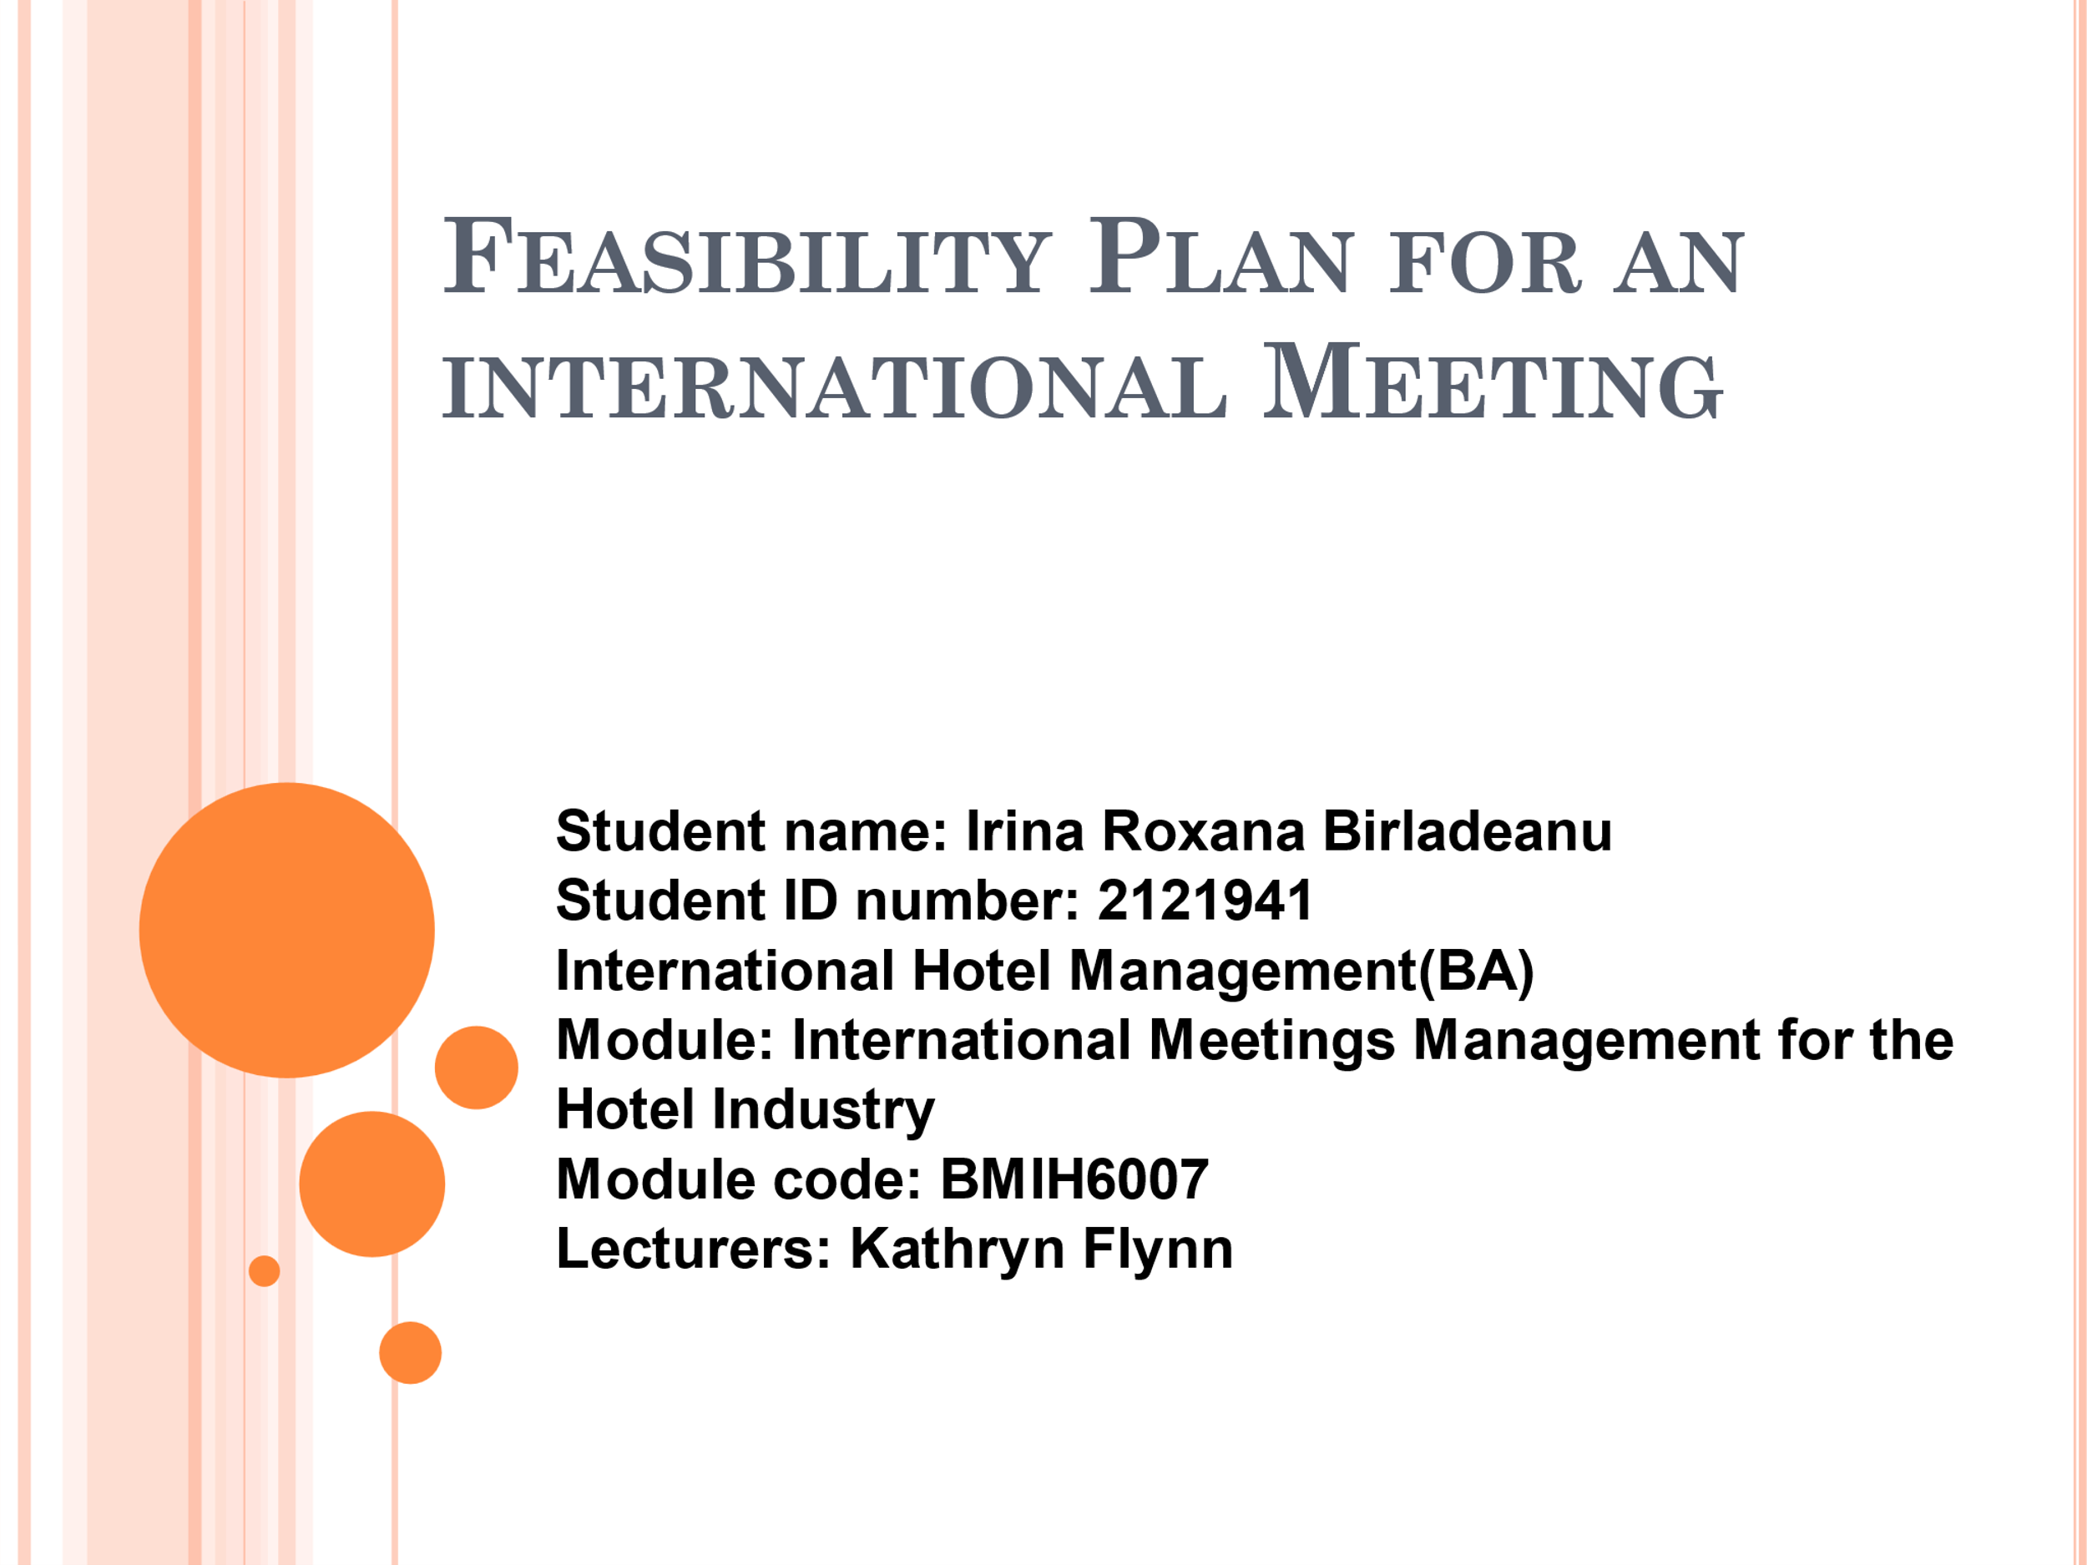

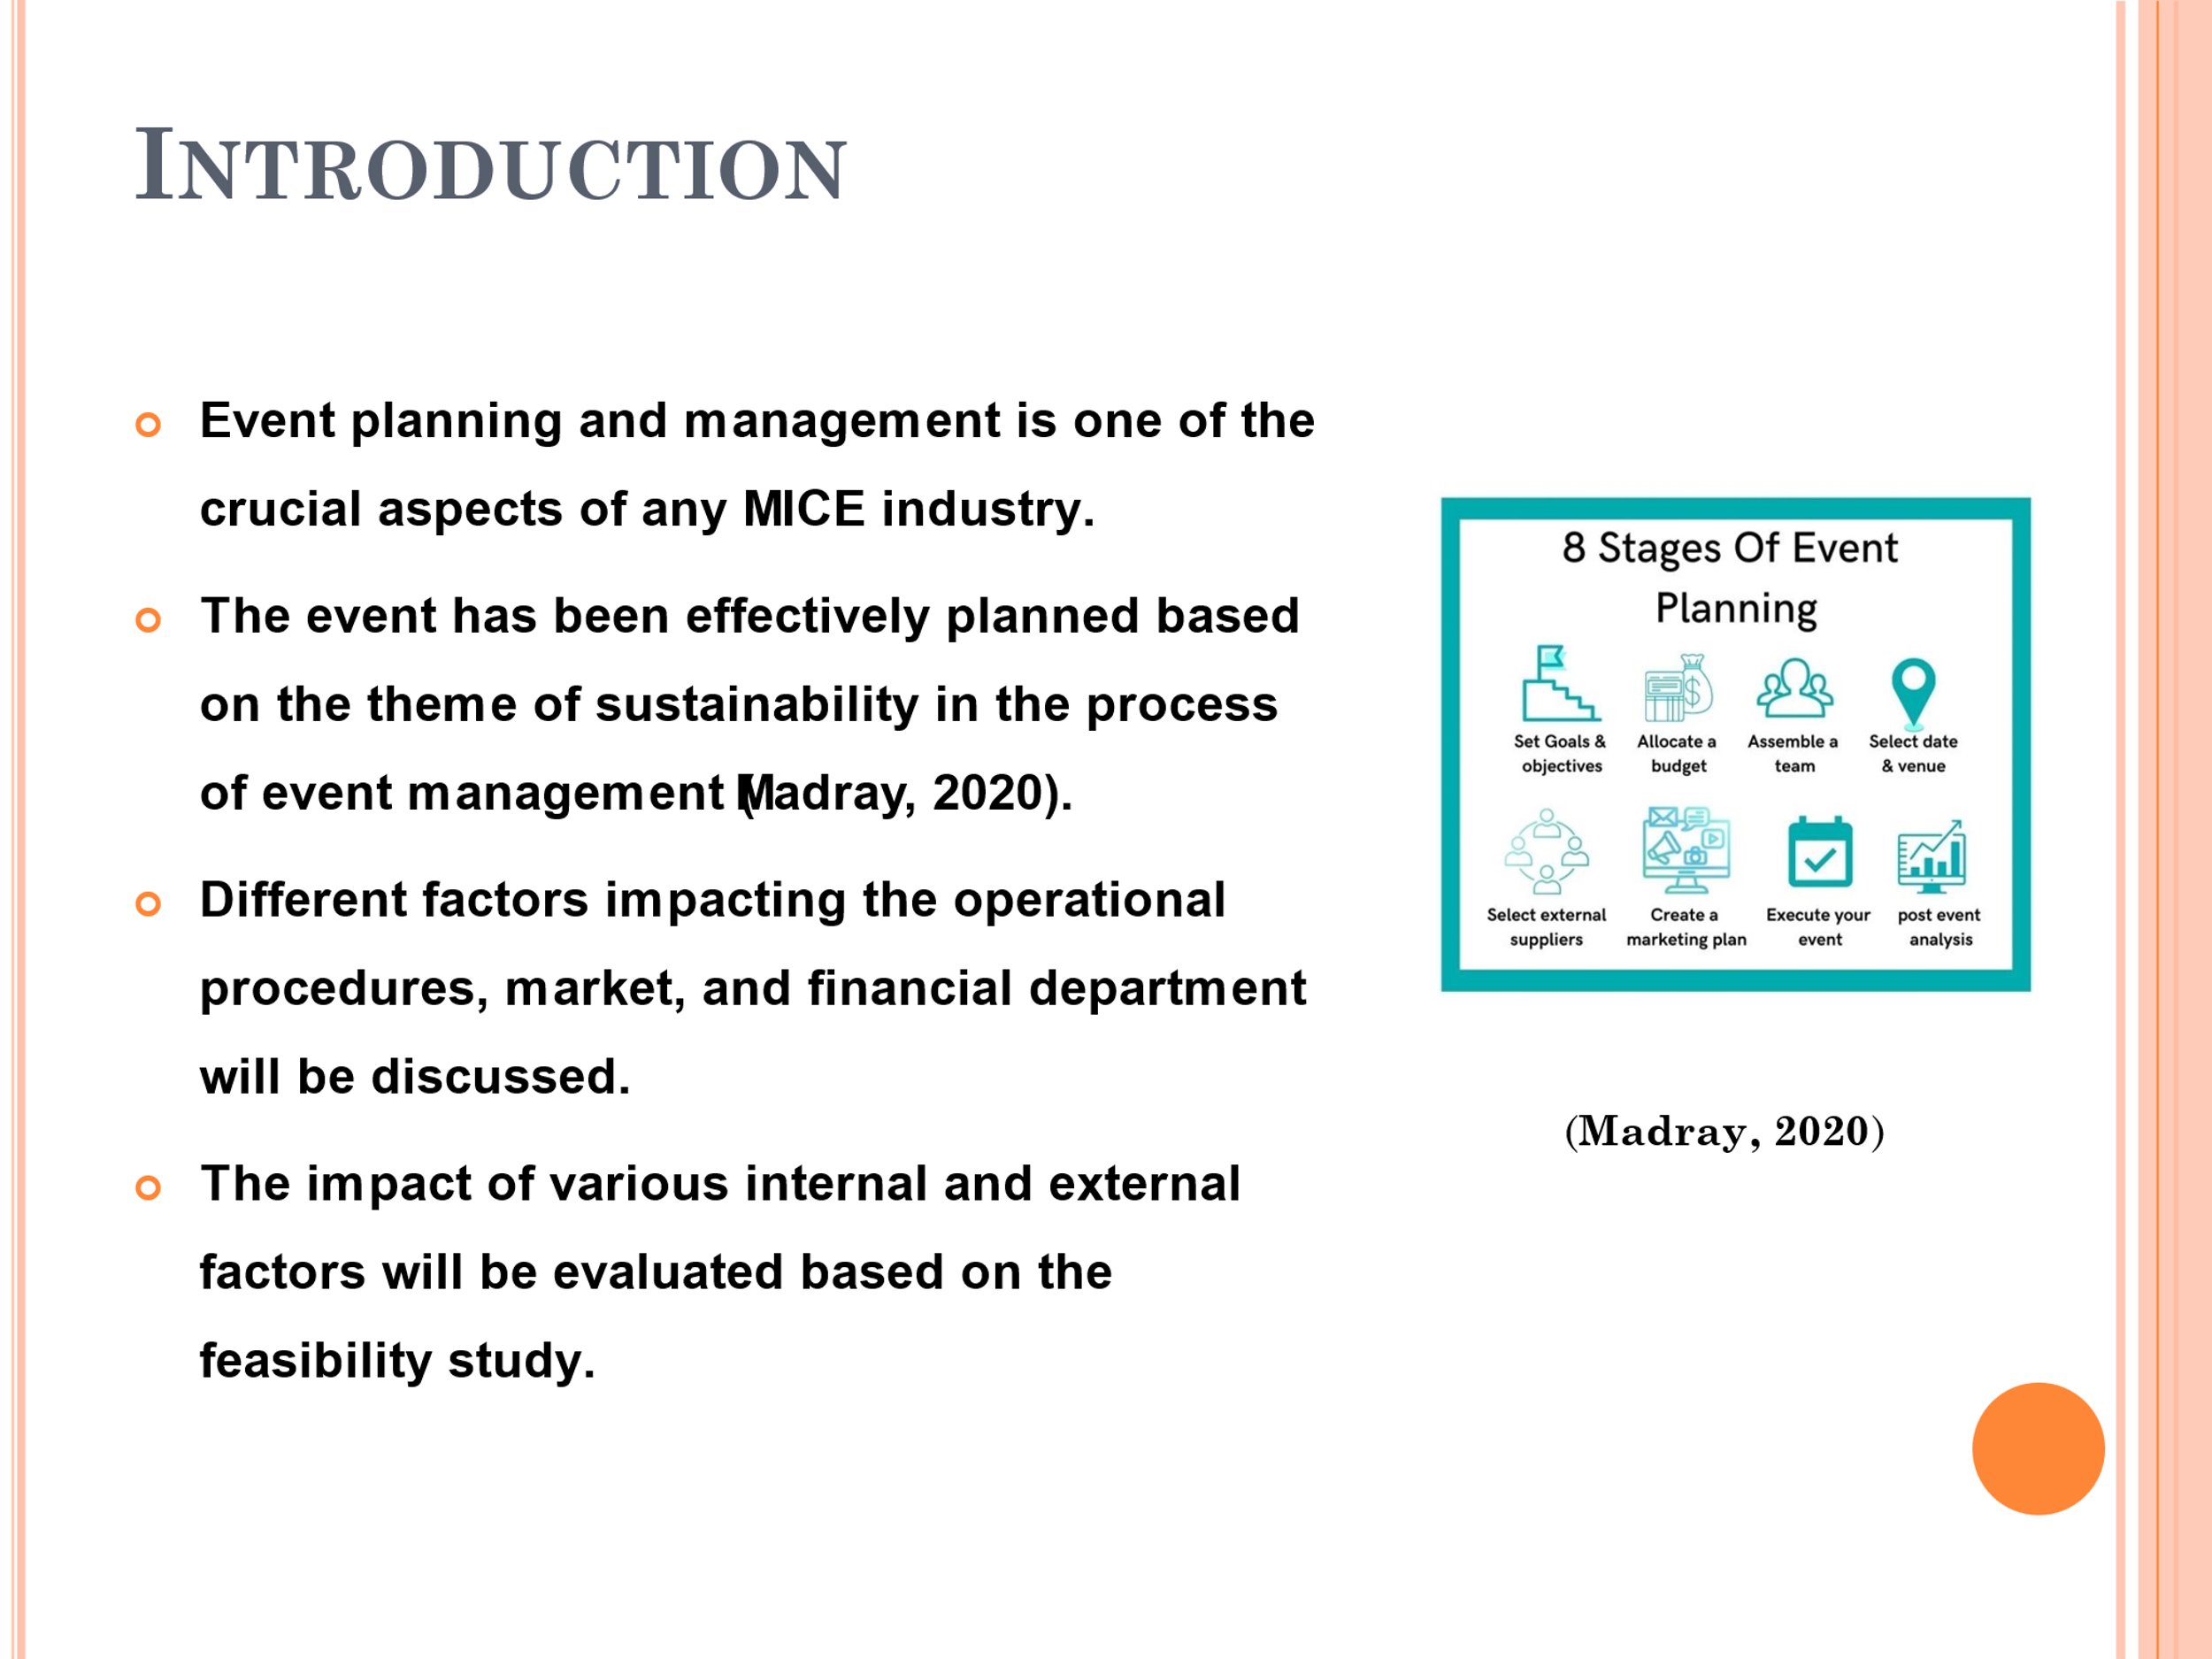
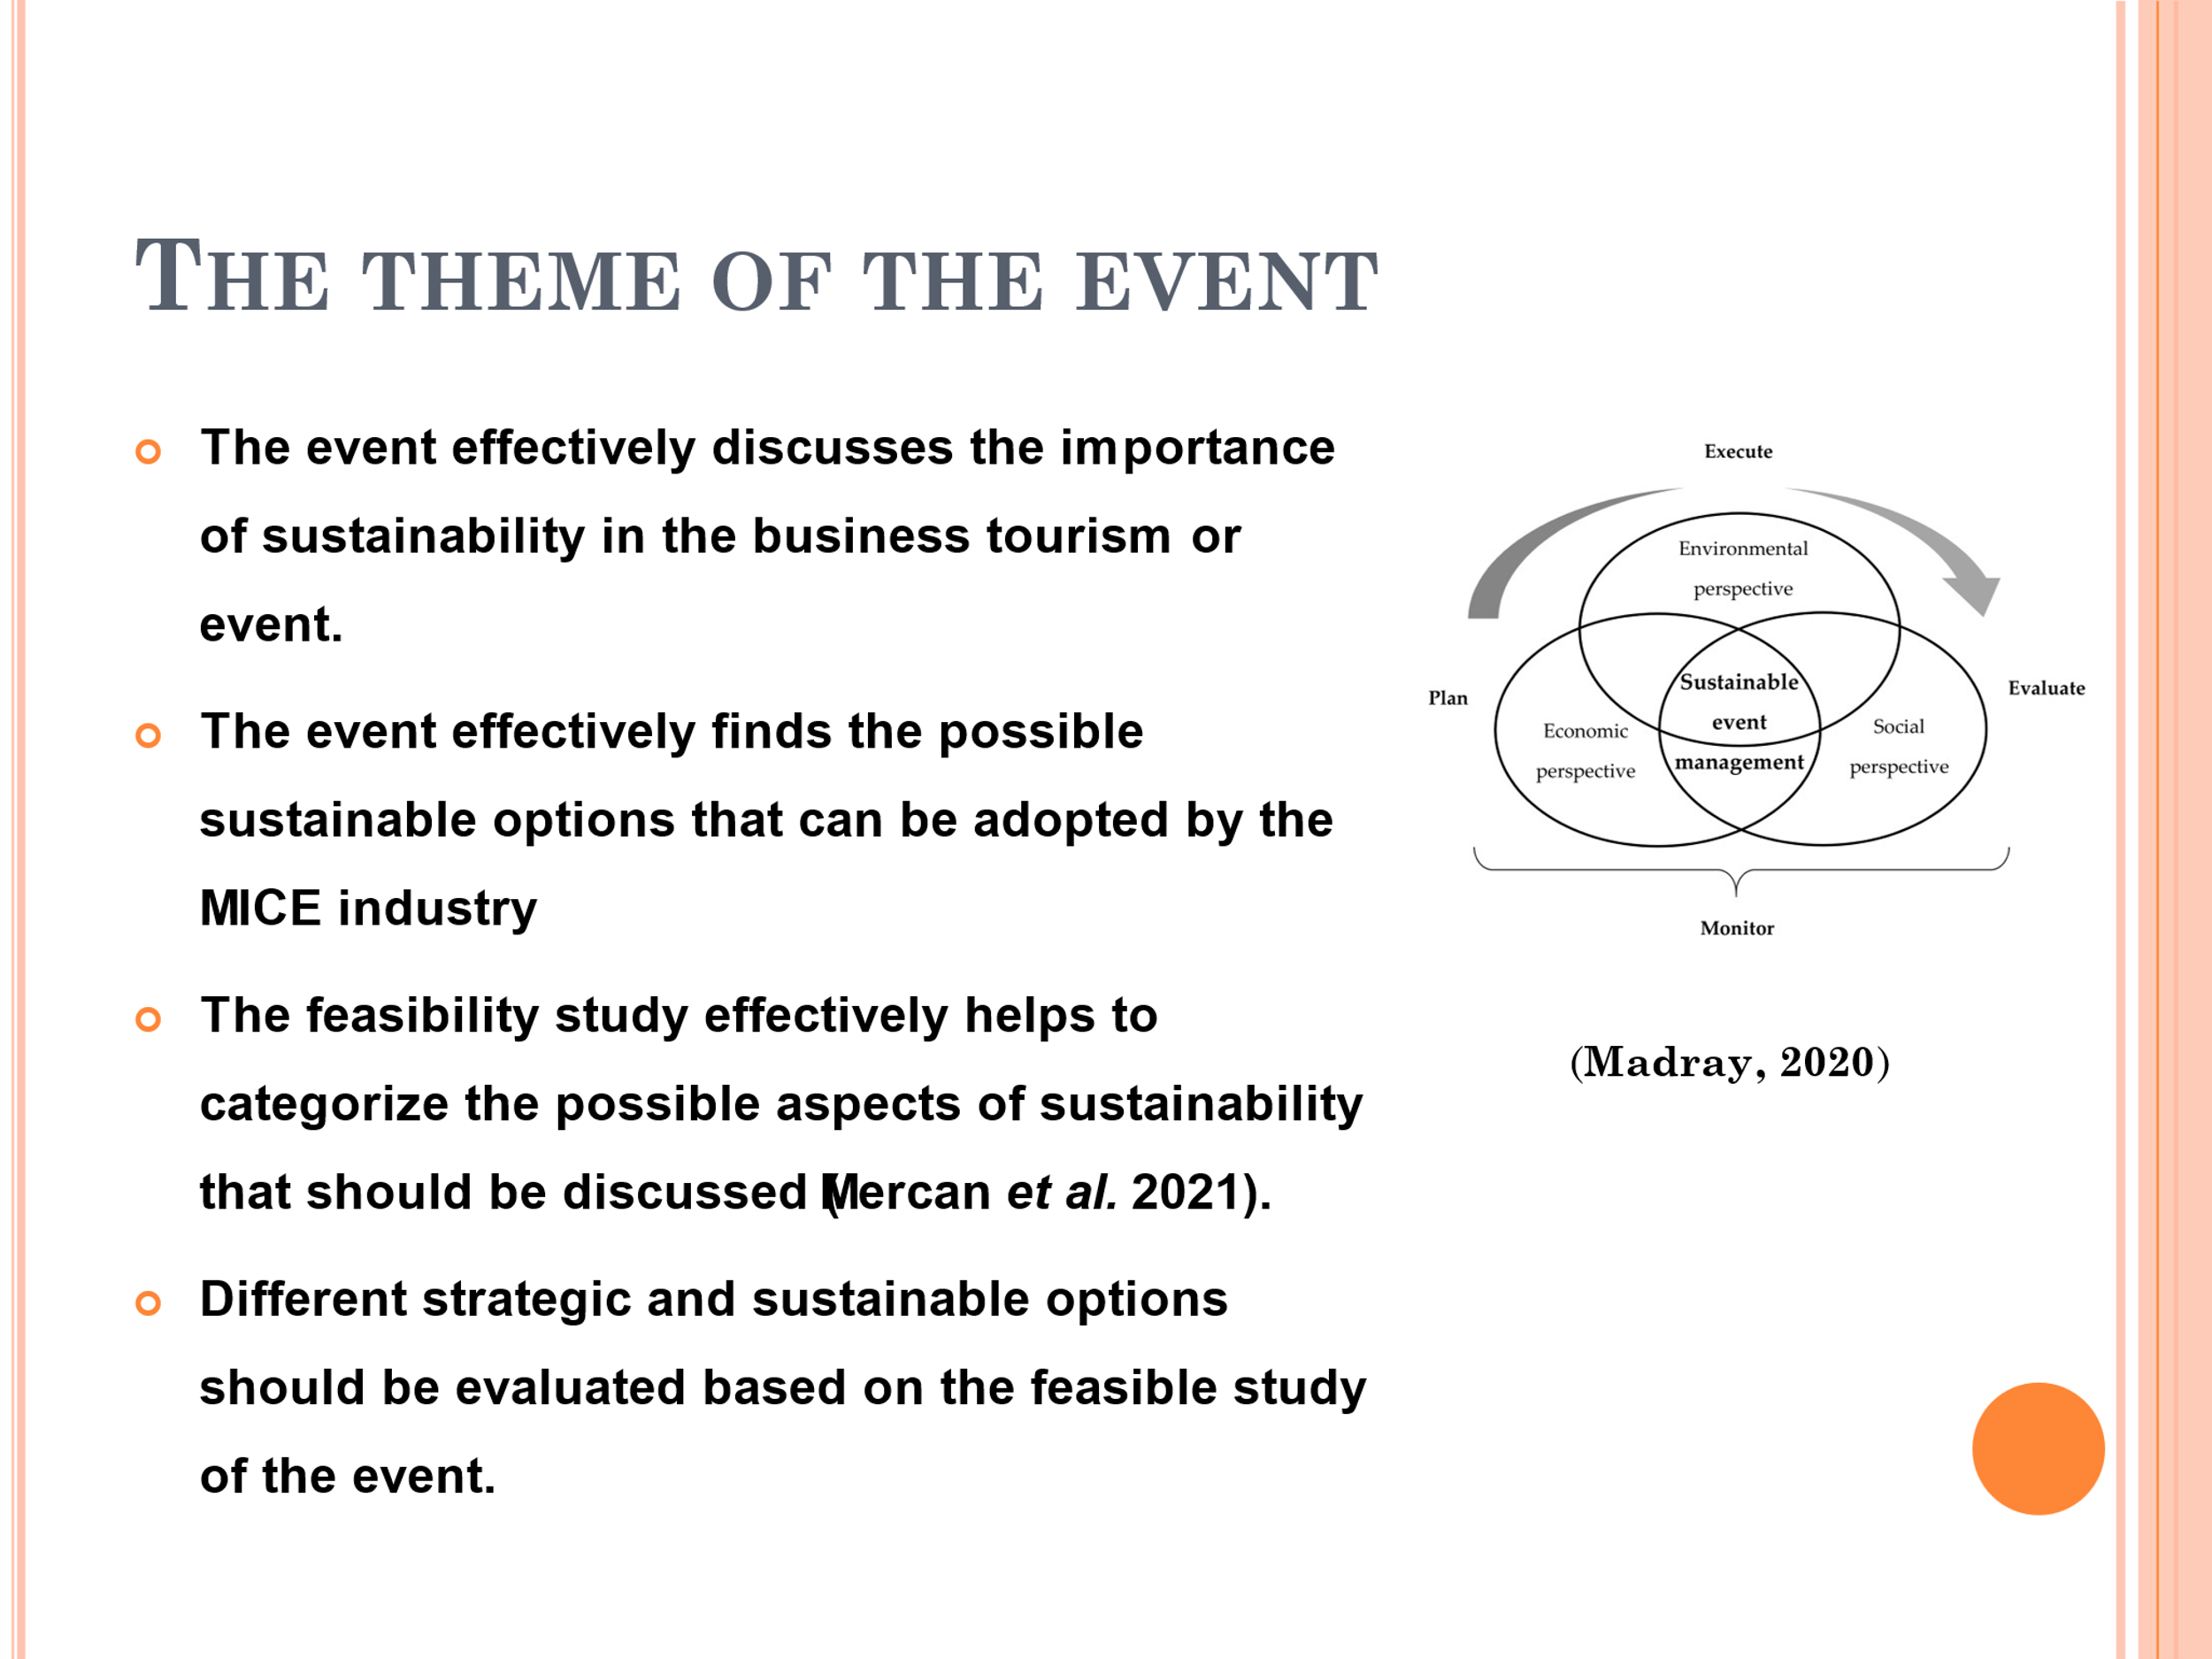
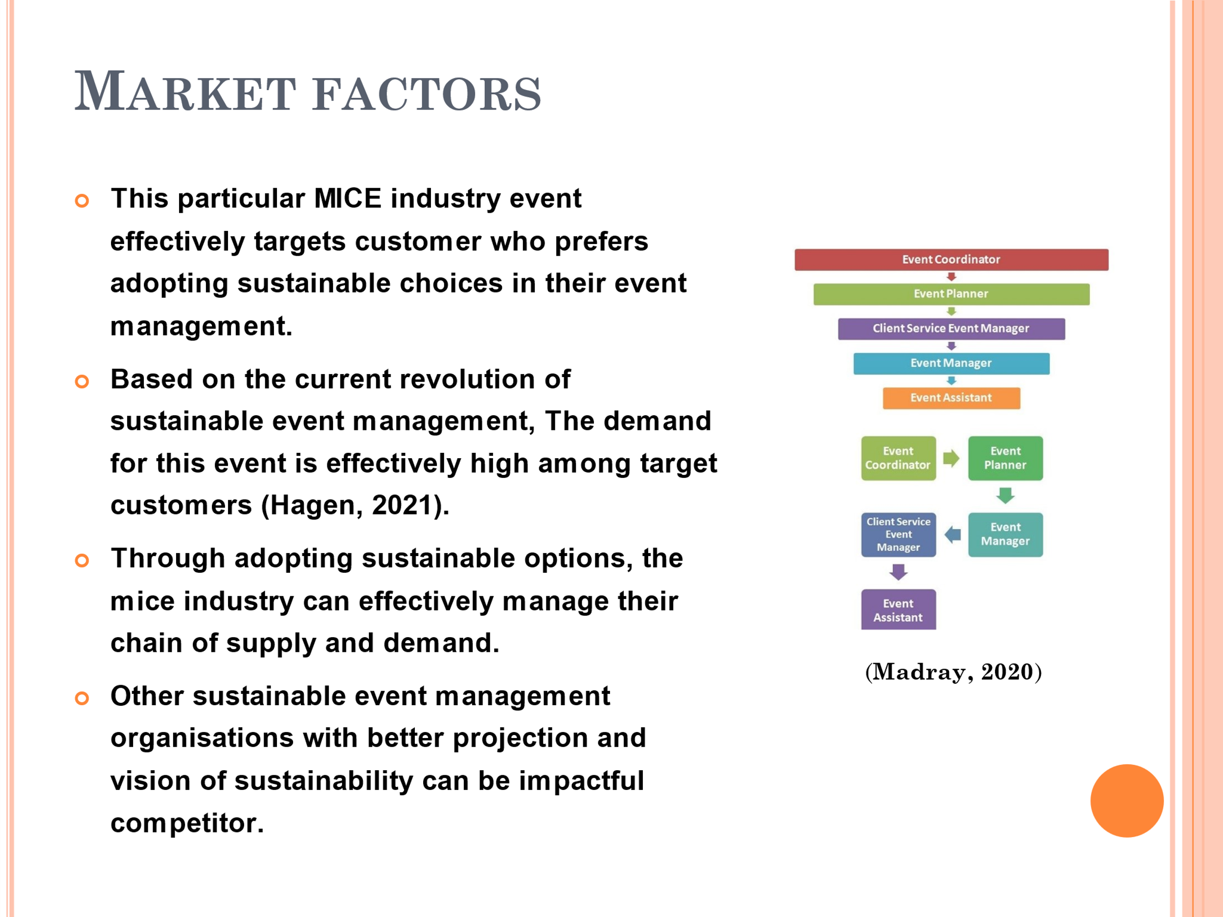

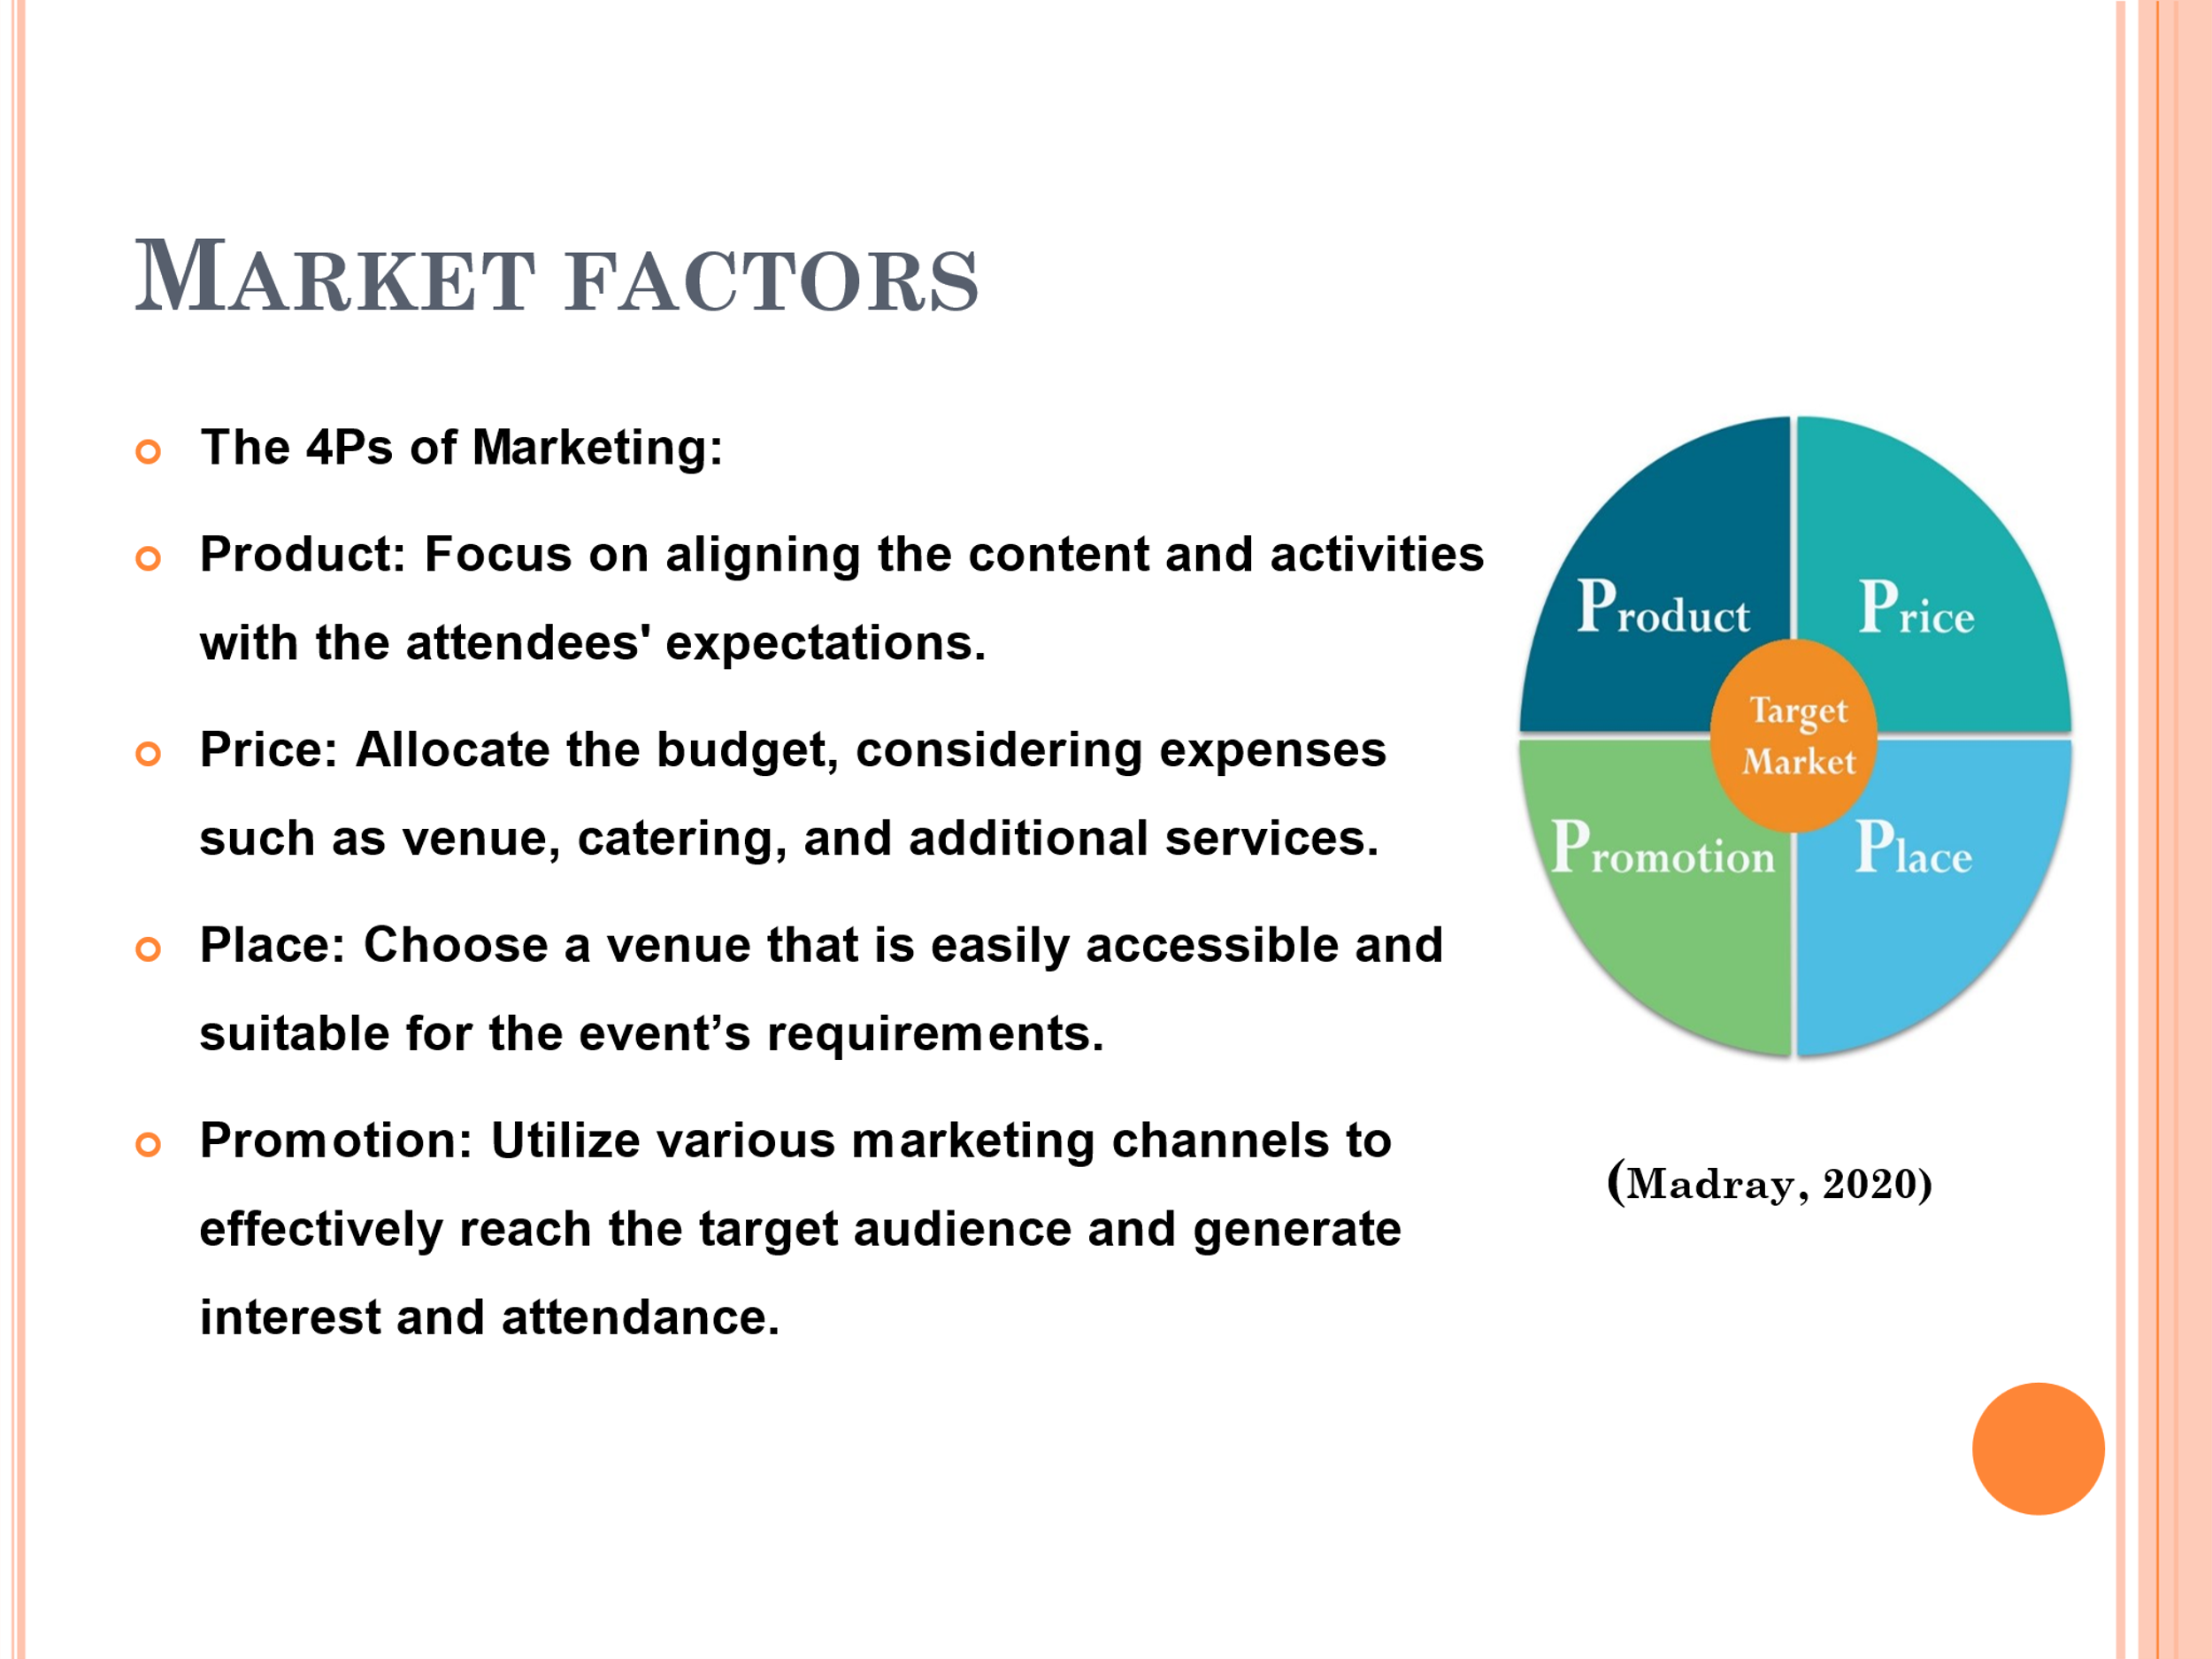

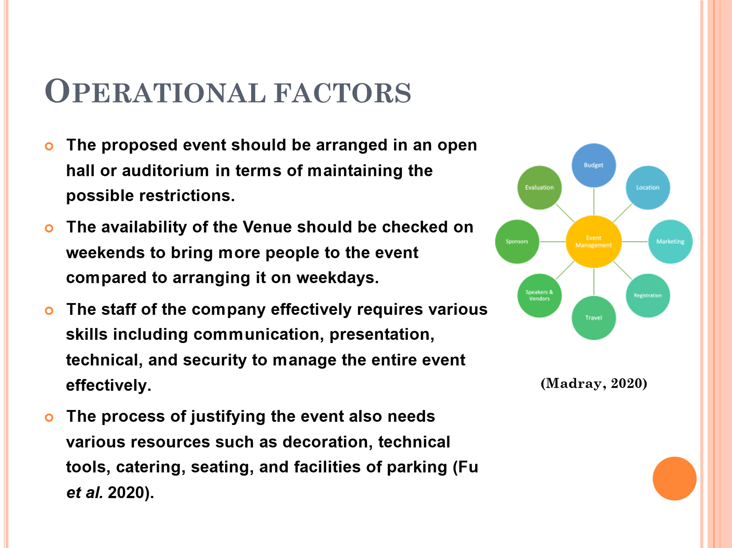

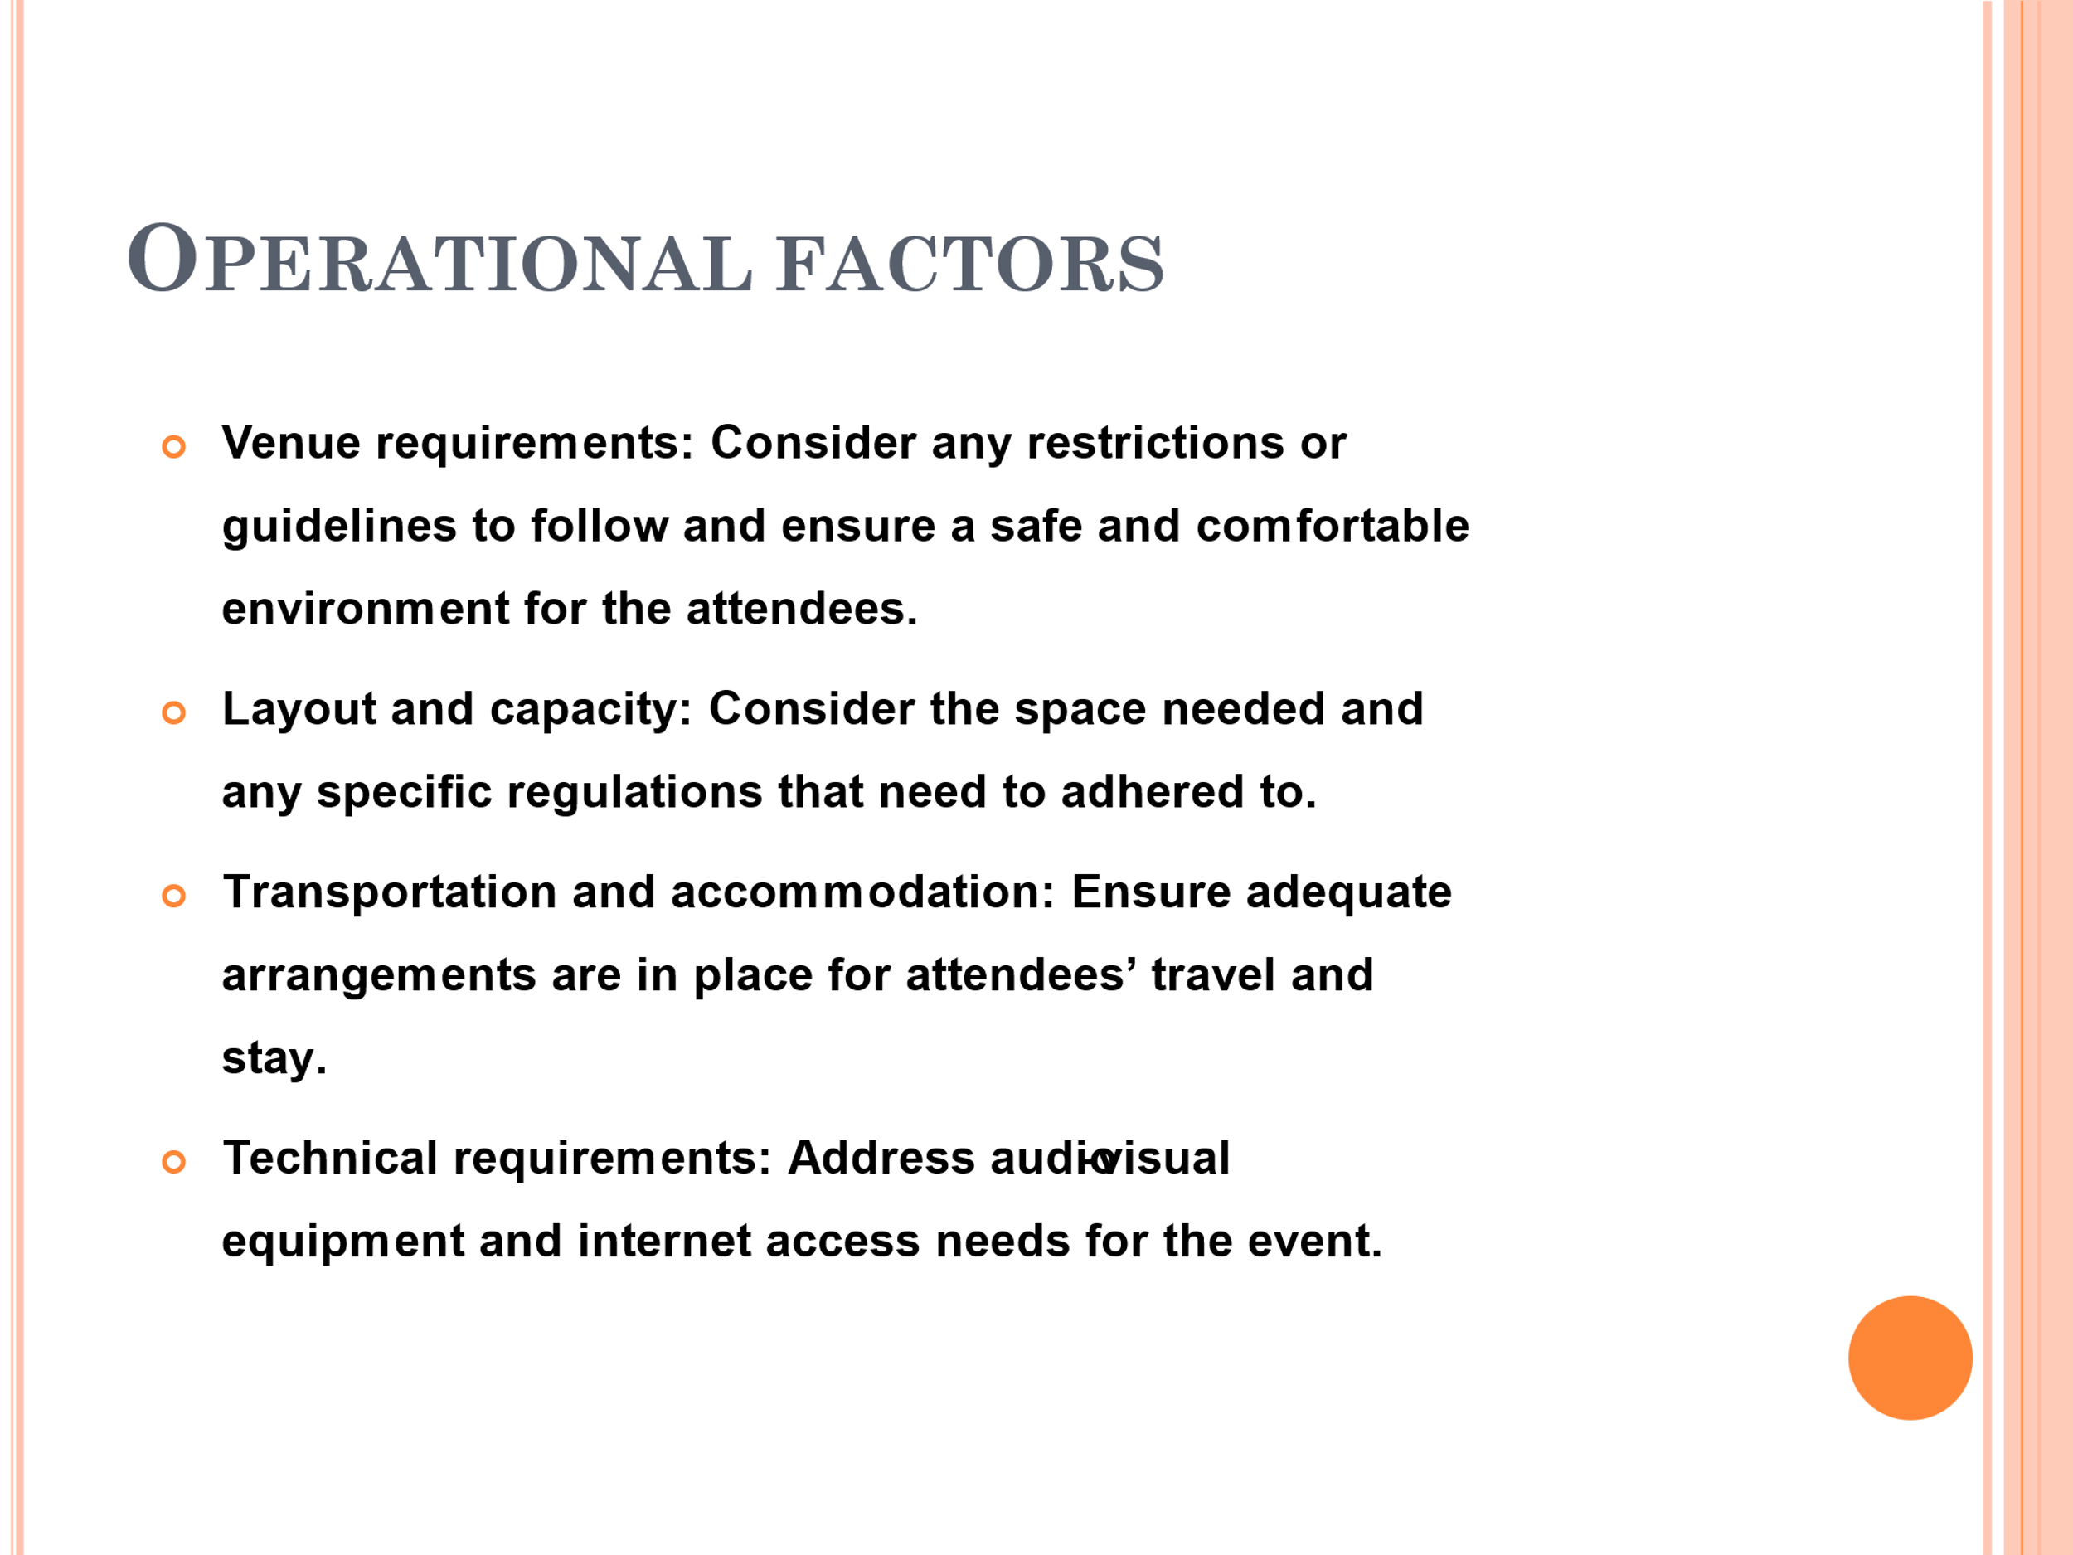
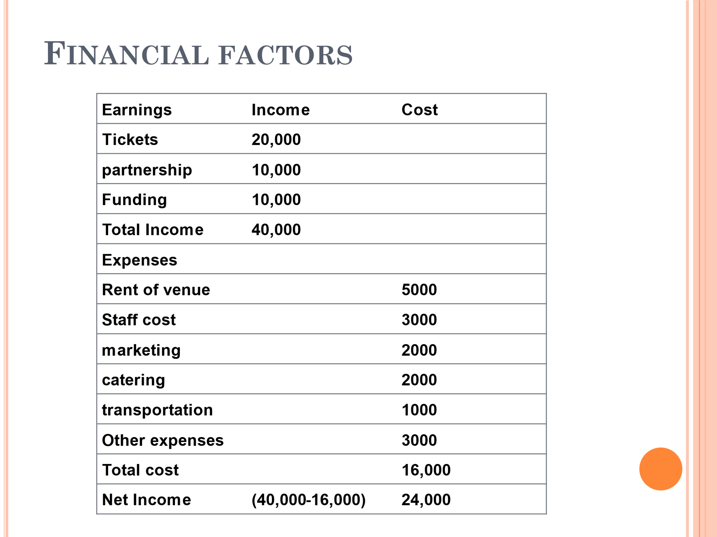

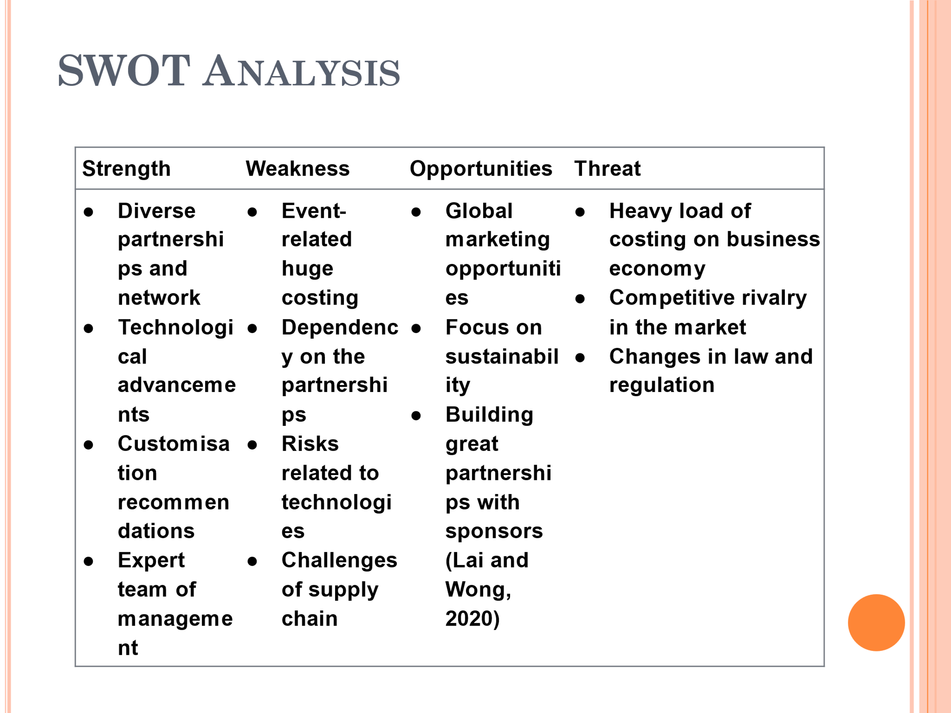
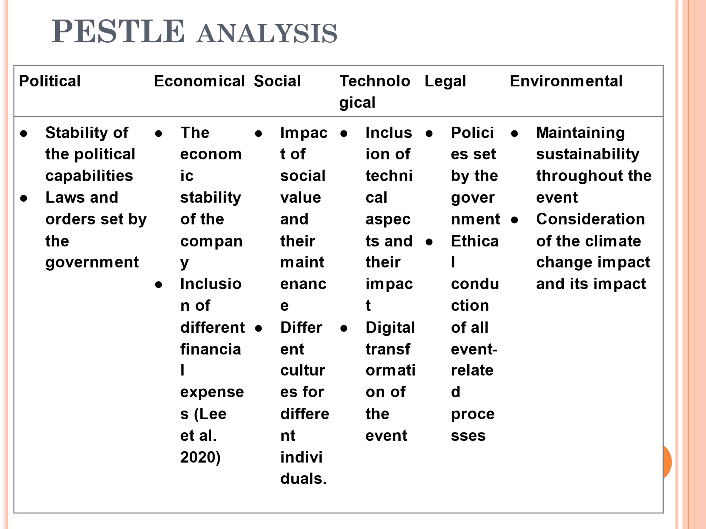
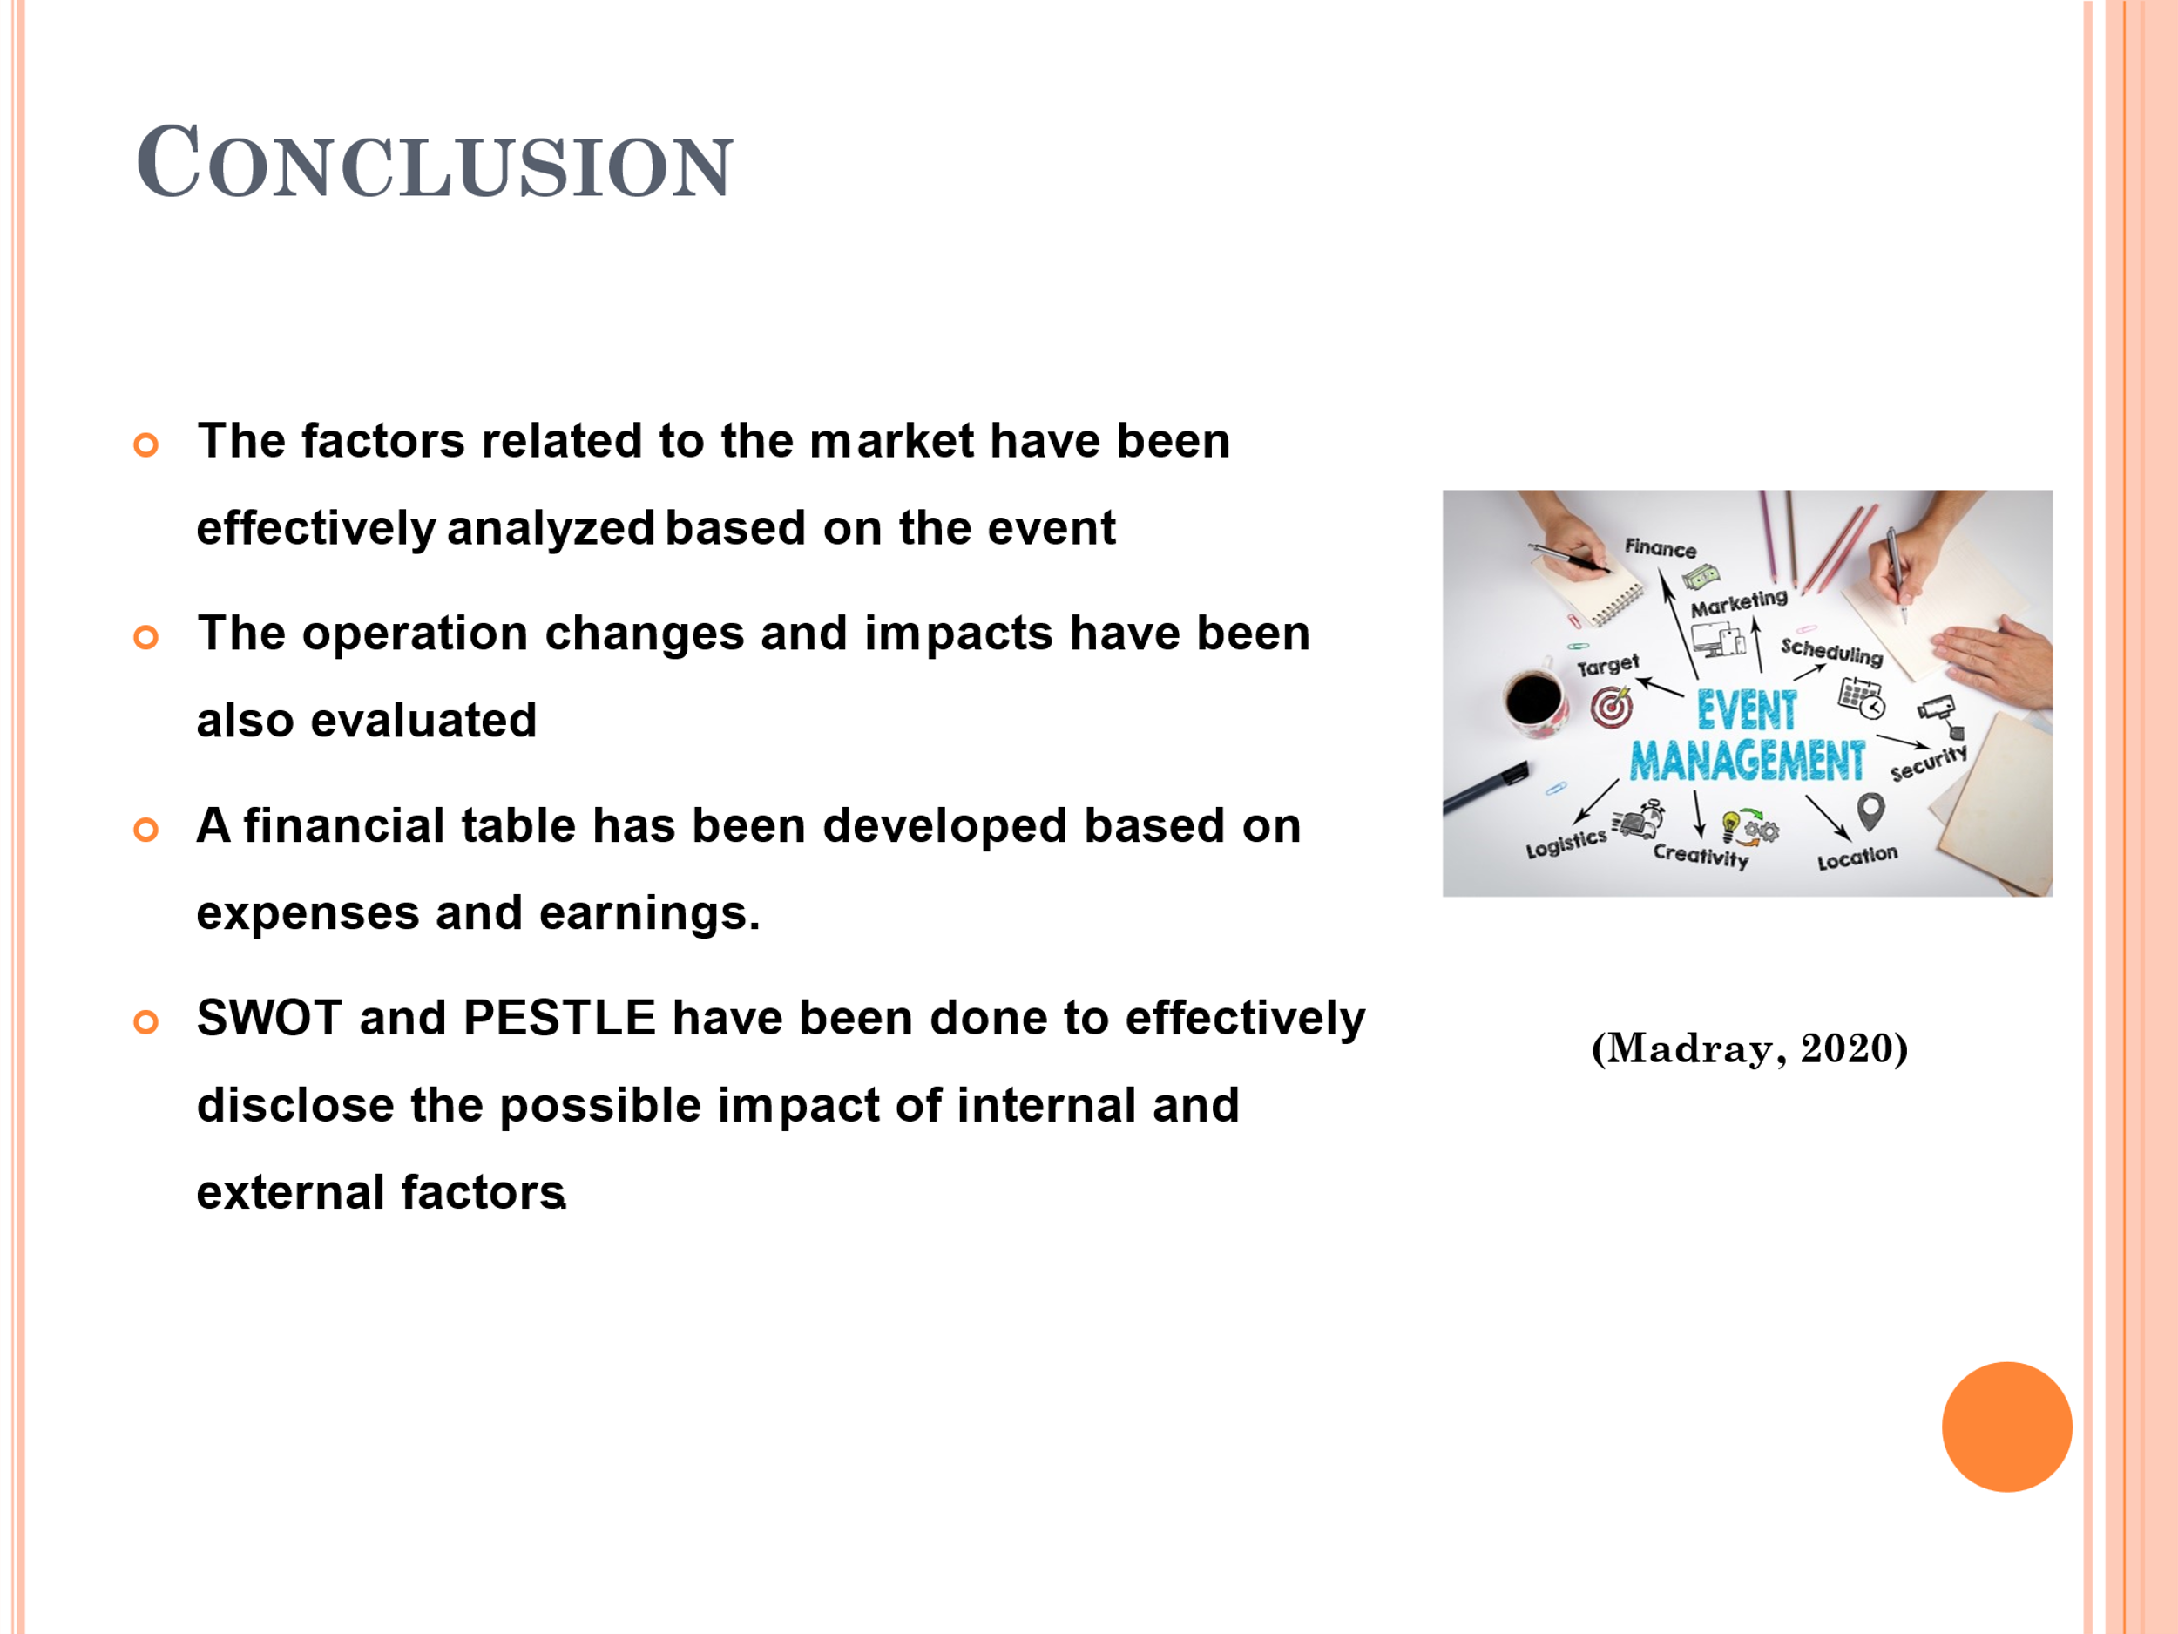
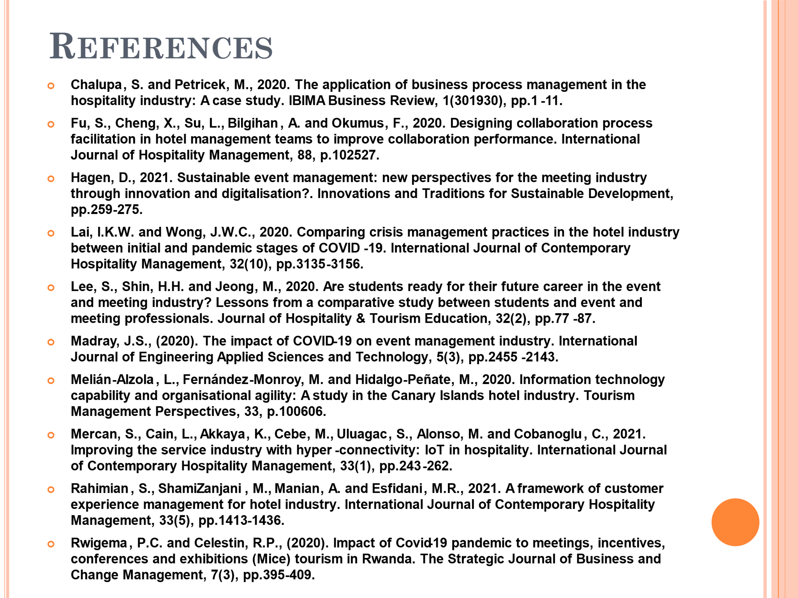

REFERENCES:
Chalupa, S. and Petricek, M., 2020. The application of business process management in the hospitality industry: A case study. IBIMA Business Review, 1(301930), pp.1-11.
Fu, S., Cheng, X., Su, L., Bilgihan, A. and Okumus, F., 2020. Designing collaboration process facilitation in hotel management teams to improve collaboration performance. International Journal of Hospitality Management, 88, p.102527.
Hagen, D., 2021. Sustainable event management: new perspectives for the meeting industry through innovation and digitalisation? Innovations and Traditions for Sustainable Development, pp.259-275.
Lai, I.K.W. and Wong, J.W.C., 2020. Comparing crisis management practices in the hotel industry between initial and pandemic stages of COVID-19. International Journal of Contemporary Hospitality Management, 32(10), pp.3135-3156.
Lee, S., Shin, H.H. and Jeong, M., 2020. Are students ready for their future career in the event and meeting industry? Lessons from a comparative study between students and event and meeting professionals. Journal of Hospitality & Tourism Education, 32(2), pp.77-87.
Madray, J.S., (2020). The impact of COVID-19 on event management industry. International Journal of Engineering Applied Sciences and Technology, 5(3), pp.2455-2143.
Melián-Alzola, L., Fernández-Monroy, M. and Hidalgo-Peñate, M., 2020. Information technology capability and organisational agility: A study in the Canary Islands hotel industry. Tourism Management Perspectives, 33, p.100606.
Mercan, S., Cain, L., Akkaya, K., Cebe, M., Uluagac, S., Alonso, M. and Cobanoglu, C., 2021. Improving the service industry with hyper-connectivity: IoT in hospitality. International Journal of Contemporary Hospitality Management, 33(1), pp.243-262.
Rahimian, S., ShamiZanjani, M., Manian, A. and Esfidani, M.R., 2021. A framework of customer experience management for hotel industry. International Journal of Contemporary Hospitality Management, 33(5), pp.1413-1436.
Rwigema, P.C. and Celestin, R.P., (2020). Impact of Covid-19 pandemic to meetings, incentives, conferences, and exhibitions (Mice) tourism in Rwanda. The Strategic Journal of Business and Change Management, 7(3), pp.395-409.

Thank you and here is the link from the PowerPoint presentation:
https://uowtsd-my.sharepoint.com/:v:/g/personal/2121941_student_uwtsd_ac_uk/EXGiA_PED8tMsS8xQ2dvrZYBXh7B2PWvS_gKr7bS1buAAQ?referrer=Teams.TEAMS-ELECTRON&referrerScenario=MeetingChicletGetLink.view.view

