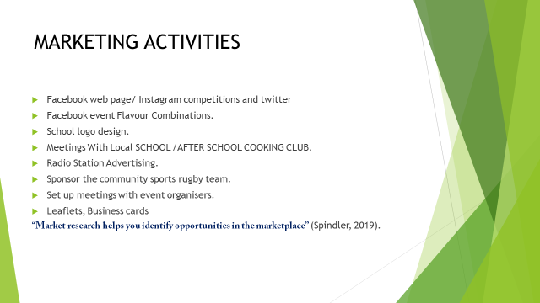
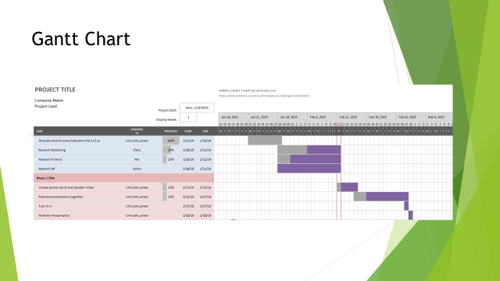


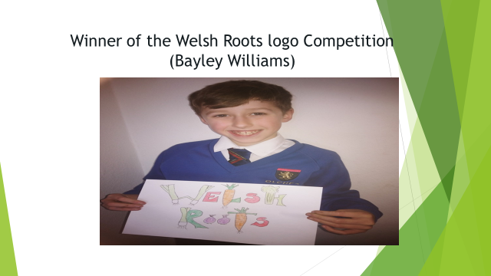
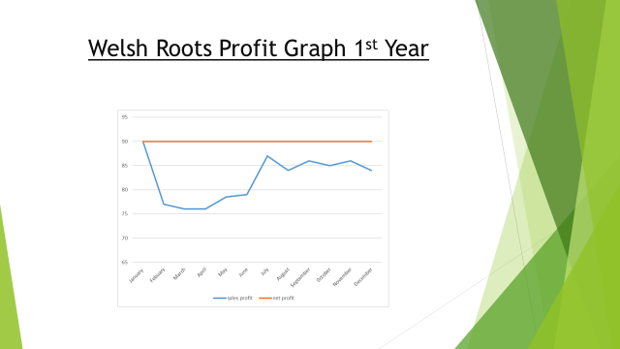

Speaker Notes Christopher Davis 1712446
WELSH ROOTS VEGAN BURGERS
MARKETING ACTIVITIES
The reason we have chosen social media as a marketing tool is that it very cost affective and in most cases free. (Procter pg39) states that a new product being marketed must be controlled by the cost to make sure as a company we make a profit.
Quarterly Throughout the year we will be running competitions where we will ask our online followers and costumers to share and post selfies of themselves with our burgers to win a free £50 Amazon Voucher.
Our Market Research has shown that Customers are willing to spend a little extra to eat food that is friendly to the planet. Market research has been a very important part of our planning (Spindler, 2019).
We will have an ongoing promotion where the costumers can get involved and send in their flavour combinations and the one with the most votes will be tried and tested.
The Local schools in Swansea have competed to design the Welsh roots logo and I am pleased to announce that Bailey Williams of Olchfa Secondary School is our winner and has received a £20 Amazon Voucher.
I have organised a meeting with Swansea bay campus and the students union and Medwin the welsh Vice chancellor and have secured a place to run our vegan burger van where 5% of the profits go back to the university. However we do get free use of their electricity.

As you can see from the Chart we have started with £90.000 of our own money in January.
February the budget has dropped as we have had to buy equipment for the business this includes the van £9000, public liability insurance £1000, Marketing £1000, sourcing local products within wales using our own cars and setting up meetings with suppliers £500 and attending a level 2 food and hygiene course £120 .we have also had a Pac test of the vans electric which cost £60 and a food standards rating of 5 from the council which cost £20. £1000 has been spent buying a generator for running the power
March we have had to spend money on stock which we keep in a chiller which is kept in the university for free the cost for the stock purchased for March is £900 and £100 for fuel for the generator.
April we have come out even as the students have started university and we have had locals buying our food over the March period.
May has seen an increase in profits as we have had the royal welsh spring show which cost £ 1000 loss for site fees £500 for generator fuel and cardboard containers to put products in and £1000 but we have had a profit of £6000 in our first festival.
June we have seen a slight increase in our profits as we have started a loyalty card scheme were the costumer gets a free burger after the 6th meal deal ordered. This has made us an extra £500 pound.
July we expect to make a profit of £8.000 because even though students are having their term break we are relying on the festivals for income.
August we have seen a slight decrease in our profit this is because we predict local customers to go on holidays so we will mainly be relying on functions and festivals for profit.
September we predict a slight increase in profit as students start to go back to university.
October we predict a slight decrease as we have invested £1000 in getting an app designed so customers can order from their phones.
November we predict a slight increase this is due to online promotions and advertising with competitions.
December we predict a loss during this month as students go home for Christmas and bad weather.

References

Kirwan, J. (2009). Good small business planning guide. 1st ed. london: A & C Black Publishers.

Spindler, M. (2019). 10 benefits of market research | | Happy Creative Limited. [online] Happy-creative.co.uk. Available at: https://happy-creative.co.uk/10-benefits-of-market-research/ [Accessed 18 Feb. 2019].
T.Procter(2000) Essentials of Marketing Research Second Edition Essex. Pearson Education Limited.

