TITRATION LAB REPORT
Theodore Dunning
UWTSD



Contents
1
INTRODUCTION 3
EQUIPMENT 3
CHEMICALS 3
METHOD 3
RESULTS 4
DISCUSSION 5
CONCLUSIONS 5
REFERENCES 5

INTRODUCTION
Titration is a method for finding out the concentration of an unknown solution [2]. By slowly dripping sodium hydroxide from a burette into a mixture of hydrochloric acid and indicator we will eventually get a reaction. This is called a neutralisation reaction. The independent variable is the volume of titrant used; the dependant variable is the concentration of the solution. The solution should go from a colourless solution to pink.

EQUIPMENT
• 50ml Burette
• Burette stand and clamp
• 3 Conical flasks, 100ml
• Small funnel
• Deionised water bottle
• Graduated cylinder, 10ml
• White sheet of paper
• Beaker for waste
• Glass pipette with pipette filler
• Small plastic pipette

CHEMICALS
• 80ml NaOH – 0.1026 mol/L
• 80ml HCL with an unknown concentration
• Phenolphthalein indicator

METHOD
• Wash the pipette with DI water, then with a bit of HCL. Washings go into waste beaker.
• Wash the burette with DI water, then with a little bit of HCL. Then rinse with a small amount of NaOH.
• Wash out the conical flask with DI water.
• Fill the burette with NaOH using the small funnel. Record he initial reading from the bottom of the meniscus.
• Using a glass pipette, fill three conical flasks with 25 ml of HCL.
• Add 3-4 of phenolphthalein drops with a small pipette to each flask.
• Add 10ml of DI water to each flask, using the graduated cylinder. Swirl each flask a few times.
• Using the burette tap, for the first flask, open the tap fully and mix roughly until it turns pink. This was for an estimate of how much was needed to neutralise the solution.
• Repeat the last step with the other flasks, but slowing down when near the estimate, mixing in-between drops slowly and stopping as soon as the solution shows any pink tinge.
• Repeat the last step enough times to have two volumes within 0.1ml of each other.
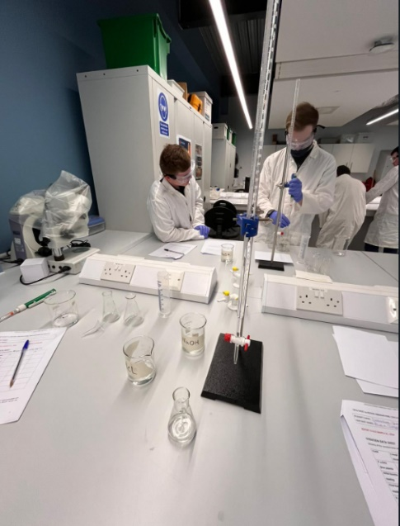
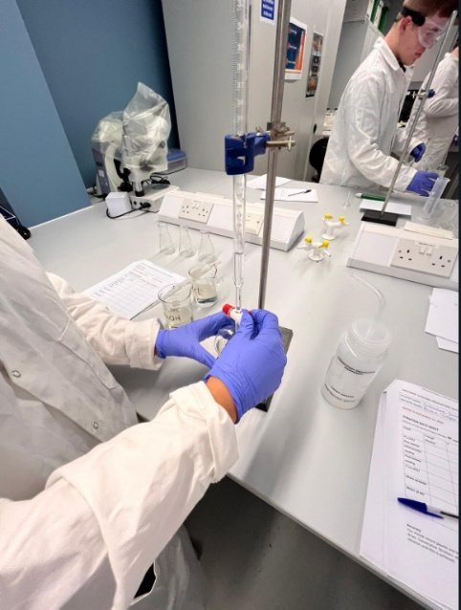
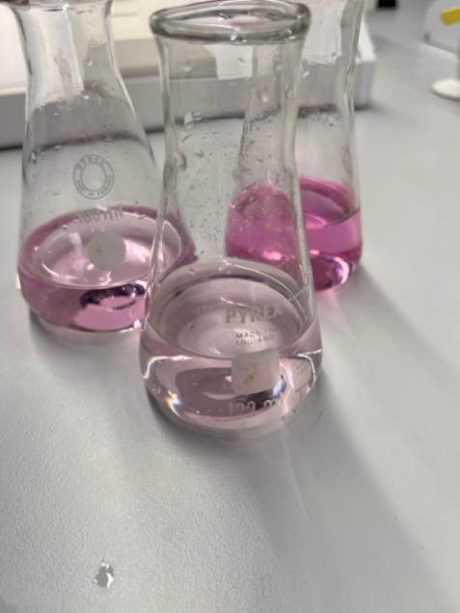

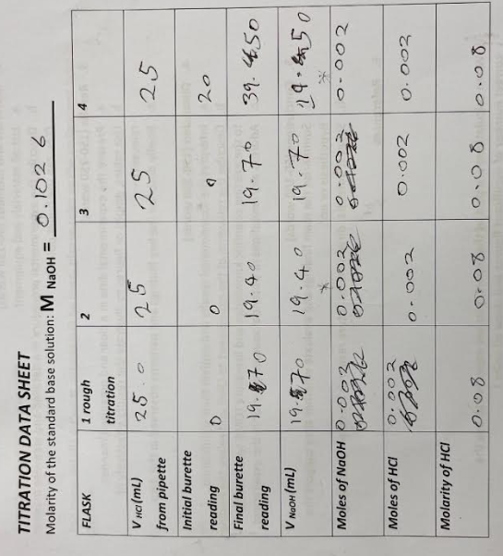
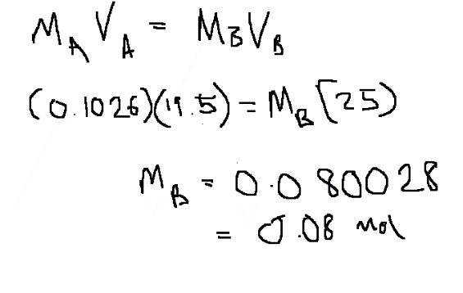
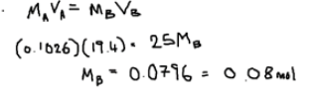
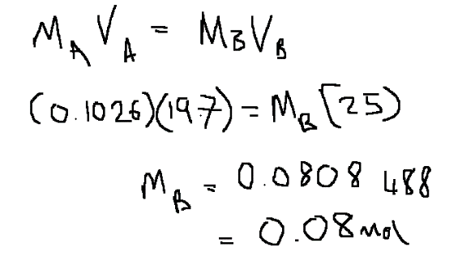
RESULTS
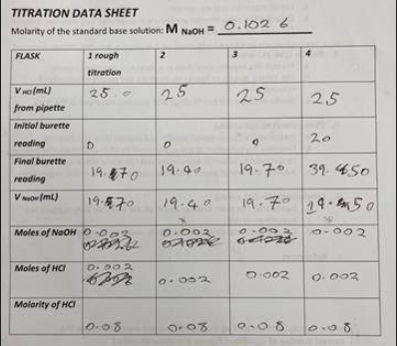

From the formula shown on right for each repetition, we have found the solution to be a very weak concentration, this is backed up by the fact the solutions given to students at university should be safe to handle with minimal risk. All the results were close to each other too.

DISCUSSION
Titrations can be used in OME as there are multiple points during production, e.g chemical mixes and manufacture, solutions are used which need to be of a known concentration. If a random solution was used it will affect the properties of the explosive and could give more sensitive material that would be dangerous for the people manufacturing near and with it. This would also affect the safety of the round in storage and when being shot. A couple areas for error were the human error when reading the burette, getting an accurate reading of the meniscus. Also, the solution turning pink could have been done more precisely with equipment that could pick up the colour before a human eye could.

CONCLUSIONS
In conclusion, the solution turned pink as expected. An automated titration machine would give a more exact reading but comes with limitations of cost and space. The experiment could be repeated multiple times to see how similar the results would be, also to work out an average.

REFERENCES
[1] myday, The University of Wales Trinity Saint David, Image, https://myday.collabco.com/resources/university-of-wales-trinity-saint-david/
[2] StudyMIND, Acids and Bases - Titrations, https://studymind.co.uk/notes/titrations/

