Cover Sheet

E-Portfolio
Module Code ECP4018
How to succeed in your degree with Psychology.

Contents sheet

pg. 3 - Summary
pg. 4 - Reference list
pg. 5 – Essay Plan
pg. 6 – Essay Plan
pg. 7 – Screenshots
pg. 8 - Infographic

How to succeed in your degree, with psychology…
There are many different approaches to studying. Research has shown that although rereading is used by over 80 percent of students, it may not be the most effective means of studying.
Research suggests that retrieval practice is a far more effective than rereading, yet Karpicke and colleagues (2009) found that only 10 percent of students use retrieval practice. Retrieval practice involves reading then self-testing by asking yourself questions about the information you have read.
Metacognition helps to understand our own ability. The Dunning-Kruger effect found that it was the least competent individuals that perceived that their levels of ability were higher than they actually were.
Procrastination can become a barrier to learning for many students. Implementation intentions, setting cues to perform tasks in order to reach goals has been shown to reduce procrastination.
Reading and note taking in a way that you understand is key to success. Elaborative interrogation helps to recall information and build knowledge.
All of these approaches reduce the chance of plagiarism. The Read, Recite, Review (3R) method will encourage the use of your own words which will lead to correct and effective paraphrasing and good academic integrity.
The simplicity and clarity of your work is crucial. Writing long and complex words can cause complication and lead to unnecessarily difficult reading for tutors.
Teamwork is an important part of learning and succeeding. This should be fair and equal, avoiding social loafing by using peer evaluation.
Presentations can be boring, its important to avoid going in to unnecessary detail and keep on track with only relevant information. The Assertion/Evidence approach will make things more clear and memorable for your audience.
Revision and studying should be enjoyable. Making adequate time for study will give better results long term. Cramming may seem a good option which may work short term but methods like spacing and retrieval practice are far more effective.

Reference list
Penn. P. (2019) How to succeed in your degree, with psychology.

Essay plan
Describe and discuss the psychological, social and physical benefits of engaging in a sporting activity
Introduction
There are many physical, social and psychological health benefits from engaging in sporting activity. Even though the primary effect from sport is physical it can also have a greatly positive effect on your mental health and general well-being as well as enhance your social skills and life in general.
Sport is a part of daily living for many people. There are lots of different sporting activities to suit most individuals according to their interests, ability and preference.
Physical activity has become increasingly important over the years as we have become more aware of the all round benefits to our health.

Main body
We will firstly look at the physical element of sport, we know that engaging in physical activity is good for our physical bodies. It strengthens our muscles, organs and bones, it prevents disease and obesity.
In this book I found that the requirement for physical activity for people has not changed over the past 40,000 years yet over time the lack of exercise and increase in food consumption is a strong contributor to many health problems today.
I also found that there are two types of physical exercise, aerobic and muscle strengthening exercise. Aerobic activity has been shown to improve heart health, benefit weight management, reduce the risk of disease as well as many other physical benefits.
Muscle strengthening has been shown to reduce muscle atrophy and osteoporosis. It also has numerous other physical benefits including increase in balance and co-ordination and a reduced risk of falling. The enhanced quality of life has been more measurable in older people because of this.
There can also be negative effects of engaging in sporting activity in regards to over training and injury. It has been shown to not always be life enhancing.
In the book “Psychology of physical activity” I found that even though many people engage in sporting activity for the physical benefit there is a great deal of research evidence that has shown that the psychological benefit on overall mental health is positive. It has a positive effect on mood, energy levels and sleep quality. It has also been shown to improve cognitive function, memory and attention.
Mental health illness has been shown to improve significantly from engaging in sporting activity. It can reduce the symptoms of depression and anxiety by physically increasing the production of endorphins in your brain as well as improving your overall sense of well-being.
The social benefits from engaging in a sporting activity involve meeting new people with similar interests, building relationships and long lasting friendships. It can help improve communication and team work skills. It has been shown to help control emotions and reduce stress levels whilst also building self-esteem and confidence.

Conclusion
In light of all this information I conclude that there are many benefits of engaging in sporting activity, Physically, Psychologically and Socially. Even sports such as darts or pool that involve the minimal amount of movement can still have a positive effect on our bodies and minds. Our bodies react physically and emotionally to exercise usually in a positive way, eliminating mental health illness and promoting good health and longevity.

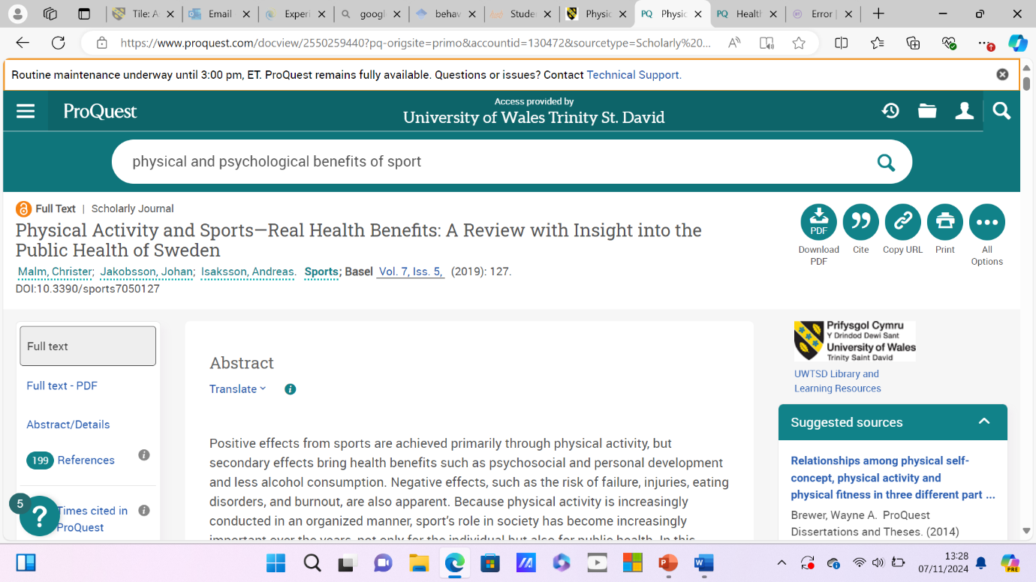

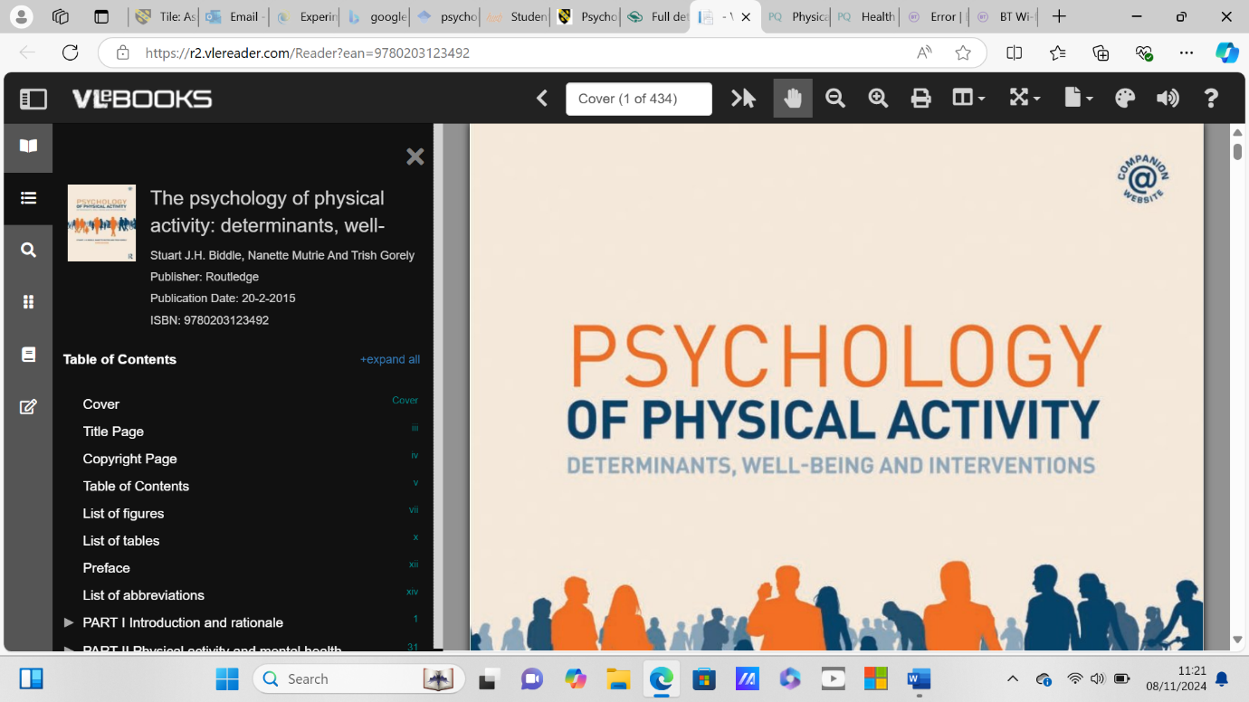
Infographic


