Management Accounting

Table of Contents
Introduction 3
Part A 4
Control documents displaying the original, flexible, and deviation budgets 4
A report on the performance of Amana through 2020, based on the control report 9
Suggestions 11
Part B 12
The reasons and the optimal alternatives 12
The benefits and drawbacks of the selected option 14
Conclusion 15
References 16

Introduction
Internal uses and internal decision-making include accounting information. This study is focused on a few specific management accounting-related challenges. This research will analyze the circumstances surrounding the family-run company Amana Ltd. The control statements that indicate the initial budget, the flexible budget, and their differences from the current expenses will be created in the first section. After then, the effects of lowering sales prices and raising costs will be examined, and on the basis of that analysis, suitable advice will be given. The greatest solution for conducting internet business will be selected in the section two.

Part A
The family-run tourism company Amana Ltd. is based in UK and provides mementos to travelers. There are multiple sites for this company in popular tourist areas around UK, including Sussex, Tower Bridge, and Central Square etc. This part will display the monthly monitoring analysis, which will showcase the original budget, the flexible budget, and any variations. This report will be used to predict Amana's efficiency in 2020. The Director of Amana will then get suggestions on several areas for development.

Control documents displaying the original, flexible, and deviation budgets
Control assessments are created to monitor administration with the goal of identifying variations from expected progress, but there won't be a delay in taking the necessary corrective measures (Bromwich and Bhimani, 2006). The top management evaluation of the efficiency of Amana's control environment over the business operations may be made with the use of this controlling document.
The initial budget: Since there is only one projected amount of activity covered by this program, it is challenging to evaluate the efficiency when current activity deviates from that amount.

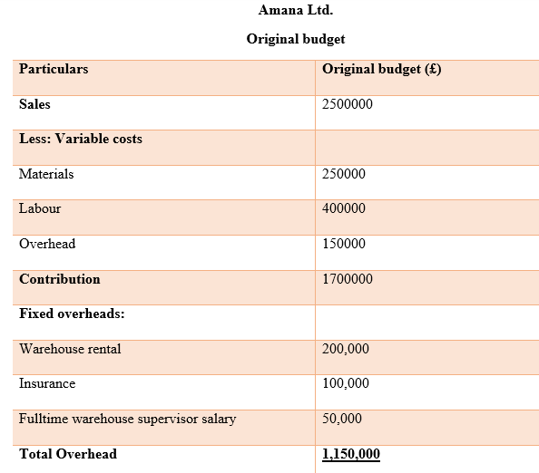
Fixed Budget: Static budgets are a specific kind of investment strategy that can't be altered to account for adjustments in activity (Rikhardsson and Yigitbasioglu, 2018). The most popular type of budget since it is easier to construct than a variable one. Incorporating a set budget into process improvement is a practical strategy to decrease its downsides. In this instance, when the current spending period has ended, the closing of the each budgeting process is included. This way the most current forecasts are included in the budget while making sure that the budget is fully-year continuously. Another approach to lessen the negative effects of an unchanging budget is to cut down the time frame it covers. As an example, a budget might only be the period of three months, after the management comes up with a budget for another three months. As a result, even if the volume of money available is set, it only applies for a limited time, which means that real results won't deviate much from predictions for a lengthy moment. The only situations where a static budget is probable to get a strong bond to real outcomes are those that costs are still mostly fixed, meaning that they are unaffected by changes in total revenue or the market as a whole, and revenues are pretty foreseeable, or in which the company is in a position of dominance where clients must accept its prices.
Flexible Budget: According to changes in real income or even other expenditures, a flexible budget can be adjusted (Zamfir and others, 2021). The final outcome is a budget which closely matches actual outcomes. This strategy differs from the more typical fixed budget, which only lists set spending figures that don't change in accordance with real income levels. The flexible budget, in its most basic version, substitutes proportions of income for some costs in place of the customary set amounts. This enables an endless number of adjustments to be made to anticipated costs that are precisely related to actual income received. This method, however, overlooks adjustments to other expenditures that don't alter in response to little variations in income. Therefore, when certain major revenue adjustments occur, a more complex structure will also include changes to several other expenses, thus accounting for stepping expenses. A corporation will also have a mechanism for evaluating real to planned amounts at various stages of the production by including these adjustments in the plan.
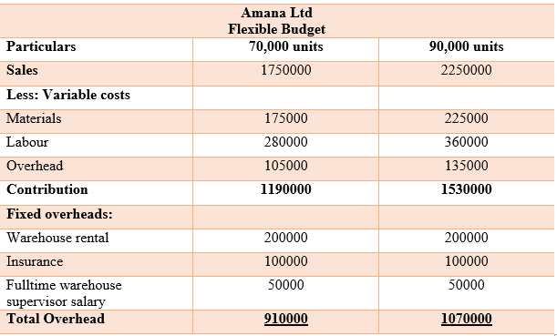
Variance: Authorities, businesses, or people may utilize budget variances on a regular basis to evaluate the discrepancy between planned and actual numbers for a certain accounting area (Xiaobei and Shengli, 2011). An unfavorable budget variance indicates negative variation, indicating losses or shortages, whereas a positive budget variance relates to leads to effective or benefits. Because analysts are imperfect at predicting future expenditures and revenues, budget deviations happen. Variances in the budget may be caused by both controlled and uncontrolled variables. For instance, personnel expenses and a badly organised budget are elements that may be managed. Unmanageable causes frequently come from events outside the firm, like a natural catastrophe, and are thus outside.
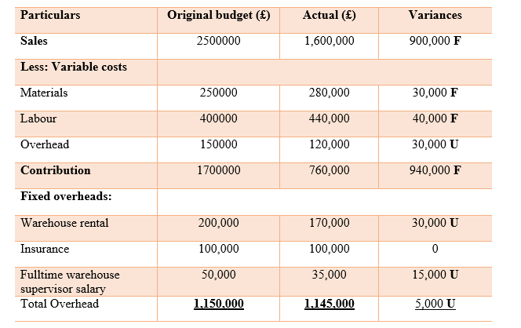
Variation between the actual budget and the flexible budget when units are 70000
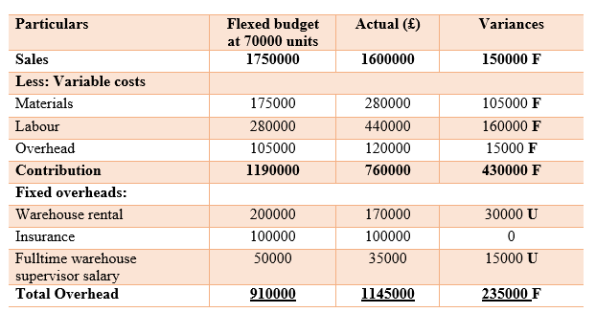
Variation between the actual budget and the flexible budget when the units are 90,000
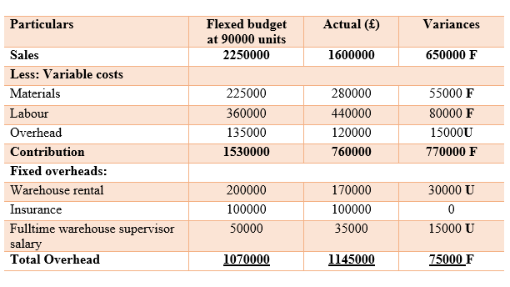

A report on the performance of Amana through 2020, based on the control report
In the present it is evident that the business has been in operation for over 40 years in a successful family-owned company to realize the rapid growth of the tourism sector. Because of the pandemic and the ongoing shutdown that the tourism sector, which includes the family-owned business was severely affected (Sufian, Min and Murad, 2020). The company's revenue was slashed significantly in the month of April 2020, as tourism firms were unable to perform their normal business operations. However, sales grows up a little in this summer.
Two key actions were made via Amana Ltd. throughout these routine shutoffs, and they are as follows:
In order to improve sales income, the firm cut the cost of goods sold. However, this enabled the business to raise the price of its own goods.
These actions are being investigated to see if they may increase Amana's efficiency levels and if not. To guarantee an effective critical analysis of the success of the organisations, the PER approach will be used. This is the performance-based reengineering, often known as the project management approach (Xiaobei and Shengli, 2011). This management approach's main objective is to assist the business in reevaluating its procedures and to support organizational reforms quickly and strategically. This is the rationale for the adoption of the PER technique to evaluate company's performance. Amana Ltd. Enjoys
Decrease in cost
Following the adoption of successful tactics and procedures, several businesses found it difficult to stay competitive in the market in the wake of the epidemic. Amana Ltd. made the decision to reduce its asking price. The main goal in this situation is to expand client numbers for the company, which will boost individual sales as well as total sales (Hofstede, 2012). The company believed that a reduction in price of selling could draw a large number of potential customers since the customers would get similar services with lower prices.
If indeed the Amana outcomes are as expected, the sale value and the quantity sold—both of which were predetermined by the firm bring in money for the business. With this type of move, the company hoped to remain competitive. Additionally, the business anticipates that this choice will boost sales. However, deciding to lower the valuation is not a sound business move. A durable selling method is not a static technique; rather, it develops over time in response to investment capital, sales personnel, technical advancements, and organization design changes that must be capable of keeping up with both the firm's current and prospective demands.
The price of materials is growing.
All types of product-based resources have expanded since the devastating impacts of the pandemic, and its capacity to negotiate with vendors of diverse materials has improved (Mieseigha and Adeniyi, 2013). In this case, the cost of all types of materials significantly increased for the company. The corporation insisted on raising other operational expenses whenever the price of certain items rose in 2020. The price of the business as a whole may have gone up, which would have raised the cost of goods and services on the per basis.
The price of items inside this sector has a significant influence on the firm's pricing structure because the business is reliant on them. Amana Ltd.’s unstable pricing policy may have a big influence, especially on how well the company performs. Under certain situations, there may not be a high degree of trust for the company. The ensuing expense is a significant factor in the urgent issues facing the company.

Suggestions
To make the cost of selling less expensive there have been some pertinent and important recommendations in this scenario for the Leader of Amana Ltd to improve the working environment of the organization. They consist of
- In addition to developing a viable sales plan that is good for the company, the climate, and customers, the organization needs look at the cost of advertising (Min, Murad and Aziz, 2020). Examining sale price is necessary to guarantee the finest quality. The main objective of this evaluation is to guarantee lengthy business profitability because the firm will not gain in the long run from the hasty choice to cut the sales price.
- Whether there's a steady rise in cost of materials, Amana Ltd. should promptly examine the pricing structure because the effect of the price rise on the company might be severe. To recover from this, a significant amount of time and money may be needed. Hence it is crucial to actively watch the expenses of the business. Additionally, the company has to make sure that the price of the components is kept under control without compromising the quality of the goods or offerings (Frew, Olson and Pelton, 2010). And that is why the company should consider moving to a less expensive vendor with a strong track record in order to firm can now have agility and stable pricing while at mean period ensuring the quality level and products at a cheaper price.

Part B
In order to attract clients from the United Kingdom, EU, and the United states, several rivals are adopting digital sites, according to Amana Ltd. The company is now looking about a number of sites, including Sussex, Liverpool, and London. Streamlining the whole business operations and shifting 60% of online stores are the main drivers driving the firm's decision to put its products on the web (Muresan and Sinuraya, 2018). There are significant elements in this situation. Like:
If one chooses to create a unique online space to advertise his company
- The price of setting up a distribution networks.
- The price of upgrading the active website,
- The pay that a full time IT developer every year.
When selling through Ebay:
Fees for completion.
Before making a choice for the company it is crucial to assess the two alternatives. Therefore, the differences between the two choices are presented below in light of the various factors in relation to the costs that are associated with them.

The reasons and the optimal alternatives
There are a few things to take into account when launching a distinct business website as opposed to working with Ebay. Since it is crucial for the business to guarantee the productivity of websites in order to produce high facilities through web pages, the firm must first create the distribution networks before updating the homepage (Yulianto and Fauzi, 2020). In this case, Ebay has accounted for the highest of the effectiveness and caliber of the site. It is really challenging for the business to promise the highest quality or greatest effectiveness of its site. The company employs an IT specialist to track and improve the internet sites and to update them on a routine basis. The company's website must be watched very closely over and supervised.
The primary problem in this specific case would've been the failure to control cost and free returns. If you are working with Ebay, the corporation should not worry about with this concern. This implies that Amana has no influence on Ebay's price policies. Ebay, which can be a sign that the company's price has changed. Additionally, the business can achieve a refund policy because it might have a major impact on the growth and reputation of the business as a whole. Ebay will still uphold the guarantee offered to Amana Ltd. even if it is selling fewer goods. The firm may offer more goods as a result of the introduction of its unique site.
The cost of the options available to Amana Ltd
Acts in the alternative | PS
Option 1: launching an online site for the company
Cost of establishing the delivery network | 120,000
Cost of updating the website to accommodate a significant amount of sales | 30,000
IT programmers per year | 25,000
The total cost | 175,000
Guaranteed sales units every year | 80,000
Option 2 Handling ebay.com
Fees for Ebay shipment | 40,000
The total cost | 40,000
Sales units are guaranteed by Ebay annually | 70,000
Inability to control the return policy and pricing
The cost of building a new website for a business is four times higher than that of Ebay, according to this graph. The cost will be greater, but the company continues to boost sales and maintain power to raise prices and refund policy. This is the rationale for the choice of this alternative. Additionally, the business has a lengthy history, and it's essential to go online and adjust to the shifting market dynamics (Min, Murad and Aziz, 2020).

The benefits and drawbacks of the selected option
Every option or choice has both good and bad effects, and it is up to the management to choose how much of each is more favorable or bad. In this case, it has been decided to introduce a new site (Yulianto and Fauzi, 2020). The benefits and drawbacks for the business will now be examined. For illustration:
Benefits: A firm like Amana Ltd might seize the opportunity to engage with the marketplace more prospective consumers by developing a brand-new site. Additionally, quick direct exchanges may be had through the website. The company is in charge of its own price structure and is free to change it whenever it wants (Muresan and Sinuraya, 2018). Additionally, it has the ability to manage feedback from the client and ensure that the return rules are properly followed. The effectiveness and caliber of internet offerings will aid organizations in preserving and enhancing their present reputations and brand values (Ray, 2006).
Cons: The price to build the new site is higher, which might affect the product's pricing structure and pricing. Extra precautions, efforts, and equipment will be necessary to finish the launching.
The relative cost of each
Amana Ltd must consider a few important factors and costs before launching its new website. The same as:
Particulars | Amount (£)
Establishing a distribution networks | 140000
Dealing with new sites | 30000
Salary of IT developer | 25000
In total | 195000

This should cost about PS195,000 to build an online site, and the firm will definitely sell 80,000 copies annually. While the costs of establishing the supply chain and updating the site are predetermined, the initial investment cost to staff may vary annually depending on whether the firm decides to raise the salary of its IT developers. This implies that the price will increase.

Conclusion
The initial budget and the flexible budget, along with distinctions to the budgeted amount, are included in the control document. The positive as well as negative circumstances have been projected presents a comparison. The action of lowering the sales price and raising the cost was then examined, and practical advice was given. The decision to introduce a successful website has been made, and its advantages and disadvantages have been evaluated while taking into account the relative value of doing so.

References
- Bromwich, M. and Bhimani, A., 2005. Management accounting: Pathways to progress. Cima publishing.
- ESCAP, U., 2018. Globalization, inclusion, and e-commerce: agenda for SMEs.
- Frew, J., Olson, R. and Pelton, M.L., 2010. Creating a Flexible Budget Process. Redbook, 96.
- Hofstede, G.H., 2012. The game of budget control. Routledge.
- Mieseigha, E.G. and Adeniyi, S.I., 2013. Budget: a tool for business management and economy engineering. Global Business and Economics Research Journal, 2(10).
- Muresan, D. and Sinuraya, R., 2018, August. Relation between internet and social media to support sales in business. In IOP Conference Series: Materials Science and Engineering (Vol. 407, No. 1, p. 012062). IOP Publishing.
- Ray, A.W. and Ray, J.J., 2006. Strategic benefits to SMEs from third party web services: An action research analysis. The Journal of Strategic Information Systems, 15(4), pp.273-291.
- Rikhardsson, P. and Yigitbasioglu, O., 2018. Business intelligence & analytics in management accounting research: Status and future focus. International Journal of Accounting Information Systems, 29, pp.37-58.
- Sufian, A., Min, C.S., Murad, M.A. and Aziz, N.A., 2020. The impact of social media marketing on sales performance of small online business. European Journal of Molecular & Clinical Medicine, 7(3), pp.922-940.
- Xiaobei, L. and Shengli, D., 2011. Research on flexible budget of marketing expenditure. In Proceedings of the 8th International Conference on Innovation and Management. November (pp. 1309-1313).
- Yulianto, H.D. and Fauzi, R., 2020, July. Design of Web-based Online Sales Information System. In IOP Conference Series: Materials Science and Engineering (Vol. 879, No. 1, p. 012007). IOP Publishing.
- Zamfir, M., Ionescu, C.A., Nicolau, N.L.G., Stanescu, S.G., Paschia, L., Coman, M.D. and Bugnariu, A.D., 2021. Flexible Budget: Management Method for Cost Control and Monitoring the Performance of Economic Entities. In CSR and Management Accounting Challenges in a Time of Global Crises (pp. 128-155). IGI Global.

