

Programme: | BA Business Management
Module: | Data Handling & Business Intelligence
Module code: | LCBB5000
Lecturer: | Anupam Mazumdar
Assignment Title: | Assessment 2 Part 1 and Part 2
Student name: | Constantin Patrascu
Student ID Number: | 2022567
Submission Date:

Table of Contents
Part 1 3
Introduction 3
Description of the data 4
Evaluation of the data 6
Conclusion 11
References 12
Part 2 13
Introduction 13
Data analysis and results 14
“Explain the most common data mining and text mining methods that can be used in business with real world examples” 25
“Discuss the advantages and disadvantages of using SPSS and Excel using relevant practical examples and present your discussions in a table” 26
Conclusion 28
References 29

Part 1

Introduction
Business intelligence includes a range of practices involving “data tools and infrastructure, data visualisation, data mining, business analytics and best practices” which allows the companies to undertake data-driven decisions (Kupzyk and Cohen, 2015). In practice, business intelligence offers a comprehensive view of the company’s data which can be used to drive change, improve efficiency and enhance the adaptability of the company with respect to the market and supply chances.
In this report the consideration of 2 data sets will be done to evaluate and interpret the data into meaningful information.

Description of the data
In the provided data set, an in-depth presentation of the crime rate of the UK has been done by making effective use of excel spreadsheets to show the figures of offences that have been reported within the nation. With context to the given data sheet, it can be seen that there are 27 columns showing the overall insights of the crime issue of the UK. As per the government report, it can be seen that the crime rate is increasing in the past 3 years which is why the government is implementing effective strategies and approaches to ensure the safety and security of the citizens. From the report, it has been identified that the crime index of the UK is 46.60, however, with the efforts of the government, the UK has been able to increase its safety index to 53.40 (Malhotra, 2015).
The evolution of this type of data allows in managing the risk and helps in putting all the risk into the perspective with respect to the prime source like “Metropolitan Police”. The dashboard for the insights as well as transparency into the crime rate in the London is an effective tool which requires being able to consider “Violence into content” Apart from that the data allows the government bodies to successfully plan their approaches and operation. It also raise awareness regarding where to expect pubic order offence, possession of dangerous weapons and violence against the person so that required actions can be taken to avoid and eliminates such issues. With the help of proper evaluation and analysis of the dashboard of offence, the sub-offences and timelines are also analysed to understand the cause of the issue in a more effective manner. The concern of the government bodies like Metropolitan police is to ensure the safety of individuals or anyone affected by their daily operations. In the most dangerous parts of London, the police are enforcing court order in order to recover the land and money. Both of these actions required a proper skill of enforcement agents so that the competing interests of the people involved can be balanced. The opponent party can be against the enforcing order of the counts and become agitated over the consequences after the enforcement actions. As a result it tends to become one of the triggering point which leads toward violence which need to be managed through various approaches. The experienced enforcement agents handle the risky situations to manage the issue.
“City of London” is considered to be one of the most dangerous small towns in London based on the reports issued by the government bodies. The overall crime rate in the city was recorded over 665 crimes per 1000 people populations in 2021. The results compares worse o the London’s overall crime rate that is 87%.
It can be justified that there are a range of features of the data set which have been implemented while analysing the data. The given table will be able to show, data involving crime rate, labour force, youth, youth unemployment and males. So that proper comparison of the other aspect and factors of the London can be done with the crime rate to generate meaningful information. It supports in the analysis and evaluation of the data so that a proper understanding of the whole situation can be done.

CrimeRate | Youth | LabourForce | Males | YouthUnemployment
45.5 | 135 | 540 | 965 | 80
52.3 | 140 | 535 | 1045 | 135
56.6 | 157 | 512 | 962 | 97
60.3 | 139 | 480 | 968 | 135
64.2 | 126 | 599 | 989 | 78
67.6 | 128 | 624 | 972 | 77
70.5 | 130 | 641 | 984 | 70
73.2 | 143 | 537 | 977 | 114
75 | 141 | 523 | 968 | 107
78.1 | 133 | 599 | 1024 | 99
79.8 | 142 | 533 | 969 | 94
82.3 | 123 | 526 | 948 | 124
83.1 | 135 | 595 | 986 | 77
84.9 | 121 | 547 | 964 | 84
85.6 | 166 | 521 | 973 | 72
88 | 140 | 632 | 1029 | 100
92.3 | 126 | 602 | 984 | 102
94.3 | 130 | 536 | 934 | 78
95.3 | 125 | 586 | 964 | 105
96.8 | 151 | 510 | 950 | 108
97.4 | 152 | 530 | 986 | 92
98.7 | 162 | 522 | 996 | 73
99.9 | 149 | 515 | 953 | 86
103 | 177 | 638 | 974 | 76
104.3 | 134 | 595 | 972 | 83
105.9 | 130 | 623 | 1049 | 113
106.6 | 157 | 553 | 955 | 81
107.2 | 148 | 601 | 998 | 84
108.3 | 126 | 542 | 990 | 102
109.4 | 135 | 537 | 978 | 89
112.1 | 142 | 497 | 956 | 116
114.3 | 127 | 519 | 982 | 97
115.1 | 131 | 574 | 1038 | 142
117.2 | 136 | 574 | 1012 | 111
119.7 | 119 | 521 | 938 | 92
121.6 | 147 | 560 | 972 | 76
123.4 | 145 | 560 | 981 | 88
127.2 | 132 | 564 | 953 | 83
132.4 | 152 | 571 | 1018 | 103
135.5 | 125 | 567 | 985 | 130
137.8 | 141 | 591 | 985 | 91
140.8 | 150 | 531 | 964 | 87
145.4 | 131 | 542 | 969 | 79
149.3 | 143 | 583 | 1012 | 96
154.3 | 124 | 580 | 966 | 77
157.7 | 136 | 577 | 994 | 102
161.8 | 131 | 631 | 1071 | 102
Table 1: Data presentation
(Source: Learner)

Evaluation of the data
“Mean, median and mode” is consider to be a 3 principal ways that helps the individuals to designate the average value of the data set. The calculation of the mean can be done by adding the number as well as dividing the sum amount from the list; it is what means by average. On the other hand, the median is consider to be the middle value of the order list of the numbers in an order that can be smallest to the largest numbers. Apart from that the mode is consider to be the most frequent value that appears on the number list. Standard deviation is considered to be measures which help in showing the dispersion if data in relation to the calculated mean. The lower standard deviation represents the clustered amount around the calculated mean. On the other hand, the higher standard deviation represents the data to be more spreader.
Data visualisation is considered as a technique through which the presentation of the data can be done through visual graphs and charts so that proper insights of the provided data can be given. The following data depicts the crime rate of the UK per million populations.
The measure of the descriptive Statistics | Values
Mean of the crime rate | 102.809
Median of Crime rate | 103
the standard deviation of crime data | 28.8933
Mean unemployment rate for youth | 95.4681
Median of the Unemployment rate for youth | 92
The standard deviation of the unemployment for the Youth | 18.0288
Mean of the labour force | 561.191
Median of the labour force | 560
Mean of the number of Males | 983.021
Median of the number of Males | 977
Table 2: Descriptive Statistics
(Source: Learner)
From the above table, it can be evaluated that the mean amount of crime rate is 102 which is higher than the mean amount of unemployment rate which is 95. The median and standards deviation of the crime rate is 103 and 28 respectively.
In terms of unemployment rate in youth of London, it can be seen that the median rate is 92 and standard deviation is 18. From the table, the statistical figure of labour forces can also be seen. The Mean amount with respect to labour force is 561.191 and the median amount of the same is 560. On the other hand, the calculated mean and median of males from the table is 983.021 and 977 respectively.

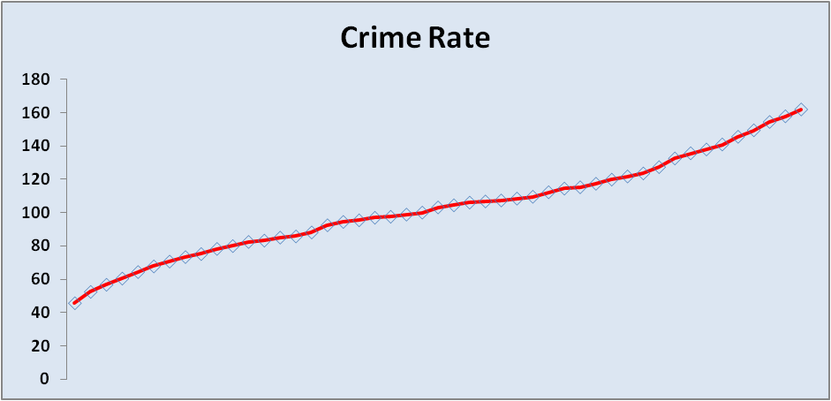
Figure 1: Crime rate
(Source: Learner)
From the above data it can be seen that there has been a major increase in the crime rate of the UK over the years.

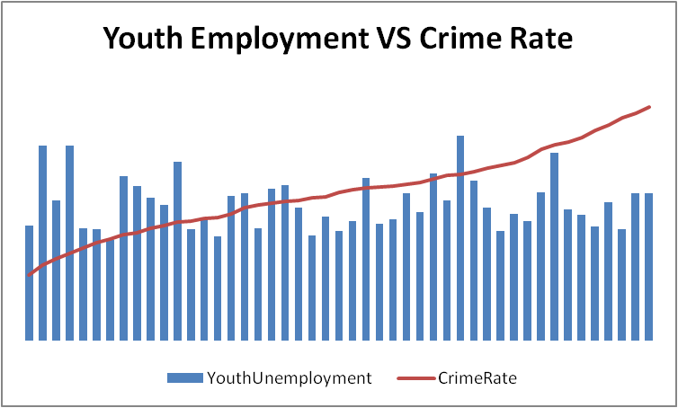
Figure 2: “Relationship between crime rate and Unemployment n of the youth”
(Source: Learner)
From the given figure, a comparison analysis of crime rate with respect to youth unemployment rate has been done. It can be seen that the youth unemployment is lower in Uk which is a positive aspect that shows that the unemployment issue in the UK is low.
Pivot table data.
The consideration of pivot table has been done to effectively sort and evaluate the given data, pivot table is consider to be a statistical tool which helps the users to reorganise and summaries the selected clowns and rows of the raw data as well as database so that a desired and concise report can be prepared. This tool does not tend to alter the data but its pivots or organise the data so that the provided data can be analysed from a different perspective to get a better idea and understanding. These types of tables are beneficial particularly with larger database which may be highly time-consuming to do to calculation manually. Several data processing functions the pivot table which can also perform functions like average, outliers, sums as well as ranges, the table rearranges the information in a meaningful yet simple layout which allows the users to focus on the key values of the data set.
Row Labels | Count of CrimeRate
70 | 2.13%
72 | 2.13%
73 | 2.13%
76 | 4.26%
77 | 6.38%
78 | 4.26%
79 | 2.13%
80 | 2.13%
81 | 2.13%
83 | 4.26%
84 | 4.26%
86 | 2.13%
87 | 2.13%
88 | 2.13%
89 | 2.13%
91 | 2.13%
92 | 4.26%
94 | 2.13%
96 | 2.13%
97 | 4.26%
99 | 2.13%
100 | 2.13%
102 | 8.51%
103 | 2.13%
105 | 2.13%
107 | 2.13%
108 | 2.13%
111 | 2.13%
113 | 2.13%
114 | 2.13%
116 | 2.13%
124 | 2.13%
130 | 2.13%
135 | 4.26%
142 | 2.13%
Grand Total | 100.00%

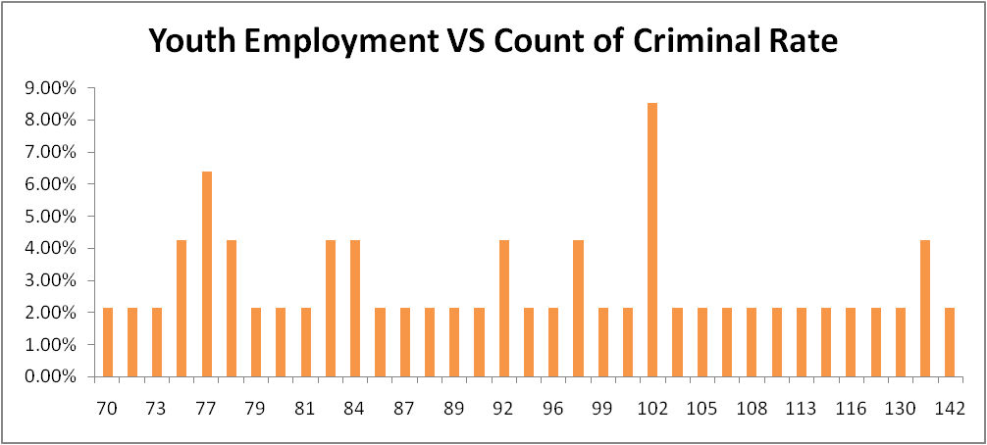
Figure 3: Youth employment VS Criminal Rate
(Source: Learner)

Conclusion
In conclusion, it can be seen that it is important for the companies to implement effective data mining as well as a text mining tool that allows them to analyse significant information that also fosters their decision-making process. Apart from that the utilisation of SPSS tools and techniques also makes it easier for the companies to statistically analyse their huge data set to gather meaningful information.

References
Kupzyk, K.A. and Cohen, M.Z., 2015. Data validation and other strategies for data entry. Western journal of nursing research, 37(4), pp.546-556.
Malhotra, N.K., 2015. Essentials of marketing research: A hands-on orientation. Essex: Pearson.

Part 2

Introduction
It is significant for the companies to effectively apply data handling methods so that the overall performance and productivity of the company can be increased. In this report, the evaluation of data mining as well as text mining method will be done considering real world examples. Apart from that the benefits and drawbacks of SPSS will also be discussed in this report.

Data analysis and results
In the given dataset, the presentation of survey reports has been done on the high school students. In this section, the data on females, ice cream, puzzles, videos and ID. The female column in the Excel shows both male and female categories. The ice cream column shows 3 flavours that are strawberry, Vanilla and chocolate. From the table it can be seen that the first column contains student ID numbers.

Data set

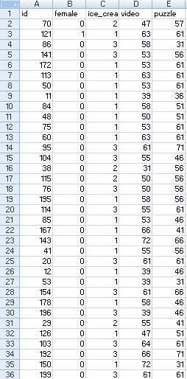
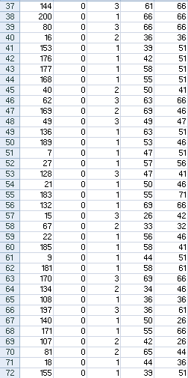
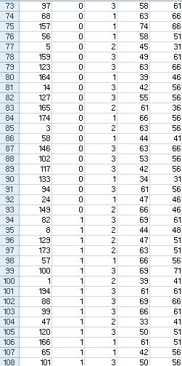
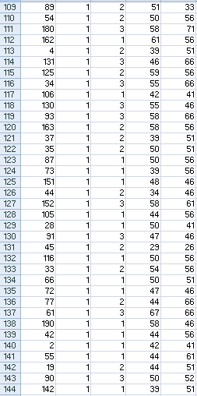
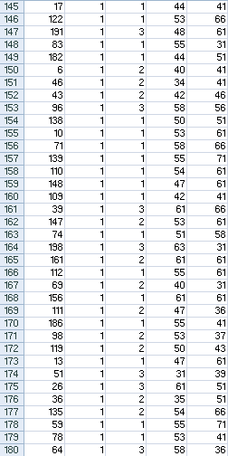
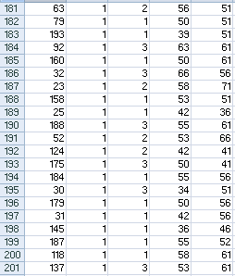

Table 1: Data representation
(Source: learner)
The sorting and analysis of the data has been done through SPSS which is a powerful software tool that offers a user-friendly interface as well as a robust system, that allows the users to evaluate and generate the data in an effective manner so that proper analysis can be done.
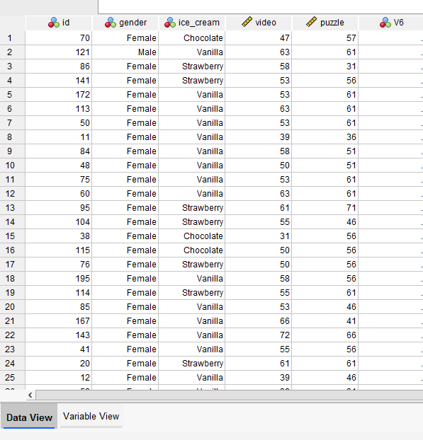
Table 2: Data Representation through SPSS
(Source: Learner)

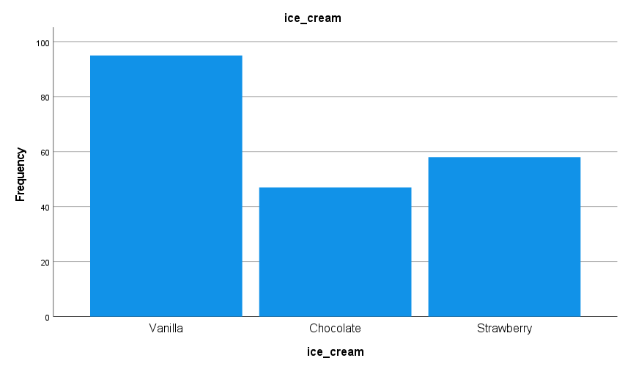
Figure 1: Distribution of respondents based on ice-cream flavours
(Source: learner)
Numbers of students liking vanilla flavour

Statistics
ice-cream
N | “Valid” | “200”
N | “Missing” | “0”

ice-cream
 |  | “Frequency” | “Per cent” | “Valid Percent” | “Cumulative Percent”
“Valid” | “Vanilla” | “95” | “47.5” | “47.5” | “47.5”
“Valid” | “Chocolate” | “47” | “23.5” | “23.5” | “71.0”
“Valid” | “Strawberry” | “58” | “29.0” | “29.0” | “100.0”
“Valid” | “Total” | “200” | “100.0” | “100.0”
Table 3: Determination of respondents like Vanilla ice cream
(Source: Created by the author)
With the help of an effective analytical tool like SPSS used to analyse the data, it has been identified that over 200 students within which 95 frequencies of students like vanilla flavour that is over 47.5% both valid and cumulative. The utilisation of the SPSS tool has made it easy to sort and evaluate the provided data and answer the given question.
Segregation of male and female respondents

Statistics
gender
N | “Valid” | “200”
N | “Missing” | “0”

gender
 |  | Frequency | Per cent | Valid Percent | Cumulative Percent
“Valid” | “Male” | “109” | “54.5” | “54.5” | “54.5”
“Valid” | “Female” | “91” | “45.5” | “45.5” | “100.0”
“Valid” | “Total” | “200” | “100.0” | “100.0”
Table 4: Determination of the respondents in terms of Gender
(Source: Created by the author)
With the help of the SPSS system the segregation of male and female respondents can be done. It can be seen that from over 200 students 109 students are male and 91 students are; female which means 54.5% and 45.5% respectively.
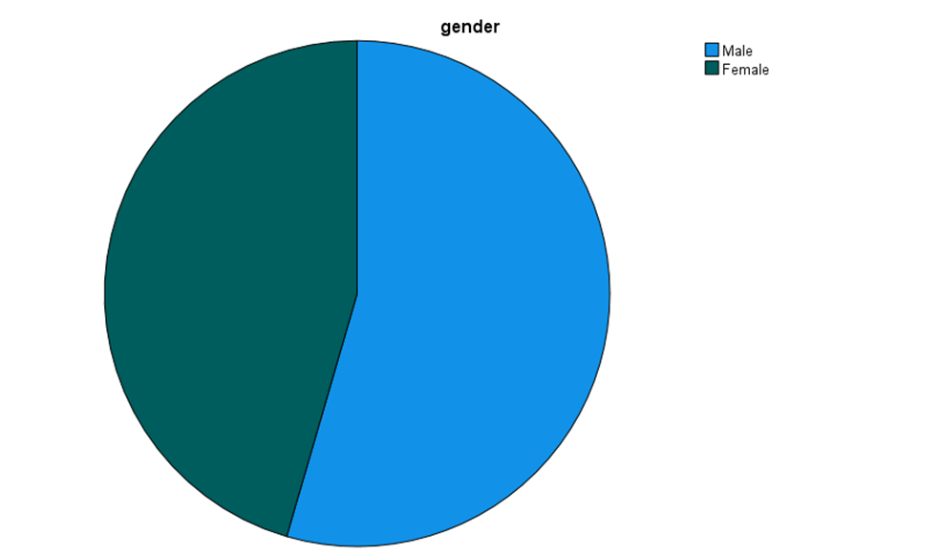
Figure 2: Male and Female students.
(Source: Created by the author)
Mean and median of the students liking strawberry and chocolate flavours of ice cream.
For the calculation of mean and median the consideration of the SPSS tool has been done. Median is considered to be the middle number in a sorted data and list of data which can be used to present a more descriptive data set. Apart from that, the mean is considered to be the average value of the data set.

Statistics
ice-cream
N | “Valid” | “200”
N | “Missing” | “0”
“Mean” |  | “1.82”
“Median” |  | “2.00”
“Mode” |  | “1”
“Minimum” |  | “1”
“Maximum” |  | “3”

ice-cream
 |  | “Frequency” | “Percent” | “Valid Percent” | “Cumulative Percent”
Valid | “Vanilla” | “95” | “47.5” | “47.5” | “47.5”
Valid | “Chocolate” | “47” | “23.5” | “23.5” | “71.0”
Valid | “Strawberry” | “58” | “29.0” | “29.0” | “100.0”
Valid | “Total” | “200” | “100.0” | “100.0”
Table 5: Data representation
(Source: learner)
From the above table, it can be seen that the 47 students like chocolate flavoured ice cream and 58 students like strawberry flavoured ice cream which is 23.5% and 29% respectively. t

“Explain the most common data mining and text mining methods that can be used in business with real world examples”
Data mining is an operation of filtering useful and important data amongst a massive amount of big data (Matsumoto et al., 2017). On the other hand, text mining includes and combines the tools of data mining, statistics, information retrieval, computational linguistics, and machine learning.
The different data and text mining methods are presented below:
- Association- Association method is used to find a connection between other items by pointing out the concealed pattern in the set of data and it is also known as relation analysis. Association method is used in “market basket analysis” to forecast consumer behaviour. The example of Netflix can be done which implements this method to find the most popular TV series and movies. It also makes use of it to determine how they can make their shows more popular and interesting to the customer. This can be achieved with the help of accurate data mining insights (Tandel et al., 2019).
- Classification- Classification method helps to differentiate the items in the set of data into groups or classes. It also helps to forecast entities behaviour within a group precisely. The example of Amazon can be done which utilises this type of tool within its operations to determine the lowest price of the products. It is an effective tool which allows the company to achieve efficiency and good performance. This method involves two steps which is given below:
- Learning step- in this step, by evaluating the training set “classification algorithm” creates the classifier.
- Classification step- test data or information utilise to calculate the accuracy of the classification rules.
- Clustering Analysis- this has almost resemblance of classification, however clusters are developed on the basis of depending on the similarities of the data items. The different groups tend to have dissimilar objectives. This method is also considered as data segmentation since the partition of the data is huge and is done into the groups as per the similarities. For example, large manufacturing companies like Unilever utilised clustering analysis to analyse its huge database which allows them to make informed decisions and get a proper insight of the overall operations of the company.

“Discuss the advantages and disadvantages of using SPSS and Excel using relevant practical examples and present your discussions in a table”
SPSS and Excel are both powerful tools with the help of which companies can analyse beneficial data which allows them to get proper insights to make valid and reliable decisions. However, there are both benefits and disbenefits of these tools which need to be considered by the companies.

 | SPSS | Excel
Definition | SPSS is considered to be a software product which is utilised for statistical analysis by the company which comprises features like data compilation, graphics, modelling, and preparation as well as analysis. | Excel is also an analytical tool which allows the users to conduct data analysis and sorting with a range of features that makes it easy for the users to get a proper insight of the data.
Advantages | The major benefit of this tool is that it is very easy and quick to utilise and implement.  These tools can also deal with large amounts of data which is a major advantage.  Apart from that the interface of the tool is also highly user friendly (Salloum et al., 2018). | The major benefits of this tool are that it offers dynamic tables with calculated columns which makes it easy to use and create. The cost for the implementation of this tool is also low which makes it cost effective for the companies to utilise this tool.  It also ensures effective data protection that allows the companies to protect its confidential data. Sharing of data sets is also a lot easier for the companies. As a result, the overall communication is also improved.
Disadvantages | However, there are a range of disadvantages as well of this tool. This tool is the most expensive to implement which counts as a downside. Apart from that this tool also offers limited functionality which does not justify the high charges. Lastly, this tool seems to be highly similar to the functions provided by Excel. | The lack of some major functionalities and features is a major disadvantage for this tool. While dealing with large data, the tool becomes significantly slow to use that decreases the efficiency level.
Table 6: Pros and cons of SPSS and Excel
(Source: Salloum et al., 2018)

Conclusion
In the analysis, it has also been evaluated that there are a range benefits and disbenefits of using such tools like Excel and SPSS which is why companies need to evaluate both the tools before implementing so that the predetermined objectives can be achieved.

References
Matsumoto, T., Sunayama, W., Hatanaka, Y. and Ogohara, K., 2017, July. Data analysis support by combining data mining and text mining. In 2017 6th IIAI International Congress on Advanced Applied Informatics (IIAI-AAI) (pp. 313-318). IEEE.
Salloum, S.A., Al-Emran, M., Monem, A.A. and Shaalan, K., 2018. Using text mining techniques for extracting information from research articles. In Intelligent natural language processing: Trends and Applications (pp. 373-397). Springer, Cham.
Tandel, S.S., Jamadar, A. and Dudugu, S., 2019, March. A survey on text mining techniques. In 2019 5th International Conference on Advanced Computing & Communication Systems (ICACCS) (pp. 1022-1026). IEEE.

