Assignment 2
Module Name: Introduction to Web and Database Concepts
Module Code: ACCA4023

Student Name: Jose Manuel Carneiro De Alva Noronha
Student ID: 2516682
Group: 2

Lecturer’s Name: Anum Paracha
UNIVERSITY OF WALES TRINITY SAINT DAVID
LONDON CAMPUS

Table of Contents
Introduction 2
Requirements and tools 2
Main Body 2
Implementation 2
Evaluation 14
SEO 14
Website 15
CSS Validation 15
Markup Validation 16
Website Comparison 19
Conclusion 20
References 20

Introduction
The objective of this project is to build a simple website. I chose to develop a university website that includes an introductory home page and a section highlighting 3 degree programs.
Additionally, it features an admin login page that allows administrators to log in and view the list of contact requests submitted by users to the university.

Requirements and tools
To create this website, it was necessary to import Bootstrap[1] (version 5.3.8), thus making it possible to insert elements into the website without the need to create them manually. Since Bootstrap[1] is necessary for the proper functioning of the website, and considering that I imported it via a URL (obtained from the official page), it is always necessary to have internet access. The elements added to the HTML were obtained through the Bootstrap documentation.
I also used AI assistance to help refine the color scheme, as the initial colors were not quite what I intended. Additionally, after encountering some difficulty aligning the navigation bar elements to the right, I consulted AI to help resolve the issue.
To assist with the development of this website, I referenced the W3Schools[2] platform. Additionally, I created a custom JavaScript file to handle the login functionality as well as some page animations and transitions.

Main Body

Implementation
Across all pages, the header features a dark blue navigation bar with the logo positioned on the left clicking it redirects the user to the home page, and a right-aligned menu with the following options: Home, Courses, About, Contact Us, and Login. The active menu item is highlighted in “#f59e0b” to indicate the user's current location.
Additionally, all pages include a dark footer at the bottom displaying the 2026 copyright notice.
In the following section, I will describe each page alongside its corresponding screenshot, excluding the navigation menu descriptions.
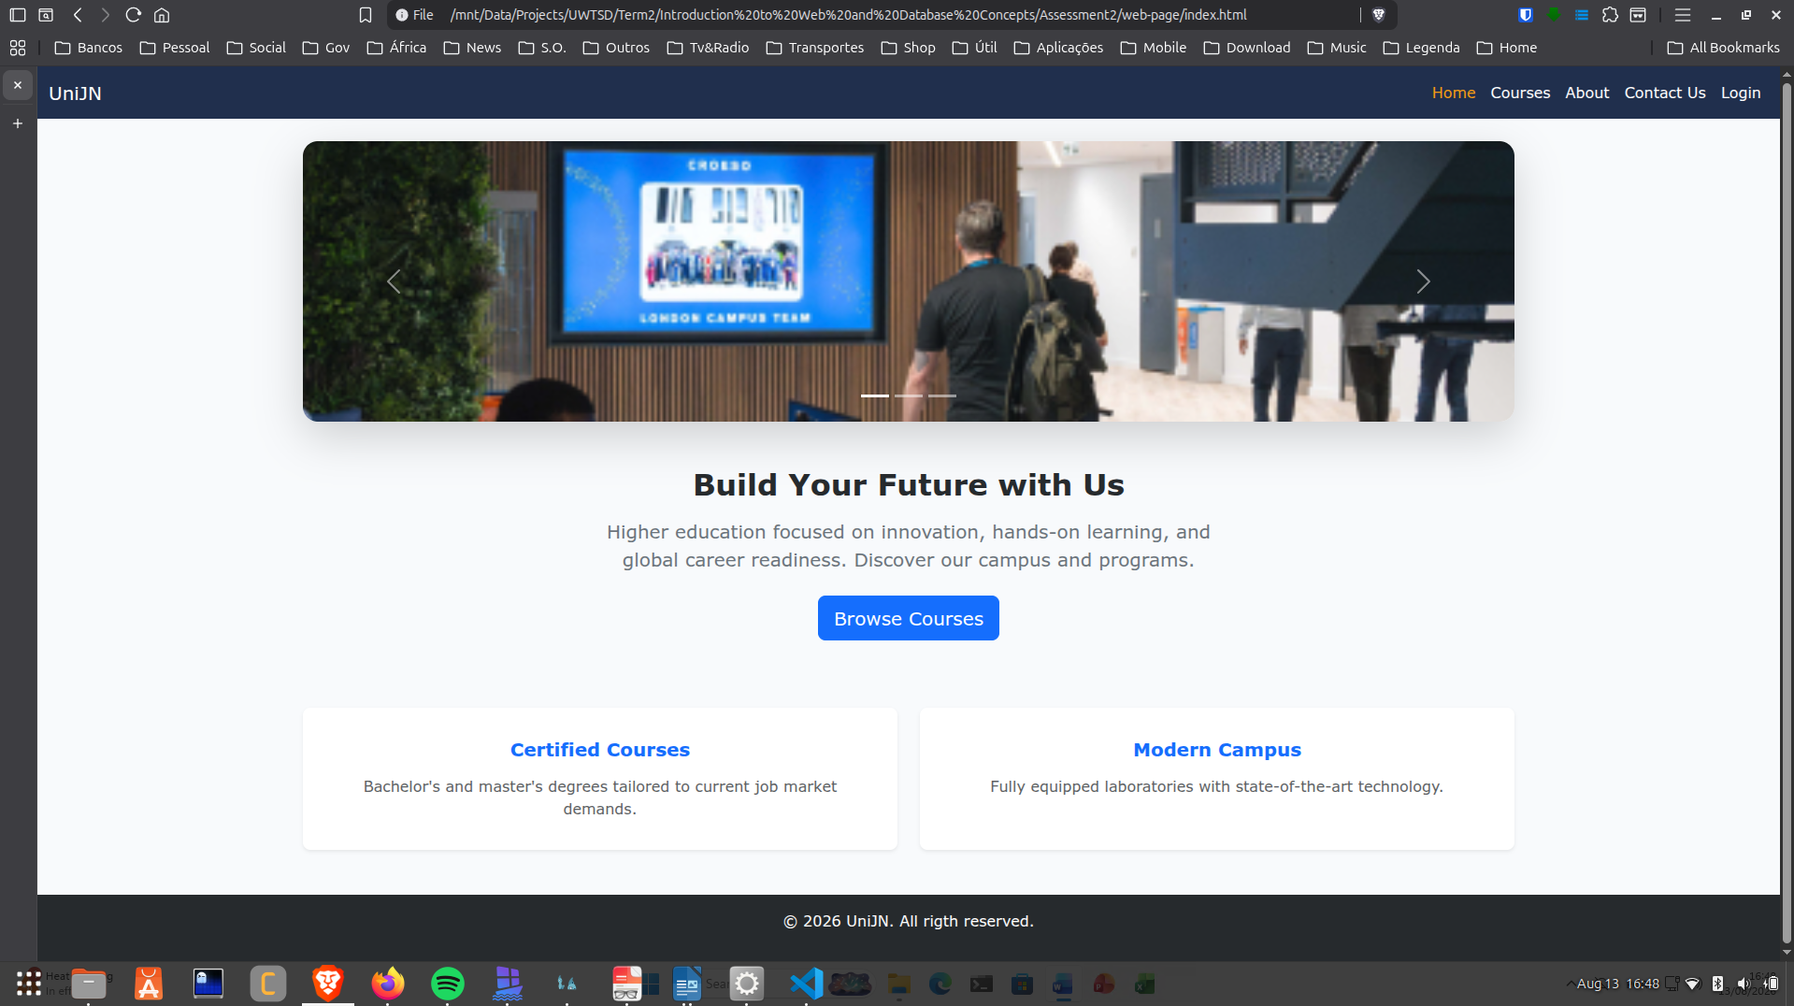
Figure 1 - Home page
On the home page, we have an image carousel showing, for example, the campus entrance of the “University of Wales Trinity Saint David London”. The main section features the eye-catching title “Build Your Future with Us”, followed by a short description centered on innovation, practical learning, and preparation for the global job market. There is also a blue action button with the text “Browse Courses” that redirects to the courses page when clicked.
In the lower section, there are two white info cards:
- One dedicated to “Certified Courses” (focused on undergraduate and postgraduate degrees)
- Another to “Modern Campus” (highlighting labs equipped with advanced technology).
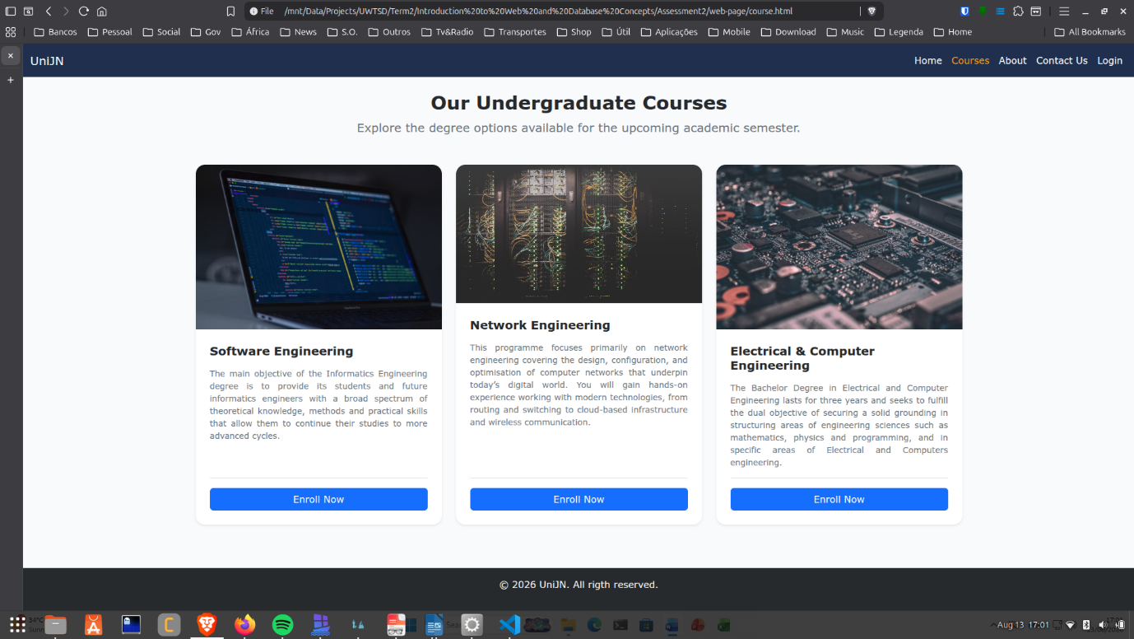
Figure 2 - Courses page
On this courses page, it is possible to observe the design consistency of the platform, offering direct and professional navigation for potential students.
The central title “Our Undergraduate Courses” invites exploration of the bachelor's degree options for the upcoming semester. The content is organized in a modern grid of three cards, each with an illustrative image, title, descriptive text, and a blue “Enroll Now” action button:
- Software Engineering: Focused on training computer engineers with theoretical and practical knowledge to pursue advanced studies.
- Network Engineering: Centered on the design, configuration, and optimization of networks, covering from routing to cloud infrastructure.
- Electrical & Computer Engineering: A three-year degree focused on engineering sciences, such as mathematics, physics, and programming.
These texts were obtained from several university websites, and some of the texts were also modified.
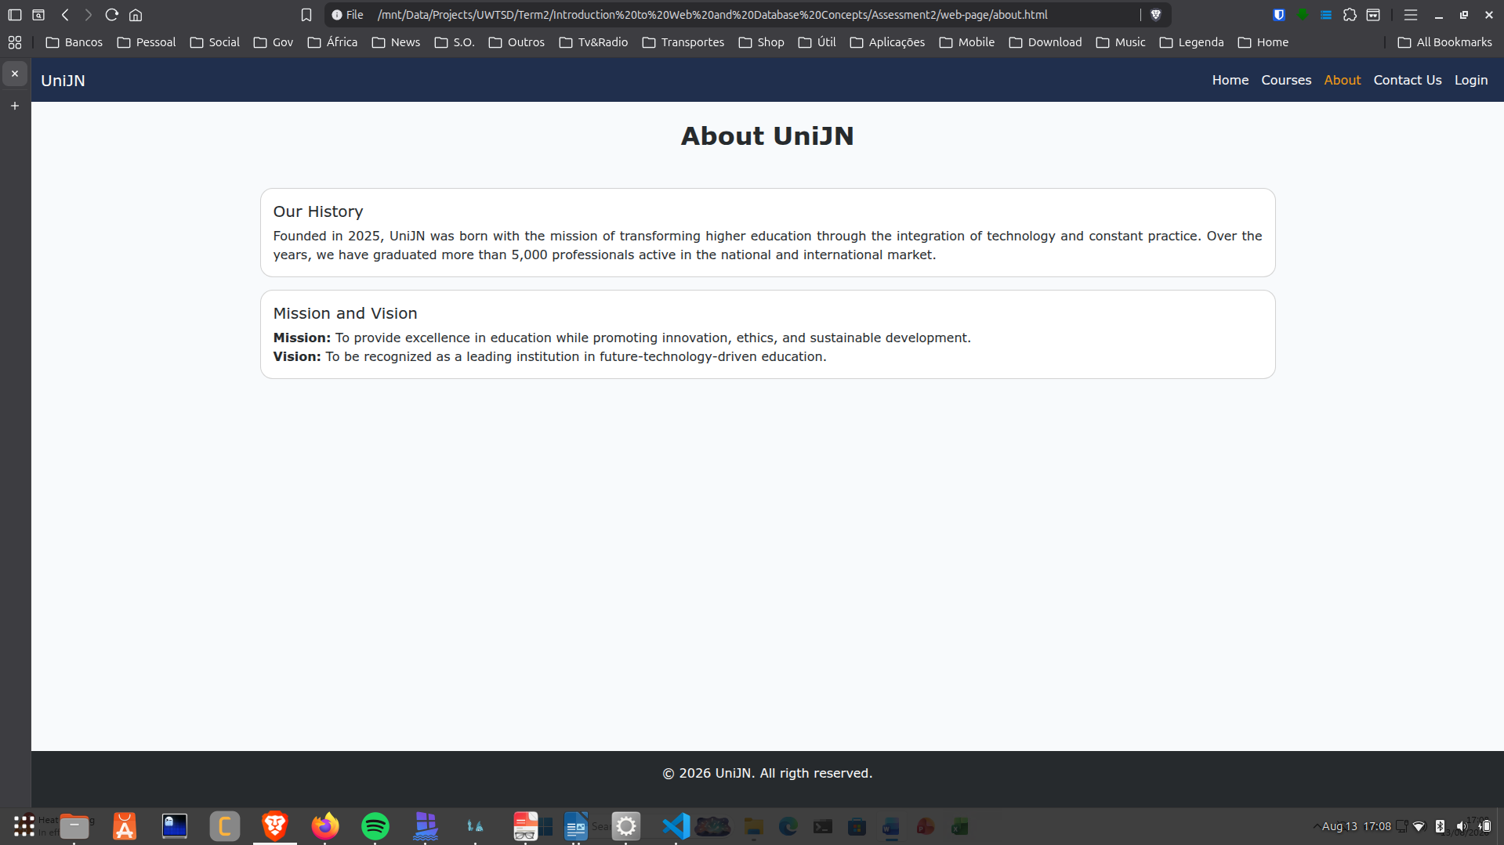
Figure 3 - About page
Being a simple page, the objective is to tell the university's history and try to convey the university's vision and mission.
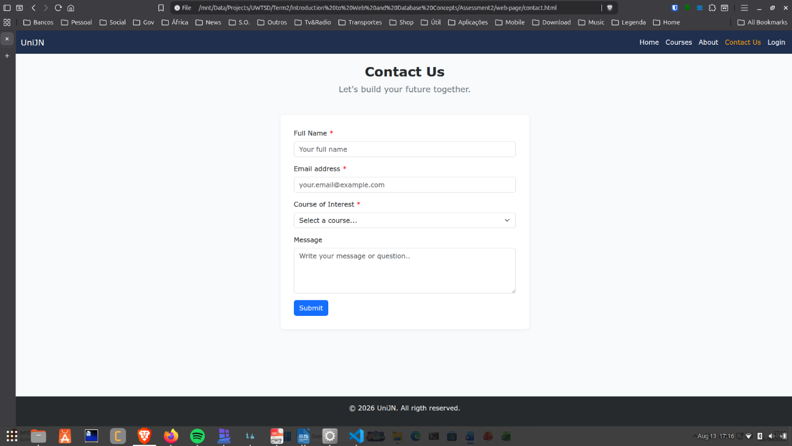
Figure 4 - Contact Us page
Maintaining a clean structure, the top navigation bar highlights the “Contact Us” menu item to ensure visual consistency.
Centered beneath the heading “Contact U” and the subtitle “Let's build your future together.”, a simple contact form is presented inside a white card:

- Required Fields: Full Name, Email address, and selection of the Course of Interest, each marked with a red asterisk.
- Message Field: A text box for user inquiries or messages (Message).
- Submission Button: A blue 'Submit' button positioned at the bottom left of the form.
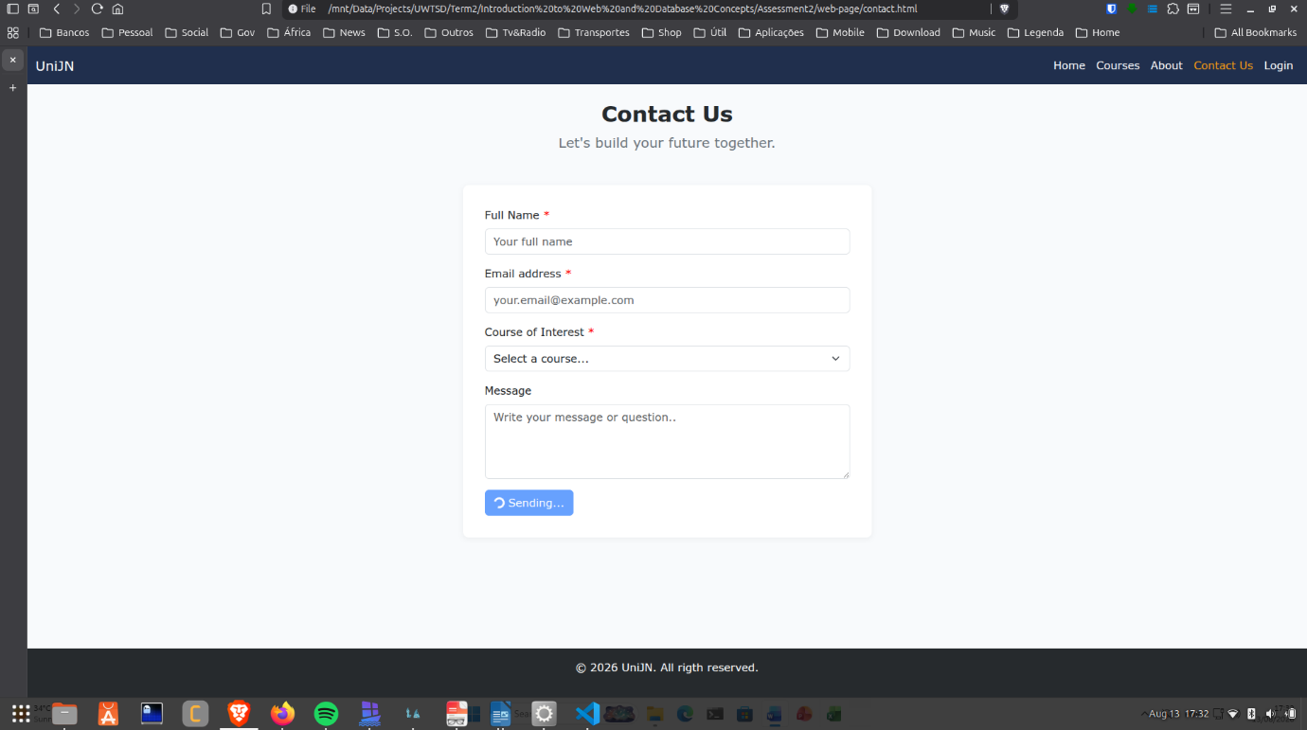
Figure 5 - Contact Us: Sending loading
Upon submission, the “processEnroll” function is called within the JavaScript file “index.js” and imported by each “HTML” with element “script”. Since I developed this file myself, I am able to explain its implementation line by line.
To improve user feedback, which would otherwise be virtually instantaneous, I created a sleep function. In most calls, I use a default value of 500ms to allow users to notice the visual transitions and page effects.
During form submission, the user may receive the following feedback scenarios, which are detailed below.
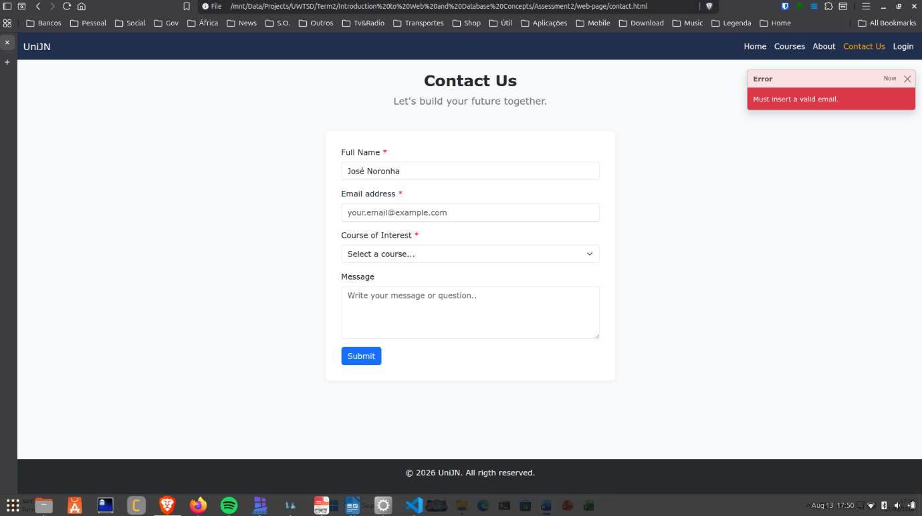
Figure 6 - Contact Us: Form ERROR message
If there is any error in the form, a red error message is displayed, indicating where the error occurred.
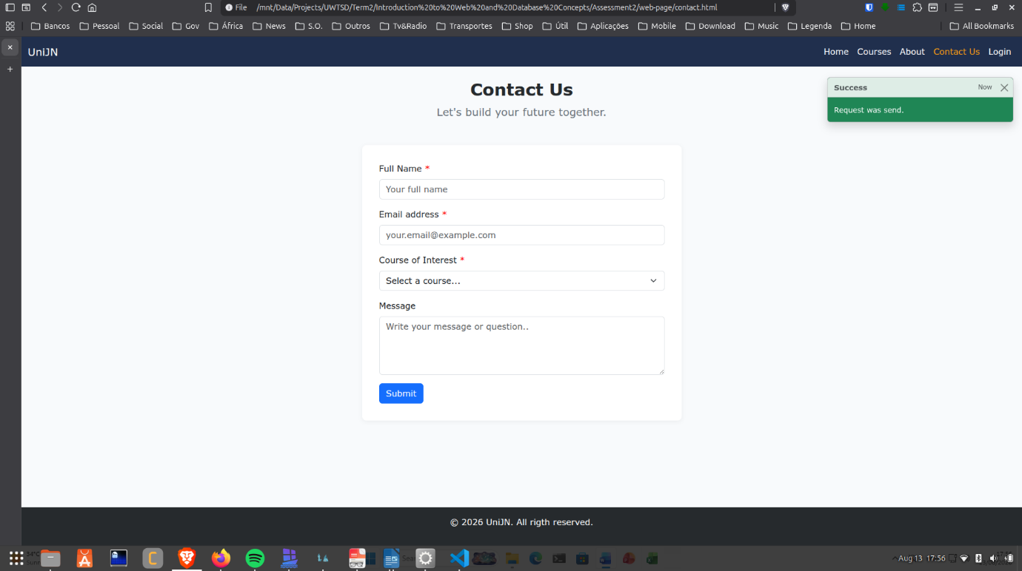
Figure 7 - Contact Us: Form SUCCESS message
If the form is correctly filled out and submitted, the user will receive a success message, as shown in the image above.
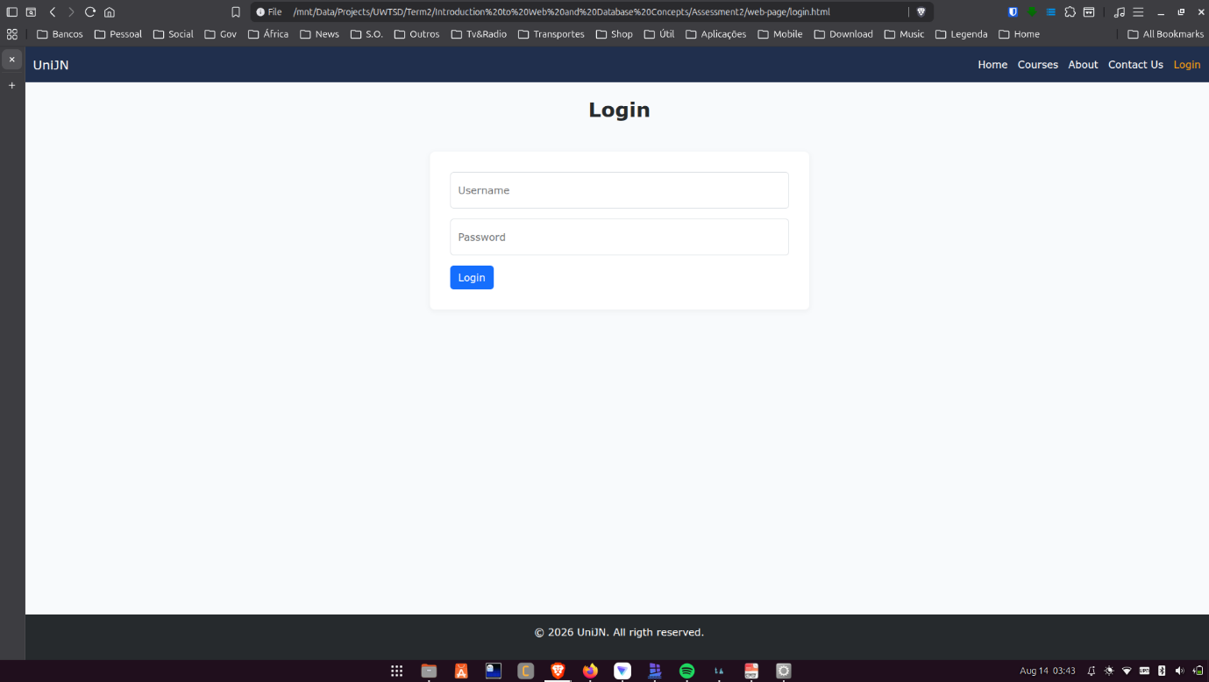
Figure 8 - Login page
This page features a login form for administrators, accessible using the credentials:
- Username: admin
- Password: admin
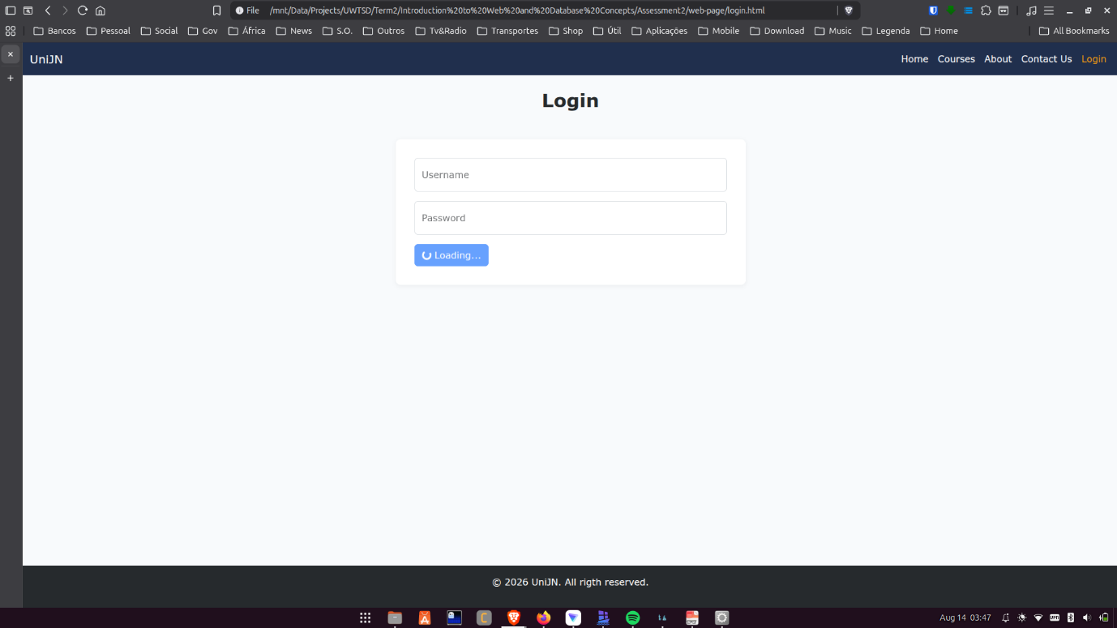
Figure 9 - Login page: Login loading
Similar to the form on the “Contact Us” page, a function named “processLogin” was implemented to handle button animation, as shown in the image above, along with username and password validation. If the username or password is incorrect, an error message is displayed similar to the one on the “Contact Us” page differing only in text, which reads “Invalid Username or Password”.
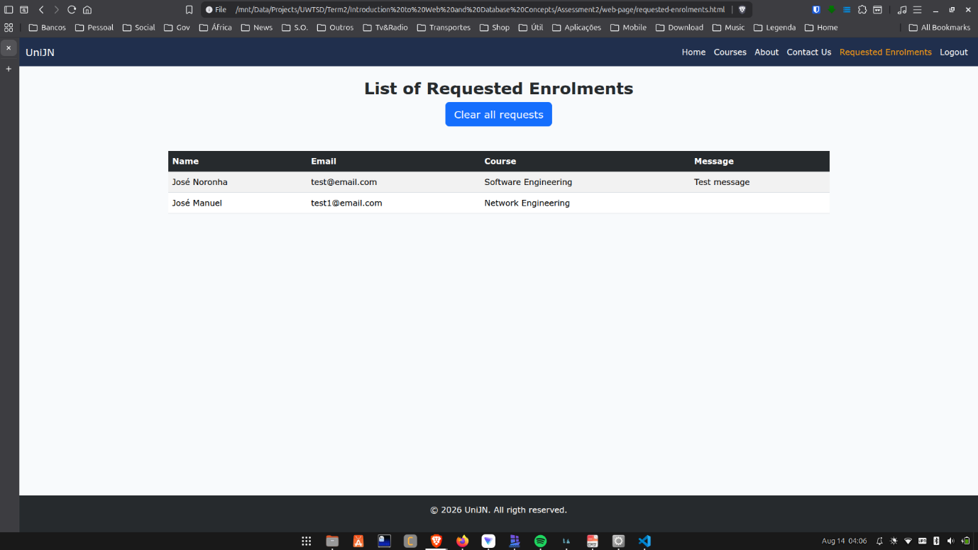
Figure 10 - Requested Enrolments page
Upon successful login, the user is redirected to the home page, where two key changes occur: a new item named “Requested Enrolments” is added to the navigation menu, and the “Login” option is replaced with “Logout”.
This page displays the list of all requests submitted through the form on the “Contact Us” page, while also providing the functionality to clear all records from the table. It is worth noting that these requests are stored in “sessionStorage”, meaning they persist only within the current browser tab and are automatically cleared once the tab or browser is closed.
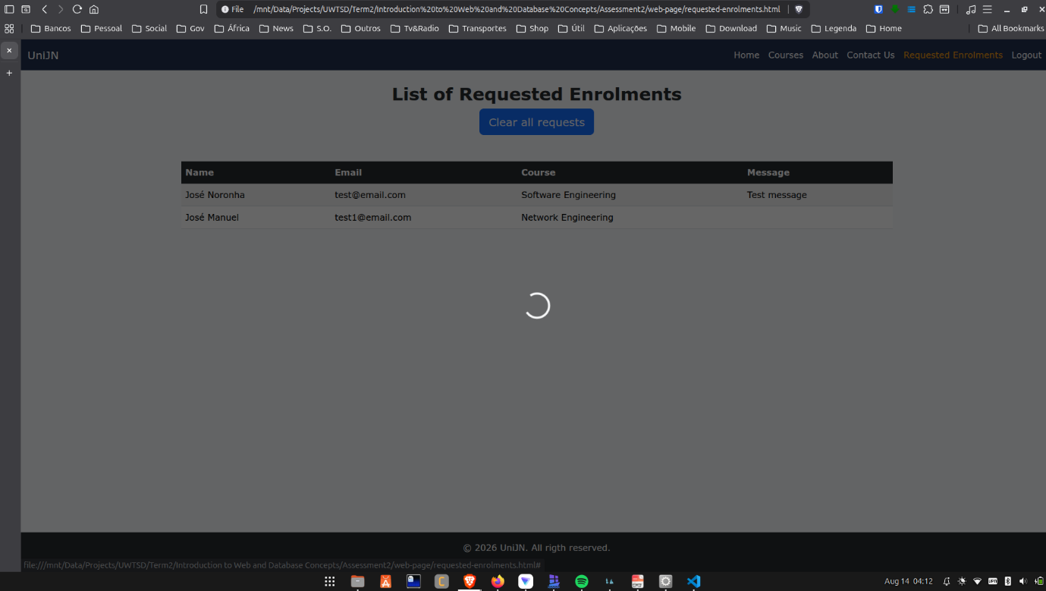
Figure 11 - Requested Enrolments page: Clear all animation
Clicking “Clear all requests” triggers an animation, as shown in the image above.
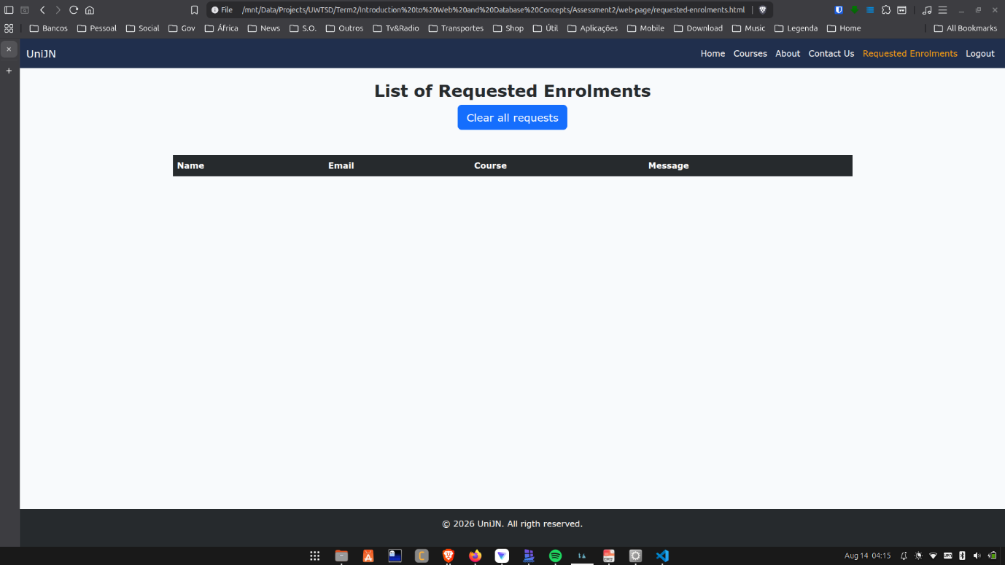
Figure 12 - Requested Enrolments page: Empty list
Following the removal of data from “sessionStorage”, the table updates automatically, leaving it empty.
It is important to note that whenever a request is submitted through the “Contact Us” page and the user navigates to the “Requested Enrolments” page, the table dynamically reloads to display the new requests.
It is important to emphasize that if an unauthorized user attempts to access the “requested-enrolments.html” file directly without logging in, they are automatically redirected to the login page. To enforce this behavior, an “isLogged” key set to “true” is stored in “sessionStorage” whenever an active user session exists.
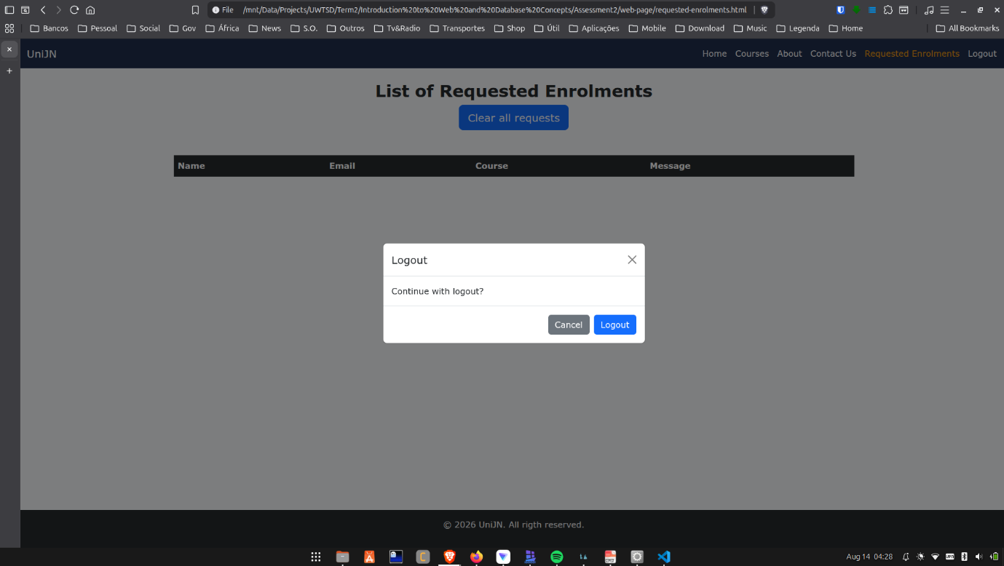
Figure 13 - Logout popup
When a user clicks “Logout”, a confirmation modal is displayed, requiring the user to explicitly confirm their intention to log out.
Upon confirming the logout action, the session key is removed from “sessionStorage”, and the user is redirected to the home page.
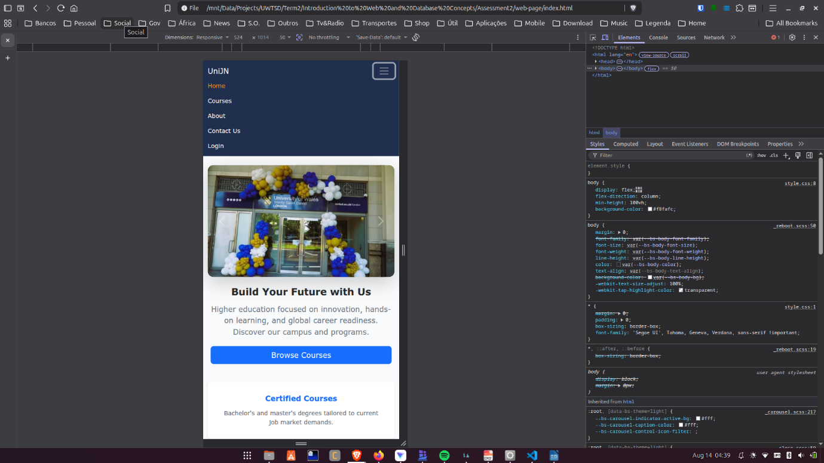
Figure 14 - Home page mobile version
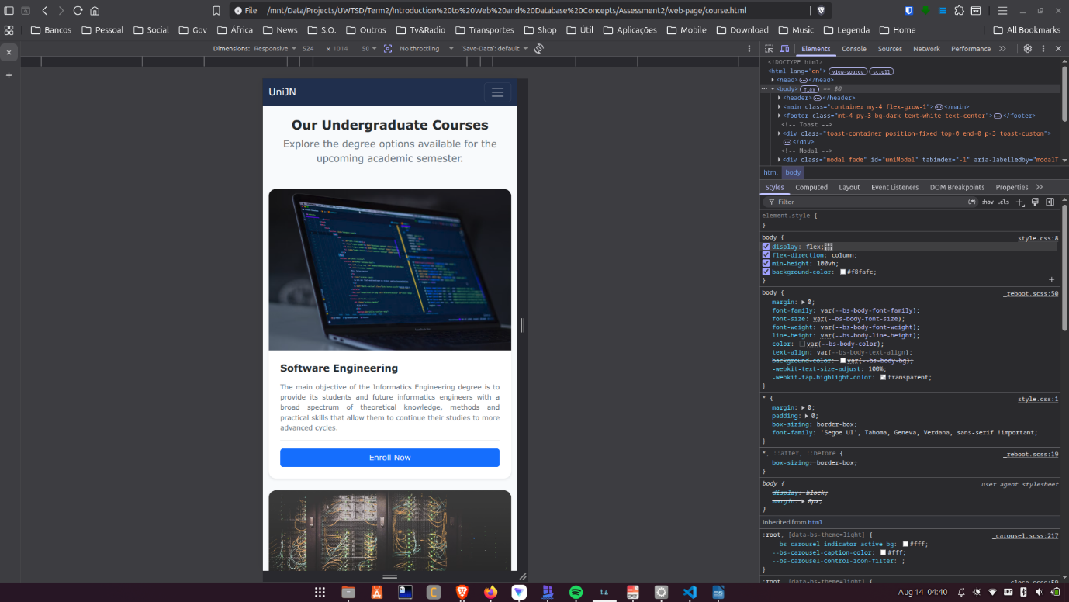
Figure 15 - Courses page mobile version
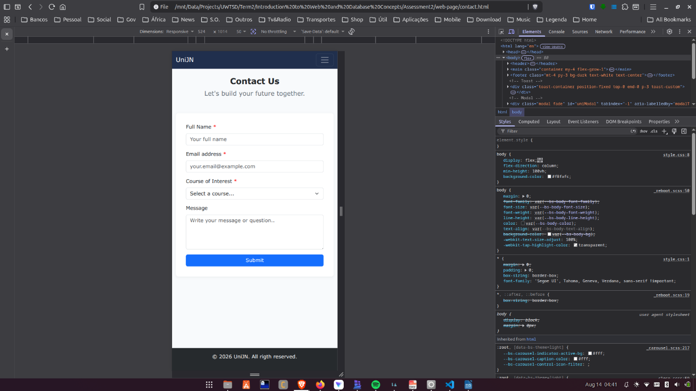
Figure 16 - Contact Us page mobile version
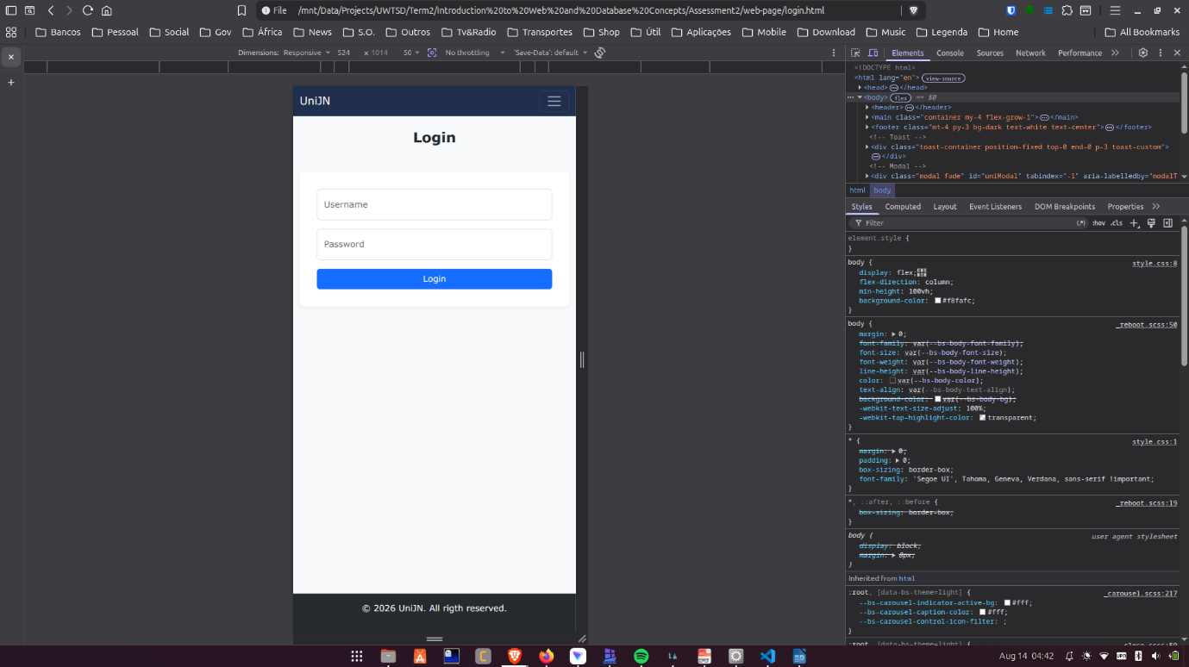
Figure 17 - Login page mobile version
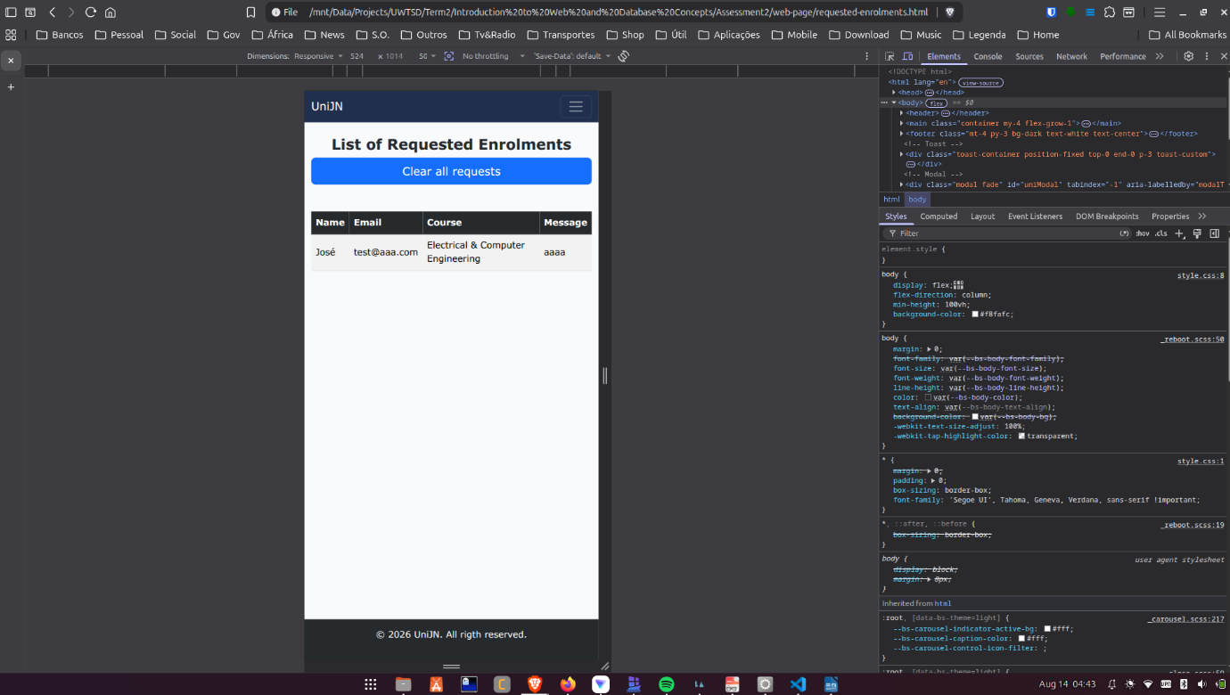
Figure 18 - Requested Enrolments page mobile version
It is important to emphasize that this website is fully responsive, as shown in the images above.

Evaluation

SEO
In this article[3], Search Engine Optimization (SEO) is defined as a set of technical adjustments and strategies that enable a website to rank at the top of search engine results pages (such as “Google”) for specific keywords. The primary objective is to organically increase the site's visibility and accessibility, serving as a more cost-effective alternative to paid advertising.
SEO techniques are broadly divided into two main categories:
- On-Page Optimization:
- Keyword Analysis: Strategic identification and placement of terms within page titles (<title>), meta tags (description, keywords), headings (<h1>), texts and URLs.
- Design and Structure: Developing with clean, lightweight HTML, while avoiding excessive use of Flash animations or frames.
- Images and Navigation: Utilization of alt attributes to describe image content and generation of XML sitemaps.
- Off-Page Optimization:
- Backlinks: Building inbound links from external, topically relevant websites to enhance PageRank.
- Social Media and Directories: Submitting the platform to web directories and actively promoting content across social platforms.

Website
During testing, it was identified that mandatory form fields needed to be distinguished from optional ones. Consequently, red asterisks (*) were added to indicate required inputs, as shown in the figure 4 above.

CSS Validation
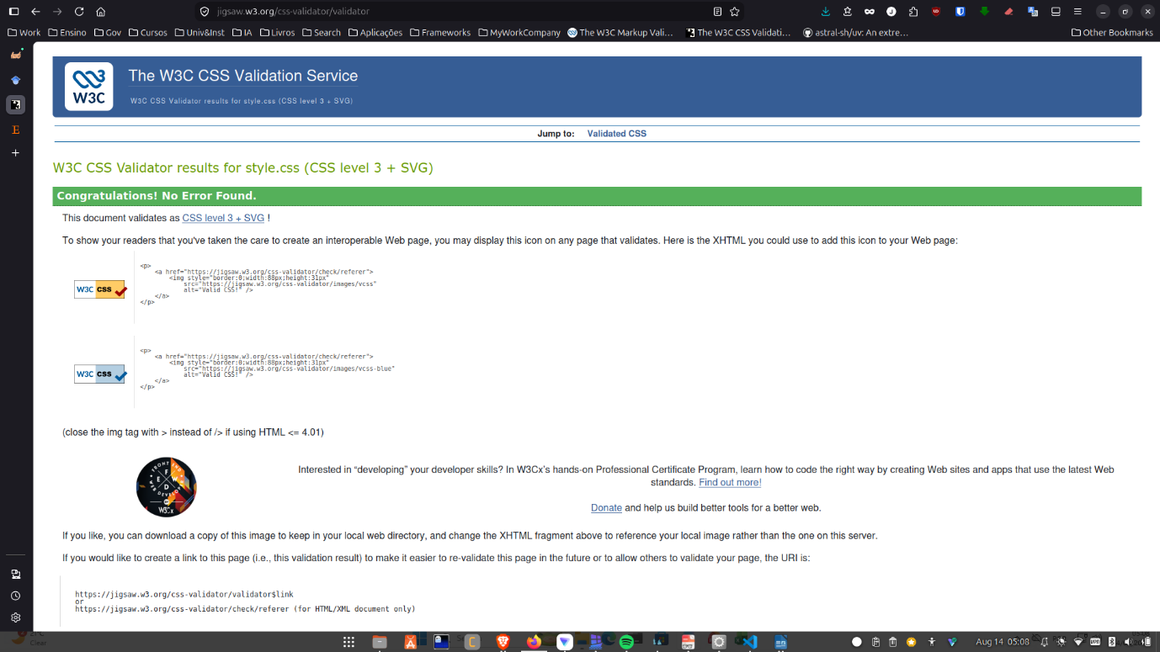
Figure 19 - CSS Validation result
As shown in the image above, no errors were detected using “The W3C CSS Validation Service”.

Markup Validation
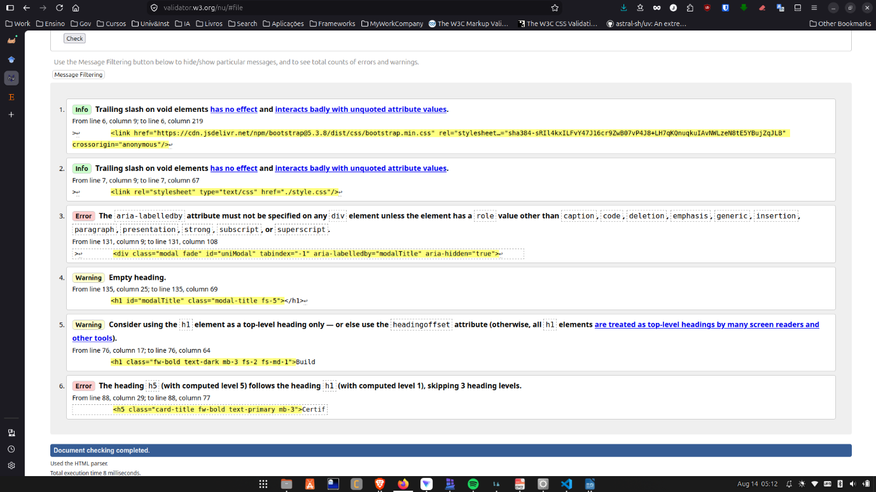
Figure 20 - index.html validation
Regarding the “aria-labelledby” error obtained, a solution has not yet been identified, as the markup was sourced directly from the official Bootstrap documentation.
Regarding the second error, this implementation was the solution devised to properly render the cards alongside their respective titles.
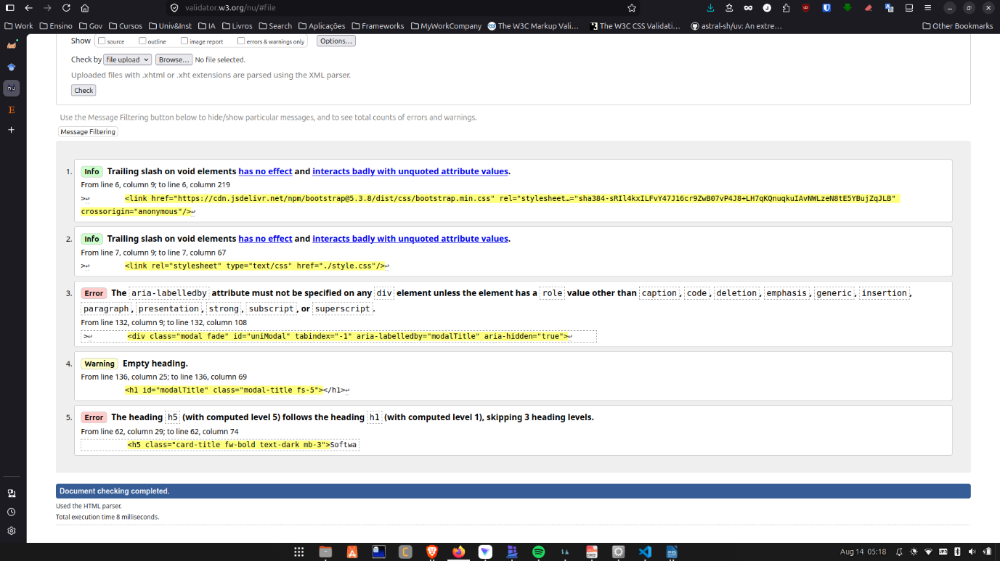
Figure 21 - course.html validation result
Since these errors are identical to those found in index.html, the same explanation applies to this instance.
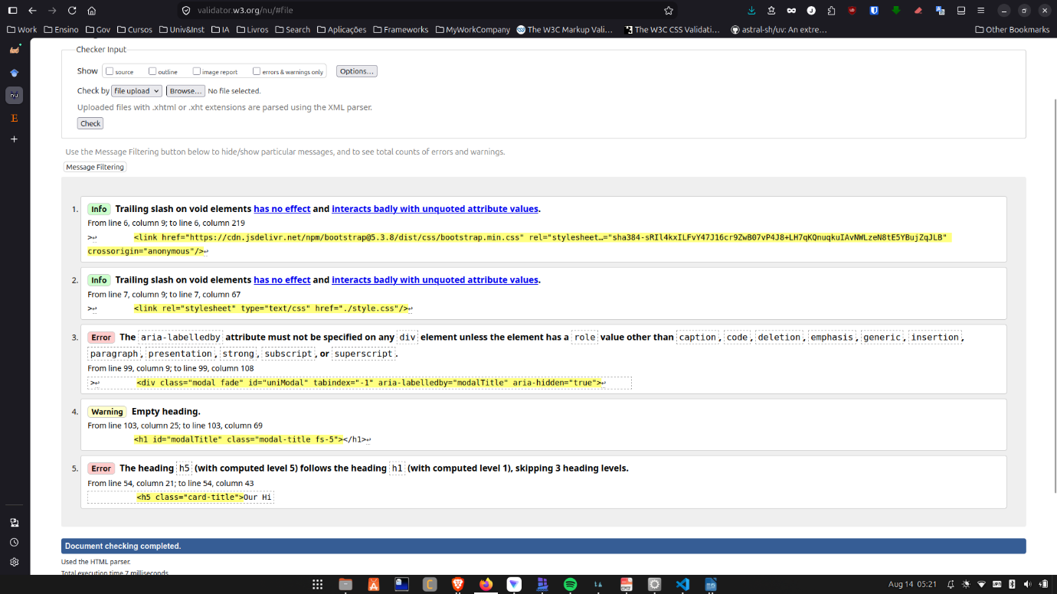
Figure 22 - about.html validation result
The same explanations also apply here.
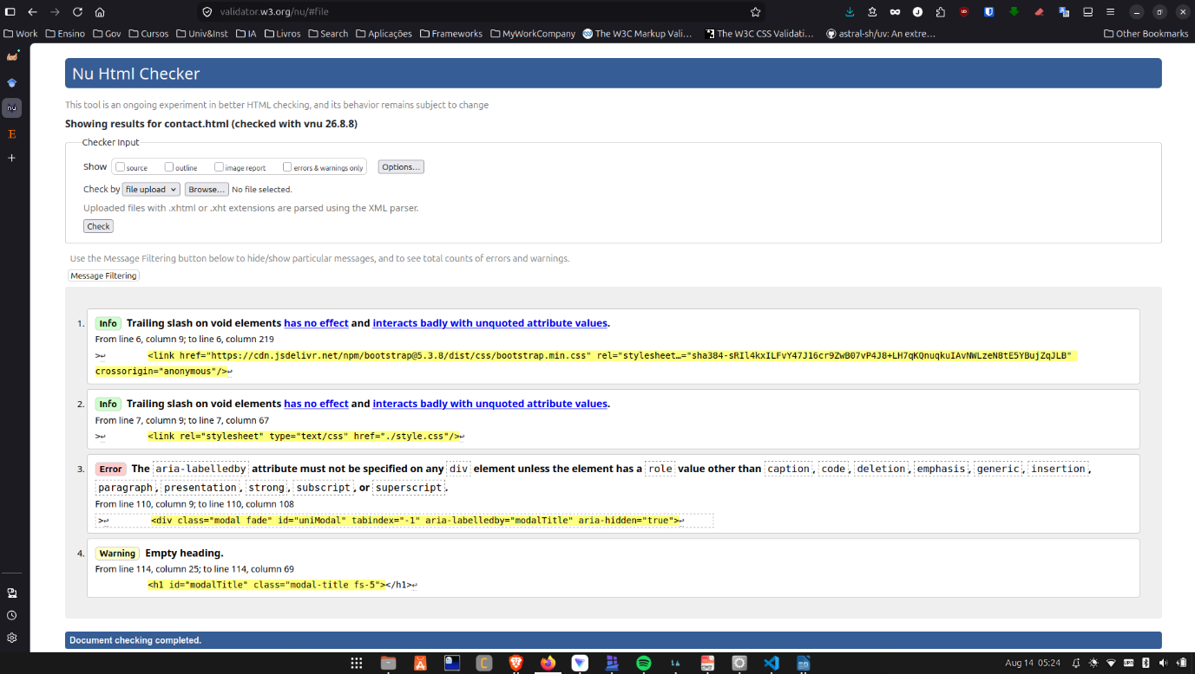
Figure 23 - contact.html validation result
The same explanations also apply here.
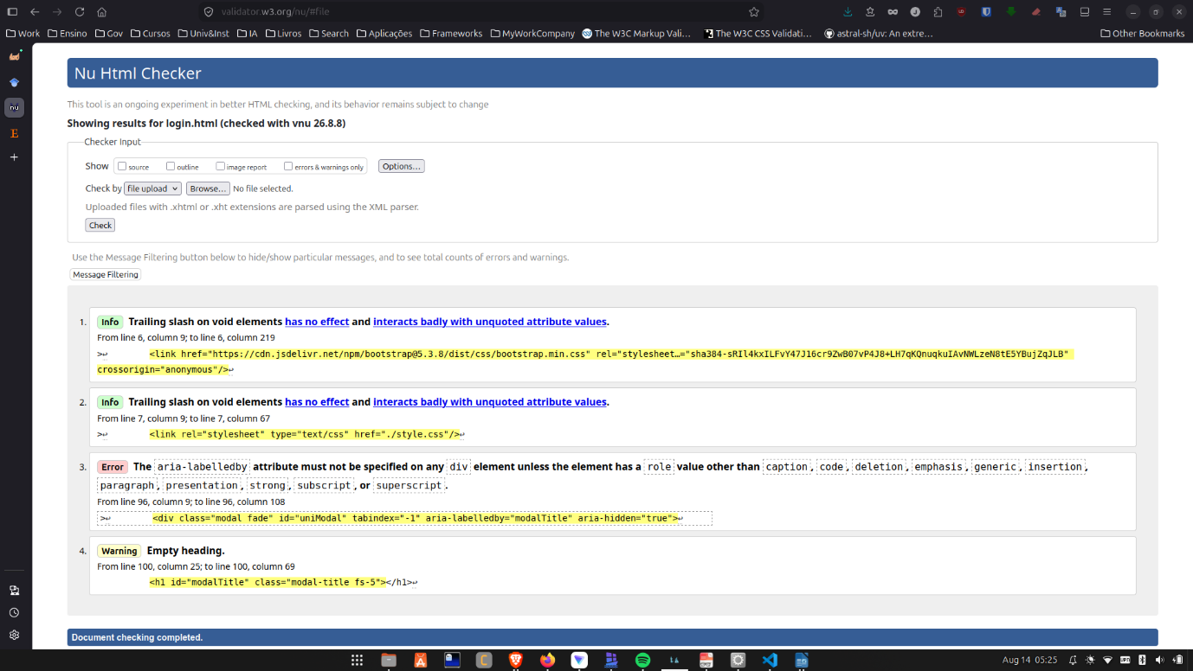
Figure 24 - login.html validation result
The same explanations also apply here.
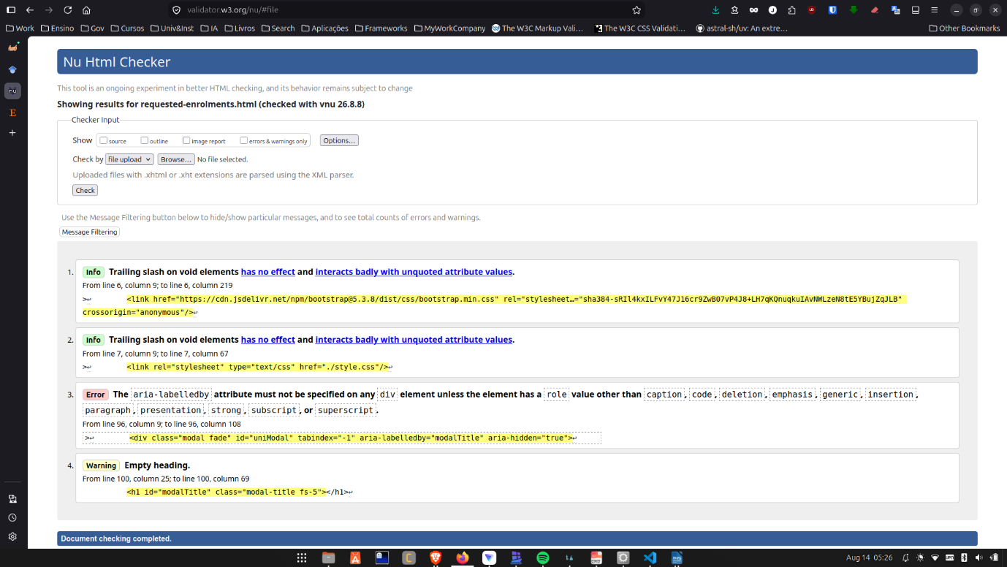
Figure 25 - requested-enrolments.html validation result
The same explanations also apply here.

Website Comparison
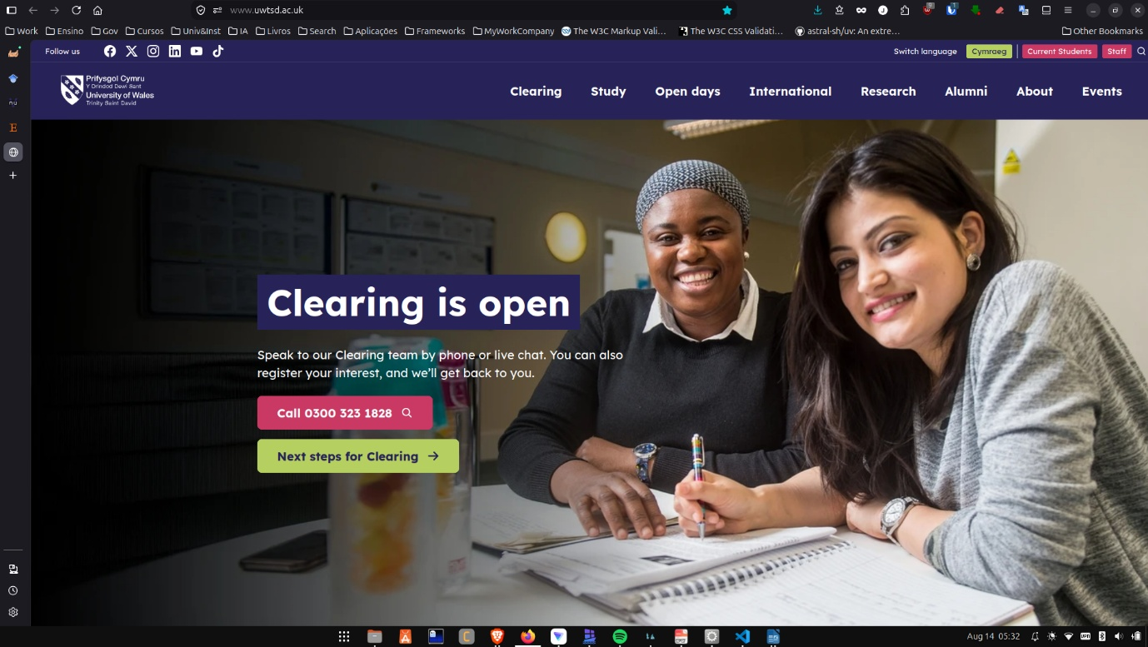
Figure 26 - University of Wales website
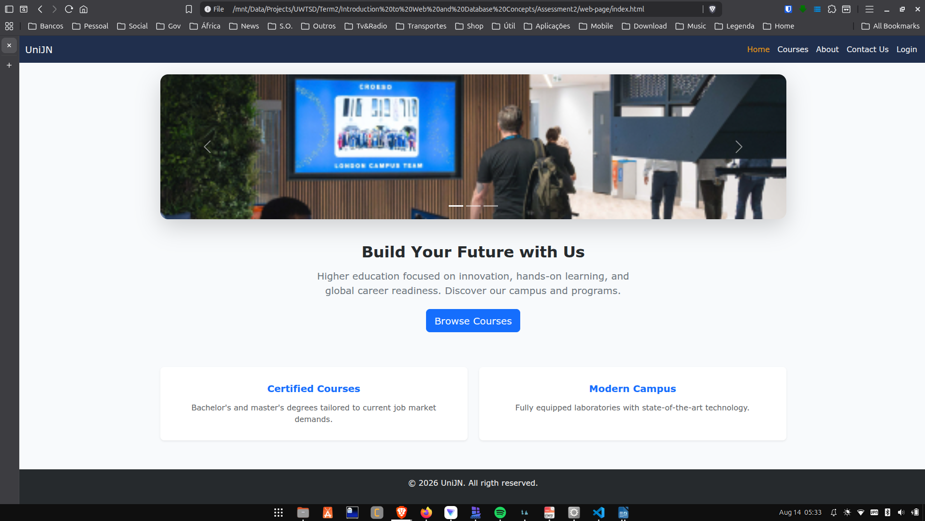
Figure 27 - Assessment website

Conclusion
Through this project, I gained practical knowledge in techniques such as SEO, as well as in the utilization of HTML and CSS validation services. Furthermore, I would like to highlight that a key focus was placed on maintaining design consistency, color palettes, and overall aesthetics throughout the application.

References
[1] Bootstrap. "Bootstrap." [Online]. Available: https://getbootstrap.com/
[2] W3Schools. "W3Schools." [Online]. Available: https://www.w3schools.com/
[3] N. Yalçın and U. Köse, "What is search engine optimization: SEO?" vol. 9, pp.487–493, 2010,

