Comparison of Two Hospitality Organisations

Student name: Corina Elena Slujitoru
Student ID number: 2111320
Module title: Financial Management for the Hotel Industry (BMIH5007)
Lecturer’s name: Dale Clarke

Table of Content

Executive summary 3
Introduction 3
✓ About Accor International 4
✓ About Hyatt Hotels 4
Discussions/ Literature 4
✓ Total revenue 4
✓ Market Position 5
✓ Growth potential 7
✓ Financial Commitment to CSR 8
Recommendations: 10
Conclusion 11
References: 12

Executive summary

In order to compare two companies of the same industry in terms of financial management, the first topic of the analysis is financial performance, which represents a general measure of a company's financial health, how well the company produces income and manages its assets and shareholders' interests (Kenton, 2021). The hospitality industry has top brands worldwide that are highly competitive globally. In these terms, the following report analyses the two top hospitality brands worldwide: Accor International, based in Europe and Hyatt Hotels, based in America and will try to compare their approach to financial management when considering core areas such as total revenue, market position, growth potential or financial commitment to corporate social responsibility. Furthermore, the report provides a brief recommendation for both companies on the areas of concern.

Introduction

The financial management of a company is a complex process of making decisions about how to raise and spend money to create value (H Kent Baker and Powell, 2005), including the company's marketing financial product, accounting and management strategic thinking, as the ultimate goal of a business is to maximise the profits for shareholders, create a good environment and provide a good income for the employees, and last but not least also to provide a good environment and services for the customers but morally and ethically.
There are a variety of hospitality organisations in the hospitality industry across the world, which varies from one another based on their business processes, marketing strategy, market position and so on. To better understand the company's financial management, an analysis has to include what the company represents in the hospitality industry and how big the scale this company is operating its business is.

- About Accor International

In 1967, in France, Paul Dubrule and Gerard Pellison, two friends, formed Accor by constructing the first Novotel hotel. Today, Accor is made up of more than forty brands and over 230,000 experts in hospitality, as they named their staff (Accor, 2019). They reinvent hospitality and inspire new worldviews by using their employees and integrated ecosystem of leading brands, personalised services, and expert solutions, as the group described themselves on Accor's website.

- About Hyatt Hotels

In 1957, Jay Pritzker bought the Hyatt House motel near Los Angeles Airport and launched Hyatt. Over time the Pritzker family built Hyatt Corporation and Hyatt International Corporation, which merged into Hyatt Hotels Corporation on December 31, 2004 (Hyatt, 2009). Today the company owns twenty brands, and as described on the Hyatt website, the company sees employees and guests as a family, creating "a world of care" where more than 130,000 "colleagues" are embraced with all their differences.

Discussions/ Literature

- Total revenue

Total revenue is the amount of money the company gets from its sales during a fixed period, which is equal to the number of goods sold multiplied by the price of each one (Lipsey and Harbury, 2004). It measures how successfully a company makes money from its primary operations in light of market demand and pricing (Investopia, n.d.). Depending on the total revenue, investors could become interested, and the company's market position is defined, as well as the company's ability to develop profitable activities from an economic point of view (Finmark, n.d.).
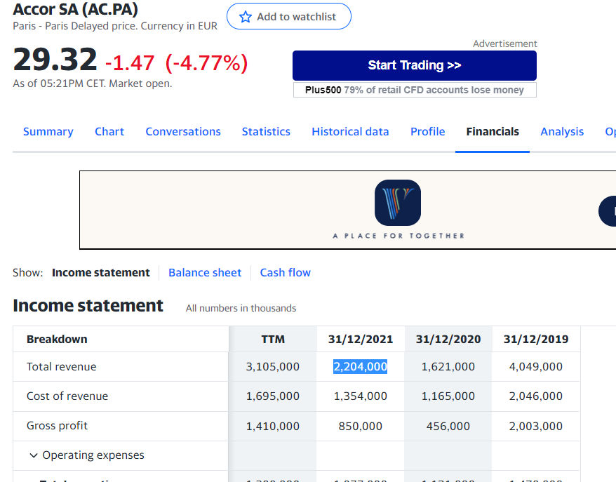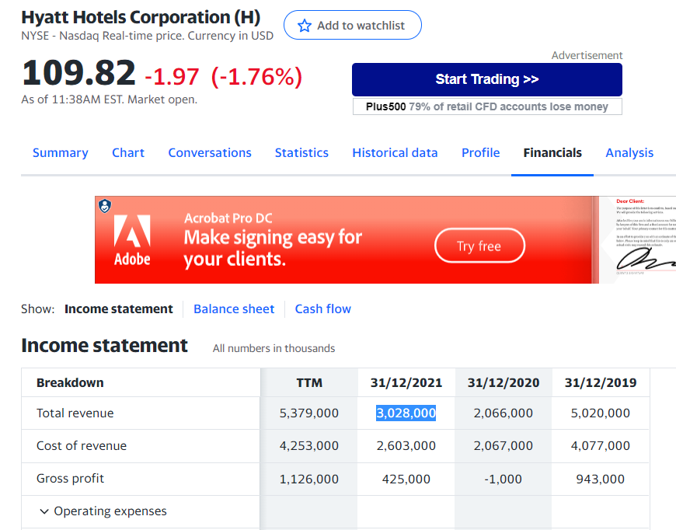
Source: uk.finance.yahoo.com

Taking as a reference the last three years of activity of the two companies, according to uk.finance.yahoo.com, Accor International achieved a turnover of €4,049,000 in 2019, €1,621,000 in 2020 and €2,204,000 in 2021. At the same time, Hyatt made $5,020,000 in 2019, $2,066,000 in 2020 and $3,028,000 in 2021. At a first analysis of the listed figures, it could be easy to say that Accor and Hyatt performed better in 2021 than in 2020 but at half the value of 2019. Considering the factors that negatively influenced the world economy, especially the hospitality industry in 2020 (Covid-19 pandemic), both companies achieved a significant increase in 2021. Comparing, however, strictly the total revenue for both companies and taking into account the EUR/USD parity, Hyatt performed better than Accor by more than USD 650,000.

- Market Position

Market positioning influences consumer perception of a brand or product compared to competitors (CFI Team, 2022). Market positioning is to shape consumers' perceptions of a brand or product.
Accor is one of the large world hospitality companies, with over 5,300 hotels and restaurants in 110 countries. The Group operates one of the most comprehensive and varied hospitality ecosystems in the business, with over 40 different hotel brands spanning the luxury, premium, midscale, and economy segments, as well as entertainment and nightlife venues, restaurants and bars, branded private residences, shared accommodation properties, concierge services, coworking spaces, and more (Accor, 2021). The corporation's marketing strategies, including asset management, multi-branding, rebranding, segmentation or growth and global expansion, allowed the company, since 2019, to implement "a strong new brand identity", which is ALL- Accor Live Limitless (Accor.com, 2019).

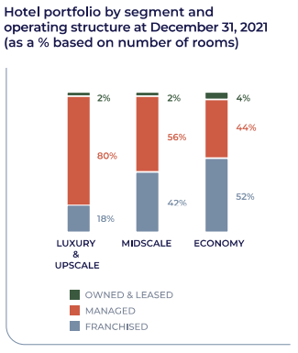
Source: Accor-2021-Integrated Report

As shown in the Accor 2021 - Integrated Report, the company has built a network of 5298 hotels, from which 97% are working under management and franchise contract, becoming number 1 worldwide, excluding the USA and China and having a pipeline of 1218 hotels (214,000 rooms). On the other hand, Hyatt Hotels, another leading hospitality organisation, has a secure position in the marketplace. The company has set a premium strategy to serve its customers and attract them to its products. However, the company plays a significant role in the perspectives of its targeted customers. According to the 2021 Annual report, Hyatt hotels offer full-service, select service, and all-inclusive resort brands providing services in the upper-midscale, upper-upscale or luxury market. The company manages, services, or licences its residential units near Hyatt-branded full-service hotels; the vacation ownership apartments use Hyatt's trademarks and administer condominium rental schemes and homeowner organisations as the mixed-use developments are designed with third parties (Hyatt.com, 2019). The company owns 20 brands totalling over 1345 properties distributed in over 134 countries worldwide (Hotel Tech Report, 2017), with a pipeline of around 117,000 rooms (www.businesswire.com, 2023).
Comparing the two companies regarding the distribution of properties worldwide, the number of promoted brands and the number of rooms available to potential clients, the figures clearly show a much more extensive Accor portfolio. However, corroborating this conclusion with the one drawn above, regarding the total revenue, Hyatt, with a smaller number of owned brands and a smaller number of properties (from the perspective of the number of rooms), achieves a higher income. It is likely about:
- a more varied range of property management (not only owned as owners but also as a franchise, managed or rented);
- the fact that Hyatt addresses to a large extent the luxury market, owning, as shown in a press release from January 20, 2023, on the businesswire.com site, "one of the largest portfolios of all-inclusive luxury resorts in the world" (www.businesswire.com, 2023).
In terms of the distribution of the services offered, both Accor, through the group.accor.com site, and Hyatt, through the hyatt.com site, make available to the clients of internet users the possibility of accessing numerous platforms that contain helpful information about the company, the possibility of making online reservations as well as loyalty programs for loyal customers (all.accor.com or world.hyatt.com).

- Growth potential

An organization's ability to increase earnings, production, and workforce as the result of the company planning to enter into new markets, development of new product lines, use of more effective marketing approaches, or other measures that grow a niche market into a volume operation indicate growth potential (SearchCIO, n.d.); this could attract public and private investors, venture capitalists, and other stakeholders.
Under the title of "More Brands, More Hotels, More Markets", Accor declares on its website the continuation of the expansion strategy on the international market in Europe: Paris, Copenhagen, Tbilisi-Georgia, Borovets-Bulgaria, London, America: Mexico City, Asia: Quingdao, Chengdu-China, India, Singapore, Tokyo-Japan and Africa: Nairobi-Kenya (Accor.com, 2019). The company added around 2100 rooms to its 24 South Caucasus and Central Asia hotels in 2022, with 15 new projects under six hotel brands (International, 2023). In terms of the services, the offer includes from eco-friendly or budget-friendly hotels to ultra-luxurious hideaways. At the same time, regarding growth potential, Hyatt declares on its website dedicated to the relationship with investors the continuation of the asset-light growth strategy through the agreement for the acquisition of Dream Hotel Group (lifestyle hotel brand), which will diversify its portfolio in important hotel markets in the Americas, Europe and Asia adding by this process over than 1700 rooms (investors. hyatt.com, n.d.). According to the Retail and Leisure International site, Hyatt develops its Middle East market by signing an agreement for three new locations in KSA and opening a luxury hotel in Kuwait, continues the company's growth in Asia by opening two new locations in Jaipur-India and Jakarta, simultaneously with the consolidation of the European and American markets (Retail & Leisure International, n.d.).
As for growth potential, both companies have as their development strategy the consolidation of the markets in which they currently operate by opening new locations and penetrating new markets with potential: China, India, South Caucasus or East Europe for Accor and Middle East or Central Asia for Hyatt, in order to become more visible through promoting their brands.

- Financial Commitment to CSR

A broad term in business, CSR stands for "corporate social responsibility" and refers to a company's promise to conduct its businesses ethically. This process includes managing their operations considering the social, economic, and environmental impacts and human rights (www.nibusinessinfo.co.uk, n.d.).
Accor's vision is "to break new ground" and to drive the change to positive hospitality (group.accor.com, n.d.). Accor's commitment promotes opening new paths to positive hospitality wherever the company is present. Moreover, the group aims to "net zero/ carbon emission by 2050, 0/single-use plastic items in guest experience by end 2022 and 700+/ hotels partnering with Too Good To Go", as stated on group.accor.com site. As shown in the Accor-2021 Integrated report, of the company's more than 230,000 employees, 46% are people under 35, and 42% are women. Looking at the concern for the group's employees during the Covid-19 pandemic, during the lockdown, Accor created (April 2020) the "All Heartist Fund" to support its employees and partners during the crisis. Thus, as shown in the same report, 98,000 requests were resolved in 76 countries, amounting to over 31 million euros.

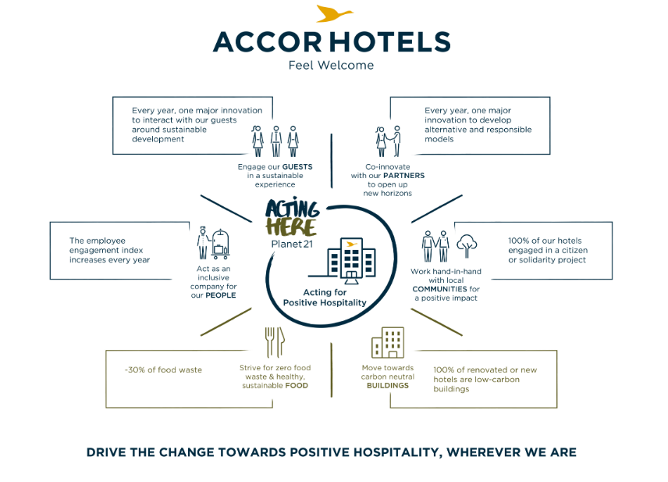
Source: press accor.com

Acting here implies acting at the level of the minor planet formed by each of the company's 5,000 hotels worldwide, where staff, guests, partners or local communities are acting in an engaged and sustainable experience daily, where all the people use all the resources responsibly (Accor.com, 2019).
Continuing the commitment by which Hyatt "care for people so they can be their best" (Hyatt, 2019), the company launched the new corporate social responsibility platform called "World of Care", through which it promotes diversity, equity and inclusion in the same way that it promotes responsible business practices (investors.hyatt.com, n.d.).

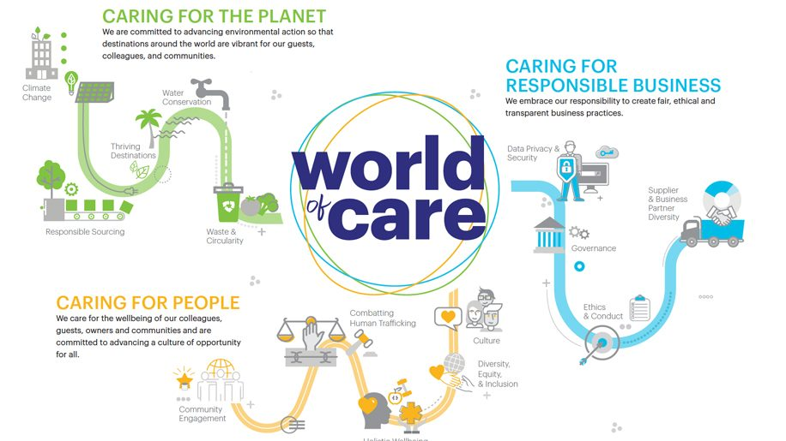
Source: businesstraveller.com

Planet, people and responsible business are the three pillars of the "world of care" (Hyatt, 2019). As a core of the world/ planet or business activities, people must use resources responsibly to benefit from a healthy and safe environment. Environmental action for water conservation or related to climate change, fair, ethical and transparent business practices, and care for the well-being of the staff, guests, owners and communities are the way to create a culture of opportunity for all.
A higher hotel number growth will give both Accor and Hyatt much better opportunities and help them engage in CSR activities which will help them to create a positive impact on society (Jackson et al., 2020).

Recommendations:

From the observations made comparing the two hotel companies from the perspective of the owned portfolio and the way of managing the properties, the organisation of information on their online distribution platforms and considering the last estimate of total revenue, respectively that of 2021, some recommendations are outlined for each company as follows:

- In terms of the growth potential of income for Accor, it could be opportune to diversify the way of managing the portfolio through the franchising process and by approaching other forms of contracts with the property owners; on the other side, Accor could give the drive to focus in order to exploit the portfolio of hotels on the luxury market more efficiently;
- Regarding the online distribution platforms for Hyatt, they could reorganise the site's structure for the internet users to have more straightforward and more organised navigation.

Conclusion

To summarise, both Accor International and Hyatt Hotels are two of the leading companies in the hotel industry operating worldwide. Accor's portfolio is more extensive than Hyatt's; however, Hyatt operates more in the luxury sector of the hospitality market. By consolidating their existing market and continuously expanding to new markets, the two chosen companies have considerable growth potential. Both companies were affected by the Covid-19 pandemic consequences and significantly increased in 2021 from the total revenue perspective. Regarding the financial commitment to corporate social responsibility, Accor and Hyatt promote human rights, ethical business practices and actions considering the environmental impact, engaging for all this not only their staff but also their guests and local communities.

Word count: 2191

References:

Accor (2019). The History of Accor. [online] Available at: https://group.accor.com/en/group/who-we-are/our-history [Accessed on 08.02.2023];
accor.com. (2019). Accor - Acting Here. [online] Available at: https://group.accor.com/en/commitment/positive-hospitality/acting-here [Accessed on 16.02.2023];

accor.com. (2019). Accor - Worldwide hospitality leader. [online] Available at: https://group.accor.com/ [Accessed on 16.02.2023];

accor.com. (2019). The new Accor strategy. [online] Available at: https://group.accor.com/en/Actualites/2019/03/strategy-all-accor-live-limitless-sebastien-bazin [Accessed on 14.02.2023];

accor.com. (2021). 2021/Integrated Report [online] Available at: https://group.accor.com/-/media/Corporate/Investors/Documents-de-reference/ACCO_RI_2021_MEL_EN_300322.pdf [Accessed on 12.02.2023];

accor.com. (2023). Accor - Accor in Key Figures. [online] Available at: https://group.accor.com/en/group/who-we-are/key-figures [Accessed on 16.02.2023];
accor.com. (2023). Accor - Shareholders & Investors. [online] Available at: https://group.accor.com/en/finance [Accessed on 15.02.2023];

businesswire.com. (2023). Hyatt Strengthens Position as Leader in Luxury, Lifestyle and Leisure in 2023 and Beyond with Record Global Pipeline. [online] Available at: https://www.businesswire.com/news/home/20230120005311/en/Hyatt-Strengthens-Position-as-Leader-in-Luxury-Lifestyle-and-Leisure-in-2023-and-Beyond-with-Record-Global-Pipeline [Accessed on 16.02.2023];

Business Traveller. (n.d.). Hyatt launches new ESG platform, World of Care. [online] Available at: https://www.businesstraveller.com/business-travel/2021/07/15/hyatt-launches-new-esg-platform-world-of-care/ [Accessed on 16.02.2023];
CFI Team (2022). Market Positioning. Influencing consumer perception of a brand or product in relation to rival brands. [online]. Available at: https://corporatefinanceinstitute.com/resources/management/market-positioning/ [Accessed on 11.02.2023];
Finmark. (2023). What is Total Revenue? (Formula + Definition). [online] Available at: https://finmark.com/glossary/total-revenue/#:~:text=Total%20revenue%2C%20also%20known%20as [Accessed on 10.02.2023];

H Kent Baker and Powell, G.E. (2005). Understanding financial management : a practical guide. Malden, Ma: Blackwell Pub;

Hotel Tech Report. (2017). Hyatt’s 14 Hotel Brands Explained. [online] Available at: https://hoteltechreport.com/news/hyatt-hotel-brands [Accessed on 10.02.2023];

hyatt.com (2009). Hyatt History. [online] Available at: https://about.hyatt.com/en/hyatthistory.html [Accessed on 08.02.2023];

hyatt.com. (2019). Hyatt Hotels Corporation - Investor Relations - Financial Reporting - Annual Reports. [online] Available at: https://investors.hyatt.com/investor-relations/financial-reporting/annual-reports/default.aspx [Accessed on 16.02.2023];

hyatt.com. (2023). Our Brands/Hyatt. [online] Available at: https://www.hyatt.com/development/ourbrands [Accessed on 11.02.2023];

Investopedia. (2022). What Is the Relationship Between Marginal Revenue and Total Revenue? [online] Available at: https://www.investopedia.com/ask/answers/033115/what-relationship-between-marginal-revenue-and-total-revenue.asp#:~:text=Total%20revenue%20is%20the%20total%20amount%20of%20money%20a%20company [Accessed on 10.02.2023];

investors.hyatt.com. (2021). Hyatt Launches ‘World of Care’ with New Commitments to Advance Diversity, Equity, and Inclusion and Responsible Business Practices. [online] Available at: https://investors.hyatt.com/investor-relations/news-and-events/financial-news/financial-news-details/2021/Hyatt-Launches-World-of-Care-with-New-Commitments-to-Advance-Diversity-Equity-and-Inclusion-and-Responsible-Business-Practices/default.aspx [Accessed on 12.02.2023];

investors.hyatt.com. (2022). Hyatt Continues Asset-Light Growth Strategy with Plans to Acquire Dream Hotel Group. [online] Available at: https://investors.hyatt.com/investor-relations/news-and-events/financial-news/financial-news-details/2022/Hyatt-Continues-Asset-Light-Growth-Strategy-with-Plans-to-Acquire-Dream-Hotel-Group/default.aspx [Accessed on 15.02.2023];

Jackson, G., Bartosch, J., Avetisyan, E., Kinderman, D. and Knudsen, J.S., 2020. Mandatory non-financial disclosure and its influence on CSR: An international comparison. Journal of Business Ethics, 162(2), pp.323-342;

Kenton, W. (2021). Financial Performance/Investopedia. [online] Available at: https://www.investopedia.com/terms/f/financialperformance.asp [Accessed on 09.02.2023];

Lipsey, R.G. and Harbury, C.D. (2004). First principles of economics. Oxford: Oup.
nibusinessinfo.co.uk. (2023). What is corporate social responsibility? [online] Available at: https://www.nibusinessinfo.co.uk/content/what-corporate-social-responsibility#:~:text=Corporate%20social%20responsibility%20(CSR)%20is[Accessed on 16.02.2023];
rli.uk.com (2023). Accor to Expand Footprint in the South Caucasus and Central Asia in 2023. Retail & Leisure International. [online] Available at: https://www.rli.uk.com/accor-to-expand-footprint-in-the-south-caucasus-and-central-asia-in-2023/ [Accessed on 16.02.2023];

Retail & Leisure International. (n.d.). Search Results for ‘hyatt’. [online] Available at: https://www.rli.uk.com/?s=hyatt [Accessed on 15.02.2023];

SearchCIO. (2023). What is growth potential? [online] Available at: https://www.techtarget.com/searchcio/definition/growth-potential#:~:text=Growth%20potential%20is%20an%20organization [Accessed on 14.02.2023];

uk.finance.yahoo.com. (2023). Accor SA (AC.PA) stock price, news, quote & history – Yahoo Finance. [online] Available at: https://uk.finance.yahoo.com/quote/AC.PA?p=AC.PA&.tsrc=fin-srch [Accessed on 10.02.2023];

uk.finance.yahoo.com. (2023). Hyatt Hotels Corporation (H) income statement – Yahoo Finance. [online] Available at: https://uk.finance.yahoo.com/quote/H/financials?p=H [Accessed on 10.02.2023].

