Oliver Altissimo 2305263: Contemporary Challenges: Making a Difference (ACCA4027)

Climate Change
Our earth has an Eco-System called Nature; it plays a role in every aspect of our life. Nature provides food, water, the air to breath, thus keeping a balanced climate which is essential for human life. In nature there occurs shifts, due to changes in the climate caused by sun activity, volcanic eruptions, and human activity. With the start of the industrial revolution in the 1800s the main influence on our climate is human activities, such as the burning of fossil fuels coal, gas, and oil to provide power. With this constant burning of fossil fuel there is a cause and effect called “Greenhouse Gasses” [1]. The main ones are carbon dioxide, methane, nitrous oxides, and water vapours. Carbon Dioxide is the most common and dangerous of these greenhouse gasses. The gases act like a blanket covering the earth and trapping the heat coming from the sun and the heat generated by human industry. With all this trapped heat the average temperature in the air has increased by 1.1c since the 1800s [1]. Subsequently this increase has brought about drought, wildfires, dangerous storms and flooding, the melting of polars ice with consequential sea level rising.
With the temperature around the globe increasing the sea level is rising. From this we are seeing a dramatic increase in changes to our oceans making it the most worrying impact of climate change.
This increase in sea level has multiple effects, it creates, thermal expansion, changes in the ocean’s currents and changes in weather patterns which in turn has significant effect on human life. There are also subtle changes to the ocean’s composition which in turn affects the sea level. This medley of changes has significant effect on the seas. The graph below shows how the sea temperature has rising over time.
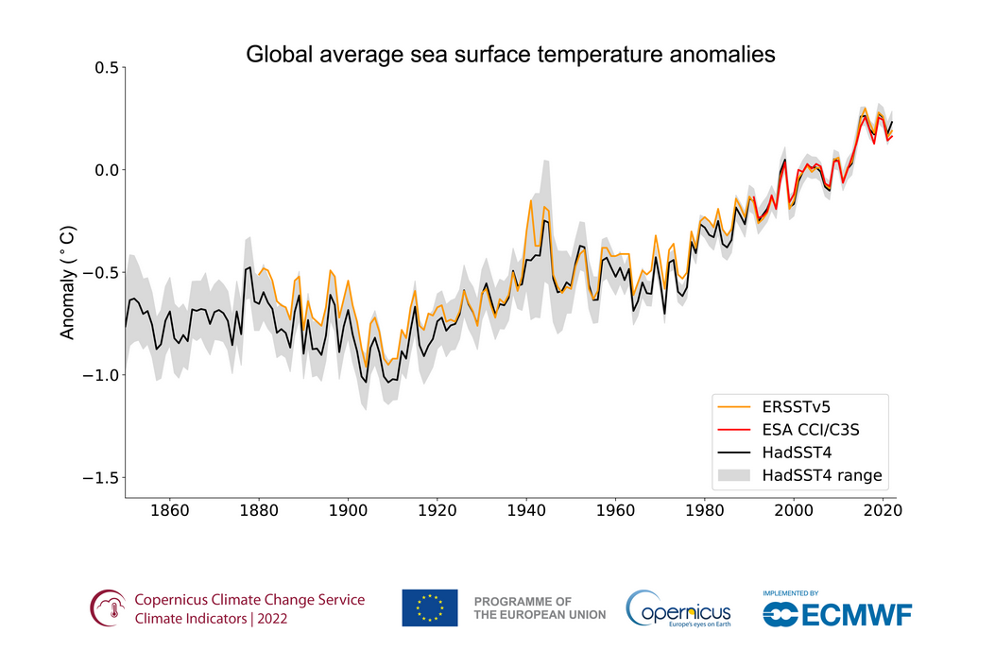
Global sea temperature anomaly [26]

The oceans cover 70% of the earth, the sheer mass allows the oceans to absorb 90% of the heat and 30% poisonous carbon dioxide which would contribute to the greenhouse effect [2]. In normal circumstances the ocean moves on a current patterned called the global conveyor belt [3], slowly moving the waters around the world. This movement is driven by the different water’s temperature and salinity. Colder and saltier waters are denser and heavier than fresh warm waters and thus creates a cycle. As the warm water approaches the polar region at the north, the water freezes and leaves behind the salt making the surroundings waters saltier and sinking deeper in the ocean.
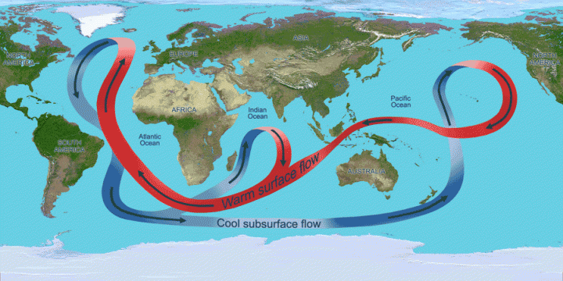
Ocean Currents Movement [33]
With the cold and saltier water sinking, this provides the main drive for the cycle to keep moving.
But with the ice sheets melting, leaking fresh water into salty water, this is lowering the salinity of the oceans. The slowing down of the ocean’s current leads to a chain reaction of the changes of the sea level. [4] [3]
With the warm waters nowhere to be disbursed they are thermally expanding contributing to the ocean level to rise. This also causes the water to evaporate, which leads to moisture in the air, and manifesting more frequent hurricanes and typhoon. [5]
Data collected from the European “Copernicus” project shows the global mean sea level has increased by 9.3 cm [6] over the past 30 years. This is contributed to:
60% of Greenland, Antarctica and the Artic, icesheets melting and losing a mass on average of 33m. [6]
With an increase in warmth the ocean is absorbing the ice melt leading to the expansion of the water and contributing 30% to the sea level rise. [6]
The last 10% is due to alterations in land water storage, such as soil moisture, surface water and groundwater. [6]
With the ocean level rising is affecting the 2.15 billion people living in coastal areas all around the world, causing flooding and submerging lands, forcing people to migrate to higher ground.
The increasing in temperature is also affecting the weather patterns. Under typical circumstances in the Pacific Ocean, a trade winds occurs below the west equator, taking the warm water from South America all the way to Asia. With the breaking of the warm-water and cold-water cycle from the deep, this causes two types of weather patterns. Scientists call these El Niño and the Niña which are two conflicting weather patterns that break the normal conditions. [7] [8]
El Niño the trade winds gets weaken, pushing the warm waters against the west coast of America, causing higher sea levels. This originates from the warm waters destabilising the Pacific jets streams from its normal path. [7] [8]
El Niña is the opposite of El Niño effect. The trade in winds is stronger than usual, pushing more warm waters towards Asia. The cold waters push the Pacific jet stream up north causing wetter, drier and colder weather patterns around Canada and in the America. These two weather patterns can last nine to twelve months and occur every two to seven years. But as these cycle between cold and warm waters are getting altered, the marine life is getting affected and causing changes.
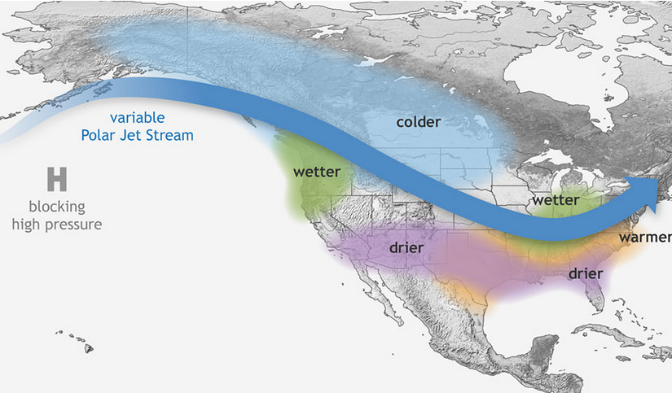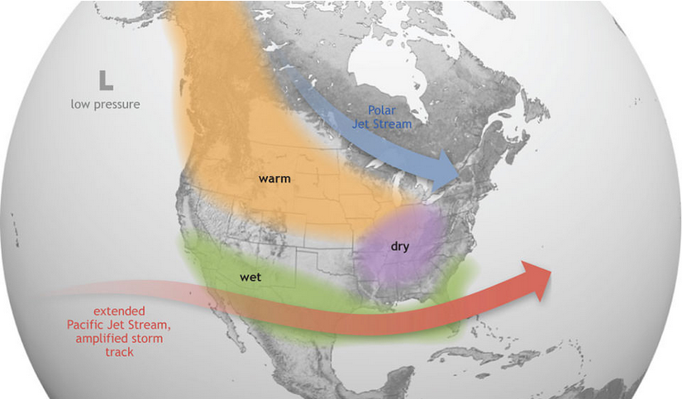
El Niña [7] El Niño [7]
As the sea is getting warmer it is affecting the animals living on the ice sheets, polar bears, penguins, in the marine eco system. In the warm tropical and subtropical waters, the Cloral Reef is getting affected by these shifts in the water temperature. The Cloral Reef a living structure is an important for the marine life (for example Star Fish, Clown Fish, are provided with shelter and food) and is essential for their survival. As data collected from the “National Ocean service” show that in January 2010 the cold-water temperature change has caused an event called Coral Bleaching which trigger the Cloral Reef to expel the microscopic algae, causing of most of it to die [9]. This is also affecting the Great Barrier Reef in Australia.
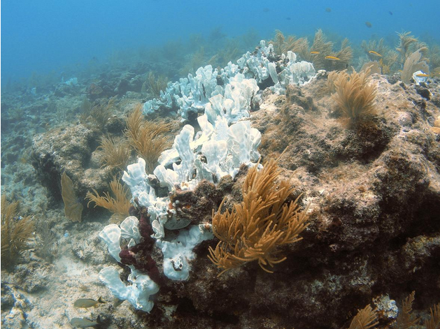

Cloral Bleaching [2]
A quote by David Attenborough “It's surely our responsibility to do everything within our power to create a planet that provides a home not just for us, but for all life on Earth." [10] sum’s this up.

These events in our oceans mean human population is going to cross a point of non-return of temperature rise unless the Greenhouse Gasse are reduced as scientists forecast. Solutions can vary from local initiative like building seawalls in the Mumbles [11] to cities like Venice where they built a system of gates where it can temporarily seal off the Venetian Lagoon from preventing subsiding.
Renewable energy may hold the key to a durable solution. Reducing greenhouse gas emissions to 50% may be achieved by moving from fossil fuels to renewable energy using natural resources [12] [13]. The source of renewable energy can come from “Solor Energy”, solar panels that capture solar radiation and turns it in to energy [14]. “Wind Energy” the wind turning propellers to spin generators and create energy [15]. There are multiple types of “Hydro Energy”, which work in a similar way, by water flowing and spinning turbines and converting kinetic energy into electrical energy [16]. These are the most common types of renewable energy which we are developing to reduce the burning of fossil fuels and therefore greenhouse gas emissions.
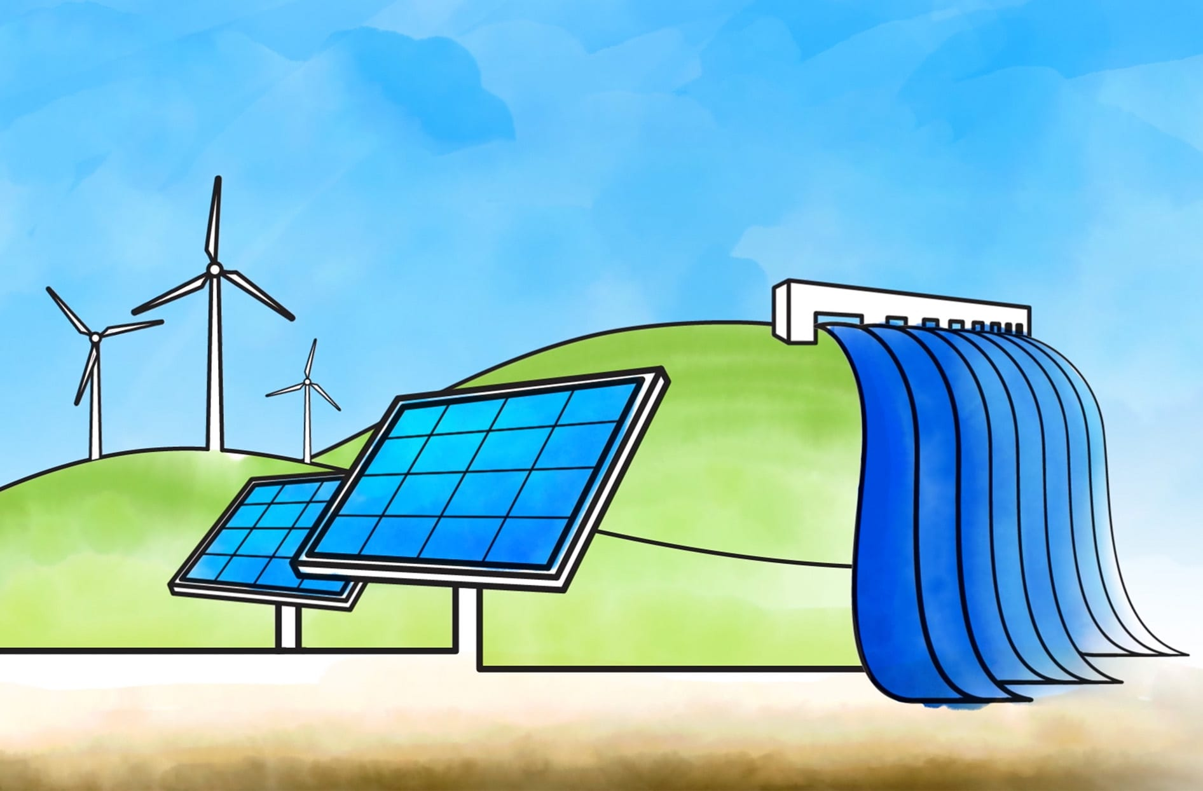 [31]
Humanity, as individuals up to governments must act upon climate change to half the emissions. Greta Tumberg, as a 16-year-old activist, initiated the "School Strike For Climate" movement, demanding political leaders' action by skipping Friday classes in protests climate change [17].
Greta Tumberg quotes “Our civilization is being sacrificed for the opportunity of a very small number of people to continue making enormous amounts of money. Our biosphere is being sacrificed so that rich people in countries like mine can live in luxury. It is the sufferings of the many which pay for the luxuries of the few.” [18]
Governments to act against climate change, held a conference in, France, on the 12 of December 2015 this made a breakthrough, known as the Paris Agreement, where world leaders reached an agreement to keep rises lower than 1.5c [19]. However, the agreement was not adhered too by some countries. Further conferences such as UN Climate Change Conference in Sharm el-Sheikh, Egypt in 2022 [19] have been held as the countries struggle to come to terms with the science and financial implications to find solutions.

The world’s climate is changing existentially as shown by the drastic rising of sea level, which is affecting EVERYTHING.
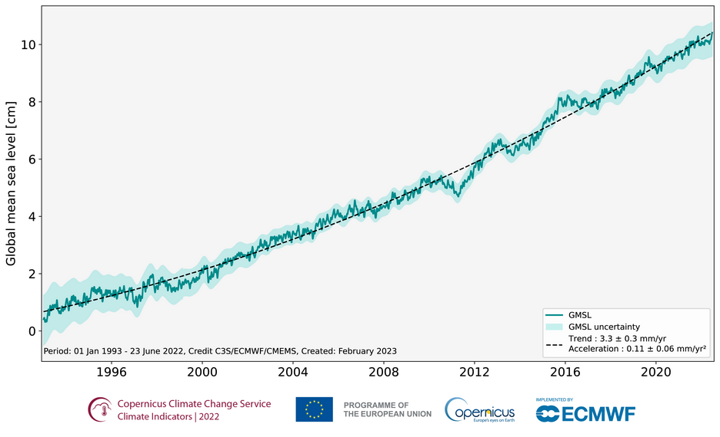
Sea level rising since the 1993. [6]
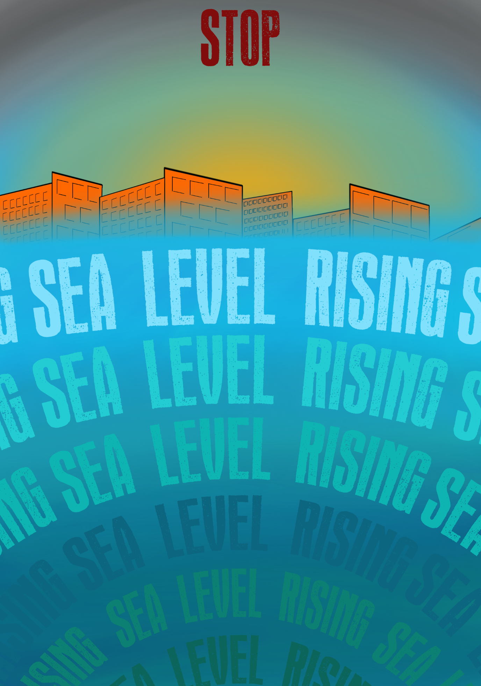

Bibliography

[1] | U. Nations, "What Is Climate Change? | United Nations," United Nations, N/A. [Online]. Available: https://www.un.org/en/climatechange/what-is-climate-change. [Accessed 12 2 2024].
[2] | NASA, "Global Climate Change: Vital Signs of the Planet," Nasa, 27 9 2023. [Online]. Available: https://climate.nasa.gov/effects/. [Accessed 14 2 2024].
[3] | c. zapatka, "Verge Science," 2 10 2018. [Online]. Available: https://www.youtube.com/watch?v=SA5zh3yG_-0&t=302s. [Accessed 23 2 2024].
[4] | C. Harvey and C. Harvey, "Is A Mega Ocean Current About to Shut Down?," Scientific American, 28 7 2023. [Online]. Available: https://www.scientificamerican.com/article/is-a-mega-ocean-current-about-to-shut-down/. [Accessed 15 2 2024].
[5] | S. King, "UK weather: Why have there been so many storms this year?," BBC News, 23 1 2024. [Online]. Available: https://www.bbc.co.uk/news/uk-68070561. [Accessed 15 2 2024].
[6] | N/A, "Sea level | Copernicus," climate.copernicus.eu, 20 4 2023. [Online]. Available: https://climate.copernicus.eu/climate-indicators/sea-level. [Accessed 11 2 2024].
[7] | NOAA, "What Are El Niño and La Niña?," Noaa.gov, N/A. [Online]. Available: https://oceanservice.noaa.gov/facts/ninonina.html. [Accessed 14 2 2024].
[8] | N/A, "Sea surface temperature | Copernicus," climate.copernicus.eu, 20 4 2023. [Online]. Available: https://climate.copernicus.eu/climate-indicators/sea-surface-temperature. [Accessed 19 2 2024].
[9] | National Ocean Service, "What Is coral bleaching?," Noaa.gov, 4 10 2023. [Online]. Available: https://oceanservice.noaa.gov/facts/coral_bleach.html . [Accessed 16 2 2024].
[10] | N/A, "10 best nature quotes from Sir David Attenborough - WWF-Australia | 10 best nature quotes from Sir David Attenborough | WWF Australia," wwf.org.au, N/A. [Online]. Available: https://wwf.org.au/blogs/10-best-nature-quotes-from-sir-david-attenborough/. [Accessed 24 2 2024].
[11] | Environment, Built;, "Sea Defence Project Reaches Key Milestone - For Safety and Sea Life," Business News Wales, 30 11 2023. [Online]. Available: https://businessnewswales.com/sea-defence-project-reaches-key-milestone-for-safety-and-sea-life/. [Accessed 23 2 2024].
[12] | P. Hawken, Regeneration, Penguin, 2021.
[13] | "Climate Action Initiatives," United Nations, [Online]. Available: https://www.un.org/en/climatechange/climate-action-coalitions. [Accessed 23 2 2024].
[14] | N/A, "How Does Solar Work?," energy.gov, N/A. [Online]. Available: https://www.energy.gov/eere/solar/how-does-solar-work#:~:text=When%20the%20sun%20shines%20onto,cell%2C%20causing%20electricity%20to%20flow.. [Accessed 23 2 2024].
[15] | N/A, "How Do Wind Turbines Work?," energy.gov, N/A. [Online]. Available: https://www.energy.gov/eere/wind/how-do-wind-turbines-work#:~:text=Wind%20turns%20the%20propeller%2Dlike,a%20generator%2C%20which%20creates%20electricity.. [Accessed 23 2 2024].
[16] | N/A, "How Hydropower Works," Energy.gov, N/A. [Online]. Available: https://www.energy.gov/eere/water/how-hydropower-works. [Accessed 23 2 2024].
[17] | D. Kraemer, "Who Is Greta Thunberg, The #FridaysForFuture Activist?," BBC News, 29 11 2019. [Online]. Available: https://www.bbc.co.uk/news/world-europe-49918719. [Accessed 23 2 2024].
[18] | B. Harvey, "32 Greta Thunberg Quotes To Inspire Climate Action," 25 5 2023. [Online]. Available: https://www.goodgoodgood.co/articles/greta-thunberg-quotes. [Accessed 23 2 2024].
[19] | United Nations, "UN Climate Change Conferences," United Nations, N/A. [Online]. Available: https://www.un.org/en/climatechange/un-climate-conferences. [Accessed 24 2 2024].
[20] | D. Attenborough, “Climate Change - the Facts,” BBC, 18 4 2019. [Online]. Available: https://www.bbc.co.uk/iplayer/episode/m00049b1/climate-change-the-facts. [Accessed 6 02 2024].
[21] | NASA, "Is the rate of sea-level rise increasing?," Nasa, N/A. [Online]. Available: https://sealevel.nasa.gov/faq/8/is-the-rate-of-sea-level-rise-increasing/. [Accessed 15 02 2024].
[22] | M. England, A. Taschetto and . B. Orihuela-Pinto, "A huge Atlantic ocean current is slowing down. If it collapses, La Niña could become the norm for Australia," UNSW , 7 05 2022. [Online]. Available: https://www.unsw.edu.au/newsroom/news/2022/06/huge-atlantic-ocean-current-slowing-down-if-it-collapses-la-nina-could-become-norm. [Accessed 20 2 2024].
[23] | R. Lindsey, "Climate Change: Global Sea Level," NOAA, 19 4 2022. [Online]. Available: https://www.climate.gov/news-features/understanding-climate/climate-change-global-sea-level. [Accessed 15 2 2024].
[24] | N. G. C. Change, "Climate Change: Vital Signs of the Planet," NASA, [Online]. Available: https://climate.nasa.gov/vital-signs/ocean-warming/. [Accessed 17 2 2024].
[25] | C. Nunez, "Sea level rise, facts and information," National Geographic, 10 4 2023. [Online]. Available: https://www.nationalgeographic.com/environment/article/sea-level-rise-1. [Accessed 21 02 2024].
[26] | N/A, "Temperature | Copernicus," climate.copernicus.eu, 20 4 2023. [Online]. Available: https://climate.copernicus.eu/climate-indicators/temperature. [Accessed 25 2 2024].
[27] | N/A, "Glaciers | Copernicus," climate.copernicus.eu, 20 4 2023. [Online]. Available: https://climate.copernicus.eu/climate-indicators/glaciers. [Accessed 19 2 2024].
[28] | N/A, "Ice sheets | Copernicus," climate.copernicus.eu, 20 4 2023. [Online]. Available: https://climate.copernicus.eu/climate-indicators/ice-sheets. [Accessed 19 2 2024].
[29] | N/A, "Sea ice | Copernicus," climate.copernicus.eu, 20 4 2023. [Online]. Available: https://climate.copernicus.eu/climate-indicators/sea-ice. [Accessed 19 2 2024].
[30] | N/A, "NASA Sea Level Change Portal," NASA Sea Level Change Portal, N/A. [Online]. Available: https://sealevel.nasa.gov/understanding-sea-level/regional-sea-level/land-water-storage. [Accessed 15 2 2024].
[31] | "Redirect Notice," [Online]. Available: https://www.google.com/url?sa=i&url=https%3A%2F%2Fwww.loblaw.ca%2Fen%2Fpowering-our-business-with-wind-sun-and-water%2F&psig=AOvVaw0umMqSx4xcFe148-jC9K9f&ust=1708973629139000&source=images&cd=vfe&opi=89978449&ved=0CBIQjRxqFwoTCOjYh-ryyIQDFQAAAAAdAAAAABAE.
[32] | W. Rees and M. Wackernagel, Our ecological footprint : reducing human impact on earth, Philadelphia: New Society Publishers, 1996.
[33] | M. Sharif-Draper and S. Burnley, Climate Change, London: Dorling Kindersley Limited, 2020.

