

Modernising Endpoint Deployment and Management with Microsoft Intune and Windows Autopilot
by
Jonathan Morgan

Supervisor: Dr Nitheesh Kaliyamurthy

Project submitted as part of the requirements for the award of
BSc (Hons) Computing (Computer Networks & Cybersecurity)

2026

DECLARATION

I, ....................................Jonathan Morgan………………………………… declare that I am the sole author of this Project; that all references cited have been consulted; that I have conducted all work of which this is a record, and that the finished work lies within the prescribed word limits.
This work has not previously been accepted as part of any other degree submission.

Date : 18/07/2026

FORM OF CONSENT

I ...................................................………………………………… hereby consent that my Project, submitted in candidature for the B.Sc.(Hons) Computing (Computer Networks & Cybersecurity) degree, if successful, may be made available for inter-library loan or photocopying (subject to the law of copyright), and that the title and abstract may be made available to outside organisations.

Date :

Abstract
This project investigates the replacement of Microsoft Deployment Toolkit (MDT) at Wales & West Housing (WWH) following Microsoft’s retirement of MDT in January 2026. WWH has historically used MDT to deploy Windows endpoint devices, but this legacy approach has many limitations in the hybrid workplace WWH now finds itself in compared to modern approaches to endpoint deployment and management. The project’s aim is to design, implement, evaluate and validate an organisational framework for adopting Microsoft Intune and Windows Autopilot as a supported replacement.
The project consists of a literature review, analysis of the existing MDT process, design and development of the new process and a governing framework, and a pilot deployment alongside survey feedback. The controlled pilot was carried out using five physical WWH devices, each tested twice using Windows Autopilot pre-provisioned deployment, and evaluated deployment time, IT hands-on effort, reliability, application readiness, policy application, user experience, IT supportability and framework suitability.
The pilot completed ten successful pre-provisioning tests, with the Autopilot pre-provisioning taking between 13 and 18 minutes per device, with approximately two to three minutes of IT hands-on time. Microsoft 365 Apps and Google Chrome were deployed successfully, although Chrome required repackaging and re-testing. BitLocker, Microsoft Defender, Windows Firewall and compliance policies were also applied successfully, although Intune compliance reporting took approximately three hours to update.
The project’s deliverable is the WWH Endpoint Deployment and Intune Governance Framework outlined in Chapter 4, which seeks to provide guidance on several areas, such as device registration, pre-provisioned deployment, application deployment, security and compliance, handover, ownership, governance and migration. The findings show that Intune and Autopilot together are suitable for replacing MDT, but wider adoption should be phased and supported by clear governance, application packaging standards, security policy ownership, handover guidance and continued evaluation and development.

Table of Contents
Abstract 3
Chapter 1 - Introduction 8
The Problem 8
Aim: 8
Objectives: 9
Project Structure 9
Chapter 2 – Research and Review of Literature 10
Introduction 10
Legacy Endpoint Deployment and Microsoft Deployment Toolkit 10
MDT Retirement and the Need for Supported Deployment Models 10
Zero-Touch Provisioning 11
Unified Endpoint Management 11
Windows Autopilot and Cloud-Based Provisioning 12
Pre-Provisioned Deployment and Low-Connectivity Scenarios 12
Policy-Driven and Intent-Based Configuration 12
Security, Compliance and Hybrid Working 13
Industry Evidence and Case Studies 13
Market Context and Strategic Relevance 14
Requirements Prioritisation and MoSCoW 14
Governance and Framework Requirements 14
Summary 15
Chapter 3 - Research and Development Methodology 16
Research Philosophy 16
Research Approach 17
Research Strategies 17
Experimental Design 18
Survey Design 19
Data Collection and Analysis 19
Validity, Reliability, Generalisability and Ethics 20
Risks and Contingency Planning 20
Development Methodology 20
Project Planning 22
Chapter 4 – Design and Implementation 24
Introduction 24
Design Requirements 24
Design Decisions 25
Current MDT Deployment Model 26
Proposed Intune / Autopilot Model 27
WWH Endpoint Deployment and Intune Governance Framework 29
Framework Ownership and Responsibility 31
Pilot Implementation 32
Issues and Iterative Changes 33
Pilot Outcome 34
Summary 34
Chapter 5 – Evaluation and Findings 36
Introduction 36
Evaluation Approach and MDT Baseline 36
Autopilot Pilot Results 36
IT Workload and Deployment Reliability 37
Application Deployment Evaluation 37
Security and Compliance Evaluation 38
End-User Survey Results and Handover 39
IT Staff Survey Results and Supportability 39
Framework Validation 40
Limitations of the Evaluation 41
Summary 41
Chapter 6 – Conclusion and Recommendations 43
Introduction 43
Achievement of the Project Aim 43
Achievement of the Project Objectives 43
Summary of Main Findings 44
Recommendations for Wales & West Housing 45
Future Work 45
Conclusion 46
Chapter 7 – Reflection 47
References 48
Appendix 51
A – Full MoSCoW Design Requirements 51
B – Survey Questions 53
C – Project risks, limitations and contingency responses 54
D – Intune and Autopilot Configuration Evidence 55
Autopilot Device Registration 55
Dynamic Device Group 56
Autopilot Deployment Profile 57
Enrolment Status Page 60
Application Deployment 61
Security and Compliance Configuration 63
Pre-Provisioning Process 68

List of Figures
Figure 1 - My 'Research Onion’ for this project 19
Figure 2 - WWH's Operating Principles 25
Figure 3 - Project Plan Gantt Chart 26
Figure 4 - A Microsoft illustration of the processes involved using MDT 30
Figure 5 - Proposed WWH Intune and Autopilot pre-provisioned deployment process 31
List of Tables
Table 1 - Experimental evaluation areas and measurements 22
Table 2 - Proposed framework areas 24
Table 3 - Summary of design requirements for the project 28
Table 4 - Showing design decisions made based on project requirements 29
Table 5 - Framework areas, governance requirements and pilot validation methods 33
Table 6 - Suggested WWH role ownership of framework areas 35
Table 7 – Comparison of MDT baseline and Autopilot pilot results 40
Table 8 – Application deployment results 41
Table 9 – Security and compliance evaluation 41
Table 10 – End-user survey results 42
Table 11 – IT staff survey results 43
Table 12 – Framework validation against pilot evidence 44
Table 13 – Assessment of project objectives 47

Chapter 1 - Introduction
In recent years, the management and deployment of endpoint devices have evolved significantly as organisations adapt to hybrid and remote working models. These developments have reshaped expectations for how IT services are delivered and have highlighted the limitations of traditional, on-premises provisioning methods that depend on direct access to internal infrastructure.
Wales & West Housing (WWH) has similarly adopted a hybrid working model, resulting in increased pressure on their legacy deployment technologies that require physical device access and local systems. This move to hybrid has highlighted the need for a cloud-based, scalable, and remotely managed deployment solution that better supports a largely semi-remote workforce.
Historically, WWH has utilised the Microsoft Deployment Toolkit (MDT) to provision Windows devices. Although effective within conventional IT environments, MDT’s image-based processes demand continuous maintenance—including image updates, driver management, and server availability—and provide limited flexibility in meeting the requirements of modern deployment scenarios.

The Problem
In addition to its operational limitations, Microsoft MDT has now been officially retired as of January 2026, with no further development, updates, or support provided by Microsoft. This introduces significant risks to WWH, such as potential security vulnerabilities, compatibility issues with future Windows releases, and long-term maintenance concerns.
Continuing to rely on MDT is no longer a sustainable option, so WWH must transition to a supported and future-proof deployment solution that aligns with modern best practices and supports a distributed workforce.
Cloud-based endpoint management platforms, such as Microsoft Intune combined with Windows Autopilot, are a potential solution. These technologies combined enable zero-touch provisioning, allowing devices to be deployed and configured remotely with minimal IT intervention, but their suitability for WWH must be evaluated through practical implementation and testing.

Aim:
To design, implement, evaluate, and validate an organisational framework for the adoption and governance of Microsoft Intune and Windows Autopilot as a supported replacement for the now-retired Microsoft Deployment Toolkit within Wales & West Housing.

Objectives:
- To review relevant literature, vendor guidance, and organisational context relating to endpoint deployment, Zero-Touch Provisioning (ZTP), Unified Endpoint Management (UEM), and cloud-based device governance.
- To critically analyse the existing MDT-based deployment process at WWH, identifying operational limitations, retirement-related risks, and baseline deployment metrics.
- To design an organisational Intune and Autopilot adoption framework covering provisioning, application deployment, security baselines, lifecycle management, ownership, and migration.
- To implement and pilot selected elements of the framework using Microsoft Intune and Windows Autopilot in a controlled experiment within WWH’s environment.
- To evaluate the pilot using quantitative and qualitative evidence and validate the suitability of the proposed framework for wider organisational adoption.

Project Structure
The remainder of this report is structured as follows –
- Chapter 2 reviews relevant academic, industry and vendor literature relating to endpoint deployment, zero-touch provisioning, Unified Endpoint Management, Microsoft Intune, Windows Autopilot and the retirement of MDT.
- Chapter 3 explains the research and development methodology used to conduct the project, including the experimental design, case study approach, data collection methods and framework validation process.
- Chapter 4 presents the design and implementation of the proposed Intune and Autopilot solution, including the development of the Wales & West Housing endpoint deployment and governance framework.
- Chapter 5 evaluates the findings from the pilot implementation, comparing the results against the MDT baseline metrics and analysing feedback from users and IT staff.
- Chapter 6 concludes the report by summarising the key findings, assessing whether the aim and objectives have been met, and providing recommendations for wider organisational adoption and future work.

Chapter 2 – Research and Review of Literature

Introduction
This chapter reviews literature and technical documentation relevant to replacing WWH’s MDT-based endpoint deployment process with Microsoft Intune and Windows Autopilot. It examines legacy image-based deployment, MDT retirement, zero-touch provisioning, Unified Endpoint Management, Autopilot pre-provisioning, policy-driven configuration, security, case study evidence and governance requirements. The purpose is to identify the concepts and design considerations needed to support the proposed WWH Endpoint Deployment and Intune Governance Framework.

Legacy Endpoint Deployment and Microsoft Deployment Toolkit
Endpoint deployment has traditionally relied on image-based provisioning, where a preconfigured operating system image containing applications, drivers and security settings is applied to devices. Microsoft Deployment Toolkit (MDT) has supported this approach by providing automation, task sequences, driver integration and scripting capabilities [1].
For centralised, office-based IT environments, this model can provide consistency and control, but it requires ongoing effort into the maintenance of images, drivers, applications and task sequences. Microsoft’s own documentation contrasts this with Windows Autopilot and Intune, where organisations can use OEM-optimised Windows installations (complete with drivers) and apply any required settings, policies and applications from the cloud [2].
This is directly relevant to WWH because the organisation now supports hybrid working. A process based on physical device access, local infrastructure and repeated image maintenance is less suitable for a workforce operating across multiple offices and remote locations.

MDT Retirement and the Need for Supported Deployment Models
The retirement of MDT significantly changes the justification for this project. MDT is no longer a sustainable long-term option, as Microsoft has ended development, updates and support for both standalone MDT and MDT integration with Configuration Manager, advising customers to consider modern provisioning solutions such as Windows Autopilot [3] [4].
WWH continuing to rely on MDT creates security, compatibility and maintainability risks, as unsupported tooling may not be tested against future Windows releases, driver models or security requirements, and operational knowledge becomes harder to maintain over time.
Migration away from MDT is therefore no longer simply an efficiency improvement. MDT is best treated as a legacy baseline, while the research problem becomes how WWH should adopt, govern and manage Intune and Autopilot as a supported replacement.

Zero-Touch Provisioning
Zero-Touch Provisioning (ZTP) refers to automated configuration with minimal manual intervention. Although the concept originated in networking, cloud and IoT environments, its underlying principle is relevant to endpoint deployment: administrators define the intended configuration in advance, and the device applies that configuration automatically when connected to the appropriate service.
Demchenko et al. [5] emphasise automation, interoperability and reduced manual configuration in distributed cloud services. Boškov et al. [6] demonstrate measurable provisioning-time improvements in IoT environments, while Liyanage et al. [7] identify ZTP and Zero-Touch Service Management as important for scalable automated management.
ZTP is relevant because MDT still requires WWH IT staff to handle devices directly and at length to perform deployment work in a specific physical space. A ZTP approach could reduce repetitive manual work, improve consistency and better support hybrid workers.

Unified Endpoint Management
Unified Endpoint Management extends earlier device management approaches by bringing laptops, desktops, mobile devices and other endpoints under a centralised, policy-driven platform. UEM allows organisations to apply configuration policies, deploy applications, monitor compliance and enforce security requirements across distributed devices.
Microsoft Intune is an example of a UEM platform, and it integrates with both Windows Autopilot and Microsoft Entra ID so that Windows devices can be enrolled, configured and managed through cloud-based profiles, policies and application assignments [8] [9]. Microsoft’s own Intune planning guidance also stresses the need to plan licensing, device types, rollout approach, communication, support processes and security requirements before adoption [10].
This supports the project’s premise that successful Intune adoption requires more than creating some configuration, that instead WWH needs a structured endpoint deployment and governance framework.

Windows Autopilot and Cloud-Based Provisioning
Windows Autopilot is used to set up and pre-configure Windows devices so that they are ready for productive use [2]. Unlike MDT, it does not deploy a custom operating system image. Instead, it uses the OEM-installed Windows image and applies organisational configuration, applications and policies through services such as Intune and Microsoft Entra ID.
Microsoft identifies several Autopilot deployment scenarios, including user-driven deployment, pre-provisioned deployment and self-deploying mode [11]. These options matter because different device types and user scenarios may require different provisioning methods.
The developed framework should therefore avoid defining a single deployment method for every device. Instead, it should define when each provisioning approach is appropriate based on user type, device type, connectivity, support needs and business risk.

Pre-Provisioned Deployment and Low-Connectivity Scenarios
Windows Autopilot pre-provisioned deployment allows IT staff, partners or resellers to prepare part of the device deployment before the device reaches the user, while still using the OEM image and cloud-based configuration [12]. This can reduce the setup time experienced by the end user and provides a compromise between traditional IT preparation and fully user-driven deployment.
This is relevant to WWH because some users may have limited connectivity, limited technical confidence or business-critical requirements. The framework should therefore include decision rules for when to use standard Autopilot, pre-provisioned deployment or manual intervention.

Policy-Driven and Intent-Based Configuration
Modern endpoint management shifts IT effort from building images to defining the desired state of devices through profiles, policies and compliance rules. Administrators specify required outcomes, such as encryption, application installation, compliance and enrolment, while the management platform applies those settings.

Antonakoglou et al. [13] describe intent-based orchestration as an approach where administrators specify desired outcomes rather than low-level implementation steps. Barrachina-Muñoz et al. [14] also show how cloud-native orchestration can support scalable remote provisioning across distributed infrastructure.
For WWH, this changes the role of IT staff. Instead of repeatedly rebuilding images, staff must define, test and govern policies. This supports the need for framework areas covering policy ownership, change control, application standards, compliance baselines and device lifecycle rules.

Security, Compliance and Hybrid Working
Hybrid working introduces endpoint security challenges because users may work outside the corporate network and connect from less controlled environments. Sabin [15] and Nurse et al. [16] highlight the need to adapt security practices for remote and hybrid working.
Cloud-based endpoint management can help by keeping devices enrolled, monitored and subject to compliance policies wherever they are located. In Intune, compliance policies, configuration profiles and security baselines can enforce settings such as encryption, endpoint protection, update behaviour and access conditions.
Moving WWH from MDT to Intune and Autopilot is therefore not only a deployment change. It is also part of a wider endpoint security and compliance model.

Industry Evidence and Case Studies
Industry reports and case studies provide evidence of the practical value of Intune and Autopilot. Forrester Consulting reported reduced device provisioning times and a positive return on investment for Microsoft Intune [17]. Proxar reported reduced IT workload after Autopilot adoption [18], while Microsoft customer stories for Carlsberg and ENGIE describe improved deployment and user experience outcomes [19] [20]. Marvell Technology’s transition from MDT to Autopilot also demonstrates a move towards a more streamlined device lifecycle [21].
These sources support the general case for Intune and Autopilot, but they should be interpreted critically because vendor-led case studies often emphasise successful outcomes and may not fully report difficulties, support costs or organisational resistance. They do not remove the need to test the approach in WWH’s own environment.

Market Context and Strategic Relevance
The endpoint management market reflects growing demand for cloud-managed, policy-driven device administration, driven by hybrid working, device diversity, security and compliance. Microsoft’s position is supported by IDC’s MarketScape 2024 report, which recognised Microsoft as a leader in UEM solutions [22], and Grand View Research also projects continued growth in the UEM market through 2030 [23].
This strategic context supports the decision for WWH to adopt a modern endpoint management approach aligned with wider industry direction.

Requirements Prioritisation and MoSCoW
A structured adoption framework requires a method for prioritising requirements. MoSCoW prioritisation classifies requirements as Must Have, Should Have, Could Have and Won’t Have / Future, helping to separate essential requirements from desirable or later-phase items [24].
This suits the WWH pilot because the project does not attempt a full organisational rollout, and instead allows essential pilot requirements to be prioritised while recording items that should be considered during later migration phases.

Governance and Framework Requirements
The literature and documentation reviewed in this chapter show that successful endpoint modernisation requires both technical implementation and governance. Microsoft’s Intune planning guidance frames adoption as a planned rollout or migration process, not simply a configuration task [10].
This is important because Intune introduces ongoing management responsibilities. WWH must define ownership for deployment profiles, application packaging, configuration changes, compliance policies and device lifecycle processes. Without this, Intune could become inconsistent or difficult to maintain even if the initial pilot succeeds.
The proposed WWH framework should therefore cover device provisioning, application deployment, security and compliance, lifecycle management, ownership, migration guidance, review and change control. The implementation and pilot are used to test selected parts of this framework.

Summary
This chapter has shown that endpoint deployment is moving away from traditional image-based methods towards cloud-based, policy-driven management. MDT was effective for centralised deployment environments, but its retirement and lack of ongoing support make it unsuitable as a long-term platform for WWH.
The literature on Zero-Touch Provisioning, Unified Endpoint Management, intent-based configuration and hybrid-working security supports the use of automated, cloud-managed endpoint deployment. Microsoft documentation and industry evidence also suggest that Intune and Windows Autopilot can reduce deployment effort, improve consistency and support distributed working.
However, the evidence also shows that successful adoption requires more than technical configuration. WWH needs a structured framework covering provisioning standards, application deployment, security and compliance, lifecycle management, ownership and migration planning. The remainder of the project therefore uses practical implementation and pilot evaluation to develop and validate a WWH-specific endpoint deployment and Intune governance framework.

Chapter 3 - Research and Development Methodology
This chapter explains the methodology used to design, implement and evaluate the WWH Endpoint Deployment and Intune Governance Framework. The project is primarily experimental because it tests a proposed Intune and Autopilot deployment model against the existing MDT process using measurable criteria. It also includes a development element because the main project deliverable is an organisational framework rather than a standalone technical configuration.
The methodology was selected because the project has both technical and organisational aims. It evaluates whether Intune and Autopilot can provision devices successfully, while also considering how the approach should be adopted, governed and supported within WWH.

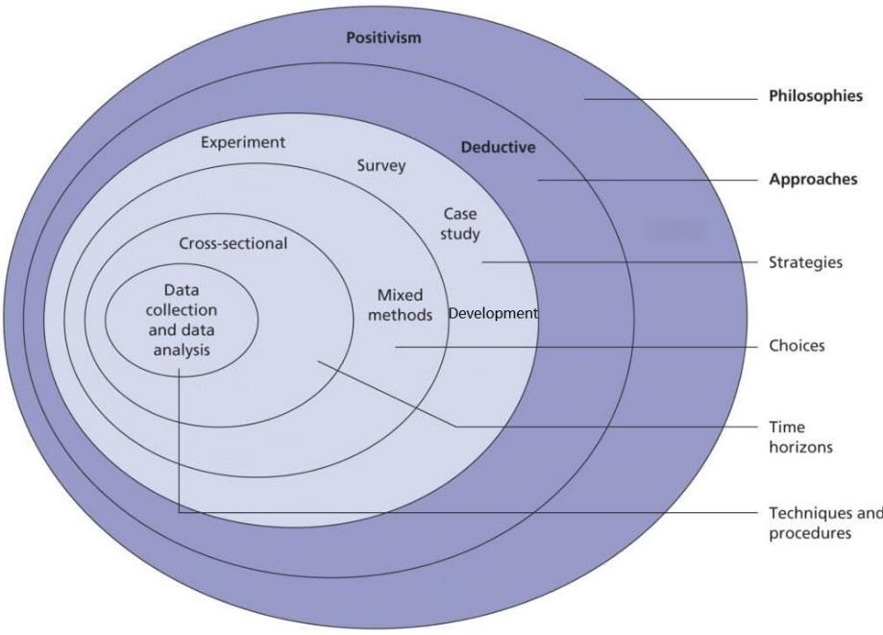
Figure 1 - My 'Research Onion’ for this project

Research Philosophy
This project adopts a mainly positivist philosophy because it uses measurable evidence such as deployment time, IT staff effort, manual interventions, deployment success rate and application readiness. These measures allow comparison between the existing MDT process and the proposed Autopilot process.
However, technical measures alone would not fully capture user experience or IT supportability. For this reason, the project also includes qualitative survey feedback from end users and IT staff, providing a more balanced evaluation of organisational suitability.

Research Approach
The project follows a deductive approach. The literature reviewed in Chapter 2 suggests that Zero-Touch Provisioning and Unified Endpoint Management can reduce manual IT effort, improve scalability and support hybrid working. The project tests this expectation within WWH by comparing a controlled Intune and Autopilot pilot against the existing MDT baseline.
This approach is suitable because the project is not exploring endpoint management from a blank starting point. Instead, it tests claims from existing literature, vendor guidance and industry practice in the specific context of WWH.

Research Strategies
The project uses a combination of experiment, case study, survey and development strategies. The experimental strategy compares the MDT baseline with the Intune and Autopilot pilot using measures such as deployment time, IT workload, reliability, application readiness and policy application.
WWH is used as the case study organisation because the project addresses a real operational problem within its own infrastructure, licensing, staff skills, support processes and hybrid-working requirements. This improves practical relevance, although it limits generalisability to other organisations.
Surveys are used to collect feedback from end users and IT staff. This is necessary because a technically successful deployment may still be unsuitable if users find the process unclear or IT staff consider it difficult to support. The surveys therefore provide evidence about user experience, supportability and wider organisational suitability.
The project also includes a development strategy because the main deliverable is the WWH Endpoint Deployment and Intune Governance Framework. The pilot implementation is used to test and refine this framework, ensuring that the project output is more than a technical configuration exercise.

Experimental Design
The experimental part of the project compares the existing MDT deployment approach with a controlled Intune and Autopilot pilot. The experimental hypothesis is:
“Devices deployed using Microsoft Intune and Windows Autopilot will require less manual IT effort and provide a more scalable and supportable deployment process than the existing MDT-based approach.”
The null hypothesis is:
“Microsoft Intune and Windows Autopilot will not provide a meaningful improvement in deployment efficiency, IT workload, user experience or organisational suitability when compared with the existing MDT-based deployment approach.”
The pilot uses five Windows 11-compatible WWH devices, alongside Microsoft Intune, Windows Autopilot, Microsoft Entra ID, Microsoft 365 applications, selected WWH standard applications, existing MDT baseline information, timing records, IT observations and survey responses. Devices were selected from standard WWH laptop models to make the results relevant to the organisation.
The experimental procedure is:
- Document the existing MDT deployment process and baseline metrics.
- Select suitable pilot devices.
- Register or prepare devices for Windows Autopilot.
- Configure the Autopilot deployment profile, application assignments and required device settings.
- Reset or prepare each device for deployment.
- Record deployment time, key deployment stages, failures, delays and manual interventions.
- Gather survey feedback from end users and IT staff.
- Compare the pilot results against the MDT baseline.
- Use the findings to refine the proposed WWH framework.

Evaluation area | Measurement
Deployment time | Time from deployment start to user-ready state.
IT workload | Number and duration of manual IT interventions.
Deployment reliability | Number of successful deployments compared with failures.
Application readiness | Whether required applications install successfully.
Policy application | Whether required settings and compliance policies apply correctly.
User experience | Survey feedback from pilot users.
IT supportability | Survey feedback from IT staff.
Framework suitability | Whether the results support the proposed WWH framework.
Table 1 - Experimental evaluation areas and measurements

The project does not rely on a single measure of success. Instead, it evaluates both technical outcomes and organisational suitability.

Survey Design
Two short surveys were used: one for end users involved in the pilot and one for IT staff involved in deployment, support or evaluation. The purpose was to collect evidence about user experience, setup clarity, IT workload, supportability, reliability and framework suitability. This was necessary because deployment time alone would not show whether the process was clear for users or supportable for IT staff. The full survey question sets are provided in Appendix B.
The survey questions used a five-point Likert scale from 1 “Strongly disagree” to 5 “Strongly agree”. This allowed responses to be summarised using averages and frequency counts, while optional comments allowed qualitative feedback.

Data Collection and Analysis
The project collected both quantitative and qualitative data. Quantitative data included MDT deployment time, Autopilot deployment time, estimated IT staff effort, manual interventions, deployment success or failure, application installation results and Likert-scale survey responses. Qualitative data included optional survey comments, researcher observations, deployment issue notes and IT staff feedback.
Quantitative data was analysed using descriptive statistics, including average deployment time, average IT staff effort, percentage change compared with the MDT baseline, deployment success rate, survey response frequency and average survey scores. This was appropriate because the pilot sample was small and the aim was to assess practical organisational suitability rather than produce statistically generalisable results.
Qualitative data was reviewed thematically and grouped around issues such as ease of use, speed of setup, application readiness, user confusion, IT support concerns, connectivity issues and suggested improvements. These themes were used to explain the quantitative findings and refine the proposed WWH framework.

Validity, Reliability, Generalisability and Ethics
Validity was supported by linking each measure directly to the project aim and objectives. Deployment time and IT effort measured operational efficiency; deployment success, application readiness and policy application measured technical effectiveness; and survey feedback measured user experience and IT supportability. Validity was also strengthened by comparing Autopilot results against the existing MDT baseline and by using realistic WWH deployment requirements during the pilot.
Reliability was supported by using a documented deployment procedure, recording the same measures across each pilot test and noting any issues. However, factors such as network performance, device model differences, application installation behaviour and user behaviour may affect repeatability, and these were considered during evaluation.
The findings are most directly applicable to WWH because the project is based on its own infrastructure, licensing, devices, staff skills and operational requirements. The findings may be relevant to similar organisations using Microsoft 365, Entra ID, Intune and Windows devices, but the framework is not claimed to apply unchanged elsewhere.
The project presented a low level of ethical risk. Survey participation was voluntary, responses were reported in summary form, individual participants were not identified, and the pilot was small and controlled to avoid unnecessary disruption to business operations.

Risks and Contingency Planning
Risks were managed by keeping the pilot scope controlled, prioritising core deployment functions and documenting any issues during testing. The full risk and contingency table is provided in Appendix C.
These risks were mitigated by using a controlled pilot, limiting the initial application scope, using objective deployment measurements, collecting survey feedback and treating unresolved areas as future recommendations.
These limitations do not invalidate the project, but they are considered when interpreting the results and defining recommendations for wider rollout.

Development Methodology
The development element of the project is the creation of the WWH Endpoint Deployment and Intune Governance Framework. This is the main organisational deliverable produced by the project and is intended to define how Intune and Autopilot should be adopted, governed and maintained beyond the pilot.
The framework was developed using evidence from the literature review, Microsoft documentation, analysis of the current MDT process, the Intune and Autopilot pilot, survey feedback and practical implementation observations. Its scope is summarised below.

Framework area | Description
Device provisioning standards | Defines when to use standard Autopilot, pre-provisioning, manual setup or other deployment approaches.
Application deployment standards | Defines required applications, optional applications, department-specific applications, assignment groups and detection standards.
Security and compliance baseline | Defines baseline settings such as BitLocker, Microsoft Defender, update rings, compliance policies and Conditional Access considerations.
Device lifecycle management | Defines processes for new devices, rebuilds, replacement devices, redeployment and retirement.
Governance and ownership | Defines responsibility for Intune policies, application packaging, Autopilot profiles, compliance settings and support documentation.
Migration roadmap | Defines a structured approach for moving WWH from MDT to Intune and Autopilot.
Table 2 - Proposed framework areas

The framework development followed an iterative approach influenced by Feature-Driven Development. Although this is not a coding project, the same principle was applied by dividing the implementation into smaller features or pieces, such as Autopilot profile configuration, application deployment, security and compliance settings, and user setup experience. Each area was configured, tested, reviewed and adjusted before moving to the next. This iterative approach reduces project risk because problems can be identified and resolved in smaller stages. It is also an approach effectively championed by WWH as the organisation’s own ‘Operating Principles’:
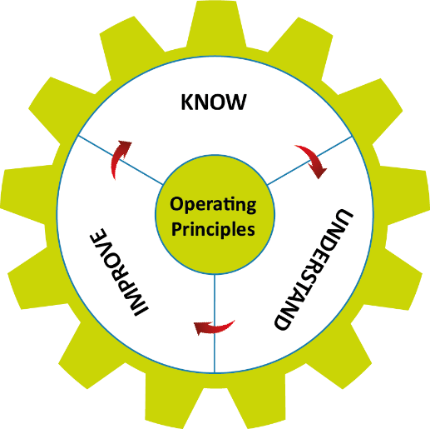
Figure 2 - WWH's Operating Principles

The framework was validated using evidence gathered during the pilot. Validation considered whether the framework reflected WWH’s operational requirements, whether the proposed provisioning process was achievable, whether applications and policies applied successfully, whether users found the process acceptable, whether IT staff considered it supportable, and whether the framework provided useful guidance for wider migration from MDT.

Project Planning
The project was planned across a six-month period using a Gantt chart (see Figure 3) to show the sequencing of research, design, implementation, evaluation and final reporting. The literature review continued throughout the project so that relevant changes in Microsoft documentation, including MDT retirement and Autopilot guidance, could be considered where they affected the project.
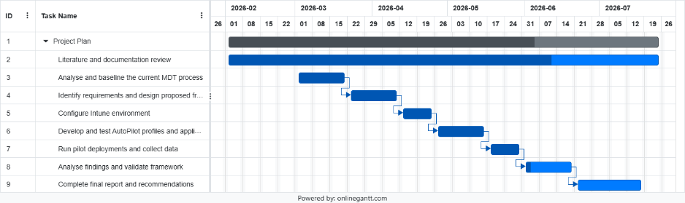
Figure 3 - Project Plan Gantt Chart

Chapter 4 – Design and Implementation

Introduction
This chapter presents the design and implementation of the proposed Wales & West Housing (WWH) Endpoint Deployment and Intune Governance Framework. The literature review, project requirements and limitations of the existing MDT process were translated into a practical Intune and Autopilot pilot.
The chapter first defines the design requirements and design decisions, then describes the current MDT model and proposed Intune/Autopilot model. It then introduces the governance framework, ownership model and pilot implementation used to test selected parts of the framework.

Design Requirements
The proposed solution was designed to replace WWH’s retired MDT-based deployment process with a supported, cloud-based endpoint deployment and management model. The requirements were developed from the literature review, Microsoft documentation, the current MDT process and WWH’s operational needs as a hybrid-working organisation.
The pilot focuses on Microsoft Entra-joined Windows devices using Windows Autopilot pre-provisioned deployment. It is limited to five devices and validates the core framework areas rather than attempting a full organisational rollout.
Requirements are grouped as organisational (OR), technical (TR) or governance (GR). MoSCoW prioritisation is used to identify which requirements are essential for the pilot and which should be considered during later rollout.
Requirement group | Main priority | Summary of requirement focus | Design response
Organisational requirements | Must / Should | The solution must support hybrid working, reduce reliance on physical MDT imaging, provide a supported replacement for MDT and support phased rollout. | The design uses Microsoft Entra ID, Intune and Windows Autopilot pre-provisioning as a cloud-based replacement model, tested through a controlled pilot.
Technical requirements | Must / Should / Could | Pilot devices must be Entra ID joined, enrol into Intune, receive the correct Autopilot profile, deploy core applications and receive a basic security and compliance baseline. | The pilot validates Autopilot profile assignment, Intune enrolment, Microsoft 365 Apps, Google Chrome, BitLocker, Defender, Firewall and compliance policy application.
Governance requirements | Must / Should / Future | The framework must define maintainability, ownership, change control, pre-provisioning rules, future application standards and phased migration from MDT. | The framework defines ownership, application onboarding, security and compliance governance, handover expectations and future migration guidance.
Table 3 - Summary of design requirements for the project

The full MoSCoW requirements table is provided in Appendix A. These summarised requirements provide the basis for the design decisions described in the following sections. They also support the evaluation of the project in Chapter 5, where the pilot results and framework are assessed against the original requirements and objectives.

Design Decisions
The requirements identified for the project led to several design decisions that shaped the proposed Intune and Autopilot pilot. These decisions were made to ensure that the implementation was realistic for WWH, achievable within the project timescale, and suitable for validating the proposed endpoint deployment and governance framework.

Design Area | Options Considered | Selected Design | Rationale
Identity model | Active Directory domain join, Microsoft Entra hybrid join, Microsoft Entra join | Microsoft Entra join | Entra ID join was selected because it aligns with the project’s cloud-based management model and reduces reliance on traditional on-premises domain join processes during deployment
Provisioning method | User-driven Autopilot, pre-provisioned Autopilot, self-deploying mode | Pre-provisioned Autopilot | Pre-provisioning was selected to reduce the risk of connectivity problems when the end user receives the device and to simplify the final user setup experience (sometimes referred to as ‘White Glove’)
Autopilot device registration | Manual hardware hash upload using PowerShell, OEM/reseller registration | Dell OEM registration into WWH’s Autopilot tenant | WWH purchases laptops through Dell, and Dell can register devices directly into the organisation’s Autopilot tenant, reducing manual administrative effort and avoids the need for IT staff to unbox devices simply to capture hardware information
Pilot size | Full rollout, large pilot, small controlled pilot | Small controlled pilot of five devices | A five-device pilot provides enough evidence to test the basic framework while remaining achievable within the project timeframe
Application scope | Full WWH application estate, departmental applications, core applications only | Core applications: Microsoft 365 Apps and Google Chrome | The pilot focuses on common baseline applications required by most users. This validates Intune application deployment without overcomplicating the pilot with department-specific software
Security scope | Full Microsoft security baseline, custom advanced hardening, minimal baseline | Minimal security and compliance baseline | A minimal baseline was selected to validate encryption, Defender/firewall, supported Windows version and compliance reporting without introducing unnecessary policy complexity
Deployment validation | Technical deployment only, full organisational rollout, controlled pilot validation | Controlled pilot validation | The pilot validates the core framework areas: provisioning, application deployment, security/compliance, handover and supportability
Migration approach | Immediate replacement of MDT, no migration planning, phased migration | Phased migration | A phased migration is more realistic because WWH will need to expand application coverage, refine policies and manage change before replacing MDT completely
Table 4 - Showing design decisions made based on project requirements

These design decisions ensure that the pilot is not treated as an isolated technical exercise. Instead, each decision supports the wider aim of developing a practical framework for how WWH should adopt and govern Intune and Autopilot following MDT retirement.

Current MDT Deployment Model
WWH currently uses Microsoft Deployment Toolkit (MDT) to provision Windows endpoint devices through a traditional image-based process. IT staff prepare the device, connect it to the internal deployment network, PXE boot the device and start the relevant MDT task sequence. The task sequence applies the Windows image, drivers, applications and configuration settings before the device is checked and handed to the user.
This model provides consistency, but it depends on maintained images, local infrastructure, physical device access and direct IT involvement. IT staff must also complete post-deployment checks, updates, application verification and handover tasks. These constraints are increasingly unsuitable for WWH’s hybrid-working environment, where users may work across multiple offices or remotely.
Figure 4, taken from Microsoft’s MDT user guide documentation [25], illustrates the involved high-level process used to create and maintain MDT deployments for target computers.
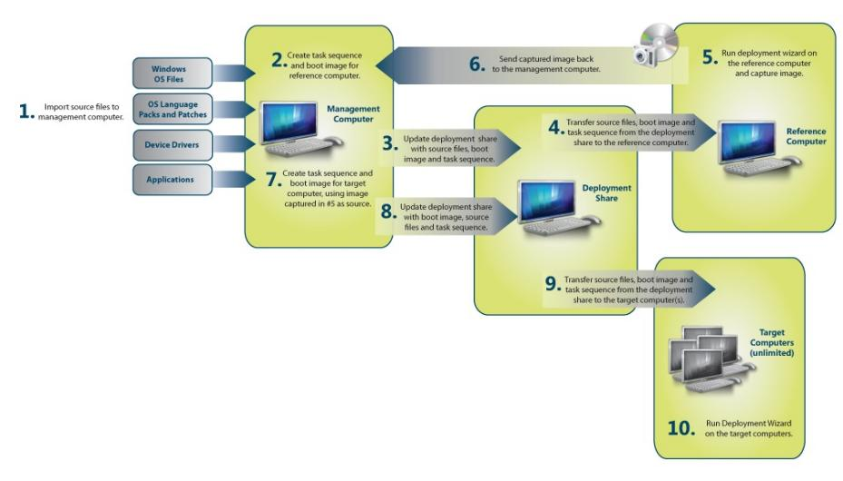
Figure 4 - A Microsoft illustration of the processes involved using MDT

As MDT has now been retired by Microsoft [3], the current process is treated as the legacy baseline against which the proposed Intune and Autopilot model is evaluated.

Proposed Intune / Autopilot Model
The proposed model replaces MDT image-based deployment with cloud-based provisioning using Microsoft Intune, Windows Autopilot and Microsoft Entra ID. The pilot uses Microsoft Entra-joined devices, reducing reliance on traditional domain-join processes during deployment. Windows Autopilot pre-provisioned deployment was selected because it allows IT staff to prepare devices before handover. During pre-provisioning, the device enrols into Intune, receives its deployment profile, applies required policies, installs core applications and is then resealed for the user. The proposed deployment flow is shown in Figure 5. Dell registers eligible devices into the WWH Windows Autopilot tenant where possible. Devices are then tagged and assigned to a dynamic device group, which links them to the correct Autopilot deployment profile.

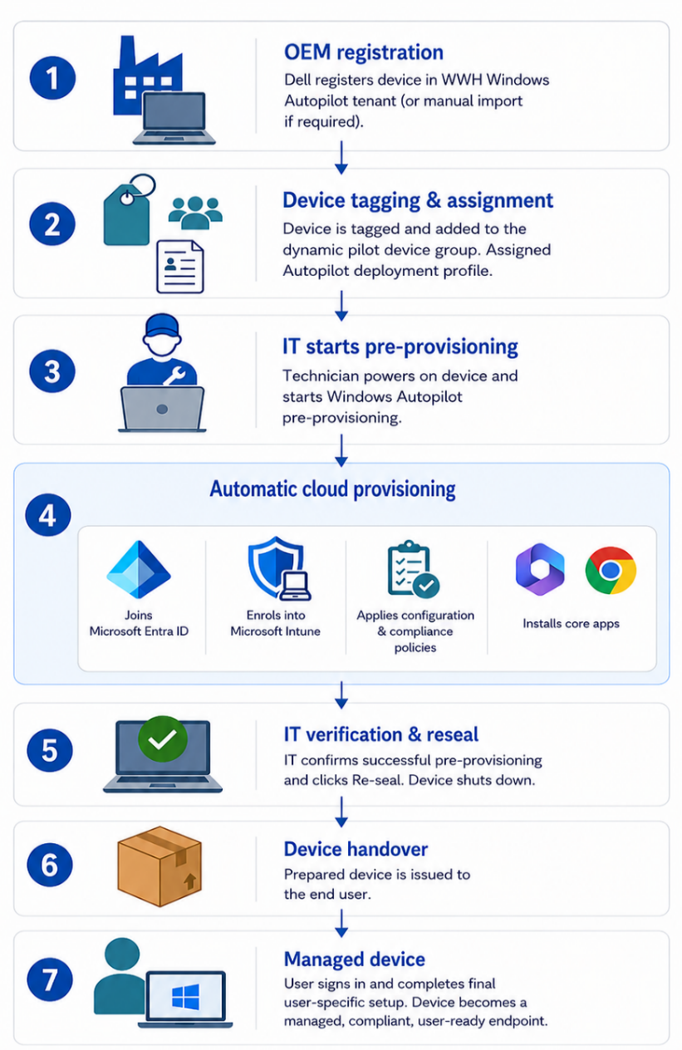
Figure 5 - Proposed WWH Intune and Autopilot pre-provisioned deployment process
This model changes deployment from maintaining and applying a full MDT image to defining the required device state through cloud-based profiles, application assignments and compliance policies. These settings continue to apply after handover, supporting ongoing device management rather than ‘one-off’ imaging.

WWH Endpoint Deployment and Intune Governance Framework
The main deliverable of this project is the WWH Endpoint Deployment and Intune Governance Framework. The purpose of the framework is to define how Microsoft Intune and Windows Autopilot should be used within WWH to provision, secure, manage and hand over Windows endpoint devices following Microsoft’s announced retirement of MDT.
The previous section described the proposed technical deployment model. However, simply configuring Intune and Autopilot is not sufficient on its own. Because Intune provides ongoing cloud-based management after a device has been issued, WWH requires a clear framework to ensure that provisioning profiles, application assignments, compliance policies and handover processes are applied consistently and can be supported effectively over time.
As outlined in Chapter 3, the framework was initially scoped across six broad areas covering provisioning, applications, security and compliance, lifecycle management, governance and migration. During design and implementation, these were developed into the eight practical framework areas shown in Table 5.
The framework therefore translates the technical implementation into a repeatable organisational process, defining standards, responsibilities and decision points required to use Intune and Autopilot effectively, rather than treating the pilot as a one-off technical configuration exercise. The framework is also intended to support future phased adoption by providing a structure that can be expanded as more devices, applications and security policies are migrated into Intune.

Framework Area | Purpose | Governance Requirement | Pilot Validation
Device registration | Ensures devices are available in Windows Autopilot before deployment begins | Devices should be registered by Dell during procurement where possible. Manual import should be used only as an exception | Pilot devices are confirmed as registered in Windows Autopilot before pre-provisioning begins
Device grouping and assignment | Links devices to the correct Autopilot deployment profile, applications and policies | Pilot and production device groups should use clear naming conventions and controlled membership rules | Pilot devices are assigned to the relevant device group and receive the correct Autopilot deployment profile
Pre-provisioned deployment | Allows IT staff to prepare devices before they are issued to end users | Pre-provisioning should be used where WWH wants to reduce user setup time, connectivity risks and support calls during handover | Pilot devices are prepared using Windows Autopilot pre-provisioning and resealed before handover
Application deployment | Defines how required applications are delivered through Intune | Core applications should be assigned consistently. Additional applications should be packaged, tested and assigned using a controlled process | Microsoft 365 Apps and Google Chrome are deployed through Intune during the pilot
Security and compliance | Ensures devices receive minimum security and compliance settings during provisioning and after handover | Compliance policies and baseline security settings should be reviewed regularly and aligned with WWH requirements | Pilot devices receive the selected basic security and compliance settings and report status in Intune
Device handover | Defines when a device is ready to be issued to the end user | IT staff should verify that provisioning has completed successfully before resealing and handing over the device | Devices are checked after pre-provisioning and only handed over once the expected deployment state has been reached
Ongoing governance | Ensures Intune and Autopilot remain manageable after the pilot | Ownership, change control, documentation and review processes should be defined for profiles, applications, policies and groups | Pilot findings are used to identify governance requirements for wider rollout
Future migration | Supports a phased transition away from MDT | Migration from MDT should be staged, prioritising common device types and core application requirements before wider rollout | The five-device pilot provides evidence for a future phased migration approach
Table 5 - Framework areas, governance requirements and pilot validation methods

The framework recognises that endpoint deployment is no longer limited to the initial build of a device. In the MDT model, the main point of control is the deployment image and task sequence. In the proposed Intune and Autopilot model, control is distributed across cloud-based profiles, policies, application assignments and compliance rules that continue after handover.

For this project, the framework is validated through a controlled five-device pilot. It does not attempt to implement every part of Intune or migrate the full WWH application estate. Instead, it tests the core framework elements needed to show whether the proposed approach is practical: registration, assignment, pre-provisioning, enrolment, application deployment, compliance policy application and handover. The detailed configuration evidence is provided in Appendix D.

Framework Ownership and Responsibility
For the framework to be maintainable beyond the pilot, ownership should be assigned to IT roles or functions rather than to individual members of staff. This reduces the risk that the Intune and Autopilot environment becomes dependent on one person’s knowledge and helps ensure that deployment profiles, policies, applications and support processes remain controlled as the service expands.
The ownership model proposed in this framework should be treated as an initial responsibility structure. Final named owners should be confirmed by WWH during wider rollout, in line with existing IT management, service desk, infrastructure and change-control processes.

Framework area | Suggested WWH owner/function | Responsibility
Overall Intune and Autopilot governance | Technology Operations Manager | Own the operational framework and ensure it remains aligned with WWH endpoint management needs.
Framework approval and strategic direction | Director of Technology & Data | Approve wider adoption, ensure alignment with technology strategy and organisational risk appetite.
Autopilot device registration | Technology Operations Manager / Infrastructure Team | Ensure new devices are registered into Windows Autopilot, preferably through Dell OEM registration.
Autopilot deployment profiles | Senior Infrastructure Engineer / Infrastructure Assistant | Create, assign, review and maintain Autopilot deployment profiles.
Dynamic device groups | Senior Infrastructure Engineer / Infrastructure Assistant | Maintain group naming standards, membership rules, group tags and assignment logic.
Intune configuration profiles | Senior Infrastructure Engineer / Infrastructure Assistant | Own device configuration profiles and ensure changes are tested before wider rollout.
Security and compliance policies | Senior Engineer (Infra / Security) / Technology Operations Manager | Own BitLocker, Defender, Firewall, compliance policy and future Conditional Access-related settings.
Core application packaging | Senior Infrastructure Engineer / Infrastructure Assistant | Package, test and document applications before deployment through Intune.
Application assignment and deployment groups | Senior Infrastructure Engineer / Infrastructure Assistant | Assign required and optional applications using controlled groups and documented approval processes.
Device pre-provisioning process | Service Desk Officer / Service Desk Assistants | Complete pre-provisioning, verify successful setup, reseal devices and follow the handover process.
End-user handover and first-line support | Service Desk Officer / Service Desk Assistants | Support users during first sign-in, record common issues and escalate technical faults where required.
Deployment issue escalation | Service Desk Officer → Infrastructure Assistant → Senior Engineer | Provide a clear escalation route for enrolment failures, app deployment issues and compliance delays.
Change control and rollout planning | Technology Operations Manager / Senior Infrastructure Engineer | Coordinate phased rollout, change records, communication and delivery planning.
Framework review | Technology Operations Manager | Review the framework periodically and after major Microsoft Intune, Autopilot or WWH process changes.
Table 6 - Suggested WWH role ownership of framework areas

This ownership model maps framework areas to WWH role functions rather than named individuals. This helps ensure that Intune and Autopilot remain maintainable beyond the pilot and that responsibility for provisioning, applications, security, support, escalation and change control is clear during wider rollout.

Pilot Implementation
The pilot implementation tested selected elements of the WWH Endpoint Deployment and Intune Governance Framework using five physical Windows devices. The implementation focused on device registration, group-based assignment, Autopilot pre-provisioning, application deployment, security and compliance policy application, and device handover.
WWH’s normal procurement route through Dell supported direct Autopilot registration of eligible devices into the WWH tenant. A pilot Group Tag was used to place devices into a dynamic Microsoft Entra ID device group, allowing the Autopilot deployment profile, required applications, security policies and compliance settings to be assigned consistently.
The Autopilot deployment profile used Microsoft Entra ID join and pre-provisioned deployment so that IT staff could prepare devices before handover. The Enrolment Status Page was configured to allow required applications and policies to install before the device was considered ready. This supported the project aim by testing whether cloud-based provisioning could replace the main functions currently performed through MDT.
Application deployment was tested using Microsoft 365 Apps and Google Chrome. Microsoft 365 Apps deployed successfully using the built-in Microsoft 365 Apps deployment option. Chrome initially required iteration, as the original Line-of-Business deployment did not install successfully and was later repackaged as a Win32 application.
The pilot security and compliance configuration included Microsoft Defender Antivirus, BitLocker, Windows Firewall and a Windows compliance policy. This provided a limited but useful baseline for testing whether Intune could apply and monitor security settings after provisioning.
The pre-provisioning process was completed by starting each registered device, entering the Autopilot pre-provisioning workflow, allowing the device to join Microsoft Entra ID and enrol into Intune, applying assigned applications and policies, and then resealing the device for handover. The detailed Intune configuration evidence and screenshots are provided in Appendix D.

Issues and Iterative Changes
The pilot was carried out iteratively so that configuration issues could be identified and reflected in the framework. Early testing used a VirtualBox virtual machine to become familiar with the Autopilot workflow and Windows out-of-box experience. However, the VM could not complete pre-provisioning because Microsoft states that this scenario requires physical devices with TPM 2.0 and device attestation, and virtual machines are not supported [27]. The VM was therefore excluded from the pilot evidence, and testing moved to physical WWH devices.
Physical-device testing completed successfully. Group Tag assignment, dynamic group membership and deployment profile assignment worked as expected, supporting their inclusion in the framework. Minor naming changes were also made to improve clarity in the Intune admin centre, highlighting the need for consistent naming standards before wider rollout.
Application deployment required more significant iteration. Google Chrome initially failed when deployed as a Line-of-Business application using the MSI installer. It was then rebuilt as a Win32 app package using the IntuneWin format with defined install and uninstall commands. This resolved the issue and showed that application deployment needs packaging standards, detection rules, testing and ownership before production use.
The Enrolment Status Page supported the pre-provisioning workflow without causing additional blocking issues, but the Chrome issue shows that WWH should carefully decide which applications are allowed to block setup. Security and compliance policies applied successfully, although Intune compliance reporting was delayed. This means support staff should not assume that compliance status will update immediately after provisioning.
Overall, the pilot identified several governance considerations: valid pre-provisioning testing requires physical devices, naming standards should be applied consistently, applications require separate packaging and testing, compliance reporting delays should be expected, and handover should occur only when the expected provisioning state has been reached.

Pilot Outcome
The pilot successfully demonstrated the core stages of the proposed WWH Intune and Autopilot deployment model. Physical devices were registered with Windows Autopilot, assigned to the relevant dynamic device group, received the assigned deployment profile and completed pre-provisioning.
The pilot also showed that devices could join Microsoft Entra ID, enrol into Intune, receive assigned configuration and compliance policies, install Microsoft 365 Apps and Google Chrome, and be resealed for handover. Chrome required repackaging as a Win32 application, and compliance reporting was delayed, but both findings helped refine the framework.
Overall, the pilot provided evidence that the proposed model can support a repeatable cloud-based deployment process within WWH. It also identified governance requirements for naming standards, application packaging, compliance reporting, policy ownership and controlled change management.

Summary
This chapter presented the design and implementation of the WWH Endpoint Deployment and Intune Governance Framework. It defined the project requirements, design decisions, legacy MDT baseline, proposed Intune and Autopilot model, framework areas, ownership model and pilot implementation.
It showed that the proposed model addresses MDT’s main limitations by reducing reliance on image maintenance, local deployment infrastructure and physical network-based deployment. It also showed that successful adoption requires governance covering device registration, grouping, pre-provisioning, application deployment, security and compliance, handover, ownership and migration.
The pilot implementation confirmed that the core provisioning process could be completed successfully on physical devices. The issues encountered during testing, including VirtualBox limitations, Chrome application packaging and compliance reporting delays, provided evidence for refining the framework and informing the evaluation in Chapter 5.

Chapter 5 – Evaluation and Findings

Introduction
This chapter evaluates the pilot implementation described in Chapter 4, its purpose is to assess whether Microsoft Intune and Windows Autopilot provide a suitable replacement direction for WWH’s existing MDT-based deployment process, and whether the pilot evidence supports the proposed WWH Endpoint Deployment and Intune Governance Framework. The evaluation is linked to the project aim and objectives and uses criteria defined in Chapter 3.

Evaluation Approach and MDT Baseline
The pilot was evaluated using deployment duration, IT hands-on time, success rate, application installation, policy application, compliance reporting, survey responses and optional comments. Five physical WWH devices of the same model were each tested twice, giving a total of ten Autopilot pre-provisioning test runs.
The results were compared against the existing MDT process. A typical MDT deployment run takes approximately 33 minutes, but the comparison is limited because MDT can deploy several devices per run, while Autopilot timings were recorded per device. The comparison should therefore be treated as an indication of individual device provisioning performance rather than a complete comparison of every deployment scenario.

Autopilot Pilot Results
The Autopilot pilot was completed successfully on five physical devices, each tested twice. This produced ten successful pre-provisioning test runs and a recorded deployment success rate of 100% for the pilot.
Pre-provisioning took between 13 and 18 minutes per device, with an average of 15.5 minutes. Compared with the approximate MDT deployment time of 33 minutes per run, this was faster for individual device provisioning, although MDT’s ability to deploy multiple devices at once must be considered when interpreting the comparison.

Measure | MDT Baseline | Autopilot Pilot Result | Evaluation
Typical deployment time | Approximately 33 minutes per run | 13–18 minutes per device | Autopilot was faster for individual device provisioning.
Average Autopilot time | Not applicable | Approximately 15.5 minutes | Provides a repeatable estimate for the pilot model.
Deployment success rate | Not formally measured in this pilot | 10 successful tests out of 10 | Autopilot pre-provisioning was reliable during pilot testing.
IT hands-on time | Higher due to imaging setup and post-deployment checks | Approximately 2–3 minutes per device | Autopilot reduced direct technician interaction during provisioning.
Physical device requirement | Device must be brought to the MDT network | Device still handled by IT for pre-provisioning, but cloud-managed | Autopilot reduced dependency on the MDT network and local imaging infrastructure.
Table 7 – Comparison of MDT baseline and Autopilot pilot results

IT Workload and Deployment Reliability
Direct IT hands-on time during the Autopilot pilot was approximately two to three minutes per device. This included starting pre-provisioning, checking completion and selecting the reseal option. Although the deployment still took time to complete, most activity occurred automatically, allowing IT staff to monitor the process rather than manually control the full build.
Reliability was also strong within the limited pilot, as all five devices completed pre-provisioning successfully on both their test runs. Earlier VirtualBox testing was excluded from the pilot evidence because Autopilot pre-provisioning requires physical hardware and it could not complete.

Application Deployment Evaluation
The pilot tested application readiness using Microsoft 365 Apps and Google Chrome. Microsoft 365 Apps installed successfully on all pilot devices. Chrome initially failed when deployed as a Line-of-Business application using the MSI installer, but installed successfully after being repackaged as a Win32 application using the IntuneWin format.

Application | Initial Result | Iterative Change | Final Result
Microsoft 365 Apps | Installed successfully | No change required | Successful
Google Chrome | Line-of-Business deployment did not install successfully | Rebuilt as Win32 app package with install and uninstall commands | Successful
Table 8 – Application deployment results

This shows that application deployment must be governed separately from device enrolment. Full adoption should define application packaging standards, detection rules, assignment groups, install and uninstall commands, testing and ownership.

Security and Compliance Evaluation
The pilot tested whether devices could receive and report against basic security and compliance settings through Intune. Microsoft Defender Antivirus, BitLocker, Windows Firewall and a Windows compliance policy all applied successfully, and each device eventually reported as compliant.
Compliance reporting was not immediate, taking approximately three hours to update in Intune, an important operational finding because support staff may need to allow time for policy evaluation and synchronisation before relying on the compliance state shown in Intune.

Security / Compliance Area | Pilot Result | Evaluation
BitLocker | Applied successfully | Confirms encryption can be managed through Intune.
Microsoft Defender Antivirus | Applied successfully | Confirms baseline endpoint protection settings can be applied.
Windows Firewall | Applied successfully | Confirms firewall settings can be centrally managed.
Compliance policy | Devices eventually reported compliant | Confirms compliance reporting works, but not instantly.
Compliance reporting delay | Approximately three hours | Should be reflected in support procedures and handover expectations.
Table 9 – Security and compliance evaluation

This supports the framework because Intune policies continue after handover and can be monitored centrally, unlike an MDT image-based process that controls the initial build only.

End-User Survey Results and Handover
Ten end-user survey responses were recorded using a five-point Likert scale, where 1 represented “Strongly disagree” and 5 represented “Strongly agree”.

End-User Survey Question | Responses | Average Score | Agree / Strongly Agree
The device setup process was easy to follow. | 10 | 3.9 | 8 / 10
The setup instructions were clear. | 10 | 4. | 8 / 10
The device was ready to use within an acceptable time. | 10 | 4.3 | 9 / 10
The applications I needed were available after setup. | 10 | 4.2 | 10 / 10
I would be comfortable using this setup process again. | 10 | 4.1 | 9 / 10
Table 10 – End-user survey results

The end-user results were generally positive. The highest scoring areas were device readiness and application availability, with average scores of 4.3 and 4.2. All respondents agreed or strongly agreed that the applications they needed were available after setup, and nine out of ten agreed or strongly agreed that the device was ready within an acceptable time.
The setup experience was slightly weaker but still positive. “The device setup process was easy to follow” scored 3.9, and “The setup instructions were clear” scored 4.0. This suggests that the handover model is acceptable, but clearer user guidance should be provided before wider rollout.

IT Staff Survey Results and Supportability
Ten IT staff survey responses were recorded using the same five-point Likert scale.

IT Staff Survey Question | Responses | Average Score | Agree / Strongly Agree
The Autopilot process required less manual effort than MDT. | 10 | 4 | 8 / 10
The process was easier to support than the MDT process. | 10 | 4.1 | 10 / 10
The deployment process was reliable during testing. | 10 | 4.4 | 10 / 10
The configuration approach is suitable for wider WWH adoption. | 10 | 3.6 | 7 / 10
The proposed framework would help standardise endpoint deployment. | 10 | 4.4 | 10 / 10
Table 11 – IT staff survey results

The IT staff results were positive, particularly for reliability and standardisation. Deployment reliability and the usefulness of the proposed framework both scored 4.4, with all respondents agreeing or strongly agreeing. Staff also viewed the process as easier to support than MDT, with an average score of 4.1.
The lowest scoring area was suitability for wider WWH adoption, with an average score of 3.6. This indicates caution rather than rejection. Written comments highlighted the need for further work around Defender, endpoint security policies, Autopatch and production readiness. The results therefore support the proposed framework, but reinforce the need for phased rollout and clear governance.

Framework Validation
The pilot provides evidence that selected elements of the proposed framework are practical within WWH’s environment. The validated framework areas are summarised in Table 12.

Framework Area | Pilot Evidence | Evaluation
Device registration | Devices were available in Windows Autopilot. | Supports use of OEM registration and manual import as an exception process.
Device grouping and assignment | Group Tags and dynamic device groups assigned the correct profile. | Supports use of controlled group membership rules.
Pre-provisioned deployment | Ten successful pre-provisioning tests completed. | Supports pre-provisioning as a suitable WWH deployment method.
Application deployment | Microsoft 365 Apps and Chrome installed successfully after packaging iteration. | Supports Intune app deployment but shows need for packaging governance.
Security and compliance | BitLocker, Defender, Firewall and compliance policies applied successfully. | Supports basic security and compliance management through Intune.
Device handover | Devices were resealed and user sign-in worked as expected. | Supports the handover process defined in the framework.
Ongoing governance | Issues identified around naming, app packaging and compliance reporting. | Confirms need for ownership, standards and change control.
Future migration | Pilot completed successfully but remained limited in scope. | Supports phased migration rather than immediate full replacement.
Table 12 – Framework validation against pilot evidence

The framework as-is is partially validated, as the pilot shows that the core deployment process can work and that the framework areas are relevant. However, wider validation would require a larger pilot, more device models, broader application testing and more user scenarios. The framework should therefore be treated as a validated starting point for phased adoption, not as a complete production-ready model.

Limitations of the Evaluation
The evaluation has several limitations. The pilot sample was small, with five devices of the same model tested twice. This improved consistency but limits generalisability across the wider WWH device estate.
The MDT comparison is also limited because MDT can deploy multiple devices per run, while Autopilot timings were recorded per device. The application scope was limited to Microsoft 365 Apps and Google Chrome, so department-specific, legacy or licensed applications may introduce further packaging and compatibility issues.
The survey sample was also small, with ten end-user responses and ten IT staff responses. Finally, the pilot did not implement all advanced Intune capabilities, such as full security baselines, Conditional Access, Microsoft Autopatch or wider update compliance reporting.

Summary
This chapter evaluated the Autopilot pilot against the criteria defined in Chapter 3. The pilot completed ten successful pre-provisioning tests across five physical WWH devices, with pre-provisioning taking 13–18 minutes per device and requiring approximately two to three minutes of IT hands-on time.
The findings show that Intune and Autopilot can support device registration, profile assignment, pre-provisioning, Entra ID join, Intune enrolment, application deployment, security policy application and compliance reporting. Survey responses were generally positive, while also highlighting the need for clearer handover guidance and further work around endpoint security, Autopatch and production readiness.
Overall, the pilot supports Intune and Autopilot as a suitable replacement direction for MDT within WWH, but confirms that wider adoption should be phased and governed through clear standards for application packaging, naming, compliance reporting, policy ownership, change control and migration.

Chapter 6 – Conclusion and Recommendations

Introduction
This chapter concludes the project by assessing whether the aim and objectives have been met, summarising the main findings, and presenting recommendations for wider adoption within Wales & West Housing (WWH). The project did not attempt a full organisational migration from MDT; instead, it designed and evaluated selected parts of a WWH Endpoint Deployment and Intune Governance Framework.

Achievement of the Project Aim
The project aim was “to design, implement, evaluate and validate an organisational framework for adopting and governing Microsoft Intune and Windows Autopilot as a supported replacement for MDT within WWH”.
This aim has been met. The project produced a WWH-specific framework covering device registration, grouping and assignment, pre-provisioned deployment, application deployment, security and compliance, handover, ownership, governance and future migration. The five-device pilot provided practical evidence that the core model is achievable: devices completed Autopilot pre-provisioning, enrolled into Intune, installed required applications, received security and compliance policies, and were resealed for handover.
The project also showed that the framework should be treated as a validated starting point rather than a complete production rollout. Wider adoption should be phased and supported by further application testing, security refinement and operational ownership.

Achievement of the Project Objectives
The project objectives were used throughout the report to guide the research, design, implementation and evaluation. Table 13 summarises how each objective was achieved.

Objective | Achievement
To review relevant literature, vendor guidance, and organisational context relating to endpoint deployment, Zero-Touch Provisioning, Unified Endpoint Management, and cloud-based device governance. | The literature review in Chapter 2, which examined MDT, MDT retirement, zero-touch provisioning, UEM, Intune, Autopilot, pre-provisioned deployment, security and governance requirements.
To critically analyse the existing MDT-based deployment process at WWH, identifying operational limitations, retirement-related risks, and baseline deployment metrics. | The analysis of the current MDT deployment model in Chapter 4 and the MDT baseline used in Chapter 5. The analysis identified image maintenance, physical access, local infrastructure dependency, onboarding delay and retirement-related support risks.
To design an organisational Intune and Autopilot adoption framework covering provisioning, application deployment, security baselines, lifecycle management, ownership, and migration. | The WWH Endpoint Deployment and Intune Governance Framework developed in Chapter 4. The framework defines practical governance areas and how they should be validated through the pilot.
To implement and pilot selected elements of the framework using Microsoft Intune and Windows Autopilot in a controlled experiment within WWH’s environment. | The five-device pilot implementation. Devices were tested using Autopilot pre-provisioning, Entra ID join, Intune enrolment, application deployment, security policies and compliance policies.
To evaluate the pilot using quantitative and qualitative evidence and validate the suitability of the proposed framework for wider organisational adoption. | Chapter 5, which evaluated deployment time, IT hands-on time, reliability, application readiness, security and compliance, survey feedback, IT supportability and framework suitability.
Table 13 – Assessment of project objectives

All objectives were achieved. The evaluation objective was the most limited because the pilot was deliberately small, but this was recognised in the methodology and reflected in the recommendation for phased rollout.

Summary of Main Findings
The project found that MDT is no longer suitable as WWH’s long-term endpoint deployment platform. It depends on local infrastructure, maintained images, physical device access and direct IT involvement, and Microsoft’s retirement of MDT increases the risk of continuing to rely on it.
The pilot showed that Microsoft Intune and Windows Autopilot provide a practical replacement direction. Ten successful pre-provisioning tests were completed across five physical WWH devices, with devices joining Microsoft Entra ID, enrolling into Intune, receiving required applications and policies, and being resealed for handover.
The findings also show that technical success alone is not enough. The Chrome packaging issue, naming changes and compliance reporting delay demonstrate the need for governance around application onboarding, policy ownership, naming standards, compliance expectations, change control and phased migration.

Recommendations for Wales & West Housing
WWH should adopt Microsoft Intune and Windows Autopilot as the strategic replacement direction for MDT, but rollout should be phased rather than immediate. The pilot outcome supports the core approach, but further work is needed before all devices, applications and user scenarios can be migrated.
WWH should formally adopt and maintain the WWH Endpoint Deployment and Intune Governance Framework. This should define ownership and standards for Autopilot profiles, Intune policies, application packaging, compliance settings, device groups, handover documentation and change control.
Autopilot pre-provisioning should continue to be used where WWH wants devices to be prepared before handover, particularly for new starters, business-critical roles, users with limited technical confidence or users with weaker home connectivity.
Before wider rollout, WWH should define an Intune application onboarding process covering packaging method, detection rules, install and uninstall commands, assignment groups, testing requirements and support ownership. The Chrome issue from the pilot shows why this control is necessary.
WWH should expand the pilot security and compliance baseline before production rollout. Future phases should review Microsoft security baselines, Conditional Access, update compliance and Microsoft Autopatch, while also defining how compliance delays or failures will be reviewed and supported.
A phased migration roadmap should be developed. The first phase should focus on standard laptop builds and common baseline applications, followed by wider device models, department-specific applications, rebuild scenarios, device retirement and production support procedures. User handover guidance and structured feedback should be included in each phase.

Future Work
Future work should expand the pilot to include more device models, more users and a wider range of applications. This would provide stronger evidence about reliability, compatibility and user experience across the WWH estate.
Further work is also required around security maturity and operational support. This should include fuller endpoint security baselines, Conditional Access, Autopatch, update compliance reporting, support procedures for failed deployments, and processes for device reset, redeployment and retirement.
Finally, the framework should be reviewed after each rollout phase. Intune and Autopilot are cloud services that change over time, so the framework should be treated as a living governance document rather than a one-off project output.

Conclusion
The project has shown that Microsoft Intune and Windows Autopilot provide a suitable replacement direction for WWH following MDT retirement. The pilot demonstrated that devices can be provisioned through Autopilot, enrolled into Intune, assigned applications and policies, secured using basic compliance controls, and prepared for handover using pre-provisioned deployment.
The project also showed that successful adoption depends on governance. The WWH Endpoint Deployment and Intune Governance Framework is therefore the main output of the project, providing a practical starting point for phased migration, wider application testing, security refinement and ongoing improvement.

Chapter 7 – Reflection
This project developed significantly from its original direction in 2025. Earlier in the research process, MDT could still be considered as a valid deployment approach to compare against Intune and Autopilot. Microsoft’s retirement of MDT right at the outset of the project in 2026 changed the nature of the problem, and the project therefore shifted from a simple comparison of two deployment methods towards the design and validation of a framework for necessarily adopting and managing a supported replacement.
The interim viva feedback was also important in shaping the final direction of the project. Earlier versions of the work risked focusing too heavily on the technical configuration of Intune and Autopilot alone. The feedback helped clarify that the project needed to produce a more substantial organisational output, not to simply demonstrate that Autopilot could deploy a device, which led to a stronger focus on the WWH Endpoint Deployment and Intune Governance Framework.
This change improved the relevance of the project but also made it more complex. It was no longer enough to show that Autopilot could deploy a device, it needed to explain how Intune and Autopilot should be governed, supported and expanded within WWH, which meant the framework became an essential deliverable. Responding to the interim feedback also helped change the emphasis from “how to configure Intune” to “how WWH should adopt and govern Intune and Autopilot as a replacement for MDT”. This made the final work more relevant to the organisation and better aligned with the requirements of an independent project as per the handbook.
The practical implementation also showed the value of iterative testing. The failed VirtualBox testing, Chrome application packaging issue, naming changes and compliance reporting delays were not simply technical problems, as they each provided evidence that helped refine the framework and identify the issues WWH would need to manage in a wider rollout.
The main limitation of the project was time. A larger pilot with more device models, more applications and more users would have provided stronger evidence. However, the controlled scope allowed the project to remain achievable and produced useful findings that can inform future work.

References
[1] "MDT Overview - Get Started." Microsoft Learn. [Online]. Available: https://learn.microsoft.com/en-us/previous-versions/windows/it-pro/windows-10/deployment/deploy-windows-mdt/get-started-with-the-microsoft-deployment-toolkit
[2] "Overview of Windows Autopilot." Microsoft.com. Accessed: Aug 2025. [Online]. Available: https://learn.microsoft.com/en-us/autopilot/overview
[3] "Retirement of MDT." Microsoft Learn. [Online]. Available: https://learn.microsoft.com/en-us/troubleshoot/mem/configmgr/mdt/mdt-retirement
[4] "MDT Support Lifecycle." [Online]. Available: https://learn.microsoft.com/en-us/troubleshoot/windows-server/setup-upgrade-and-drivers/deployment-toolkit-support
[5] Y. Demchenko, P. Grosso, C. de Laat and S. Filiposka, "Zero-Touch Provisioning (ZTP) Model and Infrastructure Components for Multi-provider Cloud Services Provisioning," 2016, [Online]. Available: https://arxiv.org/abs/1611.02758
[6] I. Boškov, H. Yetgin, M. Vučnik, C. Fortuna and M. Mohorčič, "Time-to-Provision Evaluation of IoT Devices Using Automated Zero-Touch Provisioning," 2020, [Online]. Available: https://arxiv.org/abs/2009.09731
[7] M. Liyanage, Q. -. Pham, K. Dev, M. Ylianttila and S. Srirama, "A survey on Zero-touch network and Service Management (ZSM) for 5G and beyond networks," 2022, doi: 10.1016/j.jnca.2022.103362.
[8] "Microsoft Intune Docs." [Online]. Available: https://learn.microsoft.com/en-us/intune/
[9] "Intune Device Enrolment Guide." [Online]. Available: https://learn.microsoft.com/en-us/intune/device-enrollment/windows/guide
[10] "Intune Planning Guide." [Online]. Available: https://learn.microsoft.com/en-us/intune/fundamentals/planning-guide
[11] "Windows Autopilot scenarios." Microsoft.com. Accessed: Aug 2025. [Online]. Available: https://learn.microsoft.com/en-us/autopilot/tutorial/autopilot-scenarios
[12] "Windows Autopilot for pre-provisioned deployment." Microsoft.com. Accessed: Aug 2025. [Online]. Available: https://learn.microsoft.com/en-us/autopilot/pre-provision
[13] K. Antonakoglou, I. Mavromatis, S. Ghosh, M. Rouse and K. Katsaros, "CAMINO: Cloud-native Autonomous Management and Intent-based Orchestrator," 2025, [Online]. Available: https://arxiv.org/abs/2504.03586
[14] S. Barrachina-Muñoz, "Deploying cloud-native experimental platforms for zero-touch management for 5G and beyond networks," vol. 12, no. 4, pp.123–134, 2023, doi: 10.1049/ntw2.12120.
[15] J. Sabin, "The future of security in a remote-work environment," vol. 2021, no. 10, pp.15–17, 2021, doi: 10.1016/S1353-4858(21)00103-2.
[16] J. R. C. Nurse, S. Creese, M. Goldsmith, K. Lamberts and D. Hodges, "Remote Working Pre- and Post-COVID-19: An Analysis of New Threats and Risks to Security and Privacy," 2021, [Online]. Available: https://arxiv.org/abs/2107.03907
[17] Forrester Consulting, "The Total Economic Impact of Microsoft Intune," Accessed: Jul 2026. [Online]. Available: https://cdn-dynmedia-1.microsoft.com/is/content/microsoftcorp/microsoft/final/en-us/microsoft-brand/documents/the-total-economic-impact-of-microsoft-intune.pdf?culture=en-us&country=us
[18] Proxar. "Intune Autopilot and the Modern Workplace." Proxar.co.uk. Accessed: Aug 2025. [Online]. Available: https://www.proxar.co.uk/blog/intune-autopilot-and-modern-workplace/
[19] Microsoft. "Carlsberg saves time, improves employee experience with Windows Autopilot." Microsoft.com. Accessed: Aug 2025. [Online]. Available: https://www.microsoft.com/en/customers/story/1785106654704924534-carlsberggroup-windows-autopilot-consumer-goods-en-denmark
[20] Microsoft. "ENGIE's journey to a modern workplace with Windows 11 and Intune (Windows Autopilot case)." Microsoft.com. Accessed: Aug 2025. [Online]. Available: https://www.microsoft.com/en/customers/story/18666-engie-microsoft-intune
[21] Netwoven. "Netwoven - Windows Autopilot Case Study | Marvell Technology Inc." Netwoven.com. Accessed: Aug 2025. [Online]. Available: https://netwoven.com/customers/windows-autopilot/
[22] T. Alqinawi. "Microsoft recognized as a leader in UEM software 2024 IDC MarketScape." Microsoft.com. Accessed: Aug 2025. [Online]. Available: https://techcommunity.microsoft.com/t5/microsoft-intune-blog/microsoft-recognized-as-a-leader-in-uem-software-2024-idc/ba-p/4188577
[23] Grand View Research, "Report Summary - Unified Endpoint Management Market Size, Share & Trends Analysis Report, 2023–2030," 2023. Accessed: Aug 2025. [Online]. Available: https://www.grandviewresearch.com/industry-analysis/unified-endpoint-management-market
[24] A. B. Consortium. "What is MoSCoW Prioritization?" Agile Business Consortium. (28 May, 2026). Accessed: Jul 18, 2026. [Blog]. Available at: https://www.agilebusiness.org/resource/what-is-moscow-prioritization/
[25] "MDT User Guide." [Online]. Available: https://learn.microsoft.com/en-us/intune/configmgr/mdt/use-the-mdt
[26] "Get-WindowsAutoPilotInfo 3.9." Accessed: Jul 10 2026. [Online]. Available: https://powershellgallery.com/packages/Get-WindowsAutoPilotInfo/
[27] "Autopilot Pre-Provisioning Requirements." [Online]. Available: https://learn.microsoft.com/en-us/autopilot/pre-provision#requirements

Appendix

A – Full MoSCoW Design Requirements
ID | Requirement | Priority | Design Response
OR1 | The solution must support hybrid and remote working | Must Have | Use cloud-based Intune enrolment and Autopilot provisioning rather than relying on local MDT imaging
OR2 | The deployment process must reduce dependence on physical IT imaging workflows | Must Have | Use Windows Autopilot pre-provisioning to prepare devices before handover without maintaining custom MDT images
OR3 | The approach must provide a supported replacement for MDT | Must Have | Treat MDT as a legacy baseline and design the new model around Microsoft Entra ID, Intune and Autopilot
OR4 | The end-user setup experience should be simple and predictable | Should Have | Use pre-provisioned deployment so most device preparation occurs before the user receives the device
OR5 | The approach should be suitable for phased organisational rollout | Should Have | Use the pilot findings to inform a staged migration roadmap
TR1 | Pilot devices must be Microsoft Entra ID joined | Must Have | Configure the pilot around Entra ID joined devices rather than traditional domain join or hybrid join
TR2 | Pilot devices must enrol into Microsoft Intune | Must Have | Use Autopilot and Intune enrolment to bring devices under cloud management
TR3 | Pilot devices must receive the correct Autopilot deployment profile | Must Have | Assign the pre-provisioned Autopilot profile to a defined pilot device group
TR4 | Core applications must be deployed automatically where possible | Must Have | Deploy Microsoft 365 Apps and Google Chrome using Intune application assignments
TR5 | Pilot devices must receive a basic security and compliance baseline | Must Have | Apply simple Intune policies covering encryption, Microsoft Defender/Firewall, supported Windows version and compliance reporting
TR6 | The pilot must produce measurable deployment evidence | Must Have | Record deployment timing, deployment success/failure, application installation status and any manual intervention
TR7 | Department-specific applications could be included in later testing | Could Have | Excluded from the five-device pilot to keep the scope controlled, but recommended for future rollout phases
TR8 | A full Microsoft security baseline could be evaluated later | Could Have | Excluded from the initial pilot to avoid unnecessary policy complexity or conflicts
TR9 | New devices should be registered into Windows Autopilot with minimal manual intervention | Should Have | Use Dell OEM registration into the WWH Autopilot tenant as part of the procurement process
GR1 | The solution must be maintainable by WWH IT staff | Must Have | Define ownership of Autopilot profiles, app assignments, compliance policies and support documentation within the framework
GR2 | Application and policy changes should be controlled | Should Have | Include change-control and review principles in the governance framework
GR3 | The framework must support future wider rollout | Must Have | Use the five-device pilot to validate the basic framework and inform a phased migration approach
GR4 | The framework must define when pre-provisioning should be used | Must Have | Document pre-provisioning as the pilot standard and justify its use for reducing connectivity and user-experience risks
GR5 | The framework should define future application onboarding standards | Should Have | Include recommendations for packaging and assigning additional applications after the pilot
GR6 | Full organisational migration from MDT will not be completed during this project | Won’t Have / Future | Out of scope for the pilot; addressed through recommendations and migration roadmap
GR7 | Advanced Conditional Access design will not be fully implemented during this project | Won’t Have / Future | Identified as a future security enhancement after the core framework is validated
Table A1 – Showing identified design requirements for the project

B – Survey Questions
Appendix B contains the end-user and IT staff survey question sets used to support the evaluation in Chapter 5. The main body summarises the purpose of each survey, while the full question sets are retained here as supporting project evidence.

Question | Evidence value
The device setup process was easy to follow. | Measures usability of the deployment process.
The setup instructions were clear. | Evaluates whether users received adequate guidance.
The device was ready to use within an acceptable time. | Measures perceived deployment speed.
The applications I needed were available after setup. | Evaluates application readiness.
I would be comfortable using this setup process again. | Measures user acceptance of zero-touch provisioning.
Optional comment: What worked well or could be improved? | Captures qualitative feedback and improvement suggestions.
Table B1 – End-user survey questions

Question | Evidence value
The Autopilot process required less manual effort than MDT. | Measures perceived IT workload reduction.
The process was easier to support than the MDT process. | Evaluates supportability.
The deployment process was reliable during testing. | Measures confidence in the pilot process.
The configuration approach is suitable for wider WWH adoption. | Assesses organisational suitability.
The proposed framework would help standardise endpoint deployment. | Validates the usefulness of the framework.
Optional comment: What risks or improvements should be considered? | Captures qualitative feedback from technical staff.
Table B2 – IT staff survey questions

C – Project risks, limitations and contingency responses
Risk or limitation | Potential impact | Mitigation or contingency
Small pilot sample size | Limits generalisability. | Use a representative sample where possible and acknowledge the limitation.
Internet dependency | Autopilot deployment may be delayed or fail. | Test in reliable network conditions and consider pre-provisioning for low-connectivity scenarios.
Application deployment issues | Devices may not reach a user-ready state. | Limit the pilot to core applications first, document issues and include application standards in the framework.
Insufficient pilot devices | Pilot data may be incomplete. | Use a smaller controlled sample and supplement results with process analysis and IT feedback.
Change resistance | Users or IT staff may prefer MDT. | Involve IT staff and collect user feedback.
Researcher bias | Findings may be influenced by the researcher’s role within WWH. | Use objective metrics and survey evidence.
Time constraints | Not all framework areas can be fully piloted. | Prioritise provisioning, application deployment and policy application, then address remaining areas as recommendations.
Changes to Microsoft documentation or service behaviour | Implementation steps may change during the project. | Continue reviewing Microsoft documentation and record relevant changes.
Table C1 – Project risks, limitations and contingency responses

D – Intune and Autopilot Configuration Evidence

Autopilot Device Registration
WWH procures most of its Windows laptops directly from Dell. As an authorised OEM partner linked to WWH's Microsoft tenant, Dell can register eligible purchased devices directly with Windows Autopilot, including their unique hardware identity, model and serial number.

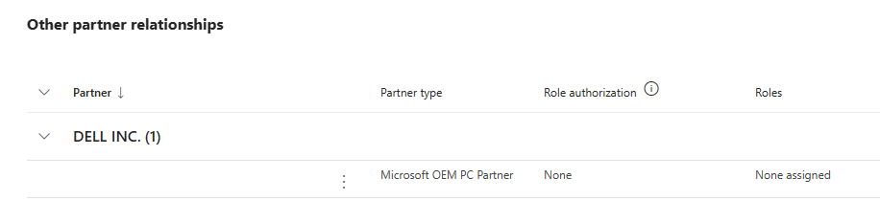
Figure D1 – Showing the OEM partner relationship in the 365 Admin Center

Where manual registration is required, Microsoft’s Get-WindowsAutoPilotInfo [26] PowerShell script can be used to collect and upload the device hardware hash to the Intune tenant [26]. Figure D2 shows the Autopilot devices view in the Intune admin centre, including device serial number, model, manufacturer, group tag and purchase order information.

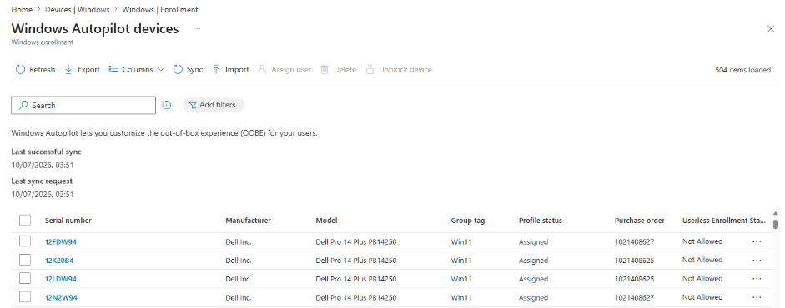
Figure D2 – A view of the Autopilot devices in Intune

Dynamic Device Group
Each Autopilot device was assigned a Group Tag value. A dynamic device group was then created in Microsoft Entra ID using this field, ensuring that devices with the pilot Group Tag were added automatically. Figures D3 and D4 show the group properties and membership rule.
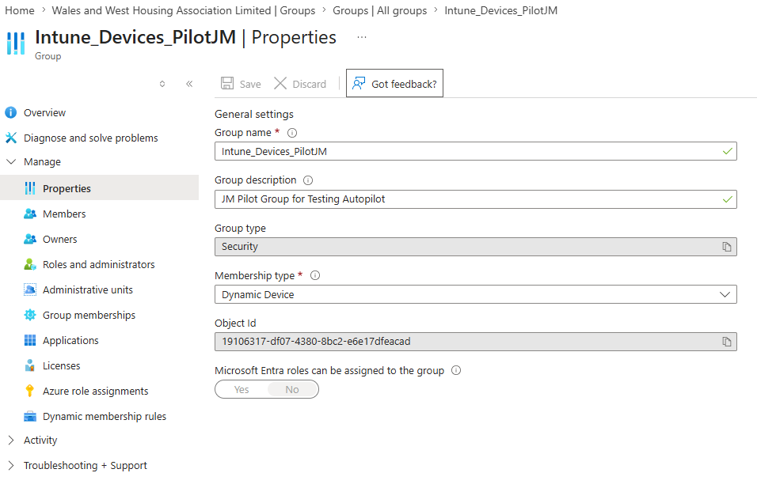
Figure D3 – Dynamic device group properties

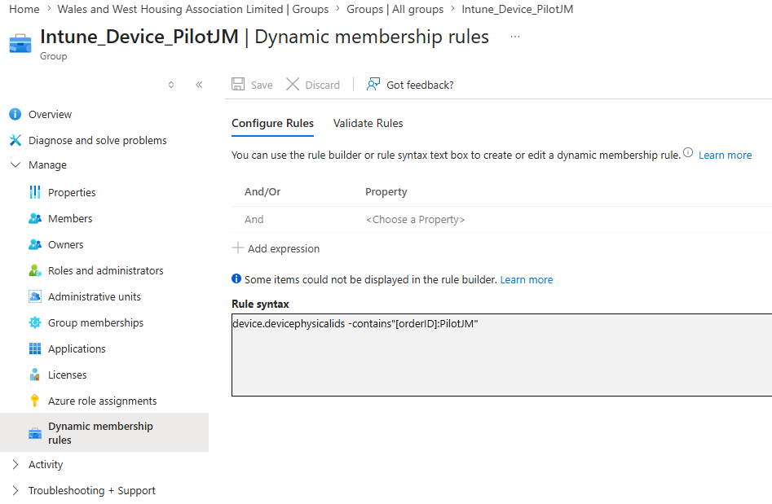
Figure D4 – Dynamic device group membership rules

For the pilot, the same dynamic device group was used for profile, policy and application assignments. In production, separate assignment groups should normally be used for different applications, policies and deployment purposes to provide more granular control.

Autopilot Deployment Profile
An Autopilot deployment profile was created and assigned to the pilot device group. The profile controlled how devices behaved during the Windows out-of-box experience and ensured that pilot devices followed the required WWH pre-provisioned deployment process.
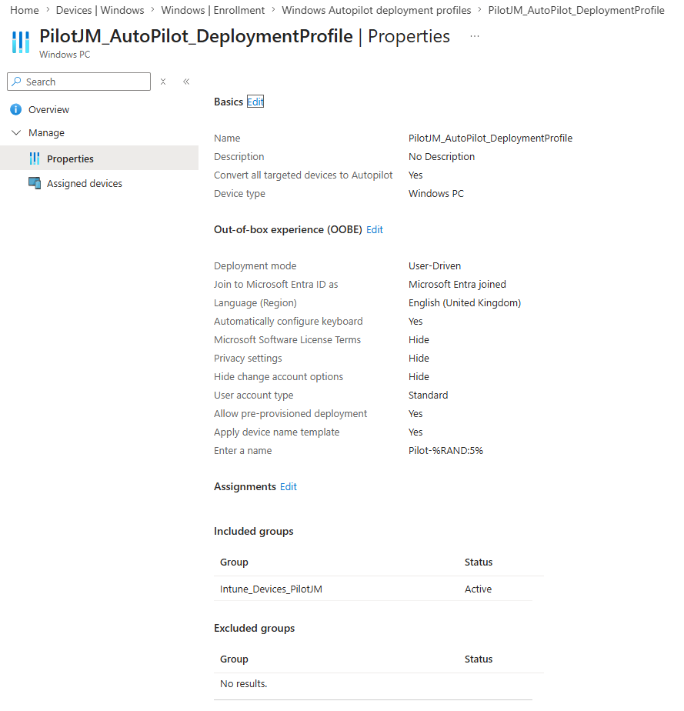
Figure D5 – Autopilot deployment profile settings

Because the profile was assigned to the dynamic pilot device group, any device registered with the correct Group Tag automatically received the correct deployment profile, as shown in Figure D6. This reduces manual assignment and supports repeatable device onboarding.
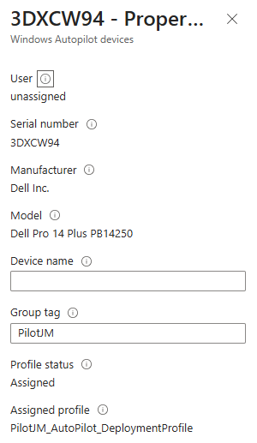
Figure D6 – Details of Autopilot device assigned profile

The key deployment profile settings used for the pilot are summarised in Table D1.

Profile Area | Pilot Configuration | Reason for Selection
Deployment mode | User-driven deployment, used with IT-led pre-provisioning | Allows IT staff to prepare the device before handover while still allowing the end user to complete final sign-in
Join type | Microsoft Entra joined | Supports the required cloud-based management model
Profile assignment | Assigned to the Autopilot pilot dynamic device group | Ensures devices with the correct Group Tag automatically receive the correct deployment profile
User account type | Standard user | A more secure default configuration by avoiding local administrator rights for end users
Device naming | Serial-number-based naming format | Supports consistent device identification in Intune and during support
OOBE privacy settings | Privacy settings hidden where possible | Reduces unnecessary user interaction during first sign-in
OOBE account setup | Organisation sign-in required | Ensures the device is associated with the correct WWH user and enrolled into management
OOBE setup screens | Unnecessary setup screens hidden where possible | Simplifies the first-use experience and makes the handover process more predictable
Pre-provisioning use | Devices prepared by IT before handover | Allows core configuration, policy application and application installation to complete before the user receives the device
Table D1 – Summary of Autopilot deployment profile settings used for the pilot

This deployment profile is a key part of the pilot because it connects the device registration and group assignment process to the actual user setup experience. It also demonstrates why governance is required: if the wrong profile is assigned, or if profile settings are changed without control, devices may be provisioned in an inconsistent or unsupported way. For this reason, the final framework recommends that Autopilot deployment profiles should have clear ownership, consistent naming standards, documented settings and a controlled change process before wider rollout.

Enrolment Status Page
An Enrolment Status Page was configured to control the device enrolment experience and allow the process to wait for required applications and policies before the device was considered ready. This was important because pre-provisioning needed to deliver more than Entra ID join and Intune enrolment; the device also needed to receive required configuration, compliance settings and core applications before handover. The ESP settings were kept deliberately simple for the pilot, as the aim was to validate the core deployment process without creating an overly complex production configuration.
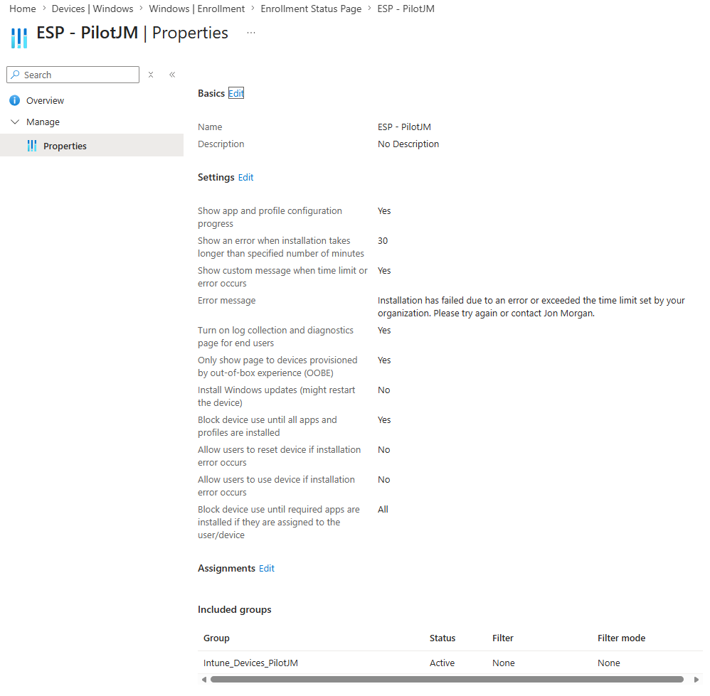
Figure D7 – The ESP configured settings

The ESP also has governance implications. In a wider rollout, WWH would need to define which applications and policies are critical enough to block setup and which can install after sign-in. Too many blocking items may slow or destabilise setup, while too few may result in users receiving devices before essential software is installed. The framework therefore recommends that ESP settings are documented, reviewed and aligned with application deployment standards.

Application Deployment
Application deployment was included in the pilot to test whether Intune could install required software automatically during the Autopilot provisioning process. This is an important part of the proposed framework because a device should not only be enrolled and managed; it should also receive the core applications required for productive use.
For the pilot, the application scope was deliberately limited to common baseline applications used by most WWH staff. Microsoft 365 Apps and Google Chrome were selected because they represent standard software required across much of the organisation. Department-specific applications were excluded from the pilot to keep the implementation controlled and to avoid introducing unnecessary packaging or compatibility issues at this stage.
Microsoft 365 Apps were deployed using the Microsoft 365 Apps deployment option within Intune. This allows the required Office applications, such as Word, Excel, Outlook and PowerPoint, to be assigned and installed without needing to package the installer manually. Google Chrome was also deployed through Intune and assigned to the pilot device group as a required application.
Both applications were assigned to the same pilot device group used for the Autopilot deployment profile. This meant that devices with the correct Autopilot Group Tag would automatically receive the required application assignments during provisioning. For the limited pilot, this simplified the assignment process and ensured that application deployment was linked to the same controlled pilot scope as the Autopilot profile.
The application deployment configuration used for the pilot is summarised in Table D2.
Application | Deployment Method | Assignment | Purpose in Pilot
Microsoft 365 Apps | Microsoft 365 Apps deployment through Intune | Required for pilot device group | Tests deployment of standard productivity applications required by most WWH users.
Google Chrome | Intune application deployment | Required for pilot device group | Tests deployment of a commonly used third-party application.
Table D2 – Summary of deployed applications

Application deployment also highlighted an important governance requirement for wider rollout. While Microsoft 365 Apps and Chrome are relatively straightforward baseline applications, the wider WWH application estate is likely to include department-specific or specialist software with different installation requirements. Before wider migration, WWH would need a controlled application onboarding process covering packaging, testing, assignment groups, detection rules, update behaviour and support ownership.
For this reason, the framework recommends that applications should be grouped into categories such as core applications, role-specific applications and optional applications. Core applications can be assigned broadly to standard devices, while role-specific applications should be tested and assigned to more targeted groups. This would reduce the risk of unnecessary software being installed on all devices and provide better control as Intune adoption expands beyond the pilot.

Security and Compliance Configuration
Security and compliance configuration was included in the pilot to test whether devices provisioned through Autopilot could also receive centrally managed security settings through Intune. This is important because the proposed model is not only concerned with deploying a device, but also with ensuring that the device remains managed and subject to security and compliance controls after handover.
For the pilot, a deliberately limited security and compliance baseline was used. The purpose was not to implement a full production security baseline, but to validate that key endpoint security settings could be applied and monitored through Intune. This kept the pilot controlled while still testing an important part of the proposed governance framework.
Three endpoint security policies were created for the pilot: Microsoft Defender Antivirus, BitLocker disk encryption, and Windows Firewall. Each policy was assigned to the pilot device group, Intune_Device_PilotJM, so that devices included in the pilot received the same baseline security configuration.
The Microsoft Defender Antivirus policy was used to enable core antivirus protection, including behaviour monitoring and cloud protection. The BitLocker policy was used to require device encryption, helping to protect data if a device is lost or stolen. The Windows Firewall policy was used to ensure that the Windows Defender Firewall was enabled for the domain network profile.
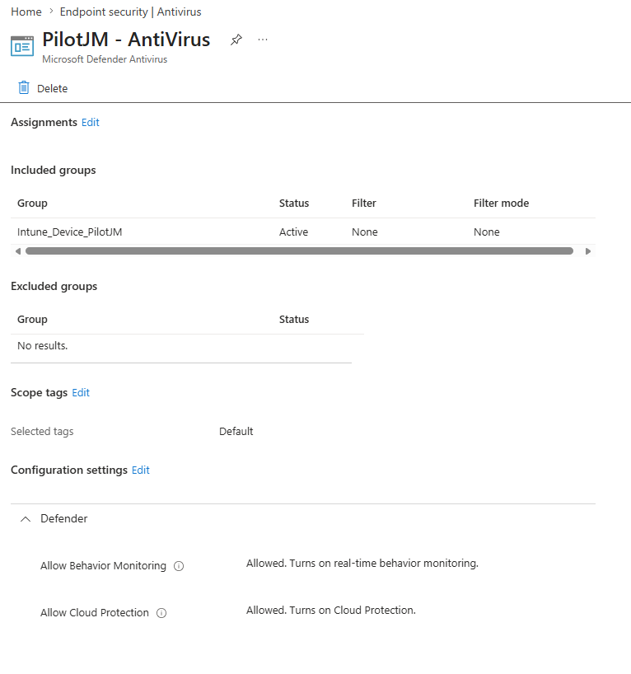
Figure D8 – Microsoft Defender Antivirus policy assigned to the pilot device group
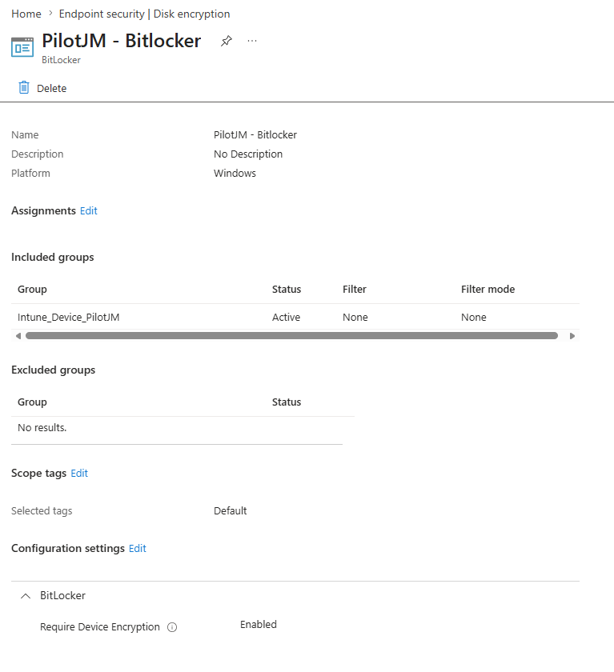
Figure D9 – Bitlocker disk encryption policy assigned to the pilot device group
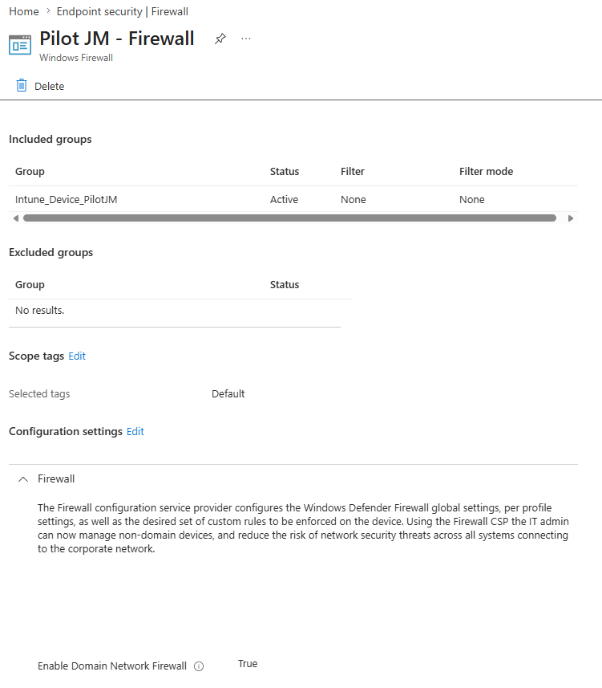
Figure D10 - Windows Firewall policy assigned to the pilot device group

A Windows compliance policy was also created and assigned to the pilot devices. This policy was used to assess whether enrolled devices met the selected minimum requirements. The configured requirements included BitLocker, Secure Boot, a minimum Windows OS version, device encryption, firewall, antivirus, Microsoft Defender Antimalware and real-time protection. Devices that did not meet these requirements were configured to be marked as non-compliant immediately.
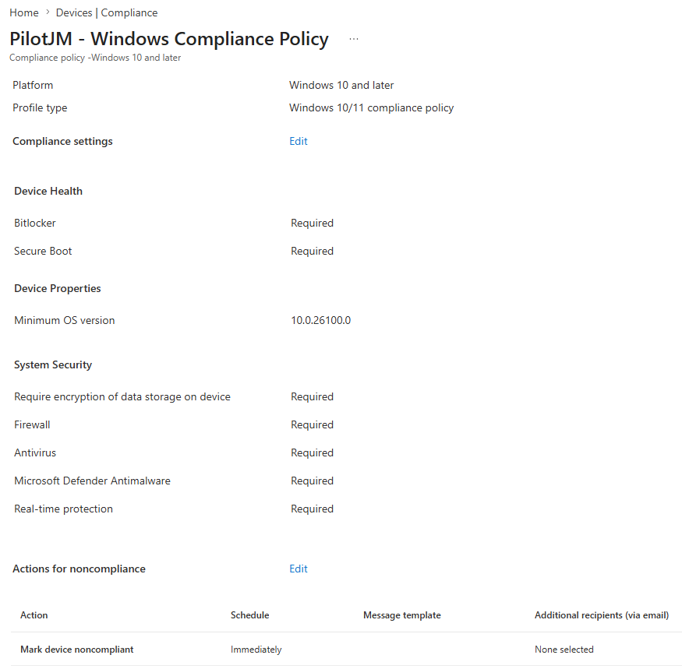
Figure D11 – Compliance policy used for the pilot

The security and compliance configuration used for the pilot is summarised below in Table D3.

Area | Pilot Configuration | Purpose
Microsoft Defender Antivirus | Behaviour monitoring and cloud protection allowed | Provides baseline malware protection for managed Windows devices.
BitLocker encryption | Device encryption required through Intune endpoint security policy | Helps protect organisational data if a device is lost or stolen.
Windows Firewall | Domain network firewall enabled | Provides baseline network protection for enrolled devices.
Secure Boot | Required through the compliance policy | Helps confirm that devices meet a basic hardware-backed security requirement.
Minimum OS version | Minimum Windows version set to 10.0.26100.0 | Ensures pilot devices are assessed against a supported Windows build requirement.
Antivirus and real-time protection | Required through the compliance policy | Ensures devices report the expected endpoint protection state.
Compliance action | Mark device non-compliant immediately | Allows compliance issues to be identified as soon as the policy is evaluated.
Table D3 – Summary of security and compliance settings used for the pilot

This configuration demonstrates how Intune can apply and monitor security requirements beyond initial deployment, as unlike with MDT, Intune policies continue to apply after handover and can be reviewed centrally.
The pilot also highlights the need for governance around security ownership and change control. Before wider rollout, WWH should define who owns endpoint security policies, how changes are tested, how compliance failures are reviewed and how exceptions are handled. The pilot baseline should be treated as a starting point, with fuller security baselines, Conditional Access integration and update compliance considered in future phases.

Pre-Provisioning Process
The pre-provisioning process starts when a WWH IT technician powers on a registered Autopilot device and enters the Windows out-of-box experience (OOBE). Network connectivity is established, with wired connectivity officially supported for pre-provisioning. The device then checks Microsoft’s cloud services and confirms whether it is registered to the WWH Autopilot tenant.
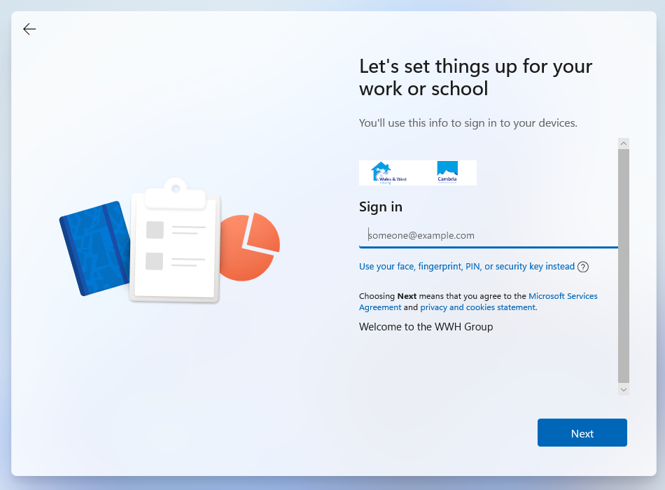
Figure D12 - WWH sign-in screen displayed during the Windows out of box experience

The technician starts pre-provisioning by pressing the Windows key five times. The device contacts the Windows Autopilot service, identifies itself using its registered hardware identity and receives the deployment profile assigned through the dynamic device group.
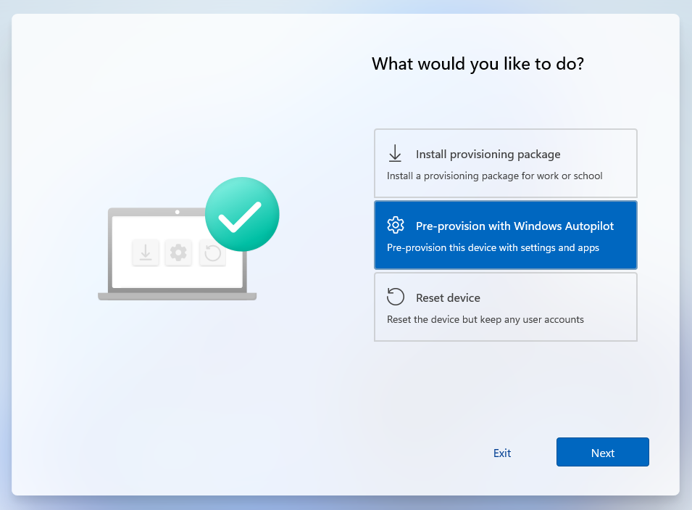
Figure D13 – Windows Autopilot pre-provisioning screen

The device then joins Microsoft Entra ID, enrols into Intune, applies assigned configuration and compliance policies, and installs required applications according to the Autopilot profile and Enrolment Status Page settings.
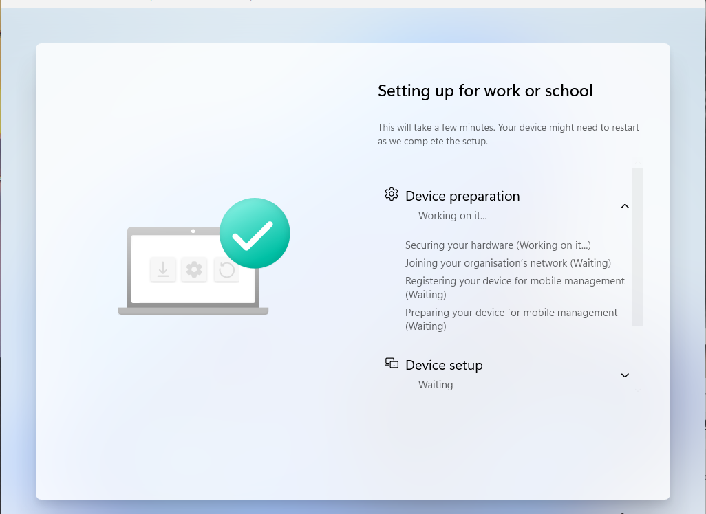
Figure D14 - Enrolment Status Page showing progress during Autopilot pre-provisioning

Once provisioning completes successfully, the technician selects Reseal. The device shuts down and is prepared for handover, leaving the end user to complete only final sign-in and user-specific setup.
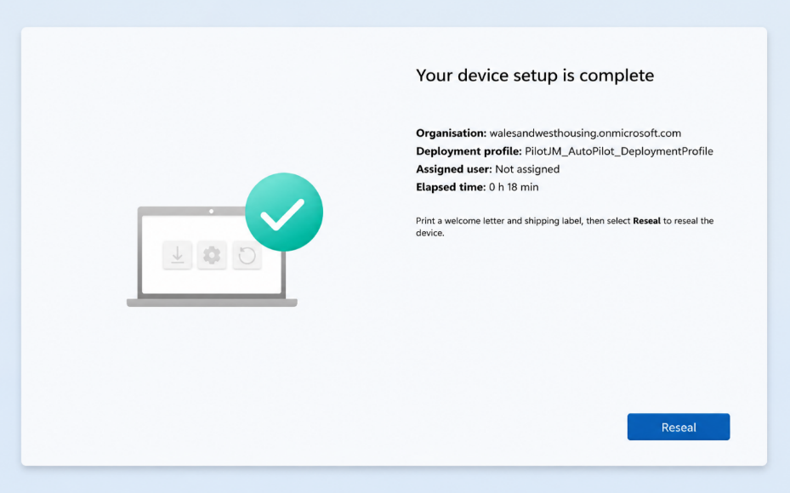
Figure D15 - Successful completion of the Windows Autopilot pre-provisioning process

