Material Properties of Rubber


Experiment conducted by Kieran Cassidy

Contents

1. Introduction…………………………………………………………………………….. 3
2. Prior Research…………………………………………………………………………. 3
2.1 Key Properties……………………………………………………………………….. 3
2.2 Vulcanization…………………………………………………………………………. 4
2.3 Temperature & Creep……………………………………………………………….. 4
3. Experimental Method………………………………………………………………….. 5
4. Results………………………………………………………………………………….. 5
4.1 Engineering Stress/ Strain………………………………………………………….. 7
4.2 True Stress/ Strain…………………………………………………………………… 9
5. Analysis of results…………………………………………………………………….. 12
5.1 Engineering Stress/ Strain Curve……………………………………………… 12
5.2 True Stress/ Strain Curve………………………………………………………….. 13
5.3 Chemistry of rubber………………………………………………………………… 13
5.4 Standard deviation………………………………………………………………….. 14
6. Experiment Accuracy………………………………………………………………… 15
7. Conclusion…………………………………………………………………………….. 15
8. References……………………………………………………………………………… 16

Introduction

The outcome of this test is to find the stress/strain curve of a rubber band. There are several definitions of stress and strain. My desired outcome is to calculate the ‘engineering stress/strain’ and then the ‘true stress/strain.’ I did this by creating my own test, applying force to a rubber band while measuring the tension.

Using an engineering stress / strain curve is useful for a design perspective. This test shows the material breaking point. This is important when designing an elastic stretched component.

Graphs incorporate Young’s modulus (see Fig. 1), which is beneficial from a design perspective because it shows how material behaves under force. The engineering stress/strain graph will show the amount the rubber can stretch compared to its original length before it breaks. The true stress/strain curve graph is more practical from a material science point of view because it shows how rubber exhibits a property where it hardens as you apply stress.

Fig 1. Labelled stress/strain curve
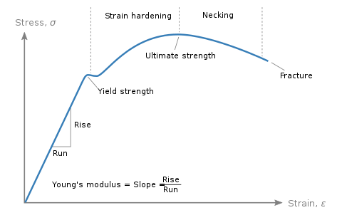

Prior Research

Before starting my testing, I decided to review existing research on rubber material testing. Exploring mechanical properties of the rubber prior to the test will benefit results. Some aspects of my research affected the way I carried out the testing and changed the way I looked at my results.

2.1 Key Properties

The key properties of rubber material are hardness, tensile strength, tensile modulus, elongation, resilience, tear Resistance, ultimate tensile strength, Young’s modulus, fatigue limit and toughness. Throughout my testing I examine these properties and investigate how they perform.
Rubber is a type of polymer. Monomers make this polymer. The monomer for rubber is isoprene. The rubber band is a vulcanised natural rubber. The advantage of using natural rubber over synthetic is the superior elasticity.

Fig 2. Underlying chemistry

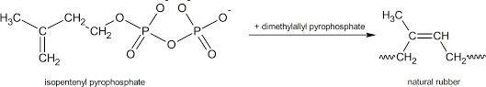

2.2 Vulcanization

Research shows the key properties of rubber material can be manipulated by processes such as ‘vulcanization’ accidentally discovered by Charles Goodyear in 1839.

When vulcanization is performed on rubber, the rubber shrinks while retaining its original shape. As Kruželák et al. (2016) suggest, rubber also hardens after the vulcanization processes, increasing the tensile strength.

“Vulcanization essentially scales down rubber to a smaller size, all without deforming or altering its shape. In addition to altering its size while retaining its shape, vulcanization also protects rubber from future deformation. As it’s shrunk, rubber hardens and becomes less vulnerable to deformation. It may still deform when exposed to enough stress, but vulcanized rubber won’t deform as easily as conventional, non-vulcanized rubber.” (Kumar and Nijasure,1997).

2.3 Temperature & Creep

One interesting aspect of the material properties I wanted to test is the concept of ‘creep’ and how temperature would affect the way the rubber band performs. Creep is when rubber deteriorates over time when subjected to a constant stress (Oman and Nagode, 2014).

“Creep tests, extending in some cases as long as 900 days, indicate that both natural and synthetic rubbers such as Neoprene and butadiene copolymer can be compounded to give satisfactory service in shear mountings. At 140° F, creep is from two to nine times greater than at 80° F, depending on the compound. Tests at room temperature do not indicate either the amount of creep or the life to be expected at higher temperatures.” (Hahn and Gazdik, 1941)

Experimental Method

When carrying out my testing, I hung the elastic band from a wire attached to a bar (see Fig. 3). The bucket had a safety rope and was attached to the band via a clip. The safety rope stopped the bucket filled with rocks falling to the ground and being damaged.

The ropes did not have any tension in them while the bucket was attached to the rubber band. They would only come into use when the band eventually snapped. After the band and bucket was attached, the bucket was gradually filled with rocks (300g each time). Each time rocks were added the length of the rubber band would be measured. The weight of the bucket (force applied to the band) and length of the band were recorded simultaneously. These results then allowed me to calculate the material properties.

Fig. 3 – Diagram of Jig Used

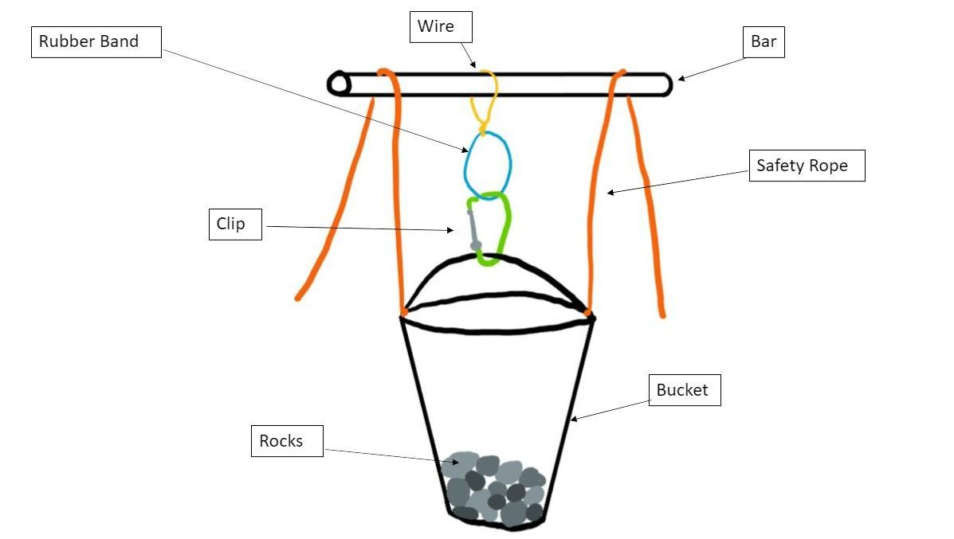

Results

In terms of results (Table 1.), the first column includes the weight of rocks added to the bucket to apply force to the rubber band.
The middle column shows the length of the rubber band at each force increase. This records, once snapped, the amount the band stretched compared to its original length.
The third column shows the force applied to the rubber band overall at each interval.

Table 1: Data on impact of applying rocks to bucket

Rocks (gf) | Length (mm) | Force (gf)
0 | 80 | 0
0 | 130 | 720
200 | 155 | 920
331 | 211 | 1251
307 | 256 | 1558
314 | 294 | 1872
341 | 324 | 2213
312 | 344 | 2525
313 | 364 | 2838
314 | 382 | 3152
323 | 394 | 3475
324 | 409 | 3799
318 | 422 | 4117
0 | SNAP | 0

After the three columns were complete, I plotted an initial graph:

Fig. 4 Graph to show tension

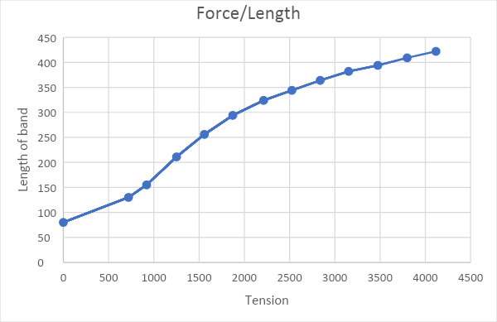

4.1 Engineering Stress/ Strain

To get a better understanding of the properties and behavers of rubber I calculated the engineering stress/strain using the following formula based on the principles of Young’s modulus:

$$ε= \frac{ΔL}{L_{O}}$$

$ε$ = Engineering Strain
$ΔL$ = Change in Length
$L_{O}$ = Original Length

To calculate Engineering Stress, I used the formula:

Engineering Stress = $\frac{Force}{Original Cross Sectional Area}$

Before using the formula, I needed to calculate the Force:

Force in N = mg

m = Mass
g = Acceleration due to gravity (9.81)

To find the cross-sectional area I used a pair of callipers.

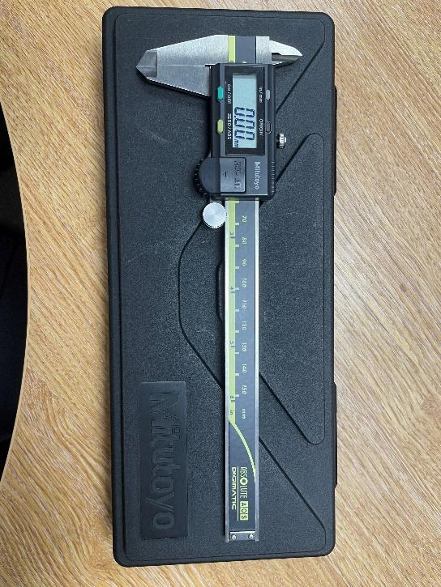

Section
1.32mm
2.34mm

Area
3.08mm

Cross Sectional Area
6.16mm

I calculated the engineering stress-strain and plotted them in an excel table.

Table 2. Engineering stress/strain calculation:

Rocks (gf) | Length (mm) | Force (gf) | Force (N) | Engineering Strain | Cross Sectional Area | Engineering Stress
0 | 80 | 0 | 0 | 0 | 6.16 | 0
0 | 130 | 720 | 7.0632 | 0.625 | 3.790769231 | 1.146623377
200 | 155 | 920 | 9.0252 | 0.9375 | 3.179354839 | 1.46512987
331 | 211 | 1251 | 12.27231 | 1.6375 | 2.335545024 | 1.992258117
307 | 256 | 1558 | 15.28398 | 2.2 | 1.925 | 2.481165584
314 | 294 | 1872 | 18.36432 | 2.675 | 1.676190476 | 2.981220779
341 | 324 | 2213 | 21.70953 | 3.05 | 1.520987654 | 3.524274351
312 | 344 | 2525 | 24.77025 | 3.3 | 1.43255814 | 4.021144481
313 | 364 | 2838 | 27.84078 | 3.55 | 1.353846154 | 4.519607143
314 | 382 | 3152 | 30.92112 | 3.775 | 1.290052356 | 5.019662338
323 | 394 | 3475 | 34.08975 | 3.925 | 1.250761421 | 5.534050325
324 | 409 | 3799 | 37.26819 | 4.1125 | 1.204889976 | 6.050030844
318 | 422 | 4117 | 40.38777 | 4.275 | 1.167772512 | 6.556456169
0 | SNAP | 0 | 0 | 0 | 0 | 0

Using this data, I plotted an engineering stress-strain graph.

Fig. 6 – Engineering stress-stain curve
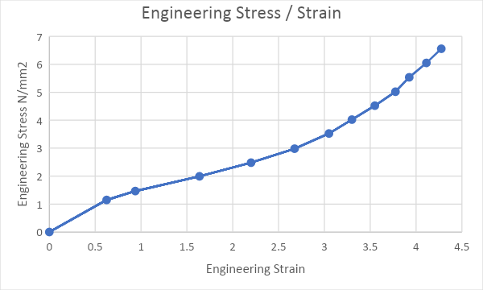

4.2 True Stress/ Strain

The next step was to create a True stress-strain curve using the formula below:

$$ϵ_{T}=Σ\frac{ΔL}{L}$$

$ϵ_{T}$ = True Strain
$Σ$ = Sum of
$ΔL$ = Change in Length
$L$ = Length at that time

$$ϵ_{T}= \int_{Lo}^{Lf}{\frac{1}{L}} dl$$

$ϵ_{T}$ = True Strain

$\int_{Lo}^{Lf}{\frac{1}{L}} dl$ = Integral of L with limit from original length to final length.

$$ϵ_{T}= \begin{matrix}Lf \\ [ \\ Lo\end{matrix} lnL ]$$

$$ϵ_{T}=ln⁡l_{f}-ln⁡l_{o}$$

$$ϵ_{T}=ln⁡\frac{l_{f}}{l_{o}}$$

$ϵ_{T}$ = True Strain
$l_{f}$ = Final Length
$l_{o}$ = Original Length

To calculate the True stress, I used the below formula.

$$\frac{Force}{Actual Cross Sectional Area}$$

I approximated that the volume of the band was going to remain constant. For example, an engineering strain of one (doubled the length) could assume half the cross-sectional area.

I then recorded the results using excel:

Table 3: Results of True stress/strain

Rocks (gf) | Length (mm) | Force (gf) | Force (N) | True Strain | Cross Sectional Area | True Stress
0 | 80 | 0 | 0 | 0 | 6.16 | 0
0 | 130 | 720 | 7.0632 | 0.485507816 | 3.790769231 | 1.863262987
200 | 155 | 920 | 9.0252 | 0.661398482 | 3.179354839 | 2.838689123
331 | 211 | 1251 | 12.27231 | 0.969831499 | 2.335545024 | 5.254580783
307 | 256 | 1558 | 15.28398 | 1.16315081 | 1.925 | 7.93972987
314 | 294 | 1872 | 18.36432 | 1.301553133 | 1.676190476 | 10.95598636
341 | 324 | 2213 | 21.70953 | 1.398716881 | 1.520987654 | 14.27331112
312 | 344 | 2525 | 24.77025 | 1.458615023 | 1.43255814 | 17.29092127
313 | 364 | 2838 | 27.84078 | 1.515127233 | 1.353846154 | 20.5642125
314 | 382 | 3152 | 30.92112 | 1.563393974 | 1.290052356 | 23.96888766
323 | 394 | 3475 | 34.08975 | 1.594324275 | 1.250761421 | 27.25519785
324 | 409 | 3799 | 37.26819 | 1.631688521 | 1.204889976 | 30.93078269
318 | 422 | 4117 | 40.38777 | 1.662978679 | 1.167772512 | 34.58530629
0 | SNAP | 0 | 0 | 0 | 0 | 0

Using this data, I plotted a True Stress/ Strain graph:

Fig. 7 True stress/strain Curve
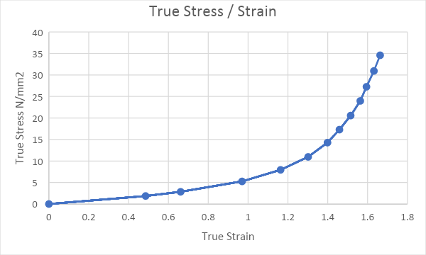

The toughness of the material is also known as the impact strength - amount of impact the material can withstand before breaking. The toughness can be found by looking at the area underneath the Engineering stress/strain curve.

To calculate the toughness, I applied the formula below to each segment.

Toughness = $\frac{Total Energy absorbed}{Total Volume}$ * 1000000

Energy absorbed = Average Force + Length Travelled in Meters

Total Volume = Cross Sectional Area * Length

The calculations can be seen below.

Length (mm) | Energy | Force (N)
80 | 0 | 0
130 | 0.17658 | 7.0632
155 | 0.201105 | 9.0252
211 | 0.59633028 | 12.27231
256 | 0.620016525 | 15.28398
294 | 0.6393177 | 18.36432
324 | 0.60110775 | 21.70953
344 | 0.4647978 | 24.77025
364 | 0.5261103 | 27.84078
382 | 0.5288571 | 30.92112
394 | 0.39006522 | 34.08975
409 | 0.53518455 | 37.26819
422 | 0.50476374 | 40.38777
SNAP |  | 0

Total Energy | 5.784235965
Total volume | 522.6144
Toughness | 11067.88478

Analysis of results

The Initial graph shows that as the tension is increased the length of the band also increases. The length of the band has increased 5.275 times the original length. This shows the elasticity of the rubber, which is often a property that is looked for in a rubber component.

Fig. 8 – Length / Tension Curve

Engineering Stress/ Strain Curve

The Engineering Stress/ Strain curve will give a better design perspective. The Ultimate Tensile Strength (UTS) from the engineering curve is 6.55N/mm². The UTS shows the how much force the rubber can hold without fracturing when stretched. Some examples of rubber products that require a high UTS would be bungee cords, rubber tie downs and drive belts. To calculate the UTS I used the below graph alongside the table.

Fig. 9 –Engineering stress/strain curve

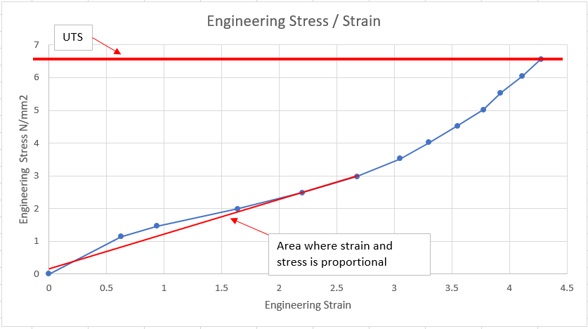

The initial Young’s modulus from the engineering curve was 1127802 N/m².

Youngs modulus = $\frac{Engineering Stress}{Engineering Strain}$

I then converted it to SI units.

The Young’s modulus is important because it shows the stiffness of the material. The steepness of the curve represents how much it resists deformation. This means the steeper the curve the tougher the rubber is.

Also, as in figure 9 the rubber band is 5.275 times its original length. I found this result the most interesting as it shows the capability of the rubber.

5.2 True Stress/ Strain Curve

The True stress/strain curve gives a better understanding of the material properties.

Fig. 10 Engineering stress/strain Curve

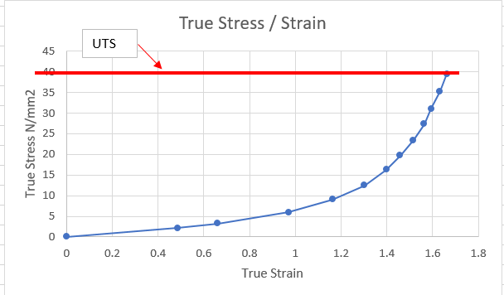

After using the graph and table I worked out the Ultimate Tensile Strength (UTS) to be 39.45N/mm². Also the Young’s modulus = 7786757 N/m2. Both of these figures are important for the reasons mentioned above.

5.3 Chemistry of rubber

It is important to note that a rubber band is a vulcanised natural rubber. Within the industry where rubber is used for a component, during the material selection process, a material with a certain property such as flame retardant may be wanted, however the material might still need to meet certain mechanical properties.
Therefore, different resins are added together to create a rubber component with flame retardant properties meeting the required mechanical specification.

Rubber is made up of polymer molecules. Some physical properties are not largely affected by the chemical structure of the polymer molecule such as tensile and tear strength. For many elastomers these would be similar values. However, when testing the rubber under different conditions the strength can change dramatically.

5.4 Standard deviation

I completed three sperate tests of supposedly identical bands. After this I took the mean and Standard deviation of the results I found. The mean and standard deviation for the True Strain results were as follows:

Band 1
Mean | 1.062436
Standard Deviation | 0.382983

Band 2
Mean | 1.484273
Standard Deviation | 0.330885

Band 3
Mean | 1.200448
Standard Deviation | 0.380361

The mean and standard deviation for the True Stress results were as follows:

Band 1
Mean | 9.376953
Standard Deviation | 5.762048

Band 2
Mean | 19.59828
Standard Deviation | 11.16308

Band 3
Mean | 12.74124
Standard Deviation | 7.67711

The formula used to find the Standard Deviation was:

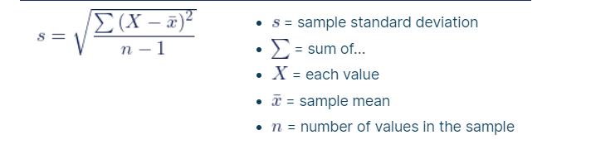

Experiment Accuracy

I am happy with the outcome of my test. Given more money and time there are a few aspects I would change or improve on. There were some sources of variation throughout my test. For example, the length in time between measuring the band, recording the results, and then adding additional weight varied and the rubber band could therefore be under stress for extended periods of time. The rocks were dropped into the bucket could also have produced variation in my results. The rubber bands were left on a table before the test began. This could have caused inaccuracies as a result of being stretched before being used.

If I had more money and time, I would design a jig that would add the weight to be more evenly distributed and added periodically. This would limit variables. Also, I would test the rubber in different temperatures. For example, in a large fridge and then an oven for different cycles. This would give me a better understanding on how temperature affects the properties of the rubber.

However, I recognised there is a trade-off between the time and money it took to complete the experiment. The quality of my results could be improved but nevertheless gave a good understanding of the material properties. Obviously more time spent on the testing would result in more accurate findings however I do not believe this would be noticeably beneficial to the results.

Conclusion

The rubber band exhibited a great elasticity range stretching more than 5 times its original length while also holding an impressive load under tension.

The rubber band showed a Ultimate Tensile strength of 39.45N/mm².

This shows it can hold impressive weights for the volume of the rubber. The results were satisfactory, but more time and precision could give a better representation of the rubbers capabilities. The vulcanised natural rubbers chemistry will be present in all rubber bands and the volume of the rubber will determine the results. These principles are important throughout all industries using or designing rubber products.

8. References

Hahn, S.H., Gazdik, I. 1941. The Creep of Natural and Synthetic Rubber Compounds in Shear. Rubber Chemistry and Technology 14 (2): 433–443.

Kruželák, J., Sýkora, R., Hudec, I. 2016. Sulphur and peroxide vulcanisation of rubber compounds – overview. Chemical Papers.

Kumar, S.S.R., Nijasure, A.M. 1997. Vulcanization of Rubber How to Alter Molecular Structure and Influence Physical Properties. Resonance. 55-59.
Oman, S., Nagode, M, 2014. Observation of the relation between uniaxial creep and stress relaxation of filled rubber Materials & Design 60 451-457.
How Vulcanization Improves the Properties of Rubber, 2019. Accessed 01.11.22: How Vulcanization Improves the Properties of Rubber | Blog Posts | OneMonroe (monroeengineering.com)

