
Skills for the Workplace
Module Assignment Submission
Student Name: | Anis Miah
Student Number: | 1818723
Module No: | BMSK5008
Module Title: | Changemakers: Building your Personal Brand for Sustainable Employment Portfolio Assignment One.

Statement of Confirmation of Authenticity
By the act of making this submission, the student declares that this is the work of the student named above. The work has not, in whole or in part, been knowingly presented elsewhere for assessment, or where assessment has been built on a previous assessment, this has been identified. Where materials have been used from other sources it has been properly acknowledged. If this statement is untrue, the student acknowledges that an assessment offence has been committed.
Attention is drawn to the plagiarism and unfair practice policies of UWTSD.

Table of Contents
PART A- 3
The report's author's personal growth strategy- 4
The current CV of the report's author- 5
PART B- 5
The letter below from report author Zander- 6
Reference 7

PART A-

PDP is in favour of the notion that learning is a continuous and all-encompassing process. The PDP process can help learners become better at reflecting on their own learning and accomplishments and making plans for their own personal, academic, and professional development. This is a fundamental learning process that is necessary throughout the educational system, as well as in many situations for work and ongoing professional growth.
(Cheung, 2015).

The report's author's personal growth strategy-

Personal development plan
Target | Action to achieve | Evidence of completion | Target date
Don't get behind on any scheduled homework and stay current with your academic’s work | - Giving yourself adequate time to finish the task without hurrying.  - practising a talent until it is mastered | The assignment work will be finished promptly and at a high standard. | Ongoing throughout study (2022-2023).
Clock keeping | - Being prepared. recognise when it is necessary and when it is not.  - Create a schedule and stick to it. | Priorities will complete the task. | 30.07.2024
Reading and conducting more academic research | - Set aside time each day for academic research.  - Acquire books outside of the curriculum to deepen your knowledge | Obtain extensive experience in the field. | 30.09.2023
Become more driven to pass my course with a decent grade | - Strive to attend as many appointments as possible and resist the urge to become lazy.  - Encourage yourself to do your assignment on time and to a high standard.  - increase your participation in class activities and group projects. | Increasing knowledge of the subjects. The work will be finished to a high standard. | Ongoing throughout study (2022-2023).

The current CV of the report's author-

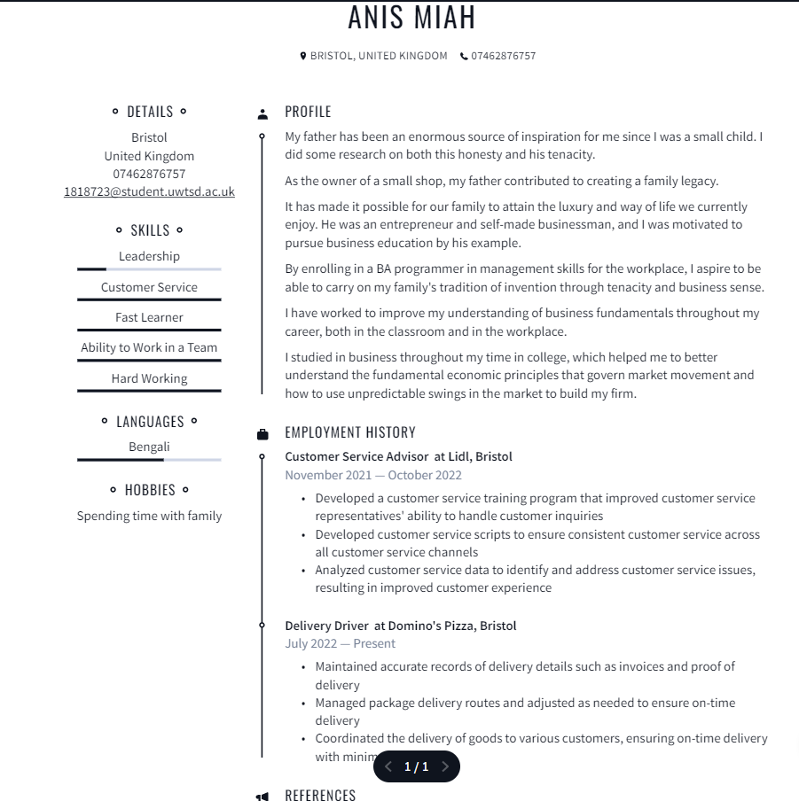

PART B-
Ben Zander is a professor at the New England Conservatory of Music as well as the conductor of the Boston Philharmonic Orchestra. For 25 years, he had to deal with the same issue: teaching pupils who were constantly worried about how their work would be judged and were hesitant to take risks. Zander requests that they emphasise in the letter "the person [the student] will have become (by the end of the course). the attitude, feelings, and worldview of that person who will have done all she wished to do or become everything he wished to be," and expresses particular interest in this.
(Rosamund Stone Zander, 2014).

The letter below from report author Zander-

Dear Anis from the past,
It's June 31st, 2023, and I have to say that I've had a very joyful and fulfilling year. I've experienced a lot of positive things and have developed into the person I wanted to be.
I'm relieved to have recovered from the health problems I had been experiencing for the past few years as a result of my father's death. I learn how to see the bright side of things thanks to my emotional intelligence skills. I also learned how to respond positively to challenging circumstances. I was able to manage my emotions and as a result, I was able to make many friends and my family began to enjoy spending more time with me.
I started believing in myself after I started my BA, which enabled me to resume working. I improved my emotional and financial stability since I had a lot of self-confidence.
I'm glad I was able to help my kids reach their full potential. They grew more conscious of their shortcomings and accepted responsibility for them. This has significantly advanced my vision!
I fulfilled numerous customers' requests and made them happy with their purchases. I gave one of my coworkers coaching and training based on their areas of weakness, which allowed them to return to their organisations and improve.
In addition, many employees in my organisation got the chance to experiment with agility and saw real benefits. Our
Sincerely,
Anis Miah

Reference
Cheung, J. C. M. (2015). Professionalism, profession, and quality assurance practitioners in external quality assurance agencies in higher education. Quality in Higher Education, 21(2), 151–170. https://doi.org/10.1080/13538322.2015.1051795
Rosamund Stone Zander. (2014). Art of possibility: transforming professional and personal life. Harvard Bus Review Press.

