Scenario to Motor Vehicle Branch ER Diagram:

Step by Step Exercise

The Scenario:
The Motor Vehicle Branch administers driving tests and issues driver's licenses. Any person who wants a driver's license must first take a learner's exam at any Motor Vehicle Branch in the province. If he/she fails the exam, he can take the exam again any time after a week of the failed exam date, at any branch. If he passes the exam, he is issued a license (type = learner's) with a unique license number. A learner's license may contain a single restriction on it. The person may take his driver's exam at any branch any time before the learner's license expiry date (which is usually set at six months after the license issue date). If he passes the exam, the branch issues him a driver's license. A driver's license must also record if the driver has completed driver's education, for insurance purposes.

Create an E-R diagram following these steps.

- Find out the entities in the spec;
- Find out the relationships among the entities;
- Figure out attributes of the entities and (if any) of the relationships;
- Figure out constraints between entities and relationships.

Solution:
First Part:
The entities in the specification are:
- Branch
- Driver
- License Learner
- License Driver
- License
Second Part:
Relationships:
takes exam(driver,branch):exam date, exam score, exam type
owns(license, driver)
issues(license, branch): issue data
"ISA" relationshhip : Learner license, Driver license "is a" license.

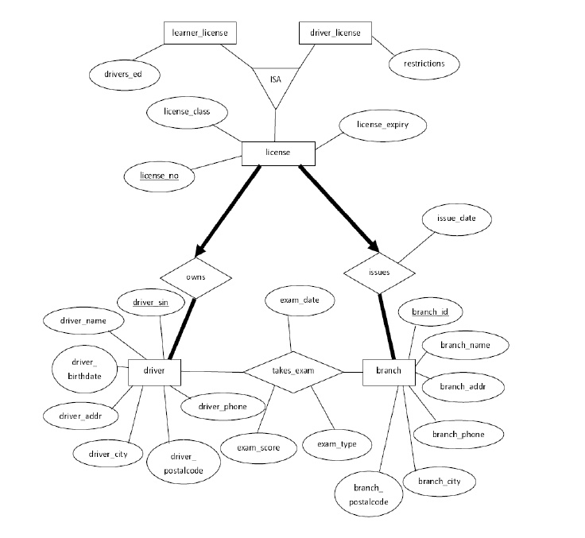

Part Four:
Constraints:
- a [driver] must <own> (at least one) [license];
- a [driver] must <take> at least one exam;
- a [license] must be <owned> by one and only one [driver];
- a [license] must be <issued> by one and only one [branch];
- a [branch] must <issue> at least one license

