LCHS7003
Community Care and Management of Longer-term Conditions
Student Name: | Sonia Altaf
Student ID: | 2209656
Lecturer | Aishat Bakre

INFORMATION BOOKLET
Dementia
Understanding the Condition
and Its Management
An information booklet for
health and care service users
and professionals in the UK


Contents
1. Understanding Dementia 4
2. How Common Is Dementia? 5
3. What Causes Dementia and Who Is at Risk? 5
4. How Does Dementia Affect People? 6
Physical impact: 6
Psychological impact: 6
Social impact: 7
5. Impact on Families and Carers 7
Emotional and psychological impact: 7
Social and financial impact: 7
Support and coping: 7
6. Treatment and Management in the NHS 8
Medication: 9
Non-drug treatments: 9
Coordinated and person-centred care: 9
Managing distress and advanced dementia: 10
7. Models for Better Long-Term Dementia Care 10
UK model 10
International model 10
Critical comparison: 11
8. Policy and Current Healthcare Priorities 11
National policy and early diagnosis: 12
Health and social care legislation: 12
Current healthcare priorities: 12
9. Living Well, Person-Centred Care and Self-Management 13
Self-management: 13
Emotional and social wellbeing: 14
Advance care planning: 14
10. Recommendations and Looking Forward 14
11. Conclusion / Key Messages 15
Refrence: 16

1. Understanding Dementia
Dementia is an umbrella term for a group of progressive conditions that damage the brain and cause decline in memory, thinking, communication, behaviour and ability to manage everyday activities.
It is not a normal part of ageing, although increasing age is the strongest known risk factor (WHO, 2026).
Alzheimer’s disease is the most common cause and accounts for approximately 60–70% of dementia cases worldwide (WHO, 2026). Other important types include vascular dementia, dementia with Lewy bodies and frontotemporal dementia. These conditions have different underlying causes; for example, vascular dementia results from reduced blood flow to the brain, whereas dementia with Lewy bodies involves abnormal deposits of alpha-synuclein protein (NHS, 2023).
Although dementia is generally progressive, its symptoms and rate of development vary between individuals. Alzheimer's disease commonly affects memory first, while vascular dementia may cause difficulties with planning, concentration and decision-making. Dementia with Lewy bodies can involve changes in alertness, movement and visual perception, whereas frontotemporal dementia often affects behaviour or language. Recognising these differences is important because assessment, treatment and support should reflect each person's symptoms and needs (NICE, 2018).

2. How Common Is Dementia?
Dementia is a growing public health concern worldwide, particularly as people live longer. According to the World Health Organization (WHO, 2025), approximately 57 million people were living with dementia globally in 2021, with nearly 10 million new cases each year. More than 60% of affected people live in low- and middle-income countries, showing that dementia is not only a problem in wealthy countries.
In the UK, Alzheimer’s Society (2024a) estimated that 982,000 people were living with dementia, with numbers projected to reach 1.4 million by 2040. However, more than one-third of affected people remain undiagnosed, making accurate measurement difficult (Alzheimer’s Society, 2024a).
The economic impact is also significant. Dementia was estimated to cost the UK £42 billion in 2024, potentially rising to £90 billion by 2040 (Alzheimer’s Society, 2024b). These projections highlight growing pressure on the NHS, social care services and families.
However, these projections depend on population trends, diagnosis rates and assumptions about future care costs. They should therefore be interpreted as estimates rather than exact predictions. Nevertheless, they highlight the need for sustainable investment in dementia prevention, diagnosis and long-term support.
3. What Causes Dementia and Who Is at Risk?
Dementia develops when brain cells become damaged, affecting memory, thinking and everyday activities. Different types have different causes. Alzheimer's disease is linked to abnormal amyloid and tau proteins in the brain, while vascular dementia develops when reduced blood flow damages brain tissue (NHS, 2023).
Non-modifiable risk factors include increasing age, genetics and family history. Age is the strongest risk factor, although dementia is not an inevitable part of ageing. Certain inherited genes increase the likelihood of developing dementia, but most cases are not directly inherited (Alzheimer's Society, 2024).
Modifiable risk factors include smoking, physical inactivity, high blood pressure, diabetes, hearing loss and social isolation. The Lancet Commission identified 14 potentially modifiable factors associated with approximately 45% of dementia cases (Livingston et al., 2024). However, this estimate does not mean that every case can be prevented, because much of the evidence comes from observational studies.
The WHO (2026) recommends healthier lifestyles and better management of existing conditions. Nevertheless, prevention also depends on access to healthcare, education and supportive environments. Therefore, reducing dementia risk requires both individual action and wider public health support.

4. How Does Dementia Affect People?
Dementia affects people physically, psychologically and socially. Its impact varies depending on the type and stage of dementia, the person's health and the support available.
Although symptoms usually become worse over time, each person's experience is different (NHS, 2023).
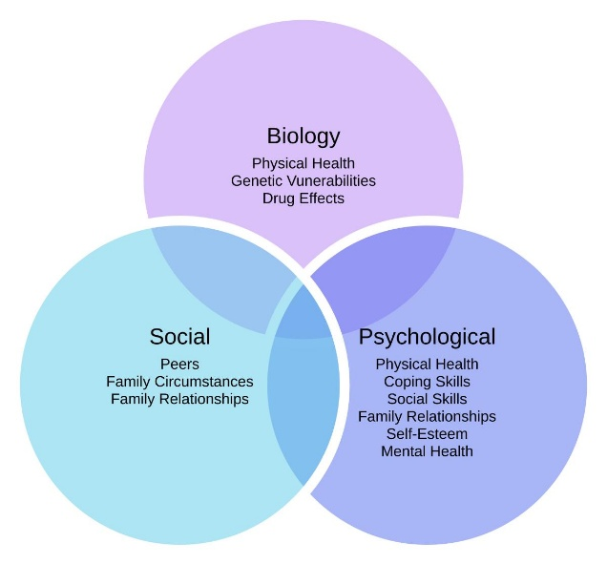
Figure 1:The biopsychosocial model illustrating biological, psychological and social factors affecting health (Source: Moment Physical Therapy and Performance, n.d.).
Physical impact: Dementia can affect movement, balance, coordination and the ability to carry out everyday activities. As the condition progresses, people may struggle with dressing, eating, washing and walking independently. Some may experience falls, swallowing difficulties and poor nutrition. These problems increase the need for support and can reduce quality of life (NICE, 2018).
Psychological impact: Memory loss, confusion and communication difficulties can cause anxiety, frustration, depression and fear. People may become distressed when they cannot recognise familiar places or remember important information. However, these experiences should not automatically be treated as unavoidable symptoms of dementia. Pain, loneliness and unsuitable environments can also contribute to distress (NICE, 2018).
Social impact: Dementia can affect relationships, employment, social activities and independence. Some people withdraw from social situations because they feel embarrassed or fear being judged. This can increase loneliness and reduce confidence. Alzheimer's Society (2024) highlights the importance of challenging stigma and helping people remain involved in their communities.
Although dementia can reduce independence, its impact varies between individuals. NICE (2018) recommends cognitive stimulation and rehabilitation to maintain abilities and wellbeing. However, their effectiveness may depend on dementia severity, individual needs and access to services. Therefore, regular reviews and personalised interventions are essential, rather than assuming that the same approach will benefit everyone. This highlights the importance of balancing independence, safety and quality of life through person-centred care (NICE, 2018).
Although cognitive stimulation and rehabilitation may support independence, their effectiveness varies according to dementia severity, individual abilities and access to services. Therefore, interventions should be regularly reviewed rather than assuming that the same approach will benefit everyone NICE (2018).

5. Impact on Families and Carers
Dementia affects not only the person diagnosed but also their family members and carers. As the condition progresses, relatives often take responsibility for personal care, medication, appointments and household activities. These increasing responsibilities can affect their emotional, physical, social and financial wellbeing (NICE, 2018).
Emotional and psychological impact: Family carers may experience stress, anxiety, depression and sadness as they observe changes in their loved one's memory, behaviour and personality. Caring responsibilities can also cause exhaustion and disturbed sleep, particularly when support is limited (Livingston et al., 2024).
Social and financial impact: Carers may reduce working hours, leave employment or withdraw from social activities. This can create financial pressure and increase isolation. However, the impact varies depending on family circumstances, available resources and access to professional support (Alzheimer's Society, 2024).
Support and coping:
Caring can also strengthen family relationships and provide a sense of purpose. Nevertheless, positive experiences do not remove the need for professional support.
NICE (2018) recommends carer assessments, practical training, emotional support and respite care. However, these measures do not automatically reduce carers' burden, as their effectiveness depends on timely access, affordability and individual circumstances. Therefore, evaluating carers' experiences is essential to ensure that support meets their needs and promotes safe, person-centred dementia care.

6. Treatment and Management in the NHS
Dementia currently has no cure, but NHS treatment can help manage symptoms, maintain independence and improve quality of life. Effective management requires early diagnosis, appropriate medication, psychological support and coordinated care based on individual needs (NICE, 2018).
Diagnosis and assessment: People experiencing memory problems usually visit their GP first. Assessment may include medical history, memory tests, blood tests and referral to a specialist memory clinic. Brain scans, such as MRI or CT, may help identify the type of dementia and exclude other conditions.

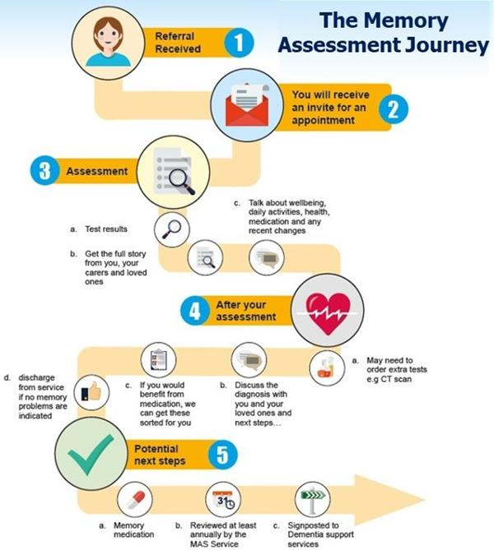
Figure 2: The Memory Assessment Journey, illustrating the stages of memory assessment, diagnosis and follow-up care (Source: Aneurin Bevan University Health Board, n.d.).

However, diagnosis can be difficult because symptoms overlap with depression, medication effects and other illnesses (NICE, 2018).
Medication: For Alzheimer's disease, the NHS may prescribe donepezil, rivastigmine or galantamine for mild to moderate symptoms. Memantine may be offered for moderate or severe Alzheimer's disease, depending on individual circumstances. These medicines can improve symptoms for some people but do not cure dementia or stop its progression (NHS, 2023).
Non-drug treatments: NICE (2018) recommends cognitive stimulation therapy for people with mild to moderate dementia. Occupational therapy, cognitive rehabilitation and meaningful activities can also support independence. Although these approaches may improve wellbeing and daily functioning, their benefits vary between individuals.
Coordinated and person-centred care: NHS dementia management involves GPs, specialists, nurses, occupational therapists and social workers. NICE (2019) recommends a named professional to coordinate care and review individual needs. Although coordinated care may reduce fragmented services, appointing a named professional does not guarantee better outcomes. Its effectiveness also depends on timely referrals, communication between services and sufficient staffing. Therefore, continuity of care should be evaluated through patient and carer experiences as well as service performance.
Managing distress and advanced dementia: Changes in behaviour should first be assessed for causes such as pain, infection or environmental stress. Antipsychotic medicines should be restricted to situations involving serious distress or risk of harm because of their potential side effects (NICE, 2018).
Although medication may improve symptoms for some people with dementia, treatment decisions must consider adverse effects, individual preferences and quality of life. Similarly, non-drug interventions should be assessed according to their impact on daily functioning and wellbeing, rather than cognitive improvement alone. This highlights the importance of regular reviews and individualised treatment planning (NICE, 2018).

7. Models for Better Long-Term Dementia Care
Long-term dementia care requires more than medical treatment. Effective care should support independence, dignity and quality of life while responding to changing needs. Two important approaches are the NHS England Enhanced Health in Care Homes (EHCH) Framework and the World Health Organization's (WHO) Integrated Care for Older People (ICOPE) Framework.
UK model – NHS England Enhanced Health in Care Homes (EHCH): This framework promotes coordinated care between GPs, community nurses, care homes and other professionals. It encourages personalised care planning, regular health reviews and early intervention to prevent avoidable hospital admissions (NHS England, 2023). For people with dementia living in care homes, this approach can improve continuity and help identify changing needs. However, its effectiveness depends on sufficient staffing, training and cooperation between services. It also focuses on care-home residents rather than everyone living with dementia in the community.
International model –
WHO Integrated Care for Older People (ICOPE): This approach promotes early assessment of memory, mobility, nutrition, mental wellbeing and social needs. It encourages personalised care plans and community-based support to maintain older people's abilities (WHO, 2025). For people with dementia, this can help address several health and social needs together.
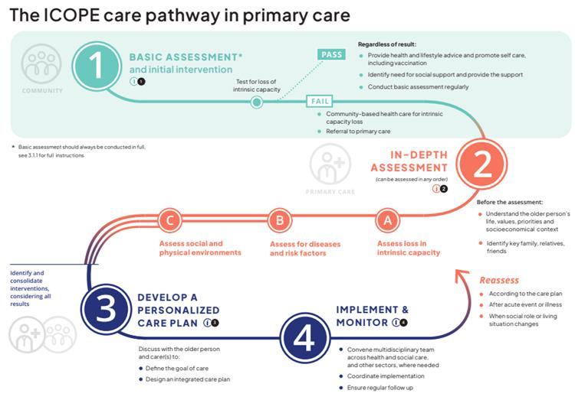
Figure 3 The ICOPE care pathway in primary care (Source: WHO, 2025).

However, ICOPE is not dementia-specific, and implementation may be difficult in countries with limited healthcare resources.
Critical comparison: Both frameworks promote coordinated, person-centred care, but their approaches differ. EHCH focuses on multidisciplinary support within NHS care homes, while ICOPE addresses broader physical, cognitive and social needs in community settings. A systematic review found that dementia case management improved some neuropsychiatric symptoms and short-term quality of life, but showed inconsistent benefits for cognition and carer burden (Saragih et al., 2021). However, this evidence does not directly establish the effectiveness of EHCH or ICOPE. Both frameworks also face challenges involving staffing, funding and access to specialist services. Therefore, combining personalised assessment with multidisciplinary reviews may offer a more comprehensive approach. However, neither framework should be considered superior without direct comparative evidence. Their value should be assessed through patient outcomes, carer experiences, service accessibility and cost-effectiveness.

8. Policy and Current Healthcare Priorities
UK dementia policies aim to improve early diagnosis, person-centred care and access to long-term support. However, delivering these priorities remains challenging because of increasing demand, workforce pressures and inequalities in healthcare access.
National policy and early diagnosis: The NHS Long Term Plan emphasises improving community healthcare and supporting people with complex conditions (NHS England, 2019). Early dementia diagnosis is important because it allows people to access treatment, plan future care and receive support. However, diagnosis alone is insufficient if specialist services and follow-up care are unavailable.
Health and social care legislation: The Care Act 2014 requires local authorities in England to assess eligible care and support needs, including those of unpaid carers. This promotes wellbeing and independence. Nevertheless, financial pressures and differences in local service provision can limit access to timely support (Great Britain, 2014).
Current healthcare priorities: The government's 10 Year Health Plan for England promotes three major changes: moving care from hospitals into communities, improving digital services and focusing on prevention (Department of Health and Social Care, 2025). NHS England (2026) also supports neighbourhood-based multidisciplinary care. These approaches could benefit people with dementia by improving continuity and reducing unnecessary hospital visits.
However, increased reliance on digital healthcare may create additional barriers for people living with dementia, particularly those experiencing cognitive difficulties or limited digital confidence. Therefore, accessible non-digital alternatives remain essential to ensure equitable access to care (NHS England, 2023).
Local implementation: At a local level, NHS memory assessment services and community-based dementia support can help translate national policy into practical care. For example, memory assessment pathways within Aneurin Bevan University Health Board illustrate how referrals, assessments and follow-up support can be organised. However, the availability and quality of these services may vary between areas. Therefore, national policies must be supported by sufficient local funding, trained professionals and accessible services.
Overall, dementia policy should prioritise equitable access, trained staff, coordinated services and carer support. Strong policies are important, but meaningful improvement depends on adequate funding and effective local implementation.

9. Living Well, Person-Centred Care and Self-Management
Living well with dementia involves maintaining independence, dignity and quality of life for as long as possible.
Person-centred care recognises individual preferences, abilities and cultural backgrounds. Although NICE (2018) recommends involving people with dementia in care decisions, balancing autonomy with safety remains challenging. Excessive protection may restrict independence, while insufficient support can increase risks. Therefore, care decisions should reflect individual preferences, changing abilities and regular assessments rather than applying the same approach to everyone.
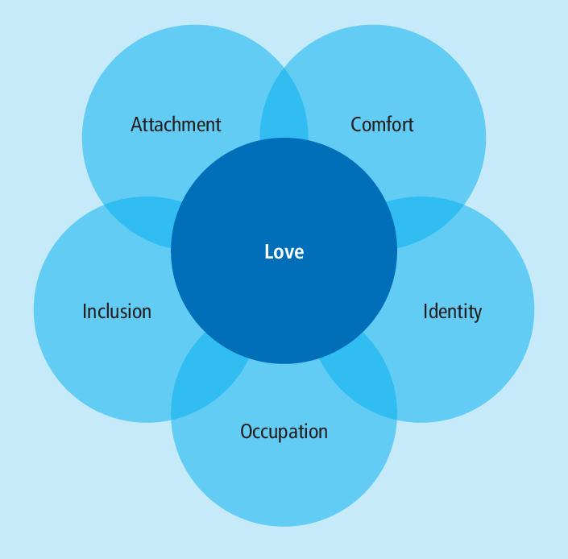
Figure 4:Kitwood’s flower of emotional needs in person-centred dementia care (Source: Lewington, Berragan and Kuruvilla, 2024).
Self-management: People with early-stage dementia can remain actively involved in managing their condition. Simple strategies, such as using calendars, medication reminders, maintaining routines and participating in physical and social activities, may support independence. However, these approaches become less effective as cognitive difficulties progress, making additional support necessary (WHO, 2019).
Emotional and social wellbeing: Meaningful activities, supportive relationships and dementia-friendly communities can reduce isolation and improve confidence. Alzheimer's Society (2024) emphasises the importance of helping people remain connected to their communities. Nevertheless, limited transport, financial difficulties and inaccessible services may prevent participation.
Advance care planning: As dementia progresses, individuals may lose the ability to communicate their treatment preferences. Early advance care planning allows people to express their wishes about future care while they have decision-making capacity. NICE (2018) recommends sensitive discussions involving individuals, families and healthcare professionals. Palliative care should also address pain, emotional distress, comfort and dignity. However, decisions may become challenging when family preferences differ from the person's previously expressed wishes. Regular reviews, clear communication and appropriate involvement of family carers can help ensure that care remains respectful, compassionate and consistent with individual preferences.

10. Recommendations and Looking Forward
Improving dementia care requires early diagnosis, coordinated services and greater support for individuals and families. Based on the evidence discussed, several improvements should be prioritised.
First, strengthen early diagnosis and follow-up care. Better access to memory clinics and regular assessments could help identify changing needs and reduce delays in treatment (NICE, 2018).
Second, improve support for family carers. Accessible training, emotional support and respite services could reduce carer stress and improve wellbeing (NICE, 2020).
Third, expand person-centred community care. Dementia-friendly activities, personalised care plans and multidisciplinary support could help maintain independence and reduce unnecessary hospital admissions (WHO, 2025).
Finally, improve advance care planning. Early discussions about future treatment, personal preferences and end-of-life care can protect dignity and support informed decisions (NICE, 2018).
However, these recommendations require adequate funding, trained professionals and equitable access. Future dementia services should prioritise quality of life alongside clinical outcomes.

11. Conclusion / Key Messages
Dementia is a growing public health challenge that affects individuals, families and healthcare services. Although there is currently no cure, early diagnosis, appropriate treatment and person-centred support can improve quality of life. Effective long-term care requires coordinated NHS services, accessible community support and greater recognition of family carers' needs. Prevention and early intervention are also important, although not all dementia cases can be avoided. Moving forward, dementia care must prioritise dignity, independence, equality and individual choice.
Adequate funding, trained professionals and compassionate care are essential to achieving better outcomes.

References:
Alzheimer’s Society (2024a) How many people have dementia in the UK? Available at: https://www.alzheimers.org.uk/cy/node/42286 (Accessed: (Accessed: 17 October 2026).
Alzheimer’s Society (2024) Living well with dementia. Available at: https://www.alzheimers.org.uk/get-support/living-with-dementia (Accessed: 17 October 2026).
Alzheimer’s Society (2024) Soaring dementia care costs reach £42 billion in UK – and families bear the brunt. Available at: https://www.alzheimers.org.uk/news/2024-05-10/soaring-dementia-care-costs-uk-42-billion (Accessed: 17 October 2026).
Alzheimer’s Society (2024b) The economic impact of dementia. Available at: https://www.alzheimers.org.uk/what-we-do/policy-and-influencing/economic-impact-of-dementia (Accessed: 17 October 2026).
Alzheimer’s Society (2026) Unlocking the door to dementia diagnosis and treatments. Available at: https://www.alzheimers.org.uk/what-we-do/policy-and-influencing/unlocking-door-dementia-diagnosis-treatments (Accessed: 11 October 2026).
Aneurin Bevan University Health Board (n.d.) The Memory Assessment Journey [Infographic]. NHS Wales. Available at: https://abuhb.nhs.wales/images/memory-assessment-service/the-memory-assessment-journey-png/ (Accessed: 10 October 2026).
Department of Health and Social Care (2025) 10 Year Health Plan for England: fit for the future. Available at: https://www.gov.uk/government/publications/10-year-health-plan-for-england-fit-for-the-future (Accessed: 17 October 2026).
Great Britain (2014) Care Act 2014. Available at: https://www.legislation.gov.uk/ukpga/2014/23/part/1 (Accessed: 11 October 2026).
Lewington, K., Berragan, L. and Kuruvilla, T. (2024) ‘Kitwood’s flower of emotional needs that evolved into person-centred care’ [Figure 1], in Trauma-informed approach to managing behaviour in dementia. Available at: https://www.researchgate.net/figure/Kitwoods-flower-of-emotional-needs-that-evolved-into-person-centred-care_fig1_380591013 (Accessed: 17 October 2026).
Livingston, G. et al. (2024) ‘Dementia prevention, intervention, and care: 2024 report of the Lancet standing Commission’, The Lancet, 404(10452), pp. 572–628. Available at: https://doi.org/10.1016/S0140-6736(24)01296-0.
Moment Physical Therapy and Performance (n.d.) What is the biopsychosocial model and how it is relevant to physical therapy. Available at: https://www.momentptp.com/blogs/what-is-the-biopsychosocial-model (Accessed: 14 October 2026).
National Institute for Health and Care Excellence (NICE) (2018) Dementia: assessment, management and support for people living with dementia and their carers. NICE guideline NG97. Available at: https://www.nice.org.uk/guidance/ng97/chapter/Recommendations (Accessed: 15 October 2026).
National Institute for Health and Care Excellence (NICE) (2019) Dementia: quality statement 4 – Coordinating care. Available at: https://www.nice.org.uk/guidance/qs184/chapter/Quality-statement-4-Coordinating-care (Accessed: 11 October 2026).
National Institute for Health and Care Excellence (NICE) (2019) Dementia: quality statement 6 – Managing distress. Available at: https://www.nice.org.uk/guidance/qs184/chapter/quality-statement-6-managing-distress (Accessed: 10 October 2026).
National Institute for Health and Care Excellence (NICE) (2020) Supporting adult carers. NICE guideline NG150. Available at: https://www.nice.org.uk/guidance/ng150 (Accessed: 14 October 2026).
NHS (2023) Can dementia be prevented?. Available at: https://www.gov.uk/government/publications/10-year-health-plan-for-england-fit-for-the-future (Accessed: 12 October 2026).
NHS (2023) Causes of dementia. Available at: https://www.nhs.uk/conditions/dementia/about-dementia/causes/ (Accessed: 10 October 2026).
NHS (2023) What are the treatments for dementia? Available at: https://www.nhs.uk/conditions/dementia/about-dementia/treatment/ (Accessed: 11 October 2026).
NHS (2024) Causes of dementia. Available at: https://www.nhs.uk/conditions/dementia/about-dementia/causes/ (Accessed: 12 October 2026).
NHS England (2019) The NHS Long Term Plan. Available at: https://www.gov.uk/government/news/nhs-long-term-plan-launched (Accessed: 12 October 2026).
NHS England (2023) Inclusive digital healthcare: a framework for NHS action on digital inclusion. Available at: https://www.england.nhs.uk/long-read/inclusive-digital-healthcare-a-framework-for-nhs-action-on-digital-inclusion/ (Accessed: 16 October 2026).
NHS England (2026) Next steps on neighbourhood health and new delivery models. Available at: https://www.england.nhs.uk/long-read/next-steps-on-neighbourhood-health-and-new-delivery-models/ (Accessed: 14 October 2026).
NHS England (2026) Providing proactive care for people living in care homes – Enhanced health in care homes framework. Version 4. Available at: https://www.england.nhs.uk/long-read/providing-proactive-care-for-people-living-in-care-homes-enhanced-health-in-care-homes-framework/ (Accessed: 16 October 2026).
NICE (2018) Dementia: assessment, management and support for people living with dementia and their carers. NG97. Available at: https://www.nice.org.uk/guidance/ng97 (Accessed: 14 October 2026).
NICE (2020) Supporting adult carers. NG150. Available at: https://www.nice.org.uk/guidance/ng150 (Accessed: 14 October 2026).
Saragih, I.D., Tonapa, S.I., Lin, C.-J. and Lee, B.-O. (2021) ‘Effects of case management intervention for people with dementia and their carers: A systematic review and meta-analysis of experimental studies’, International Journal of Nursing Studies, 121, article 104012. Available at: https://doi.org/10.1016/j.ijnurstu.2021.104012.
World Health Organization (WHO) (2019) Risk reduction of cognitive decline and dementia: WHO guidelines. Available at: https://www.who.int/publications/i/item/9789241550543 (Accessed: 14 October 2026).
World Health Organization (WHO) (2025) ICOPE training programme: Module 7 – Generic care pathway and basic assessment. Version 2.0. Draft version for field testing. Available at: https://cdn.who.int/media/docs/default-source/mca-documents/ageing/icope-training-programme/revised-modules-19-may-2025/who-icope_m7_generic-care-pathways.pdf?sfvrsn=e33b110b_3 (Accessed: 16 October 2026).
World Health Organization (WHO) (2025) Integrated care for older people (ICOPE): guidance for person-centred assessment and pathways in primary care. Available at: https://www.who.int/publications/i/item/9789240103726 (Accessed: 14 October 2026).

World Health Organization (WHO) (2026) Dementia. Available at: https://www.who.int/news-room/fact-sheets/detail/dementia (Accessed: 10 October 2026).
World Health Organization (WHO) (2026) Dementia. Available at: https://www.who.int/news-room/fact-sheets/detail/dementia (Accessed: 17 October 2026).
World Health Organization (WHO) (2026) Risk reduction of cognitive decline and dementia: WHO guidelines: executive summary, 2nd ed. Available at: https://www.who.int/publications/i/item/B09867 (Accessed: [insert actual date]).

