The Critical Review of Christopher Jones

As an artist I’ve developed a lot over the last 3 years, not just in the 3D field but in my understanding of media in general. I’ve developed a great respect for films, but most surprisingly to myself I’ve developed a greater respect for art as a whole whether it is a soundtrack, animation or painting. Prior to joining this course I truly believed that art had no greater meaning than what was presented at face value. My answer to a question such as “Why did the artist choose to do this?” was simply “Because they just did”.
Now I understand that the answer is much deeper and more complex than that. I can say that from experience; I’ve attempted to layer subtext and meaning into my projects to limited success. It’s not only issues in conveying the meaning that isn’t coming to fruition, it is every part of production so I have to ask myself the question. “What is holding me back?”

3D Modelling – Character Modelling
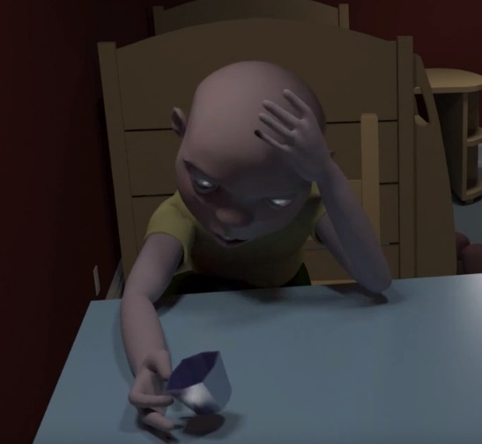
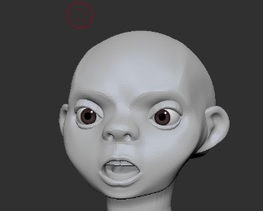
I have a love/hate relationship with 3D modelling. I love to sculpt characters in ZBrush and truly think organic modelling is what I do best. It’s something that I improve on through repetition and I just find it fun to create so many different faces. I enjoy it to such a degree that I believe I would be happy if I could spend my career sculpting character models.

Above are screenshots from my second-year final project “Clean Company. I think the above character is the single best organic model that I’ve produced so far and I am certain that now I am capable of producing sculpts way better than this.
I thought what I’d create for my third-year project “Toadstool” would be the models that outclass my previous best but frankly, I am disappointed with them. Neither of them are up to the quality of what I had produced a year previous.
It is my goal to push myself to create the high-quality models that I know I am capable of producing.

I believe the reason that the models I have produced for Toadstool were not up to the quality of my previous production was that I may have been intimidated by the size of the project. Clean Company was an animation that was set in a small room with one character, and despite being proud of my model the animation side of production was severely neglected.
On the other hand, in Toadstool, I created a set of a whole city and this time I wanted to make sure that I had an animation to showcase. Once I had created my proxy models, I saw this as everything I needed to animate the scene, so the final models of the characters were neglected.
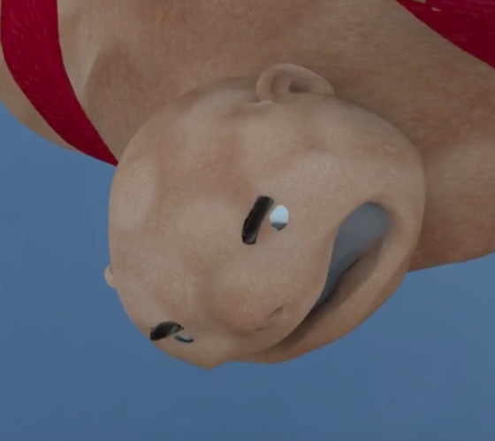
I recall that I spent approximately 3 weeks creating the main character for Clean Company, while I only spent 4 days on both characters for Toadstool.
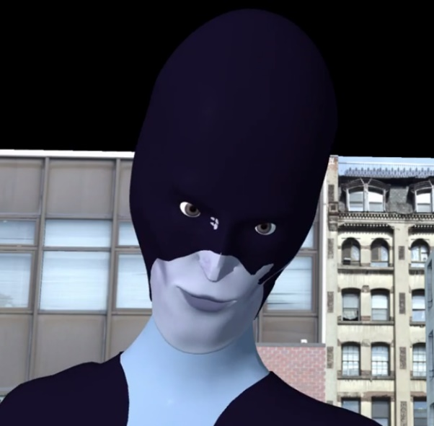
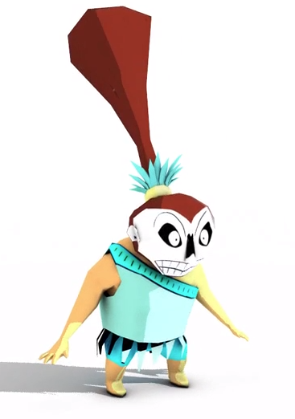
Something that I’ve noticed over the course of my time at UWTSD is that I have developed a stylised approach to the appearance of my character models, I don’t believe in the time that I’ve been here that I’ve created a single model to standard human anatomy and proportions.
I enjoy my modelling in my own style but I believe it is a habit I should work on breaking so that I can develop a better sense of the standard human anatomy as I don’t want to limit my future employment options by not showing any potential employers that I have no range in my portfolio.

To improve my general sculpting ability, I starting speed sculpting setting myself an hour and no longer to try and sculpt something. I would alternate each day, either doing a monster sculpt or a human sculpt. I saw noticeable improvement over 5 days however I stopped when I began to devote more time to the pre-production of “Toadstool.”
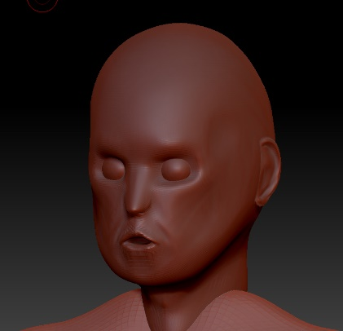
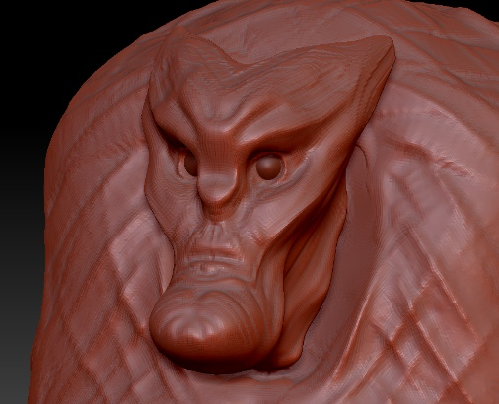

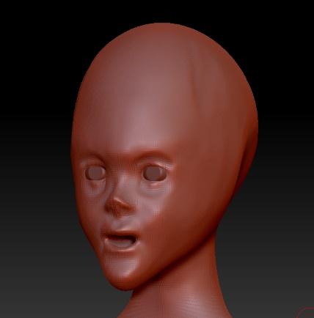
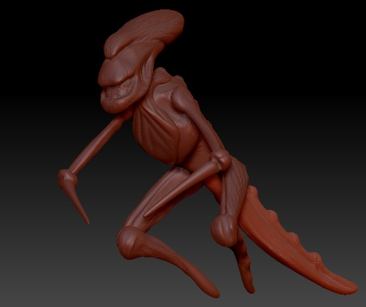

3D Modelling – Hard Surface Modelling
My attitude towards hard surface modelling, however, is the complete antithesis of my attitude towards organic modelling. I dislike it greatly and I think that is down to the fact that I have a lot less experience in hard surface modelling and so I find my work lacking.
When I first started using ZBrush I loved how simple it was and from that moment onwards every model that I created I made sure to have some ZBrush involvement and I did not use Maya for anything apart from the rigging and animation. I think this is directly impeded the development of my hard surface modelling abilities. It is obvious to anyone watching my film that I have heavily neglected my environments. Below is a screenshot of the set from “Clean Company”.

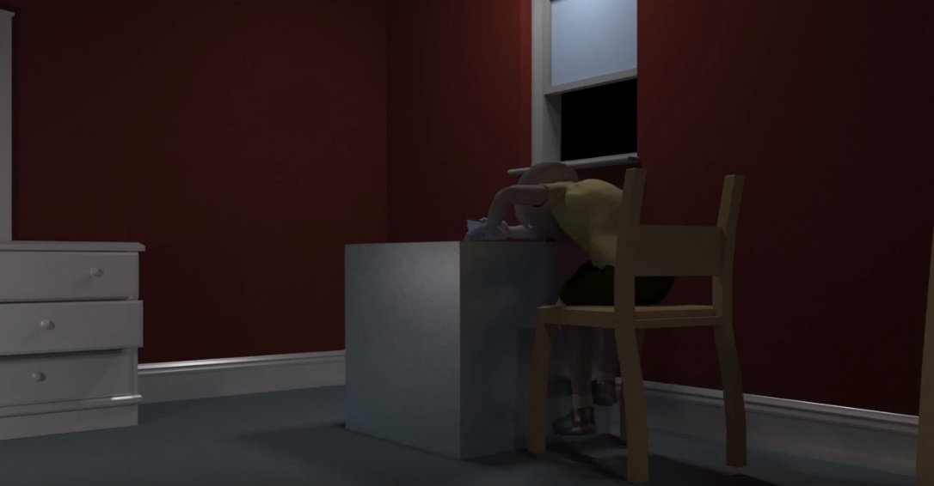

To date, the best environment I have produced so far is for my third-year final project “Toadstool”, however, I believe I have bitten off more than I could chew with this project. I made the mistake of deciding to create a whole city however this stretched my attention over a large area. It would have benefited me more to have set a story in a much smaller environment so that I can put an emphasis on quality over quantity. I’ll be keeping this information in mind for future productions, as I believe the focus on quality will be the remedy to my problems with hard surface modelling and set dressing.
I’ve been improving with practice however, the props that I have been producing for the scene as the deadline draws nearer have been considerably better than the ones that I produced at first. It feels like it’s starting to become more natural to me too.
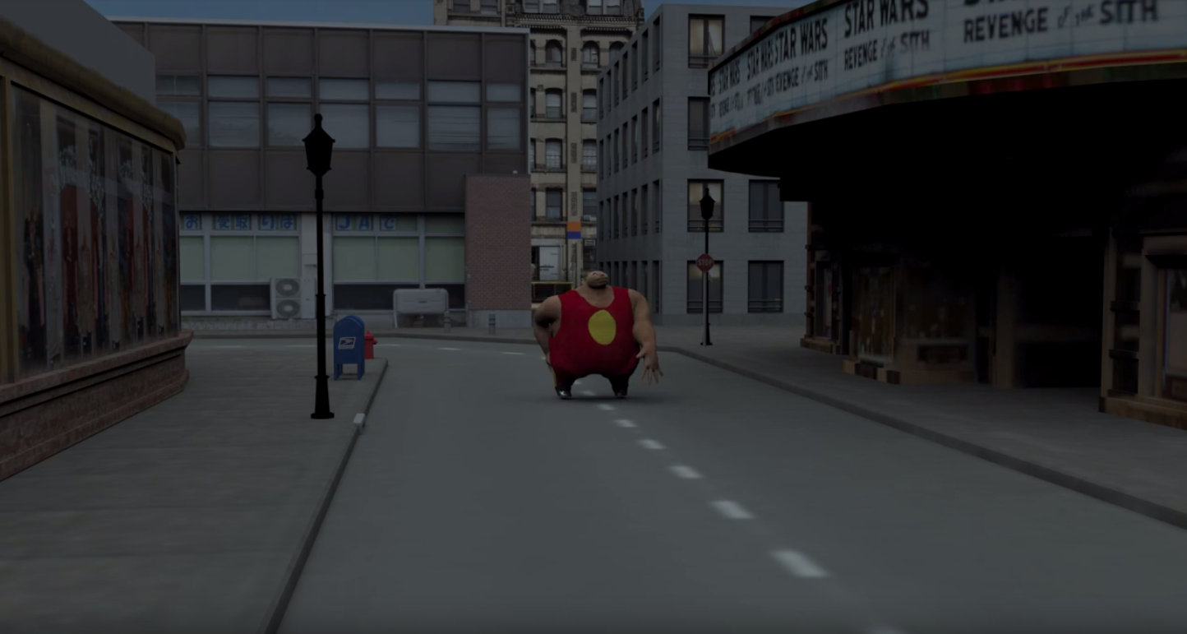

My current lack of ability in hard surface modelling is of great concern to me despite my recent improvements, as I feel underprepared for the workplace. My understanding of joining a modelling team on a production is that my first set of tasks on a production will usually revolve around creating props for the scenes.

Rigging, Blendshapes and Weight Painting
Zbrush has a function that allows you to sculpt in blendshapes into animation layers. I find that this has made it both easy and enjoyable to create the blendshapes and the GoZ function makes it simple to transfer the blendshapes into Maya for animation. Taking full advantage of my created blendshapes is not something that I have developed an affinity for yet. I understand using nurbs shapes, I can use the connection editor to connect the blendshape attributes to the movements of the nurbs to make the experience more user-friendly. I have neglected using blendshapes for facial animation during my time in university, I was originally meant to add them to the character in Clean Company but I had already moved ahead past the modelling stage in production and forget to create the blendshapes. While I have created blendshapes for Toadstool, I don’t think I am using them to their full potential. During my second year, I created a complex set of blendshapes for a group project. The project revolved around a large disembodied face, and I create 20 blendshape controls to be for use in animation. However, the team did not take full advantage of them and simply moved the mouth up and down to mimic speech. I am still disheartened that the facial blendshapes weren’t used to their fullest potential.
Rigging and weight painting is something that based on my own experiences within my peer group is generally disliked. Over the last year, however, I’ve made considerable strides in my own rigging and weight painting. For the first two years, I was terrified of weight painting and created a lot of my rigs through just parenting different parts of the mesh to each other and animating directly on to the geometry. This year weight painting has gone from something confusing to something that I am feeling quite confident in.
I’m looking forward to creating a high-quality weightpaint in my Masters year and am confident that I will succeed.

Animation
Before I joined the course, I wanted to be an animator. I worked entirely in 2D using Adobe Flash, these animations are what I presented during my interview to get into the course. Unfortunately, my love of animation has diminished somewhat but not to the point that I dislike it. It would be more appropriate to say that I get more frustrated with it that I used to do.
Back when I worked in 2D, to get any effect I wanted I just had to draw it. Now in 3D if I want to tell my own stories with my own characters, I need to go through countless steps of modelling, rigging and weight painting before I can even begin the animation process. There is also the fact that there is a lot of animation effects that I simply don’t know how to replicate in 3D such as smear frames. These provided a lot of depth to 2D animation and I don’t know how I can get it to translate into 3D.

UVing and Texturing
Over the last 3 years, I haven’t actually performed much UVing, as mentioned earlier I have heavily neglected my environmental modelling prior to this year so the only UVs I ever had to do were on the characters that I created. This year I have created my most complex environment yet so I have had the opportunity to improve my skill in UVing. Naturally, this has also extended into my ability to texture those props.
In my first year, the only texture that I made that I would say I am proud of is “Incan Adventure”. After UVing the model, I took the UV map into Photoshop and painted on the texture, this the only texture that I’ve created so far that is completely original. Additionally, I created a material that was both reflective enough to give the cel-shaded effect, without completely blotting out the texture.
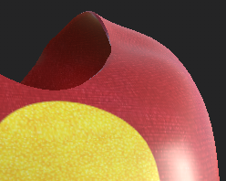
For the major project this year, I set out to try and create as high-quality textures as possible. The first sets of props that I textured were not to the standard that I wished for but as I got used to using Substance Painter my textures improved massively. The peak of my texturing thus far is the skin and leotard texture for the hero character Toadstool.
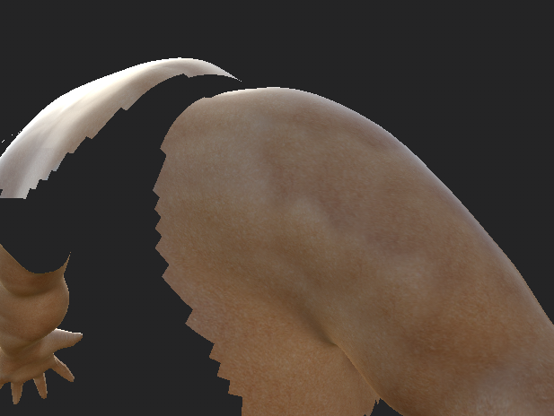

Cinematography
I’ve developed quite a taste for the planning of a film, I think it may be one subject that I’ve most improved in considering that before I started the course I had no opinion or deeper thoughts about the aspects that make up cinematography in any meaningful way. I never thought that this would be the subject I’d eventually be writing my dissertation on.
Coming to this conclusion about cinematography gives me hope for the rest of the subjects that I’m not strong with, the reason that I chose write my dissertation on this subject was due to my lack of knowledge and my desire to improve upon it. I believe the effort paid off too, as the pre-production for Toadstool has been the smoothest yet and I think the cinematography is my best yet. It is not without errors of course, but it’s a learning experience for the next film and I cannot wait to start making my plans for it.
Cinematography and the pre-production involved is an aspect of filmmaking that I’ve seen nothing but improvement in over the last academic years.

Lighting and Rendering
While I have confidence the development of my cinematography skills, I have noticed that I have issues with putting my plans into practice. Looking through my portfolio of short films, I notice that the lightning in my scenes is a major issue. I find myself struggling to get the light to move and bounce in the way that I want it to. It’s no good for me to plan out where I want the light and shadows to be if I cannot get it to do so in practice. I understand that some of my peers have improved their own lighting skills by trying to mimic scenes from movies, I can only hope that me using this method can increase my own lighting skills.
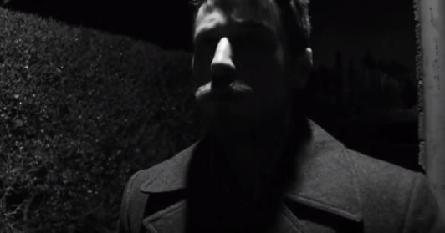
The only style of lighting that I know I can create reliably is for a noir film, as I was involved in the production of two noir short films during my first year

My preference in renderer has changed countless times during my time here, in my first year I exclusively used Maya software, but during my second year I desired more depth and shadow to my pieces so I gravitated over to Mental Ray. About halfway through my second year, I experimented with Arnold however that came with its own host of issues such as the renders having watermarks and the scenes not being properly illuminated. I overcame both of these issues for Toadstool and Arnold has become my renderer of choice since.

Future Plans
My immediate plan for next year is to create a more concentrated short film for my masters. I think it was a mistake to create such a large set for my major project this year and want to do the complete opposite for my next project.
Beyond that, I would like to get a job either modelling or animation in the games or film industry.
As I’ve developed an appreciation for cinematography this past academic year, I would love to take a shot at directing a short film, but that’s something I think I should like for much later in my career when I have experience in more aspects of filmmaking.
At some point in my career, I’d like to create a 3D film with the illusion of it being 2D. I’ve seen this over recent years with such Paperman (Kars, 2012) and current 2D side-scrolling fighting games such as Guilty Gear and Dragonball FighterZ. These three examples all use 3D models, but they are angled and presented in such a way to the camera that they believably look like drawn images.
I tend to think that the shots in 2D animations appear to be more pleasing to the eye, I’d like to transfer that same quality to shots to the 3D field. I think there must be a fundamental difference in how a shot is composed between the two fields, and I want to find out why.

Conclusion
The question I asked at the beginning of this review was “What is holding me back?” I’d like to answer more than that. I want to answer “Why is it holding me back?”
With the exclusion of hard surface modelling, I find myself to be capable at every aspect of filmmaking to some degree. I find myself not living up to my own potential when it comes to animation and 3D modelling characters, as I know I can produce better work. It’s a possibility that the reason that I’m not satisfied with the development of my animation and my modelling is that those are the two subjects that I originally cared the most about, while subjects such as cinematography in which I originally had no care for I find myself excelling in.
I believe I have grown lax with subjects that I am confident in and this has caused me to produce work that I don’t believe is up to my standards. I believe that the development of my Cinematography has jumped in quality as opposed to previous years, as I have been giving it extra time and attention at the cost of less for the animation and models.

Bibliography
Paperman. (2012). [film] Directed by J. Kars. Burbank, California: Walt Disney Animation Studios.
Guilty Gear XRD. (2014). [Game] Arc System Works: Yokohama, Japan.
Dragonball FighterZ. (2018). [Game] Arc System Works: Yokohama, Japan.

