Lab - Accessing Network Devices with SSH
Topology
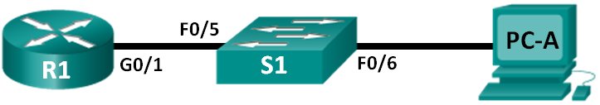
Addressing Table
Device | Interface | IP Address | Subnet Mask | Default Gateway
R1 | G0/1 | 192.168.1.1 | 255.255.255.0 | N/A
S1 | VLAN 1 | 192.168.1.11 | 255.255.255.0 | 192.168.1.1
PC-A | NIC | 192.168.1.3 | 255.255.255.0 | 192.168.1.1
Objectives
Part 1: Configure Basic Device Settings
Part 2: Configure Basic Security Measures on the Router and Switch
Part 3: Configure the Router for SSH Access
Part 4: Configure the Switch for SSH Access
Part 5: SSH from the CLI on the Switch
Background / Scenario
In the past, Telnet was the most common network protocol used to remotely configure network devices. Telnet does not encrypt the information between the client and server. This allows a network sniffer to intercept passwords and configuration information.
Secure Shell (SSH) is a network protocol that establishes a secure terminal emulation connection to a router or other networking device. SSH encrypts all information that passes over the network link and provides authentication of the remote computer. SSH is rapidly replacing Telnet as the remote login tool of choice for network professionals. SSH is most often used to log in to a remote device and execute commands; however, it can also transfer files using the associated Secure FTP (SFTP) or Secure Copy (SCP) protocols.
The network devices that are communicating must be configured to support SSH in order for SSH to function. In this lab, you will enable the SSH server on a router and then connect to that router using a PC with an SSH client installed. On a local network, the connection is normally made using Ethernet and IP.
Note: The routers used with CCNA hands-on labs are Cisco 1941 Integrated Services Routers (ISRs) with Cisco IOS Release 15.2(4)M3 (universalk9 image). The switches used are Cisco Catalyst 2960s with Cisco IOS Release 15.0(2) (lanbasek9 image). Other routers, switches, and Cisco IOS versions can be used. Depending on the model and Cisco IOS version, the commands available and the output produced might vary from what is shown in the labs. Refer to the Router Interface Summary Table at the end of this lab for the correct interface identifiers.
Note: Make sure that the routers and switches have been erased and have no startup configurations. If you are unsure, contact your instructor.
Required Resources
1 Router (Cisco 1941 with Cisco IOS Release 15.2(4)M3 universal image or comparable)
1 Switch (Cisco 2960 with Cisco IOS Release 15.0(2) lanbasek9 image or comparable)
1 PC (Windows 7 or 8 with terminal emulation program, such as Tera Term, and Wireshark installed)
Console cables to configure the Cisco IOS devices via the console ports
Ethernet cables as shown in the topology

Configure Basic Device Settings
In Part 1, you will set up the network topology and configure basic settings, such as the interface IP addresses, device access, and passwords on the router.
Cable the network as shown in the topology.
  - Initialize and reload the router and switch.
  - Configure the router.
    - Console into the router and enable privileged EXEC mode.
    - Enter configuration mode.
    - Disable DNS lookup to prevent the router from attempting to translate incorrectly entered commands as though they were host names.
    - Assign class as the privileged EXEC encrypted password.
    - Assign cisco as the console password and enable login.
    - Assign cisco as the VTY password and enable login.
    - Encrypt the plaintext passwords.
    - Create a banner that will warn anyone accessing the device that unauthorized access is prohibited.
    - Configure and activate the G0/1 interface on the router using the information contained in the Addressing Table.
    - Save the running configuration to the startup configuration file.
Configure PC-A.
Configure PC-A with an IP address and subnet mask.
Configure a default gateway for PC-A.
Verify network connectivity.
Ping R1 from PC-A. If the ping fails, troubleshoot the connection.

- Configure Basic Security Measures on the Router
  - Encrypt the clear text passwords.
R1(config)# service password-encryption
  - Strengthen passwords.
An administrator should ensure that passwords meet the standard guidelines for strong passwords. These guidelines could include combining letters, numbers and special characters in the password and setting a minimum length.
Note: Best practice guidelines require the use of strong passwords, such as those shown here, in a production environment. However, the other labs in this course use the cisco and class passwords for ease in performing the labs.
    - Change the privileged EXEC encrypted password to meet guidelines.
R1(config)# enable secret Enablep@55
    - Require that a minimum of 10 characters be used for all passwords.
R1(config)# security passwords min-length 10
  - Secure the console and VTY lines.
    - You can set the router to log out of a connection that has been idle for a specified time. If a network administrator was logged into a networking device and was suddenly called away, this command automatically logs the user out after the specified time. The following commands cause the line to log out after five minutes of inactivity.
R1(config)# line console 0
R1(config-line)# exec-timeout 5 0
R1(config-line)# line vty 0 4
R1(config-line)# exec-timeout 5 0
R1(config-line)# exit
R1(config)#
    - The following command impedes brute force login attempts. The router blocks login attempts for 30 seconds if someone fails two attempts within 120 seconds. This timer is set especially low for the purpose of this lab.
R1(config)# login block-for 30 attempts 2 within 120
What does the 2 within 120 mean in the above command?
The administrator access will be blocked if they incorrectly enter login details twice in two minutes.

What does the block-for 30 mean in the above command?
The administrator will have access blocked for 30 seconds before they are able to try again.

Verify that all unused ports are disabled.
Router ports are disabled by default, but it is always prudent to verify that all unused ports are in an administratively down state. This can be quickly checked by issuing the show ip interface brief command. Any unused ports that are not in an administratively down state should be disabled using the shutdown command in interface configuration mode.

R1# show ip interface brief
Interface IP-Address OK? Method Status Protocol
Embedded-Service-Engine0/0 unassigned YES NVRAM administratively down down
GigabitEthernet0/0 unassigned YES NVRAM administratively down down
GigabitEthernet0/1 192.168.1.1 YES manual up up
Serial0/0/0 unassigned YES NVRAM administratively down down
Serial0/0/1 unassigned YES NVRAM administratively down down

Configure the Router for SSH Access
Using Telnet to connect to a network device is a security risk because all information is transmitted in a clear text format. SSH encrypts the session data and provides device authentication, which is why SSH is recommended for remote connections. In Part 2, you will configure the router to accept SSH connections over the VTY lines.
Configure device authentication.
The device name and domain are used as part of the crypto key when it is generated. Therefore, these names must be entered prior to issuing the crypto key command.
Configure the domain for the device.
R1(config)# ip domain-name ccna-lab.com
Configure the encryption key method.
R1(config)# crypto key generate rsa modulus 1024
The name for the keys will be: R1.ccna-lab.com

% The key modulus size is 1024 bits
% Generating 1024 bit RSA keys, keys will be non-exportable...
[OK] (elapsed time was 1 seconds)

R1(config)#
*Jan 28 21:09:29.867: %SSH-5-ENABLED: SSH 1.99 has been enabled
Configure a local database username.
R1(config)# username admin privilege 15 secret adminpass
Note: A privilege level of 15 gives the user administrator rights.
Enable SSH on the VTY lines.
Enable Telnet and SSH on the inbound VTY lines using the transport input command.
R1(config)# line vty 0 4
R1(config-line)# transport input telnet ssh
Change the login method to use the local database for user verification.
R1(config-line)# login local
R1(config-line)# end
R1#
Save the running configuration to the startup configuration file.
R1# copy running-config startup-config
Destination filename [startup-config]?
Building configuration...
[OK]
R1#
Establish an SSH connection to the router.
Start Tera Term from PC-A.
Use Tera Term to telnet to R1.
Does R1 accept the Telnet connection? Explain.
No, the connection is refused as telnet is disabled
Use Tera Term, establish an SSH session to R1. Use the username admin and password admin pass. You should be able to establish an SSH session with R1.
Does R1 accept the SSH connection? Yes
Intentionally mistype the user and password information to see if login access is blocked after two attempts.
What happened after you failed to login the second time?
The connection from the switch to the router will be disconnected and the administrator won’t be able to reconnect for 30 seconds.
From your console session on the router, issue the show login command to view the login status. In the example below, the show login command was issued within the 30 second login blocking period and shows that the router is in Quiet-Mode. The router will not accept any login attempts for 14 more seconds.
R1# show login
A default login delay of 1 second is applied.
No Quiet-Mode access list has been configured.

Router enabled to watch for login Attacks.
If more than 2 login failures occur in 120 seconds or less,
logins will be disabled for 30 seconds.

Router presently in Quiet-Mode.
Will remain in Quiet-Mode for 14 seconds.
Denying logins from all sources.
R1#
After the 30 seconds has expired, SSH to R1 again and login using the SSHadmin username and Admin1p@55 for the password.
After you successfully logged in, what was displayed? The login banner for the router.
Enter privileged EXEC mode and use Enablep@55 for the password.
If you mistype this password, are you disconnected from your SSH session after two failed attempts within 120 seconds? Explain.
No only session login attempts are limited to two attempts within 120 seconds.
Issue the show running-config command at the privileged EXEC prompt to view the security settings you have applied.

Configure the Switch for SSH Access
In Part 3, you will configure the switch in the topology to accept SSH connections. After the switch has been configured, establish an SSH session using Tera Term.
Configure the basic settings on the switch.
Console into the switch and enable privileged EXEC mode.
Enter configuration mode.
Disable DNS lookup to prevent the router from attempting to translate incorrectly entered commands as though they were host names.
Assign class as the privileged EXEC encrypted password.
Assign cisco as the console password and enable login.
Assign cisco as the VTY password and enable login.
Encrypt the plain text passwords.
Create a banner that will warn anyone accessing the device that unauthorized access is prohibited.
Configure and activate the VLAN 1 interface on the switch according to the Addressing Table.
Save the running configuration to the startup configuration file.
Configure the switch for SSH connectivity.
Use the same commands that you used to configure SSH on the router in Part 2 to configure SSH for the switch.
Configure the device name as listed in the Addressing Table.
Configure the domain for the device.
S1(config)# ip domain-name ccna-lab.com
Configure the encryption key method.
S1(config)# crypto key generate rsa modulus 1024
Configure a local database username.
S1(config)# username admin privilege 15 secret adminpass
Enable Telnet and SSH on the VTY lines.
S1(config)# line vty 0 15
S1(config-line)# transport input telnet ssh
Change the login method to use the local database for user verification.
S1(config-line)# login local
S1(config-line)# end
Establish an SSH connection to the switch.
Start Tera Term from PC-A, and then SSH to the SVI interface on S1.
Are you able to establish an SSH session with the switch?
Yes, your able to establish an SSH session on the switch using the same commands as the router.

SSH From the CLI on the Switch
The SSH client is built into the Cisco IOS and can be run from the CLI. In Part 4, you will SSH to the router from the CLI on the switch.
View the parameters available for the Cisco IOS SSH client.
Use the question mark (?) to display the parameter options available with the ssh command.
S1# ssh ?
-c Select encryption algorithm
-l Log in using this user name
-m Select HMAC algorithm
-o Specify options
-p Connect to this port
-v Specify SSH Protocol Version
-vrf Specify vrf name
WORD IP address or hostname of a remote system
SSH to R1 from S1.
You must use the –l admin option when you SSH to R1. This allows you to log in as user admin. When prompted, enter adminpass for the password.
S1# ssh -l admin 192.168.1.1
Password:
***********************************************
Warning: Unauthorized Access is Prohibited!
***********************************************

R1#
You can return to S1 without closing the SSH session to R1 by pressing Ctrl+Shift+6. Release the Ctrl+Shift+6 keys and press x. The switch privileged EXEC prompt displays.
R1#
S1#
To return to the SSH session on R1, press Enter on a blank CLI line. You may need to press Enter a second time to see the router CLI prompt.
S1#
[Resuming connection 1 to 192.168.1.1 ... ]

R1#
To end the SSH session on R1, type exit at the router prompt.
R1# exit

[Connection to 192.168.1.1 closed by foreign host]
S1#

What versions of SSH are supported from the CLI?
S1 #ssh -v ?
1. Protocol Version 1
2. Protocol Version 2

How would you provide multiple users, each with their own username, access to a network device?
Using the username command, you could add the username and password for each user to the local server.

Reflection (max 800 words):
Write a research report comparing various Encryption standards, e.g AES, SHA, DES, RSA.

Comparing Various Encryption Standards

Abstraction
Ullah and Co states that data Encryption is the process of protecting information, privacy, availability and integrity of information [1]. Al Tamimi believes that there are two main characteristics that differentiates and identify encryption algorithms, they are the ability to secure the protected information against hackers and cyber-attacks. The second is the efficacy and speed that it can be done at [2]. This report compares the different encryption algorithms used to complete the tasks mentioned before.
Data Encryption Standard
On January 15, 1977 the Data Encryption standard was introduced and issued as Federal Information Processing standard 46 [3]. The DES was developed at IBM as a modification to an older system called lucifer [4].The DES it was the most widely used encryption scheme until the introduction of AES in 2001 [5]. The algorithm for DES is referred to as the Data Encryption Algorithm, the algorithm transforms a 64-bit input into a 64-bit output in a series of steps, using a 64-bit block and 56-bit key [5]. The DES originally encrypted 64bit blocks using a 128bit sized key, however it was lowered to 56bits after the NSA convinced IBM to lower it [6].The data is encrypted and decrypted using the same key and steps [5]. According to Stinson The DES is a special type of cipher referred to as a Feistel cipher [4].

Advanced Encryption Standard
Introduced by the NIST in 2001, the AES is a symmetric block cipher [5], used in several industry standards as well as numerous commercial systems. These systems include the Security Shell Network protocol, the IEEE 802.11i WIFI Encryption Standard and IPsec to name a few [6]. The algorithm for AES is called Rijndael, a standardized algorithm used by the Federal Information Processing Standard 197 [7]. The AES block length is double that of DES at 128-bits, as well as three allowable key lengths of 128-bits, 192-bits and 256bits [4]. Standard encryption uses 128-bitkey length and 128-bit block, this is referred to as AES-128 [7].

Blowfish
The Blowfish algorithm was introduced in 1993 by Schneider and has since gone on to be one of the most common encryption algorithms [2]. Blowfish is a fast and free, alternative to the other encryption algorithms out there [8]. Blowfish can work on hardware applications although its main use is software applications [1]. Author writes that blowfish is a symmetric key block cipher, has a block size of 64 bits and key lengths can range from 32 to 448 bits [9]. According to Gowda the Blowfish algorithm is harder to decrypt than the AES algorithm [10].

Rivest Shamir Adleman
RSA is the best known and most commonly used public key scheme according to Hans and Bhanot [11] and backed up by Stallings [5]. Hans and Bhanot also believes that the most important public-key cryptosystem is the RSA algorithm [11]. Two important ideas are implemented by RSA. The first is Public-key encryption, the idea is based around the need for a courier to send keys to a receiver over different secure channel before sending the original message [12]. The second idea is digital signatures, the idea is to allow the receiver to check the message has come from the sender using signatures. This is done by using the sender’s decryption key and the correct corresponding public encryption key to check the signature [12].

Comparison
Tamimi tested speed of some of the most widely used cryptographic algorithms and placed the results in a table (Appendix A), the results show that Blowfish was the best performer flowed by AES Rijndael 128-bit key [2]. Ullah & Co research also showed that Blowfish is the fastest at encrypting 16-byte blocks, with AES taking the longest, though Ullah & Co later test (Appendix B) show that AES is the most efficient algorithm of those tested [1]. Patil & Co’s research showed again that Blowfish is again faster than the algorithms tested, with RSA the slowest (Appendix C). Their research also shows that AES and Blowfish average a higher entropy per byte, entropy measures the degree of randomness of encrypted data, meaning that output is safer from malicious attack. The research also shows that algorithms took longer to encrypt the data than it took to decrypt the data. Another test performed by Patil & Co was the avalanche effect where AES showed the highest percentage, with RSA the lowest. Avalanche effect shows us the extent to which data is disseminated by a change of one bit in plain text leading to a significant change in bits of output information [8]

Conclusion
The research and comparisons show that there is no distinctively better encryption standard out there However, Al Tamimi believes that Blowfish is the clear winner due to its speed and no known security weaknesses [2]. Ullah and Co’s research concluded that AES was the winner, due to AES various key lengths that makes it vastly strong [1]. As Patil & Co write Blowfish is best suited for those who consider time and memory most important, DES is best for those where bandwidth is most important, and AES is best suited where security and confidentiality is vital [8].

Appendix A
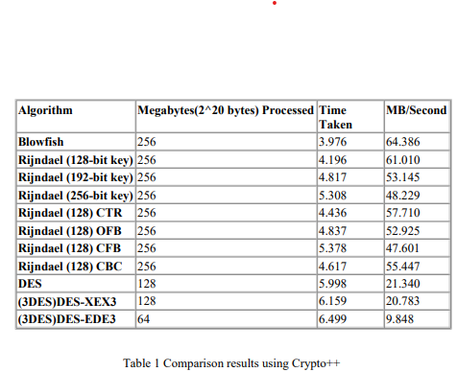 [2]

Appendix B
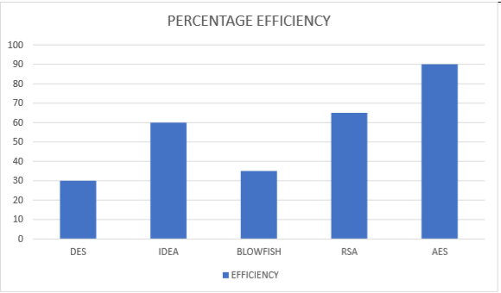 [1]
Appendix C
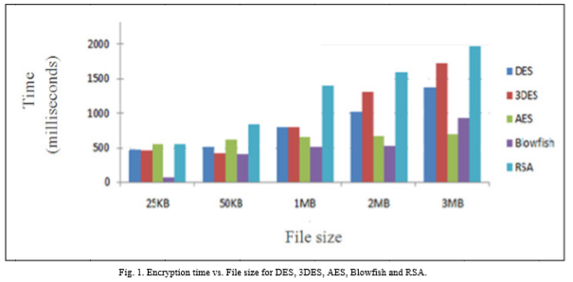
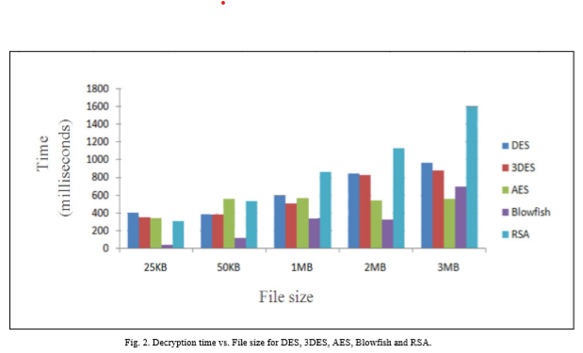

[8] [8]

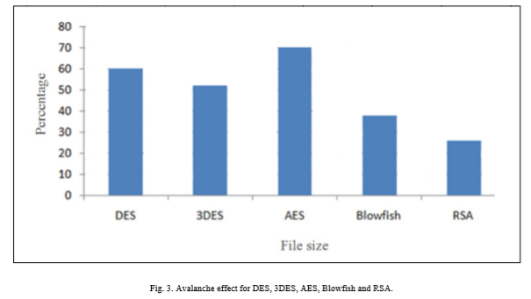
[8]

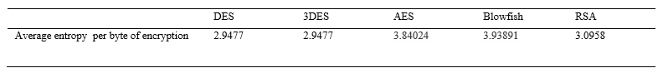
[8]

References

[1] | &. C. Kiramat Ullah, "Comparison of Various Encryption Algorithms for Securing Data," [Online]. Available: https://pdfs.semanticscholar.org/783c/039868b28f0225f240a6c3409031c6ef596c.pdf. [Accessed 11 11 2019].
[2] | A.-K. Al Tamimi, "Performance Analysis of Data Encryption Algorithms," [Online]. Available: https://www.cse.wustl.edu/~jain/cse567-06/ftp/encryption_perf.pdf. [Accessed 11 11 2019].
[3] | "Revision of FIPS 46-1, Data Encryption Standard (DES), as FIPS 46-2," Computer Security Resource Center, 30 12 1993. [Online]. Available: https://csrc.nist.gov/News/1993/Revision-of-FIPS-46-1-DES-as-FIPS-46-2. [Accessed 12 11 2019].
[4] | D. R. Stinson, Cryptography Theory and Practice, 3rd ed., Ontario: Chapman & Hall/CRC, 2006, pp. 95,102,103.
[5] | W. Stallings, Cryptography and Network Security, 7th ed., Essex: Pearson, 2017, pp. 129-131,172-174.
[6] | J. P. Christof Paar, Understanding Cryptography: A Textbook for Students and Practitioners, Bochum: Springer, 2009, pp. 55,56,87,88.
[7] | D. Selent, "ADVANCED ENCRYPTION STANDARD," InSight: RIVIER ACADEMIC JOURNAL, vol. 6, no. 2, pp. 1-3, 2010.
[8] | &. C. Priyadarshini Patil, "A Comprehensive Evaluation of Cryptographic Algorithms," in International Conference on Information Security & Privacy (ICISP2015), Nagpur, 2015.
[9] | A. M. Alabaichi, "Security analysis of blowfish algorithm.," in Informatics and Applications (ICIA), Karbala, 2013.
[10] | S. Gowda, "Using Blowfish Encryption To Enhance Security Feature Of An Image," Department of Computer Science And Engineering, R.V.College Of Engineering, Bangalore.
[11] | &. H. Bhanot, "A Review and Comparative Analysis of Various Encryption," International Journal of Security and Its Applications, vol. 9, no. 4, 2015.
[12] | E. Milanov, "The RSA Algorithm," Washintigton, 2009, https://sites.math.washington.edu/~morrow/336_09/papers/Yevgeny.pdf [Accessed 12 11 2019].

