
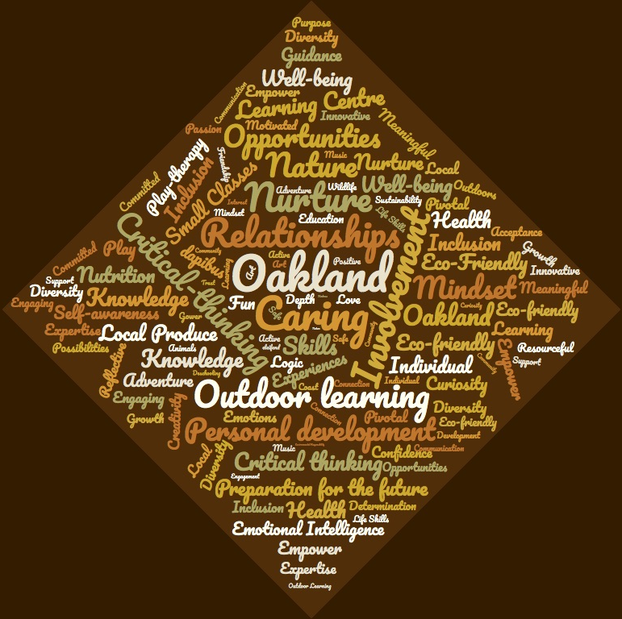
Oakland/Tir Derw School – The Centre of Learning in Gower

Head teacher – Noel Hadwen
Telephone: 01792 326526
Email: Noel.Hadwen@Oakland.co.uk

Welcome to Oakland school, the centre of learning for local students aged 3-16, as well as members of the local community in Gower who are part of our mentoring programme and provide additional provision. We are an independent school providing a holistic approach that supports each student through their academic and self-discovery journey. As you walk through the gate, you will see the school is distinct in many ways. Firstly, you are greeted with a short drive that is bordered with two fields, which are an essential part of our school, due to the emphasis on outdoor learning. At the end of the drive is the school which, which is connected to agricultural barns which are a part of our school and enable us to teach various aspects of animal husbandry, as well as being venues for our design and technology lessons. The school itself is set across multiple floors, which combines indoor and outdoor learning. These buildings are framed by an abundance of trees. Beyond the buildings, the school has created large clearings which are furnished with equipment for outdoor learning opportunities. With 16 acres of land, it provides unparalleled access to nature.
This prospectus has been produced to provide you with an insight into our life at Oakland and how your child will belong in our school. You will find information about Oaklands values and ethos, curriculum, support, and the environment your child could belong to. At Oakland, we pride ourselves in providing a safe and caring environment to nurture every student within the guidance of the United Nations Convention on the Rights of the Child (UNICEF, unknown). We deliver a wide range of learning opportunities, led by the individual’s interest to expand on their knowledge, skills and abilities. This learner-led approach, based around Montessori’s framework, starts from our foundation years through to the secondary years. At Oakland we do not rely on the learner connecting with the world through reading, instead, we connect the learner to the world through experiences and practical involvement, which guides them in discovering how to participate in the transformation of themselves and modern society (Franca, 2019). We promote each individual to have the freedom to explore creative learning which provides flexibility in how each student engages in and presents their learning and understanding. This is encouraged with every student facilitating their own learning as much as possible, ultimately having responsibility for their own success. Yet our experienced and passionate team of teachers and supporting staff guide every student to reaching their full potential.
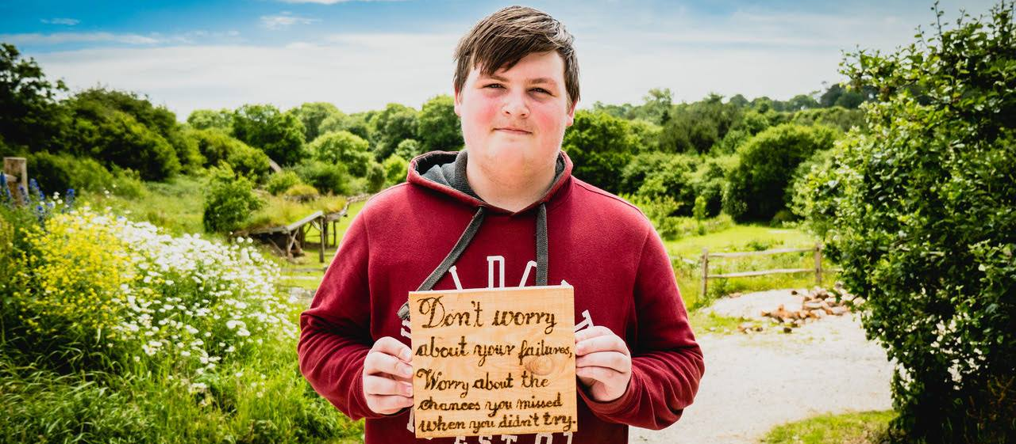
(Down to earth, unknown)

Our aims and values are decided between staff members, students, parents and the community so that the school reflects every member of the school. All staff here are committed to the development of every student and providing a supportive environment to ensure every individual is prepared for their life-long journey of discovery and learning.
At Oakland our core values are:
- Health and Well-being, which includes exercise, nutrition, time in nature and mindset.

- Inclusion, which is evident in our diverse range of students, relationships and community projects

- Critical Thinking and Creativity, which supports the students’ development in seeking objective perspectives, and using their creativity to find solutions to problems.

- Environmental Awareness and Social Responsibility, developing the students’ awareness of what it means to be human, and how they can connect to the world.
Our core values are reflected within the structure of the school, intertwining learning into our communication within the school and out in the community. Our values are also felt in the inviting atmosphere, which is essential as Oakland acts as a pillar to the residents in Gower. It is also a reflection of our varied and innovative curriculum, which support learners being healthy and confident individuals, ethical and informed citizens, ambitious and skilled learners, and creative contributors. Our curriculum is formed to suit the needs of each individual and is not bound by the national curriculum. Yet the education we deliver leads to the option of entering GCSE examinations to further their formal education.
Estyn Report 2020 -
“This school provides a quality education, with an innovative approach that supports each student through their life-long learning journey, resulting in students that are confident, creative, and have critical thinking skills that will lead them to having a successful and fulfilling life”


Curriculum and teaching approach

At Oakland, we deliver a curriculum that integrates the core subjects and combine it with our own curriculum and teaching approach that has been developed by our specialised team. We blend the arts into all our classes and deliver learning using creative teaching methods, which is an integral part of the school structure and supports our students learning by linking subjects (Arts Council, 2018). Having our own curriculum enables us to deliver a flexible programme, which allows each individual to shape their education to suit their needs and aspirations, and receive personalised support to maximize their intellectual and creative potential. This experience is enhanced with our emphasis on developing life skills and incorporating exercise, outdoor learning, relationship-focused practice and other additional learning experiences into the daily curriculum. These interactive lessons and experiences equip students with a strong self-efficacy in learning, organising and working throughout their life, alongside having confidence in working on personal achievements and self-development skills. This type of curriculum is supported in Dewey’s (2012) approach to delivering an education which prepares each individual for their future, with confidence in their abilities to achieve their goals. Experiencing an education incorporating arts and creative methods into lessons essentially communicates to our students that learning is not black and white. Making errors or mistakes increase learning opportunities and develops self-belief and resiliency because of the effort it has taken to find a solution. By embracing and encouraging every student to try, we are demonstrating that we value every individual for their contribution and do not measure learners on right or wrong answers. Most importantly, it develops learners that do not fear failure, and can commit themselves to a challenge (Eva, 2017).

Instead of focusing solely on academic attainment, we adopt the Montessori approach which focuses on the whole person, including social, emotional, intellectual, and physical development, whilst also integrating elements of Gardners (1993) multiple intelligence theory. These approaches complement each other by acknowledging the whole learner, not just their academic ability. Gardner assesses a learners intelligences in 7 areas which we use to develop appropriate teaching approaches to suit the diverse needs of our students, and provide suitable learning resources. From foundation level to secondary we provide each individual with the freedom to engage in a variety of learning materials of their choice. This allows each student to explore their natural curiosities and their intrinsic desire to learn and develop. These natural curiosities indicate a learner’s strengths and weaknesses which allow us provide suitable support. Having the autonomy to choose what they interact with supports the development of cognitive skills, the ability to concentrate for longer periods of time and independent learning skills (Montessori, unknown). Our students are not taught to be tested, we deliver lessons that are engaging and develop core skills that will support the student throughout their life. This is because we believe the process of finding strategies of seeking and learning are indispensable in education, and do not place importance on the accumulation of prepackaged knowledge (Flanagan, 2006). From the age of 3 our learners have the choice as to what learning materials to engage with, but also who they interact and play with. This form of learning is actively encouraged because unstructured play is rich with learning opportunities surrounding social interactions, empathy, independence and endurance (Gatto, unknown). As each student progresses through the school, our teachers provide materials and resources which challenge the students, and are an opportunity to develop creative problem-solving skills. We recognise that mental development is linked to physical movement, therefore we provide interactive and practical experiences for purposeful learning to take place. Examples of which are mentioned throughout this prospectus.

A selection of the subjects we discover at Oakland are listed below which includes a multitude of topics that support Gardeners multiple intelligences and enhance the students experience and enable students to thrive.
English
Mathematics
Science (Chemistry, Biology, Physics, Psychology)
Cooking and Nutrition
Philosophy (Supported with P4C in our younger years (P4C, unknown).)
History
Environmental and sustainability studies
Languages (British Sign Language, Welsh, French, Spanish, German)
Art
Music
Drama
Design and Technology

ICT
P.E and Sports (Football, Rugby, Netball, Hockey, Swimming, Tennis, Cross Country, Horse riding, Cycling and, Snow-boarding and Skiing)
Animal behaviour and husbandry

Personal Development

Life Skills (Communication Skills, Banking, Finance and Credit, Entrepreneurial Skillset, Sexual health and education, Relationship skills, and more)

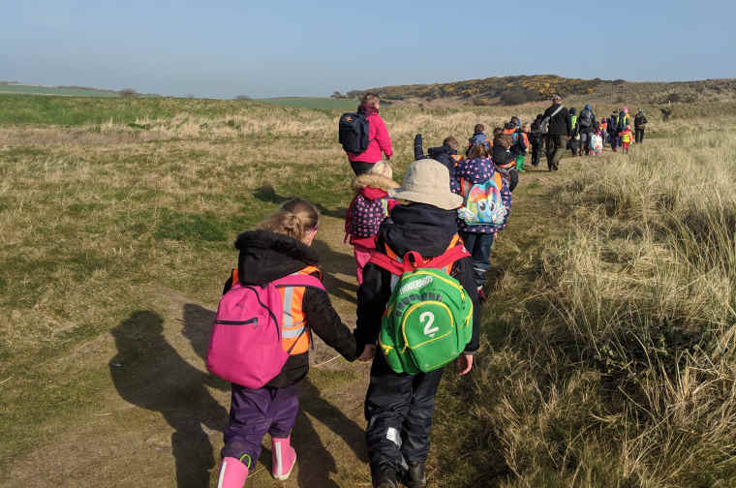
With the school open from 7am-5.30pm it provides students with the option of incorporating extra-curricular activities, projects, learning or social meetings into their day, whilst also enabling the student to immerse themselves in their learning and complete their work. This flexibility communicates to our students that we value their effort and encourage long durations of concentration (Gatto, unknown). All students can arrive between 7-9am and leave between 3-5.30pm, but must attend all scheduled lessons. However, if students are to miss lessons, their teachers will provide detailed guidance in what was covered through our online learning channels. The varied start and end allow our younger learners to have longer days in school which can support parents work schedules, and allows our older students to organise their day to suit their needs. A flexible start and end time also support our students’ health and well-being as they develop into adulthood. This is because sleep needs change during developmental stages, with lack of sleep leading to poor concentration, decrease in attainment and potential mental health issues (Kudlugi, 2016). With a flexible schedule, we have ensured that transportation is not affected, as we have a regular student bus that travels throughout Gower during the day to collect and drop off students. This option of arrival and departure time enables the student to get optimum sleep, whilst ensuring they are safeguarded with regular scheduled transportation links to school (Sleep Foundation, unknown). It also extends trust and independence to our maturing students, and incorporates life skill lessons. We find that most students choose to stay in school to be involved in projects happening in the school.

(Kids of the wild, 2020)

All our staff have teacher status which sets a minimum standard, with most specialising in particular disciplines. Each member of staff is experienced with supporting Special Educational Need’s (SEN), interacting within a person-centred framework and are i-act practitioners supporting student mental health. With passion and experience, each member of staff is dedicated to facilitating the students learning by acting as a guide when needed and being able to fully support their needs. Based on the Montessori approach students build a relationship with their teacher over a 3-year period, which allows the teacher to fully support development and provide engaging and challenging activities suitable for each learner. Having this 3-year relationship between learners and teachers also allows individuals to learn at their own pace, which instils a sense of security, especially for our SEN students. With a supportive environment, both our students and teachers are able to relax and enjoy the learning process which leads to greater achievement and motivation to learn (Flanagan, 2006). Teachers do not expect students to passively learn by listening to them speak at the front of the classroom, or by learning content. Instead, both teacher and student are authentically involved in the shared effort to understand aspects of their world, and to discover their individual learning journey. The teacher is able to freely interact with individual and groups of learners in the varied learning environments to share the experience, and guide them in discovering the depths of an inexhaustible range of topics.

Our classes have up to 15 students which have a 3-year age range and are supported by at least 3 teachers and supporting staff. These small classes enable the teacher to work with individuals and small groups, further developing understanding in subjects and also integrating into the class. These mixed age classes have shown to support cooperative learning and emotional development, which supports each learner to identify and solve challenges, regulate their emotions, and communicate and express themselves effectively, which ultimately leads to more successful outcomes. (Busch and Oakley, 2017). As the older students are mentors to the younger class members, it compounds their learning and develops divergent thinking skills to help problem solve with their class members who are at different learning stages. Each student may be working on something of their own interest, which acts as an opportunity to teach their peers and inquire about other students working and learning strategies. In a society where many students struggle with self-esteem from comparing themselves to others, multi-age classes is a form of empowering each student with their individual differences and contributions, which can help eliminate unhealthy competition. This collaboration also gives the youngest insight into what they are working towards, and to appreciate the bigger picture of their learning journey, which further supports each learner taking responsibility for their own success (Montessori Society, unknown). The collaboration of students throughout the school creates an energised and motivating atmosphere and provides the opportunity of developing their leadership and mentoring skills by supporting peers.

Our environment is specifically designed for the psychological and physical development of our learners. This leads to meaningful engagement and participation which leads to our students actively enquiring about subjects that they are interested in. This active participation and practical learning, alongside our open plan classes and option of environment, allows our learners to develop their creative abilities which leads to the emergence of critical thinking skills (Meinke, 2019). As the arts are fused into every subject, it creates an engaging learning environment and transforms the way students learn and demonstrate their understanding (Ahmet, 2016). Within our school we actively display our learners work because each choose their preferred medium to demonstrate their learning across subjects.
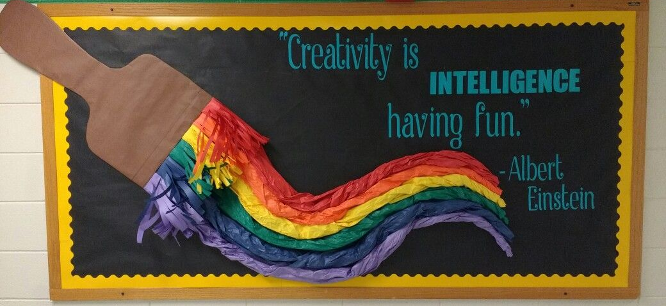

From age 3-16 teachers support the development of the learners by guiding them through the intricacies of life, and providing the freedom to explore, and engage in activities that fuel their love of learning. Complex vocabulary and abstract concepts can be understood when learning through different art mediums. For example, music has been shown to enhance students learning, therefore new words can be learnt through song, or music is played to allow students to get into the flow of writing. This form of learning helps satiate creative appetite and provides each student the opportunity to express themselves authentically. Another example of subject integration is using drama within English lessons. Students have the opportunity to engage in themed days where they can immerse themselves in fictional worlds, which is an experience that they can later draw upon in their work. This combination of practical with theoretical learning deepens their understanding and knowledge. This form of real experience and expression in this class improves standards in reading and writing and enhances the acquisition of communicating their experiences and ideas in a variety of circumstances (Arts Council, 2018).

Kaplanco. (unknown)


We believe that learning takes place in every moment, not just when a person is at school. As John Dewey noted, education should not only be of value as a form of preparation for the future, but also to prepare learners for active participation in life, supporting the process of living. (Dewey, 2012). Therefore, we harness each individuals’ natural curiosity and develop creative methods of learning to create engaging and interactive lessons. The school’s rural location lends itself to immersing our students into a variety of natural environments. The interactive features of lessons act as a powerful tool to create inclusive practice and for our SEN students to engage in activities that they may not other-wise have access to. For example, we have a strong relationship with a local charity ‘Surfability’ who make surfing accessible to children with disabilities. This inclusive practice is one of the many examples of how all our students have the opportunity to embrace nature and experience the benefits of an active life style.
(C, 2018)
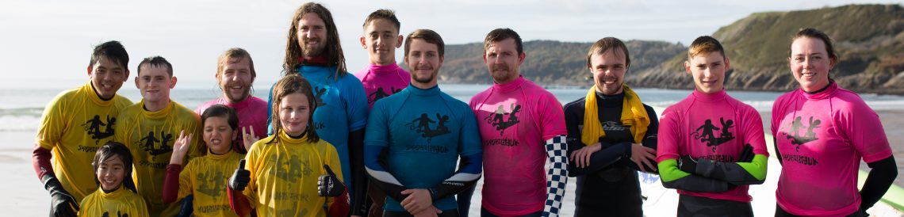(Surfability, unknown)

Our learners engage in outdoor learning for at least half of their scheduled classes, and also have access to the outdoor spaces for recreational use. This pragmatic approach empowers learners with the necessary skills to put their knowledge into practice with confidence. As students’ progress through the school, teachers facilitate the learning whilst supporting the development of resiliency and emotional intelligence. In all age groups learning is supported in the outdoor learning spaces, which enables each individual to explore and discover the natural world, whilst learning core skills such as numeracy, observation, and problem-solving. The diversity created by the combining of age groups also develops the learners understanding of individual different and ability level. (Montessori Society, unknown)


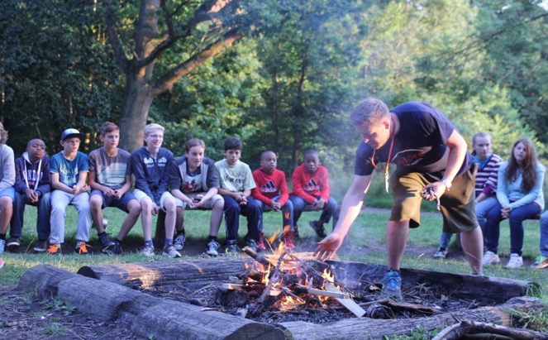
Taking Dewey’s perspective that the meaning of an idea or theory is understood when practically implemented, all students are encouraged to practically apply their learning. (Flanagan, 2006). The design of a traditional classroom is a clear example of the passive style of teaching, requiring the student to listen yet not engage in any meaningful way. When asked to think of a traditional classroom, the image of ordered tables and chairs is brought to mind. A set-up which minimises free movement and restricts individual differences. At Oakland all our outdoor learning spaces are open plan, and our indoor classrooms have a flexible furniture arrangement, allowing adaptions to be made to support learning when needed. This is because the learning environment has a direct influence on an individual’s motivation and ability to engage in creative practice (Gallagher, 2017). Having flexible learning environments helps us embrace individuality and provide an abundance of opportunities to enquire, create and experiment. Yet we believe it is essential to teach our learners about how the majority are educated and how the conditioning of false beliefs lead the learner to being unaware on what opportunities are available to them. We teach our students this philosophy so that they are aware of how learners can be oppressed, which enables our students to take the first step in liberation. (Flanagan, 2006)
(Swanson, unknown)

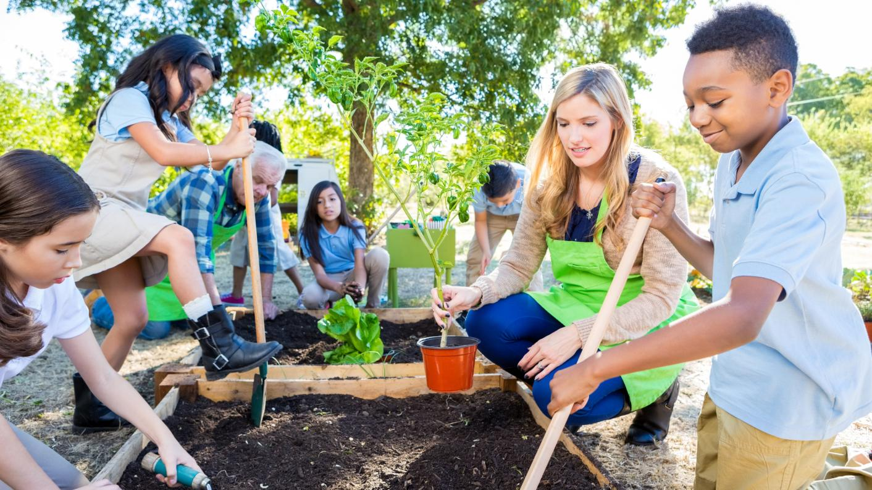
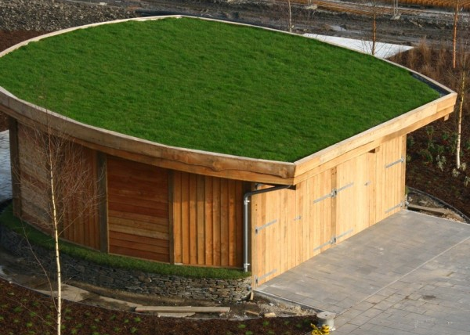
During outdoor learning time, students have the opportunities to use natural resources to directly learn with and support the development and transferring of skills to different environments. The natural resources are used for developing literacy and numeracy skills, for example, learning measuring skills to determine the length of a tree, or finding natural materials for an art project. It could also prompt further enquiry about how these resources would have been used throughout history (Learning through landscapes, unknown). Our students constructed a natural building with the support of Down to Earth, which also contributed to their enquiry into how natural materials can be used (Down to Earth, 2019). Learning outdoors encourages problem solving skills, and also develops awareness of the importance of risk assessment. This development of environmental awareness leads most of our students to foster a deep appreciation of our world, which acts as a driving force for developing eco-friendly practices in our school and community to tackle some of the key issues faced in society. Learning outdoors supports our core value of ensuring a healthy sense of well-being through physical exercise, connection to wild life and nature, and the nurturing of a pro-active mindset. Following the Montessori framework our students have the opportunity to develop their everyday life skills (Down to earth, 2019). Unlike many schools that are limited to classroom environments which have shown to suppress creativity and connection amongst the class, we have a multitude of environments on our campus for students to express their creativity transfer their knowledge and skills (Gallagher, 2017). This enables each student to connect their learning from across the curriculum and compounds their learning with practical experiences.
(Gillespie,2019)
(Down to Earth, unknown)

Cooking and Community


A distinctive aspect of Oakland is that all our school meals are prepared by our students and some staff members. Our meals are cooked using fresh ingredients grown by our students, and local produce. Cooking lunches together creates a convivial atmosphere and nurtures the desire to care for their body and develop the essential life skill of cooking. As nutrition is part of our curriculum we believe that preparing meals for other students provides the essential practice in developing their cooking skills. As mentioned previously, we recognise that purposeful learning takes place when mental processes are combined with physical activity. A basic example of this is of every learner being responsible for their environment, meaning any spills that need wiping, or mess that needs to be swept are done by our students. This responsibility extends to keeping their learning environments tidy, nurturing a sense of responsibility and respect to their environment, and is a skill they can transfer to their personal life (Tokuyama, 2018). When our students are directly involved in the growing and preparation of the food they consume it builds our learners awareness of consumption, and the process of growing food, whilst developing healthy eating habits and the skills to cook for themselves and friends/family. It is also an opportunity to learn about business relationships and the local economy which can be linked into their studies. By involving our students in the growing and preparation of their meals, it creates an appreciation for nature. All students have access to a vegetable garden which is maintained by our students, staff and members of the local community who are involved with the local charity Cae tan. This mix of age groups creates an inclusive environment where everyone can learn something from one another, placing value on every individual. This creates a sense of belonging, which meets our core value embracing the authenticity that each person brings to the community at Oakland (Berkenkamp, 2006). As a school that supports eco-friendly and sustainable development, supporting local businesses is one of the ways we contribute to creating a sustainable environment.


Gower has a strong farming community which has led to us forming a relationship with Cae Tan, the community supported agriculture project. They have access to our vegetable garden and provide weekly sessions where our students learn about growing food, connecting them with nature (Cae tan, 2020). Our connections with local businesses and charities have led to the formation of a community at Oakland. Residents of Gower contribute to the maintenance of our vegetable garden and woodland, and also act as mentors for our learners.

Mentoring Programme

As a student progresses through Oakland they will engage in the development of their mentoring skills through supporting their peers and engaging in extra-curricular activities.
Our mentoring programme is vital to the development of our students because it supports their mental health and well-being, and provides a trusted relationship where students can reflect their thoughts and learning (Broadbent an Papadopoulos, 2009). With our emphasis in outdoor learning, this has connected us with the community which delivers social and practical experiences which have shown to improve behaviour and develop interpersonal skills, supporting our learners to form deeper connections (Youth gov, unknown). This experience is also enhanced through our business relationships, where business owners can be involved in our mentoring programme. This enables our students to be involved within their community and access a range of opportunities to further develop their interests and skills, as well as being able to apply the entrepreneurial skills taught within the curriculum. This equips our students to respond creatively to the varying experiences of our students (Flanagan, 2006). To aid the development of these skills, all students have access to their own mentor who will either be a member of staff or a member of the local community.

Pastoral Care


At Oakland we have an open-door policy as we have found that students are likely to approach us outside of learning, to discuss personal challenges or interests. This additional time between students and staff members continue to develop positive relationships, and nurtures conversational skills. We believe that having effective pastoral care is integral to delivering a quality education, and has shown to positively impact attendance, and creates an atmosphere where students feel safe, valued and feel confident in accessing opportunities that enhances their achievements. To us pastoral care is more than offering academic support, it is enriching the students experience, preparing them for the next steps in their education and personal development and offering a variety of other benefits to enhance their involvement and learning. Pastoral care is a whole school approach that promotes an inclusive atmosphere and ensures that all students receive opportunities to explore their full potential. Through having open discussions with all students and nurturing a relationship of trust and respect, it eliminates inequality and culminates and overall value of engaging in learning and taking opportunities to grow (Ojewunmi, 2019). With a diverse body of students, we ensure that everyone has access to quality pastoral care with our team that aim to inspire each individual on their personal life-long learning journey, alongside having support through in-house counsellors. All our staff are accredited practitioners of the evidence-based mental health and well-being programme with i-act. With our widespread experience at Oakland, we have found that by breaking down the stigma of counselling and talking openly about emotions, mental health and traumatic experiences fosters resiliency and confidence in each student’s ability to navigate mental health challenges and seeking support (i-act, unknown). Our approach to teaching our students to not fear failure, as mentioned in the curriculum section of this prospectus, develops our learners ability to be self-compassionate, which in turns supports their mental health (Eva, 2017). With regular pastoral meetings, students learn about their emotions, behaviours and how to develop positive habits to empower themselves, whilst also deepening their connections which is essential in supporting the community at Oakland.

Online Learning

With a world that’s spending more time online, we are equipped to prepare our students in how to navigate the online world of learning, and develop skills that will enable them to thrive in this setting. Our online learning community is not dissimilar to Illich’s educational suggestions of providing students access to learning webs that facilitate cooperative learning exchanges (Flanagan, 2006). This online resource acts as a support and links to students’ learning at school, whilst providing a platform for them to collaborate and share their work.

Due to the practical nature of our curriculum attending lessons is essential. Yet our online learning platform enables our teachers to deliver theoretical teaching and discussion-based lessons, share additional resources, and support students outside of lessons. This continuation of connection with peers and staff members has shown to improve engagement and is an opportunity for students to develop their independent learning and online communication skills (Watson, 2008). We actively use technology to enhance our learners understanding of complex concepts and engage individuals in a more meaningful way than just listening to a description. This method of teaching links back to our Montessori framework as online learning develops independent learning and utilises creative thinking skills to assemble and present knowledge (Oakfields Montessori School, 2020).

(Brominicks, 2020)
Additional learning resources


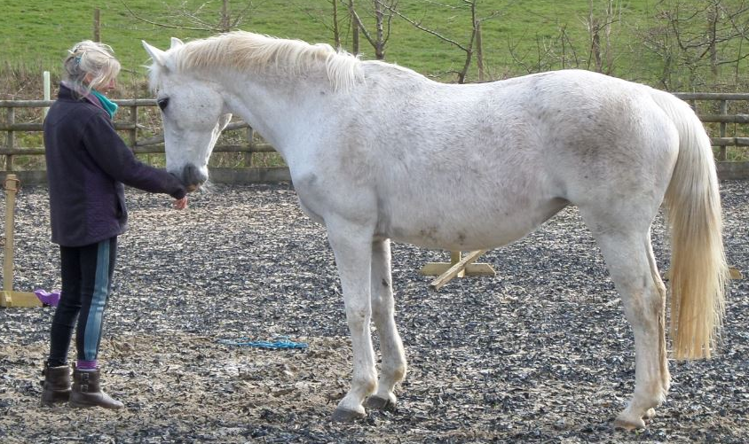
An example of an interactive learning experience that our students regularly engage in is our scheduled ‘teaching with animals’ sessions, involving learning from the animals of Oakland. As a reflection on the Montessori frame-work, alongside supporting our connections within the community we have animals such as horses, cows, alpacas, ducks, and chickens. These experiences involve learning how to care for the animals, as well as learning about their history, needs, behaviour and their place in the ecosystem. These interactive sessions enable each learner to develop their understanding of animal needs, whilst also learning skills such as empathy and responsibility (Gee, Griffin and McCardle, 2017). These sessions support the students in building confidence interacting with animals and interpreting body language, as well other skills such as public speaking. When we use animals for learning, all attention is on the animal, taking away the audiences focus on the speaker. We have therefore found that by introducing our students to public speaking when working with the animals, it supports the development of self-esteem and thr ability to present their knowledge and understanding in different subjects (Fuhrman, 2018). Long standing research shows that developing an individuals’ ability to engage in public speaking can support the development of critical and creative thinking, enhance relationships, increase self-esteem and is a skill that supports an individual to be assertive (Gee, Griffin and McCardle, 2017). These outcomes can all link back to our core values and what we aim to deliver in our teachings.
(Jamies farm, 2018)



Figure 1(Free from harm, 2013)

As the learner matures and progresses through Oakland, they will engage in a variety of academic opportunities, development of life skills and have access to speakers, activities and field trips. These opportunities, alongside our innovative curriculum supports the delivery of an education that facilitates the learning of how a student can participate in the transformation of themselves and modern society. In our ever-changing world we need innovative thinkers and creators, which is why at Oakland we strive to deliver an education that not only prepares our students academically, but prepares them for real life (Dewey, 2012). Oakland prepares students to actively participate in their community and have the foundations of self-efficacy to take-action and have a rewarding life experience, enhanced with the love of learning and a strong set of skills to navigate society. Our aim to develop well-rounded individuals that think independently and have a life-long passion for learning is achieved with the community-based, learner-led approach that Oakland has adopted, alongside delivering flexible and innovative teaching (Meinke, 2019). Through nurturing and maintaining relationships from the age of 3-16, teachers support the individual student through their educational journey so that upon leaving Oakland, they are equipped with the skills to succeed in whatever path they choose beyond us.

This prospectus should give you a brief overview of our approach and how we support the development of our students. To find out more, or to request information on open days and enrolling please use the details at the bottom of this page.

One of the realities in life is the cost of a quality education. Yet with support from local funding, we are able to extend an invitation to learn at Oakland to any family that feels their child would benefit from joining our learning community at Oakland.

Contact us:

Admissions@Oakland.co.uk
01792 326623

References
Arts Council. (2018) Bringing creative learning to life across the curriculum Available at: https://www.artsmark.org.uk/casestudies/bringing-creative-learning-life-across-curriculum-sponsored-article (Accessed 26 October 2020)
Berkenkamp, J. (2006) ‘Making the farm / school connection: Opportunities and barriers to greater use of locally-grown produce in public schools’ Leopold Center for sustainable agriculture (153) pp.1-33
Broadbent, R. Papadopoulos, T. (2009) ‘Community education and youth methoring: how to build good practice?’ Australian Journal of Adult Learning (vol.49, 2) pp.319-351. https://files.eric.ed.gov/fulltext/EJ864442.pdf
Cae Tan CSA. (2020) Children and schools. Available at: http://www.caetancsa.org (Accessed 30 October 2020)
Dewey, J. (2012) ‘My pedagogic creed’ School Journal (54) pp. 77-80
Down to Earth. (2019) Benefit of Down to Earth and the outdoors to participants’ well-being. Available at: https://downtoearthproject.org.uk/eco-building/recently-completed-oracle2/ (Accessed 26 October 2020)
Eva, A. (2017) Why we should embrace mistakes at school Available at: https://greatergood.berkeley.edu/article/item/why_we_should_embrace_mistakes_in_school (Accessed 26 October 2020)
Flanagan, F. (2006). The greatest educators..ever!
Franca, J. (2019). An interview with founder of critical pedagogy Henry Giroux on the meaning of education, suspicions regarding neutrality and on how current uncertainties could be a driving force to rethink and generate new possibilities. Available at: http://lab.cccb.org/en/henry-giroux-those-arguing-that-education-should-be-neutral-are-really-arguing-for-a-version-of-education-in-which-nobody-is-accountable (Accessed 20 October 2020)
Fuhrman, N. (2018) The one thing all great teachers do. Available at: https://www.ted.com/talks/nick_fuhrman_the_one_thing_all_great_teachers_do (Accessed 26 October 2020)
Gallagher, S. (2017) The physical space of a classroom and its impact on creativity. Available at: https://digitalcommons.wou.edu/cgi/viewcontent.cgi?article=1126&context=honors_theses (Accessed 26 October 2020)
Gardner, H. (1993) Multiple intelligences – The theory in practice Basicbooks:New York
Gatto, J. (unknown) The curriculum of play. Available at: https://www.life.ca/lifelearning/1006/curriculum_of_play_by_John_Taylor_Gatto.htm (Accessed 25 October 2020)
Gee, N. Griffin, J. McCardle, P. (2017) ‘Human-animal interaction research in school settings: Current knowledge and future directions’ Sage journals (vol 3) 2. https://doi.org/10.1177/2332858417724346
i-act (2020). i-act principles. Available at: https://www.i-act.co.uk/i-act-principles (Accessed 25 October 2020)
Kudlugi, M. (2016) Flexile starting times at the high school benefit all. Available at: https://whsbradford.org/flexible-starting-times-at-the-high-school-benefit-all/ (Accessed 28 October 2020)
Learning through landscapes. (unknown) About us. Available at: https://www.ltl.org.uk/about-us/ (Accessed 20 October 2020)
Meinke, H. (2019) Exploring the pros and cons of Montessori education Available at: https://www.rasmussen.edu/degrees/education/blog/pros_cons_montessori_education/ (Accessed 20 October)
Montessori Society. (unknown) Montessori Principles. Available at: https://www.montessorisociety.org.uk/principles (Accessed 27 October 2020)
Oakfields Montessori School. (2020) Future of learning. Available at:https://www.oakfieldsmontessorischool.org.uk/future-of-learning (Accessed 27 October 2020)
P4C. (unknown) About P4C Available at: https://p4c.com/about-p4c/ (Accessed 20 October 2020)
Percy, C. et al (2019) Insights and inspiration – exploring the impact of guest speakers in schools
Sleep Foundation. (unknown) Backgrounder: Later school start times Available at: https://www.sleepfoundation.org/articles/backgrounder-later-school-start-times (Accessed 28 October 2020)
Tokuyama, S. (2018) Cleaning Tradition. Available at: https://hundred.org/en/innovations/cleaning-tradition#791b4d9a (accessed 25 October 2020)
Unicef. (unknown). How we protect childrens rights with the UN convention on the rights of the child. Available at: https://www.unicef.org.uk/what-we-do/un-convention-child-rights/ (Accessed 20 October 2020)
Watson, J. (2008) Blended learning: The convergance of online and face-to-face education. Available at: https://files.eric.ed.gov/fulltext/ED509636.pdf (Accessed 30 October 2020)
Image references
Brominicks, J. (2020) Walk: Three Cliffs Bay, Swansea Available at: https://www.countryfile.com/go-outdoors/walks/three-cliffs-bay-gower-swansea/ (Accessed 23 October 2020)
Down to Earth. (unknown) Recently completed- Oracle2 at Swansea university Available at: https://downtoearthproject.org.uk/eco-building/recently-completed-oracle2/ (Accessed 28 October 2020)
Free from harm. (2013) How we teach children a separate morality for food animals. Available at: https://freefromharm.org/animal-products-and-culture/how-we-teach-children-a-separate-morality-for-food-animals/ (Accessed 30 October 2020)
Gillespie, A. (2019) Has any teacher really mastered outdoor learning? Available at: https://www.tes.com/news/has-any-teacher-really-mastered-outdoor-learning (Accessed 28 October 2020)
Jamies farm. (2018) From needing to needed: children working with animals. Available at: https://jamiesfarm.org.uk/from-needy-to-needed/ (Accessed 30 October 2020)
Kaplanco. (unknown). Outdoor learning inspirations. Available at:https://www.kaplanco.com/outdoor-learning (Accessed 20 October 2020)

Kids of the wild. (2020) Beach school rocks – outdoor learning at the beach. Available at: https://kidsofthewild.co.uk/2020/03/10/beach-school-outdoor-learning-education-at-the-coast-near-you/ (Accessed 28 October 2020)
Swanson, B. (unknown). 5 equipment free camping game Available at: https://www.activekids.com/outdoors/articles/5-equipment-free-camping-games-the-whole-family-will-love
C, H. (2018) Incredible UK summer camps: Hand picked for 4-19 year olds Available at: https://www.activekids.com/outdoors/articles/5-equipment-free-camping-games-the-whole-family-will-love (Accessed 25 October 2020)

