MODULE CODE: LCBB4006
GROUP WRITTEN REPORT

Student Name LEADER: IONELA SORINA OCNEANU
Student ID:2234046
GROUP: CRISTINA NICOLAE –2226305
MIHAELA MARICA-DUMITRANA-2233123
AMADU BARRIE-2323784
LECTURER : Matteew BRIAN

Executive Summary
The main purpose of the report was to evaluate the role of teamwork in developing the careers of students. There was a broad analysis of the benefits and drawbacks teamwork provides. A different teamwork-related framework such as Wheelan’s team development and Tuckman's team development has been discussed broadly. The impact of teamwork in shaping students' lives has been analysed further. There were effective recommendations which can help to improve obstacles that occur in teamwork.
Table of Contents
1.0 Introduction 5
2.0 Discussion of Teamwork 5
2.1 Explanation of Teamwork 5
2.2 Theories and Framework of Teamwork 6
2.2.1 Tuckman Group Development Model 6
2.2.2 Wheelan’s Integrated Model of Group Development 7
2.3 Significance of Teamwork 9
2.4 Influence of Teamwork on University Students 11
3.0 Recommendations for Better Teamwork 12
4.0 Conclusion 13
Reference List 14
Appendix 16
Responsibility of group members 16

1.0 Introduction
Effective teamwork is deeply interconnected with personal and professional development. In academics and working workplace, teamwork has become crucial in managing a similar project. As a result, at present having excellent teamwork skills necessary to bring growth in both academic and professional fields. Teamwork brings several benefits in students' lives to shape their future careers. That is the reason, the universities of the UK are focusing more on teamwork so that the students can bring future career development (Prada et al., 2022). In this context, the report aims to identify the potential of teamwork in developing students' careers. The report is going to evaluate the concept of teamwork along with an elaborate discussion. Different theories and frameworks have been discovered to bring deep and clear insight into teamwork. In this context, Tuckman’s team-developed theory is one of the effective team development theories which help to develop a team systematically. The theory will be discussed broadly in this report to identify its effectiveness. Another effective teamwork theory is going to be discussed in Wheelan’s Group development theory which will give clear and concise ideas on team development and its benefits for students. The beneficial factors associated with teamwork will be identified along with the challenges as well. The impact of teamwork on students' lives will be analysed further. Moreover, there will be recommendations that will help to deal with the challenges associated with teamwork in order to bring efficiency to it. Moreover, three people are going to accomplish the report as teammates to gain success.

2.0 Discussion of Teamwork

2.1 Explanation of Teamwork
Teamwork refers to a group of people working together to achieve a common goal. It is a collaborative effort of a group to accomplish a task in an effective manner. Teamwork is considered the ability to work with others and help others to meet shared goals. Teamwork is related to several interrelated actions such as adaptability, performance monitoring, backup behaviours, giving and getting feedback, coordination of action and close-loop communication (de Prada Creo et al., 2021). Therefore, various soft skills make teamwork effective and successful. Communication is the key that makes teamwork effective and successful as it helps to flow information among coworkers to be aware of workers' tasks and the common targets. Teamwork develops coordination among the team members so they can help each other to produce better outcomes. It develops the commitment in teams toward their work and the responsibility to meet better results. It fosters trust among the workers and helps them to work effectively to reach the expected organisational targets. Teamwork helps students to learn skills such as problem-solving and research while working on a common project. Effective teamwork is related to effective higher quality products and higher grades (Planas-Lladó et al., 2021).

2.2 Theories and Framework of Teamwork

2.2.1 Tuckman Group Development Model
Description the theory
In 1965 physiologist Bruce Turkman developed the Team development model which is known to all Turkman’s group development model (Vaida et al, 2021). The model explains that the teams build up ability, relationship, and maturity and leaders change their leadership styles to become more collaborative. The model describes teams' moves through five stages forming, storming, norming, performing and adjourning. According to Tuckman each of the steps is essential for team growth and development. The model is especially helpful for training people on group work.
Stages of the theory
Forming: It is the first stage of the Turkman development model where team members are introduced to each other and start getting to know each other by knowing their interests, hobbies and skills (Patterson, 2022). In this stage, employees are excited to show their abilities.
Storming: This is the second stage, where conflicts arise in teams due to different perspectives, thinking and working attitudes (Donald and Carter, 2020). In this stage, teams are focusing on developing ideas to redefine the goals.
Norming: Norming is the third stage, where team members work to understand their roles and responsibilities within the project. In this stage, teams are focusing on the energy of their production and goals. Teams also enhance the sense of comfort by expressing their feelings, ideas and constructive criticism of the team's success (Patterson, 2022).
Performing: It is the fourth stage, where team members learn to resolve conflicts and efficiently coordinate (Donald and Carter, 2020). In this stage, teams experience a feeling of job satisfaction and share their insights into personal and group processes.
Adjourning: Adjourning is the last stage, where teams are disbanded and teams feel a mixture feeling job satisfaction and anxiety about the uncertainty about the future (Donald and Carter, 2020). In this stage, team members shift their focus to developing personal relations from task orientation.
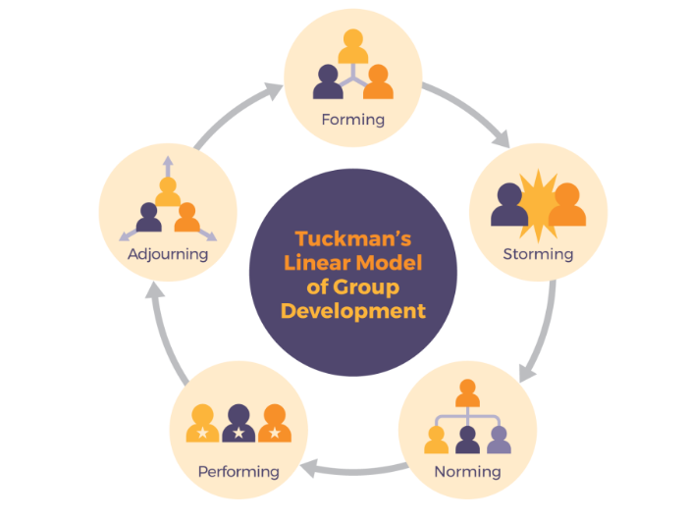
Figure 1: Tuckman Group Development Model
(Source: Patterson, 2022)
Effectiveness of the theory
Tuckman Group Development Model is effective develop strong and effective teams for any work. It helps to understand the stages of development a team goes through in work. It also helps team members to understand the dynamics of the teams and their roles in the working process. The theory is generalised well and its steps highlight the work process of teams (Vaida et al, 2021). On the other hand, in Turkman's theory, each stage has conflicts and there is no instant solution to overcome the conflicts. The lack of clarity in the second stage of the theory creates challenges in handling conflicts. The theory stages are not so much flexible and deeply depend on the precise size of the group.

2.2.2 Wheelan’s Integrated Model of Group Development
Description of the theory
Following Tuckman’s Model of Team Development and her own empirical research, Susan Wheelan proposed an ‘integrated’ or ‘unified’ group development model which is known as the ‘Wheelan Integrated Team Development’ model. The model identifies how group work makes individuals of the group mature as they continue to work together rather than simply go theory the activity stages (Vaida et al., 2021). The model discovered the early stage of group work where it described some specific issues and patterns of taking style such as those related to the stage of the theory. The theory consists of five stages which bring deep insight into the theory which are:
Stages of the Theory
Stage 1- Dependency and Inclusion: It is the first stage where a group of individuals come together to work on a similar project. Here, the team members highly depend on the designated leaders and are concerned about their inclusion and safety issues. In this stage, all members of the team rely on the leaders and powerful members of the group who can provide them with direction (Vaida et al., 2021). In this stage, employees focus on establishing their social acceptance and are cautious about expressing their thoughts. However, exchanging stories about other projects or outside activities is not allowed in such a situation.
Stage 2- Counter Dependency and Fight: It is the second stage where conflict situation arises due to disagreement among group members about the group procedures and goals. Conflict is inevitable part due to the desire for individual expression and freedom. It creates challenges for team members to explore and provide boundaries (Gren et al., 2020). It is challenging for leaders to manage conflicts along with effective solutions. Conflict is also necessary to build climate and trust which makes team members feel free to disagree and expres their throghts.
Stage 3- Trust and Structure: It is the stage where team members get a sense of structure and trust where communication becomes tsk-oriented and open. Here, groups develop the skills which they are required to negotiate and use to assign tasks, roles, and responsibilities to accomplish the tasks (Path et al., 2020).
Stage 4- Productivity and Performance: This stage represents the peak of group development where groups increase productivity and performance (Path et al., 2020). Group members cooperate and share the same goals with each other which increases their responsibility and creativity.
Stage 5- Final: It is the last stage of the theory where groups disband after accomplishing the goal and ending their together journey. It ends up with reflecting on achievements, challenges and future opportunities (Yidaki and Grinderman, 2022). However, this stage overlooks but it is crucial to get closure and learning.
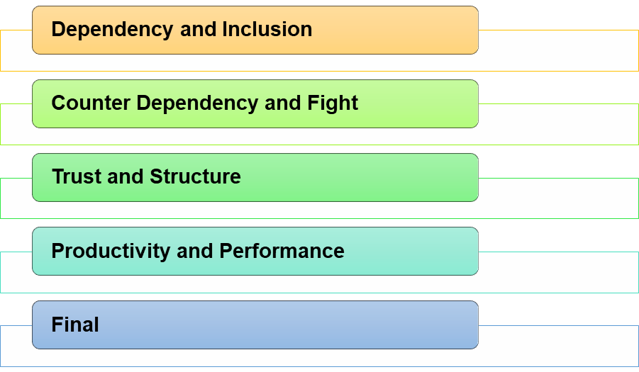
Figure 2: Wheelan’s Group Development Framewor

Effectiveness of the theory
Following the stages of group development, it has been found that the theory provides a complete systematic way, following which students can make teamwork properly in their academic life as well as future careers. Along with this, it has provided opportunities to understand the conflicts that can be arrived at due to working together which helps to be aware of the concern and prepared for betterment (Ylimaki and Brunderman, 2022). However, avoiding the conflict factors will create challenges in the near future to work within a team to achieve success. Based on this, model, Wheelan created a group development questionnaire (GDQ) and Group Development Observation System (GDOS). GDOS allow researchers to identify the group development stage by counting and categorising each complete obtained during the group session. On the other hand, GDO helps to identify the individual's perception of group members which plays a major role in the group development stage.

2.3 Significance of Teamwork
Provides personal and professional growth: Teamwork is very essential for students and individuals to achieve growth in their personal and professional lives. It provides exclusive knowledge and experiences to work in teams and helps to gain other necessary skills that are essential for growth. Therefore, when employees work together to meet a common goal then everyone gets benefits (Dol, 2024).
Enhance efficiency and productivity: In teamwork, team members share their learning and experience with each other which makes the whole team smarter and improves team flexibility and efficiency when dealing with different issues and tasks. It enhances the efficiency and productivity of individuals by capitalising on team members' diverse skills and strengths (Mobolade and Akinade, 2021). Teamwork helps to resolve conflicts among coworkers and makes huge contributions to increasing productivity.
Enable better problem-solving: Teamwork boosts the collaborative efforts of team members and leads them to innovatively solve problems to complete the task faster and produce high-quality results (Shrm, 2024). It motivates team members to develop effective communication and collaboration that helps to exchange their perspectives and ideas with each other which enables team members to better solve problems.
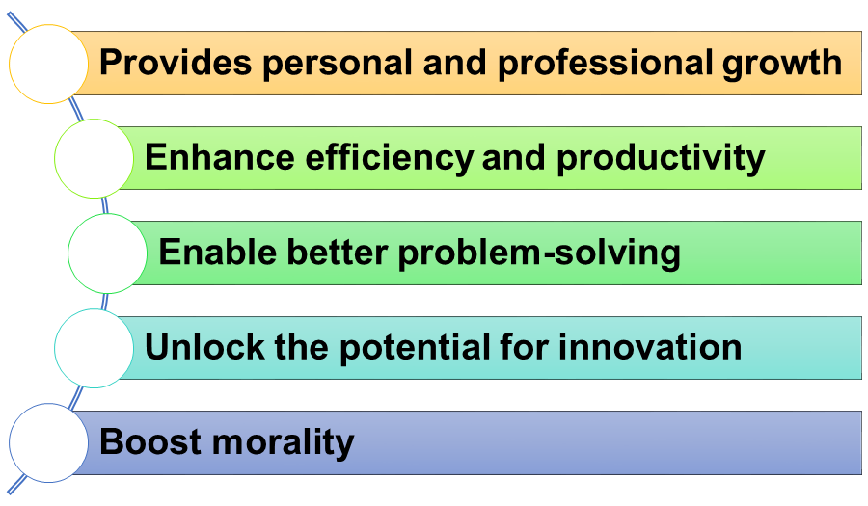
Figure 3: Significance of Teamwork
(Source: Self-created)
Unlock the potential for innovation: Teamwork encourages to development of effective communication which creates a positive work environment to unlock the potential for innovations of individuals. The interaction between team members during teamwork helps them to develop innovative ideas to improve overall production and performance (Dol, 2024). Therefore, different experiences, opinions and perspectives of team members help to increase the creativity of individuals to unlock innovative ideas.
Boost morality: Teamwork improves the utilisation of manpower and effectively raises the performance of the team members. It effectively increases employee morality to work well in teams (Mob lade and Akinwande, 2021). Teamwork motivates team members to share their workloads by supporting each other productions. Therefore, team members provided emotional support to each other that protected them from work burnout due to over pressure of work.
Teamwork has many positive sites however it also has some negative sites that can negatively impact the individuals' performance. Teamwork takes a longer time to make decisions which delays task accomplishment (Stoyanova et al., 2021). It can create work conflicts due to clashing personalities of individuals in the teams as they have different beliefs, attitudes and knowledge. Lack of clarity about the expectations and responsibilities of the team members can create a communication gap which can lead to ineffective teamwork. It is a time-consuming process which can miss the deadlines of the tasks. Disagreements among team members on a sustained topic can raise accountability issues in teamwork (Stoyanova et al., 2021). Different working styles of workers can create confusion to determine the goals of the teamwork.
Teamwork is a critical component and major soft skills that help students of universities to shape their careers. There are various reasons why teamwork is beneficial for students such as:
Build Relationship
Teamwork helps students to build better relationships with their classmates which helps to develop a supportive and positive learning environment. Therefore, working together helps students to grow their trust, respect and sense of community which helps to enhance project quality (de Prada Creo et al., 2021). Teamwork is beneficial for those students who are struggling with socialising or who may have new educational places. For example, by building relationships students will feel connected with peers and universities which leads to better engagement and performance levels.
Promote Accountability
Teamwork makes students responsible which is the reason universities provide adequate teamwork projects so that such skills can develop employment opportunities for future growth. Students will benefit by being responsible for their portion of work and having time management ability (Oosthuizen et al., 2021). Working with teams increases problem-solving abilities which helps them to mitigate the challenges and meet deadlines. It will be valuable in the future for the students to work independently and be accountable for their actions in their academic journey and workplace. For example, students would be able to identify their responsibility and work on them appropriately.
Develop Communication Skills
Effective and clear communication leads to successful teamwork which is a core aim of universities. For example, working together with groups students are able to enhance their speaking, listening and writing capabilities. Students learn how to resolve conflict, express constructive feedback and negotiate with each other (Lochner et al., 2020). It is valuable not only in academic life but also in professional life where employees can work together in a team to meet common goals.
Develop Learning
Working on a common project makes students scope to understand the strengths and weaknesses of each other. For example, it fosters a collaborative learning environment and a deeper understanding of a topic (Lochner et al., 2020). Hence, it helps students to understand new perspectives which leads to innovation and creative thinking.
Prepare for Future
In today fast spaced interconnected world, collaboration has become significant in workplaces where employees need to work and share common goals (Prada et al., 2022). Practising teamwork in universities makes them prepared to deal with teamwork projects effectively to foster growth in their careers.
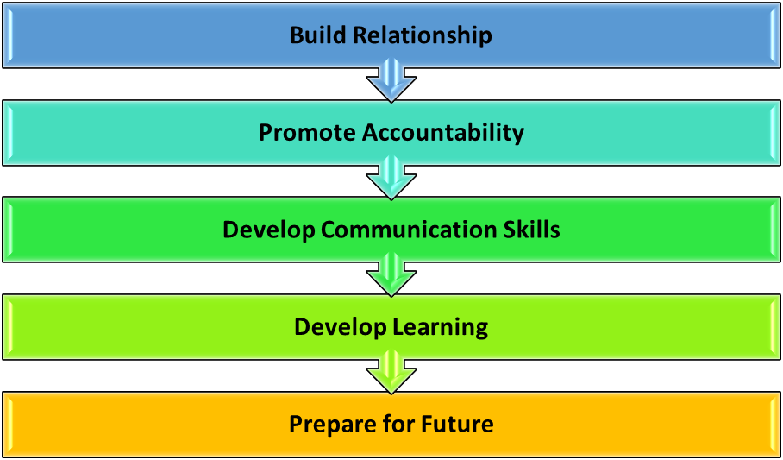
Figure 4: Beneficial impact of teamwork on students
(Source: Self-created)

3.0 Recommendations for Better Teamwork
Ensure equal contribution of everyone
It is necessary to track everyone’s contribution to teamwork so that everyone equally contributes. Unequal contribution can lead to dissatisfaction and conflict among team members (Dittmann et al., 2020). Everyone's equal contribution improves project quality and fosters success.
Meet outside for a better personal bond to reduce conflict
Meeting teammates outside the office helps to understand each other in a better manner. As a result, it increases their personal bond which they can use to improve their teamwork and build creativity (Forbes, 2023). Understanding an individual's desires, feelings, and expectations helps to respect different perspectives as well.
Include peer assessment and evaluation
Before forming teamwork, it is essential to assess individuals' thoughts which helps to reduce conflict within the team and increase performance (Forbes, 2023). As a result, teamwork goes smoothly without disruption to meet common goals.

4.0 Conclusion
It can be concluded that teamwork has several beneficial outcomes in shaping the lives of students. Utilizing teamwork students have the ability to improve several soft skills such as empathy, communication, critical thinking, problem-solving, and so on. It is beneficial in workplaces as well as academic lids bringing development in performance. There was an elaborate discussion on the concept and benefits of teamwork aligned with its challenges. Therefore, team development theories such as Tuckman’s theory and Wheelan’s team development theory have been discussed to bring clear ideas on team formation and its impact. Moreover, the significance of teamwork on students has been developed here. Recommendations such as meeting outside, equal contribution, and peer evaluation have been made to improve teamwork.

Reference List
de Prada Creo, E., Mareque, M. and Portela-Pino, I., (2021). The acquisition of teamwork skills in university students through extra-curricular activities. Education+ Training, 63(2), pp.165-181.
Dittmann, A.G., Stephens, N.M. and Townsend, S.S., (2020). Achievement is not class-neutral: Working together benefits people from working-class contexts. Journal of Personality and Social Psychology, 119(3), p.517.
Dol, (2024). Teamwork. Available at https://www.dol.gov/sites/dolgov/files/odep/topics/youth/softskills/teamwork.pdf [Accessed on 29.02.2024]
Donald, E.J. and Carter, A., (2020). Overview of common group theories. Group Development and Group Leadership in Student Affairs, p.17.Forbes, (2023). Nine Strategies For High-Performance Teamwork. Available at https://www.forbes.com/sites/forbescommunicationscouncil/2023/04/20/nine-strategies-for-high-performance-teamwork/?sh=1bfafb4b2545 [Accessed on 29.02.24]
Gren, L., Goldman, A. and Jacobsson, C., (2020). Agile ways of working: a team maturity perspective. Journal of Software: Evolution and Process, 32(6), p.e2244.
Lochner, L., Wieser, H., Oberhöller, G. and Ausserhofer, D., (2020). Interprofessional team-based learning in basic sciences: students' attitude and perception of communication and teamwork. International journal of medical education, 11, p.214.
Mobolade, G.O. and Akinade, M.E., (2021). Team building and teamwork in organizations: Implications to managers and employees in work places. International Journal of Management, Social Sciences, Peace and Conflict Studies, 11(4), p.1.
Oosthuizen, H., De Lange, P., Wilmshurst, T. and Beatson, N., (2021). Teamwork in the accounting curriculum: Stakeholder expectations, accounting students’ value proposition, and instructors’ guidance. Accounting Education, 30(2), pp.131-158.
Patterson, D., (2022). 4.6. In-depth Look: Tuckman’s Model–Five Stages of Team Development. Strategic Project Management: Theory and Practice for Human Resource Professionals.
Planas-Lladó, A., Feliu, L., Arbat, G., Pujol, J., Suñol, J.J., Castro, F. and Martí, C., (2021). An analysis of teamwork based on self and peer evaluation in higher education. Assessment & Evaluation in Higher Education, 46(2), pp.191-207.
Poth, A., Kottke, M. and Riel, A., (2020). Evaluation of agile team work quality. In Agile Processes in Software Engineering and Extreme Programming–Workshops: XP 2020 Workshops, Copenhagen, Denmark, June 8–12, 2020, Revised Selected Papers 21 (pp. 101-110). Springer International Publishing.
Prada, E.D., Mareque, M. and Pino-Juste, M., (2022). Teamwork skills in higher education: is university training contributing to their mastery?. Psicologia: Reflexao e Critica, 35.
Shrm, (2024). Developing and Sustaining High-Performance Work teams. Available at https://www.shrm.org/in/topics-tools/tools/toolkits/developing-sustaining-high-performance-work-teams [Accessed on 29.02.2024]
Stojadinović, J.S., Begovic, I. and Dašić, B., (2021). Team and teamwork in the function of effective management. Ekonomski signali: poslovni magazin, 16(1), pp.95-112.
Vaida, S.E.B.A.S.T.I.A.N. and Șerban, D., (2021). Group development stages. A brief comparative analysis of various models. Studia Universitatis Babes-Bolyai, Psychologia-Paedagogia, 66(1), pp.91-110.
Ylimaki, R.M. and Brunderman, L.A., (2022). Building and Sustaining School Leadership Capacity. Evidence-Based School Development in Changing Demographic Contexts, pp.55-61.

Responsibility of group members
The 4 members of this group associated with the teamwork are Cristina, Ionela, Mihaela and AMADU BARRIE .All members meet regularly at university and also on Teams to discuss us improvement areas and track us assignments. It has been found Cristina helped to gather updated information regarding teamwork to make quality work while Ionela helped to note down the important keywords related to teamwork. Mihaela and AMADU BARRIE helps to criticise the information before making the final decision of writing. They take similar responsibilities to accomplish the work successfully and divide the writing among themselves in order to finish within time and improve writing quality. After finishing it, they recheck grammatical errors and writing mistakes to avoid plagiarism issues.

