

Research and Case Scenario in Data Security and Compliance

  - By Jac Wilde

Contents
Task 1 – Research in Data Security and Compliance 3
Implementing a Zero Trust Architecture 3
Introduction 3
Principles 3
Challenges 5
Technological Enablers 6
Real-World Case Study: Google BeyondCorp 7
Conclusion of Findings 8
Task 2 – Work-Based Project: Chief Information Security Officer (CISO) Proposal 10
Information Security Unit Proposal 10
Introduction - Summary 10
Organizational Design & Resourcing 10
Policy Framework Development 11
Regulatory Compliance Strategy 13
Technical Standards & Architecture 14
Strategic Risk Assessment 15
Incident Response & Business Continuity 16
Governance & Strategic Roadmap 17
Conclusion 19
Bibliography 20

Task 1 – Research in Data Security and Compliance

Implementing a Zero Trust Architecture

Introduction
The modern workplace is a rapidly changing environment. Organisations are moving away from traditional networking environments towards cloud and hybrid alternatives. The addition of remote working and bring your own device (BYOD) policies has also expanded attack surfaces for cyber criminals. Employees may now access organisational resources from multiple locations and devices, making it difficult for organisations to maintain a clearly defined network perimeter. The sophistication of cyber attacks has increased in recent years, with organisations facing threats such as ransomware, credential theft and insider threats. As a result, traditional network security methods may no longer be sufficient to protect modern enterprise environments.
This research paper will investigate Zero Trust Architecture (ZTA) as a data security method within modern enterprises. ZTA is based on continuous identity verification, and least-privilege access policies. This represents a proactive approach to security rather than relying on reactive measures. This method will be researched and critically analysed to gain an in-depth understanding of its core principles, the challenges associated with its implementation and its technological enablers. The investigation aims to determine whether implementing ZTA is an effective security model for protecting sensitive data, reducing insider and outsider threats, as well as meeting compliance requirements.

Principles
The primary philosophy of ‘Zero Trust’ is: “never trust, always verify”. This comes with the assumption that threats are not always from an external source, but can also originate from within the organisation. ZTA is becoming more prevalent in modern cyber security, as traditional perimeter security is no longer effective. Rushdy and Thorig [1] explain that this is because traditional security methods maintain a defined boundary between untrusted external networks and trusted internal networks. This approach is no longer suited to current environments, which include cloud computing, remote work and IoT devices, as attacks can also originate internally.
Traditional security methods are static and less capable of adapting to changing landscapes. This makes networks vulnerable to various modern attacks, such as ‘man in the middle’ attacks, DNS hijacking and denial of service (DoS). Traditional security models can also create additional risks when an attacker successfully gains access to a legitimate user account or device, as this may allow them to move laterally through the network and access additional resources. Continuous verification of user identity can be crucial to identifying and preventing these types of attacks both internally and externally [2]. However, it is important to recognise that Zero Trust is not a solution that automatically prevents all cyber attacks. Instead, it aims to reduce the potential impact of an attack by limiting access, continuously evaluating risk and restricting an attacker's ability to move through the environment.
Nahar et al explain the assumptions and principles that the [3] zero trust model is based on. The first assumption being ‘No implicit trust’. This means that trust is not automatically given based on location. Each access request should be subject to additional verification. Second is that ‘threats exist both inside and outside’. This means that the model treats both internal and external security equally, with proactive methods such as continuous monitoring of internal activity. This leads to the third assumption; ‘Continuous monitoring is essential’. This will allow for early identification of emerging threats. Next is ‘Network Perimeter is not a reliable boundary’. Modern attackers are more than capable of breaching traditional security methods; ZTA presents a more dynamic approach. The final assumption is that a ‘Data-Centric focus’ is crucial. Protecting sensitive data is always a priority. This means that security controls should be applied around important data and resources rather than relying solely on protecting the network itself.
Continuing from the assumptions within ZTA, NIST [4] identifies several key principles. The first principle is to ‘verify explicitly’. Users, devices and systems are to be verified before access is granted, with authentication potentially being repeated depending on the level of risk. Unlike traditional security models, no user or device is automatically trusted simply because it resides within the organisation's network perimeter.
The next principle is ‘least privilege access’. This means that users are given the lowest level of access needed for them to complete their tasks. This prevents users from accessing data that they should not see, as well as reducing the impact of an account if it were compromised.
Following on from this, is the principle ‘assume breach’ [3]. Unlike traditional systems that assume everything is secure, ZTA is designed to assume that there is always a potential security breach. This encourages organisations to implement controls that limit the potential damage caused by a successful attack. For example, if an attacker compromises an employee's account, least-privilege access and segmentation should restrict the number of resources that can be accessed.
The next principle is ‘micro-segmentation’ [3]. This divides networks into separate segments, controlling access between them. For example, segments for each department within an organisation (HR, IT, Finance, etc). This helps prevent lateral movement and can contain an attack within a smaller area of the organisation. However, micro-segmentation can also increase the complexity of network management, particularly in large organisations with numerous applications and legacy systems.
The final principle is ‘conditional access and continuous monitoring’. This means that access can only be granted when specific conditions are met. The criteria for this can be user identity, device compliance, location, time, etc. The use of continuous monitoring can detect potential security risks and access that is not in line with the set criteria. Spotting this activity early gives organisations a chance to prevent attackers from moving laterally across the network.
While these principles can significantly improve security, they require organisations to maintain accurate information about users, devices and resources. Poorly maintained identity or asset information could therefore reduce the effectiveness of zero trust implementation.
The below diagram from Soni et al, provides a visual representation of how ZTA and its core components function [5]:
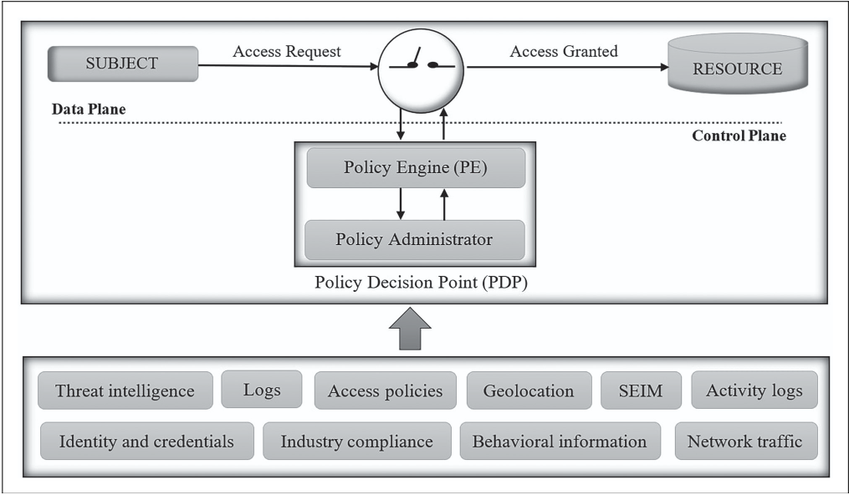
Figure 1- ZTA Framework

Challenges
Whilst ZTA is a step in the right direction where network security is concerned, it still has its share of drawbacks and challenges. A challenging step in the implementation of ZTA is the transition from legacy systems, and the shift in mindset that it requires. The removal of implicit trust could cause frustration to many employees. The transition also involves many complex steps to replacing legacy architecture, making it a difficult project to manage and implement [6]. These legacy systems may not support modern authentication protocols, meaning they would need to be replaced entirely.
This creates an important challenge for organisations because replacing legacy infrastructure can be expensive and disruptive. Many large enterprises rely on systems that have been operating for many years and may support critical business processes. Completely replacing these systems may not be practical, meaning that organisations may need to implement Zero Trust gradually. This could involve applying Zero Trust controls to newer systems first while developing alternative security controls for older infrastructure.
There are numerous technologies that underpin ZTA, such as multi-factor authentication (MFA), access control and trust assessments. Each of these technologies has their own complex requirements and technical difficulties that require solutions. This makes balancing security benefits against operational complexity a challenging task [7]. For example, requiring users to repeatedly authenticate may improve security but could also negatively affect productivity and user experience. Organisations must therefore find an appropriate balance between security and usability.
The evolution of the threat landscape introduces operational challenges to ZTA. The need for strong authorisation methods, network segmentation and consistent authentication calls for a high level of maintenance across hybrid or cloud environments [8]. This would mean an increased workload on security engineers and IT teams. Policies must also be regularly reviewed to ensure that employees have the correct level of access. If access rights are not updated when employees change roles, there could be users maintaining access to data they legally no longer have the right to view.
Other challenges that come to light when implementing ZTA are the ethical considerations that are required. If continuous monitoring is to be used, it could involve the processing of sensitive user data. This would result in concerns surrounding regulatory and legal compliance [9]. Organisations therefore need to ensure that monitoring is proportionate, and that collected information is handled appropriately. This is particularly important under data protection regulations, where organisations must consider how personal data is collected, processed and stored.
These challenges demonstrate that implementing ZTA is not a straightforward process. The architecture can provide significant security benefits, but organisations must consider the financial, technical and operational implications. A successful implementation is therefore likely to require a phased approach, supported by clear governance and regular assessment of security risks.

Technological Enablers
ZTA has many technological enablers. The first being, ‘secure access service edge’ (SASE). SASE is a cloud-based solution to networking and security. It combines tools such as software defined wide area networks (SD-WANSs), zero trust network access (ZTNA), firewall as a service (FWaaS) and secure web gateways, to aid in the implementation of a secure network [10].
The integration of networking and security into one cloud-based platform, provides a simple and agile platform for organisations to manage. Another benefit is it’s support of hybrid working. It provides the means for users to access company resources from anywhere, using a secure connection. The use of zero trust principles means that it continuously validates user identity to maintain a secure environment. The combination of these tools into one technology would potentially reduce the number of separate security technologies that an organisation needs to manage. However, SASE does not eliminate the need for traditional network security controls and may introduce additional concerns relating to cost, supplier management and cloud dependency.
The implementation of SASE can also be complex for organisations with significant legacy infrastructure. Moving existing networking and security functions towards a cloud-based model may require considerable planning and investment. Therefore, while SASE can support Zero Trust implementation, it should not be viewed as a complete replacement for all traditional security controls.
ZTNA involves the implementation of the key principles of ZTA. This will provide the network with increased protection from evolving threats, by bringing improved policy enforcement and access control. It will also aid in mitigating lateral movement of attackers. If an attacker were to gain access to one segment of the network, the additional verification needed to access resources within another segment of the network would prevent further disruption. However, the effectiveness of ZTNA depends on the accuracy of access policies and identity information. If users are incorrectly given excessive permissions, the security benefits can be reduced.
Another technological enabler is ‘identity governance and administration (IGA). A supplier of this security framework is Microsoft, with Microsoft Entra ID Governance. It is a framework designed to meet all compliance and regulatory requirements [11]. This technology would provide organisations with the ability to manage access levels for users, by elevating or restricting permissions as their role within the organisation changes. This is known as the ‘identity lifecycle’, illustrated in the below diagram [11]:
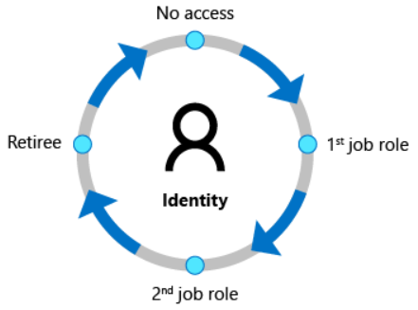
Figure 2- Identity Lifecycle
The same management is provided to user accounts with privileged access (administration privileges). For example, a service desk engineer would not have the same administrative privileges as a network administrator. So, access to services such as active directory could be read only for a service desk engineer, and full access for a network administrator. This demonstrates how IGA supports the Zero Trust principle of least privilege by ensuring that users receive only the access required to perform their role.
This tool also provides the ability to manage guest access for third parties requesting access to network resources. This access will then be automatically revoked after the access rights expire. This is particularly relevant to Zero Trust because third-party users should not be automatically trusted simply because they have been granted access previously.
The use of IGA can therefore help organisations maintain better control over identities and access permissions. However, effective identity governance relies on organisations maintaining accurate information about users and their roles. If an employee changes position but their access rights are not updated, unnecessary privileges may remain active. This highlights the importance of combining IGA with regular access reviews and continuous monitoring.
A core technology within ZTA is MFA. MFA provides an additional layer of authentication by requiring users to provide more than one form of verification. This can reduce the risk of stolen passwords being used to access organisational resources.
These technologies demonstrate that Zero Trust is not a single product that an organisation can purchase and implement. Instead, it is an overall security strategy supported by multiple technologies and processes. The effectiveness of the architecture depends on how well these technologies are integrated and managed.

Real-World Case Study: Google BeyondCorp
A real-world example of Zero Trust implementation is Google’s BeyondCorp security model. Google developed BeyondCorp as an alternative to traditional perimeter-based security, where access to company resources was primarily based on whether a user was connected to the corporate network. This traditional approach presented a potential security risk, as a compromised account or device could potentially gain access to multiple internal resources once inside the network. BeyondCorp instead moves security controls away from the network perimeter and focuses on the individual user and device requesting access. This means that access decisions are not based solely on whether a user is connected to a trusted network [12].
BeyondCorp applies several principles that are associated with ZTA. Users and devices are required to be authenticated and assessed before access is granted. The identity of the user, the device being used and other contextual information can be considered when determining whether access should be provided. This demonstrates the principle of ‘verify explicitly’ discussed earlier in this research. It also supports least-privilege access, as users are only provided with access to the specific applications and resources required to perform their role. This approach can help reduce the potential impact of compromised credentials, as gaining access to one account does not automatically provide unrestricted access to the wider organisation [12].
The implementation of BeyondCorp demonstrates the potential benefits of moving away from traditional network security models. It is particularly relevant to modern organisations that support remote working and cloud-based services, as employees do not need to rely on being physically connected to a corporate network to securely access resources. However, Google's experience also demonstrates that implementing Zero Trust at a large scale can be complex.
One of the key difficulties identified during Google's implementation was highlighted in the USENIX article ‘BeyondCorp and the long tail of Zero Trust’. While many applications could be moved towards the BeyondCorp model, some older or specialised systems did not easily support the required authentication and access controls [13]. These systems required additional work and in some cases, bespoke solutions to integrate them into the Zero Trust environment. This demonstrates one of the key challenges identified earlier in this research, where legacy systems can make the implementation of ZTA more complex and time-consuming.
The experience shows that implementing Zero Trust is not a straightforward process, as organisations must balance security improvements with the practical limitations of existing technology. Therefore, even for a large organisation such as Google, the transition to Zero Trust required significant ongoing effort rather than being achieved through a single implementation.

Conclusion of Findings
This research has investigated the implementation of Zero Trust Architecture (ZTA) within modern enterprise environments, focusing on its principles, challenges and technological enablers. The findings indicate that traditional perimeter-based security models are becoming less suitable for organisations operating across cloud, hybrid and remote working environments. ZTA provides a more dynamic approach by removing implicit trust and requiring users, devices and systems to be continuously verified before access is granted.
The principles of least privilege, micro-segmentation, conditional access and continuous monitoring can help organisations reduce the risk of unauthorised access and limit the potential impact of security breaches. However, the research has also identified several challenges associated with implementation. Legacy infrastructure, operational complexity, cost, user experience and the privacy implications of continuous monitoring can all create barriers to successful adoption.
Technological enablers such as SASE, ZTNA, IGA and MFA can support organisations in implementing Zero Trust principles. However, these technologies should not be viewed as individual solutions, as effective ZTA requires their integration alongside appropriate security policies, governance and monitoring.
Overall, the findings suggest that ZTA can be an effective security model for modern organisations. However, its effectiveness depends on careful planning, appropriate technology selection and continuous management. Therefore, Zero Trust should be considered a long-term security strategy rather than a single technology or solution.

Task 2 – Work-Based Project: Chief Information Security Officer (CISO) Proposal

Information Security Unit Proposal

Introduction - Summary
Aegis FinTech Innovations Ltd is a growing financial technology organisation developing an AI-powered financial analytics platform. The planned expansion into the European Union, alongside increasing ransomware threats and stringent regulatory requirements, means that a strong information security strategy is essential.
This proposal outlines the approach to establishing a dedicated Information Security Unit to protect Aegis's data, systems and customers. Based on the findings from Task 1, this proposal recommends adopting Zero Trust Architecture (ZTA) as the foundation of the organisation's technical security strategy. The principles of ‘never trust, always verify’, least-privilege access, continuous monitoring and micro-segmentation will be supported by technologies including ZTNA, Identity Governance and Administration (IGA), MFA and SASE.
The proposal also recommends using the NIST Cybersecurity Framework 2.0 as the overarching security framework, supported by new security policies, GDPR and DORA compliance planning, and a ransomware response strategy. A 12-month roadmap will prioritise the organisation's most critical risks and establish a proactive and resilient security unit to support secure European expansion.

Organizational Design & Resourcing
The creation of a dedicated Information Security Unit is essential for Aegis FinTech Innovations Ltd to manage the security risks associated with its AI-powered platform, cloud infrastructure and planned expansion into the European Union. The proposed structure is designed to provide specialist knowledge across technical security, identity management, compliance and risk.
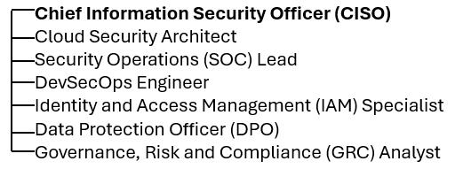
Figure 3- Proposed Information Security Unit Structure
The CISO will be responsible for the overall security strategy and will report security risks and performance to the Cyber Security Committee. The Cloud Security Architect will be responsible for securing Aegis's cloud and hybrid infrastructure, while the DevSecOps Engineer will integrate security controls into the software development lifecycle. The SOC Lead will oversee continuous monitoring and incident detection.
The IAM Specialist will manage identity governance, multi-factor authentication (MFA) and least-privilege access. This role directly supports the Zero Trust Architecture (ZTA) principles identified in Task 1, where users and devices should not be automatically trusted and access should be continuously evaluated. The DPO will oversee data protection and support GDPR and DORA compliance, while the GRC Analyst will manage security policies, risk assessments and regulatory requirements.
This structure supports the NIST Cybersecurity Framework (CSF) 2.0 by providing the specialist roles required to manage the core cybersecurity functions of the organisation:
[14]
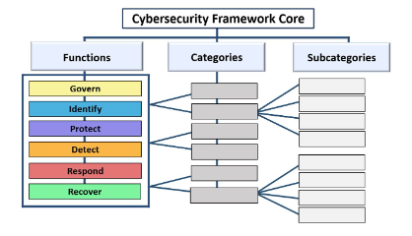
Figure 4- CSF Core Structure
The GRC Analyst and CISO support the Govern and Identify functions through security governance, risk management and asset identification. The Cloud Security Architect, DevSecOps Engineer and IAM Specialist support the Protect function by implementing appropriate access controls and security measures. The SOC Lead supports the Detect and Respond functions through continuous monitoring and incident management, while the wider security team contributes to the Recover function through business continuity and recovery planning.

Policy Framework Development
Aegis FinTech requires a clear policy framework to ensure that employees, contractors and third parties understand their responsibilities when accessing organisational systems and data. The policies proposed below are designed to support the Zero Trust Architecture (ZTA) identified in Task 1, while also addressing the risks associated with cloud services, remote working and third-party access.

Acceptable Use Policy for AI & Cloud Services
The purpose of this policy is to ensure that AI and cloud services are used securely and responsibly. Employees must only use AI and cloud services that have been approved by Aegis, with sensitive or confidential company and customer data prohibited from being uploaded to unauthorised platforms. Access to approved services will be controlled using identity verification, multi-factor authentication (MFA) and least-privilege access.
The use of AI-generated content must also be subject to appropriate human oversight, particularly where outputs could influence financial analysis or business decisions. Employees will be required to report suspected data breaches or inappropriate use of AI and cloud services to the Information Security Unit.
As identified in Task 1, modern organisations increasingly rely on cloud services, meaning traditional network boundaries are becoming less effective. Therefore, this policy supports the Zero Trust principle of ‘never trust, always verify’ by ensuring that access to cloud and AI resources is based on user identity, device security and appropriate authorisation rather than network location.

Hybrid Work and Remote Access Security Policy
This policy will establish security requirements for employees working remotely or accessing Aegis resources outside the corporate network. All users will be required to use MFA, with access determined through conditional access policies based on factors such as user identity and device compliance. Company-managed devices will be preferred, while BYOD access will be restricted to approved resources where appropriate security controls cannot be guaranteed.
Zero Trust Network Access (ZTNA) will be implemented to provide secure access to applications without automatically trusting users based on their network location. Access will follow the principle of least privilege, ensuring users can only access the resources required for their role.
This policy directly reflects the findings of Task 1, which identified remote working and BYOD as factors that have expanded organisational attack surfaces. Continuous monitoring and verification will therefore be used to reduce the risk of compromised accounts and limit potential lateral movement across the organisation.

Third-Party & Cloud Vendor Risk Management Policy
This policy will establish security requirements for third-party suppliers and cloud service providers before and during their relationship with Aegis. Vendors will undergo security assessments before being approved and will be required to meet defined security and data protection requirements. Contracts should include appropriate data protection agreements, incident notification requirements and security responsibilities.
Third-party access will be restricted using least-privilege principles and will only be provided when required. Access rights will be regularly reviewed and revoked when no longer necessary. Vendors will also be reassessed periodically to identify changes in their security posture.
This approach applies the Zero Trust principle of ‘never trust, always verify’ to third-party relationships. As identified in Task 1, users and devices should not be automatically trusted based on their location or previous access. Applying the same principle to suppliers can reduce the risk of third-party compromise and limit the potential impact of a security incident within the wider supply chain.

Regulatory Compliance Strategy
Below is a roadmap towards regulatory compliance:
Timeline (Months) | Compliance Activity
1-3 | Conduct GDPR and DORA gap assessments; identify critical data and ICT assets
4-6 | Implement data protection controls, policies and ICT risk management processes
7-9 | Test incident response, business continuity and disaster recovery procedures
10-12 | Conduct compliance reviews and address outstanding gaps before EU expansion

The GDPR compliance strategy will begin with identifying and documenting the personal data processed by Aegis. Compliance with the Digital Operational Resilience Act (DORA) is also essential for Aegis as it aims to expand to the EU market. Dora is an EU regulation that is designed to ensure that financial organisations can withstand, respond to and recover from cyber incidents [15]. This is particularly important for a financial tech organisation, as the AI-powered platform may process personal and potentially sensitive financial information. Aegis must ensure that personal data is processed lawfully, fairly and transparently, with an appropriate legal basis identified for each processing activity. Data should only be collected when necessary for a specific purpose and should not be retained for longer than required. Data protection impact assessments (DPIAs) will be completed where processing activities, particularly those involving AI, are likely to present a high risk to individuals. Aegis will also establish processes for responding to data subject rights requests and managing personal data breaches. Appropriate technical and organisational security measures, including access controls, encryption and least-privilege access, will be implemented to protect personal data from unauthorised access, loss or disclosure. Taking these measures will ensure compliance with both UK and EU GDPR [16] [17].

Technical Standards & Architecture
The proposed technical security strategy for Aegis FinTech will be based on the NIST Cybersecurity Framework (CSF) 2.0, with Zero Trust Architecture (ZTA) used as the foundation of the technical security architecture. NIST CSF 2.0 was selected because it provides a flexible framework for managing cybersecurity risks and is suitable for organisations of different sizes and sectors. The framework is structured around six core functions: Govern, Identify, Protect, Detect, Respond and Recover [14]. This provides Aegis with a structured approach to managing security risks while supporting its planned growth and EU expansion. The below diagram was created using Draw.io: [18]
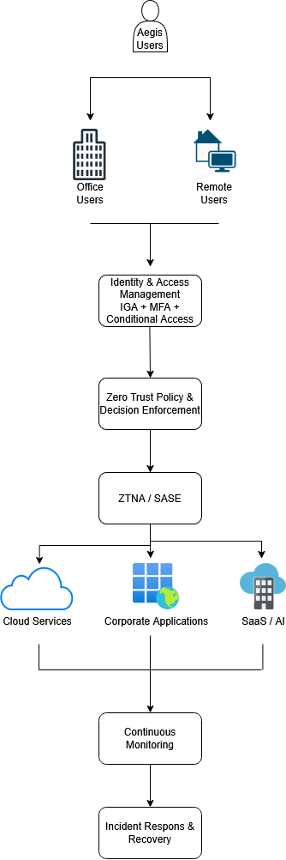
Figure 5- Technical Architecture Diagram
Identity Governance and Administration (IGA), MFA and conditional access will provide the identity controls required to support Zero Trust. ZTNA will control access to individual applications and resources, reducing reliance on traditional network perimeter security. SASE will provide additional security for users accessing resources remotely. Continuous monitoring will be provided through Endpoint Detection and Response (EDR).
Additionally, Security Information and Event Management (SIEM) could be adopted into the architecture. This tool collects and analyses security events within the organisation’s environment. It centralises logs for all devices into one location, for faster detection [19].
These tools will allow security teams to identify suspicious activity and respond to potential threats. The use of these technologies supports the principles identified in Task 1, particularly continuous monitoring and the assumption that a security breach may occur.
The proposed architecture also supports the six NIST CSF 2.0 functions. Governance and risk management will be managed through the CISO and GRC function, while asset identification and access controls will support the ‘Identify’ and ‘Protect’ functions. EDR will support ‘Detect’, while the Incident Response function will manage ‘Respond’ and ‘Recover’ activities.

Strategic Risk Assessment
Risk | Likelihood | Impact | Overall Risk | Mitigation
Cloud misconfiguration and unauthorised access | High | High | Critical | MFA, least-privilege access, encryption and continuous monitoring. Regularly review cloud configurations and access permissions.
Ransomware attack | High | Critical | Critical | Network segmentation, MFA and Zero Trust controls. Maintain tested backups and establish a ransomware incident response plan.
Third-party or supply-chain compromise | Medium | High | High | Conduct security assessments before approving suppliers. Implement third-party risk management and restrict supplier access using Zero Trust and least-privilege principles.

The first risk is cloud misconfiguration and unauthorised access. As identified in Task 1, modern organisations are increasingly dependent on cloud and hybrid environments, which can make traditional perimeter-based security less effective. Misconfigured cloud resources or excessive user permissions could expose sensitive financial and personal data. Aegis will therefore implement MFA, least-privilege access and continuous monitoring to identify and reduce these risks.
The second risk is a third-party or supply-chain compromise. Aegis is likely to depend on external cloud providers, SaaS applications and other technology suppliers. A compromise of one of these providers could potentially affect Aegis's systems or data. The proposed Third-Party and Cloud Vendor Risk Management Policy will therefore require security assessments and regular reviews of suppliers. Zero Trust principles will also be applied by limiting third-party access to only the resources required. The Microsoft Entra tool, identified in Task 1 can be used for this.
The final risk is ransomware, which is particularly relevant to Aegis due to the financial sector's attractiveness to cyber criminals. The Zero Trust principles identified in Task 1 can reduce the potential impact of ransomware by limiting access and restricting lateral movement.

Incident Response & Business Continuity
The proposed ransomware response playbook has been informed by the incident response lifecycle outlined by NIST [19]. The playbook has been adapted to the specific requirements of Aegis FinTech and includes preparation, identification, containment, eradication, recovery, communication and lessons learned.
- Preparation
Maintain MFA and Zero Trust controls. Ensure critical data is backed up. Regularly test backup restoration and conduct staff awareness training.

- Identification
The SOC will investigate alerts from the security systems to identify unusual activity, such as mass file encryption or abnormal account behaviour. The incident will be classified according to its severity.

- Containment
Compromised devices will immediately be isolated from the network. Affected user accounts will be disabled and access credentials reset. Network segmentation and Zero Trust controls will be used to prevent lateral movement.

- Eradication
Security teams will identify and remove the ransomware, investigate the initial attack and address the vulnerability that allowed the attack to occur.

- Recovery
Critical systems will be restored from verified backups. Systems will be tested for security and integrity before being returned to normal operation.

- Communication
The CISO will coordinate internal communication with the CEO, executive board and relevant teams. Legal and compliance teams will assess whether regulatory notifications are required. Customers, suppliers and other stakeholders will be informed where appropriate.

- Lessons Learned
A post-incident review will identify the cause of the attack and evaluate the effectiveness of the response. Security controls and policies will then be updated where necessary.

Governance & Strategic Roadmap
Effective governance is essential for ensuring that cybersecurity remains a strategic priority within Aegis FinTech. A Cyber Security Steering Committee will be established to provide oversight of the Information Security Unit and ensure that security decisions align with the organisation's business objectives and regulatory requirements.
The committee will be chaired by the CISO and will include the Chief Executive Officer (CEO), Chief Finance Officer (CFO), Chief Technology Officer (CTO), Head of Legal, Data Protection Officer (DPO), and a risk and compliance representative.
The CEO will provide executive oversight, while the CFO will monitor financial risks and security investment. The CTO will provide technical oversight of the organisation's infrastructure and software development. The Head of Legal will provide guidance on legal, contractual and regulatory requirements, including GDPR, DORA and third-party agreements. The DPO will provide specialist guidance on data protection and privacy requirements, while the GRC representative will monitor regulatory compliance and organisational risk.
The following roadmap takes inspiration from the NIST Cybersecurity Framework 2.0 [14], adapted to suit the needs of Aegis as an organisation.

12-Month Strategic Roadmap
Timeline | Priority Initiatives | Key Deliverables | KPIs
Q1 | - Create Information Security Unit  - Complete risk assessment  - Implement MFA  - Establish security policies | - Security team recruited.  - Risk register completed  - Core security policies approved  - MFA deployed | - 100% privileged accounts protected by MFA  - Critical risks identified  - 100% staff complete security training
Q2 | - Begin implementation of Zero Trust Architecture.  - Deploy IGA and ZTNA.  - Implement least-privilege access controls. | - Identity lifecycle management implemented.  - Least-privilege access enforced.  - Cloud security monitoring established.  - Regular access reviews introduced. | - 100% of user access reviewed.  - Reduction in excessive permissions.  - 100% of critical cloud assets monitored.
Q3 | - Implement SIEM and EDR  - Establish centralised security monitoring.  - Test the ransomware response playbook.  - Conduct an incident response exercise.  - Test backup restoration | - Security monitoring operational  - Ransomware playbook tested.  - Incident response exercise completed.  - Critical systems successfully restored from backups. | - Reduced time to detect threats  - Reduced time to respond to threats  - 100% successful backup restoration tests.
Q4 | - Conduct a formal security and compliance review.  - Assess GDPR and DORA readiness.  - Assess critical third-party suppliers.  - Address outstanding security and compliance gaps. | - Compliance gaps addressed.  - Critical suppliers assessed.  - Final security review completed.  - EU expansion readiness assessed. | - 100% of critical suppliers assessed.  - Zero unresolved critical compliance findings.  - Strategic roadmap reviewed and updated.

Conclusion
This proposal has presented a practical strategy for establishing a dedicated Information Security Unit at Aegis FinTech Innovations Ltd. Based on the findings from Task 1, Zero Trust Architecture (ZTA) has been identified as the most appropriate security model for protecting the organisation's cloud and hybrid environments, reducing the risk of ransomware and supporting future business growth. The proposed organisational structure, security policies, regulatory compliance strategy and technical architecture provide a comprehensive approach to managing cybersecurity risks.
The adoption of the NIST Cybersecurity Framework (CSF) 2.0 will provide a structured approach to governance, risk management and continuous improvement, while technologies including ZTNA, Identity Governance, MFA, SIEM and EDR will strengthen the organisation's overall security posture. The proposed strategic roadmap prioritises the implementation of these controls over a 12-month period, ensuring that security capabilities develop alongside the organisation.
Overall, the recommendations within this proposal will improve Aegis FinTech's ability to prevent, detect, respond to and recover from cyber threats while supporting compliance with GDPR and DORA. By implementing these recommendations, Aegis will be better positioned to protect its information assets, maintain customer trust and support its planned expansion into the European Union.

Bibliography

[1] | A. Rushdy and I. Thorig, “Zero Trust Architecture: A Systematic Literature Review on Adoption, Implementation and Effectiveness,” 2nd International Conference on Innovations in Engineering, Science and Technology for Sustainable Development (ICEST), pp. 1-9, 2025.
[2] | Z. Abdelhay, Y. Bello and A. Refaey, “Toward Zero-Trust 6GC: A Software Defined Perimeter Approach with Dynamic Moving Target Defense Mechanism,” IEEE wireless communications, vol. 31, no. 2, pp. 74-80, 2024.
[3] | N. Nahar, K. Andersson, O. Schelén and S. Saguna, “A Survey on Zero Trust Architecture: Applications and Challenges of 6G Networks,” IEEE Access, vol. 12, 2024.
[4] | S. Rose, O. Borchert, S. Mitchell and S. Connelly, “Zero Trust Architecture NIST Special Publication 800-207,” National Institue of Standards and Technology, 2020.
[5] | A. Soni, S. K. Nanda, R. Priyadarshini and G. Panda, “A comprehensive review and Comparative Analysis of Zero Trust Architecture: Evolution, implementation strategies, and key challenges,” Journal of Computer Security, vol. 34, no. 2, pp. 85-110, 2026.
[6] | S. Teerakanok, T. Uehara and A. Inomata, “Migrating to Zero Trust Architecture: Reviews and Challenges,” Security and communication networks, vol. 2021, pp. 1-10, 2021.
[7] | Y. He, D. Huang, L. Chen, Y. Ni and X. Ma, “A Survey on Zero Trust Architecture: Challenges and Future Trends,” Wireless communications and mobile computing, vol. 2022, no. 1, 2022.
[8] | R. Jain, B. Batra, B. Kanwer, L. Raja and V. Bhatnagar, “Transforming network security through zero trust architecture : Principles, challenges, and future directions,” Journal of discrete mathematical sciences & cryptography, vol. 29, no. 2-B, pp. 1097-1106, 2026.
[9] | S. L. Narra, “Zero Trust Architecture in Cybersecurity: Design Principles, System Model, and Enterprise Implementation,” Computer fraud & security, p. 689, Jan. 2025.
[10] | Microsoft, “What is secure access service edge (SASE)?,” Microsoft, 2026. [Online]. Available: https://www.microsoft.com/en-gb/security/business/security-101/what-is-sase. [Accessed 26 07 2026].
[11] | Microsoft, “What is Microsoft Entra ID Governance?,” Microsoft, 2026. [Online]. Available: https://learn.microsoft.com/en-us/entra/id-governance/identity-governance-overview. [Accessed 26 July 2026].
[12] | Google Cloud, “BeyondCorp,” Google, 2026. [Online]. Available: https://cloud.google.com/beyondcorp?hl=en&utm_source=chatgpt.com. [Accessed 26 July 2026].
[13] | G. Gonçalves, K. O'Malley, B. Beyer and M. Saltonstall, “BeyondCorp and the long tail of Zero Trust,” 5 June 2023. [Online]. Available: https://www.usenix.org/publications/loginonline/beyondcorp-and-long-tail-zero-trust?utm_source=chatgpt.com. [Accessed 26 July 2026].
[14] | National Institute of Standards and Technology, “The NIST Cybersecurity Framework (CSF) 2.0,” NIST, 26 February 2024.
[15] | European Parliament and Council of the European Union, “Regulation (EU) 2022/2554 of the European Parliament and of the Council of 14 December 2022 on digital operational resilience for the financial sector (Digital Operational Resilience Act – DORA),” Official Journal of the European Union, vol. L 333, 2022.
[16] | European Union, “Regulation (EU) 2016/679 (General Data Protection Regulation),” Official Journal of the European Union, 2016.
[17] | UK Parliament, “Data Protection Act 2018,” UK Public General Acts, 2018.
[18] | Draw.io, “Security-first diagramming for teams,” 2026. [Online]. Available: https://www.drawio.com/. [Accessed 27 July 2026].
[19] | A. Nelson, S. Rekhi, M. Souppaya and K. Scarfone, “Incident Response Recommendations and Considerations for Cybersecurity Risk Management,” NIST Special Publication 800, vol. 800, no. 61 Rev.3, pp. 4-10, 2025.

