1a
Introduction
Time management is important in the planning of the team goals. It is important to set realistic timelines and deadlines that can be achieved. It is also important to create SMART goals (specific, measurable, achievable, relevant, and timely) which can be used to measure the team's progress. ‘To utilize time effectively, individuals must first be able to predict how much time is needed for the activity’ (Kelly, 2002- as cited in Stoilov 2012)
Overall, effective time management is a key skill which can help any team or organization to reach their goals in a timely manner while still allowing time for the team to collaborate and develop. ‘To feel productive is to recognize as a personal accomplishment’ (GREGG 2018) It is important to create an effective time management system and to ensure that everyone is aware of the plan and the expectations. ‘Make plans outside work and perform administrative tasks- BMJ: British Medical Journal’ (Rimmer 2019) It is also important to be flexible with the plan, as things can change, and it is important to be able to adjust and adapt to the changing environment. ‘Commitment drives out flexibility, it reduces the range of options open to you’ (Peter 2007)
My chosen career as a manager,
Time management can be a critical factor in the success of a team. When everything is planned out, it allows the team to achieve their goal in a timely manner. It also allows the team to identify and focus on tasks which require more attention to ensure maximum efficiency. Additionally, it prevents team members from taking on more tasks than they can handle, reducing the risk of failure. Finally, it helps the team to prevent potential conflicts, as everyone is aware of their role and responsibilities.

Stoilov 2012; (Intech Open)
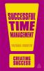Forsyth, Patrick 2013; London: (Kogan Page)
Fleming.; 2003; Management Pocketbooks

References
1-Stoilov, T. and Stoilov, T. (2012) Time Management. Edited by T. Stoilov. Croatia: Intech Open.
2-GREGG, MELISSA. “The Aesthetics of Activity: Productivity and the Order of Things.” Counterproductive: Time Management in the Knowledge Economy, Duke University Press, 2018, pp. 78–100. JSTOR, https://doi.org/10.2307/j.ctv11smmx6.7. Accessed 6 Mar. 2023.
3- Rimmer, Abi. “How Do I Improve My Time Management Skills?” BMJ: British Medical Journal, vol. 366, 2019, pp. 1–2. JSTOR, https://www.jstor.org/stable/27177811. Accessed 6 Mar. 2023.
4- Levin, Peter (2007/12/31) Skilful time management, VLEBOOKS-9780335234929.

1-B
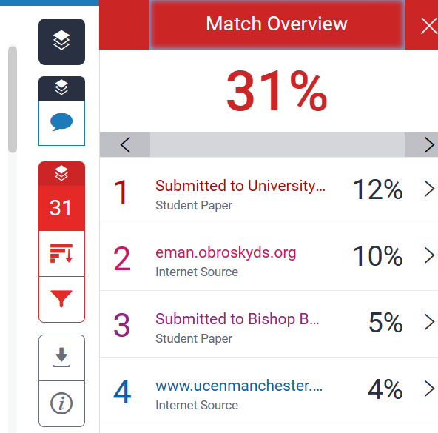

My similarity score is 31% which is not too bad however I will try to improve on this. To reach this goal, I have used Turnitin's Revision Assistant to assess my writing and received feedback. I will also use the Turnitin Originality Report to help me identify which parts of my paper need to be revised. Additionally, I will review the guidelines for formatting my references and citations according to the style of my paper. Finally, I will review the sources I have used to ensure that I have accurately cited and referenced them. By using these tools, I am confident that I can reach my goal of producing a high-quality paper.
Score 65.
I think that 65% is a good score for the work that I have done so far. I should improve my referencing and paraphrasing to get a higher score. With some more practice, I can ensure that I am properly citing the sources and accurately summarizing my ideas.

Task-4
Poster (LIFE IS A TEAM SPORT)
Screenshot poster,

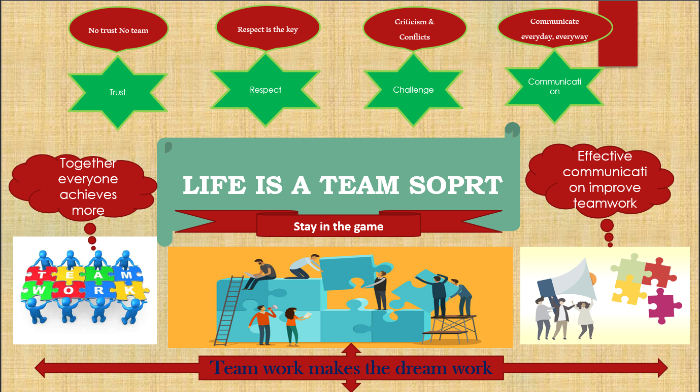

I have teamed up with Naska Sulaiman to design a group poster. Our task was to design a colourful group poster about Life is a team sport. We started the project by brainstorming ideas and discussing the best way to create a poster that would be attractive, informative and effective. After deciding on the content and design of the poster, we split up the tasks and started to work on it. We discussed our ideas and got feedback from each other which helped us make improvements. We also used a variety of online resources to research and find images and quotes to include in our poster. When we had finished the poster, we reviewed it together to make sure it was accurate and professional. We also made sure that we had correctly referenced all our sources. The colours used in the illustration are bright and vibrant, and the poster is designed to draw the viewer's attention to the central image and message. The image and text combine to create a powerful visual statement about the importance of working together and the power of collective effort in achieving success. Teamwork is not about being in the same place at the same time, but about working together to achieve a common goal.
- Trust is the foundation of any successful team. Without trust, there can be no collaboration and therefore no success.
- Respect is essential in any team. Respect the opinions and ideas of your teammates and show them the same respect you expect from them.
- Challenge yourself and your teammates to grow and develop. Encourage each other to strive for excellence.
- Effective communication is the key to any successful team. Make sure everyone is on the same page and communicate openly and honestly.
- Leadership is an essential element of any team. Set a good example, be a role model and motivate your team to achieve their goals.

1. “Teamwork makes the dream work.”
2. “Coming together is a beginning. Keeping together is progress. Working together is success.” – Henry Ford
3. “Teamwork divides the task and multiplies the success.”
4. “Individual commitment to a group effort: that is what makes a team work, a company work, a society work, a civilization work.” – Vince Lombardi
5. “No one can whistle a symphony. It takes an orchestra to play it.” – H.E. Luccock
“If everyone is moving forward together, then success takes care of itself.” — Henry Ford.[1]
[1] https://medium.com/organize-for-performance/henry-fords-3-teachings-on-successful-teamwork-b44df28b730f,

