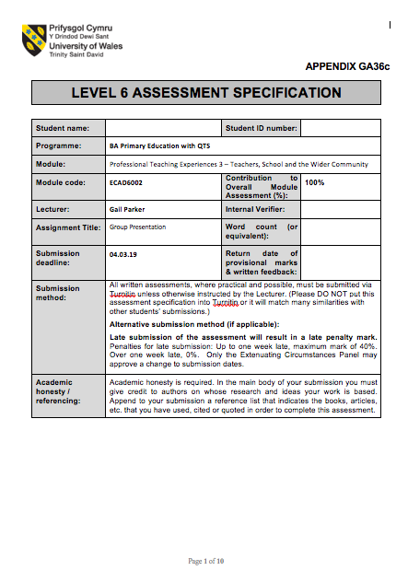
1704075
irsty Osinga (Group 1)
Kirsty Osinga (Group 1)

