

Understanding and Engaging in the Customer Experience (BMSK5003)

Student Name: Titu Miah 1708800
Lecturer: Vajira Balasuria

Contents
Executive Summary 2
1.0 Asda: 3
Asda`s CSR policies 3
1.2 McDonald’s 6
1.3 Lush 7
2.0 Deming’s model: 8
2.1 Juran`s Theories of Quality: 9
2.2 Crosby`s Cost of Quality: 10
3.0 Conclusion and Recommendations: 10
4.0 Appendix: 14
Bibliography: 15

Executive Summary
In this report we shall investigate the customer relationship in building sustainable resources and the benefits of engaging in ethical trading. Also, the report will be looking at what possible impact the organizations quality systems has on customer relationship.
The organizations that we will research on are Asda, McDonald’s and Lush. A critical discussion will be done on the report about how organizations can improve their customer relationship management by using three quality models and their theories. The quality models are Deming, Juran and Crosby. These quality models and theories will be shown that if organizations use them then they can benefit in understanding the concept of quality, its link to measuring and improving management of customer relationship.
Business ethics are a set of moral rules that governs how organizations operate, how decisions are made and how individuals are treated. There are many different individuals that an organization must answer to such as their customers, clients, shareholders, and workers. Sustainability in an organization is the process that can be maintained in creating a long-term approach. How an organization operates in the ecological, social, and economic environment must be taken into consideration for achieving long term value. It is necessary for organizations to maximize their opportunities and in turn minimize the negative impact on the environment, and the local communities and the economies in the country where they operate.
Corporate social responsibilities (CSR) gives businesses the opportunity to demonstrate their humanity side whilst also maintaining their duties towards society, the environment, and their stakeholders. CSR helps to manage the interconnections of the people, organizations, and local communities, so that they all benefit. Such as what you sell, who you buy from, who you hire and so on. The core of CSR is sustainability, so it makes sense for organizations to implement strategies of CSR into their business plan to succeed in the long-term benefits. According to CEOs at 19th annual global survey 64% say that corporate social responsibility is core to their business (19th Annual Global CEO Survey: Industrial manufacturing key findings, 2020).

1.0 Asda:
Asda has bridged the gap between producers and consumers through various business activities. Asda`s policies on how business is conducted are based on being open and trustworthy, these ideas are followed through and into their operations and impact on everything from staff, customers health and to the local communities. By introducing the smart price, they have kept the price of commodities as low. The supermarket chain Asda has a democratic consumerism project which it uses to get customers involved in their business and get their feedback on what they sell and how they are selling it. Asda believes that purchasing decisions are influenced by customers (shoppers). The objective of this project was to build trust with its customers and to get involved in its decision making. According to (Asda and sustainability – Better things in store? | Ethical Corporation, 2020) ethical or organic is not regarded important, in comparison to Waitrose but at present time consumers are being more aware of ethical sourcing. Asda believes in making the business more sustainable saves money, be more competitive in the market, improves efficiency which is linked to their statements about overall price message. According to Rimmer Asda has not been transparent and they have fought against having an independent ombudsman (Asda and sustainability – Better things in store? | Ethical Corporation, 2020).
Asda`s CSR policies:
Asda has stated on its website( https://asdasupplier.com/responsibility/our-sustainability-commitments) that they believe in protecting the environment and saving people money which is their sustainable approach. They also aim to do this by reducing the operational impact on the environment, the goods, and services that they sell and also the suppliers that they purchase from. Asda has reduced plastic by recycling and packaging weight by 27%. Asda has stopped giving single use carrier bags to its customers but is encouraging to the usage of re-usable bags. This shows how committed Asda is to reducing the environmental impact of plastic bags. Asda has a coronavirus food distribution resource. They have redistributing surplus of food and drink to charities, IGD and food banks. Asda has also created “Fight the hunger create change” which was set up in 2018 in partnership with Fare Share and Trussell Trust. This change and partnership came into place by customers asking Asda to tackle the food insecurity issue. This is an ethical response by Asda in which they have listened to what the customer wanted, and they have helped the local community who are suffering food poverty. This is something that is common to see in the UK at present. Foodbanks consolidated food donation request is shown in Appendix fig1. Asda have reduced carbon emission by more than what was agreed with the EU(ASDA,2009). This was achieved by using rail service to convey its products rather than using delivery vans. Asda has called its CSR policies as `Doing The Right Thing’. This is a summary below:
Consumers: Asda`s operations are to address matters of concern for its customers.
Prices: Having lower prices is a way which would be providing affordable healthier products for customers.
Planet: Asda is using various sustainable approaches and is also drastically reducing the impacts of their activities on the environment.
Asda`s business approach to complete these objectives includes:
Ethical Trade: Asda is a member of the ethical trading initiative (ETI) and they also support the fair-trade foundation. Asda promotes and ensures better deal, fair pay and acceptable working condition for farmers and workers (from developing countries). They sell a lot of produce for fair trade products in the shops.
Food Safety: Asda ensures that more products are certified sustainable, and all suppliers are audited. Asda has increased the range of organic products at its stores.
Staff Relationship: Asda maintain good working relationship with employees. Asda has an anniversary event for celebrating long service. Asda has planned to` pay bonuses for the employees who have been with the supermarket longer than 6 months` Lynch (2009). Asda has won the award for ‘Innovative Employer of the Year` by beating off competition from Sainsbury (The Guardian, 2006
Recycling and Waste: Asda supports waste and resources action program (WRAP). Asda is aiming to reduce waste of it stores.
Community Involvement: Asda has a foundation which is used for assisting people in need, local charities, and local projects. Asda also supports by giving surplus foods and drinks to Fare Share and Trussell Trust. They also do fundraise events such as Children in need, Tickled Pink Campaign and Tommy the charity for premature
Home Delivery Service: Asda has been using home delivery shopping service to its customers in the UK.
Best of British: Asda is using sourced products from UK business. According to Asda (2009) they are selling more locally products compared to other competitors, which is good for the local businesses and also the planet.
With all the above activities Asda believes it is meeting social responsibilities to stakeholders as the best way possible. However, it is vital for Asda to make more effort in addressing expectations of the public, not using CSR as a smoke screen in order to enhance its public image with consumers and also trying to avoid the law.

Accounting System Is Needed:
An accounting system is needed but this has led to formation of several reporting standards, global reporting initiative (GRI) Sustainability reporting, Green Globe Certification/Standard and Environmental Management Standard. All these guidelines are voluntary. Companies have a choice as to which guidelines to follow and therefore streamline them according to their needs in portraying a good image of their business.
CSR reporting is a voluntary exercise which means companies can decide the form of activities it will be reporting. By producing CSR reports it helps the company to interact with the stakeholders and enables the assessment of the company response to social and environmental concerns. It also serves as a basis for measuring social performance and also allows comparisons with other competitors in the market. This report looks to adopt the Impact on Society Benchmarking Scheme to help in assessing social responsibilities. The scheme will allow comparisons to be done of how CSR practices is being followed by a set of indicators such as” the environment, workplace, community, human rights and the marketplace” (Elliott and Elliott, 2019).

1.2 McDonald’s
McDonalds focuses its effort on energy efficiency, sustainability packaging and waste management. Energy efficiency effort is identified as its source of environmental impact is the carbon footprint of their customers. McDonalds relies mostly on all their customer movements to generate revenues and it cannot sell its product in any other way. They encourage employees to work ethically. McDonald’s promoting the health and welfare of animals, respecting human rights and to conduct business ethically. Promoting diversity, equal opportunities in the workplace and the locality.
McDonald’s will eliminate packaging by introducing re-usable solutions and encourage change of behavior to reduce usage. Use renewable, recycled materials without compromising on quality and performance. The new Mcflurry packaging will eliminate the need of plastic lid, sustainable paper-based cup for milkshakes, fiber lid for drinks which would remove the need for straws, napkins made from recycled fiber and also doing recycling at the back of the restaurant for cooking oil etc. Beef sustainability commitments by using holistic approach which is environmental protection, ethical practices, and the economic viability. Palm to be used to support sustainable production. Responsible of sourcing chicken, fish, and coffee. McDonalds global sustainability frameworks which are goals of social and environmental topics called food, planet, and sourcing (McDonalds Corporation,2011).
McDonalds Corporate Social Responsibility (CSR) revolves around what the company identifies that through sustainability, it would need to sustain its distribution networks, and this would benefit the chain of distributers and suppliers. CSR strategies have aided in identifying what the customers’ needs are within these destinations and create solutions that fits their needs. This demonstrates that McDonalds understands the customers diverse needs. McDonalds has no gender inequality, acknowledges customers are needed for them to be successful and to exist, thus making a welcoming environment for its customers and this proves to the customers of how much they are valued within the company.
McDonald have charities which help families with critically ill or injured children. There is also an event called “McHappy Days” where a certain percentage of money is donated to charities. McDonald uses biomass power plants to cut its waste and carbon footprint in the environment. McDonalds management are using selling tactics such as giving toys to children which causes the parents to be dragged in. They do not think about those children’s health, wellbeing and weather their food harms their future.
The management at McDonalds does not have an appropriate recycling process for customers who take food away. The use of thousands of unnecessary packaging, most of which ends up being littered on the streets and polluting the land buried in landfill sites.
Mc Donald’s food is considered as junk food and it has been linked to causing obesity.

1.3 Lush
Lush uses its buying team to sourcing essential oils, natural raw materials, safe synthetics and 100% recycled packaging. The company is committed to fair trade, community trade initiatives, safeguarding the environment, the social impact, and local communities from which is used to purchase ingredients. Lush take consideration of ethicality when purchasing: the workers’ rights, the unions of employees, health and safety, fair pay, working hours, discrimination, no child labor, and freedom to leave. On the environment the company considers organic, sustainability, no genetic modifications, endangered species, production emissions and the resources used to process ingredients. The company does not use any animal testing ingredients but vegetarian ingredients only. The company uses minimum air freight and the distance that the ingredients has travelled in transport.
To reduce the impact on the environment Lush uses almond and olive oil instead of mineral oil because they believe that field of trees are more important than oil fields. The packaging for the products is being minimized to the lowest possible and about 50% of the products can be taken home by customers without any packaging. When packaging is done in the shop and this is recycled material.
Waste and recycling are done by using post-consumer recycle (PCR) plastic for bottles and pots, recycled paper for carrier bags and gifts are wrapped with recycled paper.
Water consumption is reduced by making some products solid and monitoring the usage in the factories. At Lush surplus products are donated to causes such as homeless shelter, hospices and groups who serve vulnerable peoples. This is called Charity Pot Funding Which Lush gives a grant to organizations that match the values and ethics.

2.0 Deming’s model:
The Deming’s theory is based on the principle that organizations are composed by a system of interrelated processes and the people are the systems components. The philosophy was used by leaders of the Japanese industry, pushing quality ahead of production and it was used to develop a successful production system. His 14-points management philosophy are significant for serviced based industries as well as manufacturing industries. The 7 deadly disease that infect an organizations culture and prohibit it from succeeding in achieving quality for the customers. He has also invented a PDSA cycle which is for learning and change management (appendix figure 2).
Deming was hired by Ford motors to help them to improve as they were making loses in 1980. Deming spoke to ford about the management and he questioned them about the company’s culture and the way the managers operated. He told Ford that management actions were responsible for all the problems in developing better cars. He introduced them to one of his fourteen points plan which is to develop a plan to be competitive with rivals to stay in business and all employees must adapt to this theory ((Neave, 1991). Better quality leads to fewer delays and better use of factors input.
If you compare Nokia and Samsung phones on their quality, it shows two different concept of quality management. Nokia phones are made by HMD Global, but they have a company that does the software, then you have another company in China and Vietnam that does the hardware. As a result, these different companies are not tightly integrated between them, resulting in either poor hardware or a software experience for the customers. Samsung has tight integration on their software and hardware because majority of the components is built in their own manufacturing services. Also, you will get support for your phone on a much larger scale than Nokia. Samsung has the advantage as they can implement total quality management, improve the products and services, designing products for customer needs and all this would be done at their manufacturing facility.
If you look at factories in the Uk, they are using Deming’s theory in their manufacturing processes. Manufacturers were producing goods but were having poor quality products at the time of world war 1. They were following the quality assurance methods at the time. To correct this, inspectors for quality were introduced in the production process to enable the level of quality failures due were minimized. This led to the introduction of Statistical Quality Control (SQC) a theory developed by Deming’s. This method is about collecting statistics by doing sampling of the products. As it was impossible to inspect all the products, but it was possible to sample to check the quality. The theory of SQC was that a variation in the production process leads to a variation in the end product.

2.1 Juran`s Theories of Quality:
Juran`s philosophy is based upon the company`s strategic planning and minimum risk in rejections. Juran`s approach of cross functional management that comprises of the three-quality process which are quality planning, quality improvement and quality control (Greasly,2007). Ford motors have used jurans theory of six sigma is their project management methodology of choice. The reason being is that it is based on customer satisfaction quality driven which was utilizes and set up by the management. It was adapted so that ford can produce better quality cars, have a stable working environment for employees, have effective management and profitability all by the 1990s. Ford also benefitted by utilizing the six sigma, it helped to decrease the warranty repair rate compared to before. This is done by the companies’ quality operating system (QOS) for identifying and correcting problems within the manufacturing.
Toyota also adopted Jurans philosophy by having annual quality improvement, workers were able to come up with quality improvement ideas and vital few ideas were from the managers. This contribution by employees improves their sense of participation and morale. By adopting this philosophy Japan was able to improve their manufacturing process and become world leaders in quality.

2.2 Crosby`s Cost of Quality:
Crosby`s philosophy is based upon absolutes of quality management and basic elements of improvement. The performance measure is cost of quality, the only performance standard is zero defects, and the basic elements of improvement is determination, education, and implementation. Doing it right the first time, was his answer to the crisis of quality.
Organizations promote quality differently according to their value of customers. Some place quality at the center of their values and to meet customer needs the cost of products has to be taken into consideration. Managers and organizations need to see that if cost is reduced, can this achieve quality and customer satisfaction.
If you consider about supermarkets, they have to make sure certain standard of quality and pricing has to be maintained to stay competitive and also to be making profits for the company. In a comparison between Asda, Morrison, Sainsbury, and Tesco about vegetable products, it seems that Sainsbury is the cheapest which is surprising as the others have bigger stores all over the UK. The reason why Sainsbury is cheaper is because they followed the theory of Crosby which is they were improving quality management in order for quality cost system and this has given them the edge in keeping the cost down and yet staying competitive with other supermarkets.

3.0 Conclusion and Recommendations:
In this report the research of Asda, McDonalds and Lush`s businesses ethics, sustainability, and CSR policies and also the way it does affect the very stakeholders. The interesting findings that were found are the following:
- Asda has addressed most of the expectations placed on them by stakeholders and society. This is done by the increased and detailed information of their social and also environmental exposed in recent years.
- The impact of their business operations on the environment Asda has made sustainability issues as a means of survival and a part of the company’s objectives.
- Asda has been able to dominate a large share of the market by adopting an aggressive growth policy. This has helped to cement its position as one of the top leading retailers at present and to gain a larger share of the market is a case of worry to other supermarkets. Having this sort of expansion of their business is of concern to many due to its negative effect on consumers and the environment, stifling small convenience shops and other competitors within the locality.
- In my view Asda is using the CSR practices to increase market share and enhance market position through using low prices. Asda needs to do more in their ethical trading practices, recycling, and waste management. Asda has contributed to the development of local communities by doing charity donations, creating local jobs, and listening to concerns of the people. If a company does not participate in community activities, they may face backlash from the public.
- Asda has been fined for breeching 14 accounts of EU regulations on labeling of fruits and vegetables (BBC NEWS | UK Politics | 'Bendy bananas' win UK reprieve, 2020).
- Asda needs to fully comply with ETI code and other regulations that are seeking better treatments of employee and suppliers (Asda's contract changes are 'just not fair', 2020). Asda staff have raised concerns over their pay, having to work despite being sick and the working terms and conditioning being bad. The employment tribunal in Newcastle has fined Asda in February 2006 for offering wage increases to staff in exchange that they give up collective bargaining rights (BBC News, 2006). Asda has also been taken to court by employees about equal pay of female staff to be the same as male distribution staff. (Partridge, 2020).
- Asda, Tesco, Primark have all been using under paid and overworked employees in Bangladesh for making their clothes (Simms,2007). ICM poll has suggested that customers are not happy with the low-price culture, they believe staff are on lower pay scale, 61% believe market dominance by supermarkets is damaging local communities, three quarters of customers would like new rules to be in place to prevent the exploitation of suppliers in poor country(The Guardian,).
In my report for recommendation would be that supermarkets play an important part in the retailing sector of the UK economy. Supermarkets are the major food retailers, have close relations with people and the local communities. Asda needs to be more transparent about its environmental issues such as overconsumption of energy and water, waste, packaging issues and genetically modified products. They need to produced reports to show how they are dealing with the environmental issues to the public. It can be seen that CRS has been used when required but not followed through. The attention to CRS should be adhered to from internal management, from production, from supervisors to employees and operation to human resource management. When ethical problems occur, there has to be a correct and instant response is important. The external supervision of Asda and all other supermarkets for business ethical is necessarily critical. There is a need to have more clearer, more integrated, detailed rules and regulations in place to standardize the practices. External supervision can help the company to establish an organizational environment that complies with ethical social corporate responsibilities. The external pressure needs to come from consumers, the media, government, from non-governmental organizations and this is necessary to help Asda to regulate their performance as well. If this does not happen the big supermarket chains like Asda will only follow the necessary rules and regulations but will break others such as using cheap labor, animal welfare, health and safety, healthy food, packaging materials and genetically modified food products.
McDonalds has had issues with employees pay and that led to strikes in New York (Fox, 2020). The workers were being given poor working hours, under paying them and unstable employments. Workforce exploitation is a very important ethical concern for everybody. McDonald or most fast food have unhealthy food being served to customers (10 Of The Most Unhealthy Fast-Food Restaurants In The US, 2020). The company has been fined for breaking child labor law in London (McDonald's fined for exploiting child labor, 2020). McDonalds needs to promoter health conscious image. They should offer a range of healthy food on their menus because consumers are now understanding about how important is having a healthy diet. They could publish nutrition information so that customer can actually read and understand what the calories are and also weather it is healthy for them.
McDonalds can take advantage of online promotion and research. Also, they can use social networking options like twitter and Facebook. Improved analysis of the supply chain can aid in increasing revenues. Also, franchises location can be analyzed so that they can spaced more evenly to help the distribution.
Lush has strong ethical beliefs such as they will not purchase ingredients associated with the destruction of the environment or slave labor. They are able to offer products which ethical people are looking for. Lush has always protested against animal cruelty. They have stopped using palm oils to protect the habitat of chimpanzees.
Lush has a variety of products in their stores. The ones that are in solid form do not need packaging, but the other products are packaged using plastic or metal containers. If you look at the packaging at Lush its plastic is BPA-free and 100% of it is post-consumer recycled. The designers at Lush have reduced the thickness of plastic by 13%, not only was plastic reduced but customers are asked to return their bottles and pots so that Lush can use them again. This shows how much the company is committed to the environmental issues.
Lush is investing in regenerative farming. This works by reversing deforestation, restores degraded soil, increases biodiversity and all this helps the environment to resurrect itself back to how it was before. Lush have a page called “Stories”, these articles are written by employees of Lush to show transparency and dedication of Lush.

4.0 Appendix:
Figure: 1
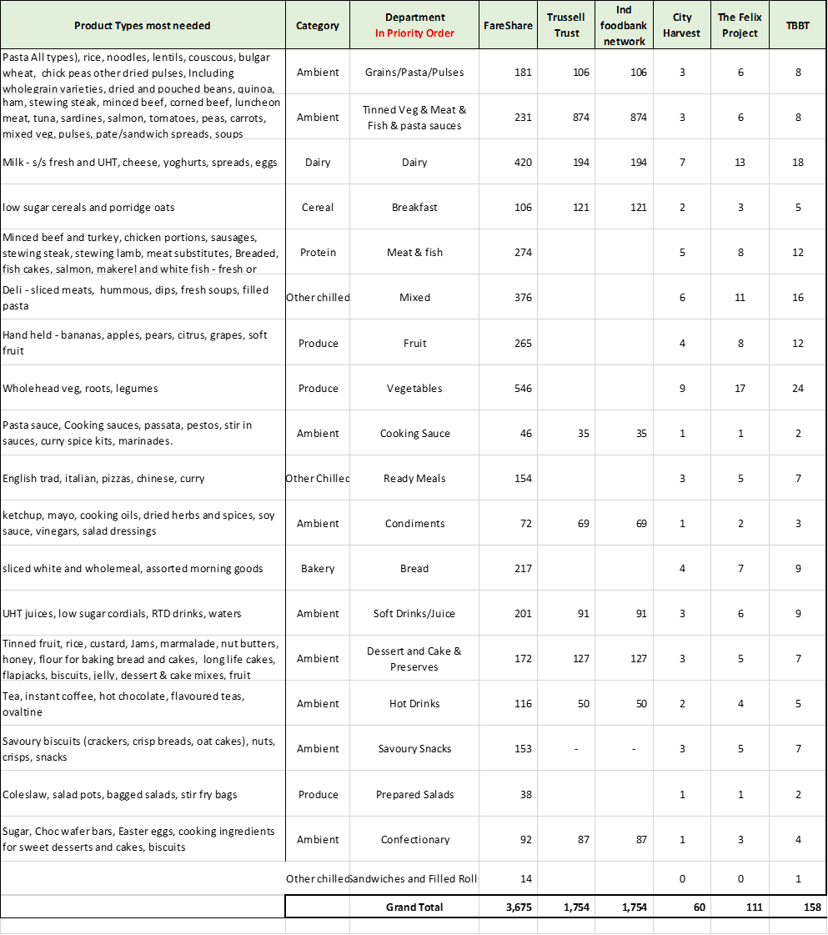

Figure:2

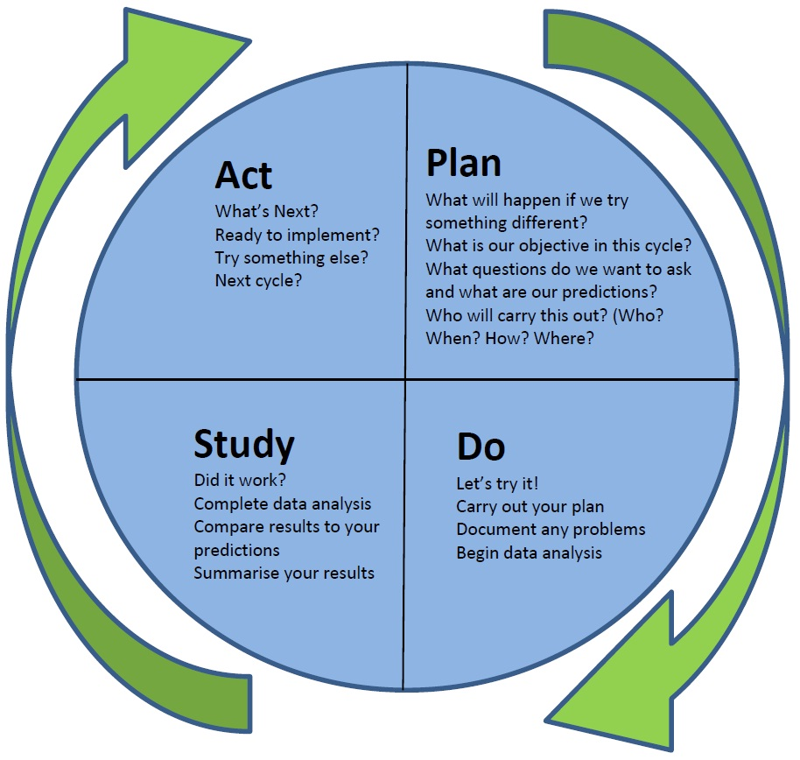

Bibliography:
BBC News. 2020. Asda's Contract Changes Are 'Just Not Fair'. [online] Available at: <https://www.bbc.co.uk/news/business-50122703> [Accessed 23 July 2020].
News.bbc.co.uk. 2020. BBC NEWS | UK Politics | 'Bendy Bananas' Win UK Reprieve. [online] Available at: <http://news.bbc.co.uk/2/hi/uk_news/politics/2066730.stm> [Accessed 23 July 2020].
Crosby, P., 1979. Quality Is Free. McGraw-Hill.
Csrwire.com. 2020. McDonald’s Announces 2020 Corporate Social Responsibility And Sustainability Plans – Press Releases On Csrwire.Com. [online] Available at: <https://www.csrwire.com/press_releases/36995-McDonald-s-Announces-2020-Corporate-Social-Responsibility-and-Sustainability-Plans> [Accessed 20 July 2020].
Corporate.mcdonalds.com. 2020. Our Approach | McDonald’s. [online] Available at: <https://corporate.mcdonalds.com/corpmcd/scale-for-good/using-our-scale-for-good.html> [Accessed 20 July 2020].
De George, R., 2014. Business Ethics. Harlow, England: Pearson Education.
Edwards, R., 1988. The roles of the individual and organizations in the ethical decision-making process. Human Reproduction, 3(1), pp.11-19.
Ethicalcorp.com. 2020. Ethical Corporation. [online] Available at: <https://ethicalcorp.com/> [Accessed 16 July 2020].
Ethics of McDonalds. 2020. McDonald’s Ethical Issues. [online] Available at: <https://mcdonaldsethics.weebly.com/mcdonalds-ethical-issues.html> [Accessed 16 July 2020].
Ethicalcorp.com. 2020. Asda And Sustainability – Better Things In Store? | Ethical Corporation. [online] Available at: <http://www.ethicalcorp.com/business-strategy/asda-and-sustainability-better-things-store> [Accessed 16 July 2020].
(Ethical cosmetics company Lush takes 'bullying' Amazon to court, 2020)
Eunson, B., 1995. Communicating With Customers. Brisbane: Wiley.
Elliott, B. and Elliott, J., 2019. Financial Accounting And Reporting. Harlow: Pearson Education Limited.
Fisher, C., Lovell, A. and Valero-Silva, N., 2013. Business Ethics And Values. Harlow: Pearson Education.
GOV.UK. 2020. Our Commitment To Corporate Social Responsibility (CSR). [online] Available at: <https://www.gov.uk/government/news/our-commitment-to-corporate-social-responsibility-csr> [Accessed 16 July 2020].
Håkansson, H. and Snehota, I., 1997. Developing Relationships In Business Networks. London: International Thomson Business Press.
Jones, P., Comfort, D., Hillier, D. and Eastwood, I., 2005. Corporate social responsibility: a case study of the UK's leading food retailers. British Food Journal, 107(6), pp.423-435.
Kumavat, P., 2012. A Book Review On Principles Of Marketing Management 14Th Edition By Philip Kotler And Gary Armstrong. International Journal of Scientific Research, 1(4), pp.83-85.
Koutra, C., 2017. Corporate Social Responsibility. Hauppauge: Nova Science Publishers, Inc.
Leppard, J. and Molyneux, L., 1994. Auditing Your Customer Service. London: Routledge.

McGregor, S., 2005. The Ethical Consumer. International Journal of Consumer Studies, 29(4), pp.387-388.
Neave, H., 1991. The Deming Philosophy.
oppulo. 2020. 5 Excellent Corporate Social Responsibility Examples ‹ Poppulo. [online] Available at: <https://www.poppulo.com/blog/corporate-social-responsibility-examples/> [Accessed 16 July 2020].
PwC. 2020. 19Th Annual Global CEO Survey: Industrial Manufacturing Key Findings. [online] Available at: <https://www.pwchk.com/en/industries/transportation-and-logistics/19th-annual-global-ceo-survey-industrial-manufacturing-key-findings.html> [Accessed 17 July 2020].
Partridge, J., 2020. Asda Equal Pay Dispute Goes To UK Supreme Court In Virtual Hearing. [online] the Guardian. Available at: <https://www.theguardian.com/society/2020/jul/13/asda-equal-pay-dispute-goes-to-supreme-court-in-decisive-virtual-hearing> [Accessed 23 July 2020].
Payne and David Ballantyne. Relationship Marketing: Creating Stakeholder Value. Oxford: Butterworth Heinemann 2002. Journal of Services Marketing, 17(4), pp.443-445.
Sk.sagepub.com. 2020. SAGE Books - The Ethical Consumer. [online] Available at: <https://sk.sagepub.com/books/the-ethical-consumer/n5.xml> [Accessed 13 July 2020]
Singh, A., 2020. At Mcdonald's, CSR Is Everybody's Business. [online] Forbes. Available at: <https://www.forbes.com/sites/csr/2010/09/10/at-mcdonalds-csr-is-everybodys-business/> [Accessed 20 July 2020].
Wilburn, M., 2007. Managing The Customer Experience. Milwaukee, Wis.: ASQ Quality Press.
Zabava Ford, W., 1998. Communicating With Customers. Cresskill, NJ: Hampton Press.
Zairi, M. and Zairi, M., 2007. Deming & Juran. Clitheroe: Spire City.

