

BA International Hotel Management
Foreign Languages and Cultural Awareness BMIH5003 - LEVEL 5
Assessment 2 – Intercultural Competence Report
Words count: 1000 words

Student Name: CRISTINA ILIUTA
Student ID: 2212526
Lecturer name: JULIA CHIFARI

Italy


Executive Summary
The report highlights key points from the study on the cultural overview of Italy, which is based on Hofstede's model and the research of the GLOBE Project, in order to demonstrate the importance of cultural intelligence and sensitivity for the progress of Diversity Hotel & Spa in Italy. Because Italian culture places a strong emphasis on family and legacy, hotel staff members need to be well-versed in local customs. According to the study, offering cultural training, feedback mechanisms, and a dedicated conflict resolution process to staff members aids in their adjustment to Italian culture. Adopting local traditions can enhance the capacity of the hotel to provide exceptional service, reduce tourist confusion, and boost satisfaction.

Table of Contents
Executive Summary 2
1 Introduction 4
2 Main Body 4
2.1 Cultural Overview 4
2.2 GLOBE Project/Country Analysis 5
2.3 Importance of Cultural Intelligence and Sensitivity for Hotel Personnel 6
3 Conclusion 7
4 Recommendations 7
5 References 8

Introduction
The report will discuss the cultural overview of Italy by briefly outlining its culture and customs. It will also enlighten the significance of cultural intelligence and sensitivity for hotel personnel. Diversity Hotel & Spa, a 5-star hotel company in the UK, recently decided to expand to overseas countries, and Italy was selected. The report will be using the GLOBE project's culture and leadership study for the country analysis of the chosen country.

Main Body

Cultural Overview
The rich cultural heritage of Italy is rooted in its historical, cultural, and culinary traditions. Italy places great importance on family life, which is mirrored in its cultural standards (Partarakis et al., 2021). Families are valued highly, and living together or in proximity across many generations is not unusual.
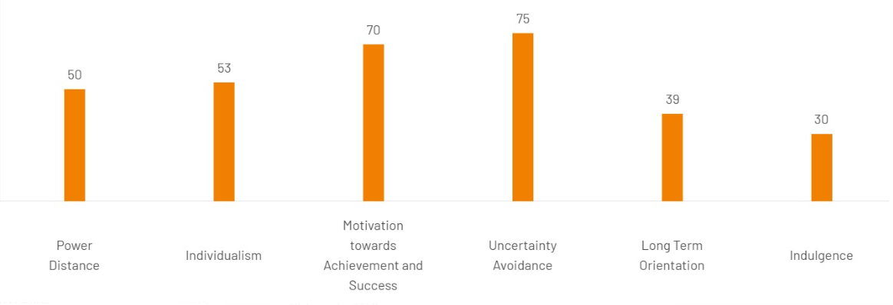
Figure 1: Hofstede Cultural Model of Italy
Source: Hofstede Insights (2023)
The family-oriented culture of Italy is high, as shown by the individualism axis in the Hofstede cultural model, as the Italians have a strong sense of community and family. Italians will seek counsel and direction from their established social groupings whenever available (Hofstede Insights, 2023). On the Hofstede scale, having close relationships with friends and family is associated with a high level of uncertainty Avoidance. In Italy, welcoming and making guests feel at home are highly valued; this is referred to as la bella figura. The long-term orientation ranking of Italy is high because of its strong regard for the arts and history (Testa et al., 2019). Italy is known for its exquisite cuisine, which has a rich historical background and is now regarded as some of the greatest in the world.

GLOBE Project/Country Analysis
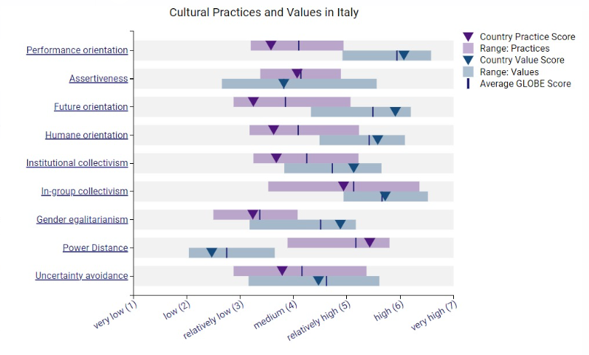
Figure 2: GLOBE Project's study of Italian culture and leadership
Source: Globe Project Italy (2020)
A complex network of interacting cultural norms and values was discovered during the GLOBE Project's study of Italian culture and leadership (Globe Project Italy, 2020). The performance orientation level in Italy is moderate, with a focus on individual and organisational achievement, a commitment to a positive work-life balance, and deep interpersonal connections. This exemplifies how the Italians see success in both their personal and professional lives. Italians are quite balanced in their aggressiveness. They are versatile in that they are outspoken and combative in the same debate, yet they also value collaboration and fostering harmony. Italy is not really focused on the future. Respecting the past is more important to Italians than being innovative and forward-thinking (Bressan et al., 2022). Their current is significantly shaped by their history. In Italian culture, there is little focus on the value of humanity and compassion. Strong family relationships and a sense of community solidarity are characteristics of this criteria. A broad spectrum of allegiances and attachments to organisations and communities outside of the immediate family are reflected in moderate institutional collectivism.
On the other hand, the emphasis on individuality provides a constructive counterbalance to this collectivism. The degree of in-group collectivism is high in Italy. Italian culture places great value on interpersonal relationships, including those with friends, family, and the workplace. In terms of gender equality, Italy takes a moderate stance. Even if there has been progress towards gender equality, traditional gender norms and expectations persist. Italy has a moderate power distance, indicating respect for authority and hierarchy, notably in familial and economic contexts, but not as prominently as in some other cultures (Travaglino and Moon, 2023). Ambiguity Italians have a low avoidance rate, which is indicative of their willingness to embrace ambiguity and flexibility in adjusting to novel circumstances.

Importance of Cultural Intelligence and Sensitivity for Hotel Personnel
Italy, a country renowned for its distinct customs and culture, requires its hotel employees to possess a high degree of cultural awareness and sensitivity (D’Arco et al., 2021). Italy is a great place to improve the quality of customer service because of the high level of hospitality that the nation offers its visitors. If hotel staff members are well-versed in Italian culture, they will be able to make guests feel more at home (Sresnewsky et al., 2020). Getting to know guests' interests before they come, accommodating any dietary needs, and respecting any cultural or religious customs they follow are a few methods to do this. Etiquette and customs are very important in day-to-day living. The staff at the hotel must be aware of customs related to the culture, such as greeting guests with two kisses and using titles like Signore and Signora. If guests are not aware of the customs of the area, miscommunications and unpleasant situations can occur (Mogea, 2023). Being culturally aware is essential to building connections with Italian guests. This leads to happy customers who return and recommend the business. In the service industry, disagreements and issues can arise (Eko and Putranto, 2019). When hotel employees possess cultural intelligence, they can address and resolve these problems with more effectiveness. For example, if one is aware of how Italians manage conflict and negotiations, misunderstandings can be avoided, and solutions can be made more quickly.

Conclusion
It has been concluded that the rich cultural heritage of Italy, which places a great focus on family ties and deep respect for the arts and past, offers the ideal environment for the development of Diversity Hotel & Spa. Hotel employees must grasp Italian customs and values, and the Hofstede Cultural Model and the GLOBE Project study shed light on this. The success of Diversity Hotel & Spa in the Italian market can be primarily ascribed to the consideration of the cultural norms and preferences of the region of the hotel staff.

Recommendations
It is recommended that the general manager of the hotel needs to focus on cultural training for all staff members. This training should include Italian culture and history in addition to how to deal with and resolve issues with Italians. Continuous feedback methods should be implemented to ensure that employees successfully overcoming any challenges and adapting to these cultural differences. The hotel must also have a structured dispute-resolution process that upholds traditional Italian values by emphasising diplomacy and compromise. This proactive approach will boost the quality of service offered to guests and make their stays unforgettable, which will contribute to the successful entry of the hotel into the Italian market.

References
Berné-Manero, C., Ciobanu, A.V., Marzo-Navarro, M. and Pedraja-Iglesias, M., 2019. The hotel management of e-wom. A cross-cultural analysis Spain-Italy. International Journal of Information Systems and Software Engineering for Big Companies, 6(2), pp.7-18.
Bernini, C. and Guizzardi, A., 2010. Internal and locational factors affecting hotel industry efficiency: Evidence from Italian business corporations. Tourism Economics, 16(4), pp.883-913.
Bresciani, S., Thrassou, A. and Vrontis, D., 2015. Determinants of performance in the hotel industry-an empirical analysis of Italy. Global Business and Economics Review, 17(1), pp.19-34.
Bressan, A., Duarte Alonso, A., Vu, O.T.K., Do, L.T.H. and Martens, W., 2022. The role of tradition for food and wine producing firms in times of an unprecedented crisis. British Food Journal, 124(4), pp.1170-1186.
D’Arco, M., Presti, L.L., Marino, V. and Maggiore, G., 2021. Is sustainable tourism a goal that came true? The Italian experience of the Cilento and Vallo di Diano National Park. Land Use Policy, 101, p.105198.
Eko, B.S. and Putranto, H., 2019. The role of intercultural competence and local wisdom in building intercultural and inter-religious tolerance. Journal of Intercultural Communication Research, 48(4), pp.341-369.
Globe Project, 2020. Italy. [Online] Available at https://globeproject.com/results/countries/ITA?menu=list#country [Accessed on 9th November 2023].
Hofstede Insights, 2023. Italy Country Comparison Tools. [Online] Available at https://www.hofstede-insights.com/country-comparison-tool?countries=italy [Accessed on 9th November 2023].
Mogea, T., 2023. Cross-Cultural Communication Barriers in Organizations. CENDEKIA: Jurnal Ilmu Sosial, Bahasa dan Pendidikan, 3(2), pp.20-33.
Partarakis, N., Kaplanidi, D., Doulgeraki, P., Karuzaki, E., Petraki, A., Metilli, D., Bartalesi, V., Adami, I., Meghini, C. and Zabulis, X., 2021. Representation and presentation of culinary tradition as cultural heritage. Heritage, 4(2), pp.612-640.
Sresnewsky, K.B.G.B., Yojo, A.S., Veloso, A.R. and Torresi, L., 2020. Rapport-building in luxury fashion retail: a collectivist culture case. Journal of Fashion Marketing and Management: An International Journal, 24(2), pp.251-276.
Testa, R., Galati, A., Schifani, G., Di Trapani, A.M. and Migliore, G., 2019. Culinary tourism experiences in agri-tourism destinations and sustainable consumption—understanding Italian tourists’ Motivations. Sustainability, 11(17), p.4588.
Travaglino, G.A. and Moon, C., 2023. The Dependency–Counterdependency Dynamic: Interactive Effects of System Justification and Power‐Distance Orientation on Radicalization against the Political System. Political Psychology, 44(3), pp.627-645.

