Changemakers
Building your personal Brand for Sustainable Employment

BMHP5015



Lecturer: Dr Mark Gallagher-Read

Mrs Gulnaz Begum 1907551

Table of Contents

CURRICULUM VITAE 2
COVER LETTER 5
DOCUMENTARY PITCH 7
BIBLIOGRAPHY 10

CURRICULUM VITAE

Gulnaz Begum
85 old farm road Stechford, Birmingham B33 9HJ
Email : gulnazbegum1@hotmail.com
Contact no: 07874857682
Personal Statement
A highly motivated and adaptable person who is well organised and pays great attention to aspects. As a professional I have demonstrated my ability to build positive relationships with colleagues and service users alike, communicating well with others at all levels. Having a caring and considerate nature has supported me in my chosen career path and developed empathy towards others. I believe that this important in this job and having emotional intelligence is essential. I am skilled and experienced with and extensive experience of working with a wide range of age groups which has helped me develop excellent communication skills and become more successful with building trust with individuals. Currently seeking a new role that will help me develop my experience as a professional as well as my CPD. With a willingness to take on additional training to support a new role.

Profile
Throughout my working life I have demonstrated adaptability whilst holding true to my values in an authentic way. I am confident in my abilities, able to make logical decisions based on an analytical mind-set and available information. I am a catalyst with the ability to use initiative and take ownership for my actions. Having emotional intelligence, demonstrating empathy in order to enable myself and others to achieve goals in a focused manner, whilst at the same time being confident in making decisions I strive to be inclusive with everyone I meet and use my negotiation skills to influence my network in order to meet positive outcomes. As a lifelong learner I strive to improve and develop myself both personally and professionally.

Key Skills
· Active Listening skills developed from youth work
· Critical thinking developed from making immediate decisions
· Computer Skills and proficient in Microsoft packages
· Instant Decision making,
· Adaptability
· Leadership skills
· Excellent Communication
· Bilingual – Fluent in Urdu,
·Punjabi and Mirpuri
· Leadership skills

Employment History Director Unite and Uplift June 2018 – present
Duties and Responsibilities
· Engaging with Youths and young adults in the community
· Getting together with social workers and other professionals
· Participating in group or individual sessions
· Organising counselling for younger generation
· Providing assistance to young people who are experiencing difficulties in their lives
· Organizing leisure activities

Volunteer youth worker All 4 youth & community 2011 – 2018
Duties and Responsibilities
· Supporting other professionals in the organisation
· Supporting with individual or group sessions
· Signposting young people to counselling
· Helping younger generation with problems in their lives
· Supporting with recreational activities
· Engaging with young adults and providing emotional support
Care worker family and friends 2000 – 2014
PT Care worker Residential Care Home 1997 – 2000
Duties and Responsibilities
· Assisting people with Mental illnesses with daily routines
· Safeguarding them from self-harm
· Attending to patient’s personal needs
· Responsible administering medication for schizophrenic patients

Qualifications
University of Wales Trinity St David 2021, BSc Health and Social Care degree
University of Wales Trinity St David, Level 4 Certificate HE in Health and Social Care Sep 2019
Leyton sixth form College, London, Level 3 Diploma in Health and Social Care

Work Experience
· Work experience in primary school
· experience of working in nursing homes
· experience in residential care home with patients with mental illnesses
· Youth and young adults work experiences

Position as a director for the company Unite & Uplift, which works with vulnerable youths and encourages them to leave crime and pursue an education. During this time, I have assisted and mentored young people suffering from mental illnesses, as well as victims of abuse and bullying. In addition, I have worked with women to improve their health and well-being. Throughout the years, the company has received numerous awards for its outstanding work with youth.

Hobbies and Interests
In my spare time I enjoy swimming, movies, designing, shopping and cleaning. I also like to spend time keeping fit and dancing.

COVER LETTER
Gulnaz Begum
Stechford, Birmingham B33 9HJ
Contact no: 07874857682
Email: gulnazbegum1@hotmail.com
Dear Sir/ Madam,
I am writing to request about the Social worker’s position that has been advertised on indeed on the 15th of July 2021.
Currently serving as a Director for Unite and Uplift, an organisation that works with vulnerable youth and adults. The organisation encourages them to leave crime and pursue an education. During my time with the company, I helped and mentored young people suffering from mental illnesses, as well as victims of abuse and bullying.
I consider that I am a suitable applicant for this position as I have a wealth of experience which ranges from working with children and young people. I have always wanted to work in this industry and have all the attributes that are needed for this role. In my position as a Director for a youth centre I have developed all the relevant skills that are essential for this job demonstrating the importance of putting young people at the centre of everything. Additionally, I feel excited at the prospect of assisting in the public sector as a social worker.
I've been collaborating with youths and adults to better understand their needs and provide them with assistance. I am confident that my qualifications and experience will contribute to your team's success. I am always committed to my job and to maintaining confidentiality and protecting clients to the best of my ability.
As a qualified Social worker I am able to demonstrate my abilities to work independently as well as being a good team player. Sharing the depth of knowledge and understanding of experience from previous roles. I am excellent at helping people responding to and cope with social, economic, emotional and behavioural problems. Over the years in my work as a Social worker I have developed self-confidence and have overcome barriers to demonstrate a high level of satisfaction in my cases; showing the ability of being able to cope with pressures by dealing with clients strengths and capability needs to be augmented with public resources and services.

Please refer to my CV attached with this letter, thank you for taking time to read my letter.
It would be a pleasure to meet with you at your earliest convenience to discuss the role further. I am also available for an interview immediately.
I eagerly await your response.
Thank you for your time and consideration.
Most Sincerely
Gulnaz Begum

DOCUMENTARY PITCH

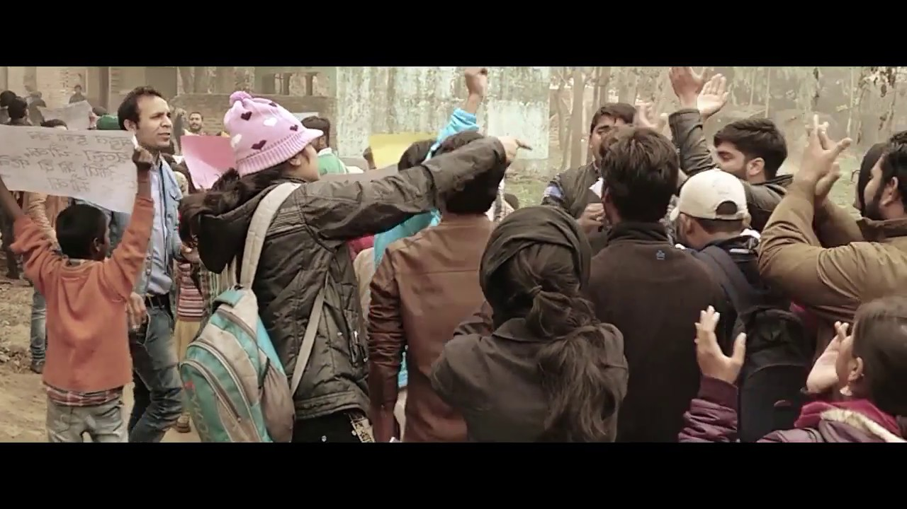
I would like to record a documentary for the BBC in respect of the mental health and the impact this has had on social workers. people have been effected due to Covid 19 and have lost family and friends during this tough time. I understand there has been a severe mental strain on people who were unable to attend funerals and grieve properly like they previously could. Families have been suffering and unable to be there for their family members before they died.

I would like to document the effects the closures of youth centres have had and the impacts it has had on social workers leading to more behavioural problems with youth centres being closed which has lead proceeding more pressure on social workers.

Social workers continue to work with clients and organisations and expose themselves and their loved ones to infection. Despite this, there has been almost no media coverage of the risk to Social workers, access to personal protective equipment (PPE), and professional responses to the pandemic are all examples of professional responses to the pandemic. I believe that social work is more important than ever before, and as such, the experiences of social workers on the frontlines of the pandemic deserve special consideration.

There is high demand for social workers just like nurses and doctors as They are also aware of other serious harms that vulnerable clients are increasingly likely to face. For example, if organisations are no longer able to distribute hygienic syringes, vulnerable substance users will be more likely to contract HIV and hepatitis C. Direct service providers are on the front lines of our society's most vulnerable and isolated citizens who struggle. Due to the fact that family and friends are not permitted to visit their loved ones in hospitals, social workers must deal with the emotional fabric of grief and loss, both related and unrelated to COVID-19.
Social workers have expressed concerns about the Coordination of video visits between patients and loved ones comes at a high emotional cost. Despite the fact that people are still suffering and dying alone, she is using new technology to connect families.

I have looked at several struggles that Covid 19 has had on social workers and other youth workers such as:

- Increased mental health or wellbeing concerns as youths not being able to engage like they used to.
- Inadequate safe spaces – including inability to access their youth services or clubs and a lack of safe spaces at home.
- Increased loneliness and isolation which leads to depression and anxiety problems.
- Due to challenging family relationships youths need to get out in a safe environment.
- Lack of trusted relationships during the pandemic.
- Increased online or social media pressure due to covid and outdoor facilities being closed down.
- A greater likelihood of being involved in gangs, abusing substances, carrying weapons, or engaging in other harmful behaviours. as children from broken families will have more time to be hanging on streets.
• A greater risk of sexual exploitation or grooming.

People's emotional needs have been created at a completely new level as a result of the pandemic, which we may never have seen before. However, due to the impact of the pandemic, social workers will be expected to go above and beyond their level of responsibility. The response should include a broader framework, such as collaboration with third-party organisations outside of the health care system.

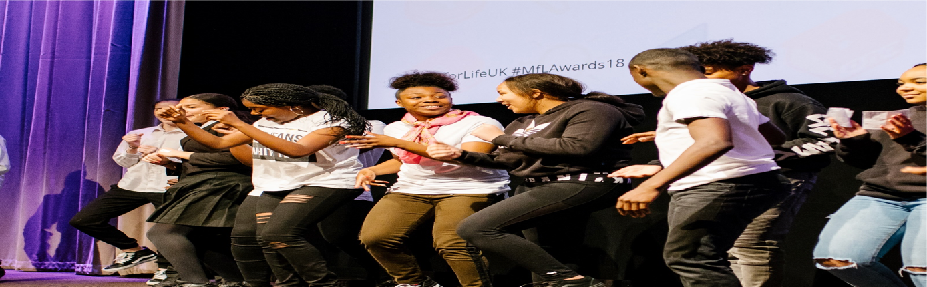
(Home - UK Youth, 2021)

Many people have experienced trauma but have found it difficult to seek emotional support due to difficulties in obtaining G.P appointments and referrals, and hospitals have suspended services. Individuals who were assigned social workers during the pandemic will be able to receive services via video conferencing, online, or telephone. During the pandemic, depression and anxiety caused many people to require additional services.

There is an increase in the amount of pressure placed on health workers, which has resulted in the development of mental disorders as a result of the heavy workload and pressure. It is suggested that the government act proactively in recognising this need and try to offer encouragement and support through training and educational interventions through communication platforms and information gathering.

Abrams and Dettlaff, (2020) says social workers are aware that their clients will become infected, will not have access to quality health care and will die unrecognised. This is true for the social worker who provides psychiatric street outreach to poor people.

Domestic violence is a multifaceted problem that affects social work clients. Domestic violence criminal justice system refers to efforts to combat domestic violence by enacting and enforcing criminal and civil laws (Danis, 2003).

Turner, (2020) mentioned that majority of the practitioners said they had to perform duties that have caused them concern due to contamination risks, despite the fact that three-quarters approve.

BIBLIOGRAPHY

- Abrams, L. and Dettlaff, A., 2020. Voices from the Frontlines: Social Workers Confront the COVID-19 Pandemic. Social Work, 65(3), pp.302-305.

- Anesthesiology, 2020. Images from the Frontlines of the COVID-19 Pandemic. 133(4), pp.724-739.

- Ben-Ezra, M. and Hamama-Raz, Y., 2020. Social Workers during COVID-19: Do Coping Strategies Differentially Mediate the Relationship between Job Demand and Psychological Distress?. The British Journal of Social Work.

- Danis, F., 2003. The Criminalization of Domestic Violence: What Social Workers Need to Know. Social Work, 48(2), pp.237-246.

- Ferguson, H., 2012. At last, a documentary that presents social work in all its complex glory. The Guardian.
- Gibson, A., Bardach, S. and Pope, N., 2020. COVID-19 and the Digital Divide: Will Social Workers Help Bridge the Gap?. Journal of Gerontological Social Work, 63(6-7), pp.671-673.

- La Fleur, R., 2020. The Crisis of Loss and Moral Injury – Lasting Effects of COVID-19 on Teenagers and Healthcare Workers. Child & Youth Services, 41(3), pp.286-289.

- Mishna, F., Milne, E., Bogo, M. and Pereira, L., 2020. Responding to COVID-19: New Trends in Social Workers’ Use of Information and Communication Technology. Clinical Social Work Journal,.

- Stepho, E., Heinrich-Williams, M., Dunne, L., Raymond, H. And Parthasarathi, U., 2020. The role of emergency psychiatry social work in a virtual clinic during the covid-19 pandemic. Canadian Social Work Review, 37(2), p.185.

- Turner, A., 2020. Most social workers say Covid-19 has negatively hit their work and the lives of those they support.

- UK Youth. 2021. Home - UK Youth. [online] Available at: <https://www.ukyouth.org/> [Accessed 14 July 2021].

- Weinberg, M., 2020. Exacerbation of inequities during covid-19: Ethical implications for social workers. Canadian Social Work Review, 37(2), p.159.

- Weiss, E., Kranke, D. and Barmak, S., 2020. Military Veterans Serving as Volunteers: What Social Workers Need to Know. Social Work, 65(3), pp.299-301.

