Revision 1
Q1
- Determine the reduced state diagram for the state diagram given below.

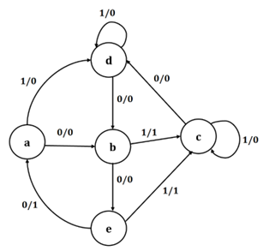
- For the Obtained reduced state diagram
  - Show its state Assignment.
  - Obtain the State Table.
  - Obtain Excitation Table using any Flip- flop.
  - Output Expressions
  - Logic Circuit

Q2
- For the given state diagram illustrated in Fig 1, answer the following.

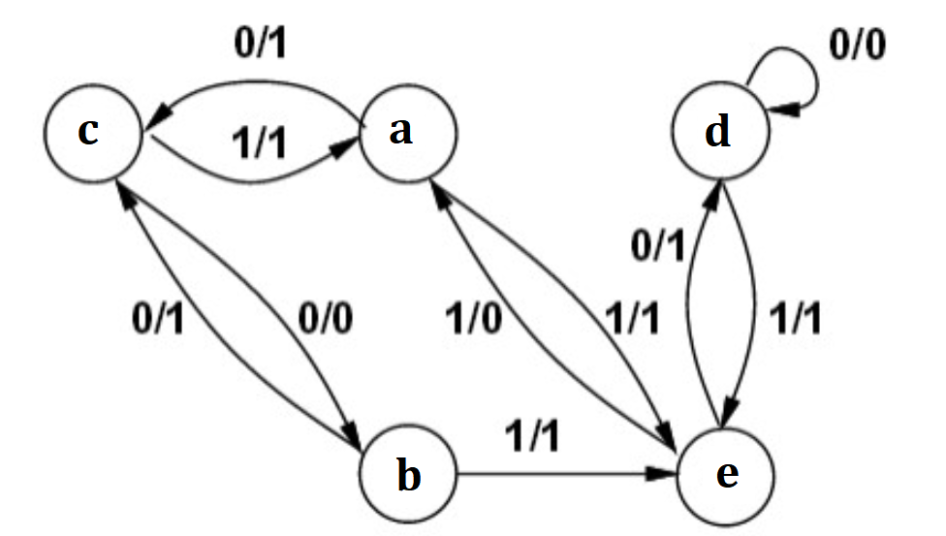
Fig 1: State Diagram
  - Provide its State Table.
  - Provide its Reduced State Table.
  - Draw the reduced State Diagram.
- Design an Asynchronous Circuit by utilising the reduced State table from the previous section (c). Your Solution Should include the following.
- State table and State Assignments.
- Excitation Table for determining input requirements using any flipflop.
- Simplified K-Map Expressions for logic minimization.
Logic Diagram to represent the final gate-level design.

Q3
- For the given state diagram illustrated in Fig 1 , answer the following.

Q3
- Determine the reduced state diagram for the state diagram given below.

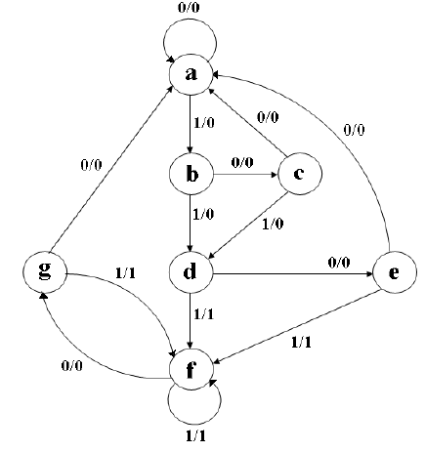
- For the Obtained reduced state diagram
  - Show its state Assignment.
  - Obtain the State Table.
  - Obtain Excitation Table using any Flip- flop.
  - Output Expressions
Logic Circuit
Q4

Design a 3- bit Johnson Counter using D- Flipflop for an Synchronous sequential circuit. This counter will be used to monitor operational stages in a digital control system-based appliance. Your Solution Should include the following.
- State Diagram to illustrate state transitions.
- State transition table
- Excitation Table for determining input requirements.
- Simplified K-Map Expressions for logic minimization.
- Logic Diagram to represent the final gate-level design.

Q5
- Design a Mod 6 counter using J-K flipflop for an asynchronous Sequential Circuit. Answer the following
  - State Diagram
  - State Table
  - State Assignment
  - Excitation Table
  - Simplified Expressions using K- Map
  - Logic Design.
Q6
- Design a Mod 5 counter using J-K flipflop for an asynchronous Sequential Circuit. Answer the following
  - State Diagram
  - State Table
  - State Assignment
  - Excitation Table
  - Simplified Expressions using K- Map
  - Logic Design.

Q7
For the JK – flipflop and D Flipflop , answer the following
- Characteristic Equation
- State Table
- Excitation Table

