
An Investigation into the material culture of the Vix burial
Dissertation

May 11, 2020
Lorna Kelly
University of Wales Trinity Saint David

I certify that this dissertation is my own work. All works by others has been fully referenced in the bibliography, this includes all images.
Ancient Civilisations
HPAH6006
Lorna Juliette Kelly
1700914

Word count: 9,377

Abstract
This dissertation will investigate the material culture of the Vix burial, explaining the key features of their discovery and what has been learnt from them. The Vix site is particularly important to the academia of Celtic studies because it is a female burial containing a rich assemblage of material culture. This dissertation will detail the burials contents, detailing artefacts that hold the greatest significance to understanding the life and social status of the woman within. Furthermore, an analysis of how the burials material culture effects the understanding of the Celts at this date and surrounding area as an ancient civilization was undertaken.

Acknowledgements
I want to thank my family for helping me through the writing of this dissertation, they helped me to keep focussed despite the times. I especially want to thank Jane Kelly and Paige Hinton for proof reading. I also want to thank Katharina Zinn for being my supervisor and pointing me in the right direction when I had too many ideas and not enough time.

Table of Contents

Abstract 2
Acknowledgements 3
Table of Figures 4
Table of Tables 6
Chapter 1 7
Introduction 7
i. Celtic Cultures 10
Chapter 2 12
The Tomb 12
Chapter 3 18
The Krater 18
Chapter 4 28
The Chariot 28
Chapter 5 33
The Adornment 33
A) Torcs 34
B) Bronze basins and Oenochoe 38
C) Silver Phiale 41
D) Attica cup 43
E) Bracelets 45
F) Beads 47
G) Fibulae 49
Chapter 6 51
Conclusions 51
References 53
Literature 53
Images 57

Table of Figures

Figure 1 : Drawing of the Lady of Vix being buried by Jochen Stuhrman © Geo Epoche 8
Figure 2 : Map of the vix tombs' location 12
Figure 3 : Aerial view of the Vix tomb (Côte-d'or), Credits: © Denis Glicksman 13
Figure 4 : Image of Mount Lassois © Klaus Rothe based on a photo by Rene Gogguey. 14
Figure 5: Plan of The Vix burial. 17
Figure 6: Coloured plan of the Vix burial 17
Figure 7 : Krater of Vix . Mathieu Rabeau NMR - Grand Palais. 20
Figure 8 : Neck of the Vix Krater 21
Figure 9 : Handle of the Vix Krater 22
Figure 10 : Side view of the Handle from the Vix Krater 25
Figure 11 : Lid for the Vix Krater 26
Figure 12 : Chariot from the Vix tomb 30
Figure 13 : Bronze insert from side of the chariot. 32
Figure 14 : Torc from the Vix Tomb 34
Figure 15 : Close up view of the torc from the Vix Tomb 35
Figure 16: Hollow torc 37
Figure 17: Silver basin from the Vix tomb 38
Figure 18: Bronze Oenochoe or jug for serving wine 39
Figure 19: Silver Phiale 41
Figure 20: Attica cup 43
Figure 21: Bracelets made from Lignite 45
Figure 22: Beads from the Vix tomb. 47
Figure 23: Fibulae 49

Table of Tables
Table 1: Table of Celtic Culture dates 11
Table 2: Key for Figure 5 16
Table 3: Key for Figure 6 17

Chapter 1

Introduction
This dissertation is an investigation into the material culture of objects discovered at the burial site of Vix. This site is part of many Celtic ‘princely’ tombs found in Europe during the last 200 years of archaeological discovery. The majority of these sites were of males, however burials such as at Vix and near Heuneburg were discovered to be female burials but are still counted as part of the Princely Phenomenon. Each of the burials included within the Princely classification hold a great assemblage of material, including golden jewellery, bronze works. The chamber of the Vix burial and that of the noble women on the Daube near Heuneburg were made from wood.
My dissertation will attempt to cover all the objects from the Vix burials and analyse why someone would have placed this assemblage of material culture into a female burial. I will clarifying if being a female burial had any impact on the objects chosen and my personal analysis of the objects found in the burial. To answer these questions, I will first present the burial in its wider historic context, including an overview of both the Hallstatt and La Tène cultures. Using these two cultures I will state if the date of the tomb agrees with its culturally similar Celtic period and the reason for this debate. Following this, I will investigate the Krater and chariot before looking at the adornments the lady of Vix was wearing or that were otherwise found in the burial. I will not be analysing the organic material found such as the body in this dissertation. I have chosen to discuss these objects going from the largest to the smallest because though there are more comparable objects for the smaller objects the larger objects have a greater impact on the interpretation of the tomb.
When I state that I will be investigating the material culture of the Vix site I mean that I will be trying to understand and read the artefacts. Artefacts are defined as things created by a person or group of people, by using the theories of phenomenology and materiality I can gain a greater understanding of their creation, uses and destruction. This destruction does not just mean when the artefacts were broken beyond repair but when they were taken out of circulation, I will not include the modern part of their story past stating that they are now housed in Musée du Pays in Chatillon-sur-Seine. I will use the ideas of phenomenology to aid my interpretations but due to the travel restrictions in place I was unable to physically visit the objects, so these ideas are limited.
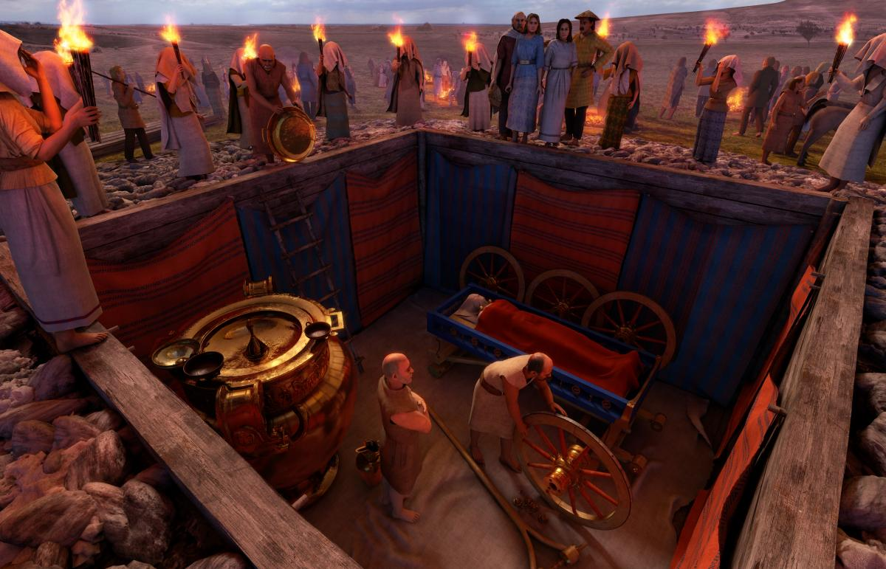 Figure 1 : Drawing of the Lady of Vix being buried by Jochen Stuhrman © Geo Epoche.
Figure 1 is a drawing turned into a digital reconstruction of the burial of the Lady at Vix, it was made by the Museum du Payes in Chattion-sur-Siene where the objects discovered are now housed and displayed. From the image you can see the diverse range of material objects; bronze, gold, wood, textiles, and pottery being the most obvious. Wooden objects and textiles were more degraded than the metal and pottery because of decomposition. As this image is a reconstruction, we cannot assume that it is accurate due to the new age view of the ‘Celts’ as a singular group of people. This view has become a mystical, and magical melting pot of fantasy and storytelling, creating a big stigma attaching to anything with the connotation ‘Celt’. The clearest connection between the peoples of the Iron age was a singular language however, the word ‘Celt’ and its similar counterparts such as Gaul or Keltoi are names that were given to the peoples of northern and eastern Europe by the Greeks and Romans. Both Romans and Greeks interacted with the ‘Celts’ but viewed them as barbarians which makes any written sources very susceptible to cultural bias, for example the way they fight as barbarians “with no fear other than the sky might fall upon them” . The fact that all primary literary sources have been written with this outside perspective and bias means that the archaeology must explain most of the details. To help me make informed conclusions about each artefact I investigate, I will be attempting to see if similar burial practises have happened in other ancient civilizations and if they could have had the same reasons for using those objects in their burial practices.
The main sources I am using are either from the surrounding academic sources on the Celtic culture as a whole or from the Musée Du Pays and translated to English to avoid language barriers. Due to the Covid 19 pandemic I was unable to visit the museum and site as I intended, thankfully, I have many images of the objects which I can then analyse individually before applying the interpretations to the burial. By comparing the Vix burial to other sites I can create my own interpretation of each object along with a reason for it to have been included in the burial.

- Celtic Cultures
The World of the Celts is Iron age Europe and are categorised into 2 main cultures: the Hallstatt and the La Tène. The Hallstatt is named after the site discovered in Austria by Johann Georg Ramsauer. It was excavated from 1846 until 1863 and exposed a wealth of material culture including 1’000 graves, weapons, bronze vessels, ceramic vessels, personal daily equipment, jewellery, well-preserved clothing, and wooden tools. The period is thought to have continued the social trends from the Urnfield culture that was spread the length of the Daube river. The Urnfield culture is named because of the similar style urns which were discovered in multiple burials along one of the major European rivers. The Hallstatt site and period named after it are thought to cover the 7th and 6th centuries BC, continuing into the early 5th century in a few places. As a site Hallstatt grew in importance because of its salt mine, gaining and losing importance proportionally to salt trade through Europe. Salt is an important part of the ancient world because of its use in the preservation of goods such as food specifically meats.The groups without access to coastal salt pans would pay high prices for salt. In the Hallstatt period, we can see a rise in trade across the Mediterranean and Europe most prominently in the 7th century an Etruscan trade post was started in what today is known as southern France, followed swiftly by the Greek city of Massalia in c.600BC. The influence of the Greeks brought wine to the Celts along with their ideas of feasting etiquette.
The later Culture is the La Tène which is named after a site that contained an amazing amount of preserved metal and woodwork. This site is situated at the edge of Lake Neuchatel in Switzerlandand it was discovered in 1857 .This site is greatly preserved because of its location, due to being thought to be a pile dwelling or a fortified oppidum on the edge of the lake. When the bridge structure collapsed or was destroyed the material on the bridge, including people, were preserved in the silt of the lake. These materials include: 40 Iron weapons (swords, spears and shields), fibulae, belt clasps, bronze vessels, iron ingots, vehicle parts and wooden piles. Excavations of this site ran from its discovery until 1917. This site was made famous by Ferdinand Keller’s publication in the 1860’s and it still today the leading example of how the European “Celts” lived their daily lives.
Hallstatt C | c.800 BC | c.600 BC
Hallstatt D1 | c.600 BC | c.530/520 BC
Hallstatt D2-3 | c.530/520 BC | c.450/440 BC
La Tène | c.450/440 BC | c.370/350 BC
Table 1: Table of Celtic Culture dates.

The start and end dates in the table above are unsure because La Tène artefacts have been found in the Late Hallstatt and Hallstatt objects in the La Tène archaeology. Having the Hallstatt appear in La Tène archaeological record is not so worrying because artefacts could have been handed down and reused over multiple generations.

Chapter 2

The Tomb
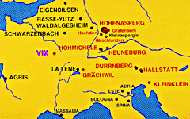
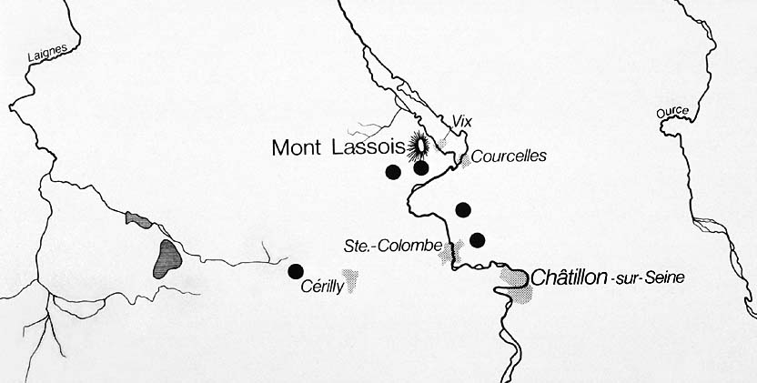
The Vix tomb was discovered in 1953 by Rene Joffroy and Maurice Moisson near Mount Lassois, in what today is Burgundy France. A visit to the site would be an estimated hour walk north of Chatillon-sur-Seine, to the base of Mount Lassois, with the local mild temperatures conducive to winemaking this would make it a nice route to travel. As wine making is what Burgundy has become known for, we can see the materials in the Vix burial as evidence of wine making in the region beginning.
Figure 2 : Map of the vix tombs' location.
Figure 2 shows the Celtic sites using different colours to define dates and influence; red for Hallstatt, black for La Tène, dark blue for classical (Greek) and purple for highlighting Vix specifically. In black and white is a modern map of the area indicates by the arrow. This makes clear where the Vix burial is compared to the other Celtic sites of Europe, along with an approximate established date. The reason I have given a modern close view of the area is because it holds more detail than the wider view.
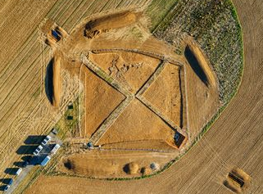
This location is thought to have belonged to the Celtic group named the Aedui when encountered by Caesar approximately 500 years after the Vix burial. While the Aedui may have been the Celtic group that buried this Lady, we are certain she was buried by the people from the nearby settlement of Vix. The Celtic people have a migratory movement because once they have used up the resources of an area, they move to a new one. Due to this movement and the time between Caesar writing about the Celts compared to the sites date, we can only tentatively name the Aedui as this Celtic group. Conversely, the peoples may have been the same but highly mobile which is why the depictions of horses and chariot are incorporated in the decoration of the tomb.

Figure 3 : Aerial view of the Vix tomb (Côte-d'or), Credits: © Denis Glicksman.
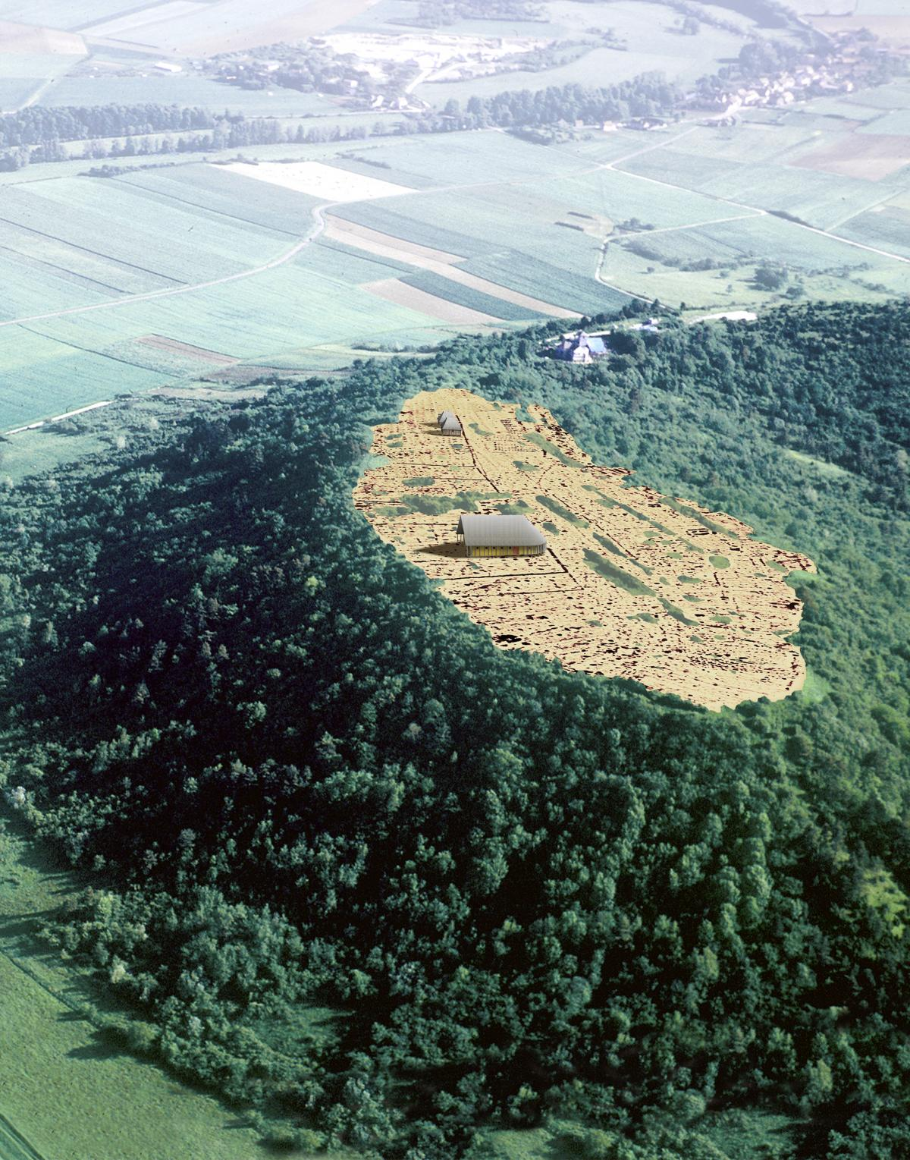
Today a modern recreation using replicas is in the Museum du Payes in Chatillion-sur-Siene. This museum houses all the objects from the original discovery, most are displayed in a single area of the museum but separate with the reconstruction showing what is thought of as the original arrangement. They have also been interpreted through processional archaeology with a touch of material culture theories but due to the diversity of ideas generated over time varying interpretations have been developed.
Figure 4 : Image of Mount Lassois © Klaus Rothe based on a photo by Rene Gogguey.
Both figures 3 and 4 are images from the recent excavations that have happened at Mount Lassois in the last 2 years. The most recent excavation was supported by the French Regional Directorate of Cultural Afairs (Drac,) with research being conducted under Inrap who had a partnership with the ARTEHIS laboratory (CNRS/ University de BourgogneFranche-Comte) . They aimed to create a more specifically chronology of the environment of the Vix burial was found using more technological archaeological techniques that were unavailable in the original excavation. The biggest deficit of the original archaeological excavation is the lack of preservation, in both the objects and the tumulus above the burial. With advancements objects ranging from tailor made trowels to scientific metallurgy testing, the archaeologists working under the French National Institute for Preventive Archaeological Research (Inrap).
The objects that were discovered in the Vix burial hold great importance to the academics interested in the interconnections between the Classical and Celtic worlds, especially those that originated in Italy (Etruscans) and Greeks (Massalia).
The artefacts from the Vix burial were discovered in a wooden chamber that measured 3 cubic metres which was in turn at the heart of a mound or tumulus with a diameter of 125ft. Due to the amount of material culture discovered in the Vix burial some of the smaller objects will not be discussed in this paper.
Figures 5 and 6 show the layout of the Vix burial at its discovery. Figure 5 also shows that the Vix burial was orientated with the Lady of Vix’s head pointing north and her feet south. We can also see that despite measuring approximately 3 metres in all directions the corner angles are not 90֯, this can most clearly be seen in the sloped north and south facing walls leaving the eastern wall slightly longer than all the others. Table 2 is the numerological key for Figure 5, while Figure 6 has a red circle next to the artefacts that I will be discussing in chapter 5.

Number  1  2  3  4  5  6-7  6  9  10  11  12  13  14  15  16  17  18  19  20  21  22  23  24  25  26  27  28  29  30  31  32  33  34-40  41-45  46-49  50  51  52 | Artefact  Bronze krater.  Silver phiale with gilded omphalos.  Attic black-figured 'Droop Cup' or kylix.  Attic black cup.  Bronze oenochoe.  Two-handled bronze basins.  Bronze basin without handles.  Four iron wheel rims.  Wheel bosses.  Axle caps.  Bronze openwork decorative plaques.  Small bronze balusters (decoration of the sides of the wagon).  Embossed bronze sheet.  Cylindrical bronze fittings for axles.  Cylindrical bronze sheet wagon fittings (position uncertain).  Sheet bronze components of the wagon box.  Bronze rosettes from the wagon box.  Long iron object (associated with the wagon parts).  Bent iron rods.  Large bronze fluted discs (phalerae).  Small bronze fluted discs (phalerae).  Bronze profiled knobs- piece of curved bronze, and an iron nail with wood remains.  Bronze profiled knobs- decorative nails with bronze sleeves.  Bronze button (beads?).  Small bronze knobs with hooks.  Linchpin.  Bronze axle caps from the pole axle.  Bronze felloe clamps.  Hollow bronze anklets.  'Belt'.  Pair of schist bracelets.  Pair of bronze sheet bracelets with amber beads.  Fibulae.  Amber beads.  Diorite stone beads.  Gold torc (Joffroy's 'diadem').  Spherical bronze terminal fitting.  Bronze rings.

Table 2: Key for Figure 5.
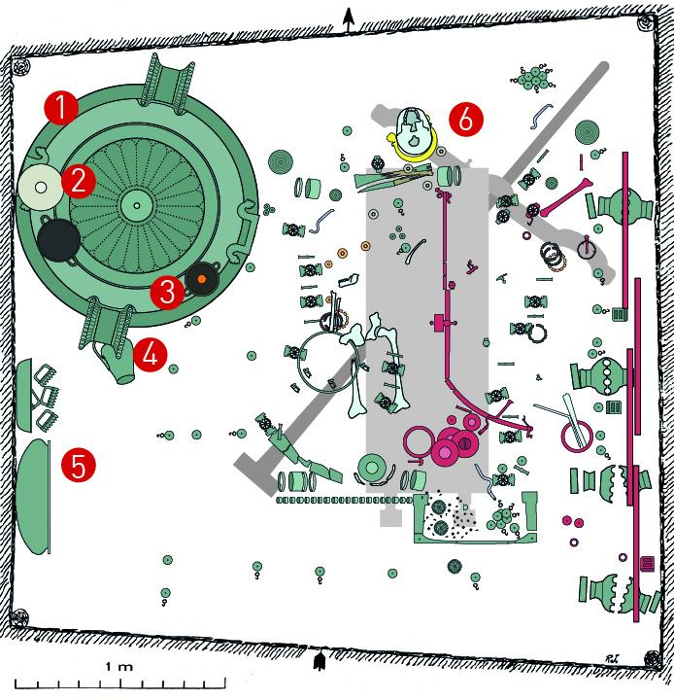
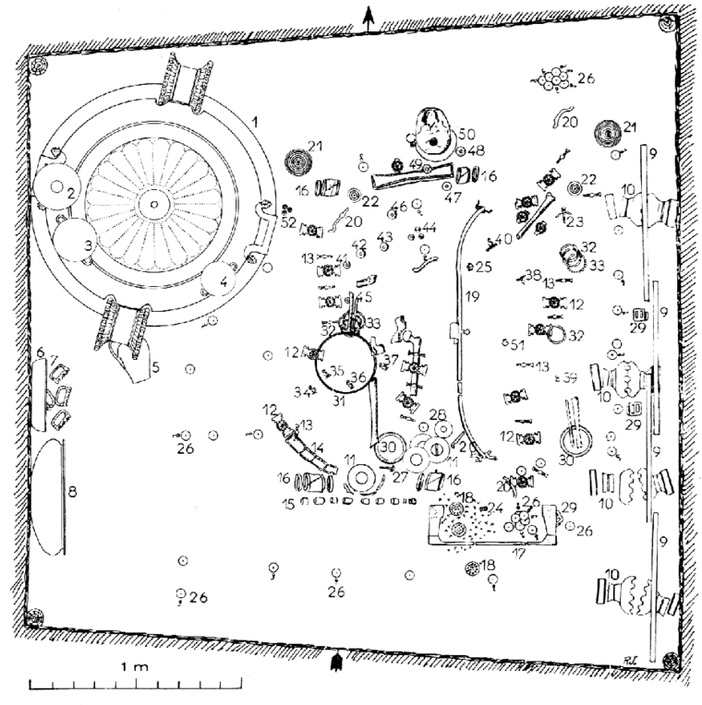
Figure 5: Plan of The Vix burial.
Colour  Green  Dark Grey  Pink  Light Grey  Black (with orange dot)  Yellow  Very pale green  Other | Material  Bronze  Wood  Iron  Silver  Pottery  Gold  Bone  Stone
Table 3: Key for Figure 6.
Figure 6: Coloured plan of the Vix burial.

Chapter 3

The Krater
The Krater found in the Vix tomb is 1.64 meters high, weighs 208 kilos and has a capacity of 1,100 litres. It consists of two pieces, the main vessel, and a lid. The pieces are made from bronze and are thought to be imported from Greece, most likely from the Etruscans but could be from Sparta. Another source has stated that the Krater was made in a workshop near the cities of Tarent which is known today as Taranto and Sybaris which is along the Gulf of Taranto archaeologically. The impressive nature of this object is one of the most fascinating aspects of the burial because to have placed this Krater in it means that the Lady of Vix had a connection with it and that the community could afford to remove it from circulation. This may mean the Lady was once from Greece and the Krater was something that she brought with her or her family. It would have come though the Etruscans or Massalians who were the closest trade port to the site, meaning that the Lady may have been Etruscan and the Krater was an heirloom that she brought into marriage or to the Celtic people of the local area. Not much is known about the Celtic marriage practices, but it thought that while a Celtic wife was subject to her husband, she would have had more freedom and opportunities than those in Greece. It has been stated that both the perspective husband and wife would bring an equal amount to married life, despite Celtic women not often appearing politically they have been document at battles being compared to their husbands as equals. Modern tales would have us think that women in Celtic society had complete independence and equal rights, but this is not a supported theory.
A Krater is an object used to make wine. It is also known as a mixing vessel It is in these vessels that wine was mixed with water to be served at drinking parties known as symposia.
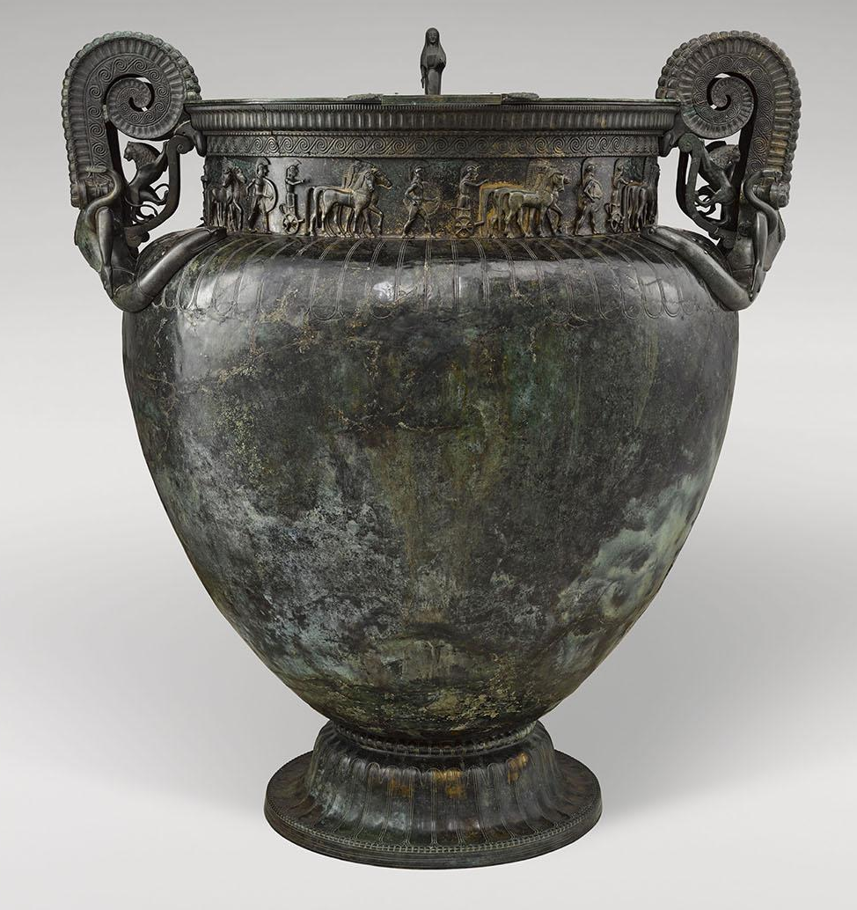
The wine trade is today what this region of France is known for. Having the Krater might have been the start of this trade or a way to import the product. The late Hallstatt known as the Hallstatt D period is when the trade along the Mediterranean reached its peak, the idea of wine and the instruments used in the production and serving of it were brought from Greece ia the trade city of Massalia. Stylistic analysis of the krater dates its manufacture to approximately 530BC

Figure 7 : Krater of Vix. Mathieu Rabeau NMR - Grand Palais.
Figure 7 shows a full-frontal view of the Krater, in it you can see how most of the decoration is concentrated around the rim, neck and handles. Most of these artworks appears to be at the very least influenced by Classical Greek art. The overall Krater is classified as a scroll Krater, probably due to the scroll like designs on the volute handles. The body of the Krater rests on a cast bronze base, while the body neck and shoulder are made from a single sheet which was hammered into shape. Comparatively, the volute handles, and applique were made through a method of wax casting which has been lost but still in solid bronze.
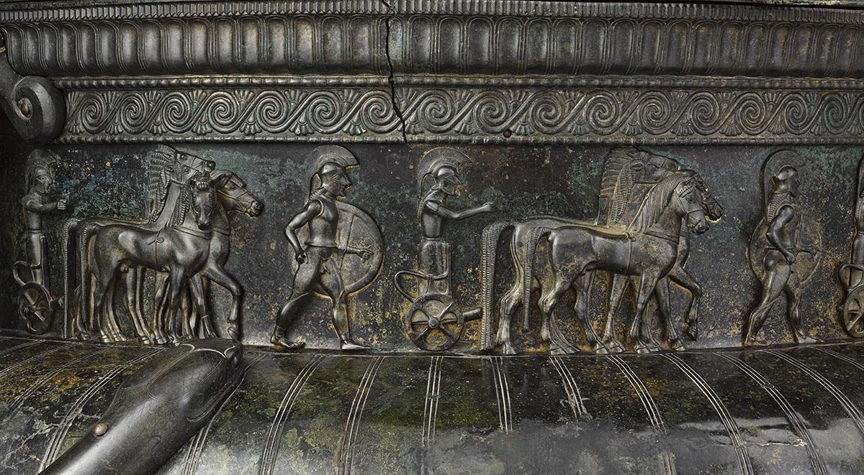
Figure 8 : Neck of the Vix Krater
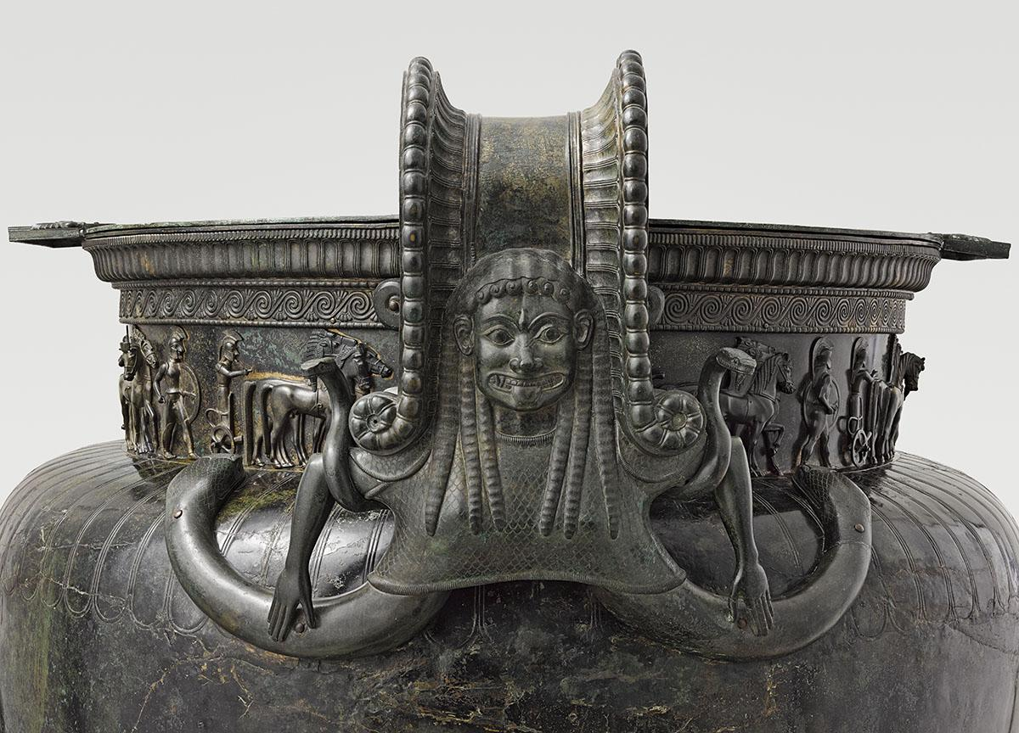
Figure 8 is a photograph of the neck or rim of the Krater it depicts a procession scene of Greek origin. We can tell it is of Greek origin due to the style of the people in the procession; the men that are walking are carrying large round shields and wearing plumed helmets. The chariots depicted in the frieze are similar to those found in Greek art both in sculptures and pottery. Horses are an important part of Celtic culture, being seen in the Hallstatt period artworks and imports. Depicting horses with their chariots on procession would likely only increase the objects value in Celtic eyes. The most significant evidence of this is the fact Epona the divine horse in Gaulish divinity generated favour in the Roman army to the point that she was the only goddess of Celtic origin we know was worshiped in Rome. An intriguing observation is that on closer inspection you can see the male genitals of the soldiers walking in the procession, but they are all wearing chest plates. Lack of clothing can be rationalized as it being too hot to wear or as evidence of where the Greek and Celtic war practises have hybridized. I think this because of Greek and Roman literary sources about the Celts in battle, however because all writing sources are from an outside and usual highly biased perspective they must be treated warily.
Figure 9 : Handle of the Vix Krater
This frieze runs around the entire neck, being given a more lifelike feel because of how the horses are depicted slightly differently as they go around. Each chariot is drawn by four horses known as a team, whose movement in-turn is shown through the positioning of the heads and legs until it appears, they are moving through the different gaits from stop to gallop. The charioteers diving the teams and walking in the procession are thought to be Hoplites.
Figure 9 is an image of the gorgon decorated volute handle. The Krater has depictions of gorgons on the handles, a gorgon is recognised by the snakes in her hair, having a snake tail or two depending on the artistic style instead of legs and a monstrous face. Gorgons are figures from Greek mythology with the most famous being Medusa who was slain by Perseus, Medusa was once beautiful but was cursed by Athena for having sexual relation with the god Poseidon in her temple. However, in the ancient world Medusa is a symbol of female power her name means “ruling one” but most Greek literature has slowly made her more monstrous with each retelling. The gorgons decorating the Krater have also been called grimacing women because of their facial expressions specifically the mouth, due to its width, long stuck out tongue and sharply pointed teeth. These gorgons have two snakes instead of legs which appear to climb the shoulder of the Krater, fixing the handle to the body. The gorgon’s torso and breasts have been covered with a scaled tunic, this both adds to her monstrous appearance. Her hair however is does not follow the typical made of snake’s pattern but is instead coiling in crazy curls to frame her face in a Greek style. There are snakes curling through the gorgon’s arms and standing facing the same direction as she is. These is a connection between the image of Medusa and individual female power, the fact that the gorgons are larger than the men with their chariots makes a statement. Add this to being found in an elite female burial it is likely that while she was alive the Lady of Vix used this Krater to show her status above others even men to visitors and locals alike at every large feast.
The wax casting method allows the handles to show the high detail, so a high level of specialization is needed to produce it making it an example of someone who specialized in bronze work. The gorgons head is lined up with the main part of the handle, making it look almost like a pair of horns or scrolls when looking from the side. This method of casting bronze has been lost to history, but we can appreciate the artwork that was once created.
Figure 10 is an image of the applique behind the volute handles from the side view which gives us a detailed view of the prowling lions sculpted on the inside. It also gives us a chance to see the swirl pattern that curves up the handle, this pattern can also be found above the frieze bordering the neck and rim of the Krater. The elegance and movement of the lions is shown in how they appear to climb the neck of the Krater, with their heads turned away and tails swaying. Lions are a common icon from Mediterranean and Aegean art, they are even used in connection with the Pharaoh in Egypt. In Greek art of the 7th and 6th centuries BC lions are associated with the Goddess Artemis, this connection with powerful females appears many times around the Mediterranean and Asia minor. This symbol of royalty and nobility has lasted until today due to being part of the British Royal coat of arms.

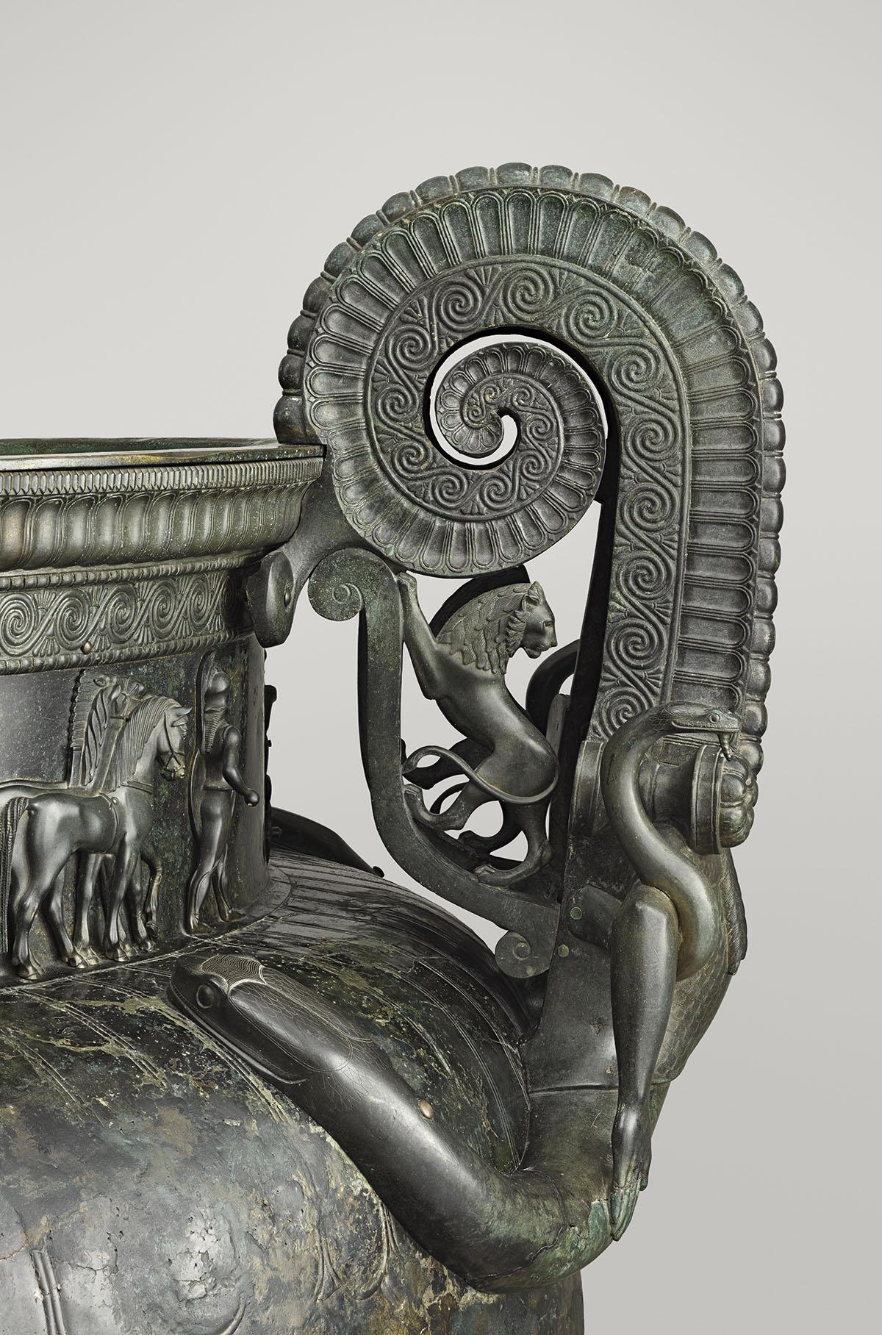
Figure 10 : Side view of the Handle from the Vix Krater
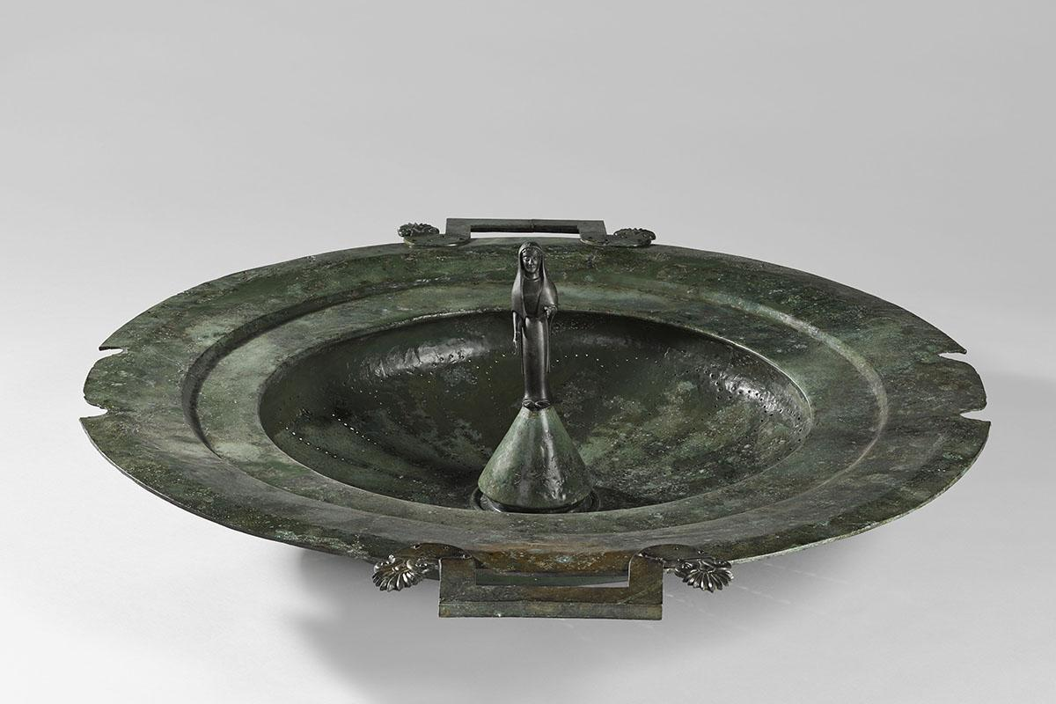
Figure 11 : Lid for the Vix Krater
Figure 10 is an image of the lid for the Krater. I am including the analysis of this object with the Krater itself because they are displayed together and would have been discovered as a single object. Like the main body of the Krater the lid is made of bronze, it has 2 handles on opposite sides which were most likely used to lift the lid from the Krater to either place materials into or remove material from the Krater. The opposing sides are grooved to fit the lid around the large handles of the Krater’s body. At the centre of the lid is a female figure, she is elevated on a conical stand that sits in the focus of the bowl depression that takes up most of the lid. The female figure is veiled and wearing only a simple dress and reaching her left hand in front of her towards one of the lid handles. It is possible that the female figure is of a goddess or ancestor, perhaps the original lady to bring wine to the area. Unfortunately, you cannot see the small holes in the lid that may have been for filtering the mixture or holding additional figures to create a scene. This may be the connection between the object and the Lady of Vix, or her family thought this object symbolised what she had done for Vix as a community. We cannot know for certain why this Krater was able to be removed from circulation and why it was placed with this Lady for her burial. Bur we can be sure that it is an example of wine being used by the Hallstatt elite as a status symbol.

Chapter 4

The Chariot
The chariot is where the body of the Lady of Vix was discovered, she was laid out on the chariot bed with the wheels laying against the wall beside it. The image is figure 12 is a reconstruction of the original, I am including this rather than the actual object because due to how long the objects were in the burial site the wood would have decayed enough to make a clear showing of what it was difficult. Many of the burials counted as ‘princely burials’ have a similar feature of laying out the body on a chariot or bench. Having a four- wheel wagon or chariot in a burial is a characteristic of central European Hallstatt Culture, though the use of vehicles in burials continues into the La Tène period they are more likely to use a two-wheeled chariot or cart.
Unlike in figure 12 when the chariot was discovered it had been dismantled so that the Lady of Vix had a stable place to lay on in death. The wheels that had been removed were still placed in the tomb as you can see in figure 5, they were leaning against one of the wooden walls. The dismantling of the chariot was probably done to create a steady place to lay the body but elevating it off the ground as a show of status. The breaking of objects is a religious act that often accompanies death, either so that the object cannot hurt the deceased or so that they will travel with them even in death. This is also thought of as ritually killing an object, the breaking of funerary objects appear in multiple cultures around the world and many reasons have been given for doing this such as; to reduce the risk of the tombs being robbed; repugnance of using an item that has already been used in funerary context; to prevent quarrels among those who survive the deceased and as previously mentioned to accompany the deceased into the afterlife. Both types of chariots used in Celtic funerary contexts are commonly dismantled and occasionally richly furnished with personal or feasting item or even weapons.
Chariot burials are famous for being found in Yorkshire where multiple burials were found of Celtic Iron age people who were buried with their horses and chariots.This cemetery has been named after the later medieval village of Arras, the most useful for comparative purposes is the Queen’s barrow due to the beads and golden ring but in there was also a King’s and Charioteer’s barrow both of these housed chariots. These three barrows were excavated in 1817-1817 by Edward Stillingfleet, Barnard Clackson and Thomas Hull though they were mapped out by William Watson in 1816. A third chariot burial was excavated by Canon Willian Greenwell in 1876, which was continued by Ian stead in 1959. All the burials of the Arras have been dated to the 5th century BC at the earliest and have a square shape which is similar to that found at the Vix burial but unlike at Vix the burial went directly into the ground instead of a wooden structure.
Being buried with a chariot is thought to be part of the Celtic culture for some Celtic groups, similar to how Viking chieftains were buried with their long ships and worldly possessions. The Vikings came after the majority of the Celtic civilization so there is a chance that using their people’s main mode of transport be it boat or chariot as part of an elite burial has been transferred along with materials. We know contact between these peoples are likely because of the Baltic amber used in Celtic jewellery.
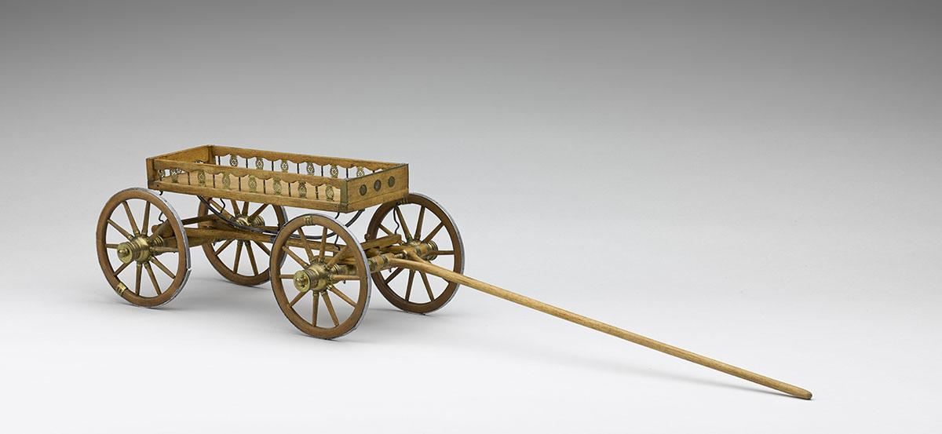
Figure 12 : Chariot from the Vix tomb
Wood as a resource for the Celts was easy so source due to Europe still having forests at the time, though less than in the Bronze age do to increase agriculture. The caped spoked wheels take skill to make especially due to the tire like rim made from iron keeping everything tightly together. The little remaining wood is fossilised where it is in contact with the Iron, due to this we know that the outer wheel and spokes were made from beech wood while the hub was made from ash. This along with the inlayed metal for the chariot bed mean that it was probably made by a craftsman and then bought by someone else to use.
Compared to the chariots depicted in the Krater there are some obvious differences, such as this chariot having four wheels instead of two and being pulled by two horses instead of three. I know some of these differences may be due to this chariot having a different purpose than those on the Krater, one being for battle and one for transport. The Musée du Pays names classifies this chariot as a four wheeled pageantry. The pageantry or chariot has an elegant design because three sides are open, with only the shortest side at the front closest to the horses is closed. The closed side is decorated with rosettes fixing onto the wood, probably beech like the wheels, the opposite short side is decorated with openwork plate which form a rosette and alternating with balusters. I am unsure how they would have driven this chariot, but I am sure they would either walk beside or sit at the closed end.
Another idea is that the Lady of Vix held enough status that she rode in the chariot instead of walk place to place, this may be a modernised idea inspired by elitist views of separating classes. It is not likely that this was this chariots purpose, but it could easily work with the romanticized Celtic view.
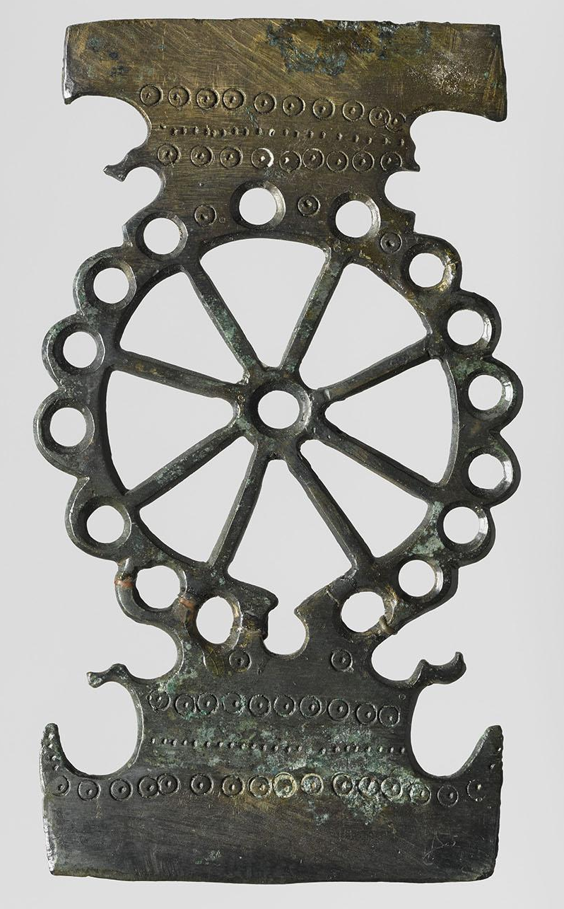
Figure 13 : Bronze insert from side of the chariot.
Figure 12 is a close view of one of the bronze inserts which lined both of the long sides of the chariot bed. They were placed in an alternating pattern with wooden columns, this pattern open two sides of the pageantry allowing a higher standard of workmanship. Lines of rings are detailing the insert where it would connect with the wood at each end almost like phases of the moon. It also allowed for someone to tie objects tightly to the bed of the wagon, making it easier to travel.

Chapter 5

The Adornment
The adornment of the Vix burial is not just limited to the artefacts that the Lady of Vix was wearing when she was discovered but all the medium sized objects that are named grave goods. These artefacts are known as the treasures of Vix and are the reason she is why believing the Lady of Vix was an ancient princess is not impossible. This wealth of the Vix burial can be seen most clearly in the gold jewellery and silver vessels. These include a Celtic filigree embellished torc figure 14, a silver Oenochoe figure 18 and an Attica cup figure 20. These objects are located laid out on the dismantled chariot in the reconstruction, showing that they would be placed upon the body in death. The arrangement of all the artefacts from the Vix burial can be seen in figures 5 and 6.
There are no fabric remains that have survived due to the environment, length of time in the burial and poor preservation techniques during the original excavatiom. I cannot personally visit the site and artefacts my interpretations are limited. For this reason, I have brought in ideas from other ancient societies such as the Egyptians, Cycladic and Vikings. Both the Ancient Egyptians and Cycladic civilizations are far older than the Celts but had large trade influence which is a shared by the Celts of the later Hallstatt period. Vikings are much later than the Celts in written sources but are they have associated with each other and are grouped together during their invasions of Scotland. The Greeks are the largest society that the Celts had contact with during the Hallstatt D period because of trade post cities that had been set up in the western Mediterranean.
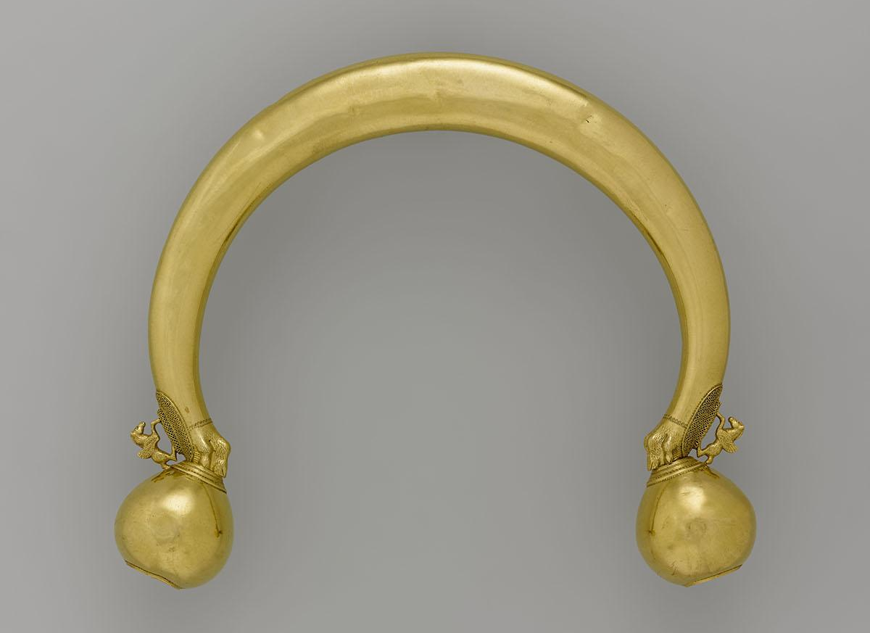
- Torcs
Figure 14 : Torc from the Vix Tomb
A torc like the one depicted in figure 14 was typically worn about the head, perhaps to keep hair or a fabric veil way from the face. This torc is made from gold which is not unexpected because it is a metal however having such an object means that it was unlikely to be worn as part of everyday dress. Gold is a precious metal, however the value we have for it today may be different from the value of it during the Hallstatt D period.
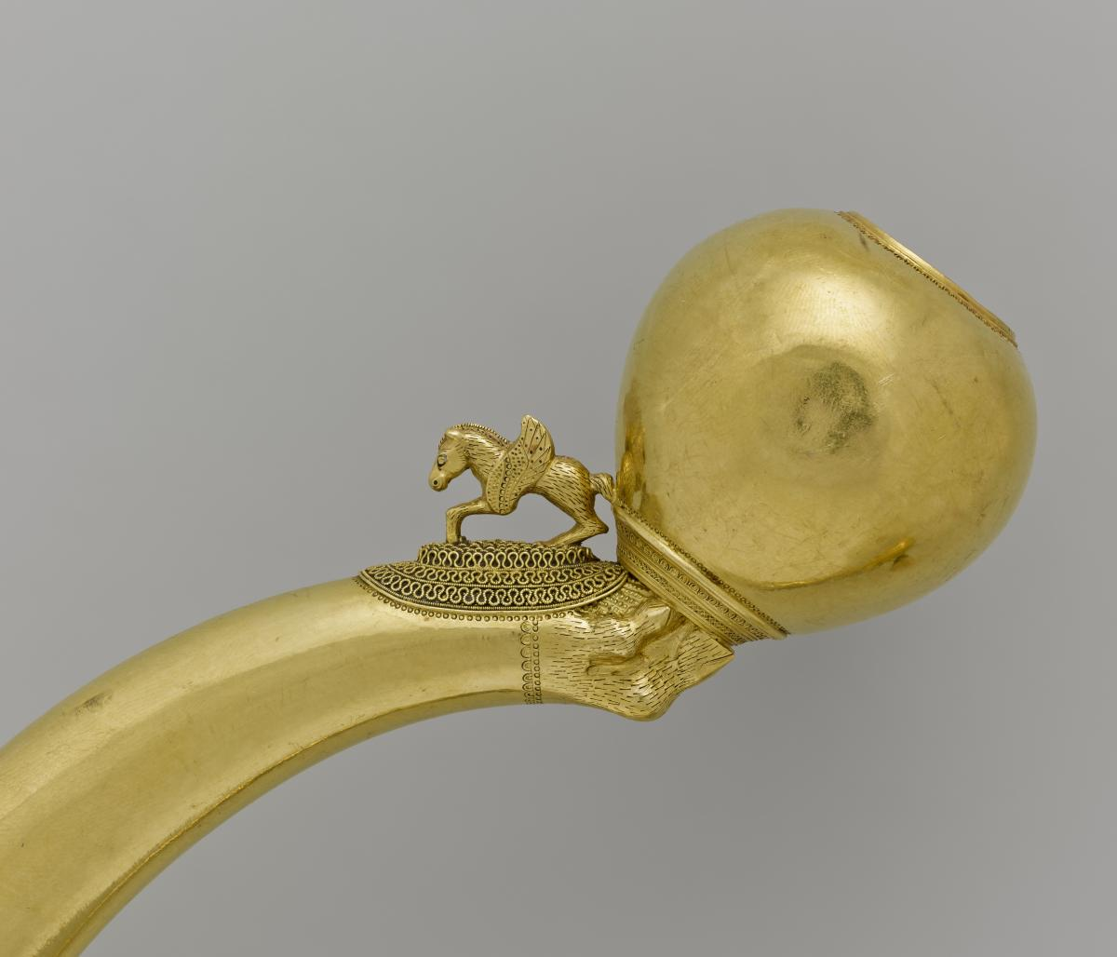
Figure 15 : Close up view of the torc from the Vix Tomb
Figure 15 shows the Celts of Europe have great skill at moulding and crafting gold, we can see this due to the miniature winged horse galloping. The torc was made from a rod of gold that weighs approximately 480g that was hammered into the desired arc. The arc of the torc has been worked into lions’ paws, which are resting on balls with one flattened side decorated in geometric circular pattern. The junction where the lions’ paws and ball meet are further decorated with a winged horse resting on a cushion of gold threads. The winged horse is instantly thought of as from Greek origin due to the Pegasus myths however the Celtic peoples put high importance and social standing connecting to horses. The use of their image on a golden object in not a surprise and the Lady of Vix may have had a connection to it while living. For example, it could have been a gift given to the lady by her husband, a male suiter or to symbolise her status in the local community. There is no evidence that the Lady of Vix was married but neither is there any that she was not, meaning that we cannot conclude that the torc was not a gift. It may give the idea of the Lady being known as the ‘princess of Vix’ more basis. Comparatively, the Pegasus was born from the blood of medusa when her head was cut off by Perseus.
The detailing is fine and would have needed a highly specialized craftsman. This high level of specialization is associated with societies where there is an elite group, this group can fund those below them into creating beautiful items through buying their wares. In less developed societies there are not many highly skill craftsmen. This agrees with the idea of the Lady of vix being part of the elite, which is further proven with the use of imported items used to elevate a person’s status.
The golden torc was probably made in a local workshop because it is decorated in what is thought of as the traditional Celtic way, irons all coming from a central theme. The torc form the Vix burial has a solar motif, framing motif and a support motif which is on the legs of the lion. If this torc was truly made in an indigenous workshop like we think due to its choice of icons and manufacture, it becomes evidence that cultures are mixing in the area of Vix and that people are transferring technological knowledge along with their culture.
The golden torc of figures 14 and 15 was not the only torc in the Vix burial, another was found place at the Lady of Vix’s abdomen.
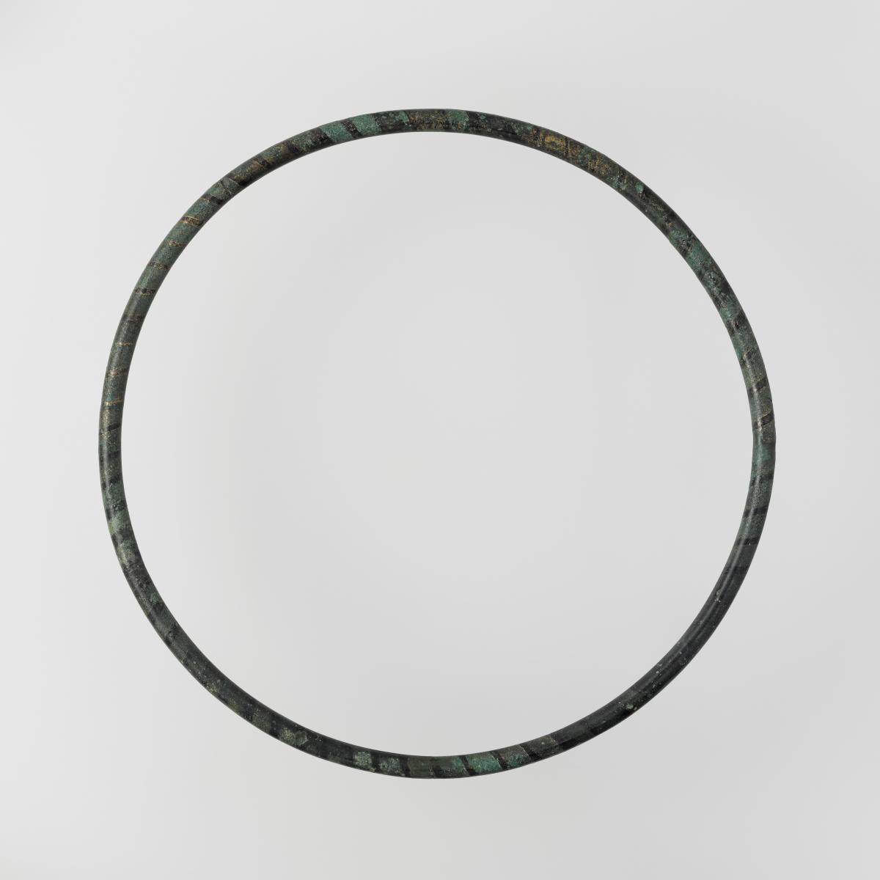
Figure 16 is an image of the hollow torc also called a closed torc, it measures 26.8 cm at its diameter and is made from bronze. The location of this object on the remains made it difficult to tell whether the Lady of Vix was wearing a belt along with figuring out how she would have worn this object. Due to having no opening and its size it is unlikely that it was worn as a necklace because it would have been extremely uncomfortable. You can see marks left from when organic material, most probably leather or fabric was would in a spiral around the bronze. It has been proposed that the Lady of Vix had a system to hang this object or attach it to her clothing.
Figure 16: Hollow torc

- Bronze basins and Oenochoe
There were three bronze basins found in the Vix tomb, they were all grouped together leaning against the wall closest to the Krater. Two of the basins are approximately 35cm at their diameter, they have to two handles on opposing sides which are decorated with three palmites alternating with ovoid buttons. This basin was probably used for cooking or cleaning and it was possible that it was used by the Lady of Vix in her everyday life. Conversely, they may have been used to clean and wash items or to cook vegetation. These two basins were almost certainly used in banquets which is why they were found so close to the Krater. One of these basins carries a beaded cord which was welded to the top of the wooden wall of the tomb.
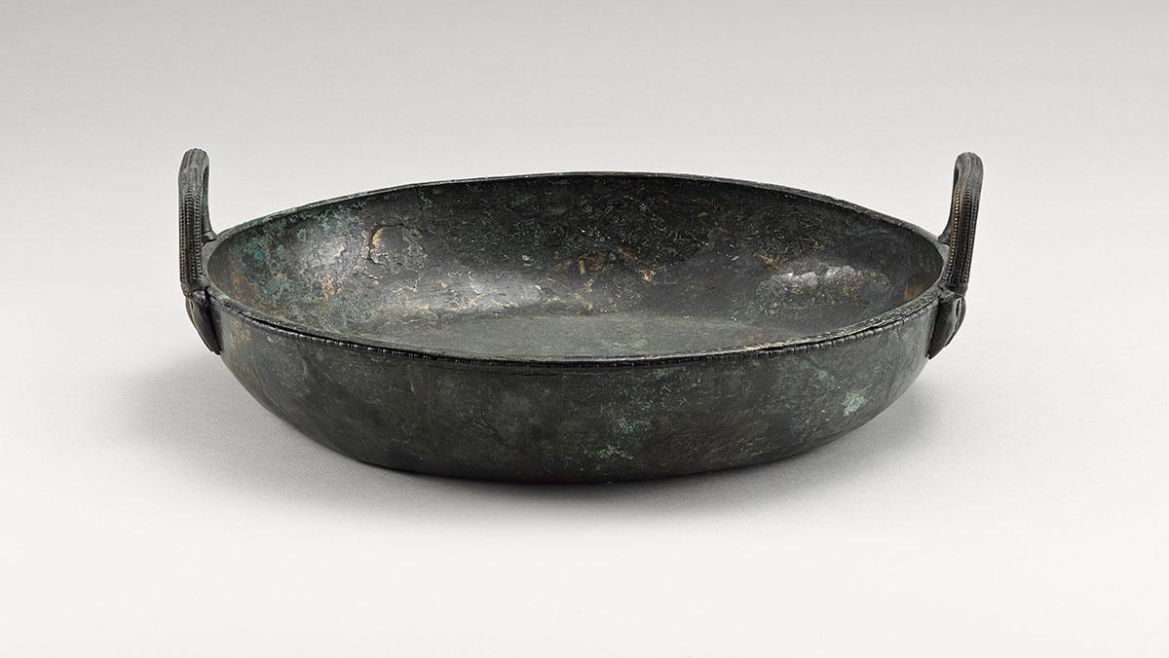
Figure 17 is an image of a basin; its two handles made for ease when transporting its contents or hanging over a fire. The use of this object in her everyday life or supposed everyday life was probably why it was included in the Lady of Vix’s burial.
Figure 17: Bronze basin from the Vix tomb
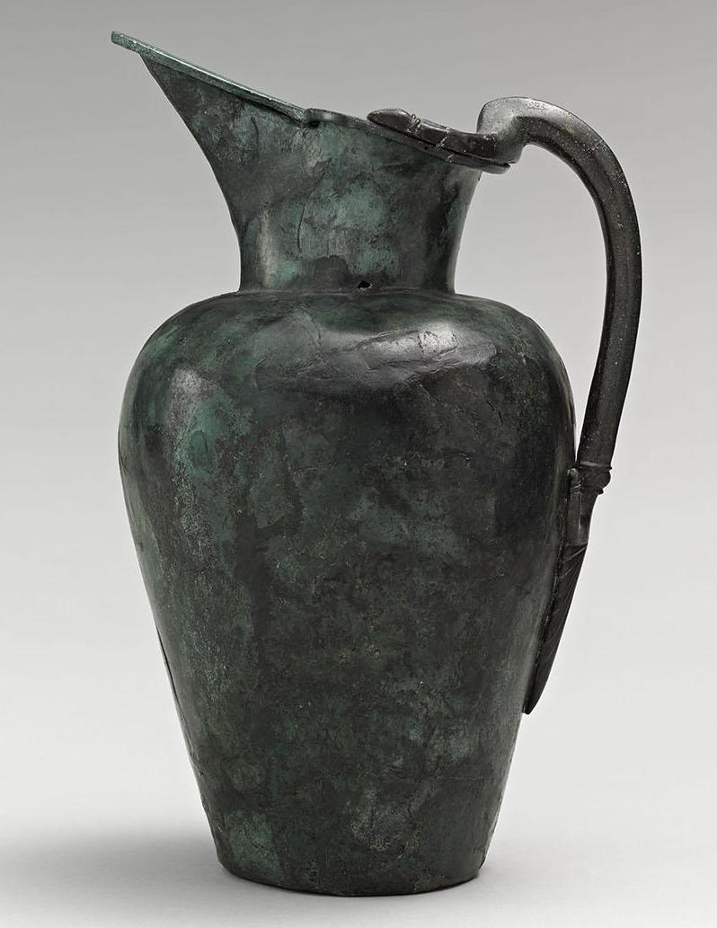
The third basin has a diameter of 55cm and an umbilicus, unlike the other two this one has a braid elaborately decorating the brim. This decoration has also been found at the top of Lebes de Sainte-Colombe. The use of this vessel is unsure, but it was most likely used at banquets for ablution such as washing your hands before tasting the wine similar to a Greek banquet instead of for food.
Figure 18: Bronze Oenochoe or jug for serving wine
Figure 18 is an image of a jug; it has also been named an oenochoe is a jug which was used by the Greeks to draw the mixture of water and wine from a Krater. It was probably used with the Krater also found in the Lady of Vix burial. It is probable that holding feasts was part of the funerary process for the Celts, to celebrate the life the departed. It was almost definitely part of negotiating and is evidence of the power plays within the elite of the early Iron age. This artefact may have been used during daily life, perhaps not every day but regularly used to celebrate important occasions as a family or community is unknown but due to the size of the Krater I think that the celebration as a community is more likely.
Figure 18 is a typical example of an oenochoe which shares its Etruscan style with many similar objects which have been spread from Champagne to Bohemia. It has a stocky body, short neck and an oblique mouth which ends with a spatula beak.David Bougrait and Benoit Mille performed metallographic analysis which concluded that there was a high possibility that the basins and the oenochoe were made in the same workshop. Due to the Basins being fitting the Etruscan production style with flat bottom handles found in the corpus of Vulci region, we can date both object to an estimate 510 to 480BC.

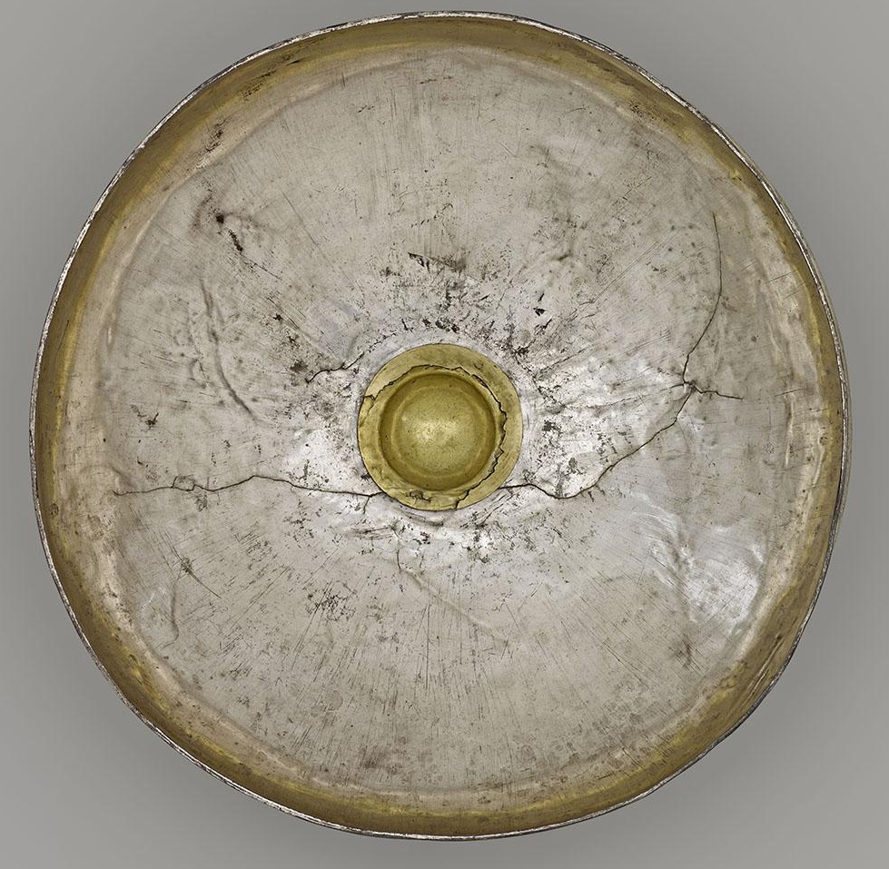
- Silver Phiale
Figure 19: Silver Phiale
The silver phiale from the Vix burial was found on the Krater and is a flared silver bowl with an approximate diameter of 25cm. as shown in figure 19 at the centre of the silver bowl is a bulge covered in gold leaf which is called the omphalos or umbilicus.
This silver phiale was likely gripped from the bulge as it was probably not used to drink but instead to serve the gods. The object was made by hammering the silver into the desired shape which means that the origin of this object is vague because it could have come from Greece, Etruria or the Iberian Peninsula. This silver phial is the oldest silver vessel north of the Alps and is clear evidence of cultural exchange because serving the gods is a part of Greek culture and banquet etiquette.
While some phiales are decorated with images, tales of men, women and myths they are the exceptions. Though phiales are commonly thought of as ritual objects because of its form and decoration the phiale of Vix is one of many embellished libation vessels found in the archaeological record. It can be used for in more than just funerary contexts, as libations to deities is part of many worldwide religious practices.

- Attica cup
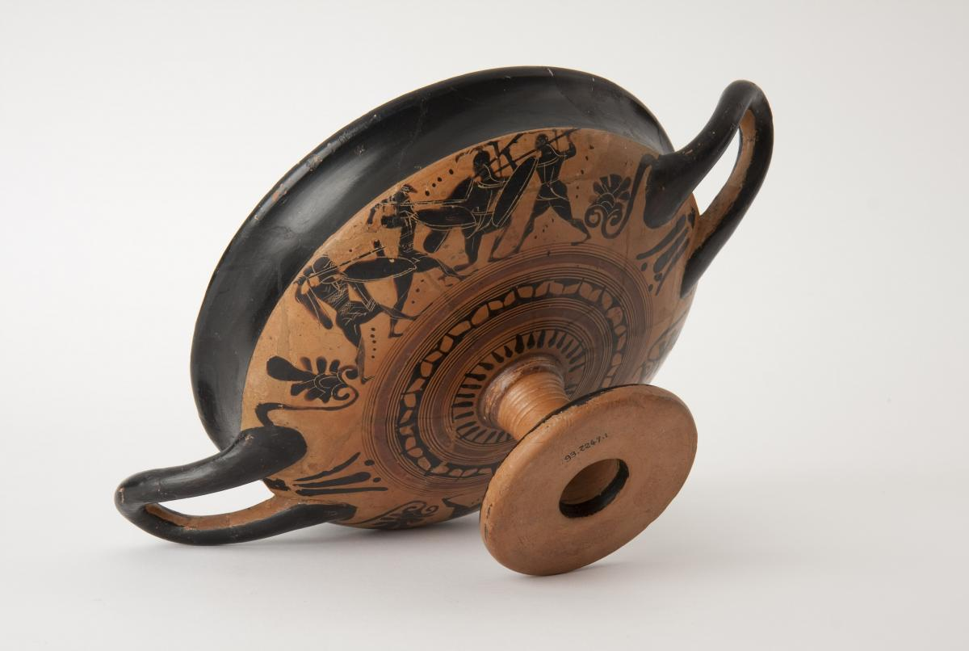
Figure 20: Attica cup
The cup in Figure 20 is also known as a droop cup, it is known for its distinctive shape. These cups have been found in Etruscan sites but depict Greek battle scenes, specifically those between the Hoplites and the Amazons. This cup is made from clay and fired to set the shape before being painted, due to stylistic comparison it is estimated that this cup dates to around 520-515BC. The pattern is named after shadow because the figures depicted look like shadows, the artist was named the “Painter of Spectres” for this reason. A cup with black varnish and lowered foot has been classified Bloesch C, this type originates from the region of Massalia . We know that Attica cup were distributed across the Mediterranean because they were found as cargo in a shipwreck near Massalia around the same date as this one. Having an Attica cup gave prestige to a person, the fact very few of this object type ever made it to Burgundy furthers this prestige.
Finding pottery in funerary assemblages is a theme repeated throughout the Celtic cultures. It even continues in other cultures around the Aegean and Mediterranean, though earlier vessels were traded Egyptian stone. An example of this in burial practise can be seen in the use of obsidian blades as a regular burial feature of early Cycladic era (EB1).These materials being placed into funerary areas were usually for reasons associated with creation, expression and most significantly social identity of the area they live. I think that these idea can also be applied to the Attica cup being in the Vix burial because not only does trade become a large part of Cycladic social identity, it also a large part to thanks for the wealth of Vix. In both societies as they develop as civilizations the material culture found in their burials increases with status of the deceased, this rise of an elite is shared across many civilizations.

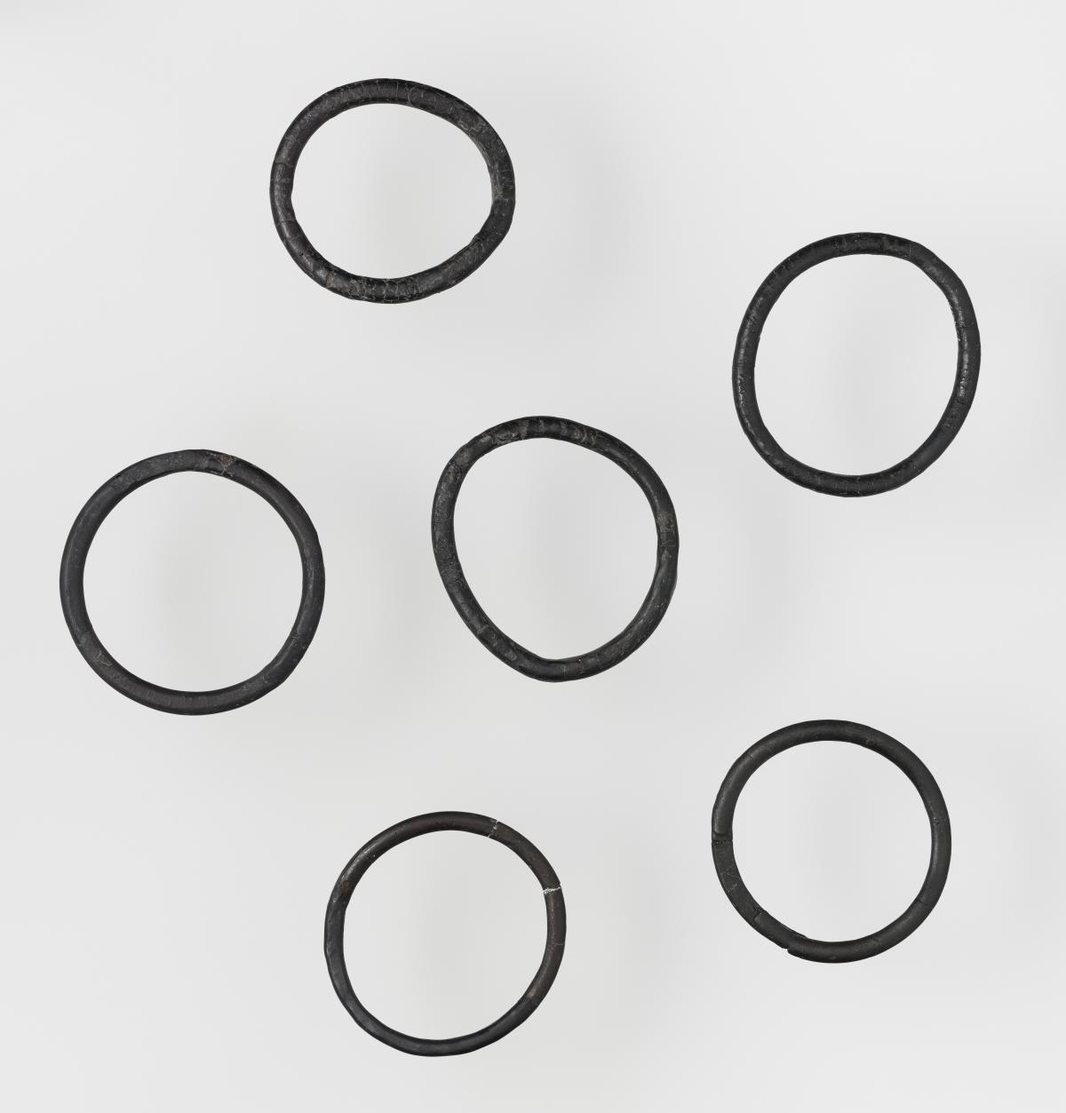
- Bracelets
Figure 21: Bracelets made from Lignite
Figure 21 is of the rings found on the wrists of the Lady from Vix. The Lady of Vix wore four bracelets on each wrist, of the total eight; six were made from the black rock lignite and two were made from amber. Both these materials were prestigious by the end of the Hallstatt period, but lignite is a type of jet which has been worked into ornaments since the Palaeolithic though they really came into their own during the Iron age. Comparatively, amber is prized due to its exotic nature because it comes from the Baltic and is diffused into the Celtic trade due to the north-south roads that spanned Europe.
I have no images of the anklets but the Lady of Vix wore a bronze ring on each ankle. They each are made from a sheet of bronze rounded into a rod and closed with a pin. The surface of the rings is the most fascinating part because it is exceedingly rare form of decoration, this may mean that it was created solely for this lady or for ladies only of a curtain status. This decoration is a series, an incision of incised streaks, perpendicular to the axis of the jewel and bordered by a frieze of semi-circular arcs. The incisions are collected into three thread which alternate with smooth bronze. Wearing anklets is most likely for a personal and cultural reason that has since long been lost to time but I would think the Lady of Vix wore these when she wished to look her best such as for feasting or to impress her partner if she had one.
Each bracelet likely made a different sound when they tapped against each other while the Lady of Vix was in motion, be it walking or dancing. Due to the materials involved I think they might have been earned by the deceased during her life, perhaps through helping the people of Vix to make advantageous trade agreements or through fighting. The anklets may have had a similar purpose or been gained a similar way but were only worn at feasts. This would be due to the weight pressing down on the ankles when she walks because unless Celtic women had a different way of walking. Otherwise, the anklets would constantly clang together or catch on the materials in their immediate environment.

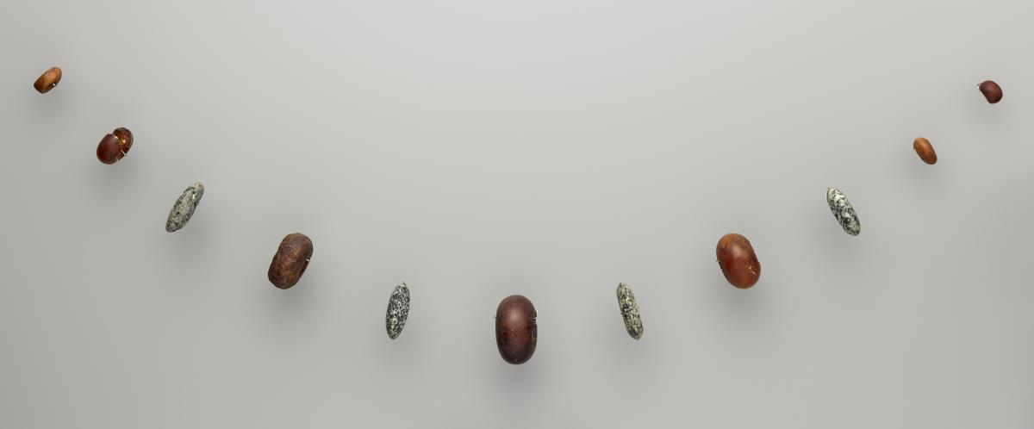
- Beads
Figure 22: Beads from the Vix tomb.
These beads or pearls were found on approximately the chest of the Lady of Vix. Due to this we can assume that they were worn as a necklace of some kind. They are named pearls by some sources, but all are made from stones, these were probably worn on a cord and may have been a gift or gathered over the life of the Lady of Vix. The stones used to make these beads when put into a singular necklace make it very distinctive. Seven of the beads are made from Baltic amber which when polished resembles honey due to being made of fossilised vegetable resins. Three beads are made from Diorite which after being polished becomes a beautiful mixture of white, beige and black crystals. The final bead is made of serpentine. The largest bead had a diameter of approximately 46mm and all from the Vix burial a spherical.
Beads are nearly a staple for burials across most ancient civilizations, especially for female burials. The ancient Egyptians use beads as funerary amulets, they mainly use reds and blues, but both are crafted from natural precious stones, the red from cornelian and the blue from lapis lazuli. The colours, patterns and materials original meanings have been lost today. This means that any interpretation of the emotions evoked by the colours and textures are from a modern perspective. Having a variety of colours and textures in a single necklace is usually found in tombs of those from a higher status, especially if those materials are exotic in nature. Exotic material cost more to import thus making them difficult to get and so making the finished object more desirable for the elites of the Hallstatt period.

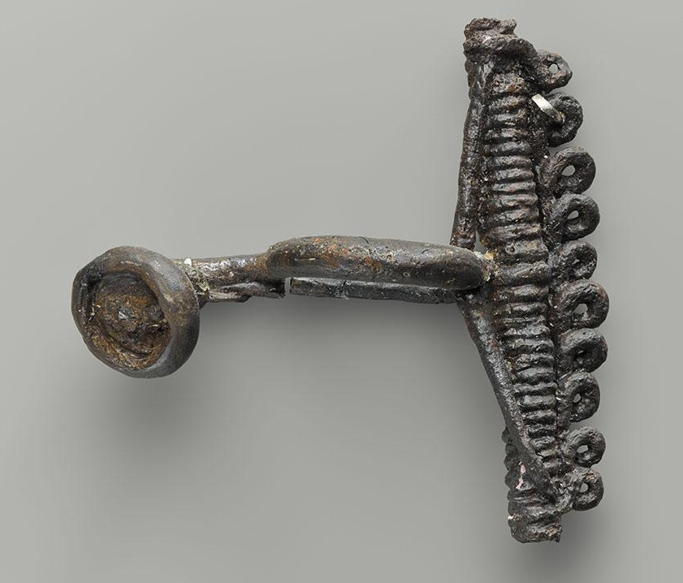
- Fibulae
Figure 23: Fibulae
Figure 23 is most likely a fibula which at the time of burial was very rare. Today fibulae make up 90% of the archaeological corpus as votive offerings at the source of Douix in Chatillon-sur-Seine. The Vix tomb contains eight fibulae that were found near the bone remains of the Lady, six of which were exceptionally preserved. One of these was made from iron and is classified as a Mansfeld F3Btype, known for its false rope and loop design along with its large dimensions. Five other fibulae were enhanced through decoration, specifically precious stones such as an amber disk from the Baltic combined with coral cabochon from the Mediterranean. Due to the original rarity of this object and then its use as an offering it is thought that fibulae are a symbol of power or prestige, in some cases both. In figure 5 you can see that the fibulae have gathered near the hollow torc, which means we can assume that they once were at the waist of the Lady of Vix. Whether the fibulae were worn by the Lady of Vix as decorative broches or in a pouch attached to a belt is unknown. The use of exotic stones from both north and south of Vix symbolise the hybridization happening at the Vix site, because without working and profitable trade routes using these materials together would not be possible.
Having one fibula made from iron, even if it is shaped into a pattern may mean that this was the fibulae used the most in daily life, while the more ornate fibulae were used for feasts. If they were used for feasts it makes sense for them to be included in the burial because most of the artefacts also have a connection with feasting.

Chapter 6

Conclusions
To conclude I have found that the artefacts from the Lady of Vix burial are amazing examples of how diverse the late Hallstatt period Celtic peoples were in their trade agreements. It showcases nearly all the expected elements of high social standing, meaning that the burial being for a princess of female member of the Halsstatt elite is very reasonable conclusion. Having a female in high elite society buried with a wealth of treasure shows how the Celtic culture valued the elites in death. The fact that she would have had to earn this high status as a woman emphasises the fact the Celtic women had a much more engaging role in society, that they had the freedom to gain social status. To bury a women with as many treasures as the Lady of Vix shows just how large a role she probably had in the Vix community, this is due to the fact those she left behind thought that they could remove all these objects from their lives to support her in death.
If the Celts believed similarly to the Ancient Egyptians that what was buried with the dead was used by the dead in the afterlife, the Lady of Vix having multiple treasures related to trade would allow for a lavish afterlife. As we have no evidence for or against this interpretation it is unlikely that this was the Celtic funerary beliefs. Comparatively, most of the artefacts have some connection to feasting this may be due to the people of having a feast to honour or celebrate the live of the deceased as part of their burial practice. These artefacts may have been meant for use in the afterlife by the Lady of Vix joining her ancestors in a feast. If so the golden and exotic jewellery she was wearing are probably the items she would wear to a feast being held at Vix. This idea is found in the Viking belief in Valhalla, where a warrior would feast with their ancestors until they were needed to fight in Ragnarøk. Whether the Viking ideas were shared with the people of Vix is unknown but probable due to materials like amber coming from the Baltic. This conversion and hybridization of culture happening at the Vix site is expressed through the materials and styles used in the artefacts. By using the ideas from these societies, I have found it easier to investigate the Vix burials material culture because of the many similarities between certain objects and death.
Thoughout this investigation I have found that though the Celts can be tentatively categorized as less civilised than the Greeks, Roman or Egyptians they are a part of the vast trade network of the Mediterranean. This classification as less civilised has more to do with the lack of written literature than anything else because the Celts have evidence of craft specialization, a common language, a social hierarchy and as a civilization the Celts rise and fall. As part of this I have found that the artefacts of the Vix burial express the trade diversity of the Hallstatt, through their materials and patterns. Though this site lacks the typical weapons we connect with the Celtic people, but it still gives us an idea into how they saw their world and fighting within it. All of this comes together to portray the image of a powerful Celt woman who was buried with her finest riches and today gives us all an insight into her life and the lives of those who buried her.

References

Literature

Bevan, A. 2004. Emerging civilized values? The consumption and limitation of Egyptian stone vessels in EMII-MMI Crete and its wider Eastern Mediterranean context. file:///C:/Users/user/Downloads/Bevan%202004%20(1).pdf - accessed: 03/05/20

Bogucki, P. 2017. The Barbarians: Lost civilizations. Reaktion books. London.

Carter, T. 2007. The Theatrics of technology: Consuming obsidian in the early Cycladic burial arena. Stanford University. Redwood city, USA. C:/Users/user/Downloads/Carter_T._2007_The_theatrics_of_technolo%20(1)%20(1).pdf - accessed: 03/05/20

Cunliffe, B. 2018. The Ancient Celts, 2nd ed. Oxford university press. Oxford.

Darvil, T. 2009. The concise Oxford Dictionary of Archaeology, 2nd ed. Oxford University Press. Oxford.

Dexter, M. 2010. The Ferocious and the Erotic: “Beautiful” Medusa and the Neolithic Bird and Snake. Journal of Feminist Studies in Religion, Vol.26. Issue.1. pg. 25-41. doi:10.2979/fsr.2010.26.1.25

Ellis, P. B. 1995. Celtic women: women in Celtic society and lit. Constable. London.

Ellis, P. B. 1992. Dictionary of Celtic mythology. Constable. London.

Eluère, C. 1993. The Celts first masters of Europe. Thames and Hudson Ltd. London.

Fitzpatrick, A. P. 2018. The finds from La Tène in the British Museum: La Tène, un site, un mythe 6. The Antiquaries Journal. Vol. 98. Pg, 43-80. Cambridge University Press. Doi: 10.1017/S0003581518000550.

Freeman, P. 2002. War, Women and druids: eyewitness reports and early accounts of the ancient Celts. University of Texas Press. Austin, USA.
Green, M. J. 1992. Dictionary of Celtic myth and Legend. Thames and Hudson Ltd. London.

Grinsell, L. V. 1961. The breaking of objects as a funerary rite. Folklore, vol. 72, Issue. 3. pg. 475–491. JSTOR. www.jstor.org/stable/1258576. accessed:11/05/20.

Halkon, P. Lyall, J. et al. 2019. Arras 200: revisiting Britain’s most famous Iron Age cemetery. In. Antiquity, vol. 93, Issue 368. Pg. 11. Cambridge University Press. Doi: 10.15184/aqy.2019.28.

Harris, O. J. T. Cobb, H. et al. 2017. Assembeling places and persons: a tenthe-century Viking boat burial from Swordle Bay on the Ardnamuchan peninsula, wester Scotland. In. Antiquity. Vol. 91, Issue 355. Pg 191-206 Cambridge University Press. Doi: 10.15184/aqy.2016.222.

Haspels, C. 1951. Lions. Mnemosyne. Series 4. Vol. 4. Fasc. ¾.pg. 230-234. www.jstor.org/stable/4427310. accessed: 11/05/20.

Hicks, D. 2010. The Material Culture turn: event and effect. In. Hicks, D. Beaudry, M. C. (ed.) The Oxford handbook of Material culture studies. Oxford University Press. Oxford. Pg. 25-99

Hultgård, A. 2019. Myth on stone and tapestry: Ragnarøk in pictures? In. Wilkström af Edholm, K. et al. (ed). Myth, materiality and lived religion: in Merovingia and Viking Scandinavia. Stockholm University Press. Stockholm. http://library.oapen.org/handle/20.500.12657/25005. Accessed: 11/05/20

Kéi, N. 2014. Autour de la phiale mesomphalos: Images et contextes. Revue De L'histoire Des Religions. Vol. 231. Isuue. 4. Pg. 745-773. www.jstor.org/stable/44649784. accessed: 11/05/20.

Kimzl. K.H. ed. 2010. A companion to the classical Greek world. Wiley-Blackwell publication. Chichester.

Klimczak, N. 2016. Examining the rich tomb of a Celtic princess. https://www.ancient-origins.net/ancient-places-europe/examining-rich-tomb-mysterious-celtic-princess-005388 - accessed: 24/03/20

Knüsel, C. 2002. More Circe than Cassandra: 1 The Princess of Vix in Ritualise social context. European Journal of Archaeology. Vol, 5. Issue 3. Pg. 275-308. Sage Publications. London. Doi: 10.1179/eja.2002.5.3.275

Leonard, J. 2016. The Vix Krater: A testament to the Greek wine trade. https://www.greece-is.com/the-vix-krater/ accessed: 29/03/20

Megaw, J.V. S. 1966. The Vix burial. In. Antiquity: vol 40, issue 157. Antiquity publications Ltd. Durham.

Musée Du Pays. Collection: Treasure of Vix. https://musee-vix.fr/fr/visite-collection/tresor-de-vix#sthash.QensXc1r.gg6FcwnY.dpbs accessed: 02/04/20

Neils, J. 2007. Myth and Greek Art: Creating a Visual Language. In R. Woodard (Ed.), The Cambridge Companion to Greek Mythology (Cambridge Companions to Literature). pg. 286-304. Cambridge University Press. Doi:10.1017/CCOL9780521845205.011

Praetzellis, A. 2016. Archaeological Theory in a nutshell. Routledge. Abingdon.
Roberts, A. 2015. The Celts: search for a civilization. Heron Books. London.

Styring, A., Rösch, M., Stephan, E., et al. 2017. Centralisation and long-term change in farming regimes: Comparing agricultural practices in Neolithic and Iron Age south-west Germany. Proceedings of the Prehistoric Society. Vol. 83. Pg. 357-381. University Press. Cambridge. Doi:10.1017/ppr.2017.3

Tann. 2019. New Excavation of ‘Princely Tomb’ of Vix underway. 2019. https://archaeologynewsnetwork.blogspot.com/2019/09/new-excavation-of-princely-tomb-of-vix.html accessed: 12/04/20

Taylor, 2001. Death and the Afterlife in Ancient Egypt. British Museum Press. London.

Vix and the princely phenomenon. 2019. https://www.franceculture.fr/emissions/carbone-14-le-magazine-de-larcheologie/vix-et-le-phenomene-princier Accessed: 14/03/20

Wengrow, D. 2010. What makes Civilization: The ancient near east and the future of the West. Oxford University Press. Oxford.

Images

Figure 1: Drawing of the Lady of Vix being buried by Jochen Stuhrman © Geo Epoche. - Musée Du Pays. Collection: Treasure of Vix. https://musee-vix.fr/fr/visite-collection/tresor-de-vix#sthash.QensXc1r.gg6FcwnY.dpbs accessed: 02/04/20
Figure 2: Map of the vix tomb’s location. Arranged by Author. Witt, C. M. 1997. Barbarians on the Greek Periphery? Origins of Celtic art. University of Virginia. Overlay image: after Joffroy 1979, 17 fig. 2. From the same source.
http://www2.iath.virginia.edu/Barbarians/first.html -03/04/20 http://www2.iath.virginia.edu/Barbarians/Sites/Vix/Vix_site.html -03/04/20
Figure 3: Aerial view of the Vix tomb (Côte-d'or), Credits: © Denis Glicksman. - Princely phenomenon. 11/03/19. https://www.franceculture.fr/emissions/carbone-14-le-magazine-de-larcheologie/vix-et-le-phenomene-princier- 14/03/20
Figure 4 : Image of Mount Lassois © Klaus Rothe based on a photo by Rene Gogguey.
Figure 5: Plan of the Vix burial. – Source: Egg and France-Lanord, 1987. Knüsel, C. 2002. More Circe than Cassandra: 1 The Princess of Vix in Ritualise social context. European Journal of Archaeology. Vol, 5. Issue 3. Pg. 275-308. Sage Publications. London. Doi: 10.1179/eja.2002.5.3.275
Figure 6 : Coloured plan of the Vix tomb. - Musée Du Pays. Collection: Treasure of Vix. https://musee-vix.fr/fr/visite-collection/tresor-de-vix#sthash.QensXc1r.gg6FcwnY.dpbs accessed: 02/04/20
Figure 7 : Krater of Vix . Mathieu Rabeau NMR - Grand Palais. - Musée Du Pays. Collection: Treasure of Vix. https://musee-vix.fr/fr/visite-collection/tresor-de-vix#sthash.QensXc1r.gg6FcwnY.dpbs accessed: 02/04/20
Figure 8 : Neck of the Vix Krater. - Musée Du Pays. Collection: Treasure of Vix. https://musee-vix.fr/fr/visite-collection/tresor-de-vix#sthash.QensXc1r.gg6FcwnY.dpbs accessed: 02/04/20
Figure 9 : Handle of the Vix Krater. - Musée Du Pays. Collection: Treasure of Vix. https://musee-vix.fr/fr/visite-collection/tresor-de-vix#sthash.QensXc1r.gg6FcwnY.dpbs accessed: 02/04/20
Figure 10 : Side view of the Handle from the Vix Krater. - Musée Du Pays. Collection: Treasure of Vix. https://musee-vix.fr/fr/visite-collection/tresor-de-vix#sthash.QensXc1r.gg6FcwnY.dpbs accessed: 02/04/20
Figure 11 : Lid for the Vix Krater. - Musée Du Pays. Collection: Treasure of Vix. https://musee-vix.fr/fr/visite-collection/tresor-de-vix#sthash.QensXc1r.gg6FcwnY.dpbs accessed: 02/04/20
Figure 12 : Chariot from the Vix tomb. - Musée Du Pays. Collection: Treasure of Vix. https://musee-vix.fr/fr/visite-collection/tresor-de-vix#sthash.QensXc1r.gg6FcwnY.dpbs accessed: 02/04/20
Figure 13 : Bronze insert from side of the chariot. - Musée Du Pays. Collection: Treasure of Vix. https://musee-vix.fr/fr/visite-collection/tresor-de-vix#sthash.QensXc1r.gg6FcwnY.dpbs accessed: 02/04/20
Figure 14 : Torc from the Vix Tomb. - Musée Du Pays. Collection: Treasure of Vix. https://musee-vix.fr/fr/visite-collection/tresor-de-vix#sthash.QensXc1r.gg6FcwnY.dpbs accessed: 02/04/20
Figure 15 : Close up view of the torc from the Vix Tomb. - Musée Du Pays. Collection: Treasure of Vix. https://musee-vix.fr/fr/visite-collection/tresor-de-vix#sthash.QensXc1r.gg6FcwnY.dpbs accessed: 02/04/20
Figure 16: Hollow torc. - Musée Du Pays. Collection: Treasure of Vix. https://musee-vix.fr/fr/visite-collection/tresor-de-vix#sthash.QensXc1r.gg6FcwnY.dpbs accessed: 02/04/20
Figure 17: Silver basin from the Vix tomb. - Musée Du Pays. Collection: Treasure of Vix. https://musee-vix.fr/fr/visite-collection/tresor-de-vix#sthash.QensXc1r.gg6FcwnY.dpbs accessed: 02/04/20
Figure 18: Bronze Oenochoe or jug for serving wine. - Musée Du Pays. Collection: Treasure of Vix. https://musee-vix.fr/fr/visite-collection/tresor-de-vix#sthash.QensXc1r.gg6FcwnY.dpbs accessed: 02/04/20
Figure 19: Silver Phiale. - Musée Du Pays. Collection: Treasure of Vix. https://musee-vix.fr/fr/visite-collection/tresor-de-vix#sthash.QensXc1r.gg6FcwnY.dpbs accessed: 02/04/20
Figure 10: Attica cup. - Musée Du Pays. Collection: Treasure of Vix. https://musee-vix.fr/fr/visite-collection/tresor-de-vix#sthash.QensXc1r.gg6FcwnY.dpbs accessed: 02/04/20
Figure 21: Braclets made from Lignite. - Musée Du Pays. Collection: Treasure of Vix. https://musee-vix.fr/fr/visite-collection/tresor-de-vix#sthash.QensXc1r.gg6FcwnY.dpbs accessed: 02/04/20
Figure 22: Beads from the Vix tomb. - Musée Du Pays. Collection: Treasure of Vix. https://musee-vix.fr/fr/visite-collection/tresor-de-vix#sthash.QensXc1r.gg6FcwnY.dpbs accessed: 02/04/20
Figure 23: Fibulae. - Musée Du Pays. Collection: Treasure of Vix. https://musee-vix.fr/fr/visite-collection/tresor-de-vix#sthash.QensXc1r.gg6FcwnY.dpbs accessed: 02/04/20

Klimczak, 2016.
Praetzellis, 2016.
Praetzellis, 2016.
Musée Du Pays. 2020.
Roberts, 2015. Cunliffe, 2018.
Roberts, 2015.
Ptolemy I (4th century BC; s.v. Strabo 7.3.8)
Musée du Pays, 2020.
Roberts,2015. Cunliffe, 2018.
Roberts, 2015. Cunliffe, 2018.
Cunliffe, 2018.
Cunliffe, 2018.
Roberts, 2015.
Fitzpatrick, 2018
Fitzpatrick, 2018.
Cunliffe, 2018.
Fitzpatrick, 2018.
Cunliffe, 2018.
Cunliffe, 2018.
Ellis, 1995..
Inrap. 2019
Inrap. 2019.
Ellis. 1995.
Praetzellis, 2016.
Hicks. 2010.
Tann, 2019.
Tann, 2019.
Green. 1992.
Ellis, 1995.
Bogucki, 2017.
Knüsel, 2002.
Leonard. 2016.
Bogucki, 2017.
Green. 1992. Cunliffe. 2018.
Freeman, 2002.
Cunliffe, 2018.
Freeman, 2002.
Leonard. 2016
Leonard. 2016.
Roberts. 2015.
Musée du Pays, 2020.
Musée du Pays, 2020.
Musée du Pays, 2020.
Musée du Pays, 2020.
Neils, 2007.
Ellis, 1992.
Musée du Pays, 2020.
Musée du Pays, 2020.
Musée du Pays, 2020.
Dexter, 2010.
Dexter, 2010.
Dexter, 2010.
Musée du Pays, 2020.
Musée du Pays, 2020.
Musée du Pays, 2020.
Musée du Pays, 2020.
Musée du Pays, 2020.
Musée du Pays, 2020.
Haspels, 1951.
Musée du Pays, 2020.
Bogukci, 2017.
Eluère, 1993.
Darvil, 2009.
Grinsell, 1961.
Grinsell, 1961.
Darvil, 2009.
Cunliffe, 2018.
Halkon, et al, 2019.
Halkon, et al, 2019.
Halkon, et al, 2019.
Halkon, et al, 2019.
Harris, 2017.
Styring, et al, 2017.
Musée du Pays, 2020.
Musée du Pays, 2020.
Musée du Pays, 2020.
Musée du Pays, 2020.
Musée du Pays, 2020.
Musée du Pays, 2020.
Ellis, 1995.
Green, 1992.
Cunliffe, 2018.
Musée du Pays, 2020.
Musée du Pays, 2020.
Musée du Pays, 2020.
Musée du Pays, 2020.
Musée du Pays, 2020.
Wengrow, 2010.
Musée du Pays, 2020.
Haspels, 1951.
Musée du Pays, 2020.
Musée du Pays, 2020.
Musée du Pays, 2020.
Musée du Pays, 2020.
Musée du Pays, 2020.
Musée du Pays, 2020.
Musée du Pays, 2020.
Musée du Pays, 2020.
Musée du Pays, 2020.
Musée du Pays, 2020.
Musée du Pays, 2020.
Musée du Pays, 2020.
Styring, et al, 2017.
Styring, et al, 2017.
Musée du Pays, 2020.
Musée du Pays, 2020.
Musée du Pays, 2020.
Musée du Pays, 2020.
Musée du Pays, 2020.
Musée du Pays, 2020.
Musée du Pays, 2020.
Musée du Pays, 2020.
Musée du Pays, 2020.
Kéi, 2014.
Musée du Pays, 2020.
Musée du Pays, 2020.
Musée du Pays, 2020.
Musée du Pays, 2020.
Musée du Pays, 2020.
Musée du Pays, 2020.
Carter, 2007.
Bevan, 2004.
Carter, 2007.
Carter, 2007.
Musée du Pays, 2020.
Musée du Pays, 2020.
Musée du Pays, 2020.
Musée du Pays, 2020.
Musée du Pays, 2020.
Musée du Pays, 2020.
Musée du Pays, 2020.
Musée du Pays, 2020.
Musée du Pays, 2020.
Musée du Pays, 2020.
Taylor, 2001.
Musée du pays, 2020.
Musée du Pays, 2020.
Musée du Pays, 2020.
Musée du Pays, 2020.
Cunliffe, 2018.
Roberts, 2015.
Hultgård, 2019.
Wengrow, 2010.
Wengrow, 2010.

