Digital Skills and Research Methods.

Student name | diane matadi
Student number | 2228627
Lecturer name | Zahida khan
Module code | LCHS4002-BIRM

3.Contents.

4. Introduction………………………………………………………………………P4
5. Research………….………………………………………………………………P5
5.1 Research design…………………………………………………………. P5
5.2 Research Question……………………………………………………… P5
6. Methods……………………………………………………………………………P6
7. Methods……………………………………………………………………………P7
8. Ethical considerations…………………………………………………………. P8
9. Results…………………………………………………………………………….. P9
10. Results……………………………………………………………………………P10
11. Discussion……………………………………………………………………… P11
12. Conclusion……………………………………………………………………… P12
13. References……………………………………………………………………… P13
14. References……………………………………………………………………… P14
15. Appendix…………………………………………………………………………P15
16. Appendix…………………………………………………………………………P16

4.Introduction
A person’s capacity and understanding to extract information from sources via digital techniques are referred to as their digital talents. It is the capacity of an individual to use information technologies to locate make use of assess produce and distribute material. Moreover, primary and secondary sources are thought of as the main types of research methods. Information that has been obtained through first-hand research methods, such as surveys questionnaires and focus group talks refers to as primary method. Records that another party has already collected refers to as secondary method such as reading newspaper articles company reports and conducting online research. Janssen, J, et al. (2013).
Students need to have digital abilities since they will use them to improve their knowledge and skills in certain subject. Learning many other new things begins with studying the fundamentals of digital confidence these can boost your in using technology for job school and daily life. They enable us instantly and worldwide interact collaborate produce and share material.
The major goal of this report is to determine which digital skills UWTSD students think are most important, it also describes the research mode including the question asked and procedures used to recruit participants, any ethical decisions that were taken during the research, and the specifics of the questionnaire.

5.Research
Research is defined as the production of new knowledge or the innovative use of pre-existing knowledge to provide novel ideas, approaches, and comprehensions. This might involve synthesising and analysing earlier research to the point that it produces original and innovative results. Fleetwood, D. (2018).

5.1 Research design
The research design refers to the methodology framework that a researcher chooses to use when conducting a study. Researchers can focus on the approaches that are most appropriate for the topic at hand and set up their investigations for success by using research design. Bhat, A. (2018) a controlled and methodical approach to conducting research is the research design process. For the study to be credible, trustworthy, and yield useful data, the method is crucial.

5.2 Research question
A research question is the issue on which you focus your investigation, it should be concise and explicit enough so that readers can understand its meaning without further explanation. Bouchrika, I. (2021). To learn which digital skills students at UWTSD think is most important, as well as which digital tools students believe is most crucial for information and documents sharing my research will focus on that.

6.Methods
I employ both primary and secondary sources of information in my research, for primary data collection, we conducted a survey. For secondary collection, we used various online sources. We used an application called forms to develop the surveys questionnaire, asking participants to rank the importance of various digital tools according to UWTSD students. There are 12 questions total in the questionnaire, and they are divided into several categories including closed, ranked, and Likert questions. A closed question in one that offers a reply to a choice of pre-set answers. Team, T. E. 2022). We used a closed question such, do you think Moodle is the most important digital tool? As an example, in our survey. Closed questions are simple to respond to and don’t take much time from participants, but one drawback is that there aren’t many options available.
Survey respondents are asked to compare, and order assorted options according to their preferences in ranked questions. Survey sparrow. (2022). Which digital tool do you use the most to share documents? Is an example of a ranked question we used in our survey. The following responses are listed in ranked order: outlook, OneDrive, and WhatsApp. Outlines ranked questions provide.
insight into how to satisfy the audience depending on what is important to them, but on the other hand, if you ask participants to rank a lot of things, they could become disinterested.
A rating scale known as Likert inquiry allows respondents to choose from a range of options in order to acquire a deeper understanding of respondent’s attitudes, beliefs, or opinions. Pollfish resources, (2020). An example of Likert question we used in our survey is I feel using Microsoft word is the most important digital tool? The following responses are listed in Likert order: strongly agree, agree, disagree, and strongly disagree.
We recruited six participants from level 4 certificate in health and social care during the digital skills and research methods class because my research topic is aimed at UWTSD students. in the interest of the peers to scan and complete the online survey, we created a QR code automatically received and added to the form application the responses. the first question on the survey asks participants if they are glad and agree to engage in the survey, and all respondents said that they were happy to complete it.

8.Ethical considerations
A set of principles called ethical concerns in research serve as a guide for your study designs and procedures. these principles include potential for harm, communication of results, informed consent, potential of harm, anonymity, and confidentiality. Scribbr. (n.d) we guarantee the following while conducting our survey.
- Informed consent before agreeing to participate, individuals will be aware of the research’s goal, advantages, and dangers. They can check a box on the survey to indicate that they are willing to complete it.
- Each participant will receive the identical treatment.
- Voluntary: the study’s volunteers are free to leave at any moment.
- All participants have a tendency to maintain their anonymity.
- Participants in the avoidance of harm programme won’t suffer any harm, and their physical is original, and we will accurately disclose our findings without engaging in unethical research practises.
- Participants in the avoidance of harm programme won’t suffer any harm, and their physical and emotional health will be always safeguarded.
- Confidentially we shall treat all information in accordance with the data protection act with secrecy.
- Communication of results: our work is original, and we will accurately disclose our findings without engaging in unethical research practises.
- It is necessary to disclose all types of afflictions, funding sources, and potential conflicts of interest.

9.Results
In this section, I will present my findings regarding the digital tools that UWTSD students believe to be the most important including those that they believe to be the most significant for documents and information sharing. Graphs and charts will be used to show data that was collected. W.mindtools.com. (n.d)
I consent to take part in the questionnaire.

Figure shows participants were happy to complete the survey.

what is the most important digital tool

l.

figure 1 shows most of participants feel Microsoft word is the most important digital tool.

I feel using microsoft word is the most important digital tool
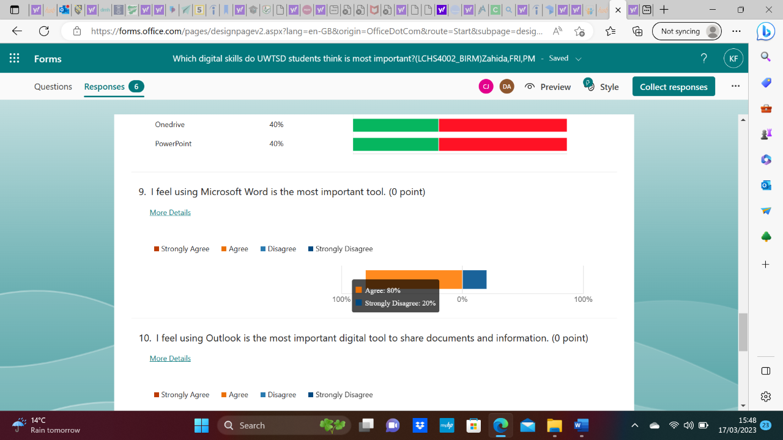

Figure 1 shows 100% participants feel using Microsoft word is the most important digital tool.

I feel using outlook is the most digital tool to share documents and information.

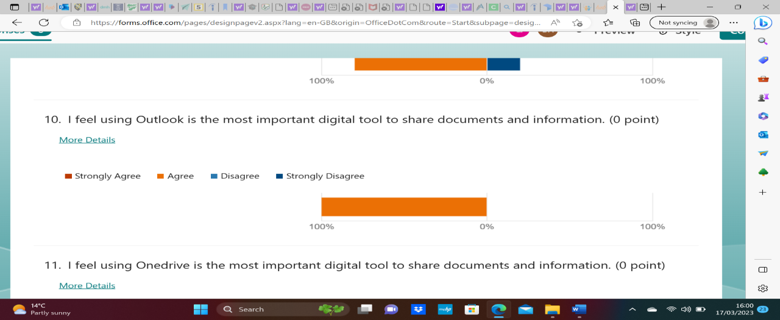

Figure shows 100% believe outlook is the most important digital tool for sharing information and documents.

11. Discussion

According to my research’s section 10 results, all participants in our study granted their agreement to participate voluntarily, with 100% of participants agreeing to complete the questionnaire.
If you look at the survey findings in the appendix, pupils believe that Microsoft word is the most digital tool. Many participants agreed that Microsoft word is the most important digital tool when we questioned them in question 9 using the Likert approach as shown in figure 2 below.
In question 4 we used a closed question format to ask participants if they believed that Microsoft word was the most important digital tool.
Participants were questioned about whether they believed using digital tools had improved their academic according to the results, 83% of participants said they had, while only 17% said they had not. As a result, most participants believe that digital tools have improved their performance. Participants were asked to rank one drive and outlook as the most important digital tools for sharing documents and information, the results show that 16.7% strongly agree, 50% agree, and 33% disagree that one drive is the most crucial digital tool for doing so outlook also received 100% of participants” agreement.
The outcomes match my expectations, and I am pleased with them.

12. References
Bhat, A. (2018). Research Design: Definition, Characteristics and Types. (online). Available at: https://www.questionpro.com/blog/research-design. [accessed 09 March 2023].

Bouchrika, I. (2021). How to Write a Research Question: Types, Steps, and Examples «Guide 2 Research. [online] research.com. Available at: https://research.com/research/how-to-write-a-research-question. [Accessed 9 Mar 2023]

Fleetwood, D. (2018). What is Research- Definition, Types, Methods & Examples.(online) QuestionPro. Available at: https://www.questionpro.com/blog/what-is-research/. [Accessed 09 March 2023]
‌Janssen, J., Stoyanov, S., Ferrari, A., Punie, Y., Pannekeet, K. and Sloep, P. (2013). Experts’ views on digital competence: Commonalities and differences. Computers & Education, 68, pp.473–481. (online). Available at:
https://doi.org/10.1016/j.compedu.2013.06.008. [Accessed 09 March 2023].

Pollfish Resources. (2020). Likert Scale Questions: Definition, Examples and How to Use | Pollfish. (online) Available at: https://resources.pollfish.com/market-research/rating-scales-and-likert-scales/. [Accessed 9 March 2023].
‌Scribbr. (n.d.). What are ethical considerations in research? (online) Available at: https://www.scribbr.co.uk/faqs/what-are-ethical-considerations-in-research/ .[Accessed 11 03 2022].
Survey Sparrow. (2022). 12 Survey Ranking Questions Examples — Definition, Examples. (online) Available at: https://www.surveysparrow.com/blog/ranking-questions-examples/ [Accessed 12 Mar 2023].
‌Team, T.E. (2022). Close-ended questions: Definition, types, examples, and advantages. (online) Delighted. Available at: https://delighted.com/blog/close-ended-questions. [Accessed 12 Mar 2023]

‌ w.mindtools.com. (n.d.). MindTools | Home. (online) Available at: https://www.mindtools.com/ahb9niu/how-to-use-charts-and-graphs-effectively [Accessed 12 Mar 2023]

14.Appendix
This is how our questionnaire look like

1.
Are you happy to complete this survey?
 | Yes | 6
 | No | 0
2.
Do you think using Moodle is the most important digital tool?
 | Yes | 4
 | No | 2
3.
Do you think Outlook is the most important digital tool?
 | Yes | 3
 | No | 3
4.
Do you think using Microsoft Word is the most important digital tool?
 | Yes | 5
 | No | 1
5.
Do you think using OneDrive for sharing documents is the most important digital tool?
 | Yes | 3
 | No | 3
6.
Which digital tool do you use the most to share documents?
0% of respondents (0 of 6) answered this question correctly.
WhatsApp | 33.3%
OneDrive | 33.3%
Outlook | 33.3%
Correct
Incorrect
7.
On a scale of 0-10 do you think Microsoft Teams is an important digital tool to communicate with students and tutors.
Promoters | 2
Passives | 1
Detractors | 3
8.
Which digital tools do you think is the most important in order?
0% of respondents (0 of 5) answered this question correctly.
PowerPoint | 20%
OneDrive | 20%
Moodle | 0%
Word | 40%
Outlook | 40%
Correct
incorrect
9.
I feel using Microsoft Word is the most important tool.
Strongly Agree
Agree
Disagree
Strongly Disagree
10.
I feel using Outlook is the most important digital tool to share documents and information.
Strongly Agree
Agree
Disagree
Strongly Disagree
Agree: 100%
11.
I feel using OneDrive is the most important digital tool to share documents and information.
Strongly Agree
Agree
Disagree
Strongly Disagree
Agree: 50%
12.
Do you feel digital tools have helped you better your performance in your studies?
 | Yes | 5
 | No | 1

‌

‌
‌

‌

