

Student Name- Mihir Sudhirbhai Patel

Student ID-2504998

Module: Business Development Proposal

Module code: LCMB7037

Lecturers Name- Balendran Kanadasamy

PROPOSED TITLE- Evaluating the Feasibility of MediDirect UK: A Digital Medicine-Adherence and Pharmacy Support Service for Patients with Long-Term Health Conditions
Word Count-1095
Term-3

Table of Contents
1. Introduction 3
2. Aim and objectives 3
3. Literature Review 4
4. Methodology 5
5. Preliminary Market Opportunity Assessment 5
6. Limitations 6
7. Timeframe 6
8. Conclusion 6
References 7

1. Introduction
Digital healthcare services are growing in the United Kingdom, and businesses are looking to take advantage of this to enhance the accessibility, convenience and efficiency of healthcare services (Tech UK, 2024). Some patients with chronic diseases will need to be prescribed on a repeat basis and will need to liaise regularly with pharmacists. Difficulties, however, may arise for some patients in attending physical pharmacies, keeping to the drug regime, arranging for the prescription to be picked up and obtaining the necessary healthcare assistance.
MediDirect UK is a planned digital healthcare service designed to bridge the gap between patients and prescription services, pharmacies, medication reminders, and health information in a single easy-to-use online tool. The primary audience would consist of patients at the NHS, those who need to take regular medicines, people with limited mobility, busy professionals and consumers looking for convenient digital health solutions (NHS, 2024).
The envisioned service would be more focused on supporting adherence to the medications, customised reminders, communication with the pharmacist and follow-up support rather than conventional ePharmacies.
The study is intended to test the marketability of the service, gauge the competitive landscape, review operational and regulatory challenges and to suggest implementable recommendations based on facts and figures.

2. Aim and objectives
Aim
1. To evaluate the market feasibility of MediDirect UK by examining customer needs, digital healthcare trends and demand for prescription-management support.
Objectives
The objectives of this research are:
1. To analyse the needs of patients who use repeat prescriptions or require long-term medication support.
2. To examine the level of demand for digital prescription-management, medication-reminder and pharmacy-support services.
3. To review the strengths and weaknesses of key competitors such as Pharmacy2U, LloydsDirect, Boots Online Pharmacy and Healthera.
4. To identify suitable revenue streams, including subscriptions, hourly support, pharmacy partnerships and business-to-business models.
5. To assess key ethical, regulatory and data-protection issues linked to digital healthcare services.
6. To provide recommendations on the future development and implementation of MediDirect UK.
Research Question:
How feasible is the launch of MediDirect UK as a digital medicine-adherence and pharmacy support service for patients with long-term health conditions in the UK?

3. Literature Review
The literature review will provide the theoretical and practical background for the evaluation of MediDirect UK. The first theme will discuss adherence to medications, including the factors contributing to forgetfulness, delay and/or non-adherence of prescribed medications. We will take into account limited understanding, complicated medication routines, mobility issues and poor communication with health professionals.
The second theme will be on the uptake of digital healthcare in the UK. It will consider the development of online pharmacies, e-prescriptions, mobile health apps and technology-supported patient support. The review will reflect on the potential for digital platforms to enhance convenience, as well as issues around trust, access, digital literacy and service quality.
The third theme will focus on digital medication-management interventions, such as reminder systems, pharmacist messaging, tracking and adherence monitoring of prescriptions. The final theme will examine the commercial, legal and regulatory landscape in which digital pharmacy support plays a part. The literature review will uncover gaps in the current services on offer and will assess if better integration of prescription access, reminders and pharmacist communication can offer a viable market opportunity.

4. Methodology
The research will be conducted secondarily with a desk research method. It won't rely on questionnaires, interviews, focus groups, observations or direct contact with patients, pharmacists or others. The project is therefore deemed to be of low ethical risk, and the health and personal information collected by the project will not be personal or identifiable.
Credible published sources such as NHS England, NHS Business Services Authority, Office for National Statistics, UK government publications, Medicines and Healthcare products Regulatory Agency, General Pharmaceutical Council, academic journals, industry reports and publicly available company information will be used to gather data.
A mixed-method of analysis will be used for this study. Healthcare, regulatory and market evidence will be interpreted using content and thematic analysis. Information about market trends, prices, service costs and potential financial outcomes will be presented in numerical form to be compared using descriptive analysis. PESTLE analysis, SWOT analysis, competitor benchmarking, market analysis and financial forecasting will be included in Business frameworks. Evidence will be cross-referenced between government bodies, regulatory bodies, academic and industry evidence to minimise the impact of using outdated information or commercial information.

5. Preliminary Market Opportunity Assessment
A first market opportunity analysis will assess the need for repeat prescription and digital healthcare platforms and medication adherence support. It will test the possible needs of people living with long-term conditions and look to determine the segments of customers who would benefit the most from MediDirect UK.
The service will be benchmarked against Pharmacy2U, LloydsDirect, Boots Online Pharmacy and Healthera. They offer services like ordering prescriptions, home delivery, and referrals to local pharmacies. But MediDirect UK will set itself apart by offering individualised medication reminders, pharmacist communication, adherence support and pharmacy partnerships in one place.
Potential revenue streams will also be explored, such as subscription fees, pharmacy partnership fees and support features. The platform's development, pharmacist availability, integration with prescriptions, and customer support will be evaluated to ensure it meets the operational needs. Additionally, cybersecurity and coordinating medicine delivery will be evaluated. There will be a discussion of the regulatory analysis of the pharmacy standards, healthcare communication responsibilities and data protection requirements.

6. Limitations
All of the research will be based upon secondary evidence and therefore will not provide the patients, pharmacists or providers with direct access to their opinions. Information available to the general public about competitors might not reveal their internal costs, strategies or challenges. The information contained in industry reports can be commercially biased, and healthcare technology and regulation can change rapidly. Financial projections will now, therefore, be based on a best-guess approach and not confirmed business results.

7. Timeframe
The study will take place from July 22nd to September 25th, 2026. Literature collection and market research will be the initial step in the early phase. This will be followed by competitor, regulatory and operational analysis. Later stages will involve financial forecasting, feasibility assessment, recommendations, editing, referencing and submission.

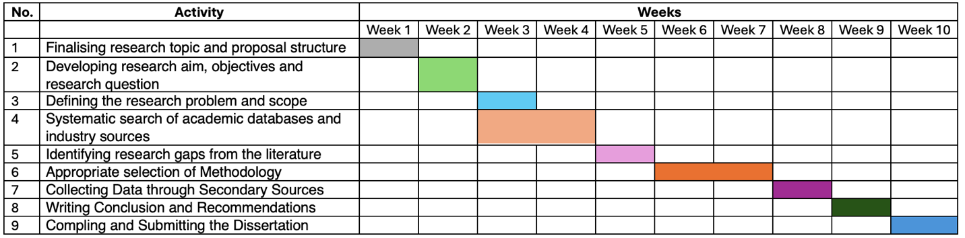

8. Conclusion
The dissertation will assess the commercial viability and operational feasibility of the digital healthcare opportunity that MediDirect UK offers. Will make recommendations on target customers, service design, technology, pharmacy partnerships, pricing, compliance and implementation.

References
NHS., 2024. Delivery plan for recovering access to primary care. [Online]. Available at: https://www.england.nhs.uk/long-read/delivery-plan-for-recovering-access-to-primary-care-2/ [Accessed on: 25/7/2026].
Tech UK., 2024. The Digital Pulse: Transforming UK Healthcare with Cutting-Edge Identity Solutions. [Online]. Available at: https://www.techuk.org/resource/the-digital-pulse-transforming-uk-healthcare-with-cutting-edge-identity-solutions.html [Accessed on: 25/7/2026].

