  LOCATION Swansea | LLEOLIAD abertawe
LEVEL 6 | LEFEL 6
EXAMINATION PERIOD | CYFNOD ARHOLIADAU
May 2017 | Mai 2017

MODULE CODE: M3X8529
Embedded Microcontrollers

Marking Scheme

ANSWER ALL QUESTIONS

QUESTION ONE (35 marks total)
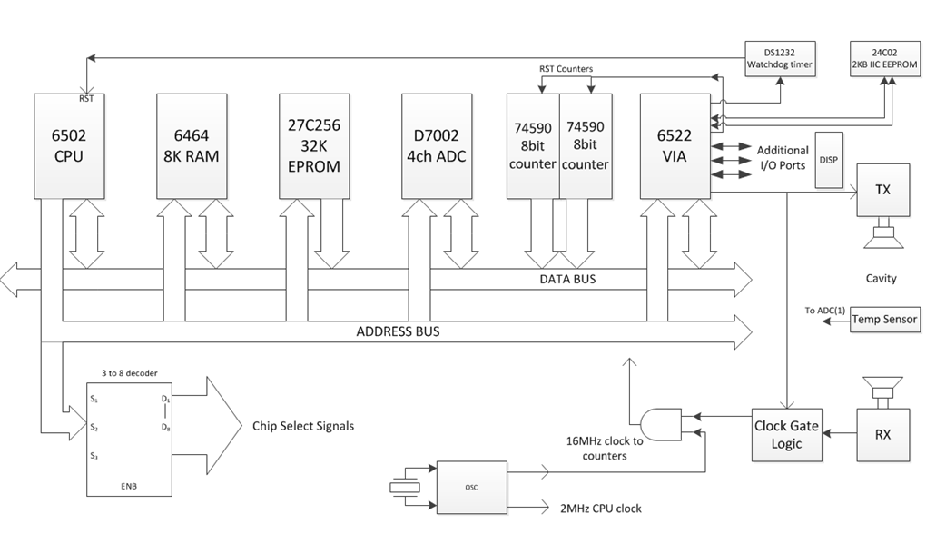

The system diagram above is of one of the case studies covered during the course of the term. It illustrates the design of a microprocessor controlled device that calculates the concentration of Carbon Dioxide in the air, based on time of flight information of an ultrasonic pulse sent through an air cavity but also utilising a compensation value from a temperature sensor.

- What is the purpose of the DS1232 watchdog timer? Explain its fundamental operation, and what needs to be incorporated into the final software code to ensure its intended function operates correctly. (7 marks)
Correct description of chip producing a reset pulse if the CPU locks up – 3marks
1 mark for noting chips like these also produce brownout protection
3 marks for describing the need to insert routines in the software that exercise an i/o pin (in this case, from the VIA chip) that regularly resets the watchdog timer.

- What is the purpose of the 3 to 8 address decoder chip? (3 marks)
3 marks for correct description of how it takes the 3 MSbits and provides 8 discrete enable pins which activate the various chips that are all connected to the busses.

- Given that the 6502 is an 8 bit device with a 16 bit address bus, sketch a typical memory map that one might find when all the devices shown in the circuit diagram are connected as above. Explain your reasoning. (10 marks)
Student to produce a sensible memory map diagram, 64KB in total, showing the basic split of 32KB ROM, 8K RAM etc. (4 marks)
ADC, counters and the VIA would probably be designed to be on 8K boundaries – this needs to be indicated. (2 marks)
Other components should NOT be mapped e.g. the 24C02, as it is an IIC device and clearly driven of i/o pins – 4 marks for general reasoning.

- Imagine you are now given the task of updating the design to try and reduce the overall component count and base as much as possible around as inexpensive an embedded microcontroller. What would be your general considerations and thought processes when deciding on a suitable device? (15 marks)

Students should cover areas such as:
Price.
Suitable number of digital i/o pins
On chip ADC with sufficient resolution
On chip timer circuit that can be stopped by an external trigger.
Timer needs to have sufficient resolution (total bits) and also be able to run at the requires speed (many micros internally divide the timer clocks down)
Built in power monitoring – brownout protection
Built in watchdog timer
Availability and price of a suitable high level language development environment.
Etc. 15 marks total spread amongst the areas.

QUESTION TWO (15 marks total)

- Many complex embedded systems require the use of an RTOS. Explain what is meant when one describes this type of Operating System as ‘Real Time’ , and what are the key characteristics of an RTOS.

Students should stress the predictability of an RTOS – a guaranteed response time. Not necessarily optimised for speed. The ability to be deterministic.
Key Characteristics of an RTOS can be:
Reliability
Predictability
Performance
Compactness
Scalability
15 marks total for an overall well presented answer.

QUESTION THREE (30 marks total)

- What type of system does the PC104 standard define? Produce a brief report explaining what it is and highlighting the general features available to the embedded systems designer.
(10 marks)

Student to describe the basic concept of the PC104 – small stackable PC form factor. With ISO and PCI expansion versions(4 marks)
Features such as the general PC functionality (hard drive support, graphics, I/O etc), (4 marks) plus an overview of the 3rd party interface boards already available (2 marks)

- The following circuit is typical of the type of design that could be employed to interface a custom I/O circuit (which would be located to the Right Hand Side), to the interface of a standard ISA based PC104 system (the Left Hand Side connection pins).
Attempt to reverse engineer the circuit and thus explain its general principle of operation and the function of each Integrated Circuit. (20 marks)

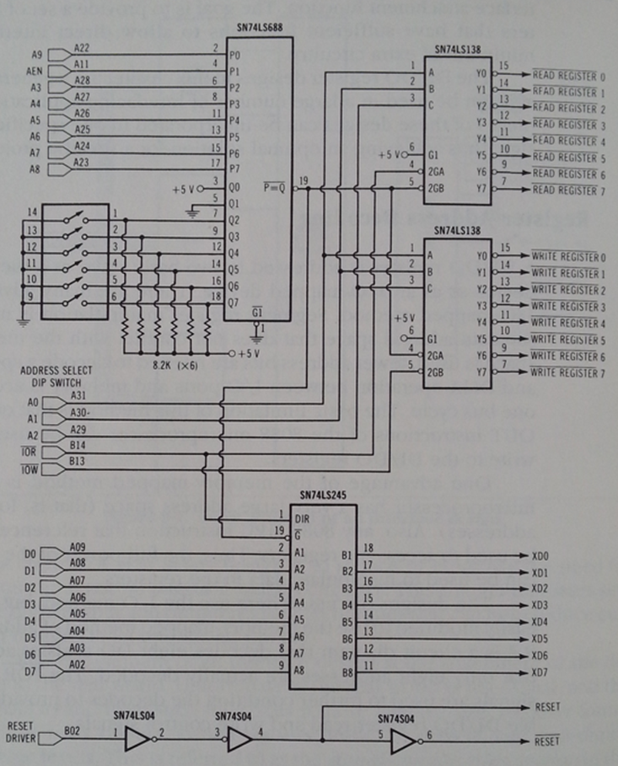

74LS688 as a digital comparator to allow the DIP switches to select which memory bank the expansion card should occupy – when the salient address appears on the relevant address pins, pin19 goes low to enable the resulting chips/tristate buffers. (6 marks)

74LS245 is a tristate, bidirectional buffer. Allows the effective disconnection (to a floating state) of the boards electronics when it is not addresses (output of the 688). When it is addressed, it can buffer and allow the data to flow – direction will be dictated depending on the state of pin 1. (6 marks)

The 74LS138 chips are 3 to 8 decoders, allowing the lower 3 bits to address 1 of 8 registers on the expansion board – effectively providing individual enable pins – also subject to the 138 chip itself being enabled from the 688 and a matching board address being present. (6 marks)

The 7404 contains inverting buffers, used to buffer the Reset signal to ensure a cleanup is performed, it also provides an inverted version for any chips that require that polarity of operation. (2 marks)

QUESTION FOUR (20 marks total)

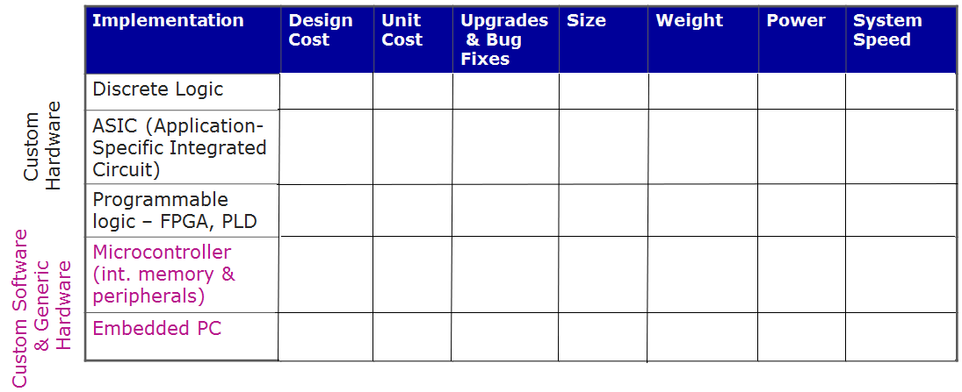

a)
The table above contains a matrix which can be used when trying to decide what approach to use when designing an embedded controller.
Reproduce the table in your answer book, filling in the blank matrix entries. The choices you have at your disposal for each column are:
Design Cost - Low, medium or high
Unit Cost – Very low, mid to low, mid, high
Upgrade & bug fixes – easy or hard
Size – microscopic, small, medium, large
Weight – very low, low, moderate to high, high
Power (consumption) – Variable, low, medium, medium to high
System Speed – slow to moderate, fast, very fast, extremely fast
(15 marks)

b)
For each of the five implementation types, give one example scenario of where you might choose it as the preferable option over the others. (5 marks)

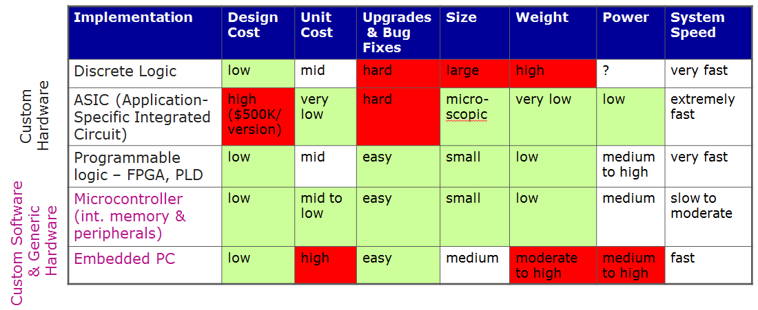

15 marks for the table (approx. 0.5 marks for each correct box)
1 mark each for the 5 implementation types in part b

