Introduction
What is the first 1000 days?
The first 1000 days marks the crucial period from conception to a child's second birthday. During this time the child's brain, body and immune system are rapidly developing (Brodie, 2018, p.12). This displays the importance of nutrition, loving relationships, safety, security, time to play and healthy environments within the child’s early years (Karakochuk et al, 2018, p.3).
When a child’s development progress begins to stagger and fall behind the development of their peers, it increases the possibility that they will fall farther behind in their next years.
Investing in a child's first 1000 days of life lays a strong foundation for lifelong health, positive learning and wellbeing. By investing in this crucial window and implementing positive environments, we can significantly impact a child's physical growth, brain development and overall emotional wellbeing. This will largely influence their future learning opportunities, development and builds a positive foundation for further education and learning opportunities.
There are many potential influences that can restrict the development of children within the early years stage such as, parenting, safeguarding, poverty, staffing, environment and physical health. By following procedures for early interventions, we can minimise the fatal impact of these and provide a positive environment for children to grow and develop.
Why are the first 1000 days fundamental?
The first 1000 days are a fundamental time for children, it sets the framework for their future and generates a positive atmosphere for development. From pregnancy to the age of 2 the brain grows up to 80% capacity. Children's brains discover and learn through connections, each experience impacts their brain. This is done through sound, touch and sight. If these connections are not reciprocated by the primary adults in the child's life, it can be detrimental to the childs mental health, ability to form relationships, creates delays in language development and can reduce capacity for pleasure and a lack of vitality.
Another fundamental factor within the early years development is early interventions. The brain is most adaptable during the early years and is more likely to adapt and learn from their environments. Early intervention can result in the child having better mental health and a higher chance of successful education. Failure to provide effective support can create a disadvantage for the child that is difficult to mold and ‘fix’ in later life, cause systematic delays, health risks and achievement gaps.
Nutrition is a particularly influential factor within the early stages of a childs life. Nutrition can impact a childs growth, health, learning and overall potential. By providing children with nutritious and rich diet, we can assist their physical and mental growth as well as create a structure for positive future habits and overall health. Lack of nutrition can severely impact a childs potential by stunting their growth, depriving the child of necessary antibodies, limiting cognitive capacity and establishing unhealthy habits.

Caregiving
The term caregivers refers to anyone involved in providing a childs consistent care and development. The key caregivers hold a vital role in the shaping of the childs future, health, emotional wellbeing and education.
Exceptional caregiving refers to the practice of providing children in early years with high quality education, child centred care, safety and security, good nutrition, opportunities for play and inclusivity with the aim of supporting their overall development, wellbeing and promoting lifelong learning. This can be done through responding to daily needs, effective body language, modelling behaviour, guided exploration, safe environments, observing and responding, building trust and providing a healthy diet. Effective caregiving allows the child to feel happy, safe, listened to and exited to learn all while supporting and communicating with families and developing relationships.
Good caregiving supports a childs kinaesthetic sense through tummy time, freedom to move, freedom to play, effective resources, monitoring and observing as well as regular health checks (Smith, 2020). This level of caregiving develops a childs lifelong skills in movement and coordination.
By meeting a childs physical and mental needs, providing emotional care, supporting learning and protection, we as caregivers can set them up for survival, lifelong health, strong social skills and great confidence.
Why is caregiving important?
Exceptional caregiving is vital in the first 1000 days of life as the quality of care they receive can determine the quality of their future. The first 1000 days is a great window of opportunity to mold, support and encourage development for young children. The care that children receive has lasting impacts on their future progression, mental and future health, displaying its up most importance.
Exceptional caregiving is important as it promotes healthy brain development and minimises the influence of poor experiences, this ensures that each child can progress positively and is less likely to be impacted by developmental delays, feelings of anxiety or stress, sensory development issues, physical health risks and a need for later intervention (VNS Health, no date).

Another important factor of caregiving is partnerships and relationships. By creating positive, trusting and supportive relationships with parents we are able to bridge a connection between home and education with the aim of improving the childs emotional well-being, generate consistency and empower families. By seeing adults form healthy relationships, it aids the childs ability to manage their emotions and for future healthy relationships.
The ability to provide holistic support through exceptional care is vital in the first 1000 days of life as it nurtures the whole child by focusing on the physical, emotional, social, cognitive and language development. Holistic development encourages curiosity, confidence, independence and self-esteem by providing an inclusive learning environment (Brodie, 2018, p.13). If caregivers fail to provide this level of care and support it can cause life long impacts such as developmental delays, behaviour issues and poor social skills causing a need for later intervention and further support that could have been avoided by early intervention.

Professional partnerships
Professional partnerships can be described as a collaborative professional working relationship created between services, caregivers and early years professionals with the aim of supporting the learning, growth, development and wellbeing of the children who rely sourly on our care.
Families play a irreplaceable role in the early years developmental stages as they are the childs primary educators. Families shape the childs values, beliefs, behaviours, cultural identity and language from a early age (Brodie, 2018, p.216). The childs parents are able to provide the services information about the childs routines, interests, preferences, developmental concerns, emotional triggers and health needs through partnership. This allows for individualised and tailored care, shared strategies for support and a better understanding of the childs likes, dislikes and learning needs (Brodie, 2018, p.218).
Parents, carers, practitioners and professionals are also known as enabling adults as we actively support, nurture and guide young children to explore, learn, develop and socialize. We can enable children for positive growth by communicating through professional partnerships in order to align expectations, approaches and routines for a more structured and organised environment (The education people, 2021).
Partnerships between enabling adults are formed on connections of trust, communication and shared common goals. Professional partnerships may include:
- Early years practitioners
- Parents/carers
- Health care professionals
- Special educational needs coordinators and other specialist services
These professionals and services are required to share information and knowledge with each other, work together to plan and set common goals and have a mutual level of respect, this ensures that the children receive coordinated, inclusive, high quality education that is tailored to their specific needs as a individual.
Working through professional partnerships allows the involved services to make faster connections, make necessary adaptions, provide consistent care and opportunities, share knowledge and understanding, share workloads, consider new and diverse perspectives, improve potential outcomes and supporting families. Professional partnerships ensure that the children and families receive tailored support that is specific to their needs.
Why are professional partnerships vital?
Professional partnerships are very important within the first 1000 days as it improves the process of early intervention. Partnerships allow concerns to be identified and addressed early in order to minimise negative impacts in the future. The combined skills and understanding of professionals, families and practitioners lead to better outcomes and more individualized support. Ultimately this improves long term outcomes, promotes inclusion and brings consistency to the childs levels of support.
Another important reason for professional partnerships is the level of trust and communication with parents. Parents are the childs first educators and are the ones who know them best. Great relationships between professionals and families directly improve the childs development and wellbeing. Good partnerships provide consistency, builds trust and supports early intervention. Failure to build positive relationships can result in a poor understanding of a childs needs, causes delays in addressing concerns, lack of trust and a negative impact on the childs emotional wellbeing.
Professional partnerships are also vital to the early years as it is a large benefit to the childs feelings of security, provides consistent care and routine and the guided support they need to fulfil their lifelong potential. Children learn and make connections through examples, by displaying good relationships and connections to the children we care for, they in turn will imitate this and will generate the ability to bond with others and build meaningful relationships.
Maternal factors have a large impact on the development and growth of a child up until the age of 2. Mothers have a significant influence on the health and wellbeing of their child as they are the childs first primary caregiver and their source for nutrition, communication and safety. There are many maternal factors that can influence the development of a child such as physical health during pregnancy, Poor nutrition, substance abuse and chronic illness can severely impact the child future health generating a risk for premature birth and delayed physical or cognitive development (Gerhardt, 2015, p.17). Another factor is the mother's personal mental health and emotional wellbeing. If she is suffering from postnatal depression, anxiety, stress or bonding difficulties this could cause a critical impact on her childs social development, language skills and emotional regulation (Gerhardt, 2015, p.25). Age and life experience can also be a challenge, young and isolated mothers may suffer with limited support networks and little social life, this can cause reduced confidence, increased stress and difficulty meeting developmental needs (Gerhardt, 2015, p.19).

Challenges faced by early years practitioners in the first 1000 days
Practitioners face many challenges on a daily basis, it is important these challenges are managed and acknowledged to ensure that the quality of care is not impacted. Managing challenges helps us ensure that the level of care provided is still held to a high standard, is kept consistent, is person centred and that the environment is safe for those we care for.
One significant challenge is potential health issues as they can significantly impact the caregivers ability to provide excellent care within their setting due to a potential lack of stamina, emotional resilience, physical restraints and safety concerns. A caregiver's health is strongly linked to the ability they have to provide positive and high standard care. Any health issues have the possibility of impacting the caregivers ability to stay focussed, their responsiveness and ability to maintain the standards of care required. Health restrictions and challenges can be well managed by prioritising personal physical and mental health, attending regular health check-ups, practicing self-care, managing stress and pacing themselves.
Stress and burn out is another influential challenge faced by caregivers as it can significantly impact their overall emotional wellbeing. This could be through depression, emotional exhaustion, detachment or compassion fatigue, this challenges the practitioner's ability to provide emotional and mental support to those in their care. Caregivers may become distant, lack concentration, struggle to problem solve, loose their patience and level of communication. Practitioners can manage these concerns by ensuring they rest regularly, join relevant support groups, use mindfulness techniques and taking regular and scheduled breaks.
Financial insecurity can also pose as a huge challenge faced by caregivers within the early years as it can restrain the caregivers ability to provide exceptional standards of care due to stress, anxiety and fear. When caregivers are burdened by financial strain, their cognitive and emotional ability to meet necessary standards is lowered significantly, this ultimately impacts their ability to make justified decisions, generate a level of consistency and reduces their ability to be empathetic. Solutions for this challenge include, seeking available benefits or grants, using community resources, building a support network and prioritising their well-being.
Another common challenge faced by caregivers in the early years is the lack of support or staffing within a setting. This highly influences the standards of care provided within early years settings as it has a direct impact on the safety, wellbeing, quality of care and overall ability to meet statutory requirements of care. Lack of staff results in higher adult-child ratios, meaning staff will struggle to provide individual attention to the children, will be less responsive and less nurturing. This will reduce the overall ability of staff to observe, plan and support each childs individual needs. Settings with a short staffing are at a higher risk of accidents, missed hazards and safeguarding concerns. This will impact the settings reputation and impact their ability to comply with necessary regulations and welfare requirements. A solution for staff shortages is to improve staff retention and increase the level of training and development they receive. By fostering a nurturing environment for staff, they will ultimately feel more confident in their ability's and overall enjoyment at work.

Activities
Activities in the early years are play based experiences that are designed to support the growth and development of young children (Brodie, 2018, p.109). They support the childs physical, cognitive, language, social and emotional development through engaging and fun experiences. Activities that target physical development will help the child build strength, coordination and motor skills (Duncombe, 2019, p.34). Cognitive development is aided through experiences of memory games, sorting objects and solving puzzles. We develop the childs language through story times, picture books, singing, role play and conversation. Social and emotional development is supported through the building of strong relationships, cooperative play and circle time (Sagastui et al., 2021, p.710). All activities should be inclusive and adaptable to ensure everyone has a opportunity to take part in free play and provides equal opportunities (Knowles, 2018, p.30). These opportunities for activity should be child led, allowing them the choice of participation and freedom to play as they wish (Reggio children, 2022).
Story baskets
Story baskets are containers that are filled with engaging objects that are relevant to elements of your chosen story. This brings the story to life and creates a visual representation for the characters, places, textures or sounds that appear in the story, allowing the children to connect, encourage them to retell the events and create their own narratives. This is a great way to develop a childs vocabulary, encourage conversation, imagination and sensory stimulation.
This type of activity is very inclusive as it can be used with one individual or a small, controlled group, it encourages imaginative play, language development, conversation and stimulating sensory play while strengthening their emotional development. Props such as; small figurines, fabrics, sand, leaves, teddys and other natural items encourage the children to get involved with the story.
Example;
This image shows a prepared story basket containing a book, props for stimulation and is placed in an engaging atmosphere. This story, ‘dear zoo’ follows the story of a child who has been writing letters to the zoo asking for a pet, however each animal they receive is unsuitable, until the zoo finally sends them a puppy.
This is a great example of a story basket as;
- The book is repetitive, simple and catchy – encouraging the children to get involved with the reading and repetitive phrases used
- Displays animal characteristics – to teach and familiarise them with the characters in the story
- Is interactive – allowing the children to feel involved and physically connect with the story while listening
- Uses great vocabulary and introduces adjectives – this can be used to encourage the children to describe other animals or props from the container.
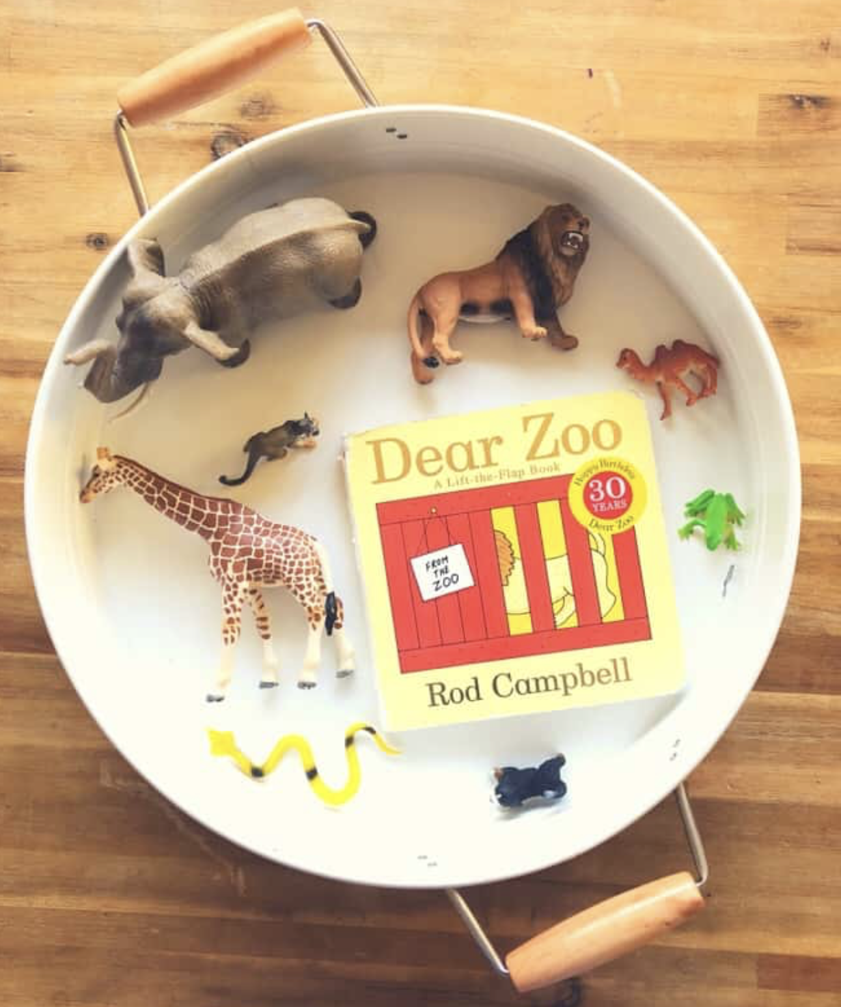 Figure 1: dear zoo story tray (Play inspired mum, 2018)
Obstacle course
An obstacle course is a physical activity designed to encourage the children's coordination, agility and problem-solving skills in a fun, engaging and sequential way while developing their motor skills, body awareness, spatial awareness, memory, focus and creativity. This activity is very sensory rich; children can feel the equipment while hurdling through the course and strengthen their vestibular skills.
Children must run, jump, climb, crawl and balance through a series of challenges to reach the end of the course. Overcoming these challenges will ultimately boost the childs self-esteem, teamwork skills, resilience and imagination.
This activity can be made more engaging by involving the children in the building and setting up of the obstacle course, allowing them to generate a sense of ownership and control, or use themes such as ‘jungle escape’ or ‘water station rescue’ to pair with a harrowing story.
Examples;
This Video shows an engaging obstacle course with challenges well designed for the age and ability levels of the child taking part. The obstacle course is safe for the child, but provides an element of risk and problem solving for them to coordinate themselves around using body awareness.
This is an excellent example of a obstacle course as;
- It encourages the children to problem solve and work as a team
- Provides an appropriate outlet for exercise – children will feel calm and regulated after participation
- Is inclusive for all the children taking part – challenging but accessible for all
- Provides opportunity for sensory stimulation – the comfort of the cushions, the ridges in the wood
- Encourages resilience and emotional regulation – facing a fear or overcoming something they found difficult
Figure 2: Video demonstrating an interactive obstacle course (Lovevery, 2020)
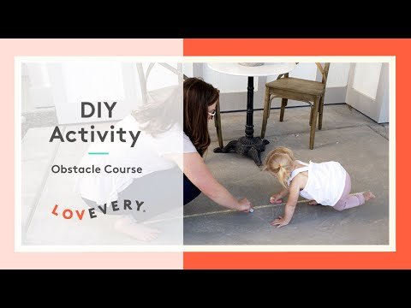

Sensory bin
This is a great opportunity for imaginative and creative learning through child led experiences. This activity is engaging and designed to provide a stimulating environment to promote learning, fine motor skills and language through exploration.
Sensory bins are large containers filled with engaging materials that are designed to heighten the childs senses, creativity and imagination for optimal learning and development. Materials such as rice, pasta, slime, foam, water and shredded paper are great, easy and cheap options for a stimulating environment – By adding tools such as scoops, buckets and small toys, we can further the childs experience and encourage educational play. This activity can be used in a controlled environment or messy free play, themed or simple making it a great and easy resource.
Example;
This picture shows a practitioner setting up a sensory bin during free play, this allows children to come and explore the environment by their own choice and free will (Gascoyne, 2018, p.15). Children can get involved in setting up the activity or choose to just come and play later (Gascoyne, 2018, p.199).
This sensory bin contains plastic bugs, rice and handheld tools all of which are great stimulating materials that will aid the development of the childs brain and enhance their learning experience.
This is a great example as;
- It offers tactile, visual and auditory experiences – the child can feel the bugs, hear the rice falling and see the results
- Provides a calm and regulating environment – children are free to play as they wish and are stimulated
- Promotes child lead learning – children can decide if they would like to participate or not
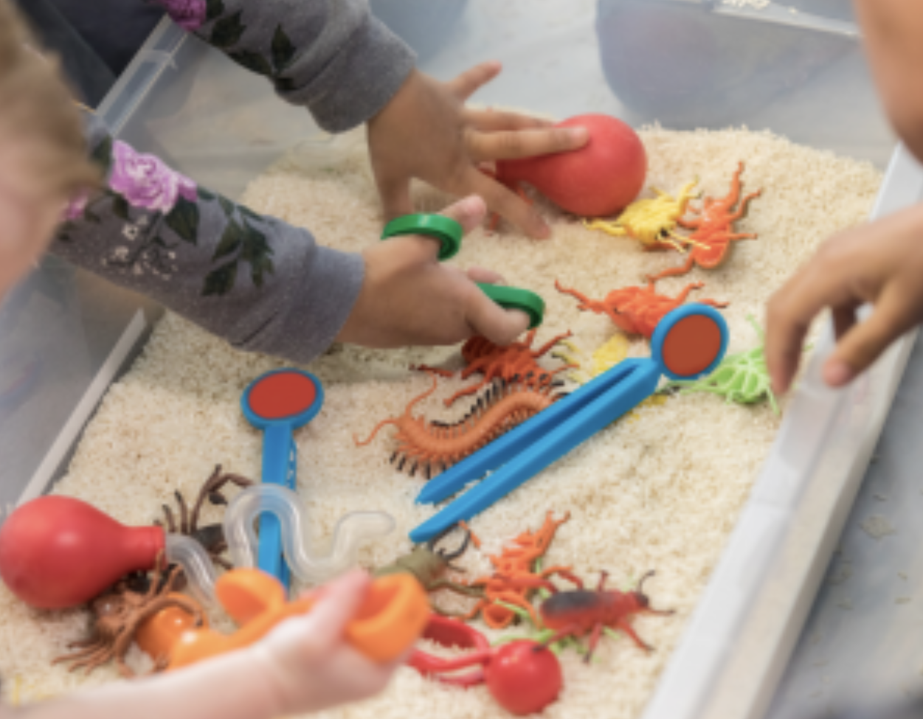 Figure 3: Sensory box filled with toys and tools (NAPA, 2025)

Reference list
- Brodie, K. (2018) The Holistic Care and Development of Children from Birth to Three: An Essential Guide for Students and Practitioners. Routledge.
- Duncombe, R. (2019) The physical development needs of young children. Abingdon, Oxon; New York, NY:, Routledge.
- Gascoyne, S. (2018) Messy play in the early years : supporting learning through material engagements. First edition. Boca Raton, FL : Routledge.
- Gerhardt, S. (2015) Why love matters : how affection shapes a baby’s brain. Second edition. London ; New York :, Routledge Taylor & Francis Group.
- Healthy Texas Kids (2019) Physical Activity Games For Kids: Obstacle Course. Available at: https://www.youtube.com/watch?v=6K2y5twc1FE (Accessed: 13th January 2026)
- Karakochuk, C.D., Whitfield, K.C., Green, T.J. & Kraemer, K. (2018) The biology of the first 1,000 days. 1st edition. Boca Raton: Taylor & Francis.
- Knowles, G. (2018) Supporting inclusive practice and ensuring opportunity is equal for all. 3rd edn. London, England; Routledge.
- NAPA (2025) Sensory Bins for Toddlers: Our Favourite Ideas and Items. Available at: https://napacenter.org/sensory-items/ (Accessed 13th January 2026)
- Play Inspired Mum. (2018) story tray – dear zoo. Available at: https://playinspiredmum.com/story-tray-dear-zoo/#google_vignette (Accessed: 13th January 2026)
- Reggio Children. (2022). ‘Reggio Emelia Approach’. Available at:https://www.reggiochildren.it/en/reggio-emilia-approach/ (Accessed: 13th January 2026)
- Sagastui, J., Herrán, E. and Anguera, M.T. (2021) Adult intervention levels in young children’s free play: an observational study on how Pikler educators combine the instrumental and relational dimensions of their educational activity. Volume 37. European journal of psychology of education.
- Smith, R. (2020). Kinaesthesia and a Feeling for Relations. Review of General Psychology, 24(4), 355368. https://doi.org/10.1177/1089268020930193
- The Education People. (2021). ‘Urie Bronfenbrenner's Ecological Systems Theory’. Available at: https://www.theeducationpeople.org/blog/exploring-pedagogy-introducing-urie-bronfenbrenner/ (Accessed: 13th January 2026)
- Tomco, E. (no date) ‘what is the pikler approach?’ sprout. Available at:https://sprout-kids.com/blogs/sprouting-ideas/what-is-the-pikler-approach?srsltid=AfmBOoplc1k5Go0RFhKt39nXBkArCxXE3ADtBP5foBqNN2Gid9GSECmu (Accessed: 12 January 2026)
- VNS Health (no date). ‘Best Qualities of a Good Caregiver’. Best Qualities of a Good Caregiver - VNS Health

