Jordan Jones
2114985@student.uwtsd.ac.uk
Question
Through your own research, select two existing habitable buildings from around the world, one of Concrete Frame, one of Steel Frame and report on the details of their original design planning, construction method and potential impact in consideration of social and environmental sustainability, at the site of each building.
ACBA4006 – Material Science and Builidng Services
Assignment 1
List of Appendices

Appendix 1: Introduction

Appendix 2: Steel Frame Building

Appendix 3: Concrete Frame Building

Appendix 4: References

Introduction
Within this report I will be evaluating, comparing and contrasting two existing habitable building, one steel frame and one concrete frame. I will use my academic research and own knowledge to report on the original details of their design, the construction methods used and take into consideration the social and environmental impact at the location of the site.

Gorseinon Primary School – Steel Frame Building
Gorseinon Primary School is a Steel Frame Building which was constructed by Andrew Scott Ltd. between June 2019 and August 2020 and was part of the 21st Century Schools scheme. The original design stage for the project started back in 2014 and then was successfully tendered by Andrew Scott as a Design & Build project. Unfortunately, due to the proposed location being a Greenfield site there were several objections by residents to the Planning Application. I have attached an Architectural drawing of the Proposed Location Plan for the Build.
Image 1

The build was going to take up a large proportion of the current Sports Grounds area and there was also a playground/park area that was in a poor state although precious to the local community.

Image 2

This photo was sourced from Google maps and was captured in August 2010, that is just short of nine years prior to the project starting and the playground shown was one of the major constraints as to why the project didn’t start sooner. In 2018, after 4 years of the development being on stop, we retendered the project and with certain additions to our contract, such as relocating the playground and a proposal from Swansea City Council that once the new school was complete and the old school was demolished, they would ensure the land was turned into a greenfield site. This meant planning permission was finally granted and Andrew Scott Ltd could start progressing with the project.
The new proposal was for a Single Storey Building with 2G Synthetic Pitch and Tarmacadam Multi-Use-Games-Area (MUGA) Pitch. Both pitches once constructed would be able to be used by the local community. Below, I have attached the Proposed Site Plan which we based our construction for the project upon.
Image 3

The construction methods of the build, as previously mentioned is a Steel Frame building where the 86.60 tonnes of hot rolled and 14.94 tonnes of cold rolled steel were manufactured in Llanelli, Wales. This meant that with the material coming from just 10miles from site the project was sustainable and kept local labour in work. While, this building was situated in quite an open and expansive area which experienced relatively high winds the fact that is was a low-rise building combined with a steel frame meant it was very durable. Additionally, to ensure the frame isn’t exposed to the elements it’s protected by 12.5mm Siniat GTEC Weather Defence External Sheathing Board which is a highly moisture resistant and non-combustible material, along with a traditional cavity wall construction. This would ensure that the End-User doesn’t have to carry out any maintenance as there should never be any water ingress to the main structure and would’ve been a factor in the design teams thinking when opting for this material. Moreover, a number of other advantages to a steel frame building would include: It is non-combustible and so it makes it easier to achieve the Approved Document B-Fire Safety; The installation of Mechanical, Electrical and other utility services is simplified due to the supports generally being around the main perimeter of the building. Some of the disadvantages of using a steel frame would include: The initially high cost of the material, the aesthetics of the building as they can often look rather rigid and square and finally the cost of fireproofing the steel beams.

In relation to the assembly of the frame for this project, once the material was delivered to site the steels were craned into position and bolted down onto the pad foundations that were designed to suit the size of the beam. Also, there were 600mm wide x 350mm deep strip foundations around the perimeter of the building. This is shown in the below drawing:
Image 4

It took just ten days to have the frame fully erected from the time it arrived to site. This saves a lot of time in the build where there is little room for delay in such tight contract programmes that Main Contractors have to work with in the 21st Century.

Regarding, the future adaptions to this building the current design already allows for an extension that would provide the school with 2 extra classrooms and as this is a steel frame building you would easily be able to bolt onto the existing frame. When designing this project, it was always within the team’s mind to ensure that if ever required the school would be able to increase their pupil capacity quite simply by taking advantage of the steel frame components.

Burj Khalifa - Concrete Frame Building

The Burj Khalifa is a well-known building all around the world and this is probably because it holds the Guinness World Record for being the tallest building on earth. The main contractor on this project was Samsung C&T who are a South Korean based company and are also responsible for the construction of the Petronas Twin Towers and Taipei 101. The Burj Khalifa stands at 828m in the sky and as previously mentioned it is the world’s tallest building.
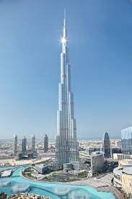
Image 5

The construction of the Burj Khalifa started in January 2004 and the grand opening of the building was six years later in January 2010. According to several sources including the Burj Khalifa website itself there was a total of 330,000 cubic metres of concrete poured and 39,000 of steel rebar used.

Moving onto the durability and climatic resistance, there were around 40 wind tunnel tests carried out to determine the effects that wind would have on the structure. The tests helped research how the building would cope with the Stack effect or chimney effect. These affect high-rise buildings and come through the change in pressure and temperature due to the height these buildings sit in the sky. Additionally, when wind hits buildings it can cause a ‘downdraught effect’ as shown in the below image.
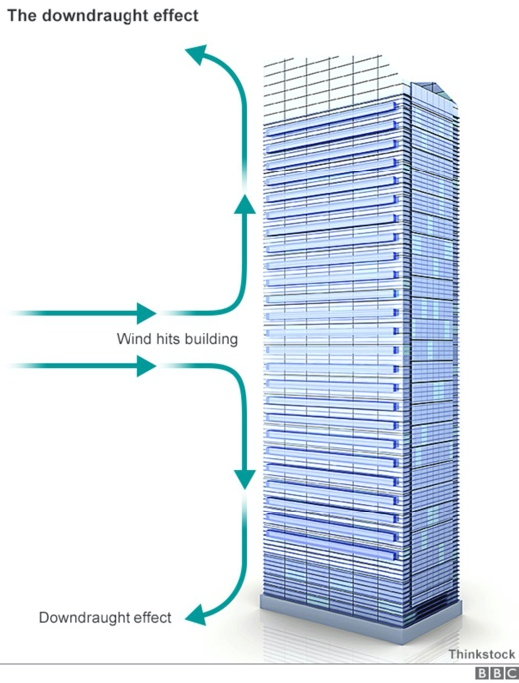
Image 6

As the image shows a building that has completely square corners this wouldn’t be an accurate representation of what happens at the site of the Burj Khalifa and this is because the building has been designed around the wind tunnel tests. The Burj Khalifa designed by Adrian Smith has a ‘Y’ shaped base and due to the building narrowing closer to the core as it progresses higher and higher it reduces the wind forces that act upon the structure. The system that the Burj Khalifa has been designed around is called the ‘Buttressed Core System’ which involves having to use high performance concrete that will guarantee low permeability and high durability. To support the resistance to the wind all three wings are supported by each other through the central core of the building and some corridor walls extent the length of these wings. The walls then thicken towards the perimeter of the building to resist the forces from the wind. There are also concrete columns that are linked to the concrete floor slabs to send the load bearing through the building.
To be able to construct such a tall building the materials used on the Burj Khalifa certainly had to have a high compressive strength. Therefore, C80 and C60 concrete was used and incorporated Portland cement, water, coarse and fine aggregates, fly ash and admixtures such as Elkem Microsilica. Elkem Microsilika claim that their product “is used as a cost-effective means to increase the compressive strength of the concrete mix” while the “triple blend approach to the concrete mix design enables optimum high strength and high durability to be achieved”. Youngs Modulus is a tensile testing exercise and is measured within the Elastic Range of Stress. A reading of 43800N/mm^2 is said to be granted by C80 strength concrete according to ‘The Constructor’. However, while concrete has a very high compressive strength, on its own it has a low tensile strength which is why steel rebar would’ve been used to provide a greater tensile strength. Concrete is the most used material in the world and according to the BBC cement which is used to produce concrete it produces around “8% of the world’s carbon dioxide (C02) emissions. This demonstrates that due to the shear amount of concrete (330,000 cubic metres) that was used to build the Burj Khalifa, it would have had a hugely detrimental effect to the worlds carbon footprint.
When constructing the concrete frame for this project it certainly wasn’t an easy one and due to the size of the building it was never going to be! To pump the C80 and C60 concrete mixtures some of the world’s largest concrete pumps had to be used and they were pumping to height of 600m at any one time. To add to the challenge, because Dubai sees such warm temperatures throughout the day (see the below graph), all the concrete pours had to be carried out during the night to avoid cracks as a result of shrinkage. To prevent shrinkage in the concrete slabs the design team would’ve had to ensure there were construction joints throughout the building as well as movement joints to absorb the expansion and contraction of the surrounding building materials.
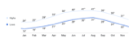
Graph 1 – Source: National Oceanic and Atmospheric Administration (NOAA)

Another admixture used in the concrete mix was in fact ice! This was to again help prevent shrinkage in the mix. Furthermore, due to the temperatures in Dubai retarders such as super plasticizers or gypsum could’ve been used within the mix to slow the rate of curing and ensure the mix stays workable. However, when using these admixtures it is essential that the correct amounts are used otherwise it can decrease the strength of the mix and can be catastrophic on a project of such magnitude.
Within the total life cycle of this building, I do not believe that it would be easy to adapt at all and this is largely down to its complex shape. It is clear to see that the design teams focus has not been to ever extend or adapt the building and the focus was on designing a building that was going to be the tallest in the world for quite some time!

Compare and Contrast – Steel & Concrete Frame Buildings
While in many ways it seems strange to compare and contrast a 7.5-million-pound school in the South Wales region to the other which is a world renown, record breaking tallest building that reportedly cost a whopping £1.1 billion pounds there are many properties in the two buildings that we can. Personally, I believe that the materials used to construct each building were correct for the design intent of each building. While the purpose of concrete used for the structure of the Burj Khalifa is very durable, versatile, and easy to form into the required shapes that makes the building look so unique. The Steel Frame used at Gorseinon Primary School is easily adaptable, reliable and can be constructed quickly and precisely without having to worry about cracks, shrinkage, and creep. With Gorseinon being a low-rise single storey building there was little downward compression with some tensile force due to the large spans of the building and this made for Steel being the perfect material. On the other hand, the Burj Khalifa is an 828m high building which would’ve been exerting very high amounts of compression. So, the only material able to cope with this kind of load bearing is concrete, but also, due to the height of the building and the forces that the wind would be putting on the building they had add steel rebar to give the concrete a higher tensile strength. Additionally, with regards to the Burj Khalifa steel wouldn’t have been the correct material to use as it is far less economical when compared to concrete and it wouldn’t be able to mould into the shapes that had been designed. Finally, to summarise both materials have their advantages and disadvantages and so the design stage is critical to determining which properties you require most to ensure that the building is safe and suitable during and after the construction phase.

References – Research

http://www.secc.co.kr/en/html/biz/building.asp

https://www.burjkhalifa.ae/en/the-tower/facts-figures/

https://www.burjkhalifa.ae/en/the-tower/design-construction/

https://theconstructor.org/structures/structural-details-burj-khalifa-concrete-grade-foundations/20512/

https://www.elkem.com/silicon-products/construction/concrete/high-strength-concrete/

References – Images
Image 1 – Austin-Smith: Lord LLP – L(91)00 A Location Plan
Image 2 – https://www.google.com/maps/@51.6708899,-4.0486672,3a,75y,130.38h,83.15t/data=!3m6!1e1!3m4!1s8pEX1Hzl1ux4x5bhhXNuiQ!2e0!7i13312!8i6656
Image 3 – Austin-Smith: Lord LLP – L(90)001 JJ Proposed Site Plan
Image 4 – Cambria – CAM XX BG GA S 16 002 C4 Foundation Plan
Image 5 – https://www.burjkhalifa.ae/en/the-tower/facts-figures/

Image 6 – https://www.bbc.co.uk/news/magazine-33426889

