INTRO
One of the main benefits of Internet Protocol version 6 (IPv6) over previously used Internet Protocol version 4 (IPv4) is the large address-space that contains (addressing) information to route packets for the next generation Internet.

IPv6 supports 128-bit address space and can potentially support 2^128 or 3.4 x 10^38 unique IP addresses (as opposed to 32-bit address space of IPv4). With this large address-space scheme, IPv6 has the capability to provide unique addresses to each and every device or node attached to the Internet.
The following are the three conventional forms used to represent the IPv6 addresses as text strings:
- Colon-hexadecimal form. This is the preferred form n:n:n:n:n:n:n:n. Each n represents the hexadecimal value of one of the eight 16-bit elements of the address. For example: 3FFE:FFFF:7654:FEDA:1245:BA98:3210:4562.
- Compressed form. Due to the address length, it is common to have addresses containing a long string of zeros. To simplify writing these addresses, use the compressed form, in which a single contiguous sequence of 0 blocks are represented by a double-colon symbol (::). This symbol can appear only once in an address. For example, the multicast address FFED:0:0:0:0:BA98:3210:4562 in compressed form is FFED::BA98:3210:4562. The unicast address 3FFE:FFFF:0:0:8:800:20C4:0 in compressed form is 3FFE:FFFF::8:800:20C4:0. The loopback address 0:0:0:0:0:0:0:1 in compressed form is ::1. The unspecified address 0:0:0:0:0:0:0:0 in compressed form is ::.
- Mixed form. This form combines IPv4 and IPv6 addresses. In this case, the address format is n:n:n:n:n:n:d.d.d.d, where each n represents the hexadecimal values of the six IPv6 high-order 16-bit address elements, and each d represents the decimal value of an IPv4 address.
The leading bits in the address define the specific IPv6 address type. The variable-length field containing these leading bits is called a Format Prefix (FP).
An IPv6 unicast address is divided into two parts. The first part contains the address prefix, and the second part contains the interface identifier. A concise way to express an IPv6 address/prefix combination is as follows: ipv6-address/prefix-length.
The following is an example of an address with a 64-bit prefix.
3FFE:FFFF:0:CD30:0:0:0:0/64.
The prefix in this example is 3FFE:FFFF:0:CD30. The address can also be written in a compressed form, as 3FFE:FFFF:0:CD30::/64.
IPv6 defines the following address types:
- Unicast address. An identifier for a single interface. A packet sent to this address is delivered to the identified interface. The unicast addresses are distinguished from the multicast addresses by the value of the high-order octet. The multicast addresses' high-order octet has the hexadecimal value of FF. Any other value for this octet identifies a unicast address. The following are different types of unicast addresses:
  - Link-local addresses. These addresses are used on a single link and have the following format: FE80::InterfaceID. Link-local addresses are used between nodes on a link for auto-address configuration, neighbor discovery, or when no routers are present. A link-local address is used primarily at startup and when the system has not yet acquired addresses of larger scope.
  - Site-local addresses. These addresses are used on a single site and have the following format: FEC0::SubnetID:InterfaceID. The site-local addresses are used for addressing inside a site without the need for a global prefix.
  - Global IPv6 unicast addresses. These addresses can be used across the Internet and have the following format: 010(FP, 3 bits) TLA ID (13 bits) Reserved (8 bits) NLA ID (24 bits) SLA ID (16 bits) InterfaceID (64 bits).
- Multicast address. An identifier for a set of interfaces (typically belonging to different nodes). A packet sent to this address is delivered to all the interfaces identified by the address. The multicast address types supersede the IPv4 broadcast addresses.
- Anycast address. An identifier for a set of interfaces (typically belonging to different nodes). A packet sent to this address is delivered to only one interface identified by the address. This is the nearest interface as identified by routing metrics. Anycast addresses are taken from the unicast address space and are not syntactically distinguishable. The addressed interface performs the distinction between unicast and anycast addresses as a function of its configuration.
In general, a node always has a link-local address. It might have a site-local address and one or more global addresses.

Dual Stack
Dual-stack migration strategy is to make the transition from the core to the edge. This involves enabling two TCP/IP protocol stacks on the WAN core routers, then perimeter routers and firewalls, then the server-farm routers and finally the desktop access routers. After the network supports IPv6 and IPv4 protocols, the process will enable dual protocol stacks on the servers and then the edge computer systems.

Tunneling
Tunneling introduces carrying one protocol inside another. These tunnels take IPv6 packets and encapsulate them in IPv4 packets to be sent across portions of the network that haven’t yet been upgraded to IPv6. Tunnels can be created where there are IPv6 islands separated by an IPv4 ocean, which will be the norm during the early stages of the transition to IPv6. Later there will be IPv4 islands that will need to be bridged across an IPv6 ocean.

IPv6 for Cisco Software
IPv6, formerly named IPng (next generation), is the latest version of the Internet Protocol (IP). IP is a packet-based protocol used to exchange data, voice, and video traffic over digital networks. IPv6 was proposed when it became clear that the 32-bit addressing scheme of IP version 4 (IPv4) was inadequate to meet the demands of Internet growth. After extensive discussion it was decided to base IPng on IP but add a much larger address space and improvements such as a simplified main header and extension headers. IPv6 is described initially in RFC 2460, Internet Protocol, Version 6 (IPv6) Specification, issued by the Internet Engineering Task Force (IETF). Further RFCs describe the architecture and services supported by IPv6.
The architecture of IPv6 has been designed to allow existing IPv4 users to transition easily to IPv6 while providing services such as end-to-end security, quality of service (QoS), and globally unique addresses. The larger IPv6 address space allows networks to scale and provide global reachability. The simplified IPv6 packet header format handles packets more efficiently. IPv6 prefix aggregation, simplified network renumbering, and IPv6 site multihoming capabilities provide an IPv6 addressing hierarchy that allows for more efficient routing. IPv6 supports widely deployed routing protocols such as Routing Information Protocol (RIP), Integrated Intermediate System-to-Intermediate System (IS-IS), Open Shortest Path First (OSPF) for IPv6, and multiprotocol Border Gateway Protocol (BGP). Other available features include stateless autoconfiguration and an increased number of multicast addresses.

Large IPv6 Address Space for Unique Addresses
The primary motivation for IPv6 is the need to meet the demand for globally unique IP addresses. IPv6 quadruples the number of network address bits from 32 bits (in IPv4) to 128 bits, which provides more than enough globally unique IP addresses for every networked device on the planet. By being globally unique, IPv6 addresses inherently enable global reachability and end-to-end security for networked devices, functionality that is crucial to the applications and services that are driving the demand for the addresses. Additionally, the flexibility of the IPv6 address space reduces the need for private addresses; therefore, IPv6 enables new application protocols that do not require special processing by border devices at the edge of networks.

IPv6 Data Links
In IPv6 networks, a data link is a network sharing a particular link-local prefix. Data links are networks arbitrarily segmented by a network administrator in order to provide a multilevel, hierarchical routing structure while shielding the subnetwork from the addressing complexity of attached networks. The function of a subnetwork in IPv6 is similar to a subnetwork in IPv4. A subnetwork prefix is associated with one data link; multiple subnetwork prefixes may be assigned to the same data link.
The following data links are supported for IPv6: FDDI, Frame Relay PVC, Cisco High-Level Data Link Control (HDLC), PPP over Packet over SONET, ISDN, and serial interfaces.

Dual IPv4 and IPv6 Protocol Stacks
The dual IPv4 and IPv6 protocol stack technique can be used to transition to IPv6. It enables gradual, one-by-one upgrades to applications running on nodes. Applications running on nodes are upgraded to make use of the IPv6 protocol stack. Applications that are not upgraded (for example, they support only the IPv4 protocol stack) can coexist with upgraded applications on a node. New and upgraded applications make use of both the IPv4 and IPv6 protocol stacks (see the figure below).

SPECIAL ADDRESSES IN IPV6
- ::/96 The zero prefix denotes addresses that are compatible with the previously used IPv4 protocol.
- ::/128 An IPv6 address with all zeroes in it is referred to as an unspecified address and is used for addressing purposes within a software.
- ::1/128 This is called the loop back address and is used to refer to the local host. An application sending a packet to this address will get the packet back after it is looped back by the IPv6 stack. The local host address in the IPv4 was 127.0.0.1.2001:db8::/32 This is a documentation prefix allowed in the IPv6. All the examples of IPv6 addresses should ideally use this prefix to indicate that it is an example.
- fec0::/10 This is a site-local prefix offered by IPv6. This address prefix signifies that the address is valid only within the local organization. Subsequently, the usage of this prefix has been discouraged by the RFC.
- fc00::/7 This is called the Unique Local Address (ULA). These addresses are routed only within a set of cooperating sites. These were introduced in the IPv6 to replace the site-local addresses. These addresses also provide a 40-bit pseudorandom number that reduces the risk of address conflicts.
- ff00::/8 This prefix is offered by IPv6 to denote the multicast addresses. Any address carrying this prefix is automatically understood to be a multicast address.
- fe80::/10 This is a link-local prefix offered by IPv6. This address prefix signifies that the address is valid only in the local physical link.

IP addressing scheme:
The first server will be allocated addresses from 172.16.0.0 through 172.16.0.63. The next thing to calculate is which of these addresses are usable and which are reserved for the subnet and broadcast addresses. As the subnet address is the lowest number in the range, it is 172.16.0.0; as the broadcast address is the highest address in the range, it is 172.16.0.63, leaving the addresses from 172.16.0.1 through 172.16.0.62 as usable.
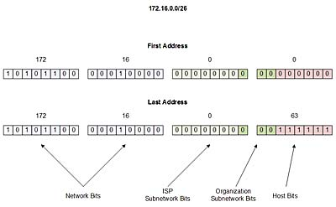

The second subnetwork will begin where the first left off at 172.16.0.64 and go up to 172.16.0.127;
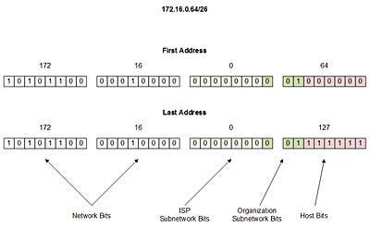
- (DNS) 172.16.0.0—172.16.0.63

The second server will be allocated addresses from 172.16.0.64 through 172.16.0.127. Again, the subnet and broadcast address must be found and reserved. As the subnet address is the lowest number in the range it is 172.16.0.64 and the broadcast address is the highest address in the range it is 172.16.0.127, leaving the addresses from 172.16.0.65 through 172.16.0.126 as usable
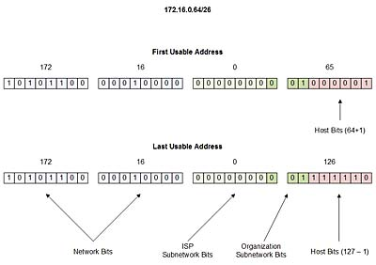
The third subnetwork will begin where the second left off at 172.16.0.128 and go up to 172.16.0.191
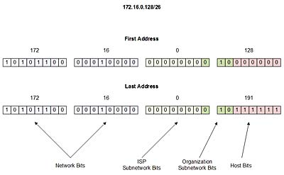
- (Email) 172.16.0.64—172.16.0.127

The third server will be allocated addresses from 172.16.0.128 through 172.16.0.191. The subnet and broadcast address must be found and reserved. As the subnet address is the lowest number in the range, it is 172.16.0.128; as the broadcast address is the highest address in the range, it is 172.16.0.191, leaving the addresses from 172.16.0.129 through 172.16.0.190 as usable.
- (Finance): 172.16.0.128—172.16.0.191
The fourth subnetwork will begin where the third left off at 172.16.0.192 and go up to 172.16.0.255;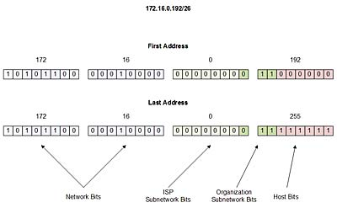

The fourth server will be allocated addresses from 172.16.0.192 through 172.16.0.255. Again, the subnet and broadcast address must be found and reserved. As the subnet address is the lowest number in the range, it is 172.16.0.192; as the broadcast address is the highest address in the range, it is 172.16.0.255, leaving the addresses from 172.16.0.193 through 172.16.0.254 as usable.
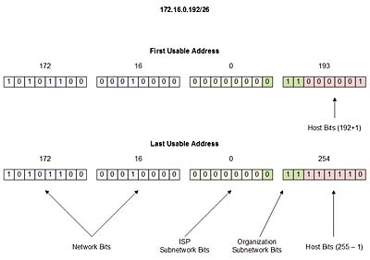

The fifth subnetwork will begin where the fourth left off at 172.16.1.0 and go up to 172.16.1.63;
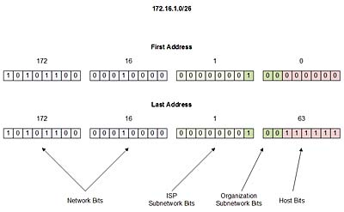
- (Registry): 172.16.0.192—172.16.0.255

The fifth server will be allocated addresses from 172.16.1.0 through 172.16.1.63. The subnet and broadcast address must be found and reserved. As the subnet address is the lowest number in the range, it is 172.16.1.0; as the broadcast address is the highest address in the range, it is 172.16.1.63, leaving the addresses from 172.16.1.1 through 172.16.1.62 as usable.
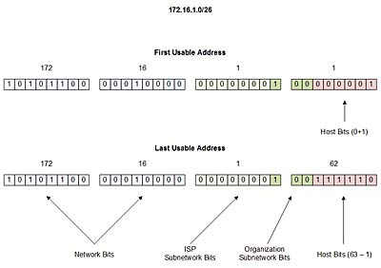
The Sixth subnetwork will begin where the fifth left off at 172.16.1.64 and go up to 172.16.1.127;
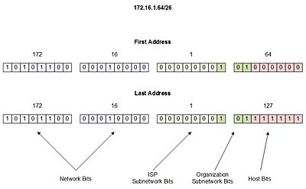

- (File server): 172.16.1.0—172.16.1.63

The sixth department (Internet Technology school) will be allocated addresses from 172.16.1.64 through 172.16.1.127. The subnet and broadcast address must be found and reserved. As the subnet address is the lowest number in the range, it is 172.16.1.64; as the broadcast address is the highest address in the range, it is 172.16.1.127, leaving the addresses from 172.16.1.65 through 172.16.1.126 as usable.
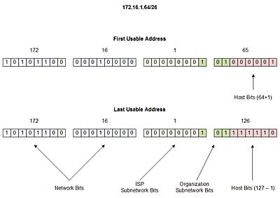

The seventh subnetwork will begin where the sixth left off at 172.16.128 and go up to 172.16.1.191;
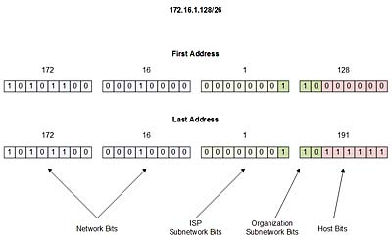
- (Print server): 172.16.1.64—172.16.1.127

