

Student Name: Shingala Dhruv Girishbhai
Student ID: 2530033
Module Name: Strategic Management
Module Code: LCMB7003
Lecturer’s Name: Dr. Ghulam Mujtaba

Term 2
-
Title- Strategic Management Evaluation: A Case of L’Oréal Paris in the United Kingdom
Programme: Master of Business Administration

Contents
Section 1: Strategic Management Report 3
1. Organisational Context and Overview 3
1.1 Company Overview 3
2. External and Internal Analysis 4
2.1 External Factors 4
2.2 Internal Environment 6
2.3 SWOT Analysis 7
3. Comprehensive And Holistic View of the Organisation 9
3.1 Current CSR Strategy 9
3.2 The Balanced Scorecard 11
4. Strategic Choices and Implementation 13
4.1 Available Strategic Choices 13
4.2 Most Suitable Strategy 14
4.3 Potential Challenges and Solutions 15
Conclusion 16
Section 2: Reflection 17
Gibbs Reflective Cycle 17
References 19

Section 1: Strategic Management Report

1. Organisational Context and Overview
Strategic management is one of the most critical components for the success of any organisations. This report is going to focus on analysis of strategic position of the organisation and enhance its competitive advantage for long-term success (Lynch et al., 2024). For this assessment, L’Oréal Paris has been chosen to understand its value proposition and position in the United Kingdom. It is one of the most competitive beauty and cosmetic brand in the globe, which makes it a highly suitable option. United Kingdom is a suitable market choice with rising demand for cosmetics, skincare, and beauty products. L’Oréal Paris has a huge sales and presence in United Kingdom, which makes it a suitable market to evaluate strategic position.
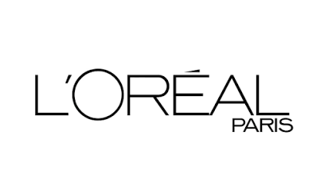
Figure 1: L’Oréal Paris
(Source: L’Oréal Paris, 2026)

1.1 Company Overview
L’Oréal S.A. is a French multinational company that focuses on personal care. L’Oréal Paris is the flagship company of the overall L’Oréal group and one of the leading cosmetics and personal care brands across the globe. It was found in year 1909 by Eugène Schueller, who is a French chemist. It has a strong reputation for high-quality and innovative products at affordable prices. It distributes its products in over 150 countries providing massive loyalty and trust of consumers. L’Oréal Paris focuses on advanced beauty solutions and investment in scientific innovation. It has been in operations since 1932 in the United Kingdom, which has made it one of the longest international markets in the country. It has created a strong brand presence in UK with the strategic partnerships along with online platforms (Fahira & Moh. Djemdjem Djamaludin, 2023). The mission of the company is to provide accessible high-quality products for all. Hence, inclusivity, diversity and environmental responsibility play a key role in the aim of the company. Constant innovation is focused to strengthen its position and create long-term value.

2. External and Internal Analysis

2.1 External Factors
L’Oréal has extensive global operations, and it is one of the most successful companies in beauty and skincare industry. Being its flagship company, L’Oréal Paris has emerged as one of the most dynamic and competitive brands across the beauty and cosmetics sector (Gilbert, 2021). Hence, it is necessary to examine external environment involving sustainability, profitability, and competitive positioning. United Kingdom is characterised by fluctuating consumer preferences and intense competition with evolving regulations. This makes L’Oréal Paris vulnerable to significant opportunities along with potential risks. Hence, the external framework of L’Oréal Paris for the UK market would be analysed with PESTEL framework.
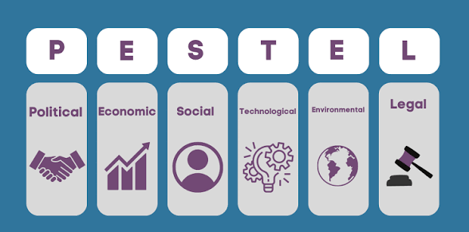
Figure 2: PESTEL Analysis
(Source: James, 2026)
- Political
As a cosmetics business, there are significant conditions which must be adhered about regulations, taxation, and other compliance. There are several laws imposed by European Union which makes it important for the cosmetic brand to upheld strict compliance (Ferreira et al., 2023). This gives rise to increased ethical sourcing and transparency. There are several border checks and customs that need to be fulfilled for transfer of products and raw materials across Europe and UK. However, there is constant support from the UK government to achieve innovation in all the sectors which gives a huge opportunity for L’Oréal Paris to strengthen its position in the country with the help of technological innovation. As the European Union continues to update its laws along with new restrictions for UV filters and cosmetic regulations, there are increased compliances to be met with increased costs.
- Economic
The economy of the country and the global conditions have a huge impact on how global brands work and there is always a constant challenge. L’Oréal Paris has sustained itself through highly challenging times such as the COVID-19. However, there are issues such inflation and living expensive observed in the UK economy, which has resulted in lower spending among consumers (Dekimpe & van Heerde, 2023). Because of this, increased price sensitivity has resulted, and alternatives are preferred than expensive products. As the brand positioning of L’Oréal Paris have been on an affordable side, it has created a beneficial image of good quality products at accessible rates.
- Social
There has been vast increase observed in the demand for cosmetics and skin care across the globe, including the United Kingdom. This has given a major opportunity for L’Oréal Paris to position itself strongly in the minds of the consumers. There has been increasing preference within the UK consumers for skincare and beauty (Turcu et al., 2025). There is opportunity for L’Oréal Paris to target this growing sector. Also, there has been a growth in the trend of adaptability in products for various ethnicities and skin tone. L’Oréal Paris can gain leverage by promoting thoughtful messages for the global community and diversity while innovating its products for it.
- Technological
As L’Oréal Paris is a part of the overall L’Oréal brand, there are significant capital resources which can be used for further innovation. There has been a growing expectation seen among the UK consumers for organic and ethical cosmetic products. Hence, there is a need to invest in effective skin care with research and development for ethical sourcing and sustainability within its products. This can also be used as a major competitive advantage along with investment in emerging technologies such as AI and virtual reality for make up try ons and innovations for consumer engagement with latest technologies.
- Environment
Across the globe, governments are increasingly pressurising companies to ensure minimum carbon emissions with ambitious policies for environmental sustainability. Along with that, the Green Deal by the European Union has strong goals for climate neutrality. This has put increased pressure on L’Oréal Paris to ensure transparency, sustainability, and eco-friendly solutions with innovation. There has been growing trend among the public in the United Kingdom for favouring brands that have genuine regards for sustainability, transparency, and ethical usage (Popa et al., 2025). Hence, this is a challenging aspect. However, it also provides opportunity for a competitive advantage by promoting sustainability and strengthening brand image.
- Legal
There has been changing regulations and compliances within UK for safety standards about cosmetics and beauty products. The industry itself is surrounded with major legal requirements and protection legislations for consumers. Thus, it is important for L’Oréal Paris to ensure regular and compliant policies, transparency, and product safety standards.

2.2 Internal Environment
With the assessment of the external factors of the brand, it has been understood that there are several challenges and opportunities to be addressed for the company. However, to ensure long-term success and understand the strategic position of the company, it is important to critically assess its internal environment for its strengths and weaknesses. This will help to understand how strong brand reputation and competitive advantage can be gained by highlighting strengths and weaknesses by evaluating its capabilities. Hence, VRIO framework will be used for analysing the internal environment of the organisation which will be focusing on four criteria to sustain competitive advantage of the company.
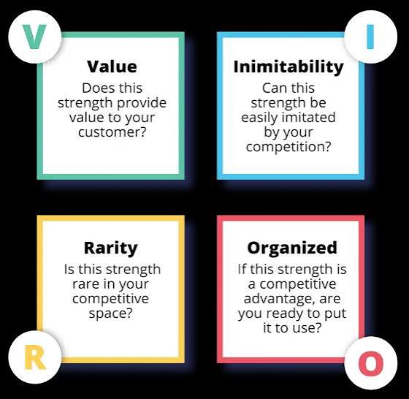
Figure 3: VRIO Analysis
(Source: Appinio, 2026)
- Valuable
These capabilities enable L’Oréal Paris to enhance its effectiveness in the United Kingdom. First and foremost, it has a very strong global presence and network, which is one of its primary competitive advantages. Since it is highly known among the consumers, there is significant local knowledge for about the country to expand its reach (Qin, 2023). From this, it has been understood that there is strong network of the company in the United Kingdom, which gives power to conduct extensive research to understand its competitors, consumers and innovate accordingly. This network helps to widen accessibility of its products across various resources. Also, technological innovation has been focused by the brand that has allowed seamless infrastructure of knowledge sharing and constant improvement internally. These are the valuable resources which has helped the brand to gain its effectiveness in UK. It continuously enables the brand to remain successful with a competitive edge in the market.
- Rare
L’Oréal Paris is a global brand with a strong consumer base in UK. Along with that, it has earned special license, which has provided brand equity in addition to the already established reputation and consumer trust (Shi, 2026). Another rare capability is the intellectual property that helps to sustain creativity and experiment with innovation. As it is positioned as an affordable brand with the image of providing high-quality products, it is an incredibly strong element which has been perceived positively by the consumers.
- Inimitable
L’Oréal Paris is a global brand, and it has core values and beliefs which makes it robust with a highly established brand equity that ensures constant sales and trust of consumers. The brand reputation remains the most inimitable element of the company because of the global presence, and it cannot be achieved by competitors easily or within a brief period. This also caters the specific knowledge that has been attained by the brand about its consumers and target market with vast amount of experience. This helps to accumulate its profits and business reach, which cannot be duplicated by competitors.
- Organisational
There is structure within the L’Oréal Paris, which helps in improved employee performance and success of the organisation. The internal HRM department helps in training activities and career growth opportunities along with focusing on rising issues such as sustainability, ethical sourcing, diversity, and inclusion (Lunt et al., 2018). This promotes goodwill of the brand with local confidence and acceptability of consumers for its practises. There is a supportive leadership retained within the brand with a positive environment, which is transparent and promotes moral values.

2.3 SWOT Analysis
The PESTEL and VRIO framework provided a comprehensive understanding of internal and external environment of the L’Oréal Paris. However, it is important to understand the strategic position and competitive advantages of the organisation to understand its value proposition. SWOT analysis will be conducted to understand the strengths, weaknesses, opportunities, and threats of the brand and determine its ability to retain itself in the market.
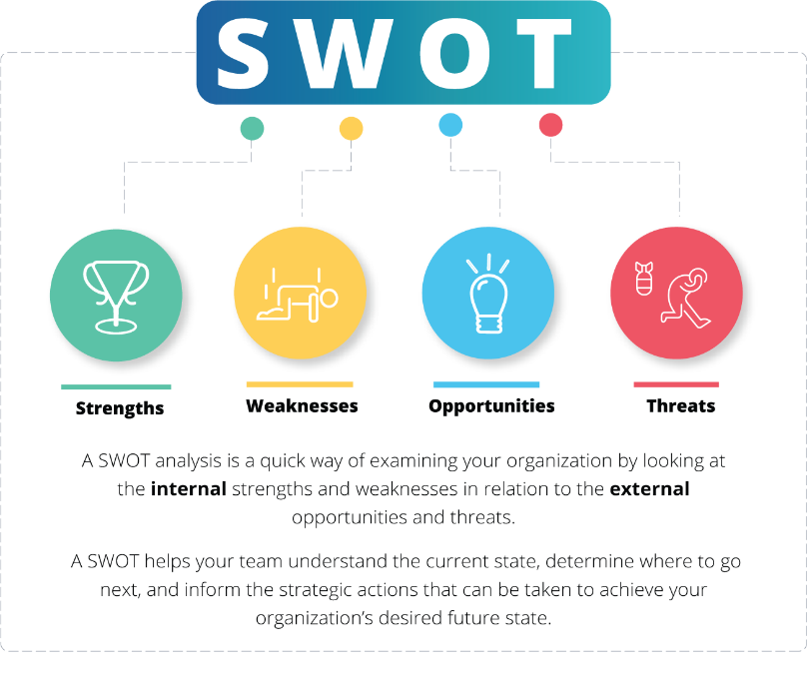
Figure 4: SWOT Analysis
(Source: OnStratergy, 2022)
- Strengths
Increased global presence: L’Oréal Paris is a known name in over 150 countries that has has provided extensive knowledge of the consumers. It has given a sense of reliability among the consumers as it is a positively perceived brand across nations.
Brand reputation and trust: Over the decades, it has provided accessible products with cost effective prices, even when high-quality products were provided. Hence, it established itself as a leading brand for beauty and skin care that attracts new consumers constantly while still retaining the existing ones (Fahira & Moh. Djemdjem Djamaludin, 2023).
Substantial financial resources: As a global brand, it has strong financial backing and capabilities to constantly innovate and promote initiatives towards emerging trends such as sustainability and ethical sources. This provides resilience during difficult periods of uncertainty for long-term sustainability. This also helps in constant research and development to support innovation and meet the trending expectations of the consumers.
- Weaknesses
Intense competition: While it is one of the highly established beauty and cosmetic brand, it faces intense competition with other established and emerging brands such as Unilever, Proctor and Gamble and Estee Lauder products (Monika et al., 2025). Unilever and Procter & Gamble are highly accessible, affordable, and household products that give major competition to conserve the competitive advantage for L’Oréal Paris. On the other hand, companies like Estee Lauder are highly trending and appealing to new consumers, which provide a different sort of competition.
Global supply chain dependency: As the supply chain of L’areal Paris is highly dependent, it poses risks of disruptions that will have an impact over the availability of raw materials and transportation networks. It also leads to higher chances of disruption and instability because of the geopolitical uncertainties.
- Opportunities
Rising demand of skincare and beauty products: In UK and the overall globe, there has been increasing preference for self-care, well-being, cosmetics, and beauty products. The constant rise in demand highlights a trend that innovations are acceptable within the new generations for cosmetics, beauty, and skin care. This gives a beneficial opportunity for L’Oréal Paris to expand its portfolio for high growth categories and innovative and science-based products that will help future growth.
Growth of e-commerce: With constant innovation and investment in digital marketing, higher sales can be generated online with personalised experiences, loyalty programmes, and consumer engagement with social media. It reduces investments and reliability in retail channels. This will help to create a strong brand image with increased accessibility for consumers (Mustika & Wahyudi, 2022). Additionally, e-commerce platforms provide a reliable resource to expand the reach of products.
- Threats
Fluctuating consumer preferences: As new trends come and go very quickly, it has a massive impact on consumer preferences. In today’s time, everyone is seeking for new products, and the preferences are evolving constantly. It becomes difficult to stay in tune with these changing expectations and trends. Hence, constant investment in research and innovation in the market is needed to respond quickly
Economic and regulatory uncertainty: A significant threat is imposed because of rising inflation in the United Kingdom that has reduced consumer spending levels and other more affordable alternatives are preferred. This may affect sales growth and requires strategic decisions over the target market and affordability. Along with that strict regulations have been imposed in the skincare and beauty industry by the European Union about transparency, product safety, environment reporting, and packaging, which requires additional costs and scrutiny for compliance (Monika et al., 2025).

3. Comprehensive And Holistic View of the Organisation

3.1 Current CSR Strategy
L’Oréal Paris has expressed that environmental responsibility is one of the key goals of the business. This makes it essential to understand how it strives being a responsible business in today’s time. Corporate social responsibility is the major aspect to understand philanthropic, environmental, and social responsibility of an organisation and its overall strategy. With successful CSR strategies, there is strengthened competitive advantage, long-term sustainable growth, and brand reputation. Ambitious commitment, policies, and initiatives are adapted by the L’Oréal group with responsible business practises. Triple Bottom Line framework will be used to understand the effectiveness of CSR strategy of L’Oréal Paris (Hussain et al., 2016). It is an accounting framework that analyses three dimensions of sustainability to measure the performance and responsibility of the company towards the society.
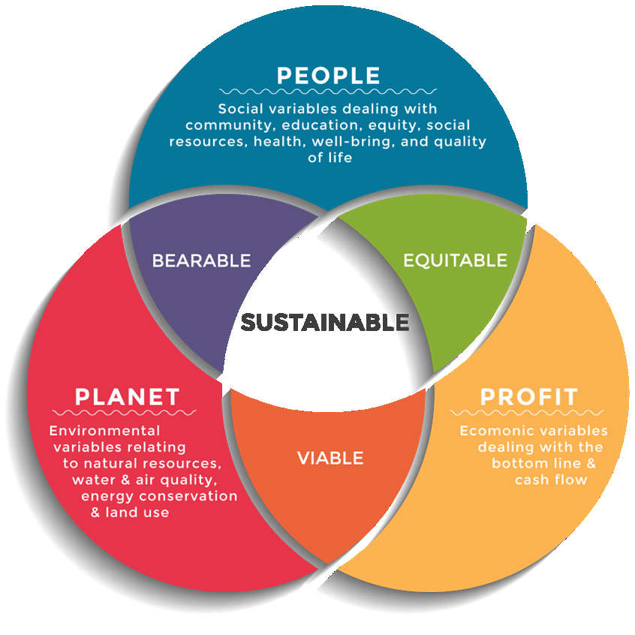
Figure 5: Triple Bottom Line
(Source: Dalibozhko & Krakovetskaya, 2018)
- People
This dimension highlights the social impact created by the organisation across various stakeholders that include employees, consumers, suppliers, shareholders, and other wider communities. Social responsibility is highly prioritised by the brand with various programmes for leadership, future growth, and education. Various resources have been provided for women who are stuck in vulnerable positions that helps them to focus on future development (Sánchez-Labella Martín et al., 2024). Philanthropic efforts are focused by the company with diversity and inclusion commitments, and innovation with inclusive beauty products with thoughtful messaging and advertising campaigns for facilitating various ethnic grounds.
- Planet
This dimension focuses on the degree of environment impact made by the organisation and concerns raised with it. The L’Oréal group has is focused on improving its responsibility towards the environment and promoting initiatives for sustainability programmes and measurable targets for reducing carbon emissions. L’Oréal Paris has implemented various initiatives closely with the business goals of the overall group to reduce greenhouse gas emissions (Zielińska-Chmielewska et al., 2025). Furthermore, the company implements circular packaging solutions to ensure recycling is encouraged and plastic waste is minimised. It has worked with natural ingredients and ensuring responsible sourcing of materials to protect biodiversity and improve responsible practices with transparency.
- Profit
This element of the triple bottom line focuses on the value created in terms of finance. However, it suggests that profit making should not be the only purpose of the company, it should also focus on social and economic goals along with economic ones. Considering these aspects, CSR commitments have been integrated into the brand strategy by L’Oréal Paris to ensure responsible business practices (Popa et al., 2025). It has become one of the core pillars of the operations of the L’Oréal group as well. There has been commitment for embedding sustainability into operations that will help in innovation and research for ensuring sustainable practises with eco-efficient products. This is helped in strengthening brand reputation and attracting new consumers who seek sustainability. Evolving expectations are met with new commitment towards CSR that has helped in constant innovation. As strong ESG principles are adopted by L’Oréal Paris, it benefits financially as they are backed by investors who value responsible governance.

3.2 The Balanced Scorecard
The Balanced Scorecard is a strategic framework that was introduced by Robert S. Kaplan and David P. Norton in 1992. It is an emerging model that focuses on financial as well as non-financial aspects of the business that provides a comprehensive understanding of the performance of an organisation. With the use of this framework, it would be helpful to understand the strategic position and value preposition of L’Oréal Paris in the United Kingdom.
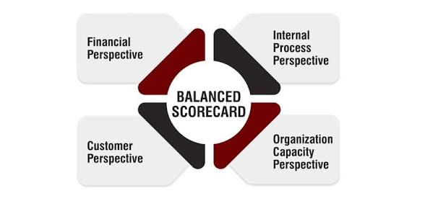
Figure 6: The Balanced Scorecard
(Source: Investopedia, 2020)
Financial perspective
This element would analyse long-term profitability of the organisation through its performance (Yawson & Paros, 2023). The key performance indicator for this segment is going to be the financial outcome of L’Oréal Paris. The financial objective of the company remains to ensure stable increase in the revenue and market share of the company in the United Kingdom. This ensures constant support for product innovation, marketing, and sales channels to deal with competition. The other objective is to improve profitability with the help of strategic investment and optimised resource utilisation. L’Oréal Paris recorded 3.5% growth in terms of revenue. Similar targets are maintained by the company for this year as well. Thus, return on investment KPI is useful to assess profit margins and product cost per unit that will determine how targets are achieved.
Consumer perspective
This segment is going to assess value created by the company for consumers. The major objective of the L’Oréal Paris is to assure constantly increasing consumers satisfaction across all products to boost loyalty. Hence, high-quality products are provided at affordable prices, and the company is leaning towards scientifically based products. The key performance indicator which will be helpful to assess this perspective is net promoter score, which will analyse retention rates of the consumers and repeat purchases to understand if target satisfaction levels are achieved (Radhi et al., 2024).
Business process perspective
For L’Oréal Paris effectiveness in United Kingdom, internal business process will be assessed to determine how operational effectiveness support the goals of the organisation. The foremost objective of the company is innovation to meet rapidly evolving expectations of consumers and respond to trends. The key performance indicator will be assessment of successful products launched each year along with the revenue generated and reviews given by the consumers. A secondary objective is to enhance resilience in the supply chain to ensure product availability and accessibility with different logistics partners. Hence, the KPI of inventory turnover and order fulfilment rates would be used to understand if operational performance is successful.
Organisational perspective
This segment focuses on various factors, including innovation, research and development, technology, and other capabilities. L’Oréal Paris aims to train employees and develop their knowledge to increase capabilities for responding to changing market dynamics. This will enable effective adaptation for emerging trends, technology, and sustainability challenges. The company also aims to improve its innovation capabilities with scientifically advanced products that will be relevant in today’s time (Bag & Mandal, 2025).. Hence, the KPI of employee engagement and retention rates are useful to assess employee perception and acceptance towards training skills. Secondly, return on investment KPI will be used to assess profitability from innovation programmes and new products.

4. Strategic Choices and Implementation

4.1 Available Strategic Choices
There will be a comprehensive discussion over business level strategy that are available for L’Oréal Paris to strengthen its strategic position and value proposition in the United Kingdom. This will help to answer rapidly evolving preferences and trends with increasing demand for sustainability among consumers. Porters’s Generic Strategic Choices approach will be utilised that focuses on various aspects of the business to understand suitable strategies for long-term sustainability.
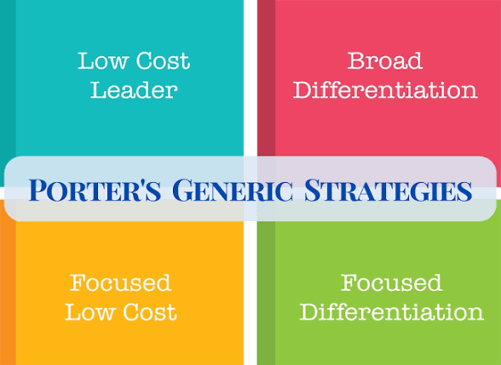
Figure 7: Porter’s Generic Strategies
(Source: Jurevicius, 2025)
- Cost leadership
Under this strategy, L’Oréal Paris should aim to gain a competitive advantage by preserving competitive prices even though high-quality products are provided. This requires strengthening global supply chain that helps in effective cost controls, and economy of scale to provide mass market product portfolio across the United Kingdom (Bhat et al., 2024). The cost leadership will help L’Oréal Paris to retain the brand image around affordable high-quality products while expanding the scalability.
- Differentiation strategy
Under this aspect, L’Oréal Paris should focus to differentiate itself from competitors within the United Kingdom. As discussed before, affordable household brands, such as Proctor and Gamble, and Unilever imposes certain threats along with Estee Lauder and similar high-end companies that are trending. Hence, the current positioning of the brand needs to be amplified with innovative and accessible beauty products that meets the trends (Xiong, 2024). Thus, scientific based skincare formulations and cosmetics products should be focused that will provide product differentiation from other competitors.
- A focus strategy
This strategy suggests that products should be tailored according to the unique needs of the market. While L’Oréal Paris believes to create a global image for its products and brand image, in today’s time, United Kingdom consumers and European Union regulations have made it important to ensure sustainability and ethical usage within cosmetic brands. The new trends require business to reflect upon its transparency and promote sustainability, ethics, innovation and inclusivity (Sedita et al., 2021). Hence, instead of focusing on a narrow consumer segment, L’Oréal Paris can focus its future differentiation for to fulfil consumer expectations, such as scientific based products, innovation, trending products and sustainability in its strategy that will help to boost the market reach in the United Kingdom.

4.2 Most Suitable Strategy
With the evaluation of the available strategic choices of the organisation, the most appropriate strategy at business level is the differentiation strategy. Differentiation strategy can provide a competitive advantage to the brand if it focuses on innovation and research and development to leverage the trust and loyalty of the consumers to provide value holding products. There is a huge opportunity for L’Oréal Paris to innovate products that will help the current challenges faced by the people about skincare, well-being, and beauty by experimenting risky products. As it has achieved a global image that can be leveraged to differentiate through higher value product collections while sustaining the identity of the brand. This will provide a huge advantage to meet the needs of the consumers while also providing traditional products of the brand. The Ansoff Matrix will be used to justify the how differentiation strategy is most suitable for L’Oréal Paris
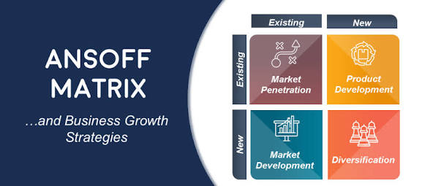
Figure 8: The Ansoff Matrix
(Source: Hanlon, 2021)
Market penetration
If L’Oréal Paris adopts differentiation strategy, it can leverage the visibility and accessibility of its product with completing prices, loyalty programmes, social media, and beauty influences to create awareness of the products (Yannopoulou, 2026). This will give a differentiated positioning and reinforce the image of the brand into new age innovation.
Market development
L’Oréal Paris can look forward to research and development to develop products that are new in the market but provide something meaningful to the consumers. This also gives opportunities to shift towards premium pricing if innovation fulfils trends and expectations of consumers (Choi, 2022). Differentiation strategy suggest that the market in today’s time is adaptable to new research-based products which can be highly sought from consumers.
Product development
It has been understood that the GenZ consumers or the new age consumers in the United Kingdom prefer scientific based and effective products. However, there is a high demand for affordable products that are also dermatologist approved are eco-friendly (Sagastume-Canova & Fernández-Guarino, 2026). This highlights that product development can adopt differentiation strategy to fulfil these demands within skincare and beauty.
Diversification
Diversification can help in increased profitability for the company. However, significant investment is required. Therefore, company should focus on extensive research and development of consumers in the United Kingdom and focus on pain points and expectations to provide products that aligns with the brand identity while developing innovative products.

4.3 Potential Challenges and Solutions
- Significant initial costs: Differentiation and product innovation requires excessive cost to develop differentiating products with a risk of unsuccessful results.
Hence, a phased investment approach is needed for differentiation strategy along with extensive research and development of UK market and consumer needs to reduce risk.
- Rapid fluctuation in consumer preferences: It requires significant time to develop products and differentiate itself in the market (Jovanka & Kinkin, 2024). However, today’s lifestyle is evolvong constantly with trends and social media influencing personal preferences. Hence, there is a risk if products become less relevant even during a short span of time.
To overcome this challenge, the use of emerging technology such as artificial intelligence and real time consumer analytics. It will help to constantly analyse purchasing behaviour and forecast future trends nog just focus on the present ones.
- Intense competition: Every competitor is looking forward to focus on differentiation, competitive advantage and fulfil market trends. Hence, innovation is the backbone of each competitor and there might be competitive pricing strategies as well.
For this issue, L’Oréal Palace needs to focus on constant innovation, research and development, personalisation, and sustainability elements to differentiate itself and maintain strategic position in the United Kingdom (Zakwan Fadil Bakri, 2023).

Conclusion
From this report, it has been concluded that there are significant opportunities and strategic choices available for L’Oréal Paris to expand its value proposition in the United Kingdom. The external and internal environment suggests that L’Oréal Paris is a strong global brand that can deal with threats and challenges. However, there are strict regulations and requirements in the industry to focus on sustainability. This can provide a competitive edge and differentiation to the company. Thus, it should focus on CSR and sustainability initiatives. Differentiation is the strongest business level strategic choice to meet the consumer expectations within UK and other countries as well with constant innovation, research and development and technological adaption to deal with challenges.

Section 2: Reflection
Throughout this report, I have evaluated various aspects of the L’Oréal brand and its operations that has given me critical insights into a global brand. Hence, to reflect on my experience, I am going to use Gibb’s reflective cycle to evaluate my learning experience.

Gibbs Reflective Cycle
Description
In this report, I selected L’Oréal Paris for my assessment and its operations across the United Kingdom. I focused on analysing its strategic position and value proposition by examining external and internal environment to understand threats and challenges (Galli & New, 2022). This gave me wide scope of analysis, concepts, theories, and competitive environment. Hence, I gathered information from various sources that can support my analysis, and I understood various trends, aspects, and dynamics of the UK market. With evaluation of operations, internal and external environment of the company, I understood critical aspects of a global brand.
Feelings
During the assignment, I felt overwhelmed with success of research, but there were certain times where I lacked focus. The selection of L’Oréal Paris made me confident because of the availability of information. I became engaged with my research and gained more understanding of various theories and frameworks that refined my analytical and research skills. I felt positive and an eager to complete this assessment as I collected credible evidence to evaluate diverse options. A powerful sense of achievement was felt when I fulfilled this assignment with critical thinking and newfound skills.
Evaluation
This assessment was a highly valuable experience that gave me numerous opportunities. I was able to conduct this research within time and manage my priorities for this task, personal activities, and studies. It was difficult for me to manage my time and focus on important tasks. With this task, I improved my time management skills (Alvarez Sainz et al., 2019). I was able to successfully apply learnt frameworks in this assessment which refined my analytical thinking skills. Good organisational and stress management skills were showcased by me as there was certain times where I was anxious about researching and ensuring effectiveness in the report. However, I focused on patience and consistency instead of stressing and delaying my work.
Analysis
While I completed this assessment successfully and I was satisfied with the results, there were certain challenges which requires my attention. I struggled with self confidence even though I had performed extensive research to ensure most relevant data and facts. I was constantly seeking reassurance over focusing my own judgement (Axelrod, 2016). I was not confident in myself, because of which more time was allocated to tasks than necessary. While I was able to collect vast amount of data and reports to strengthen my report, it was difficult for me to interpret and analyse the data and understand quantitative information. I need to improve data analysis skills to understand reliable sources of information effectively. Lastly, I understood that I have a tendency of indecisiveness where I cannot choose between multiple options, and I require someone to push me or advise me for it. This limits my understanding and ability to handle complex situations.
Conclusion
With this reflection, I was able to assess my strengths and weaknesses. This assessment has been one of the most vital learning experiences for me and it has developed highly relevant skills that could help my future goals. This assessment and reflection contributed to my academic development, and I will use it for my professional growth. I seek continues improvement by addressing my weaknesses and incorporating practices to overcome them.
Action plan
As per my reflection on the overall experience from this assessment, I understood my weaknesses. I look forward to creating an accurate plan to address and strengthen my weaknesses. Firstly, I will focus on improving self-confidence and not question my decisions. I need to take part in discussions and present my ideas openly without fear of judgements that will gradually improve confidence (Smith, 2025). I look forward to improving my data analysis skills for which I am going to join online learning platforms to interpret difficult reports and industry data. This will align with my analytical skills and support future professional endeavours. Lastly, I will focus on overcoming indecisiveness tendency and focus on evidence-based approach to have confidence in my decision-making abilities. I will not spend more than necessary time to over analyse every alternative. Instead, I will focus on reliable facts and my own analytical abilities to select the best solution. I aim to refine decision-making skills by understanding business case studies and asking for my seniors to provide feedback.

References
Alvarez Sainz, M., Ferrero, A.M. and Ugidos, A. (2019) ‘Time Management: Skills to learn and put into practice’, Education + Training, 61(5), pp. 635–648. doi:10.1108/et-01-2018-0027.
Appinio (2026) VRIO framework: Definition, analysis, examples | appinio blog. Available at: https://www.appinio.com/en/blog/market-research/vrio-framework (Accessed: 26 July 2026).
Axelrod, R.H. (2016) ‘Leadership and self-confidence’, Springer Texts in Business and Economics, pp. 297–313. doi:10.1007/978-3-319-31036-7_17.
Bag, S. and Mandal, K. (2025) Augmented reality impacts on consumer behaviour in beauty and personal care: Pre-purchase immersion and post-purchase engagement [Preprint]. doi:10.2139/ssrn.5134416.
Bhat, M., Agrawal, A. and Barmpas, M.V. (2024) ‘Differentiation, cost leadership, or ending up in the middle? A reflection on the viability of Porter’s generic strategies through a case study comparison of McDonalds and Starbucks’, Athens Journal of Business &amp; Economics, 10(3), pp. 217–238. doi:10.30958/ajbe.10-3-3.
Choi, E. (2022) ‘A paradigm shift in beauty education in response to the Digital Transformation ERA -based on analysis of trends in the cosmetics and beauty industry-’, Journal of the Korean Society of Cosmetology, 28(4), pp. 675–688. doi:10.52660/jksc.2022.28.4.675.
Dalibozhko, A. and Krakovetskaya, I. (2018) ‘Youth entrepreneurial projects for the Sustainable Development of Global Community: Evidence from Enactus Program’, SHS Web of Conferences, 57, p. 01009. doi:10.1051/shsconf/20185701009.
Dekimpe, M.G. and van Heerde, H.J. (2023) ‘Retailing in times of soaring inflation: What we know, what we don’t know, and a research agenda’, Journal of Retailing, 99(3), pp. 322–336. doi:10.1016/j.jretai.2023.07.002.
Fahira, A. and Moh. Djemdjem Djamaludin (2023) ‘The influence of Brand Trust and satisfaction towards consumer loyalty of a local cosmetic products brand X among generation Z’, Journal of Consumer Sciences, 8(1), pp. 27–44. doi:10.29244/jcs.8.1.27-44.
Ferreira, L. et al. (2023) ‘Nanomaterials in Cosmetics: An outlook for European regulatory requirements and a step forward in sustainability’, Cosmetics, 10(2), p. 53. doi:10.3390/cosmetics10020053.
Galli, F. and New, C.J. (2022) ‘Gibbs’ Cycle Review. emotions as a part of the cycle’, e-Motion: Revista de Educación, Motricidad e Investigación [Preprint], (19). doi:10.33776/remo.vi19.7224.
Gilbert, J. (2021) ‘How l’oréal adopted new technologies to scale personalisation, adapt to new customer demands and evolve into the Top Beauty Tech Company’, Journal of Digital &amp; Social Media Marketing, 9(2), p. 102. doi:10.69554/jyiz2460.
Hanlon, A. (2021) The ansoff model [marketing strategy matrix] | smart insights. Available at: https://www.smartinsights.com/marketing-planning/create-a-marketing-plan/ansoff-model/ (Accessed: 27 July 2026).
Hussain, N., Rigoni, U. and Orij, R.P. (2016) ‘Corporate governance and sustainability performance: Analysis of Triple Bottom Line Performance’, Journal of Business Ethics, 149(2), pp. 411–432. doi:10.1007/s10551-016-3099-5.
Investopedia (2020) Balanced scorecard (BSC): What it is, examples, and uses. Available at: https://www.investopedia.com/terms/b/balancedscorecard.asp (Accessed: 27 July 2026).
James, K. (2026) What is a pestel analysis? - Oxford College of Marketing Blog. Available at: https://blog.oxfordcollegeofmarketing.com/2016/06/30/pestel-analysis/ (Accessed: 26 July 2026).
Jovanka, A. and Kinkin (2024) ‘Analysis of generation Z’s consumer behavior towards purchasing beauty products’, International Journal of Finance, Insurance and Risk Management, 14(Issue 3), pp. 96–104. doi:10.35808/ijfirm/398.
Jurevicius, O. (2025) Porter’s (three) generic strategies explained - SM insight. Available at: https://strategicmanagementinsight.com/tools/porters-three-generic-strategies/ (Accessed: 27 July 2026).
L’orèal Paris (2026) L’ORÉAL Paris. Available at: https://www.loreal.com/en/consumer-products-division/loreal-paris/ (Accessed: 26 July 2026).
Lunt, J., Staves, M. and Weyman, A. (2018) ‘Ensuring safe behaviour on a global scale: L’oréal’s approach’, Policy and Practice in Health and Safety, 17(1), pp. 32–53. doi:10.1080/14773996.2018.1528724.
Lynch, R. et al. (2024) Strategic management [Preprint]. doi:10.4135/9781036233181.
Monika et al. (2025) ‘The global cosmetic industry: Regulatory challenges and innovations for ensuring safety and compliance’, Current Cosmetic Science, 04. doi:10.2174/0126667797343989241226101025.
Mustika, D.V. and Wahyudi, L. (2022) ‘Does the quality of beauty E-commerce impact online purchase intention? the role of perceived enjoyment and perceived trust’, International Journal of Economics, Business and Management Research, 06(04), pp. 199–218. doi:10.51505/ijebmr.2022.6415.
OnStratergy (2022) SWOT analysis I what is a SWOT analysis? I onstrategy, OnStratergy. Available at: https://onstrategyhq.com/resources/swot-analysis/ (Accessed: 26 July 2026).
Popa, D.-A. et al. (2025) ‘L’Oréal’s implementation of sustainability principles and the company’s impact on the global market’, CECCAR Business Review, 6(6), pp. 20–29. doi:10.37945/cbr.2025.06.03.
Qin, Y. (2023) ‘Market swot analysis on L’OrÉAl Beauty Company’, Journal of Education, Humanities and Social Sciences, 16, pp. 98–102. doi:10.54097/ehss.v16i.9520.
Radhi, A., Hamdan, A. and Al Mubarak, M. (2024) ‘Factors influencing consumer buying behavior of beauty and personal care’, Studies in Systems, Decision and Control, pp. 409–424. doi:10.1007/978-3-031-62106-2_32.
Sagastume-Canova, R. and Fernández-Guarino, M. (2026) ‘Emerging trends in facial cosmetics: Innovation, Science, and sustainable beauty’, Cosmetics, 13(2), p. 58. doi:10.3390/cosmetics13020058.
Sánchez-Labella Martín, I., Raya Bravo, I. and Durán Manso, V. (2024) ‘The “cosmetic feminism” of L’Oréal Paris. A study of the representation of mature women from the perspective of femvertising’, Women’s Studies, 53(4), pp. 468–494. doi:10.1080/00497878.2023.2292135.
Sedita, S.R. et al. (2021) ‘The technological acquisitions paradox in the beauty industry’, European Journal of Innovation Management, 25(6), pp. 393–412. doi:10.1108/ejim-05-2021-0235.
Shi, J. (2026) ‘What makes consumers buy: A study of go–stop psychological signals in L’Oréal’s FMCG Marketing’, Financial Economics Research, 3(2), pp. 400–406. doi:10.70267/fer.250302.400406.
Smith, A. (2025) ‘Confidence and self-belief’, You’ve Got This, pp. 109–118. doi:10.5040/9781399416757.0016.
Turcu, O., Brancu, C. and Busu, C. (2025) ‘The beauty boom: Analyzing the socio-economic contribution of the beauty industry to the European Union’, Springer Proceedings in Business and Economics, pp. 403–412. doi:10.1007/978-3-031-78179-7_24.
Xiong, W. (2024) ‘Research on multinational cosmetic corporations’ business models and marketing strategies based on The 4p theory: A case study of l’oréal group’, Highlights in Business, Economics and Management, 27, pp. 119–126. doi:10.54097/bjq4qy76.
Yannopoulou, N. (2026) ‘Ansoff product-market growth matrix’, Strategy Formulation [Preprint]. doi:10.4135/9798348861704.
Yawson, R.M. and Paros, A.K. (2023) ‘Systems perspective of the use of the balanced scorecard for organization development and change’, Sage Open, 13(4). doi:10.1177/21582440231218064.
Zakwan Fadil Bakri (2023) ‘Analyzing the influence of digital marketing strategies on business performance in The beauty industry: A comprehensive analysis of social media engagement and influencer collaborations’, Journal on Economics, Management and Business Technology, 2(1), pp. 37–48. doi:10.35335/jembut.v2i1.187.
Zielińska-Chmielewska, A., Malinowska, P. and Otto, I.M. (2025) ‘Implementation of the sustainable development principles of the L’Oréal Paris Products in Marketing Communication in Europe’, Economics and Environment, 93(2), p. 996. doi:10.34659/eis.2025.93.2.996.

