Kalon Smithers

1451522
The Significance of Reflective Practice to Facilitate Professional Development
As a professional practitioner, one of the most important skills needed for development and success is reflection. Throughout this essay, we will examine how reflection can help a professional to grow and become more productive. The ability to critically analyse an incident not only after it has occurred, but also as it is being conducted, will only be gained by reflecting on practice and reflecting in practice. In order to enhance skill and consideration, the integration and development of these two types of reflective practices are fundamental for effective professional practice (Schon, 1983).

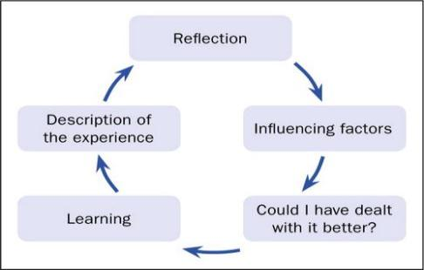
Reflective Practice as a Professional Practitioner
Professional practitioners who engage in reflective practice on a regular basis are better able to make decisions with regard to the situations and problems they face on a day-to-day basis when they engage in reflective practice on a regular basis. In the event of a potential similar situation arising in the future, we may be able to identify ways to identify improvements through the use of a critical review of past experiences so we can anticipate a better outcome for the future (Brock, 2014). According to Johns' (2006) 'Model of Reflection', reflection and accountability of a person's actions are crucial to enhancing one's professional effectiveness. Having a full capacity as a professional means that you must always strive to achieve your full potential as an individual

#
(MAG online library, 2017)
Practitioners may find it helpful to utilize reflective learning, particularly if they create a personal journal where they express their past experiences and how they dealt with them during those experiences. The constant updating and re-assessment of your decisions in conjunction with self-reviewing can contribute to a better practice in the future (Cottrell, 2003). Cottrell (2003) elaborates on the use of a journal or diary as a way of documenting progress on paper. By doing so, we remove our clouded judgment from our minds, and we can look back on our past experiences to build a better plan for the future. If we keep a record of our experiences, we are able to learn from the past as well as from the present. We have the ability to critically analyze our development, strengthen our skills, and enhance our abilities to become better professionals if we can identify our strengths and weaknesses and reflect on them (Tarrant, 2013). As Tarrant (2013) elaborates more, we can also become more aware of what it means to advance from a beginner to a specialist through the development of habits and regular reflection.


Theories and Models on Reflective Practice
Gibbs' reflective model is considered by many to be one of the most beneficial models and theories for promoting reflective practice. In the writings of Gibbs (1988), the author suggests that if one lives through events and does not reflect on them, neither the event nor one's actions will be remembered. Whenever you do not use reflection when dealing with an incident, you are missing the opportunity to learn from it. I would like to discuss again Cottrell (2003), the idea that by writing down and reviewing your reasoning and reactions to an experience, you will be able to grasp different perceptions of future outcomes and will have an outside perspective to look back on your past self and improve. Thereby, you will develop new ideas to enhance and modify your decision-making in new situations, and things will be handled more effectively and efficiently once you become familiar with them (Gibbs 1988).

(Crowe Associates Ltd, No Date)

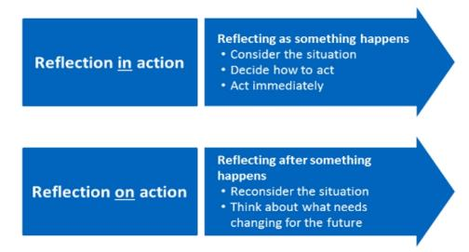
Another helpful model of explicit knowledge that should be investigated is Schon's reflective model; similar to what we discussed in a previous post, explicit knowledge consists of knowing what you are doing and reflecting on what you're doing. These are examples of explicit knowledge that is based on fact and practice. Furthermore, there is the tacit knowledge component of knowledge, which is actually an aspect of our mind that runs much deeper than the explicit knowledge component. Our ability to draw inferences from the information from everything going on around us and the ability to pick up on signals and signs to make a judgement is based upon a combination of reflected past experience derived from trial and error, along with our own individually unique natural intuition. (Klein, 2018) refers to this as tactic knowledge.

(Essay Service UK,No date)
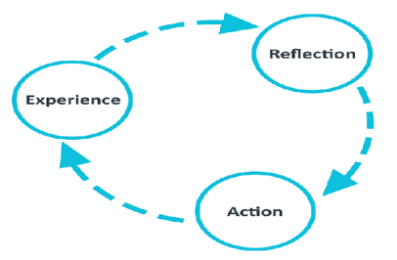
As well as Schon (1983) and Gibbs (1988), we can also consider several other models of reflection that we can use as a starting point, and another simplified method would be the ERA cycle. In order to fully comprehend the process, Jasper (2013) divided the process into three simple sections. The concept of 'experience' can be based on past experiences or current experiences, whether they were good or bad. Towards the end of the experience, a second stage of 'reflection' can be appropriate that involves looking back, assessing, and considering how it went and what observed, as well as how it might be improved in the future. As a result, we come to the third and final part of 'action', which entails what we do to prevent future incidents from occurring and how we deal with new situations based on how previous incidents have been reviewed. Following this stage, we return to the 'experience' stage, where we can use what we have learned in previous steps to complete the process.

(University of edinburugh, no date)
(Skills Hub, No Date)
Although this is a much simpler cycle and concept to understand and apply, we should also consider Kolb (1984) Experiential Learning Cycle. Kolb (1984) argues that there are four stages that reflect the development made through reflection and the recognition of past experiences. It will not only be a matter of experiencing the concept, but also of recording our reflections and ideas regarding that concept we have yet to observe. As a result, this further adds to Cottrell (2003)'s view on the importance of noting progress and new ideas. Through this procedure, we can analyze events that have happened and what we did not comprehend at the time. We can then ensure that if a recurrence occurs, we have analyzed the causes and will be better prepared to handle it in the future or avoid it in the future. Last but not least, we apply our new and previously reviewed techniques to the new situations.

While cycles such as these can be beneficial and can inspire better practice in education, they may also be ineffective if they are too rigid, which can ultimately result in bad outcomes. Brock (2014) found that when applied to daily practices, they provide a balance between pros and cons. Having to adhere to such a specific order may preclude a better, more creative and individual approach. In addition to this, criticisms of Kolbs' theory also emphasize the idea that it places an excessive emphasis on experience and condenses it too tightly and ignores the tacit knowledge of the individual (Moon, 2004). It is impossible for us to eliminate the possibility of the unknown if we do not take account of our tacit knowledge. There are many nuances to life as a childcare professional, and situations that are not as straightforward as they seem. Due to the unpredictable nature of our modern world, our ability to learn from past experiences is often unorganized and disorganized. As well as following a guide, it is possible to learn through more unstructured methods in unstructured fashion just by using the natural processes (Moon, 2004).

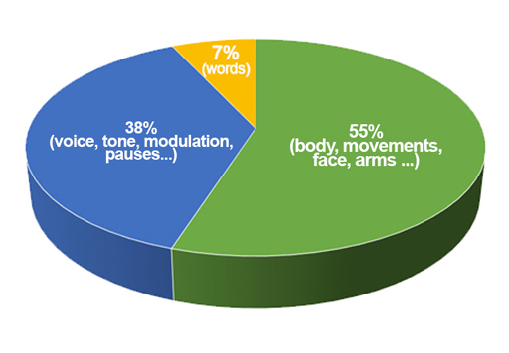
The importance of how to implement different techniques and skills of reflective practice in the early years setting must be discussed, such as personal tacit knowledge gained through our relationships with children and the sub-concious ability to notice something out of character from instinct and not by following a specific guideline. The individual must be able to accurately identify these things and respond accordingly and professionally (Brock, 2014). The concept of tacit knowledge is rather popular, yet enigmatic amongst professionals, and was described by Polanyi (1967) as something we intuitively know, but which we are unable to explain. When we have an intuition that "something does not seem right", we are acting on our tacit knowledge. It is an example that complements Schons' (1983) concept of reflection in action. The significance of establishing these relationships allows us to develop tacit knowledge that allows us to understand each child's personality and needs. For this reason, we can better understand things through nonverbal cues and tacit knowledge accumulated through experience. The graph on the right illustrates the importance of body language and its impact on communication. There are many signs of something being wrong, including tonality, slouching and lack of eye contact. When working with children, these are signs to be aware of and to register, since words alone cannot convey a message. Understanding a person's non-verbal cues is of far greater importance (Mehrabian, 1972).

(Open Learn, 2020)

In conclusion to this briefing, we would like to suggest that following the above methods and understanding the different approaches will provide practitioners with sufficient tools for developing their reflective practices. As well, this briefing paper illustrates how reflection can enhance the quality and effectiveness of clinical services that are provided by practitioners in this field.

When using reflective practice in early childhood education, creative and innovative thinking is one of the key elements. If practitioners follow these directions, they will be better able to develop relationships with children and their families by communicating what works and what does not (Brodie, 2016). According to Brodie (2016), it may also be possible to capture children's creativity by means of focusing on interactions between young children and early childhood practitioners. Taking this approach will not only provide us with the opportunity to reflect on our own actions and experiences, but it will also provide us with an opportunity to reflect on our experiences as a group of professionals, as well as learning from the experiences of the children. As you build tacit knowledge, it is very important to avoid taking this knowledge for granted, and therefore to always act based on the current situation without allowing the past experiences to interfere with the current knowledge. Using the above theories and models you will then be able to keep your decisions grounded in your instincts so that you can be a very effective professional (Edge, 2013).

Reflective Practice and Communication to Enhance Quality Service Provision
Effective communication is one of the most essential elements of providing high quality childcare. Through reflective practice, childcare workers may improve their ability to come up with creative solutions to difficult communication situations and to identify factors that promote their creative competency within a reflective setting (Lutz, 2016).
Having a discussion with your colleagues in the workplace can be beneficial for your career development. You can all share your opinions and reflect together as a team, gaining a second opinion rather than looking at a problem alone.
As Tarrant (2013) suggests a very good way to help you reflect on your practice in the form of a learning round. While your colleagues will observe you during this lesson, you will gain a great deal from their observations, and you will also gain tremendously as well. By studying practice and reflecting upon alternative approaches to the accomplishment of tasks, participants are able to evaluate their findings in a professional and constructive manner (Page, 2016). There is a focus here which is not totally focused on learning and reflection about oneself because the purpose is to move from a variety of observations to general conclusions about learning as a group, benefiting everyone (Hargreaves, 2016).
The ability to communicate creatively and to devise innovative ways to resolve challenging personal situations may be a necessary skill and may benefit from training. Reflective group practice can help groups to improve their ability to use their knowledge and skills to address difficult professional or communication situations in new, useful ways and to explore new opportunities (Vettraino, 2015).

