Placement-Managing Guest Service Operations
BMIH6003
Student Name: Diana Andrusko
Student ID: 2025664

Lecturer: Lisa- Marie Bassler
Date: 2. November 2023.

Content Page

Content Page 2
Introduction 2
Experience 3
Reflection 6
Action 7
Conclusion 8
Reference 9

Appendices
Appendix 1 Page 3
Appendix 2 Page 5
Appendix 3 Page 6
Appendix 4 Page 7
Appendix 5 Page 8

Introduction
The Marriott Waltham Abbey placement in the guest service sector was a fascinating and uplifting experience for me. I was struck by the Marriott family's exceptional level of service and friendliness as soon as I stepped into the facility. I was able to expand my skill set and sharpen my guest service abilities because to this employment. I have always been drawn to the guest service industry, and the Marriott Waltham Abbey provided me with the chance to demonstrate my abilities. I had the opportunity to see the cleaning process of the rooms and participated in the work myself. I concentrated on developing my problem-solving and effective communication abilities during my internship at the Marriott Waltham Abbey. Every day, in the building's dynamic environment, I faced fresh, intriguing issues for which I had to rapidly think of an answer.
I will use the ERA reflection model to review events.

Figure1 Jessica Robinson (2022)

Experience
My primary task was to ensure that the guest had a comfortable and pleasant stay with the team. I have always valued attention to intricate details and tried to complete tasks as well as possible. My positive experience was the room service, where I felt good that I could contribute to the comfort of the guests by serving the sumptuous breakfasts. Most guests who choose to eat in their room do so because it is convenient (usually for business guests) or because it is luxurious and relaxing, (Herz, 2020). Exceptional guest experiences also start a positive cycle of high guest satisfaction and good online reputation, which in turn leads to newer and repeat business, (Guest Joy, 2022). Of course, there are also dissatisfied guests, which must be dealt with immediately.
During my accommodation work at the Marriott Waltham Abbey, a guest had a negative experience with the bedding, which gave me personal reflective feelings. A guest's experience encompasses their feelings during their interactions with the hotel and its several departments, offerings, and services, Anders Johansson (2022). Given the circumstances, the problem was as follows. Since the cleaners work in a different system, the OMNI program is not digitally compatible with the Opera System used in the Front Office. Unfortunately, this is a communication error, and the housekeeping manager did not properly check the tasks to be performed, and he was not communicated well with the Front Office, so we do not know about the problem either. In most hotels, what is the most important thing? Excellent and economical guest service. However, the way hotel departments interact has a significant impact on how well guests are served. If they do not communicate well, guest will not enjoy their stay at the hotel and will not want to return, (Ehotelier, 2020). This hotel has not invested money in connecting the programs, what is 7000 pounds expenditure said the Housekeeping Manager, which led to bad guest experiences. The employees on the shift were sad and they were also nervous because they said that this was not the first case of this kind, so it was a recurring problem.
There were complaints about the outdated heating system, non-functioning heating in the rooms, but the positive thing is that the maintenance staff, with all their knowledge, resolve the complaints in the shortest possible time. The maintenance and functionality of the equipment is ensured by the continuous cooperation of the maintenance staff and the food and beverage, cleaning and front office departments, Rajak (2023) makes this partnership crucial to ensure visitor experience. First, it is important to note that problems are discussed the all-department management and tried to be solved in the shortest possible time at the daily management meeting. Why is the daily management meeting important?
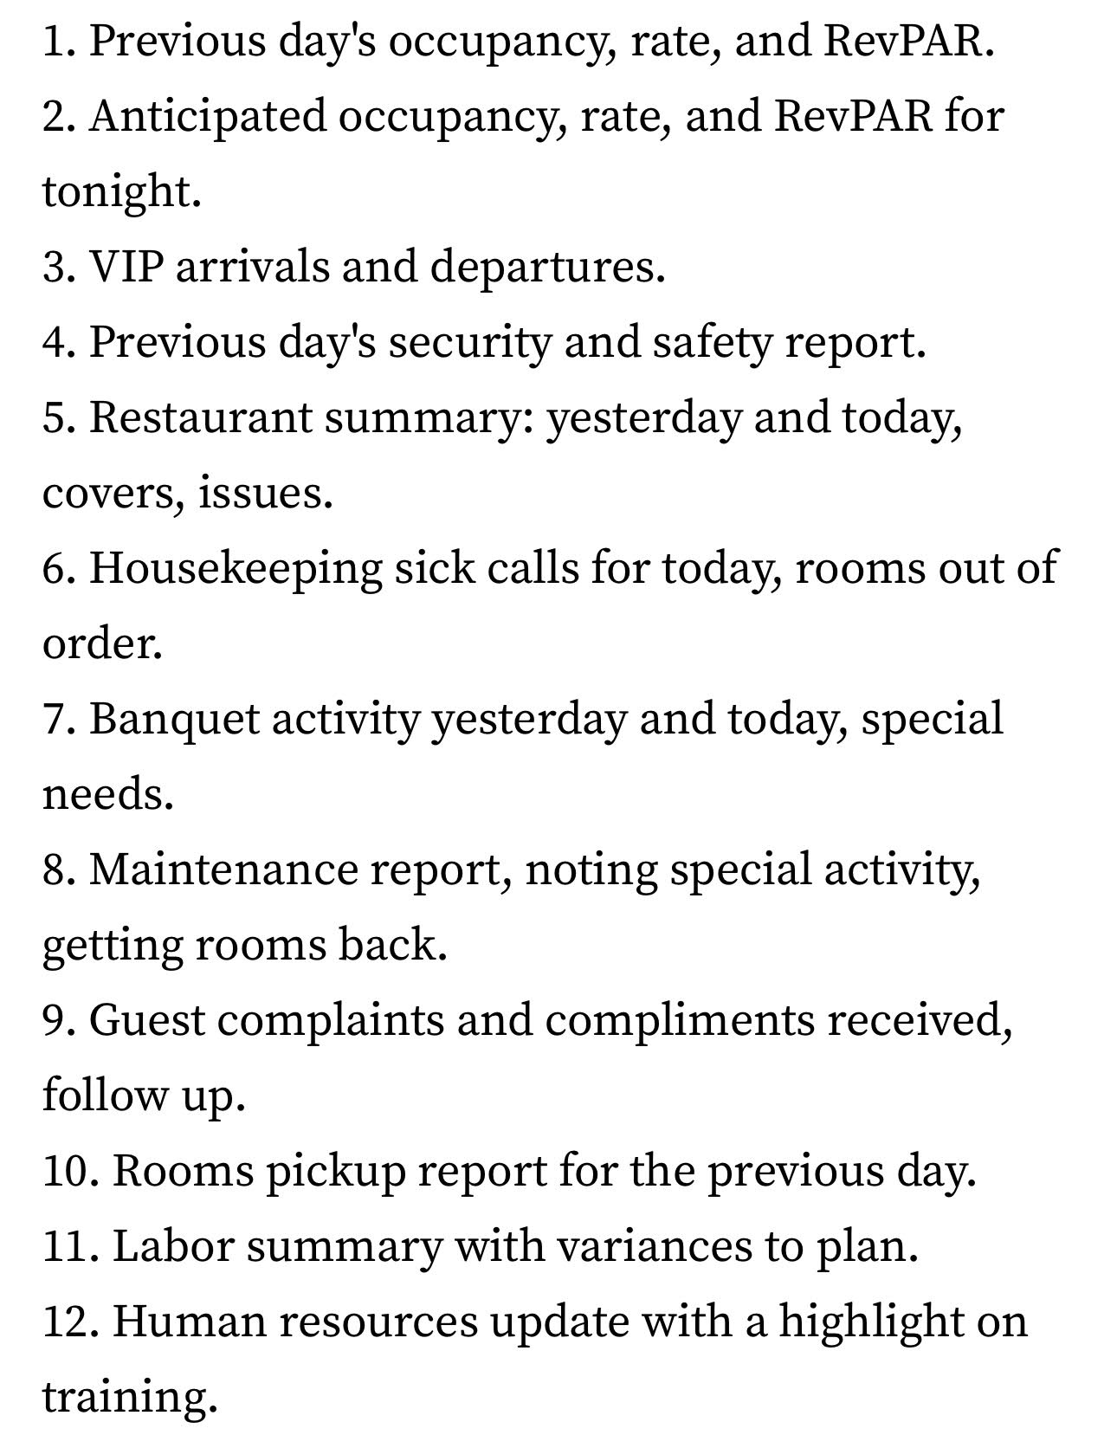
Figure2 (Lund, 2018)
The guest was particularly startled by the pool and sauna shutting. The hotel suffered a monetary loss in this region due to the 150% increase in gas costs and the 300% increase in energy rates, making upkeep of this section costly. Unfortunately, as I was unable to participate in the work in this area, I missed this opportunity. Based on the (House of Commons Library report 2023), published by the UK (United Kingdom) Parliament, in April 2022 alone, there were monthly price hikes for gas and electricity that were by far the most on record since 1988. The energy price cap limits saw increases of 12% in October 2021, 54% in April 2022, and 80% (gas by 91% and electricity by 70%) in October 2022. This is how the management's decision is understandable.
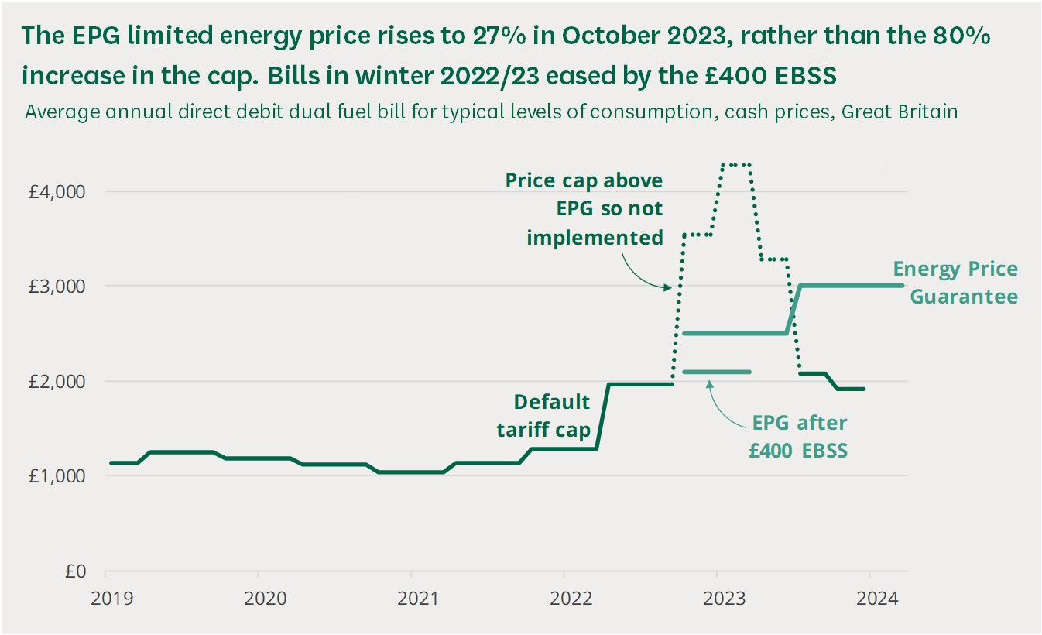
Figure3 (House of Commons Library report, 2023)

Reflection
I felt like I was getting personal criticism when the guest complained about the bedding, and it took a bit of a toll on my confidence. In addition, it was often cold in the hotel, which made me frustrated because the heating system did not work well, and I was cold. The staff was also stressed because this problem keeps coming back. They work hard every day in the cleaning department. It is important to note that the job of a hotel housekeeper is physically demanding, even if it does not seem difficult, Thomas (2023).
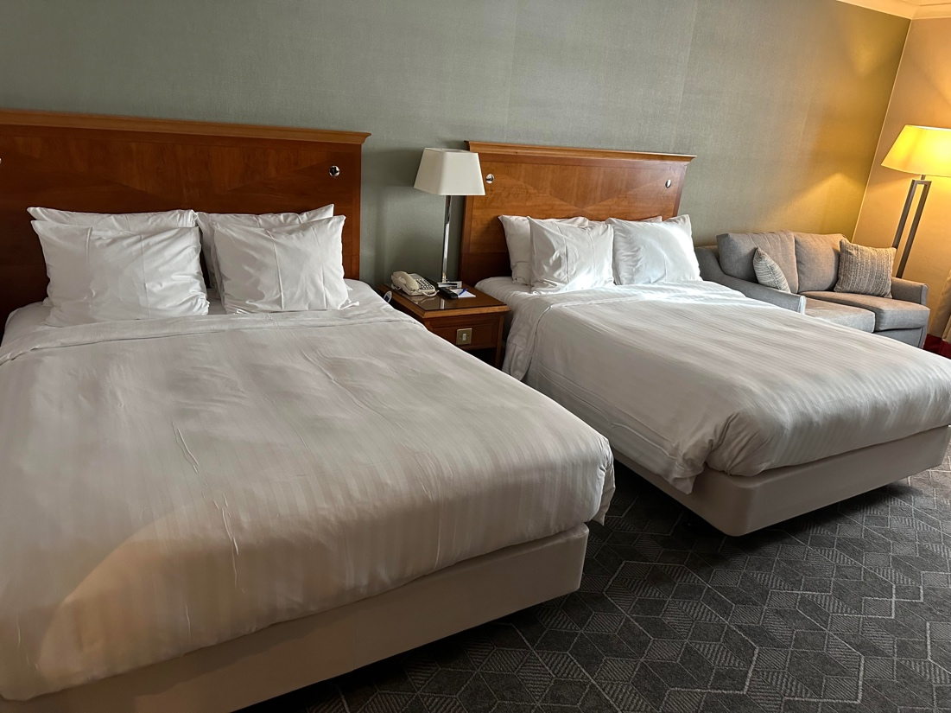
Figure4 By author (Waltham Abbey Family Room)
My reaction to guest complaints was quite intense, I became stressed. In the next situation, I must improve on this, because the guest also sees this negative in me. It only takes one ill-mannered employee to get a negative review from a customer, so it is essential that staff know how to handle complaints politely and appreciate the importance of a good attitude, Alemar (2022). Also, the fact that I had an unpleasant experience due to the heating is not the guest's fault, so I must improve my reaction. Superior skills can enhance the experience by showing that you value their comments, pay attention to them, and communicate things clearly (Sage-Advices, 2021). Overall, although this negative experience left me with an unpleasant feeling, it gave me an opportunity for professional development.
“The existence of hospitable behaviour, or ‘hospitableness’, is a vital prerequisite for the provision of hospitality in its fullest sense” (Wood, 2013, p. 60).
This reflective process reinforced in me the desire to always strive for the satisfaction and comfort of the guest, even if I make mistakes in the process.
“In addition to the areas of hospitality we discussed, professional housekeeping requires a staff with a sense of pride. Housekeeping staffs must show concern for guests, which will make the guests want to return” (Jones, 2008, p.4).

Action
I learned from my reflection that next time I will be calm and not take any mistakes personally. I learned that it is necessary to check the submitted requests in the system several times and that the Manager also needs to handle this information much more efficiently and communicate with the team and motivate them.
“The motivation of employees is accomplished by the manager creating an environment in which employees can motivate themselves.” (Jones, 2008, p.11).
This will avoid such unpleasant situations in the future. I still recommend the improvement of the communication line, as this may lead to further dissatisfaction of the guests, and the modernisation of the heating is essential.
Overall, more than 50% Waltham Abbey hotel rated 5 or 4 stars based on TripAdvisor reviews, which is fantastic, but could still be improved.
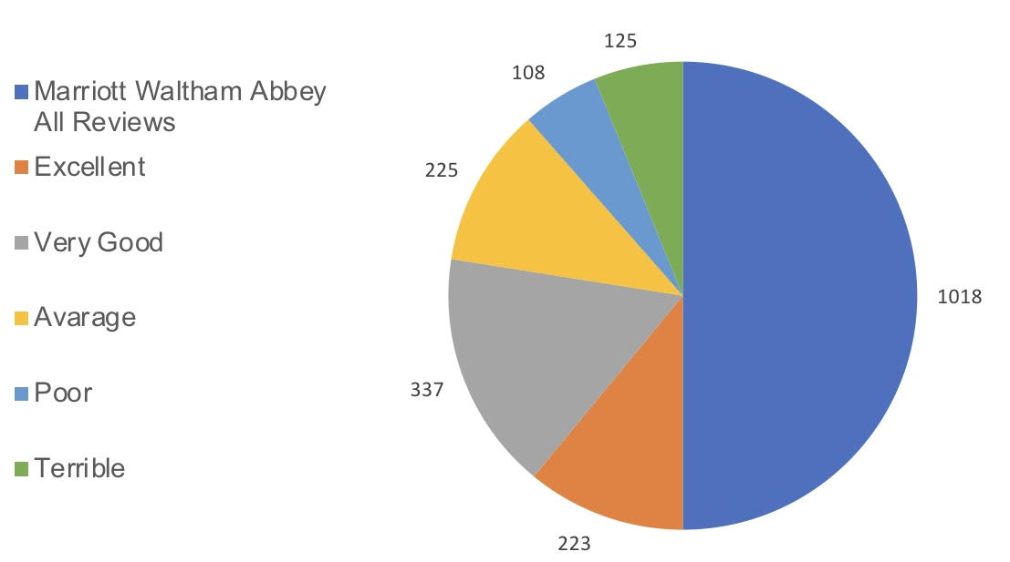
Figure5 By author (Reviews Statistic)

Conclusion
My time at Marriott Waltham Abbey was beneficial to my personal development. In the hospitality industry, true hospitality goes beyond simply completing tasks – it involves understanding and meeting the needs of guests. I am glad I had the opportunity to learn how to make the most of my talents and provide exceptional service. It is essential to understand that guest satisfaction is the most important aspect of my job. When guests are satisfied, it not only enhances their experience, but also contributes to the hotel's overall reputation and success. Empathy and a positive attitude are vital qualities in the hospitality sector. My ability to empathise with guests and understand their needs and concerns allows me to provide personalised and attentive service. I have gained valuable insight from my experience, and I am sure that these lessons will continue to be useful in my future endeavours.

Reference

David Lund (2028) Hospitality Financial Leadership – The Morning Meeting. Available at: https://www.hospitalitynet.org/opinion/4089892.html#:~:text=The%20morning%20meeting%20is%20a%20mainstay%20in%20almost,highlight%20important%20changes%20to%20groups%20and%20business%20volumes (Accessed: 1 November 2023).
Gregor Herz (2020) How relevant is room service in the modern hotel? Bringing hotel room service into the 21st century. Available at: https://www.hospitalitynet.org/opinion/4099515.html (Accessed: 2 November 2023).
Joy G. (2022). Everything you need to know about guest experience in the hotel industry. [blog]. 27 October. Available at: https://guestjoy.com/blog/everything-you-need-to-know-about-guest-experience-in-the-hotel-industry/ (Accessed: 2 November 2023).
Johansson A. (2022) What is the difference between guest service and guest experience? [blog]. 5 April. Available at: https://www.demandcalendar.com/blog/what-is-the-difference-between-guest-service-and-guest-experience (Accessed: 27 October 2023).
eHotelier (2020) How to improve the communication systems between departments. Available at: https://insights.ehotelier.com/insights/2020/12/02/how-to-improve-the-communication-systems-between-departments/ (Accessed: 26 October 2023).
Jones. (2008) Professional management of housekeeping operations (5th ed.). John Wiley & Sons. (Accessed: 28 October 2023).
Himanshu Rajak (2023) Maintenance in the Hotel Industry: Importance, Organization, and Comparisons. Available at: https://hmhub.in/maintenance-in-the-hotel-industry/ (Accessed: 1 November 2023).
House of Common Library (2022) Domestic energy prices. Available at: https://researchbriefings.files.parliament.uk/documents/CBP-9491/CBP-9491.pdf (Accessed: 31 October 2023).
Sage-Advices (2021) Why is it important to have a good relationship with housekeeping to front office? 10 May. Available at: https://sage-advices.com/why-is-it-important-to-have-a-good-relationship-with-housekeeping-to-front-office/ (Accessed: 27 October 2023).
Robinson J. (2022) Self-introspection and Improvement with ERA Reflective Cycle. [blog]. 10 November. Available at: https://crowjack.com/blog/strategy/reflection-models/era-cycle#example-of-era-cycle (Accessed: 28 October 2023).
Sara Thomas (2023) Is Hotel Housekeeping A Good Job? Available at: https://hotelchantelle.com/is-hotel-housekeeping-a-good-job/ (Accessed: 30 October 2023).
Stephen Alemar (2022) Customer Service in the Hotel Industry: 9 Ways To Improve. Available at: https://www.canarytechnologies.com/post/customer-service-in-hotel-industry#:~:text=9%20Ways%20To%20Improve%20Customer%20Service%20in%20the,7%207.%20Analyze%20Customer%20Feedback%20...%20More%20items (Accessed: 29 October 2023).
TripAdvisor (2023) Reviews. [TripAdvisor]. Available at: https://www.tripadvisor.co.uk/Hotel_Review-g503793-d229504-Reviews-Delta_Hotels_by_Marriott_Waltham_Abbey-Waltham_Abbey_Essex_England.html#REVIEWS (Accessed: 2 November 2023).
Wood (Ed.). (2013). Key concepts in hospitality management. SAGE Publications Ltd. (Accessed: 29 October 2023).

