

UNIVERSITY OF WALES TRINITY SAINT

DAVID LONDON

BA BUSINESS MANAGEMENT

MODULE : MARKETING FUNDAMENTALS

( SBUS4109)

MODULE TUTOR : RICHARD SMALL

ASSIGNMENT TITLE : BLOGGING TO COMMUNICATE

NAME : HARSHKUMAR B PATEL

STUDENT ID : 1604553

STUDENT E-MAIL ID : 1604553@student.uwtsd.ac.uk

CONTENTS

Introduction
Task 1A-4s
Blog 1 : The Availability of ck perfume
Blog 2 : The Product Development History of ck perfume
Blog 3 : The Value ck perfume Offers To the Customers
Blog 4 : Main Feature of ck perfume
Task 1B : The Planning and Development of Blog In Light Of the Marketing Strategy of ck perfume
Conclusion
References

INTRODUCTION
The invention is an Renowned part of the modern life and people are spent their time with an electronic who changing strategy of marketing and the business university is adopting new means to Communicate with the customer for exacerbate their dividend and to gain competitive benefits. as we talk about ck perfumes.ck are very well-known brand all over the world. They are doing very well in Today’s Competitive Market Requirement.

Task 1 A-5 Series of Blog Posts That Form Part of the Communications campaign of ck perfumes

Blog 1: The Availability of ck perfume
Calvin Klein are founded in 1968, it is a huge perfume brand in whole world as well as very popular, Calvin Klein is the most fastest growing business brand in the UK, they make cosmetics perfume makeup and other stuff for Man and woman and good business strategy and product quality give permeation to create good reputation and quality assurance which are demand of market and achieve their satisfaction.

Blog 2: The Product Development History of ck perfume
In Market many types of perfume brands but as my research Calvin Klein is the perfect brand. The artificial perfumes are creating threads in public health and research sowing about 30% and the artificial are made with artificial fragment which is very harm full to the people’s health and it’s too dangerous for life.

Blog 3: The Value ck perfume Offers To the Customers
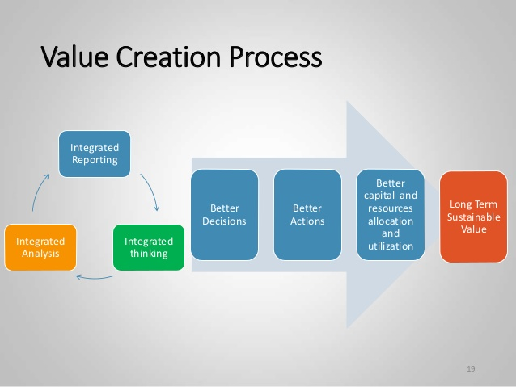
Calvin Klein is recognise for its products cost and quality, people are like this and they got positive market feedback in the Above figure shows the value creation process steps for organisation, and they do excellence RND in his all products.

Blog 4: Main Feature of ck perfume
The Ck One is Ck s best product offering to market it is to beneficiary, for the health of people and anti allergic formulas and unisex feature. It is not totally comical free product but its content good ingredient it is also cleared all laboratory process and become a successful. They make all perfume feels like very reach and something different “ feels like fly in the air”, it is clinically approver in body safety(kotler and Keller,2015).

Task 1-B: The Planning and Development of The Blog In Light Of the Marketing Strategy of ck perfume
Concept of The Marketing
Marketing is a Main Process of any small or big organisation, and presentation of product to market, its play a good role as a seller and meet demand of customer and customer satisfaction (Palmer, 2015).
Macro and Micro Environment
Calvin Klein consider the impact of macro and micro environment on their marketing strategy and Its process they are developing their marketing strategy for success of the organisation. Calvin Klein considers SWOT and PEST analysis for appraise the macro and micro environment (pride, 2017).

Marketing Mix
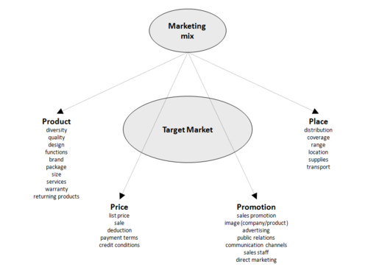
In the above figure shows the marketing mix, marketing mix is directly effect to four main factors to target the market,
- Product
- Price
- Promotion
- Place

by this all factors product are step ahead in market and achieve success, all this factors affect top to bottom in this organisation.

Conclusion
A popular perfume Calvin Klein is one of the mist selling product in all over the World market, they are attract his customer to buy more product and attract other customer to buy their product Globally and day by day They can increase its sales. specially this product represent the organisation and achieving competitive advantage.

References
- Diamond, J. and Pintel, G. (2015). Principles of marketing. Englewood Cliffs, N.J.: Prentice Hall.
- Housden M (2010), Marketing Information & Research, Butterworth Heinemann.
- Jobber D & Fahy J (2012), Foundations of Marketing, McGraw Hill.
- Jobber D (2012) Principles and Practice of Marketing, McGraw Hill 7ed.
- Kotler, P. and Armstrong, G. (2016). Principles of marketing.
- Kotler, P. and Keller, K. (2015). Marketing management.
- Lefebvre, R. (2016). Social Marketing: Principles and Practice

