Mood board/inspo

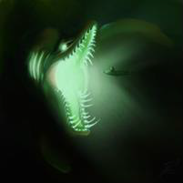
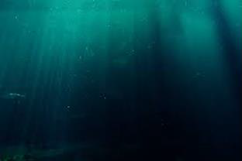
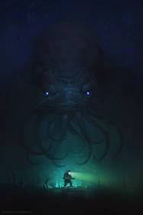
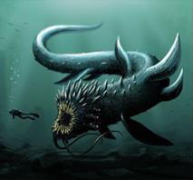
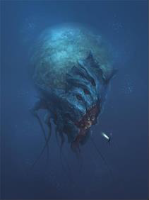
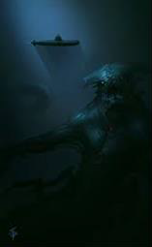
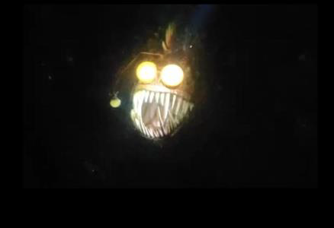

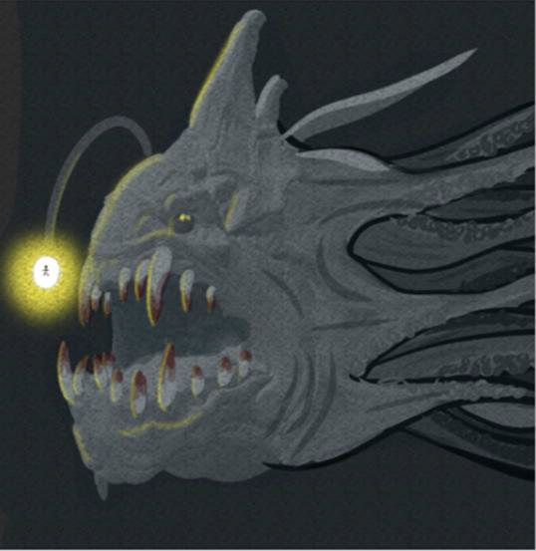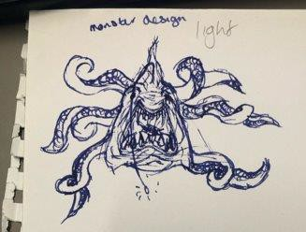

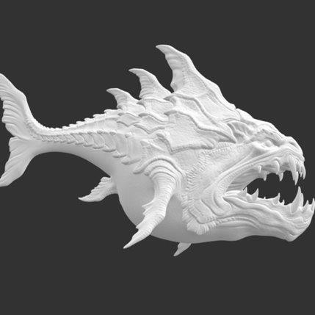
Based on monster angler fish model. Tentacles to be less recognizable and more of a threat

https://cults3d.com/en/3d-model/game/deepsea-
monster

Finalized creature design + diver size below
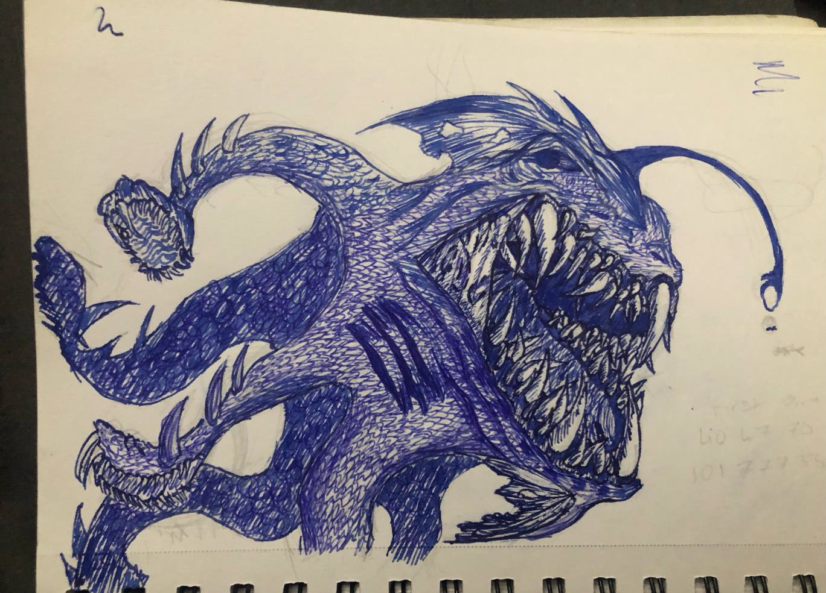



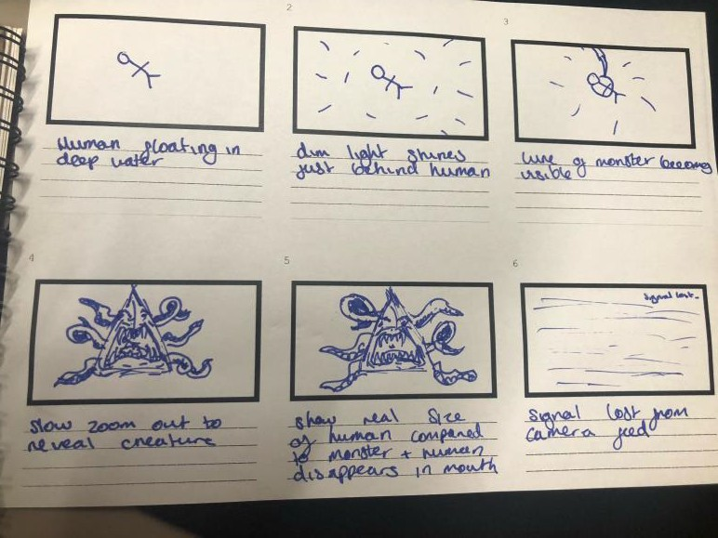
Mainly monochromatic, due to ocean reflection. use yellow of lure as accent colour

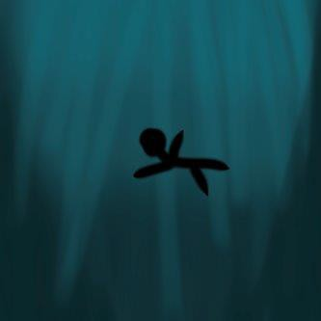
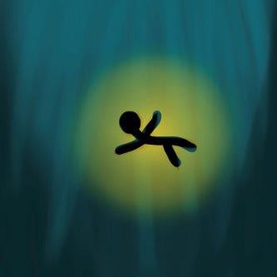
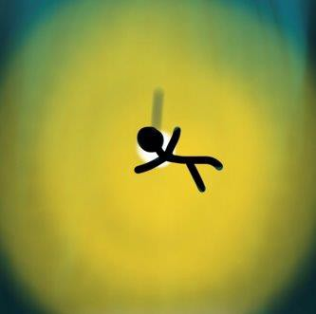
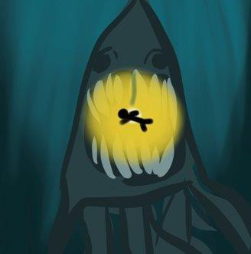
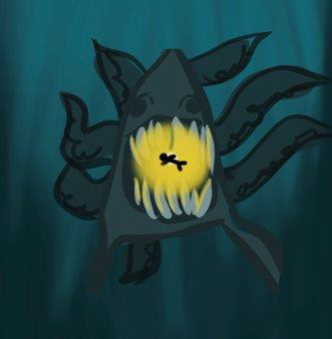
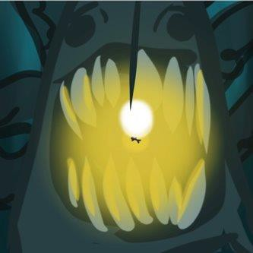

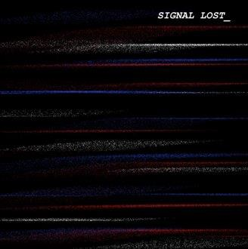

Set in dark open water to show depth of field, focus on human, with slight growing backlighting, which is slowly revealed to be the lure of the sea monster, which travels over the humans head and then over the camera, when teeth start to emerge from the all encompassing shadows. Camera pans out to show the true size of the creature, the human barely measuring up to the size of one of its eyes. Creature opens its mouth wider and the human disappears into the shadows inside, then the creature continues getting closer before devouring the camera, possibly showing offline feed screen to help
add depth to the story premise. The camera could be interpreted as a pov shot
from another devoured diver, or just a general research camera the main diver was using. sound would be extremely basic, just the sound of moving water and possibly a low groan when monster emerges, use sound to enhance not steal focus

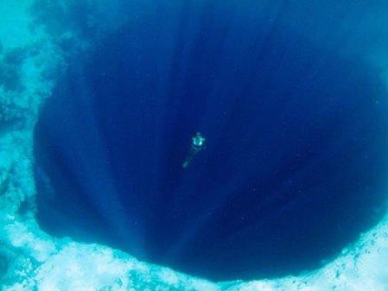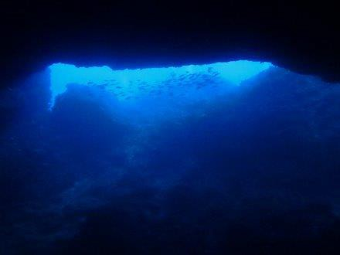

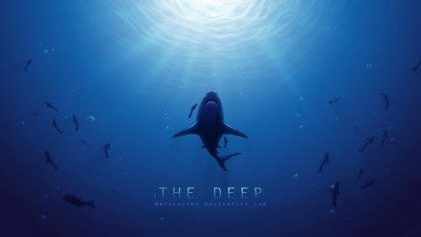
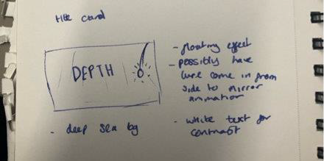

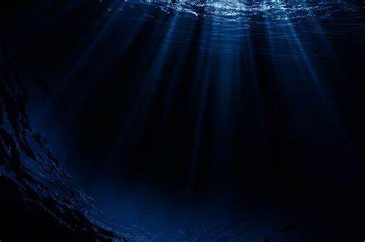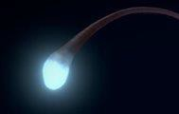

DEPTH

Basic concept
(lure comes in from side, bobs slightly?)

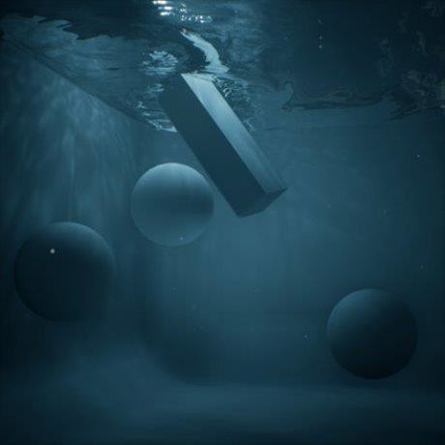
Underwater lighting example

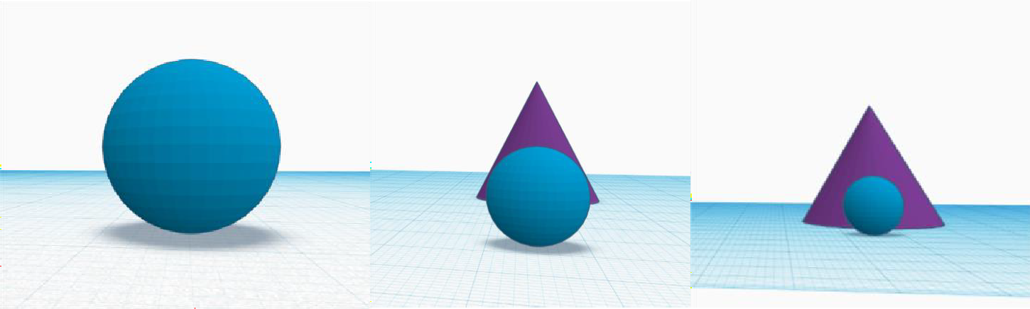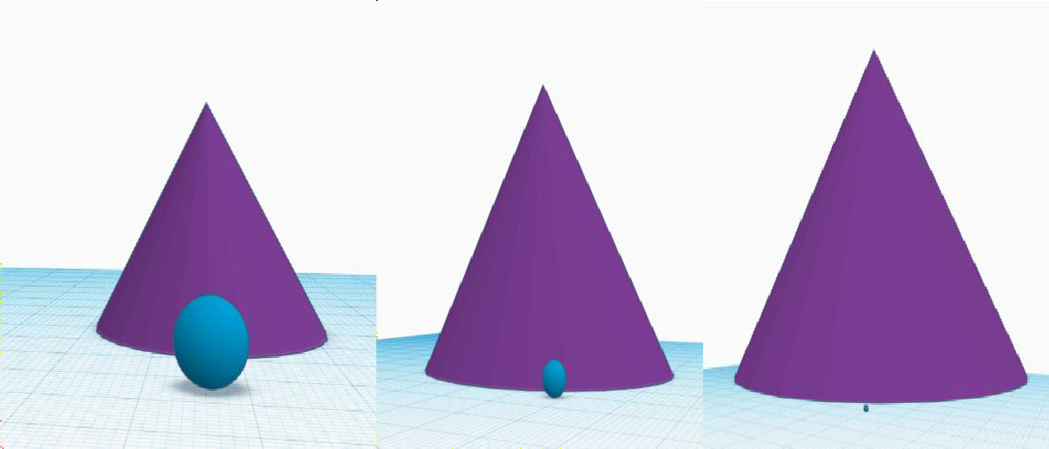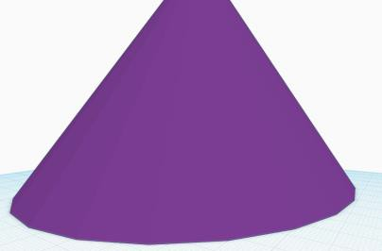

Maya placeholder animation linked to show the diver (blue sphere) and creature (purple cone) in size comparison and to grasp the general motion of the creature swimming toward the camera

https://youtu.be/WsVQeQ TCOjY

Lighting studies

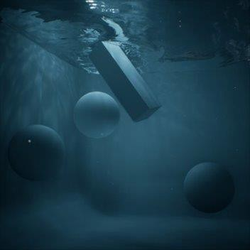

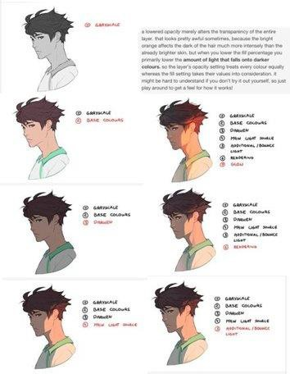
https://80.lv/articles/worki ng-with-underwater- caustics-in-real-time/

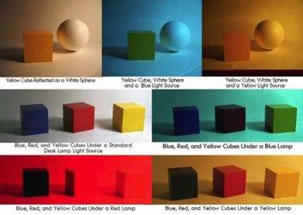
I looked into lighting as the scene will be dimly lit to emphasise the dramatic and mysterious nature of the creature. I found underwater 3d lighting guides the most useful as they show how to use light sources and replicate the blue light of water

