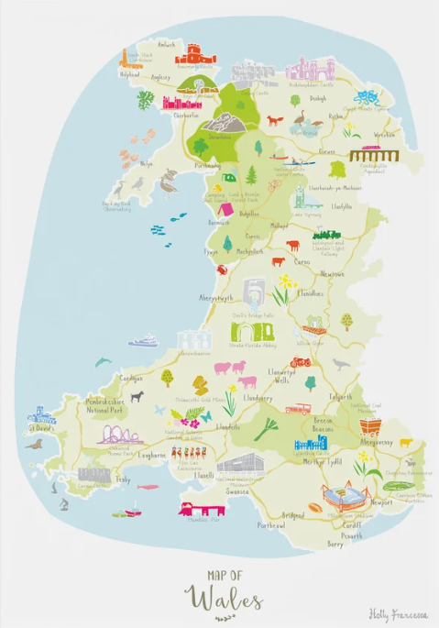
Portfolio

Promoting the Welsh
Language in school

2300218
Ellie Kelman

Contents page

Contents page..………………………………………………………………………….. 2
Introduction ..…………………………………………………………………………….. 3
Rationale ……..………………………………………………………………………….. 4
Activity One ……………………………………………………………………………… 6
Activity Two ………………..…………………………………………………………….. 8
Conclusion ……………………………………………………………………………….10
Appendices ………………………………………………………………………………11
Reference page …………….…………………………………………………………..

Introduction

The Welsh language is much more than just a tick in the box, which makes a school look good on an Eystn report. The Welsh language is a culture, heritage, and a way of life for so many people in Wales. Although many can speak English, there are some who can speak Welsh, and only a very few, Welsh only. It comes to something when the home language of a nation is not the most dominant one. After all, if you went to Italy, everyone would be speaking Italian, with only a few speaking English. The same with Spain, India, and Russia for example, all have their language as the one that everyone speaks within their own country.
This Portfolio will be looking at why this is not the case in Wales. Why Welsh people predominantly speak English and not Welsh, and what the local government and education system is doing to help improve this. To bring back the Welsh language to its home nation, its culture, traditions, and the new generations going forward.
All of this will be considered in activity one and activity two.

Rationale

Welsh history- The Welsh language, culture and belonging. Something that every Welsh person feels and is proud of, is the fact the Welsh flag has a dragon on it, shows how proud Welsh Celts were, when the Myth of the Red Welsh Dragon beating the White English Dragon. Miles-Watson (2009), stated how this myth gave the Welsh their strength, power and passion for Wales. Where the passion and power of Wales came from, when the dragon of the homeland beat the one from the Saxons. This is where the dragon originated from, and yet it is still one of the proudest and most passionate parts of Welsh culture. One, that when you see it, you instantly feel the pride of Cymraig.
Unfortunately, later, the pride of Wales and the Welsh language was cut short by the Act of Union in 1536. Here, King Henry VIII decided that Wales had too many Marcher Lords and they could not maintain order. Simkin (2000), states that Henry's fears about the power of the Marcher Lords grew after his break with the Catholic church in 1534. Some of these Marcher Lords were supporters of the Pope and Henry was worried that they might rebel against him. This created almost a state of paranoia in King Henry, with him not understanding the Welsh language, culture, and sense of pride and belonging that Wales had, and still has to this day. Henry wanted to deprive Wales of its status, stature and language, especially in the courts. This made life very difficult for people in Wales, they could not speak English. The courts being taken over and overruled by an English court, changed everything. Anyone going to court at that time would be scared and vulnerable as they did not understand the language being spoken to them in their own town. They had what they held most dear to them taken away. Their ability to communicate. The Welsh language deteriorated from here on.
However, in the Owen Report (1927), it clearly shows how Wales has fought back with language, “ High percentages of Welsh speakers still exist in Anglesey, Merioneth, Caernarvon, Carmarthen, and Cardigan,” this shows how geographically, the Welsh language was stronger in the West than the East; something which is still evident today. This can be seen though looking at the 1921 Census, 82.5% spoke Welsh in Carmarthenshire, compared to 5% in Cardiff and 7.5% in Monmouthshire. In Carmarthenshire alone, 27,158 spoke Welsh only, out of the 136,044 total Welsh speaking. This is evidence of how Welsh culture and language is still strong at this time.
Unfortunately, this did not last long. Looking at the number of Welsh speakers in the census for the next century shows a rapid decline (Welsh Government 2022). Welsh speakers in general hit an all-time low of 503,500 in 1981. Welsh only speakers became so low that this information has not been recorded in the national census since. Wales has been a bilingual country for centuries with the “1993 Welsh Language Act giving Welsh equal official status with English” (BBC Wales, 1999). This was updated to the Welsh Language Act of 1967 (appendix A) to state that all schools in Wales must have compulsory Welsh. Some schools were given until 1999, if they had no Welsh speakers in their community. The education system of Wales has recognized how important bilingualism is, on a multi-dimensional level.
New Curriculum for Wales being introduced in 2022, the Welsh Government shows full support for multilingualism by unifying International Languages, Welsh and English into one curriculum area, LLC (Languages, Literacy and Communication). This creates a language learning pathway from Primary to Secondary, ensuring immersion is key to student development in language.(Cristahazell, 2020).
This is using a child’s basic interpersonal communicational skills and their cognitive academic language proficiency, within their learning, starting at a young age, and building on this in a fun learning environment. These are the key skills to being bilingual (appendix B). In order to be bilingual, you have to have a good understanding of basic interpersonal communication skills first (Cummins,1979). This “refers to everyday social language used in informal interactions – this is the language used on the playground, when greeting people” (Limacher-Riebold, 2024). Without the basic communication skills, understanding body language, tone and pitch, learning anything becomes difficult, let alone another language.

Activity 1

In 2024, School A started up the ‘Siarter Iaith’ (Hwb, 2016), program to encourage more Welsh speaking around the school environment, working alongside the Welsh Government scheme of around a million Welsh speakers. Part of this includes a ‘Crew Cymraeg’ group of pupils who join up once a week and only speak Welsh to each other. They also encourage others to speak Welsh in class. Such as “ga i mynd i ty bach?, bore da, shwmae” as well as many other Welsh phrases. Every time a pupil speaks Welsh in a classroom, they are entitled to an achievement point ‘cymraeg’ for speaking and promoting Welsh around the school. It is surprising how quick pupils would then say something in Welsh to gain the extra achievement point.
Pupils of the Crew Cymraeg, can also hand out ‘tocyn iaith’ (appendix C). This is only given out by the Crew Cymraeg, where they have heard another pupil speaking Welsh in or outside of the classroom. The pupil can then hand this to a member of staff, who can then acknowledge Welsh was spoken, and an achievement point noted on the system. Such a simple way to encourage pupils to be involved in learning and expressing the Welsh language.
All staff are encouraged to greet all pupils in Welsh on arrival and write the date on the board in Welsh, small subtle changes such as, classwork changing to Gwaith Dosbarth, the day of the week changed to Dydd, is a great start to introducing basic Welsh into the classroom. This is also working alongside the Welsh Government’s scheme of having a million Welsh speakers by 2050 (2017). Also to help staff, every classroom now has an everyday Welsh booklet and Welsh (appendix D). This is all linked to the Siarter Iaith where school A is working towards the bronze award. This is also supported by the Donaldson report (2015), created for the Welsh government. This report looks at, not only language and culture, but also wellbeing. Assuring that all the curriculum and assessment in Wales are fit for purpose, up to date, and engaging, as well as ensuring that the Welsh language and culture is not forgotten; it is embedded in the six areas of learning.
Although the tocyn iaith, is a great incentive at the start, six months in, it seems to have lost its momentum within school A. All pupils were great at the start, speaking Welsh all the time to build up the achievement points. However, not every member of staff would then put the points on the system, which then is unfair, to the ones who really try to speak Welsh, out of their comfort zone but do not get the recognition for it. Teachers do not always have enough time to put these points on the system.
Although teachers are the ‘knowledgeable other in the room’ (Vygotsky 1934), sometimes, especially after a long day, it is not that easy to remember all the new subject specific phrases in class. So, it is handy to have them visualized up on the wall. This helps the teacher and the pupils work together on learning new phrases that are key to their subject in the curriculum, although some teachers do not feel comfortable with using the Welsh language as they are not Welsh speakers. The school has also offered Welsh lessons to support this; however, they are not always able to attend due to the timings of the lesson.
This also works alongside the Welsh Government Scheme (2017). Working on building up to 10% of the curriculum in Welsh by 2036. School A mindful of this, with the Welsh department double checking over all subject specific phrases which also works well with Curriculum Cymreig (appendix E). Ensuring Welsh is embedded within the curriculum across all subjects, builds up the teacher and pupil confidence on speaking Welsh.
This activity supports the use of bilingualism within the setting and is supporting the “million Welsh speakers by 2050” (Welsh Government, 2017). It is working well with those teachers who use the system correctly. Most work with this, very few find it difficult but some still and try to avoid the use of Welsh due to not being confident enough to speak Welsh in front of the class.
There have been two whole school assemblies on ‘Siarter Iaith’, these do encourage the use of Welsh language more and you can clearly see that the pupils take the information on board. If there were more out of school activities, meeting up with other secondary schools, for example, those who are also working on Siarter Iaith it would be encouraging and positive for the pupils. A S4C club as such, is promoting the use of Welsh language, television programs that they can watch during lunch club would really help promote this further.

Activity 2

During the Eisteddfod (appendix F) week, school A runs a competition within each department. The Drama department looks into the history of the ‘Welsh Not’. This competition is run over five lessons. In the first lesson, pupils are given a basic background about this, with two You Tube videos. Once they have watched the videos, they are given a research task about the Welsh Not. The pupils are given a worksheet (appendix G) to fill in with the research. During the second lesson they will work as a group and come up with a script and a scene to go with it. They then have two more lessons to rehearse this, before they can perform it in front of the class. This activity links in with Curriculum Cymraig (2017) as it is working on looking at the history of not only the Welsh language, but the Welsh laws at the time. For example, how the Act of Union (1536), changed Wales overnight. When King Henry VIII decided that Wales was part of England and all courts must be in English. The feeling of not knowing any other language but not being able to speak your mother tongue, would have been a terrifying feeling indeed, especially if you were in a child in school at the time. The impact this had on the Welsh language was phenomenal.
The impact this had education, was that every child, even though they did not know the language would have to speak English. Most of them only spoke Welsh. This would have been a terrifying time for them. Now, the only place they could speak the only language they have known, was at home or in church. If they did speak Welsh, it would mean they had to wear the Welsh not (appendix H). The last person wearing this at the end of the day would be punished in some way. This would be a terrifying experience, when at school you should feel safe, yet you are scared to speak.
This activity fits directly into Donaldsons (2015) Successful future. How in Wales, children have a right now to learn in their native language, the importance of their language and other languages too. The rights of a child, the right to learn, in a safe comfortable environment is now guaranteed. The report, also investigated Welsh history, language and culture, they must looked at the reason why this happened (Hwb, 2023). The research the pupils carry out, fits in with the digital competency framework, as pupils must independently research this information to answer the questions. This is something school A has refocused on throughout the curriculum to ensure it falls in line with the Curriculum of Wales (Hwb, 2008).Once this is completed, the pupils work as a team to create a script, looking at their literacy skills, as well as the expressive arts, where the pupils also think about how it would feel if they were there at that time, bringing in health and wellbeing too.
Although this activity, considers the Donaldson report (Donaldson, 2016), Government framework (Hwb, 2025) and Curriculum Cymraig (Hwb, 2023), by demonstrating Welsh history and the importance of the language and looking into local history and culture, in an inquisitive way. However, I do feel it could be improved. Looking at the questions, the pupils must answer (appendix F) there should also be a knowledge check, before question. Such as, what they think it is, or why they think it is important. This opens the mind more and creates more of a curiosity on the topic. When creating the script, some pupils really struggle with this and need clear direction on where to start. Especially when those pupils have additional needs, this can be very challenging. For those pupils, a differentiated worksheet for the digital competency part, is needed, with clearer questions or an idea where to find them. When it comes to performance and script writing, direction on setting scene, characters and a basic plot line to build on, would really support these learners.

Conclusion
Looking at both activities, which are carried out in school A, It is clear how they both support the Welsh language and heritage. Therefore, schools do play a significant part in promoting the Welsh language, ensuring it is a language that adapts and mutates to stay as strong as it did a thousand years ago. Teaching pupils about these cultural, historical and geographical features of the language, for example how the Welsh Not had a different impact depending on where geographically you were in Wales, is a vital piece of missing history.
However, there are difficulties in sustaining this. For example, not adding extra strain and workload to already overloaded and over worked teachers. With class sizes getting larger, and the ALN needs of pupils put back onto the teachers to support not teaching assistants, makes every lesson difficult. However, with the right training, support, and time, this would not be the case. Teachers who have additional time could be directed to focus on the Welsh language provision.
Schools must keep teaching, not only the Welsh language, but the culture heritage, and geographical historic importance of our language culture and traditions. However, bilingual schools, such as school A, must incorporate extra training and time for teachers to be able to fulfill this. This plays a significant part in keeping the Welsh language, culture, and traditions alive.

Appendices

Appendix A - Welsh Language Act of 1967
This act gave Welsh the same status as English in the law courts. Something that had been taken away centuries ago. Welsh language can now be used in a court of law and any legal documentation in Wales, not just in English. Although this Act helped promote the Welsh language, it quickly became outdated. The Act was then updated in 1993 (Law Wales,2020), gave official recognition to promote the Welsh language in public life. Truley supporting bilingualism. As part of this, schools had to teach the Welsh language, including sitting exams at GCSE level by 1999. Before this, Welsh was an optional subject within school at GCSE level. There was an annual grant of 13 million pounds to facilitate this by the Welsh language board. However, in 2012 the Welsh Language Board was replaced by the Welsh language service. “Welsh Language Strategy for 2012 to 2017 “A living language: a language for living.”(Welsh Language Service 2025). This act has helped push forward bilingualism in Wales, teaching and promoting the Welsh language.

Appendix B – Basic Interpersonal Communication Skills (Bics) and Cognitive Academic Language Proficiency (Calp)
Language and understanding one language can take a long time to develop. The Basic Interpersonal Communication Skills are the very basics of language and communication. This is not just works, but facial expression, tone, and body language, to be able to tell that someone is in a ‘bad mood’ before they say something. This skill is key to any form of communication. “Like an iceberg; BICS may represent only about 10% of the overall proficiency of an academically competent learner”. (Roessingh, 2006) shows that not all a person needs to have good interpersonal and language skills. In fact, without this, the Cognitive academic language would not be able to be processed. It is vital that a child has a good understanding of this in their first language, before being able to become bilingual. Being bilingual, not only supports cognitive development of language, but it also supports social learning, cultures and traditions (Cummins 2004), opening doors for the future to those who can speak and understand more than one language.

Appendix C –Tocyn Iaith
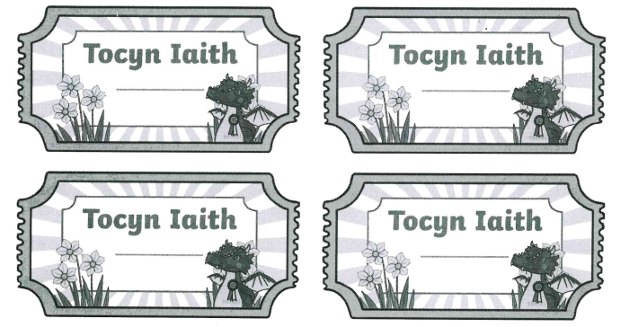Llewellyn (2025)
Appendix D – Welsh Booklet- Cymraeg Bob Dydd 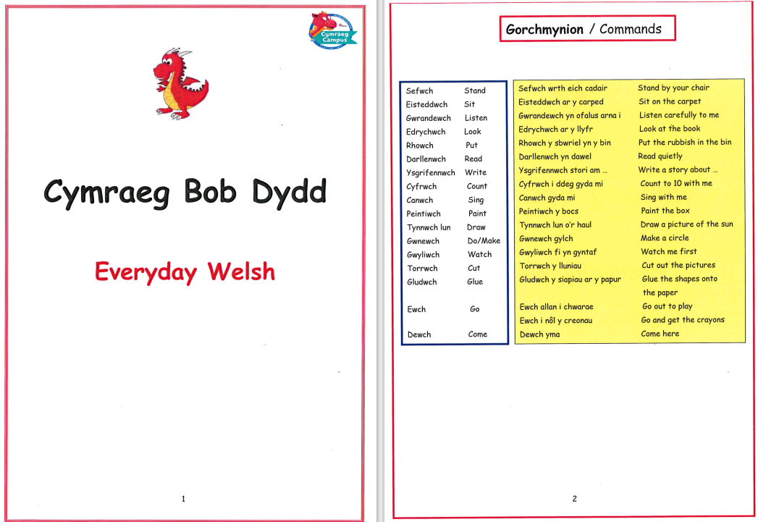
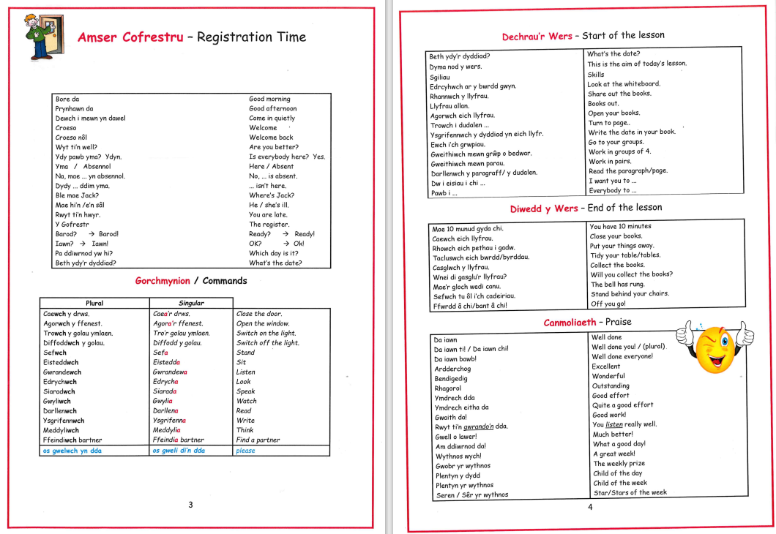
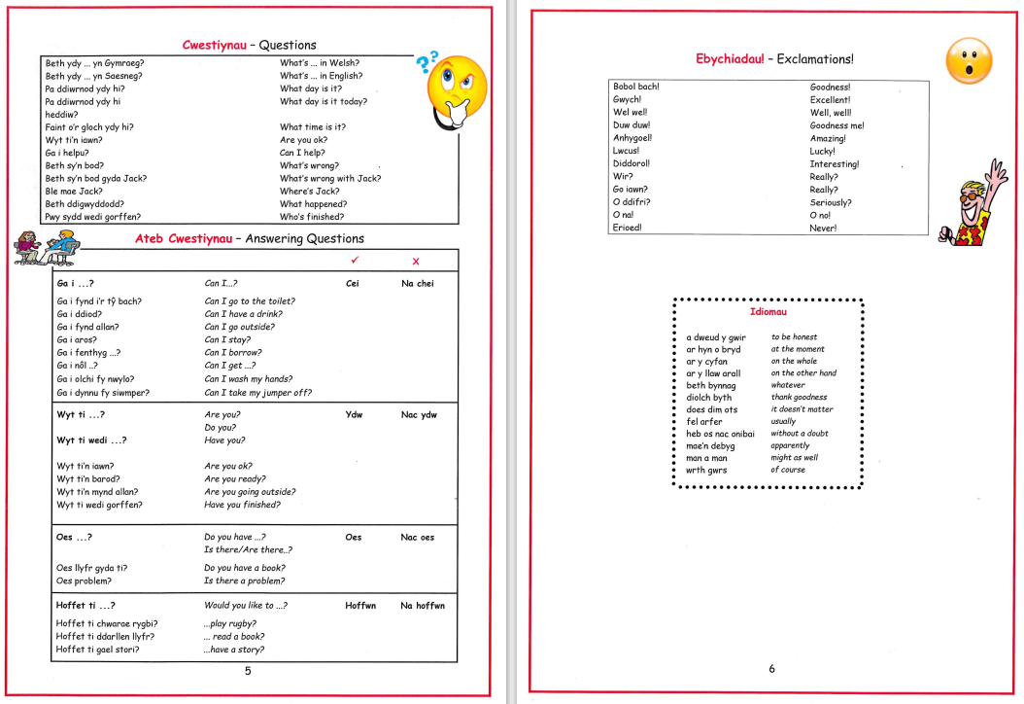
Llewellyn (2025)
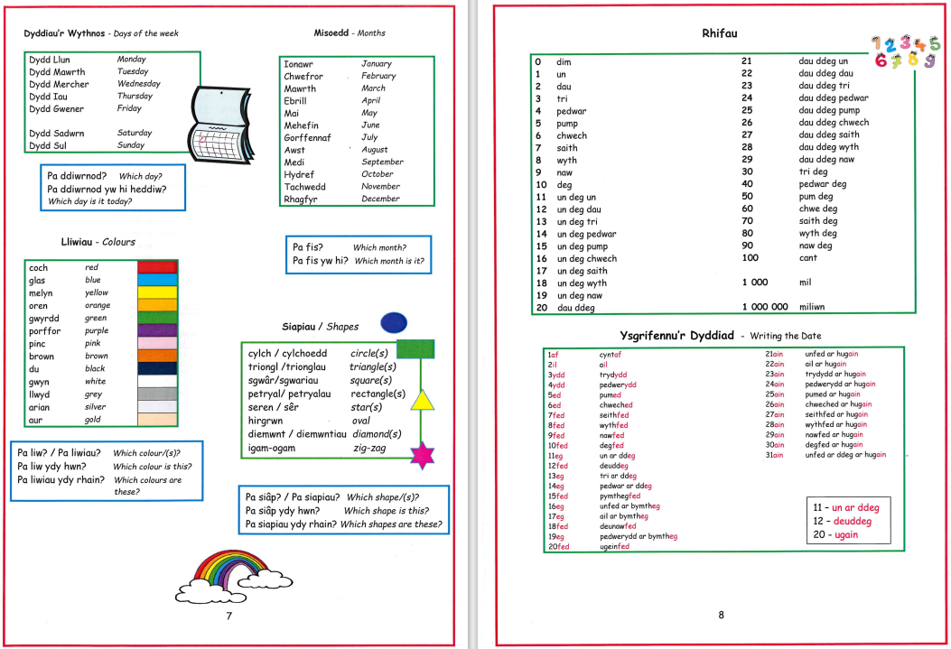
Appendix E – Curriculum Cymreig
Curriculum Cymraig (2013), is a Welsh Government incentive, that started off as a campaign to ensure that Welsh history, culture and language was not lost within a joint curriculum of England and Wales. “After considerable campaigning, it was agreed that some subjects, such as history and geography, would have different programs of study”. (Hwb 2013) In 1999, Wales created its own independent education system, Meaning, there was no longer a statutory education system with and additional educational system alongside, as they had for years. Within Curriculum Cymraig, core subjects stay the same, however historically and geographically, Wales is completely different to England, now this can be taught; and be taught bilingually across Wales. Of course, some things such as world wars are intwined and still play a huge part of historical content. Wales now has one educational system for Wales. This was later put under review to be updated with the National Numeracy and Literacy Frameworks (2018). Later, they look at the wider curriculum to ensure that Welsh history and culture are included. This brings the curriculum up to date to the new National Curriculum of 2022.
Another part of Curriculum Cymreig is to put the Welshness back into the curriculum (Smith, 2016). This includes all subjects, not just the Welsh language. Especially in secondary school where you have subject specific words. This is displayed on the walls in each classroom. So, each pupil has the choice of using Welsh or English, encouraging pupils to use incidental Welsh. This is not only working towards bilingualism in schools but also supporting the million Welsh speakers by 2050. (Welsh Assembly Government, 2003) Curriculum Cymreig also fits perfectly in with Activity A as well as Activity B. Within Activity A, there is a pupil who says over the Tanoy every Tuesday during reg what the Welsh phrase of the week is. Another two year nine girls run Clwb Cymreag for year sevens only on Wednesdays

Appendix F- Eisteddfod
The national Eisteddfod, a Welsh national cultural festival that has been annunally for the last 850 years (Griffiths, 2022), with the first one being held in Cardigan Castle in 1176. Here, singers and poets from all celtic lands competed for prizes. “it was in the late eighteenth century that the modern eisteddfod came into its own, beginning with a gathering of poets and probably some singing at Corwen in 1789” (Griffiths, 2022). This shows how much Wales prides itself in culture and tradition alone. For the last 850 years, this musical festival has grown into a national competition, where thousands compete to attend each year. A celebration of Welsh Culture and language, now with more than “1 ,000 events and activities for all ages across all artistic genres will take place, from modern to traditional music, poetry and literature, art, dance and comedy” (James, 2024). The national Eisteddfod is an event held in the hearts of many, a traditional and culture, that the nation is proud of, and is continuing to support the promotion of the Welsh language evolving though the centuries to the National Eisteddfod seen today.

Appendix G – Welsh Not worksheet
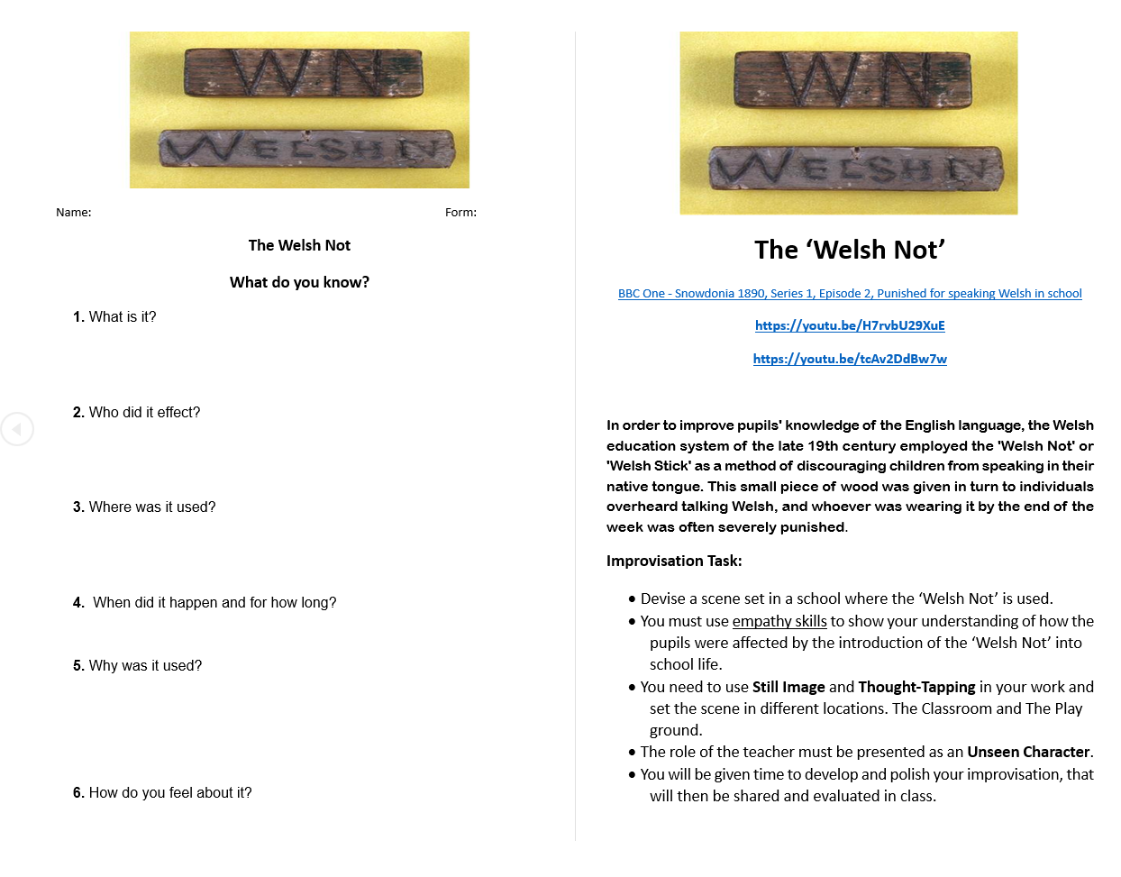

Appendix H – Welsh Not sign
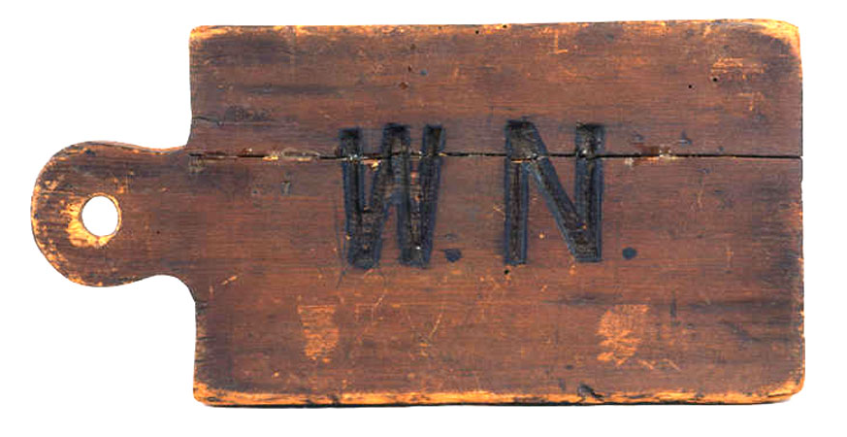(Welshnot.com)

References

- Cummings J. (2004) Language, Power and Pedagogy: UK Camrian Printers LTD
- Cummins, J. (9179) Linguistic Interdependence and the Educational Development of Bilingual Children Review of Educational Research, 49(2), 222-251.(Original work published 1979) Available at : https://doi.org/10.3102/00346543049002222 Accessed on: 10/12/2025
- Donaldson, C. (2025) Successful Futures. Independent Review of Curriculum and Assessment Arrangements in Wales. Available at: https://www.gov.wales/sites/default/files/publications/2018-03/successful-futures.pdf Accessed on 9/12/2025
- Donaldson G. (2016) “A Systematic Approach to Curriculum Reform in Wales”, Wales Journal of Education 18(1), 7-20. Available at: A Systematic Approach to Curriculum Reform in Wales | Wales Journal of Education Accessed on: 12/12/2025
- Franceseca H (2025) Map of Wales. Available at: https://www.etsy.com/listing/267071127/map-of-wales-art-print Accessed on 28/11/2025
- Hwb (2008) Digital Competency Framework. Available at: Digital Competence Framework: Curriculum 2008 version - Hwb Accessed on 13/12/2025
- Hwb (2016) Siarter Iaith available at: https://hwb.gov.wales/api/storage/f6a6a550-1ad9-4cd5-badd-84ec012089ed/siarter-iaith-guide-primary-and-secondary-v2.pdf Accessed on : 3/12/2025
- Hwb (2003), Developing the Curriculum Cymreig. Available at: Developing the Curriculum Cymreig - Hwb Accessed on: 13/12/2025
- James, C (2024) The Deep History of the National Eisteddfod Available at: The deep history of the National Eisteddfod accessed on 17/12/2025
- Law Wales (2020) Welsh Language Act 1993. Available at: https://law.gov.wales/culture/welsh-language/welsh-language-act-1993 accessed on 10/12/2025
- Limacher-Riebold (2024) Bringing Languages For Multilinguals. Available at: Bridging Languages and Learning: A Short Guide to BICS, CALP, CUP & CALS for Multilinguals – Embracing multiple languages and cultures across the lifespan accessed on 10/12/2025
- Llewellyn A. (2025) Tocyn Iaith. Penyerheol Comprehensive School
- Llewellyn A. (2025) Cymreag Bob Dyyd Penyerheol Comprehensive School
- Miles-Watson J (2009) Welsh Mythology Neo-structuralist Analyst. Cambria Press. Available at: https://books.google.co.uk/books?hl=en&lr=&id=_qbPrsL3KeoC&oi=fnd&pg=PR11&dq=red+dragon+welsh+mythology&ots=4aejMBms3l&sig=8UBH-3sTuIucKgW2EVu-Qbm1mEM&redir_esc=y#v=onepage&q=red%20dragon&f=false Accessed on 2/12/2025
- Owen report (1927) Welsh Education and Life. Available at: https://education-uk.org/documents/wales1927/index.html#03%E2%80%8B Accessed on 10/12/2025
- Roessingh H. (2006) “BICS – CALP an introduction for some, a review for others.” Tesl Canada Journal 91 vol. 23, no. 2, spring 2006 p91-96
- School A- Penyrheol Comprehensive School (2025) Welsh not worksheet.
- Smith, K, (2016). Curriculum, culture and citizenship education in Wales: Investigations into the Curriculum Cymreig. Springer.
- Simkin J (2000) Act of Union. (1536/1543) Spartacus Education System Available at: https://spartacus-educational.com/TUDactunion.htm Accessed on: 2 /12/2025
- Stori Iaith (2025) Stori Iaith. Available at: https://mwyostoririaith.cymru/en/adnoddau/y-deddfau-uno/#1 Accessed on: 2/12/2025
- Welsh Assembly Government (2003) Developing the Curriculum Cymreig Available at: developing-the-curriculum-cymreig.pdf Accessed on:15/12/2025
- Welsh Government (2017) Cymraeg 2050: A million welsh Speakers Available at: https://www.gov.wales/sites/default/files/publications/2018-12/cymraeg-2050-welsh-language-strategy.pdf accessed on: 3/12/2025
- Welsh Government (2022) Welsh language in Wales. Available at: https://www.gov.wales/welsh-language-wales-census-2021-html accessed on 10/12/2025)
- Welsh Language Service (2025) Formerly the Welsh Language Board. Available at: https://www.welsh-language-board.org.uk/ accessed on :10/12/2025
- Welshnot.com (2025) Available at: www.welshnot.com accessed on: 8/12/2025

