


Network Security (NS)

Lab 6

Faculty of Architecture, Computing & Engineering
I.Q. Building room 205
Swansea
SA1 6ED

Introduction

The labs given within this module is geared to assist you in carrying out penetration testing on systems. In a penetration test an Ethical Hacker attempts to break into a company’s network to find vulnerability or the weakest link in the network or the network system. They are also required to analyzes the company security policy and procedures and report any vulnerability to management.

An Ethical Hacker is a person who performs most of the same activities as a hacker but with the owner of the company’s permission. The distinction is important and can mean the difference between being charged with a crime or not being charged. Ethical Hackers are usually contracted to perform penetration tests or security tests. After pre-engagement activities, penetration testers begin gathering information about their targets. Often all the information learned from a client is the list of IP addresses and/or web domains that are in scope. Penetration testers then learn as much about the client and their systems as possible, from searching for employees on social networking sites to scanning die perimeter for live systems and open ports. Taking all the information gathered into account, penetration testers study the systems to find the best routes of attack. Tins is similar to what an attacker would door what an invading army would do when trying to breach the perimeter. Then penetration testers move into vulnerability analysis, the first phase where they are actively engaging the target.

Task 1:
A Trojan is a program that contains malicious or harmful code inside apparently harmless programming or data in such a way that it can get control and cause damage, such as mining the file allocation table on a hard drive.

As more and more people regularly use die Internet, cyber security is becoming more important for everyone, and yet many people are not aware of it. Hacker are using malware to hack personal information, financial data, and business information by infecting systems with viruses, worms, and Trojan horses. But Internet security is not only about protecting your machine from malware; hackers can also sniff your data, which means that the hackers can listen to your communication with another machine. Other attacks include spoofing, mapping, and hijacking. Some hackers may take control of your and many other machines to conduct a denial-of-service attack, which makes target computers unavailable for normal business. Against high-profile web servers such as banks and credit card gateways. You are a security administrator of your company, and your job responsibilities include protecting the network from Trojans and backdoors, Trojan attacks, theft of valuable data from the network, and identity theft.

Lab Objectives
The objective of this lab is to help students learn to detect Trojan and backdoor attacks.

The objectives of the lab include:
- Creating a server and testing the network for attack
- Detecting Trojans and backdoors
- Attacking a network using sample Trojans and documenting all vulnerabilities and flaws detected

Getting started, you need:
To carry this out, you need:

- The Prorat tool located on the shared One drive
- A computer running Window 8 (Virtual Machine)
- Windows Server 2008 running in Virtual Machine
- A web browser with Internet access
- Administrative privileges to run tools

A Trojan is a program that contains malicious or harmful code inside apparently harmless programming or data in such a way that it can get control and cause damage, such as ruining die file allocation table on a hard drive.

Lab Tasks

- Launch Windows 8 Virtual Machine and navigate to the shared One drive to access ProRat
- Double-click ProRat.exe in Windows 8 Virtual Machine.
- Click Create Pro Rat Server to start preparing to create a server.

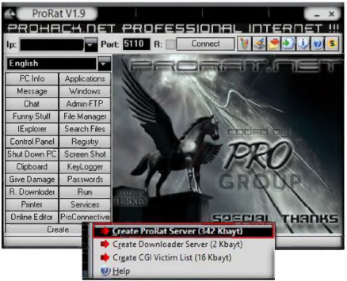

- The Create Server window appears.
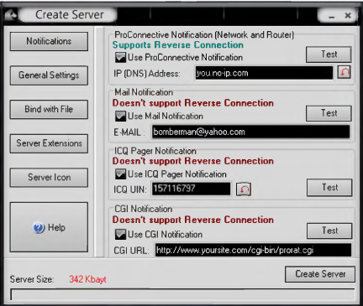

- Click General Settings to change features, such as Server Port. Server Password, Victim Name, and the Port Number you wish to connect over the connection you have to the victim or live the settings default.
- Uncheck the highlighted options as shown in the following screenshot.

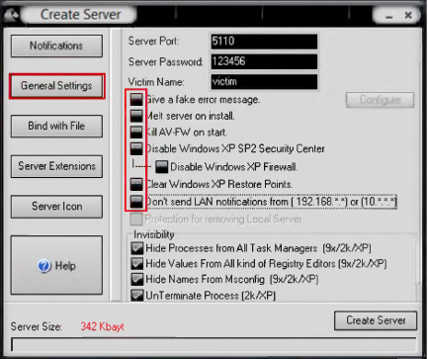

- Click Bind with File to bind the server with a file; in this lab we are using the .jpg file to bind the server.
- Check Bind s e r v e r with a file. Click S e le c t File, and navigate to the one drive folder Trojans and Backdoors\Trojans T yp e s\R em o te A c c e s s Trojans (RAT)\ProRat\lmages.
- Select the Girl.jpg file to bind with the server.

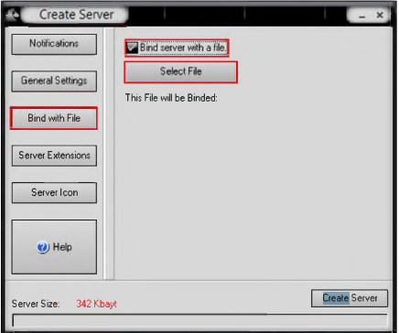

- Select Girl.jpg 111 the window and then click Open to bind the file.

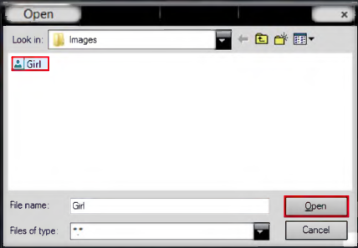

- Click OK after selecting the image for binding with a server.
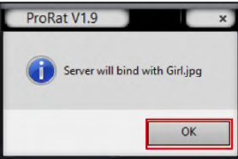

- In Server Extensions settings, select EXE (lias icon support) in Select Server Extension options.

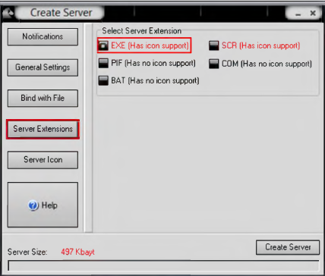

- In Server Icon select any of the icons and click the Create Server button at bottom right side of the ProRat window.

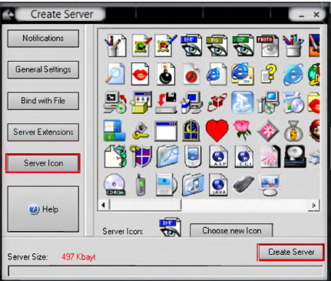

- Click OK after the server has been prepared, as shown in the following screenshot.

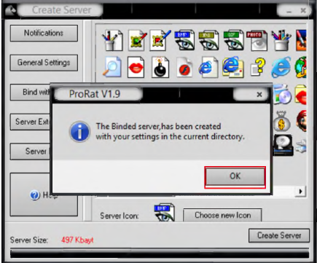

- Now you can send die server file by mail or any communication media to the victim’s machine as, for example, a celebration file to run.

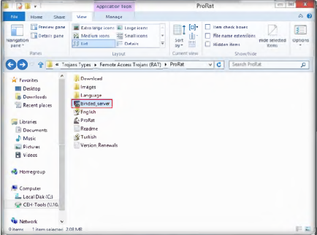

- Now go to Windows Server 2008 and navigate to Trojans and Backdoors\Trojans Types\Remote Ac c e ss Trojans (RAT)\ProRat.
- Double-click binder_server.exe as shown in the following screenshot.

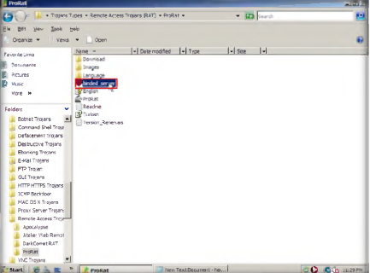

- Now switch to Windows 8 Virtual Machine and enter the IP address of Windows Server 2008 and the live port number as the default 111 the ProRat main window and click Connect.
- In this lab, the IP address of Windows Server 2008 is (10.0.0.13)

Note: IP addresses might be differ in classroom labs

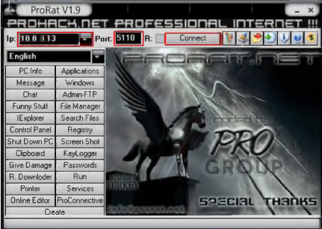

- Enter the password you provided at the time of creating the server and click OK.

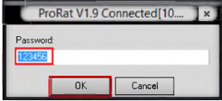

- Now you are connected to the victim machine. To test the connection, click PC Info and choose the system information as 111 the following figure.

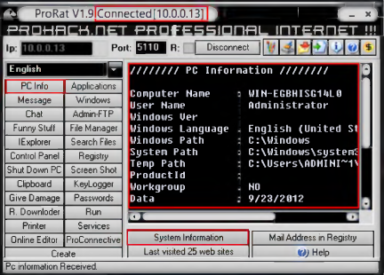

- Now click KeyLogger to steal user passwords for the online system.

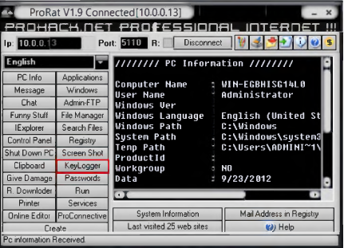

- The Key Logger window will appear.

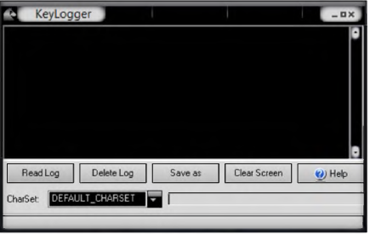

- Now switch to Windows Server 2008 machine and open a browser or Notepad and type any text.

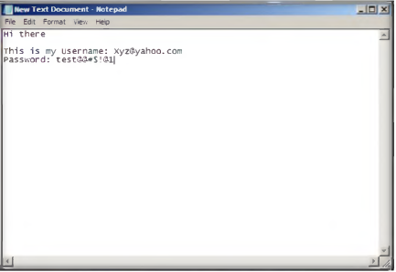

- While the victim is writing a message or entering a user name and password, you can capture the log entity.
- Now switch to Windows 8 Virtual Machine and click Read Log from time to time to check for data updates from the victim machine.

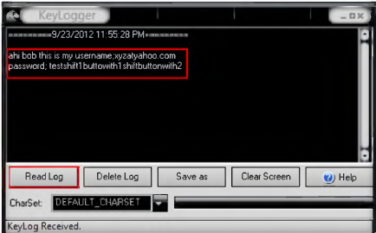

- Now you can use a lot of features from ProRat on the victim’s machine.

Note: ProRat Keylogger will not read special characters.

Lab Analysis

Analyse and document die results related to die lab exercise. Give your opinion on your target’s security posture and exposure posture public and free information.

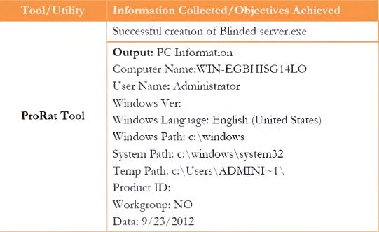

Questions:

- Create a server with advanced options such as Kill AV-FW on start, disable Windows XP Firewall, etc., send it and connect it to the victim machine, and verify whether you can communicate with the victim machine.
- Evaluate and examine various methods to connect to victims if they are in other cities or countries.

Task 2

Internet Worm Maker Thing is a tool to create norms. It also has a feature to
convert a virus into a norm.

Lab Scenario

In recent years there has been a large growth in Internet traffic generated by malware, that is, internet worms and viruses. This traffic usually only impinges 011 the user when either their machine gets infected or during the epidemic stage of a new worm, when the Internet becomes unusable due to overloaded routers. What is less well-known is that there is a background level of malware traffic at times of non-epidemic growth and that anyone plugging an unfirewalled machine into the Internet today will see a steady stream of port scans, back-scatter from attempted distributed denial-of-service attacks, and hostscans. We must better firewalls, protect the Internet router infrastructure, and provide early-warning mechanisms for new attacks.

Since you are an expert ethical hacker and penetration tester, your IT director instructs you to test the network to determine whether any viruses and worms will damage or steal the organization’s information. You need to construct viruses and worms, try to inject them into a dummy network (virtual machine), and check their behaviour, whether they are detected by an antivirus and if they bypass the firewall.

Lab Objectives

The objective of tins lab is to make students learn and understand how to make viruses and worms.

Lab Environment

To carry out the lab, you need:

- Internet Worm Maker Thing located at on the shared One Drive Worm Maker Thing\Generator.exe
- A computer running Windows Server 2012 as host machine
- Run this tool on Windows Server 2012
- Administrative privileges to run tools

A virus is a self-replicating program that produces its own code by attaching copies of it onto other e x e c u ta b le co d e s. Some viruses affect computers as soon as their codes are executed; others lie dormant until a determined logical circumstance is met.

Lab Tasks

- Launch die Internet Worm Maker Thing tool. Installation is not required for Internet Worm Maker Thing. Double-click and launch die Generator.exe file.

- The Internet Worm Maker Thing window appears.
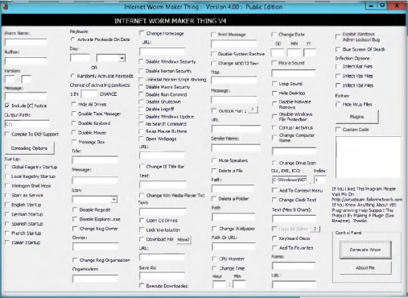

- Enter a Worm Name, Author, Version, Message, and Output Path for the created worm.
- Check the Compile to Exe support check box
- In startup: select English Startup.

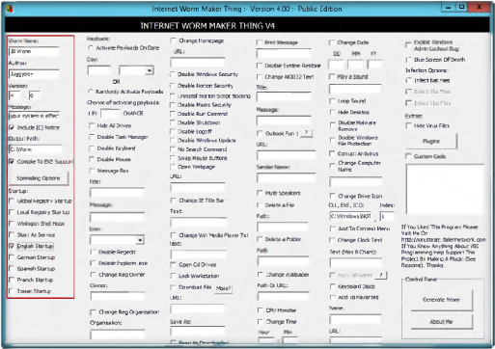

- Select the Activate Payloads on Data radio button, and for Chance of activating payloads, enter 5.
- Check the Hide All Drives, Disable Task Manager, Disable keyboard, Disable Mouse and Message Box check boxes.
- Enter Tile, Message, and Select Icon as Information from the drop-down list.
- Check the Disable Regedit, Disable Explorer.exe and change Reg owner check boxes.

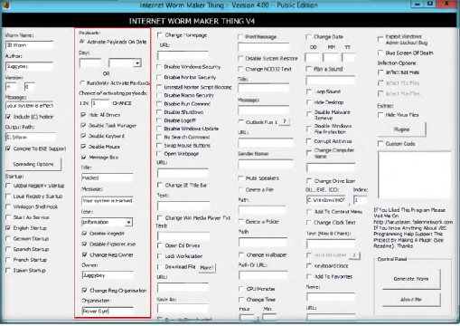

- Check the Change Homepage check box. In die URL held, enter http://www.powrgym.com.
- Check the Disable Windows Security. Disable Norton Security. Uninstall Norton Script Blocking. Disable Micro Security, Disable Run Command. Disable Shutdown. Disable Logoff. Disable Windows Updates. No Search Command. Swap Mouse button, and Open Webpage check boxes.
- Check the Change IE Title bar, change win Media Player Txt, Open Cd drive, and Lock workstation check boxes.
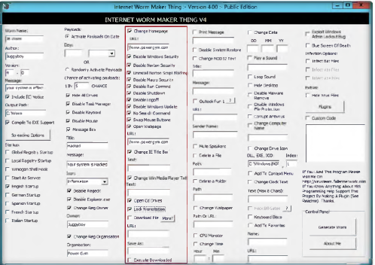

- Check the Print Message, Disable system Restore, and Change NOD32 Text check boxes.
- Enter a Title and Message in the respective fields.
- Enter die URL as http://www.powrgvm.com and the Sender Name as juggyboy.
- Check the Mute speakers. Delete a Folder. Change Wallpaper, and CPU Monster check boxes.
- Select the Change Time check box enter hour and min the respective fields.

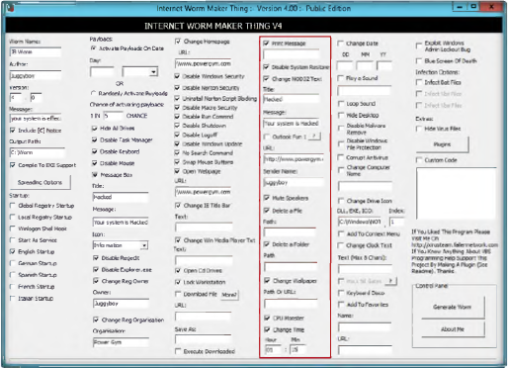

- Check the Change Date check box, and enter die DD, MM, YY in the respective fields.
- Check the Loop Sound, Hide Desktop, Disable Malware Remove. Disable Windows File Protection, Computer Antivirus, and Change Computer Name check boxes.
- Check the Change the Drive Icon, Add To Context Menu, Change Clock Text, Keyboard Disco, and Add To Favourites check boxes.

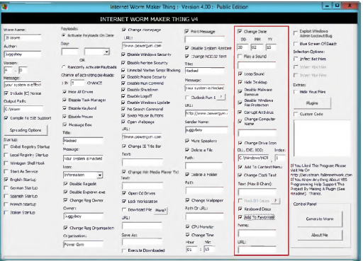

- Check the Exploit Windows Admin Lockout Bug and Blue Screen of Death check boxes.
- Check the Infect Bat Files check box from Infection Options.
- Check the Hide Virus Files check box from Extras.
- Click Generate Worm in Control Panel.

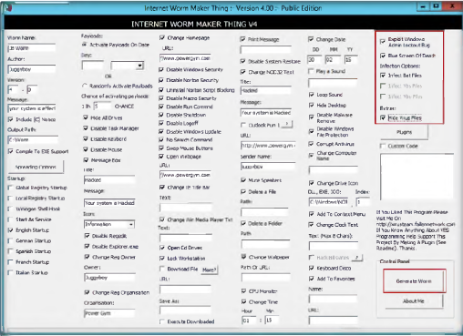

- The worm is successfully created. The following window appears. Click OK.

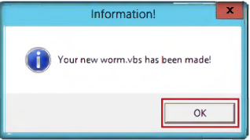

- The created worm.vbs file is located at the C: drive.

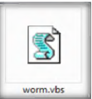

Lab Analysis

Document all die files, created viruses, and worms in a separate location.

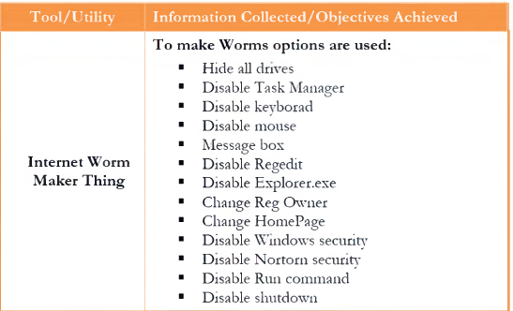

Questions

- Examine whether the created worms are detected or blocked by any antivirus or antispyware programs.

