Contents
Daniel James Cooksley (2008898) 1
Level-4-Assessment-Specification-Web and Database 1
ACCB4013-CW 1
Visio Draft Build 2
Access Final Build 3
Creation of Invoice 3

Daniel James Cooksley (2008898)

Level-4-Assessment-Specification-Web and Database

ACCB4013-CW

Visio Draft Build

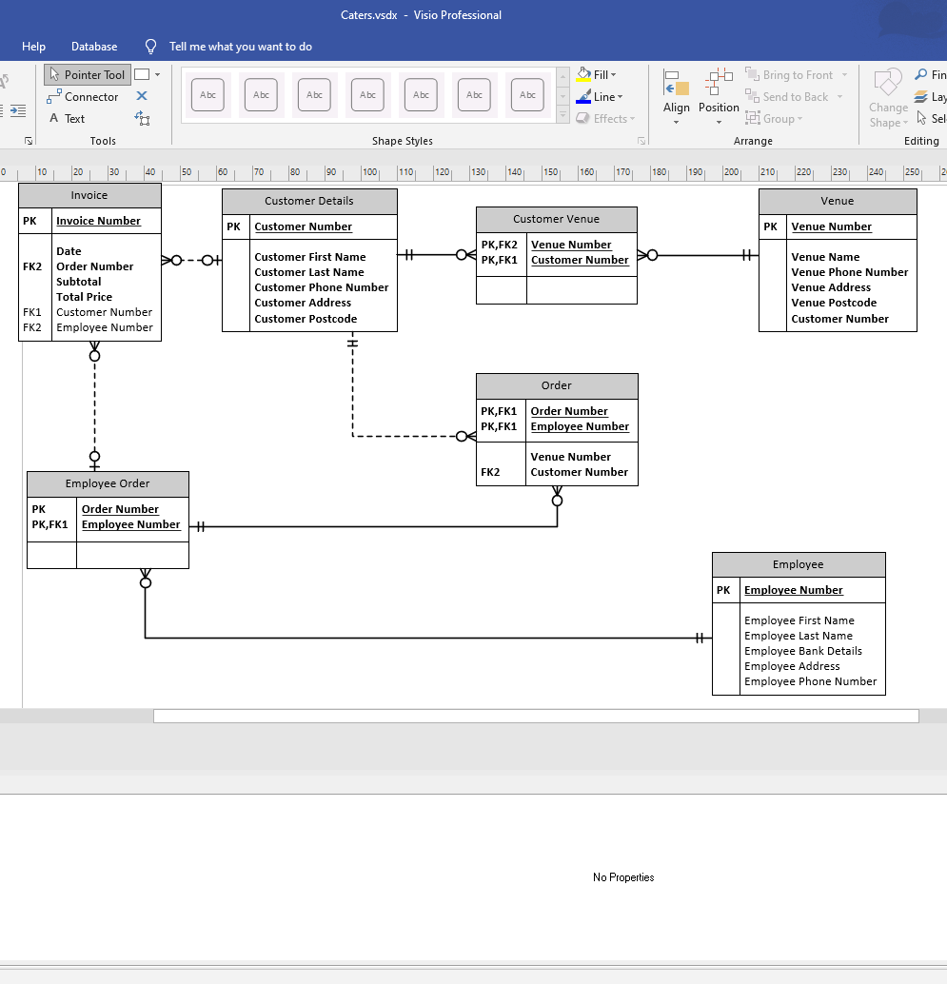
Above shows the original concept that I will implement in Access.
I’ve added relationships such PK and FK (Primary Key and Function Key/Foreign Key) This can change and may change whilst building the database in Access.

Access Final Build

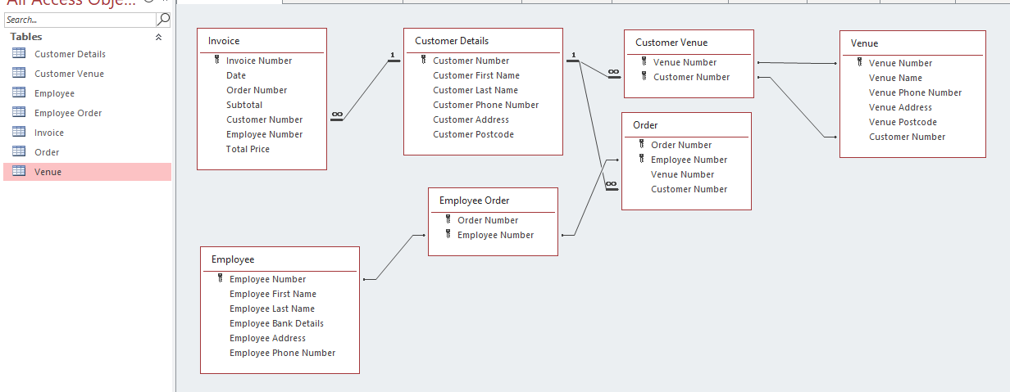

Above shows the finalised relationships within Access. As you can see the relationship shows 1 to many as they can be found on each form across the database this allows data to be pulled across from multiple tables. Making it easier for the end user to understand and easier to edit when it comes to creating forms, such as invoices and different reporting methods.

Creation of Invoice

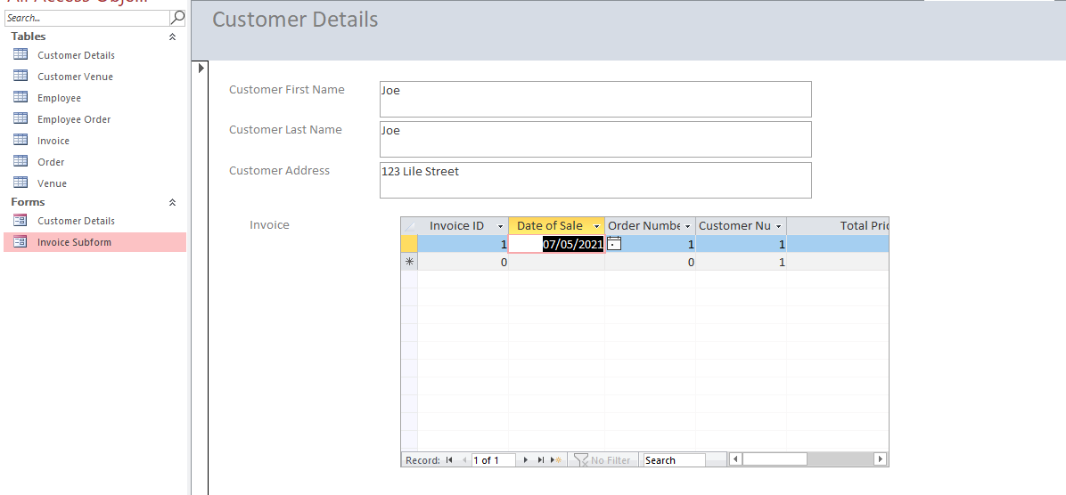
As you can see from the table above, I have now created invoicing for the end user to use when creating invoice. This makes it easier for the user to create an invoice using one sheet. I done this by using the form Wizard in access and giving the wizard to certain parameters and data I wanted to use in creating the “Invoice Form”

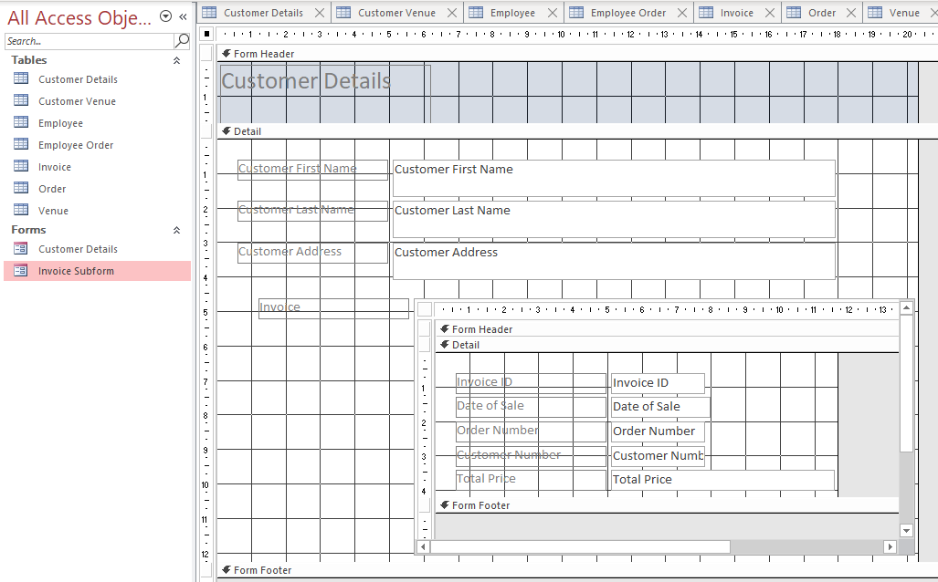
Here is the design view of the invoice allowing me to change the layout, to fit the end users needs and style. This can work to better suite the catering business on a vanity front allowing them to pick and choose colours and themes that fit with the catering business.

