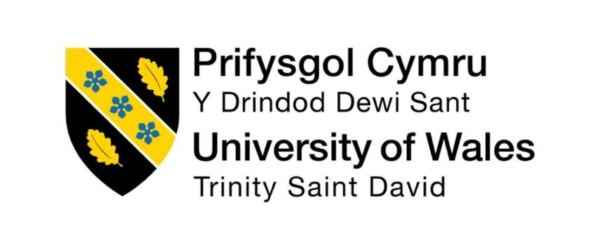

Programme: Master of Business Administration
Module: Human Capital Management
Module code: LCMB7023
Assesment Component 1: Individual Report
Word count: 2781
Lecturer : Ejike Udeogu (Birmingham)
Student Name : Sifat Al Galib
Student ID: 2438313
Submission Date- 17th October 2025

Table of content

1 | Introduction | 3
2 | Workplace Flexibility And Work-Life Integration: Redefining Organisational Boundaries | 3-5
3 | Skills-Based Talent Management: Moving Beyond Traditional Job Architectures | 5-7
4 | Hr Technology And Automation: Balancing Efficiency With Human Connection | 8
5 | Personal Competency Reflection: Bridging Cultural And Technological Divides | 9-11
6 | Conclusion | 11
7 | References | 11-13

INTRODUCTION
The HRM is currently going through an inflection point where the unparalleled amounts of technological change, shifting labour demographics and growing employee expectations are stretching or destabilising the conventional HRM practices with potentially profound implications to the practice of HR, the administration of labour and organisations more generally. I am a Bangladeshi student undertaking a postgraduate degree in the UK and thus I am witnessing how organisations in the developed and emerging economies are coping with the above transformative forces. The employer-employee relationship has changed with the generation diversity, speed of technological disruption and continued impacts of global health crisis that has posed new challenge to the talent management process and organisational development. This descriptive study identifies three major upheavals revolutionizing the HRM practice in the modern era: the evolution of traditional work arrangements to agile and boundaryless work systems; transformation of job-based talent management models to skills-based models; and the application of artificial intelligence and automation in the delivery of HR services. To the HRM and IHRM members, these trends and developments are both opportunities and threats that they should react to with complex strategies so as to experience global integration and local responsiveness. This discussion concludes with a reflection of some of the personal competencies that would enable me to negotiate this new landscape based on my experience as an international student who bridges Eastern and Western management paradigm.

WORKPLACE FLEXIBILITY AND WORK-LIFE INTEGRATION: REDEFINING ORGANISATIONAL BOUNDARIES
Flexibility in the workplace has lately assumed the format of a fundamental organisational policy, as opposed to a secondary employee perquisite, and has a direct impact on talent acquisition/retention and competitive edge. Kelliher and Anderson (2010) reveal that aside from the fact that the flexible working arrangements increase the organisational commitment and discretionary effort among employees, it also results into the reduction of the operational cost and reduction of the carbon footprint. And this change extends to the delivery of remote work capabilities to be inclusive of full-body work-life integration strategies that view the employee as a holistic human being with various duties and aspirations.

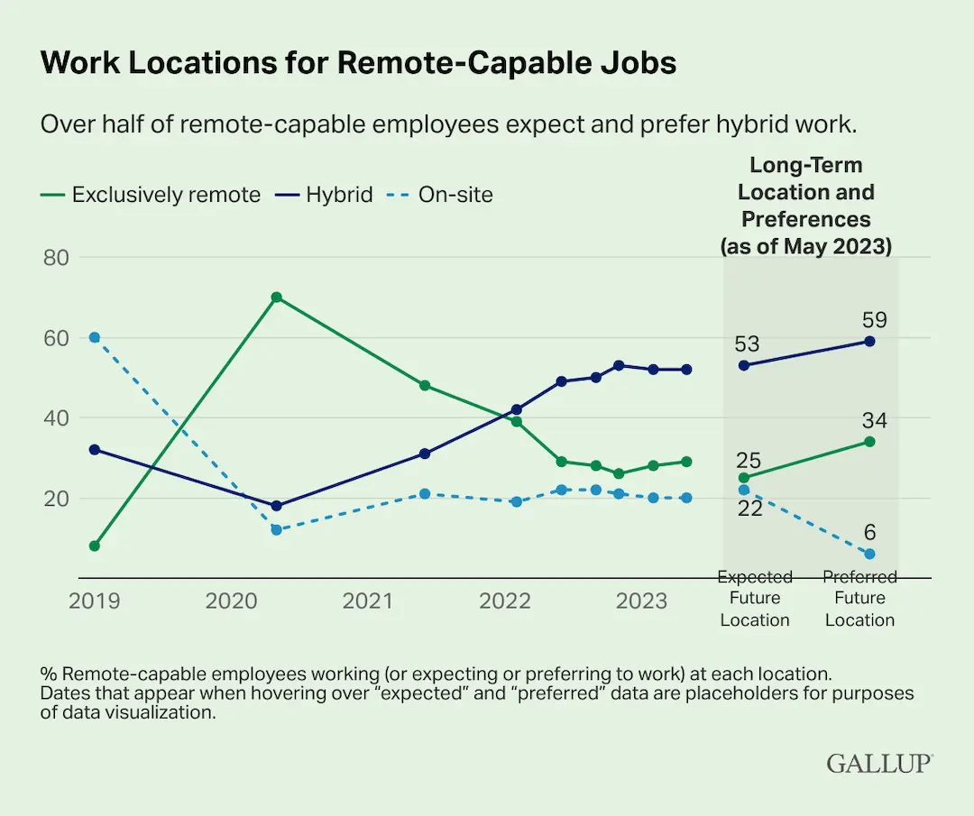
Source: Operating Model for Skills-Based Organization (Richardson Consulting Group, n.d.)
The contemporary HRM must develop flexibility system that will allow it to consider the different needs of employees without compromising organisational unity and efficiency. The example of Novartis, which provides staff with a range of different options to select their own uniquely designed work arrangements that align with their personal needs and those of the company under the so-called Choice with Responsibility programme (Beauregard and Henry, 2009).
Similarly, PricewaterhouseCoopers accounting firm has resorted to the idea of so-called flexable talent networks, which enable workers to increase or decrease their work levels on demand, which would otherwise lose good human resources to dichotomous approaches to employment (Kossek and Lautsch, 2018). These programs require developed policymaking responses that address practical problems like evaluation of results, fairness in promotion and growth as well as coordination of work in disjointed workplaces.
Particularly, the IMHRM implications of workplace flexibility are particularly muddled, since discrete regulatory environments, costume anticipations, and traffic environments would like to inspire task. Caligiuri and Bonache (2016) speak about the great difference in preferences related to flexibility in national cultures where autonomous work order is less accepted by collective cultures than individualistic societies where physical presence and face-to-face communication are the priorities. To illustrate it, the concept of working remotely in Bangladesh is directly going against the historically ingrained hierarchal chain of command culture surrounding the physical presence of an employee at the workplace, which requires a slow implementation plan (Rahman and Hossain, 2020).
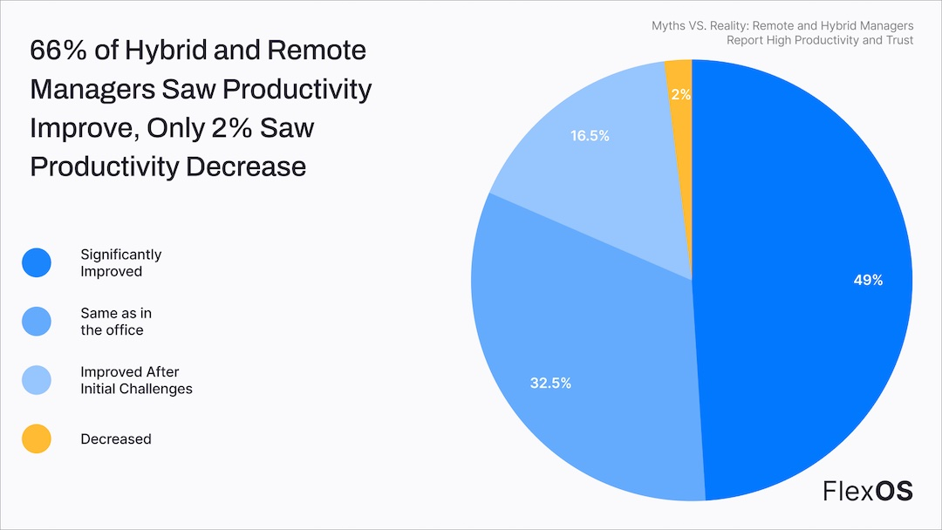
Source: Global Adoption of AI and Automation in HR (Deloitte Insights, 2023)
Moreover, as different jurisdictions have varying labour laws, it becomes more difficult to ensure that multinationals adopt global flexibility policies across the board. In sharp opposition to the scenarios that are less controlled in some areas of the Asia-Pacific, regulation such as the right to disconnect in the European Union requires IHRM professionals to develop frameworks that will support the local legal requirements and allow organisations to uphold fairness (Eurofound, 2021).

SKILLS-BASED TALENT MANAGEMENT: MOVING BEYOND TRADITIONAL JOB ARCHITECTURES
The increased rate of technological change, the business model evolution and consequent obsolescence of the traditional job based organisational framework is generating the push behind the move towards job based to skills based talent management systems. Cappelli and Keller (2014) argue that the skills-oriented methodology enables greater flexibility of the organization because of the emphasis on capabilities compared to the formal structure that causes the rapid redistribution of resources with the fluctuations of the market. It involves redesigning the HR core processes which include workforce planning, talent acquisition, career management and pay models.
The leading organisations are establishing new structures of managing talent based on skills, which are focused on capability development as opposed to promotion up the hierarchy. IBM is a platform known as Your Learning and it is an artificial intelligence that proposes individualised skill learning paths according to the career objectives and skill gaps, as well as gaps in organisational capabilities and it accumulates 130+ million learning hours annually (Kiron et al., 2021).
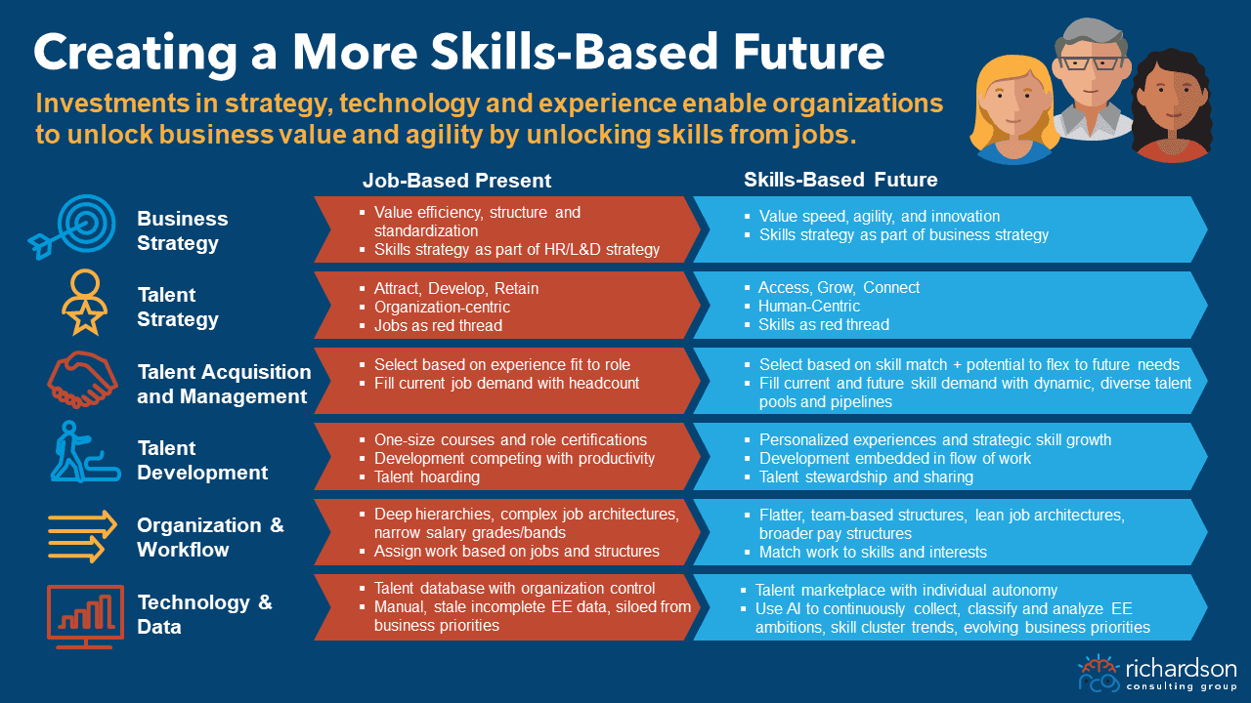
Source: Key Areas of Digital Transformation in HRM (AIHR, 2024)
Further, Schneider Electric implemented an internal talent market, the company matches employees with project opportunities by their skills and capabilities instead of their existing job titles and reduced external recruiting cost by 40 percent and internal mobility rose by 40 percent (Jesuthasan and Boudreau, 2018). These systems require extremely advanced skills taxonomies, ongoing ability measurement systems, and a cultural change in which learning agility is considered to be more important than position power. The use of global skills-based talent strategy might be a challenging task to IHRM practitioners because skills are technical in nature (e.g., how to identify, compare and create skill equivalencies across countries; how capabilities are manifested in various ways across cultures). The difference between countries regarding educational systems, training directions, and professional levels of certification is too broad, and it is hard to evaluate skills and compare them (Thunnissen and Buttiens, 2017).

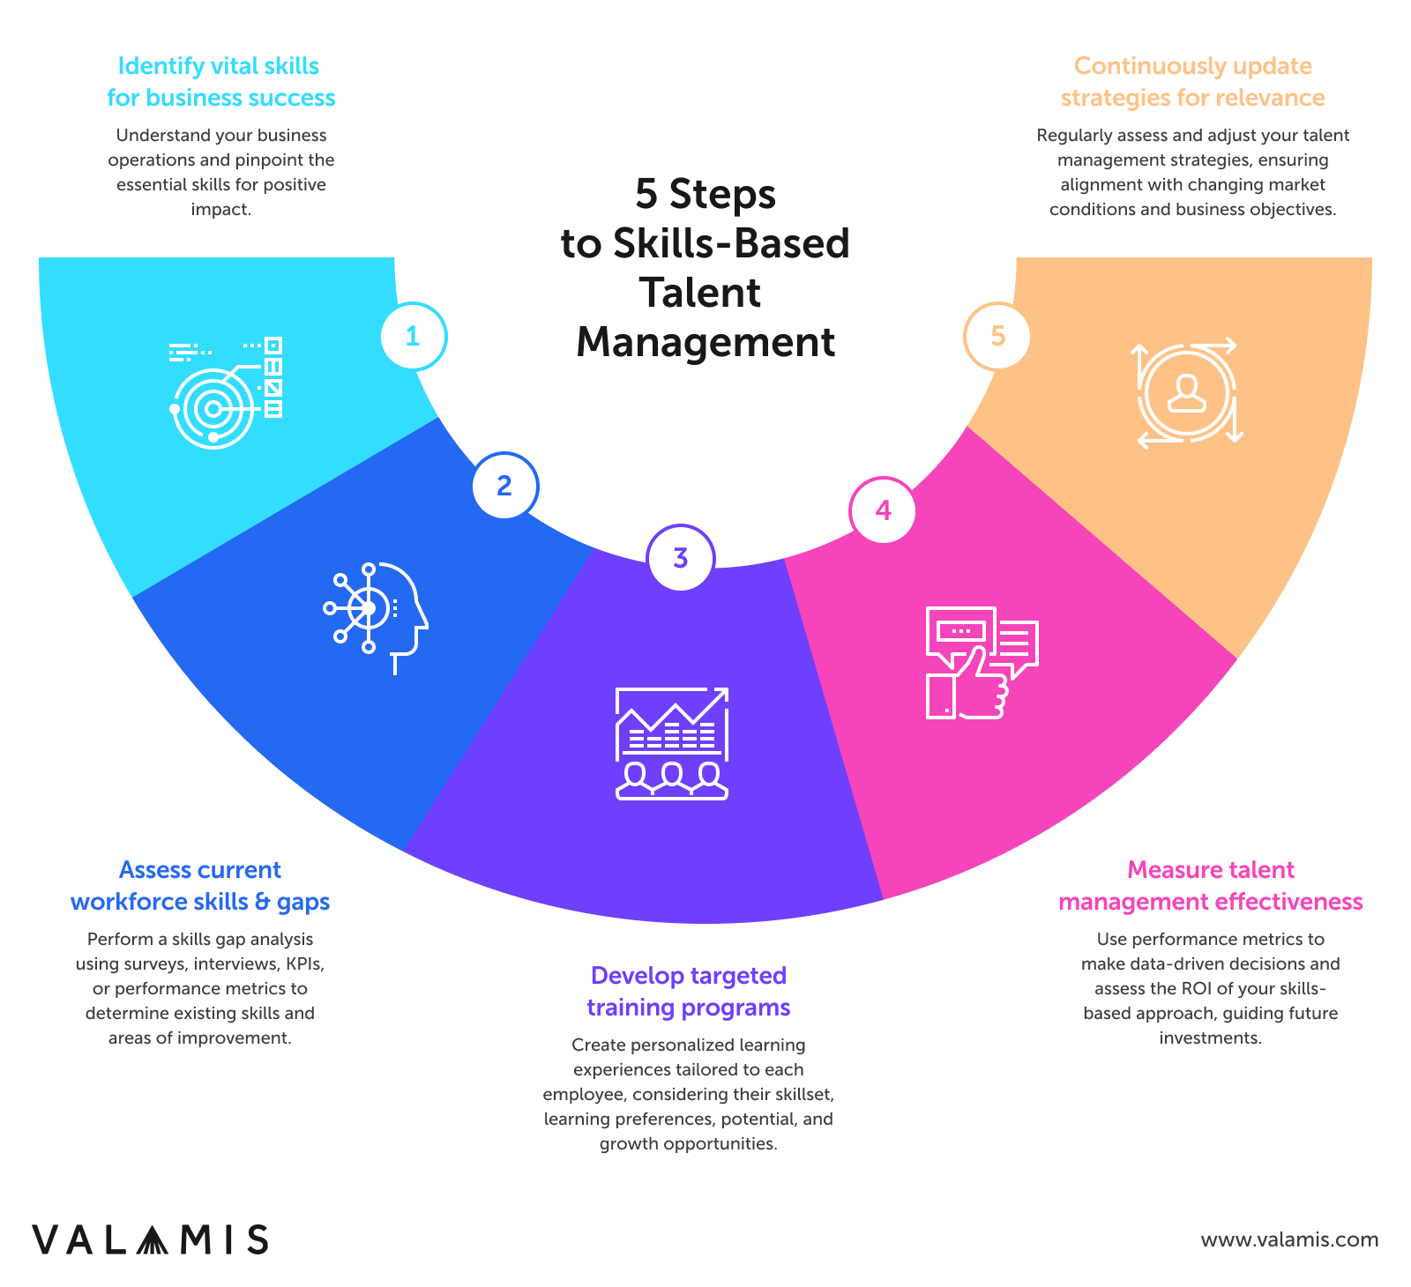
Source: Hybrid and Remote Work Statistics 2024 (FlexOS, 2024)
This is complicated by the fact that in my own case, despite theoretically equal competencies using the classes achieved via Bangladesh engineering education system, much contextualisation was required to bring the competencies up to the standards of the UK industry. Further self-promotion and articulation of capabilities influence visible skills because in the evaluation process employees of high context cultures like Bangladesh tend to underprice and downstate their capabilities compared to those of Western countries like USA (Tung, 2016). Successful global skills strategies and access pathways involving culturally responsive assessment techniques need to feature as well to ensure that they are just and equal to the different cultural contexts where they exist.

HR TECHNOLOGY AND AUTOMATION: BALANCING EFFICIENCY WITH HUMAN CONNECTION
Having AI, machine learning (ML) and robotic process automation integrated into the service delivery of HR is a groundbreaking move in the way organisations handle their human capital. Strohmeier (2020) singles out three waves of HR digitalisation, including process automation, predictive analytics, and prescriptive intelligence, each of which is more sophisticated in terms of how HR can make a difference.
However, human aspect of human resources, privacy and algorithmic bias have been posed as questions by this change of technology. To the progressive organisations, the effects of HR technology are not limited to automation but rather increased traditional human decision making and the creation of hybrid systems where technology and people are a complement to one another based on sound pragmatism, efficiency and judgment. In the case of Unilever, gamification and AI-driven video analysis in the online recruitment processes are used to screen candidates, and the results have seen the company cut their time-to-hire by 90 per cent and deliver diversity results by eradicating biases (Tambe et al., 2019).
Conversely, conversational AI is employed by Hilton Hotels to address common employee questions and then direct the time of HR professionals to more complex, high-value activities that demand emotional intelligence and rational thinking (Malik et al., 2021). When used responsibly, these fulfil the vision of technology, which makes work more human, rather than less. There are also more opportunities and risks in HR technology in the IHRM. Once an organisation takes a global step, it has to consider the character of the technical infrastructure, the degree of digital literacy, the rules and regulations that are different in various territories where the organisation operates.
In the meantime, the Artificial Intelligence Act set by the European Union assigns the stricter requirements to the application of such AI systems in the employment settings compared to the lax regulatory climate in the rest of the world (European Commission, 2021). There are also significant differences in the lingering relational attitudes of societies toward the technology mediated interactions; whereas Scandinavian countries are free-flowing in accepting digital HR services, highly relationship-oriented cultural settings of South Asia and Latin America might find automated systems cold and detached (Bondarouk and Brewster, 2016).
My personal experience is a context because I have traversed the maze of the relationship-based business culture in Bangladesh to the transactional world of the UK and thus I noticed that technology adoption must be localised not only in the context of cultural expectations but also in the context of architectural structure without compromising the integrity of the global system.

PERSONAL COMPETENCY REFLECTION: BRIDGING CULTURAL AND TECHNOLOGICAL DIVIDES
The HRM landscape has been transformed and so has the requirement of matured technical capabilities, cultural acuity and nimbleness. The experience of being a Bangladeshi student in the UK has revealed my strengths related to the cross-cultural experience and developmental aspects that need to be addressed in the future to ensure future success.
Global Mindset and Cultural Intelligence
Strengths: I have been raised in a collectivistic, highly-hierarchy-driven culture of Bangladesh, and now I live in the UK, which is significantly more egalitarian and individualistic; hence, my code-switching skills are extremely high. In a recent British-Bangladeshi business consulting assignment, I was able to act as a moderate with the requirements of standardisation at headquarters and the requirements of localisation at the subsidiary; I was able to negotiate innovative compromises which appreciated both sides.
This strengthened my culture as a cultural translator translating not only the language, but more abstract assumptions and values. Areas of enhancement - I have been exposed to cultures mostly South Asian and British hence I might have blind spots when dealing with other cultural paradigms. As an example, I struggle with Anglo-Germanic conflict-strategies and high-context culture of indirectness of East Japanese cultures such as Japan.
Challenged with: Participation in the Global Virtual Teams program of the university, completion of one semester project with students of five or more cultural backgrounds. I will also complete the Leading Across Cultures certification on Erin Meyer to acquire frameworks to work or even work nearby a culture that I will be no longer familiar with. Digital Literacy and Data Proficiency.
Since: The first section regarding weakness strengths you people know that I am an engineer by my under graduation in Bangladesh so I have good background education in quantitative base in Bangladesh. Therefore I will be able to acquire the data analysis skill set at the earliest stage. Recently I have completed a course on Python in HR analytics where I used machine learning algorithms to predict employee engagement.
Development Areas: I am solid technically, but still, have little experience with the working process of the enterprise HR systems in large organizations. As Bangladesh is primarily a country of small and medium enterprises, I was not accustomed to the integrated talent management platform, such as that of Workday or SuccessFactors.
Plan of Action: I would become a certified SAP Success Factor using the university corporate partnership programme which offers SAP modules via the internet and SandBoxes where I will be able to test the system. In addition, I will only seek internship opportunities in organisations that are still undergoing HR digital transformation.
Change Management & Transformation Leadership
Strengths: Strong and adaptable to change, having gone through both the educational systems in both Bangladesh and the UK, this has given me a lot of personal strength As a member, I initiated a change process that made the governing structure and the communication channels of the Bangladeshi Student Association very modern, forcing the traditional members out of the way.
Areas of improvement: I have been involved in change management previously but in a laid back manner without a management system and a framework. In the presence of opposition to the change, I can openly confess that I have found myself being trapped most of the times in my attempts to create a consensus at the cost of acting. Step 3: I have enrolled in the Change Management Certification offered by Prosci that will provide me with more approaches to organisation that are structured in transformational leadership. Moreover I will volunteer to facilitate the digitalisation of one of the local charities, where aspects of change management can be put into effect and its outcomes evaluated.
Ethical Leadership and Sustainable Practice
Weaknesses: See and feel Deep commitment. To illustrate the point, I recently started working on sustainable supply chains and how they are conducted in the garment industry and suggested the frameworks that will enable a balanced economic development and welfare of workers.
Area of Development: To illustrate, my business ethics at times do not fit well with my ethical principles especially when dealing in other countries that have different ethical practices. I am uncomfortable trying to fit in where local custom is in conflict with my own system of values and I appear so obstinate and judgemental.
Action plan: I will also become a member of the Business Ethics Circle at the university where I will participate in case studies whereby we will be required to consider ethical dilemmas in the various cultures. I will also take the Business and Human Rights course of the UN Global Compact, constructing blueprints of the most obscure ethical waters. Strategic Thinking and Business Acumen.
Weaknesses: I am immensely analytical and systems-oriented as a part of my thinking due to my educational background and professional experience in the field of engineering and business. Being a summer intern of a UK manufacturing company, after I noticed the correlations between HR measures and operational performance, I proposed integrated dashboards, as a result of which regardless of their adoption or nonadoption, there was increased strategic thinking.
Strengths: I sometimes fail to value dynamics with mature markets and established industries because of the emerging section of the Bangladesh economy to which I belong. There are occasions when the strategic advice which I give can be thoughtless, amorphous, and/or theoretical by the practitioner who has many years of industry experience.
What I will do: Participate in MBA Challenge of Financial Times where I will be analysing real-life business cases and comparing my recommendations with the professional solution. I will also seek the assistance of senior HR practitioners to mentor me on how to create effective strategy in practice using the CIPD mentoring programme.

CONCLUSION
The development of HRM reflects the wider social trends toward flexibility, emphasis on skills and technology uptake, which demand human-centered-practitioners able to operate to increasing degrees of complexity. Diversity of geographic cultures will make new issues like puzzle of how to achieve acceptance of flexible working arrangements, how the BLR-based talent systems would be practically presented and received locally (or not) etc. etc but all of this will create unique set of complexities in which art of the successful implementation of the practices would have to incorporate scale along with a local lead footed sophistication.
In this regard, my experience of moving to the UK after leaving Bangladesh has helped me understand, how cross cultural experience can be a resource in dealing with the duality and yet, regions of development that will be important to be relevant in the future. The vision of CTHUM is a future-proof HRM profession, and competencies to be successful in transformed HRM are not limited to technical competence, but also to true orientation towards culture, ethics, and flexibility. By being purposeful in the development of such capabilities, based on their own varied perceptions through different cultural experiences, emerging HR professionals can create a meaningful contribution to more agile, inclusive, and sustainable organisations. HRM will not belong to the individuals who sit at the fence and observe the debacle of technology versus man, global versus local, efficiency versus empathy and so on - but those who will take part in connect-the-dots-game in order to produce work environments that will take care of both personal well-being and business success.

REFERENCES
AIHR. (2024) Digital Transformation in HR: Trends, Tools, and Strategy. Available at: https://www.aihr.com/blog/digital-transformation-in-hr/ (Accessed: 16 October 2025).
Beauregard, T.A. and Henry, L.C. (2009) 'Making the link between work-life balance practices and organizational performance', Human Resource Management Review, 19(1), pp. 9-22.
Bondarouk, T. and Brewster, C. (2016) 'Conceptualising the future of HRM and technology research', The International Journal of Human Resource Management, 27(21), pp. 2652-2671.
Boxall, P. and Purcell, J. (2016) Strategy and human resource management. 4th edn. London: Palgrave Macmillan.
Caligiuri, P. and Bonache, J. (2016) 'Evolving and enduring challenges in global mobility', Journal of World Business, 51(1), pp. 127-141.
Cappelli, P. and Keller, J.R. (2014) 'Talent management: Conceptual approaches and practical challenges', Annual Review of Organizational Psychology and Organizational Behavior, 1(1), pp. 305-331.
CIPD (2023) Flexible working practices report 2023. Available at: https://www.cipd.co.uk/knowledge/fundamentals/relations/flexible-working/flexible-working-practices (Accessed: 16 October 2025).
Collings, D.G., Wood, G.T. and Szamosi, L.T. (2019) Human resource management: A critical approach. 2nd edn. London: Routledge.
Deloitte (2023) Global human capital trends: New fundamentals for a boundaryless world. Available at: https://www2.deloitte.com/us/en/insights/focus/human-capital-trends.html (Accessed: 16 October 2025).
Deloitte Insights. (2023) The Skills-Based Organization: A New Operating Model for Work and the Workforce. Available at: https://www.deloitte.com/us/en/insights/topics/talent/skills-based-organization.html (Accessed: 16 October 2025).
Eurofound (2021) Right to disconnect: Exploring company practices. Available at: https://www.eurofound.europa.eu/publications/report/2021/right-to-disconnect-exploring-company-practices (Accessed: 16 October 2025)
European Commission (2021) Proposal for a Regulation on Artificial Intelligence. Available at: https://digital-strategy.ec.europa.eu/en/policies/regulatory-framework-ai (Accessed: 16 October 2025)
FlexOS. (2024) 100+ Hybrid Work Statistics and Trends. Available at: https://www.flexos.work/learn/hybrid-work-statistics-and-trends (Accessed: 16 October 2025).
Jesuthasan, R. and Boudreau, J. (2018) Reinventing jobs: A 4-step approach for applying automation to work. Boston, MA: Harvard Business Review Press.
Kelliher, C. and Anderson, D. (2010) 'Doing more with less? Flexible working practices and the intensification of work', Human Relations, 63(1), pp. 83-106.
Kiron, D., Schrage, M. and Boudreau, J. (2021) Workforce ecosystems: A new strategic approach to the future of work. Available at: https://sloanreview.mit.edu/projects/workforce-ecosystems-a-new-strategic-approach-to-the-future-of-work/ (Accessed: 16 October 2025).
Kossek, E.E. and Lautsch, B.A. (2018) 'Work-life flexibility for whom? Occupational status and work-life inequality in upper, middle, and lower level jobs', Academy of Management Annals, 12(1), pp. 5-36.
Malik, A., Budhwar, P., Patel, C. and Srikanth, N.R. (2021) 'May the force be with you: The role of HR technology in enhancing HR service delivery', The International Journal of Human Resource Management, 32(7), pp. 1470-1494.
PwC (2023) Workforce of the future: The competing forces shaping 2030. Available at: https://www.pwc.com/gx/en/services/people-organisation/workforce-of-the-future/workforce-of-the-future-the-competing-forces-shaping-2030-pwc.pdf (Accessed: 10 May 2024).
Rahman, M.S. and Hossain, M.I. (2020) 'Flexible working arrangements in Bangladesh: Evidence and challenges', South Asian Journal of Human Resources Management, 7(2), pp. 235-252.
Richardson Consulting Group. (n.d.) An Operating Model for Building a Skills-Based Organization. Available at: https://richardsonconsultinggroup.com/an-operating-model-for-building-a-skills-based-organization/ (Accessed: 16 October 2025).
Sparrow, P., Brewster, C. and Chung, C. (2017) Globalizing human resource management. 2nd edn. London: Routledge.
Strohmeier, S. (2020) 'Digital human resource management: A conceptual clarification', German Journal of Human Resource Management, 34(3), pp. 345-365.
Tambe, P., Cappelli, P. and Yakubovich, V. (2019) 'Artificial intelligence in human resources management: Challenges and a path forward', California Management Review, 61(4), pp. 15-42.
Thunnissen, M. and Buttiens, D. (2017) 'Talent management in public sector organizations: A study on the impact of contextual factors on TM approach', Public Personnel Management, 46(4), pp. 391-418.
Tung, R.L. (2016) 'New perspectives on human resource management in a global context', Journal of World Business, 51(1), pp. 142-152.
World Economic Forum (2023) The future of jobs report 2023. Available at: https://www.weforum.org/reports/the-future-of-jobs-report-2023 (Accessed: 10 May 2024).

