A Comprehensive Strategic Marketing Plan for Morrisons in the UK Retail Industry

Module Title: Principles of Marketing
Module Code: LCBB5015
Assessment Type: Report
Student Name:
Elvis Fanel Margelu
Carmen Niculae
Valya Borisova
Diana Luhova
Vasile Emanuel Dumitru

Executive Summary
The marketing report has critically analysed the external environment of the UK grocer Morrisons. It has been found that the company has both opportunities and challenges in the UK retail sector, which is fluctuating as well as growing in parallel. PESTEL Analysis revealed the complete external environment and the retail landscape of the UK. A STP analysis has been conducted for the renowned retail company, Morrisons, to state its segmentation, targeting and Positioning strategies. Additionally, its integrated marketing approaches have been highlighted in the report.
Morrisons has used its own food production methodology to revive its growth. It has resulted in considerable cost reductions and network expansion for Morrisons Daily. To maintain its position as a major rival in the UK market, the corporation has also increased client loyalty and expanded its online presence through Amazon. The following task has focused on evaluating some major implementations and controlling approaches through key aspects. This generally involves the utilisation of Key Performance Indicators and balanced scorecards in contrast with their aim to ensure a better marketing plan.
Table of Contents
Introduction 4
Introduction to Morrisons and the UK retail industry 4
Outlining the report 4
PESTEL Analysis 5
Marketing Strategy 7
STP analysis 7
Integrated Marketing 7
Implementing the Ansoff Matrix in the Business 9
Applying the Marketing Mix Strategy of 7Ps 11
Implementation and Control 14
KPIs for Morrisons 14
Balance Scorecards in the Organisation 14
Conclusion 16
Recommendations 16
References 17

Elvis Fanel Margelu
Student Id:2328842

Introduction

Introduction to Morrisons and the UK retail industry
Morrisons Supermarket Limited is a premium and prominent British grocer headquartered in West Yorkshire. It operates within the highly competitive UK retail industry and distinguishes itself mainly through its vertically integrated business model. Morrisons is the only UK grocer that manages its own food production through Myton food group that manufactures 50% of the fresh food that it sells (Morrisons, 2026). The main products sold by Morrisons are daily groceries, clothing under their Nutmeg brand, which are delivered to customers through 1800 supermarkets and Morrisons daily convenience stores. Morrisons is the 5th largest UK supermarket at present, with a market share of 8.3% as of March 2026 (Farrell, 2026). The retail market in the United Kingdom is growing, and the sales have increased for the first time in three months, since February 2026. Tesco PLC is the market leader with 28% share of the UK grocery retail market. The total retail sales value in the country was £492 billion in 2025.

Outlining the report
The report will be a comprehensive marketing plan for Morrisons, designed to achieve its marketing goals and objectives. A marketing plan provides the strategic road map for achieving the organisation's sales targets and maximising the impact of marketing activity. The key area of focus will be situation analysis, or the PESTEL analysis, for the external environment of the company. followed by a marketing strategy analysis consisting of STP, integrated marketing and an Ansoff matrix. Finally, a marketing mix strategy consisting of 7Ps will be given for meeting the marketing objectives of the retailer.

PESTEL Analysis
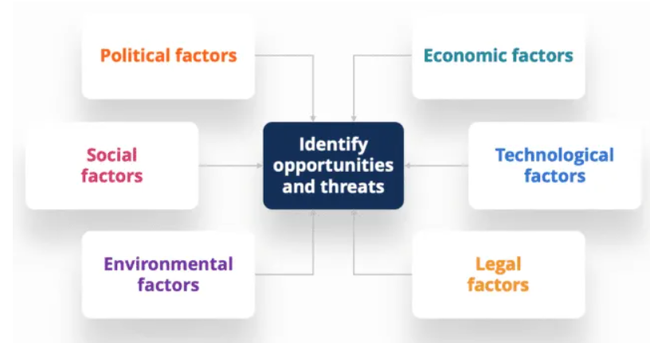
Figure: PESTEL Analysis
Source: (Peterdy, 2022)
Political factors
The government has recently introduced higher employer taxes and the new level for packaging, which can have a significant impact on the profit margins of Morrisons. Also, the new minimum wages for workers set by the government are going to impact, which can lead to cost headwinds as of 2026. Supply chain disruptions continue to plague the sourcing of its raw goods and imported products, though the vertical integration of the company partially helps it mitigate these risks as compared to its competitors.
Economic Factors
Food inflation in the UK has increased to 3.3% year-on-year as of February 2026 (Tradingeconomics, 2026). This is likely to have an impact on the sales of the company as consumers are preferring value in cheaper options over highly branded products. Morrisons has slipped to 5th position in the market due to its sales growing only by meagre 2.3%. The super-fast market penetration by discounters such as Aldi and Lidl is a cause of worry for the grocer. However, being a part of the largest employment sector of the U, which has 3.7 million people, the annual value of sales is likely to grow.
Social Factors
UK households are prioritising healthy eating and purchasing value-based products. Health is their top concern, which has led to a huge demand for high-fibre and high-protein food. Morrisons needs to capitalise on this growing trend of health and wellness among the people. It can help in distinguishing itself from the competitors and secure a better and comparative position in the market. People are also willing to spend 10% extra for buying sustainable and healthy foods that have a clear supply chain and reduce environmental impact.
Technological Factors
Artificial intelligence and automation are rapidly disrupting and reshaping the retail landscape in the country, which has spooked the workers due to the possibility of job losses. Morrisons is rapidly developing AI and machine learning using Google Gemini, which has put 200 jobs at risk (BBC, 2026). They are using Google Cloud to build Vertex AI for accurate machine learning and forecasting models to help business departments make strategic decisions. Therefore, in 2026, the UK retail market will be largely influenced by technological factors.
Environmental factors
The UK government has made stringent laws regarding carbon reporting that require retailers to integrate the sustainability Matrix and strictly adhere to them, especially in logistics and production. The packaging level and public sentiment against single-use plastic have further accelerated the use of recyclable and reusable packaging for all private-level goods in the UK retail market. The organisation is committed to achieving net zero emissions by 2050 with 80% reduction in scope 1 and scope 2 emissions (Morrisons, 2026).
Legal Factors
The main legal factor for the company is paying the minimum national wage of £12.71, effective April 2026 onwards. Along with that, the changing labour dynamics in the retail market and the rise of the gig economy are likely to impact the cost of staffing on its workforce. It also abides by the employment laws and the local operating awards, without which it may be subjected to strict fines and penalties from the regulatory bodies.

Carmen Niculae
Student Id:2431195

Marketing Strategy

STP analysis
Segmentation
Morrisons has divided its UK grocery market primarily based on four distinct factors, such as Geographic, Demographic, Psychographic, and Behavioural. The marketing approaches of this company are mainly focused on the UK, along with having a strong presence in the North of England. Along with that, it has also expanded nationwide with smaller convenience formats. For the demographic factor, its targets are the middle-income earners, families and the consumers who value traditionally prepared fresh food items. Additionally, its psychographic targets are customers who value provenance, quality and sustainability, while its behavioural segment focuses towards consumers who value market street fresh food, online convenience and value for money.
Targeting
A multi-segment target and differentiated strategy are utilised by Morrisons. The company targets families that prioritise high-quality and fresh food at a competitive price, along with focusing on consumers who value skilled and in-house food preparation. In addition to that, this respective retail target audience can be said to be targeting the convenience shoppers, as well as the customers prioritising vegan, organic or health-conscious food products.
Positioning
A competitive, value-oriented pricing strategy is combined with the offering of high-quality fresh food by Morrisons to showcase itself as a unique retailer. Its unique selling point is vertical integration by owning bakeries, butchers, produce packing and other manufacturing sites, which helps in ensuring traceability, freshness and quality control. The company’s positioning statement is focused towards high standards in fresh foods, friendly customer service and hygiene (Morrisons-corporate, 2026). Additionally, its pricing strategy is observed to be competitive in order to maintain quality while offering value.

Integrated Marketing
Fresh from Market Street Campaign
The above-mentioned marketing campaign of Morrisons helps the company to highlight its collaboration and relationships with British fishermen and farmers (Leoburnett, 2026). These strategic partnerships also help the respective retail firm to represent its expertise in in-store bakers and butchers. Additionally, it can naturally showcase the ability of the renowned brand to offer fresh and high-quality food products at a competitive price, which can help it to attract consumers.
Omnichannel Loyalty
Morrisons promotes its More Card initiative and loyalty program heavily, which is one of its integrated marketing strategies as well (Morrisons, 2026). Through this loyalty program, digital application experiences are linked with the company’s physical stores to provide loyalty rewards to the customers. Personalised data is used in this strategy to drive consumer engagement through the implementation of this strategy, which helps the brand to generate sales and revenue.
Retail Media
Advanced digital tools and technologies have been adopted by Morrisons to enhance its customer service standards and quality. One of such initiatives is the Morrisons Media Group, through which a one-stop shop for suppliers is offered by the brand (The Morrison Media Group, 2026). Through this strategy, the customer engagement is fostered through online channels, digital screens and social media, helping in enhancing brand appeal. Enhanced customer engagement and brand appeal can naturally act as a key component of the company’s integrated marketing strategy to attract consumers and drive sales.

Valya Borisova Student Id:2430598

Implementing the Ansoff Matrix in the Business
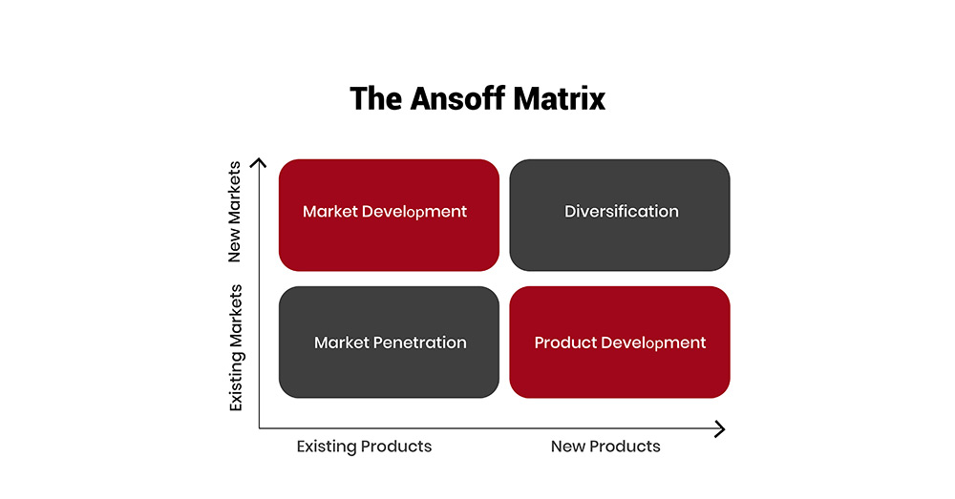
Figure: Ansoff Matrix
Source: (Thestrategyinstitute, 2024)
Market Penetration
Market penetration with the existing product and in the existing market is the lowest risk strategy for Morrisons. The company uses its Match and More cards for its business enhancement to rival Tesco and Sainsbury’s. On the other hand, the application of Morrisons More allows its customers to access loyalty programs. Consumer retention can be possible with the approach, and store refurbishment is an option as well for enhanced marketing approaches.
Market Development
Market development is the notion that involves existing products and a new market for the promotion of offerings. Gaining a new segment of customers with the existing products by expanding the business into urban shoppers who may not have previously had access to supermarkets (Peterdy, 2022). Moreover, partnering with Amazon and McColl’s have been helpful for the company to strategies its advancement in new markets. Opening new sites in the South of England and London can be beneficial for the business, as those geographic regions are not often accessed by the venture.
Product Development
Morrisons has transitioned its business from a physical-only brand to a digital-first system. The strategy of product development with new products in the existing market can enhance the customer base to a certain extent. Moreover, the Nutmeg brand has attracted a new consumer segment with modern style and design in the market. Eco-friendly products in the business have also fascinated people with sustainable perspectives.
Diversification
Diversification is an approach that focuses on new products in a new market segment, which is a high-risk strategy for the organisation. Since the region will be completely unknown to the authority, a cultural clash can be observed. Logistics can be affected in the business, as currency friction can emerge (Jackson, 2024).

Diana Luhova
Student Id:2428698

Applying the Marketing Mix Strategy of 7Ps
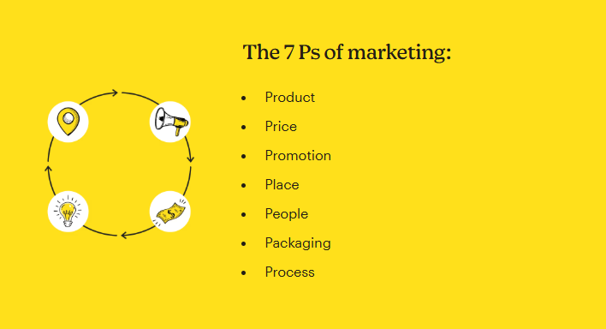
Figure: 7Ps of Marketing Mix Strategy
Source: (Mailchimp, 2026)
Product
The primary product of Morrisons is freshly manufactured food and grocery items that are produced with vertical integration. Maintaining its quality has been done with its culture of managing the supply chain indoors by investing in farms and sires. A notion of Market Street refers to the importance of freshness with skilled employees. Butchers, bakers and fishmongers are prioritised in the business to a great degree for fostering a standard in the business. Its brands, like The Best, provide premium quality items, which have grown 17.4% in Christmas 2025 (Morrisons, 2026). Nutmeg is a clothing brand, and its health-based business line is NuMe, which operates under the enterprise.
Price
The pricing strategy of the company focuses on both affordable and premium products to fascinate a diverse customer base in the industry. It cultivates a culture of lowering prices on essential items. For example, 2500 items have become more cost-efficient than before in January 2026. The value triangle is another strategy followed by the venture for a long time that has been attracting customers. Better prices, adaptable costs and enhanced loyalty are the factors included in the triangle that has been mentioned. These aspects are essential in going against inflation, and tags like half-price and Match and More tools advance the business to a certain extent.
Place
Morrisons operates all over the UK with its omnichannel accessibility. The company manages over 497 supermarkets with expansion plans in new market segments. Further, Morrisons Daily operates according to a convenience approach, which has been planning to expand to 400 new sites by the end of 2026. Collaborations with Amazon and Ocado have proven to be beneficial for the organisation to open up its digital prospects in the market (Ocadogroup, 2026). The distribution segment of the venture is supported by a robust logistics department that operates at national and seven regional centres.
Promotion
The promotion segment of the brand uses an intensive and robust communication system to fascinate customers on a daily basis. Its omnichannel advertising system through television, print and social media platforms helps connect consumers with the employees. Seasonal events like Christmas or Disney-themed promotions often attract families with children. The Morrisons More Card is a loyalty program that identifies customers with consistent purchases, which has grown to 8,000,000 active users in 2026. As a result, it can also offer personalised products and suggestions to retain individuals towards the business.
People
People are the primary staff of Morrisons to enhance its food market in the retail industry. Its employees are experts in several segments like baking, butchering and cultivating fish. Having such experts as colleagues has made the business prosper in the UK with its advanced services. The company also prioritise recruiting local individuals to connect with regional aspects. Community integration is one of the most significant parts of the business, and training employees to understand each other can help in such a diverse workforce. Providing development sessions among 118000 colleagues has become essential due to the sustainable needs in society.
Process
Process is an important aspect of the business which fosters efficiency in delivery and customer experience by reducing expenses. Implementing a digital-first approach to incorporate self-service innovations can provide the opportunity to customers with autonomous services. For example, the option of scan and go can help them check out and save time. Morrisons has also introduced a program which was invested in by the authority of £845 million in 2026 to re-establish its infrastructure and manufacturing systems (Morrisons, 2026). A modernisation program in need of operations was the primary motto of the initiative. Therefore, a seamless approach through automation can be maintained in the business for a long time.
Physical Evidence
Morrisons has a unique design for its brand that helps in its promotion in the industry. The stored layouts are relevant to the revamped Warrington style that provides an authentic field of the farm. As a result, people can connect with the rural freshness of its products and rely on its quality. Moreover, its branding and packaging are also part of a robust strategy of viability that focuses on environmental elevation. Eco-conscious customers are the foremost individuals who are attracted to the establishment due to its approaches. A comprehensive digital presence can also be observed through its website and other platforms with an attached feedback program.

Vasile Emanuel Dumitru
Student Id:2026658

Implementation and Control

KPIs for Morrisons
Customer Loyalty and Retention
According to the latest marketing status of Morrisons, it can clearly be ensured that through customer loyalty and retention, they can propose a key performance indicator. Subsequently, as of the 2026 report, they are expected to focus on the value triangle, which involves price, loyalty and promotions, to track more card swipe rates by 67% and link sales by 81% (Striim, 2026). Furthermore, real-time personalisation, market street DNA and digital integration are some major strategies which can be proposed through this KPI.
Sales and Market Performance
Market share and Like-for-Like sales growth are some major perspectives which the retail company must focus on to establish a beneficial KPI and ensure a relevant marketing plan. Significantly, this will directly highlight their sales and market performance, where their sales have been reported to be 2.8% in early 2026, followed by £15.8 billion in 2025. On the other hand, the organisation’s market performance will help them in monitoring their competition with other brands like Tesco, Sainsbury and others.
Operational and Service KPIs
As per the vast aspect of ensuring a strong marketing plan, it is evident that they can incorporate operational and service KPIs to enhance customer experience and supply chain efficiency. This generally involves net promoter score, which will assist them in measuring the overall customer loyalty and satisfaction, followed by queue times and customer satisfaction score for tracking feedback on service quality (Morrisons-corporate, 2026). Moreover, operational efficiency metrics can commence marketing campaigns for new items while focusing on waste reduction and conversion rate to track efficiency in manufacturing.

Balance Scorecards in the Organisation
Customer Perspective
Enhancing brand loyalty and market share are two key aspects that must be pursued by the company from the customer perspective, and this will help them enhance the value and freshness of their products. Significantly, in order to propose these segments of balanced scorecards, they need to commence Net Promoter Score, market share growth and loyalty participation.
Financial Perspective
Following the present marketing scenario of Morrisons, it can clearly be highlighted that in order to balance low-price strategies with sustainable profitability, they must ensure some key aspects. Furthermore, with an aim to initiate this plan, they must monitor revenue trends, maintain healthy margins and assess the effectiveness of their promotional campaigns (Visionedgemarketing, 2026).
Internal Business Process Perspective
Efficient supply chains and leveraging of vertical integration are referred to as some key perspectives in the business’s internal process, which can aid them in maintaining a balanced scorecard. Symbolically, such a beneficial approach can be instigated by commencing high availability of fresh and locally sourced goods, while speeding up the introduction of new ranges.
Learning and Growth Perspective
According to the vast aspect of building a culture of teamwork and digital capability in Morrisons’s learning and growth perspective, they can focus on some actionable KPIs. This generally involves engagement of its colleagues and digital adoption, which will assist them in measuring satisfaction among in-store teams and training the employees on new technologies (Vcmo, 2026).

Conclusion
The report here concludes that Morrisons is the 5th largest UK supermarket and is facing tremendous competition from discounters such as Aldi and Lidl. A situational analysis revealed that it has both opportunities and challenges in the UK retail sector. The marketing strategy analysis also concludes that there are some areas it needs to enhance for remaining competitive in the market. The 7Ps strategy of marketing mix has been recommended for the company to meet its marketing aims and objectives.

Recommendations
For segmentation
The company should refine its segmentation by utilising AI-driven data to identify high-value customers who prioritise health and healthy food consumption. This will help them to make an entirely separate segment of customers who can be served on a priority basis with the product on the day exactly needed.
For Targeting
Morrisons should expand the daily convenience hub to target the urban commuters who are always in a hurry and can grab a grocery or a meal on the go.
For Positioning
The company must position itself as the only one to have its own fresh food production and aggressively market the vertical integration that differentiates it even from the discounters such as Lidl and Aldi.
For Marketing Mix
Morrisons should implement dynamic pricing to counter food inflation and expand its product range in the high-protein and high-value range (Purnomo, 2023). They must also focus on digital channel promotions that can help them increase customer retention and loyalty by increasing the basket size.

References
BBC, (2026). Morrisons plans to cut 200 jobs at head office. [Online] Available at: https://www.bbc.com/news/articles/cz677p23xljo [Accessed 15 April 2026].
Farrell, S., (2026). Lidl matches Morrisons in grocery market share. [Online] Available at: https://www.thegrocer.co.uk/news/lidl-matches-morrisons-in-grocery-market-share/717166.article [Accessed 15 April 2026].
Jackson, K., (2024). The Ansoff Matrix. [Online] Available at: https://www.mindtools.com/a2gy5ya/the-ansoff-matrix/ [Accessed 15 April 2026].
Leoburnett, (2026). Morrisons Fresh from Market Street. [Online] Available at: https://leoburnett.co.uk/fresh-from-market-street/ [Accessed 15 April 2026].
Mailchimp, (2026). Marketing Mix: The 7 Ps of Marketing. [Online] Available at: https://mailchimp.com/marketing-glossary/marketing-mix-7ps/ [Accessed 15 April 2026].
Morrisons, (2026). Company History. [Online] Available at: https://www.morrisons-corporate.com/about-us/company-history/ [Accessed 15 April 2026].
Morrisons, (2026). Morrisons Backs British Farming With £1.6 Billion Commitment For 2026. [Online] Available at: https://www.morrisons-corporate.com/media-centre/corporate-news/morrisons-backs-british-farming-with-1.6-billion-commitment-for-2026/ [Accessed 15 April 2026].
Morrisons, (2026). Morrisons full year 2024/25 results and Christmas 2025 trading update. [Online] Available at: https://www.morrisons-corporate.com/media-centre/corporate-news/morrisons-full-year-202425-results-and-christmas-2025-trading-update/ [Accessed 15 April 2026].
Morrisons, (2026). Pay less with More Card. [Online] Available at: https://www.morrisons.com/more [Accessed 15 April 2026].
Morrisons, (2026). Sustainability. [Online] Available at: https://www.morrisons.jobs/life-at-morrisons/sustainability [Accessed 15 April 2026].
Morrisons-corporate, (2026). Strategy. [Online] Available at: https://www.morrisons-corporate.com/about-us/strategy/ [Accessed 15 April 2026].
Ocadogroup, (2026). Our partnership with Morrisons. [Online] Available at: https://www.ocadogroup.com/about-us/osp-partners/morrisons [Accessed 15 April 2026].
Peterdy, K., (2022). Ansoff Matrix. [Online] Available at: https://corporatefinanceinstitute.com/resources/management/ansoff-matrix/ [Accessed 15 April 2026].
Peterdy, K., (2022). PESTEL Analysis. [Online] Available at: https://corporatefinanceinstitute.com/resources/management/pestel-analysis/ [Accessed 15 April 2026].
Purnomo, Y.J., (2023). Digital marketing strategy to increase sales conversion on e-commerce platforms. Journal of Contemporary Administration and Management (ADMAN), 1(2), pp.54-62.
Striim, (2026). Morrisons Updates Data Infrastructure to Drive Real-Time Insights and Improve Customer Experience. [Online] Available at: https://www.striim.com/blog/morrisons-data-infastructure/ [Accessed 15 April 2026].
The Morrison Media Group, (2026). Building Stories That Move People. [Online] Available at: https://www.morrisonmediahq.com/ [Accessed 15 April 2026].
Thestrategyinstitute, (2024). The Ansoff Matrix: A Powerful Tool for Business Strategy and Growth. [Online] Available at: https://www.thestrategyinstitute.org/insights/the-ansoff-matrix-a-powerful-tool-for-business-strategy-and-growth [Accessed 15 April 2026].
Tradingeconomics, (2026). United Kingdom Food Inflation. [Online] Available at: https://tradingeconomics.com/united-kingdom/food-inflation [Accessed 15 April 2026].
Vcmo, (2026). What Is A Balanced Scorecard?. [Online] Available at: https://www.vcmo.uk/resources/glossary/what-is-a-balanced-scorecard-in-marketing [Accessed 15 April 2026].
Visionedgemarketing, (2026). How to Use Balanced Scorecards for Marketing Measures. [Online] Available at: https://visionedgemarketing.com/balance-scorecards-incorporate-marketing-measures/ [Accessed 15 April 2026].

