Revision 1
Q1
- For the function $f(A,B,C,D)$ , Implement a 4:2 Encoder and represent the following
- Combinational Diagram
- Truth Table
- Logic Diagram
SOLUTION
- Combinational Diagram
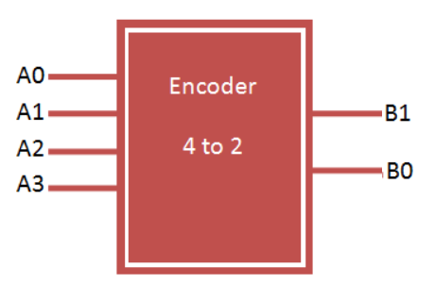

- Truth Table
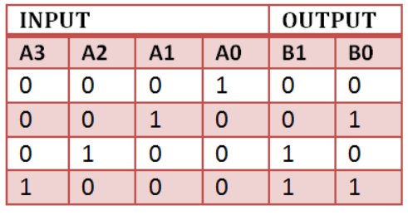

- Logic Diagram
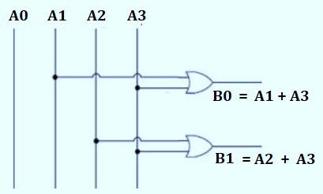

Q2
- For the function $f(A,B,C,D)$ , Implement a 1:4 De-mux and represent the following
- Combinational Diagram
- Truth Table
- Logic Diagram
SOLUTION
- Combinational Diagram

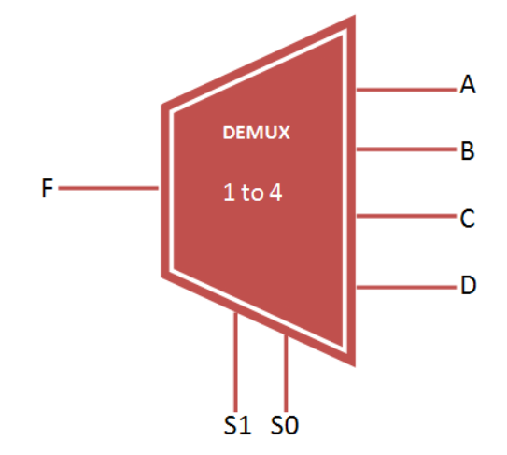

- Truth Table

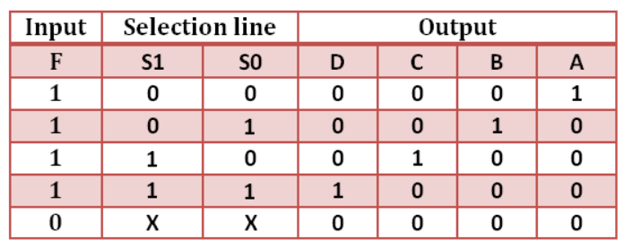

- Logic Diagram
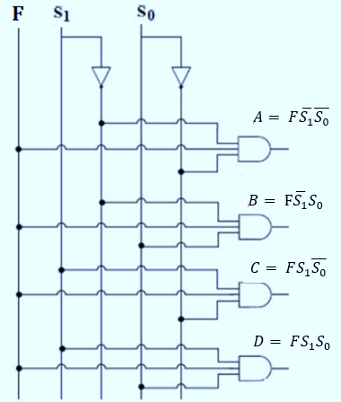

Q3
- For the function f , Implement a half subtractor and represent the following
- Combinational Diagram
- Truth Table
- Logic Diagram
SOLUTION
- Combinational Diagram

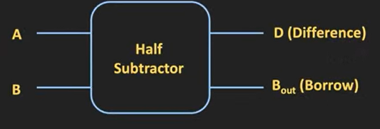
- Truth Table
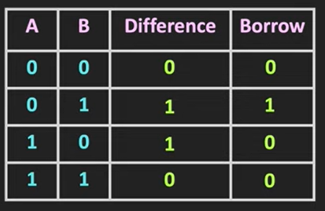
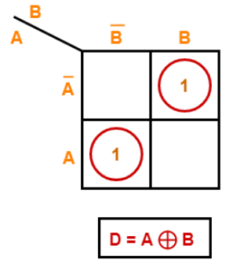
K- Map Expression for Difference and Borrow

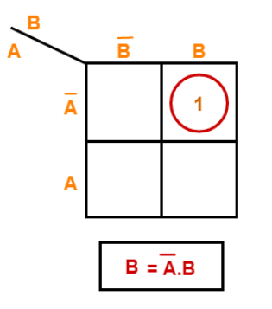

- Logic Diagram
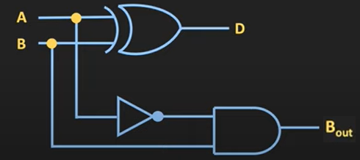

Q4
- For the function f , Implement a Full adder and represent the following
- Combinational Diagram
- Truth Table
- Logic Diagram
SOLUTION
- Combinational Diagram

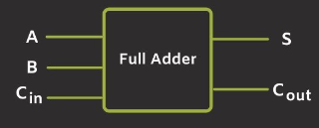
- Truth Table
INPUTS |  |  | OUTPUTS
A | B | C_{in} | C_{out} | SUM
0 | 0 | 0 | 0 | 0
0 | 0 | 1 | 0 | 1
0 | 1 | 0 | 0 | 1
0 | 1 | 1 | 1 | 0
1 | 0 | 0 | 0 | 1
1 | 0 | 1 | 1 | 0
1 | 1 | 0 | 1 | 0
1 | 1 | 1 | 1 | 1

Carry ($C_{Out}$)
Sum ( S)
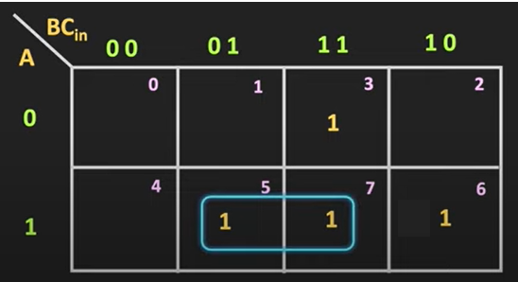
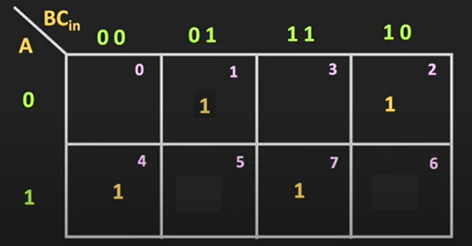

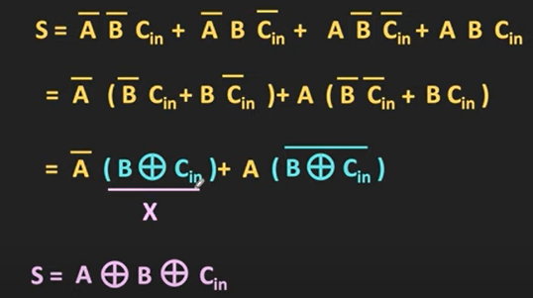

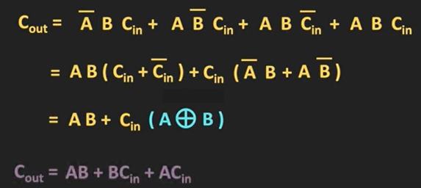

- Logic Diagram

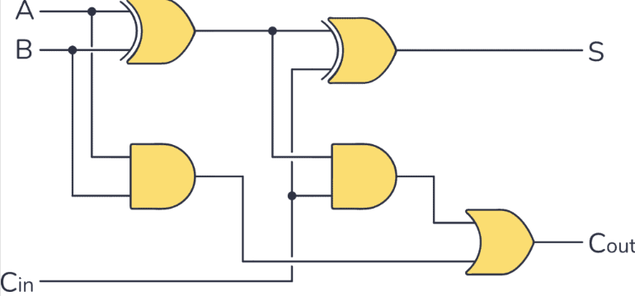

Q5
Implement a 4:1 Multiplexer for the function $f=A_{0},A_{1},A_{2},A_{3}$ and represent the following.
  - Combinational Diagram
  - Truth Table and Expressions
  - Logic Diagram
SOLUTION
- Combinational Diagram
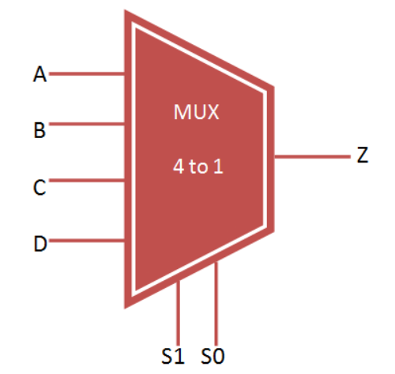
- Truth Table and Expressions

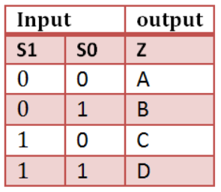
- Logic Diagram
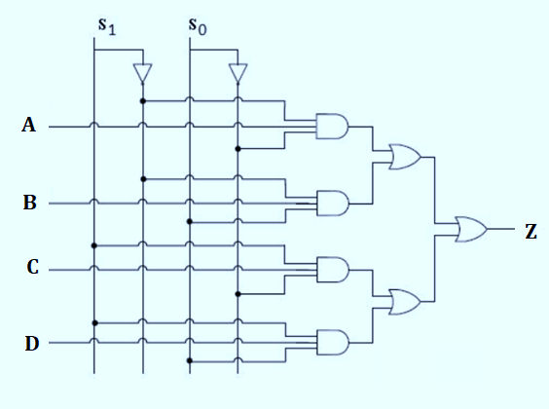

Q6
Find the Minimal Expression for the function $F_{1}= Σ_{m}(0,1,10,14)+Σ_{d}$(4,5, 8,12) using K- Map.
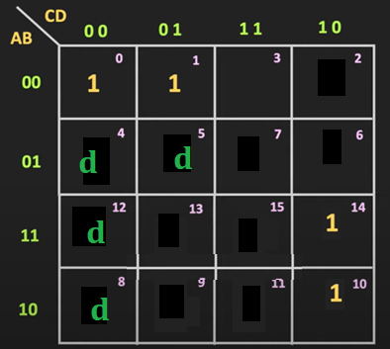
SOLUTION

$F_{1}=\overline{A}$ $\overline{C}$+A $\overline{D}$

Q7
Find the sum and carry of $A=1001$ and B = 1100 and explain how the operation is carried using Parallel Binary Adder with relevant diagrams.
SOLUTION

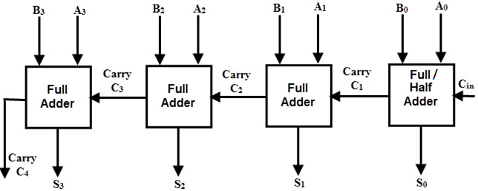

Q8
Obtain the Canonical SOP for the function $f\left(A,B,C,D\right)=(A+B)(C+D)$
SOLUTION

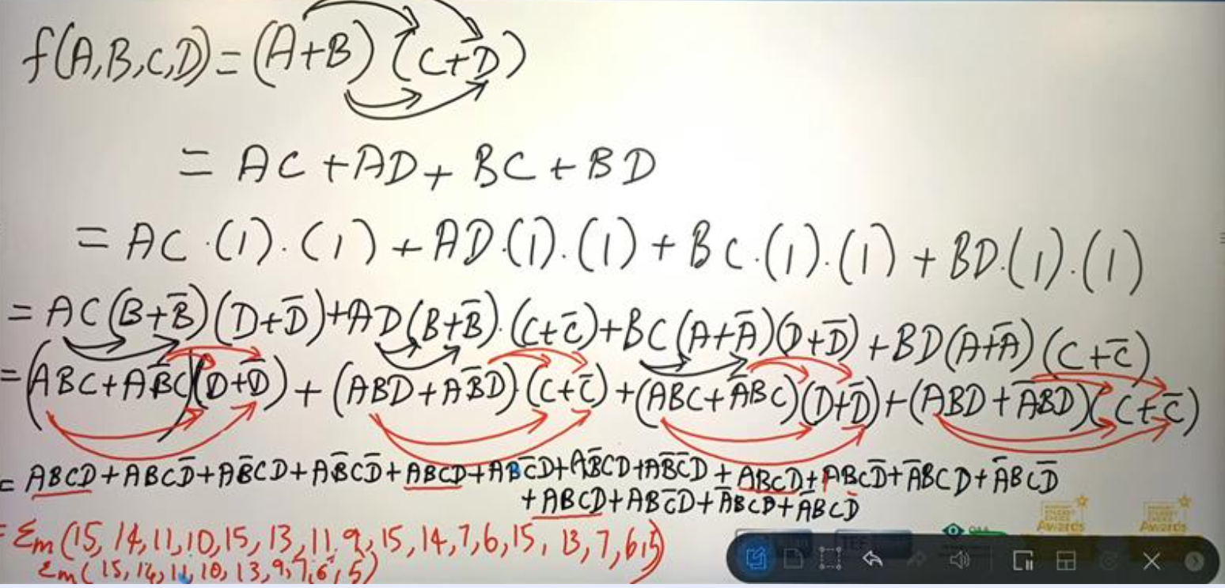

Q9
Find the Expression for the function $f=Σ_{m}(0,3,4,5,7,8)$
or $f=m_{0}+m_{3}+m_{4}+m_{5}+m_{7}+m_{8}$

SOLUTION

