MENU ENGINEERING
PART I: Restaurant Concept
PART II: Menu Design

Author name: Jayson Anthony Luba
Student number: 2245377
Module Tutor: Antoinette Milne
Submission date: 06.11.2023.
- Word count Part I: 418

Part 1: Restaurant Concept

Trinity Hotel London Leyton: Where Modern Luxury Meets Timeless Culinary Delights - Timeless Elegance of a Bygone Era

Located in the vibrant heart of London Leyton, Trinity Hotel brings the renowned excellence of the 4-star Trinity Hotel chain to this bustling city. Our vision is to introduce a captivating restaurant concept (Styler, C., 2006) that perfectly aligns with the Trinity Hotel's high standards, offering a unique and delightful dining experience to our guests.

Restaurant Concept:

Our restaurant, nestled within the, Timeless Elegance of a Bygone Era is a harmonious blend of modern luxury and timeless culinary delights. Inspired by the rich heritage of London and the diverse culture that defines this city; our concept celebrates the fusion of tradition and innovation (Kanani, 2017). We have meticulously crafted an atmosphere that caters to a wide range of discerning diners, from travellers seeking an authentic taste of London to locals in search of a memorable dining experience.

Target Audience:

Our restaurant welcomes a diverse range of patrons, from tourists to locals. Timeless Elegance of a Bygone Era combines classic and contemporary cuisine, making it a perfect dining spot for various occasions. We strive to celebrate London's rich history while embracing modern flavors (Namkung and Jang, 2008).

Our menu embodies our commitment to providing a diverse and enticing selection (Cousins et al., 2014), carefully crafted based on thorough research into our guests' preferences (Piqueras-Fiszman et al., 2013). Drawing inspiration from London's multicultural culinary tapestry, our menu seamlessly blends British classics with international influences, ensuring a wide range of options to satisfy every palate. From hearty British roasts to tantalizing Indian curries and fresh Mediterranean salads, our menu celebrates the global flavours that define London's culinary scene (Zellner et al., 2014).

To accommodate modern dietary preferences, we offer a dedicated selection of vegan, vegetarian, and gluten-free dishes, allowing all our guests to savor their dining experience. Our beverages are thoughtfully chosen, featuring a diverse wine list and craft cocktails expertly paired with each dish.

In shaping our restaurant concept and menu choices, we are deeply committed to delivering a memorable and inclusive dining experience (Davis et al., 2013) that upholds the high standards of the Trinity Hotel chain. Timeless Elegance of a Bygone Era invites you to embark on a gastronomic journey that transcends time (Hayes et al., 2017), all within the comfort and elegance of our 4-star establishment. We eagerly anticipate the opportunity to welcome you and create enduring memories through our exceptional cuisine and unparalleled service (Rozekhi et al., 2016).

Part 2: Menu Design

Tasting Menu: "Timeless Elegance of a Bygone Era"
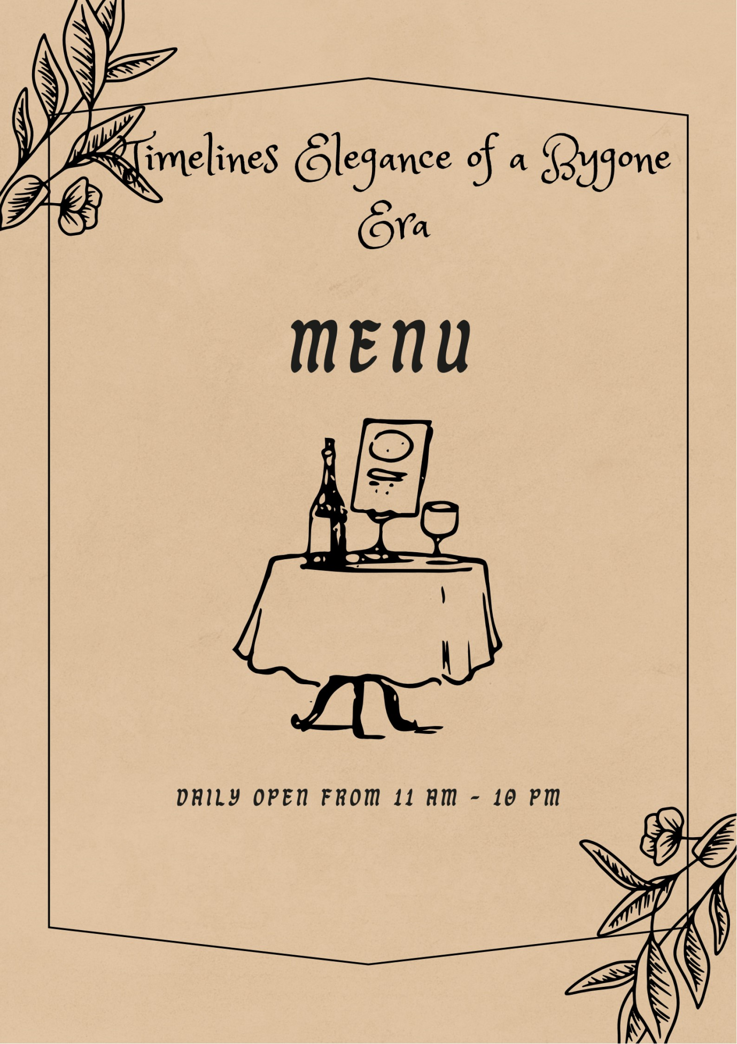
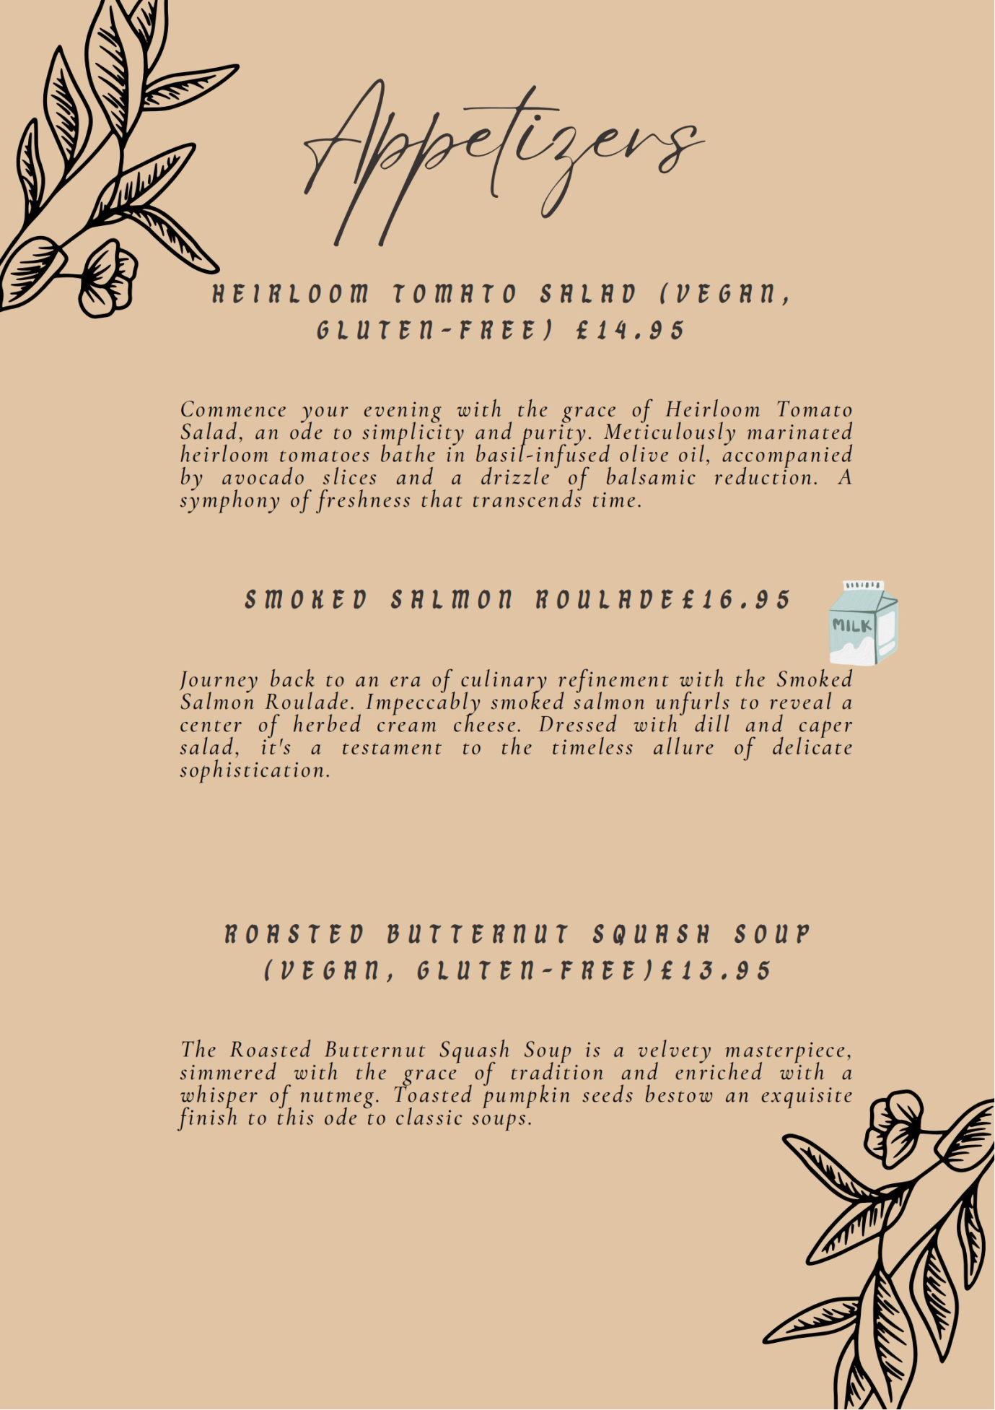
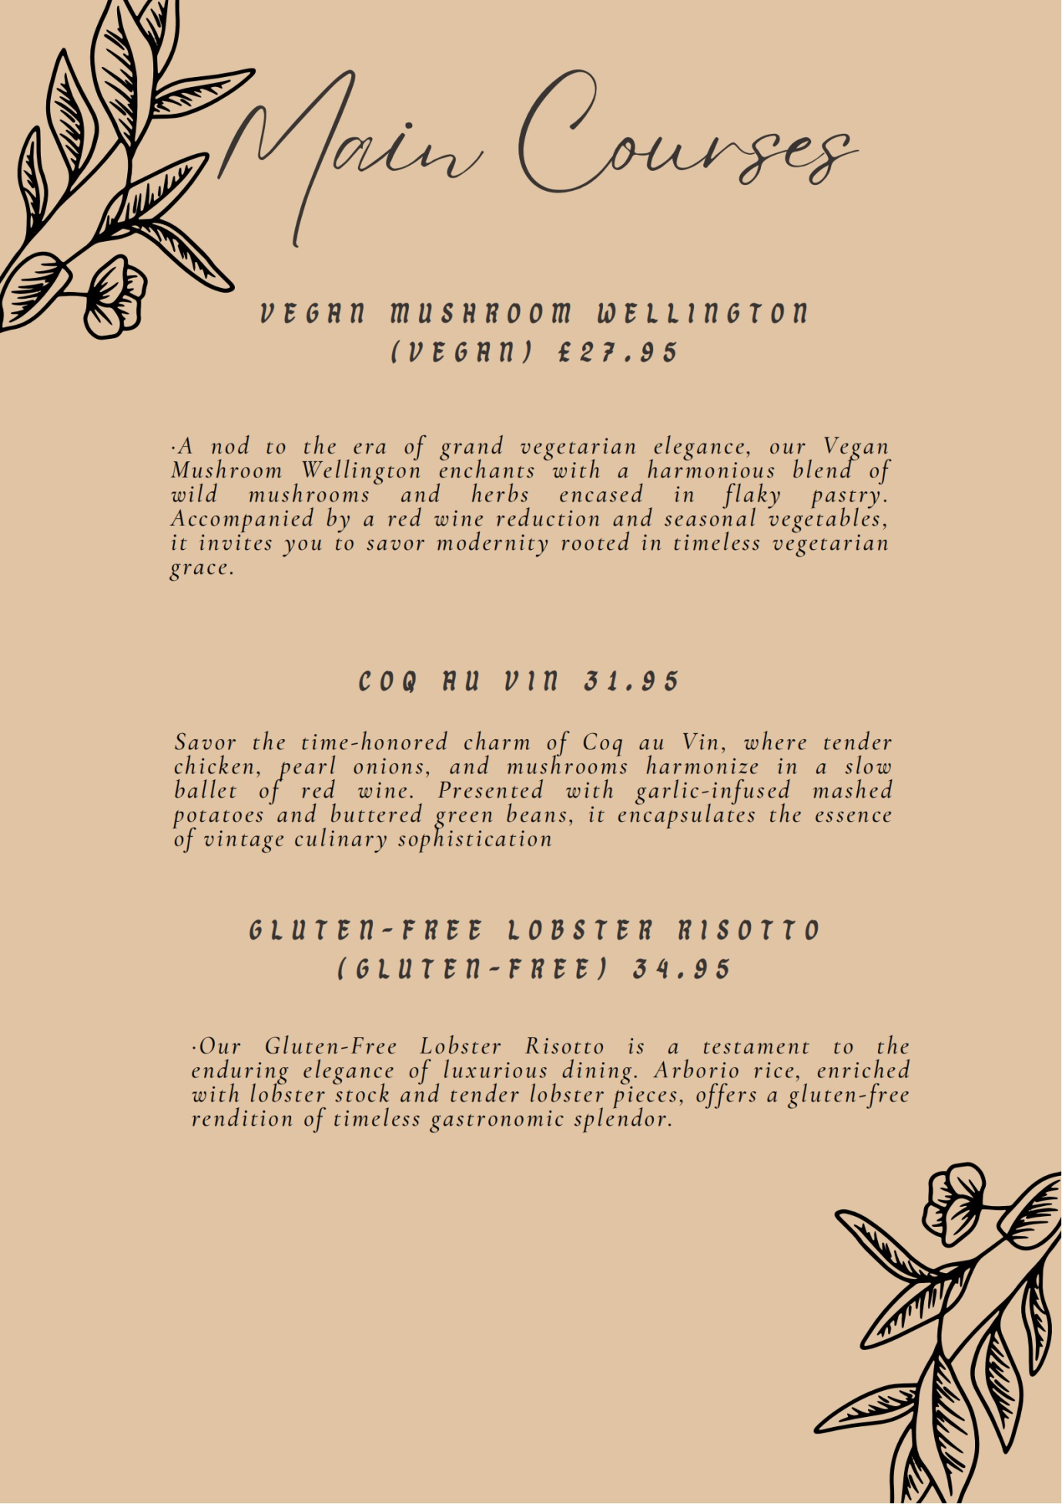
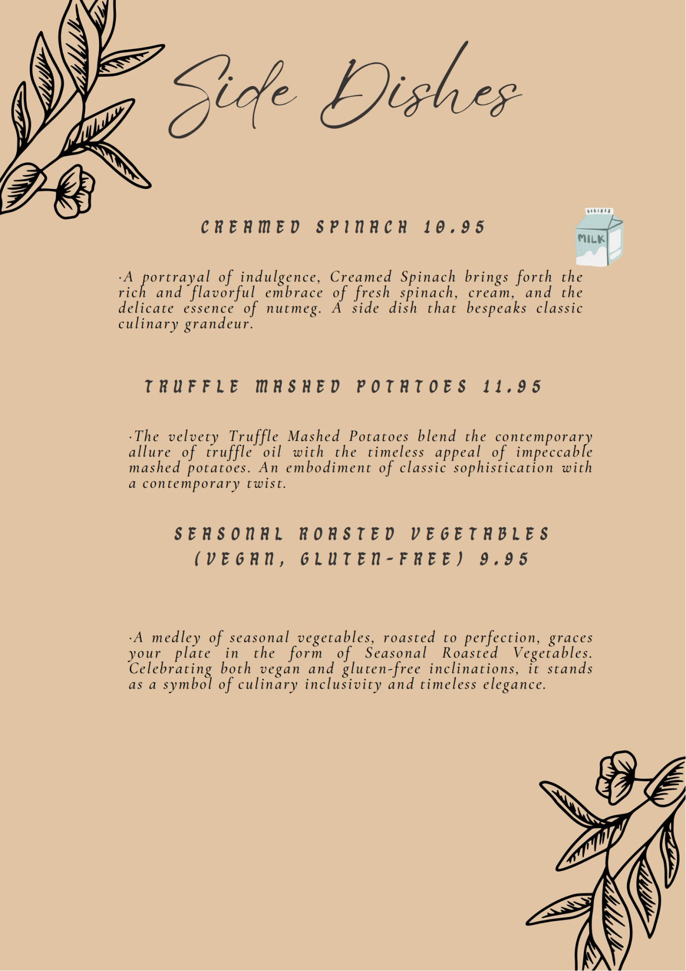
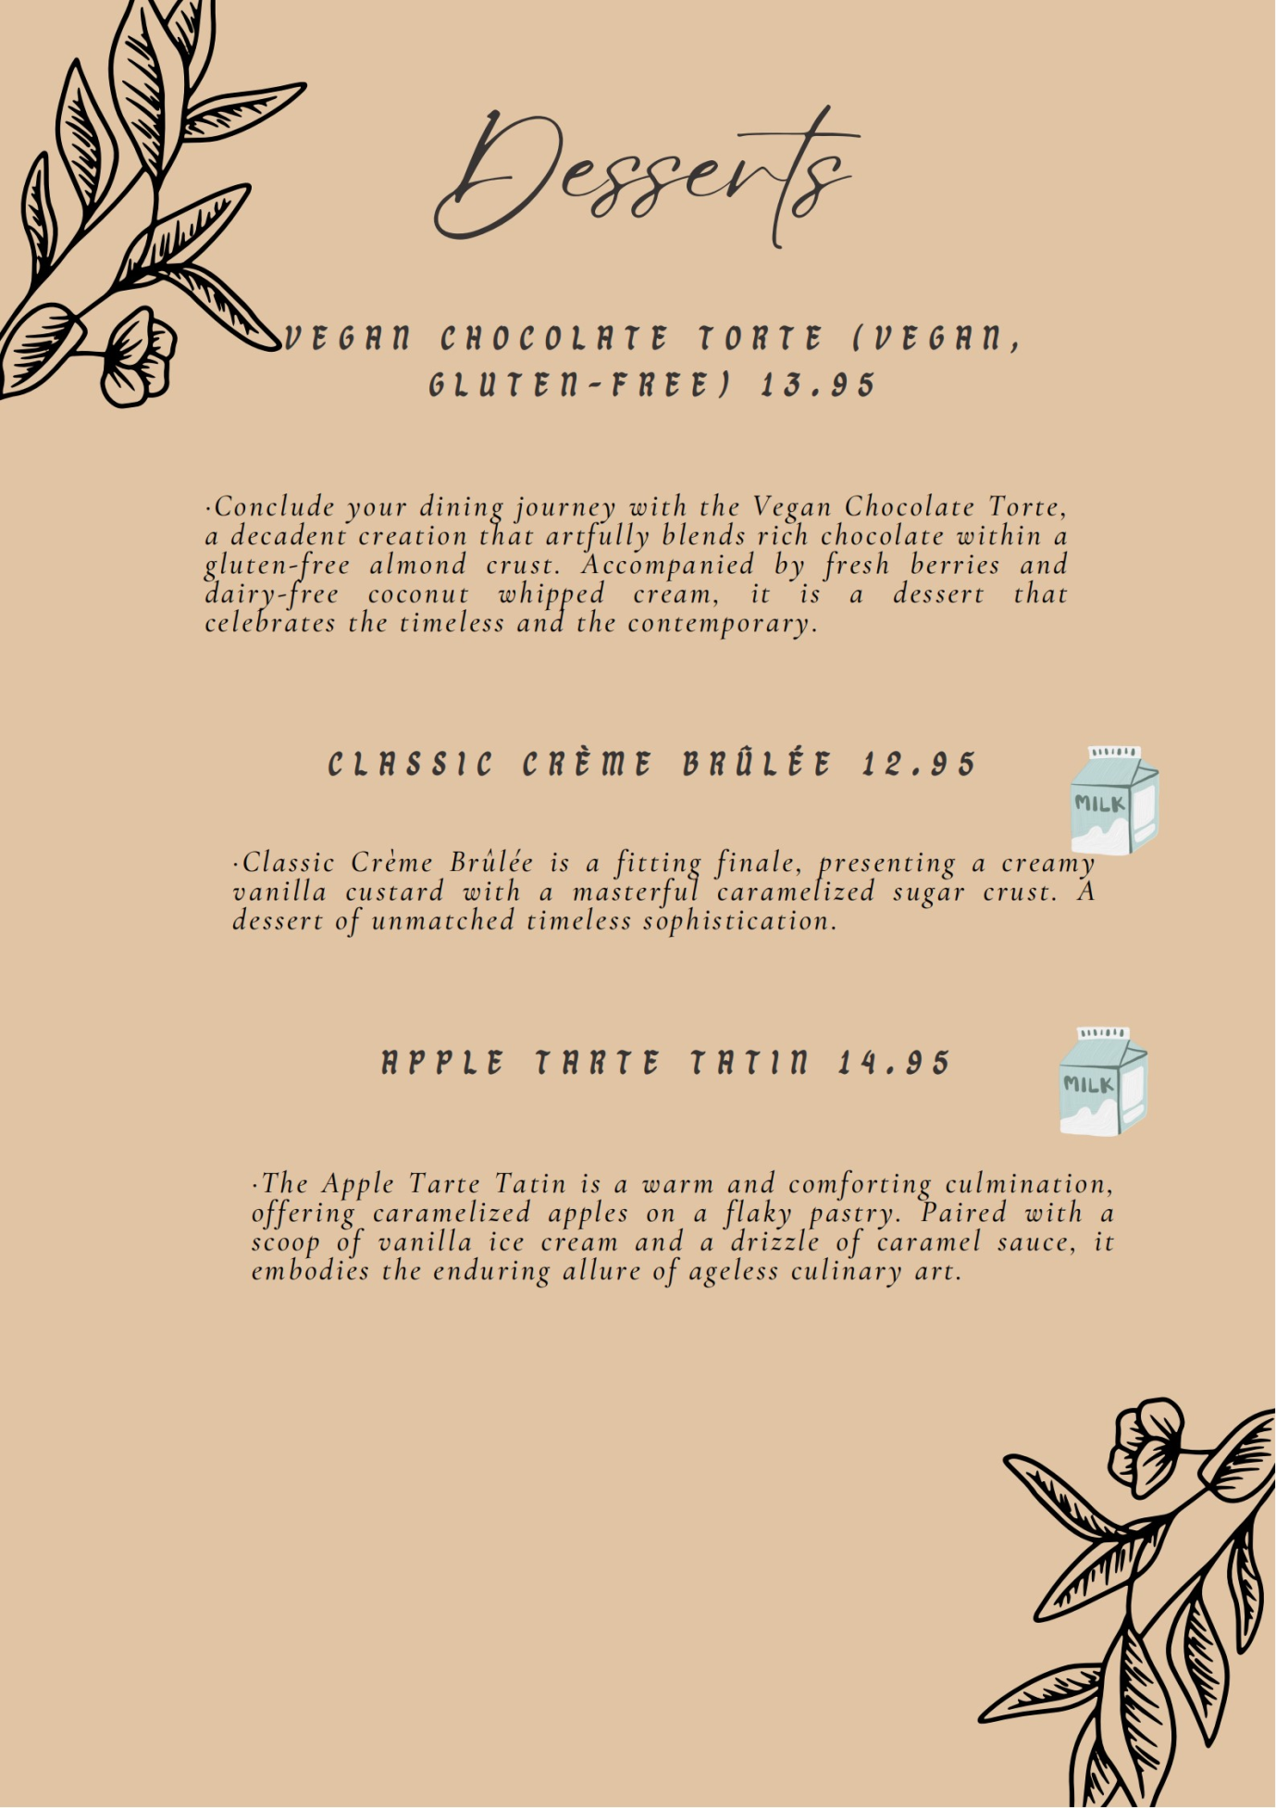
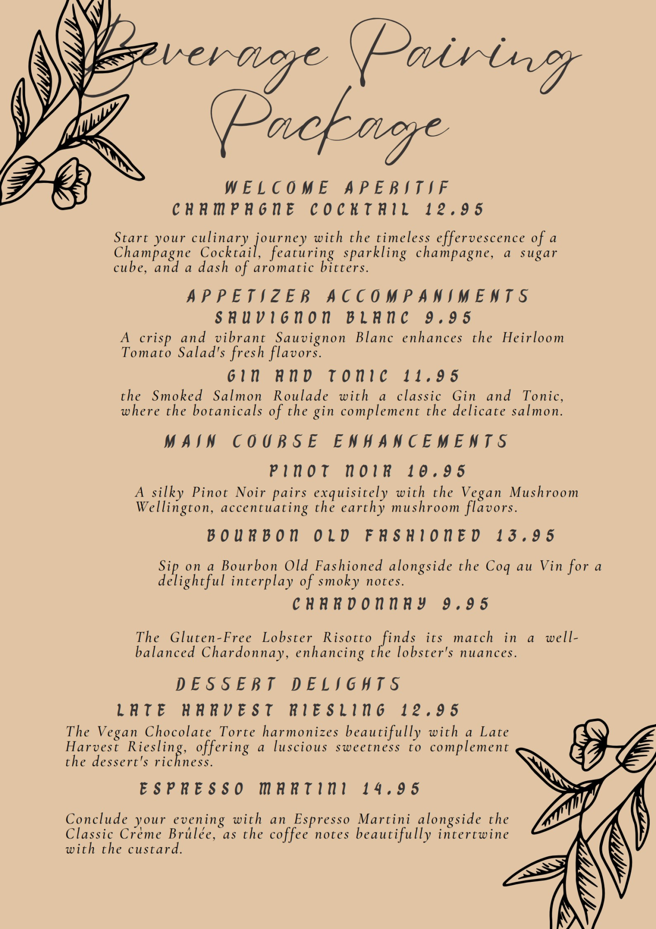
(Canva, 2023).

Citations
- Canva. (2023). Canva. Retrieved from https://www.canva.com.
- Cousins, J., Lillicrap, D., & Weekes, S. (2014). Food and beverage service. Hachette UK.
- Davis, B., Lockwood, A., Pantelidis, I., & Alcott, P. (2013). Food and beverage management. Routledge.
- Hayes, D. K., Ninemeier, J. D., & Miller, A. A. (2017). Hotel operations management. Pearson.
- Kanani, R. B. (2017). A wealth of insight: the world's best luxury hoteliers on leadership, management, and the future of 5-star hospitality. Black Truffle Press.
- Namkung, Y., & Jang, S. (2008). Are highly satisfied restaurant customers really different? A quality perception perspective. International Journal of Contemporary Hospitality Management, 20(2), 142-155.
- Piqueras-Fiszman, B., Giboreau, A., & Spence, C. (2013). Assessing the influence of the color of the plate on the perception of a complex food in a restaurant setting. Flavour, 2, 1-11.
- Rozekhi, N. A., Hussin, S., Siddiqe, A. S. K. A. R., Rashid, P. D. A., & Salmi, N. S. (2016). The influence of food quality on customer satisfaction in fine dining restaurant: Case in Penang. International Academic Research Journal of Business and Technology, 2(2), 45-50.
- Styler, C. (2006). Working the plate: The art of food presentation. John Wiley & Sons.
- Zellner, D. A., Loss, C. R., Zearfoss, J., & Remolina, S. (2014). It tastes as good as it looks! The effect of food presentation on liking for the flavor of food. Appetite, 77, 31-35.

