

‘An Investigation into the Use of Gamification for Learning Maths’

By

Jamie Bragg

250976

Supervisor: John Williams

Second Marker: Andrew Green

Project submitted as part of the requirements for the award of BSc (Hons) Applied Computing

April 2021

Declaration Form and Form of Consent

DECLARATION
I, Jamie Ethan Bragg declare that I am the sole author of this Project; that all references cited have been consulted; that I have conducted all work of which this is a record, and that the finished work lies within the prescribed word limits. This work has not previously been accepted as part of any other degree submission.

FORM OF CONSENT
I Jamie Ethan Bragg hereby consent that my Project, submitted in candidature for the B.Sc. (Hons) Applied Computing degree, if successful, may be made available for inter-library loan or photocopying (subject to the law of copyright), and that the title and abstract may be made available to outside organisations.
Contents
Declaration Form and Form of Consent 2
DECLARATION 2
FORM OF CONSENT 2
Abstract 5
1. Introduction 5
2. Literature Review & Research 5
2.1 Difficulties in Learning Mathematics 5
2.2 Learning Styles 6
2.2.1 What are Learning Styles? 6
2.2.2 Types of Learning Styles 6
2.2.3 Effectiveness of Learning Styles 6
2.3 Gamification 7
2.3.1 What is Gamification 7
2.3.2 Gamification in Education 7
2.3.3 Effect of Gamification on Motivation 8
2.3.4 Gamification at Elementary and Secondary Levels 10
2.4 Existing Tools 11
2.4.1 Kahoot! 11
2.4.2 Knowre 11
2.4.3 Maphi 12
2.5 Primary Research Findings 12
2.6 Research Findings 13
3. Methodologies 14
3.1 Research Methodology 14
3.1.1 Philosophy 14
3.1.2 Approach 14
3.1.3 Strategy 14
3.1.4 Time Horizon 15
3.1.5 Data Collection Method 15
3.1.6 Evaluation Criteria 15
3.1.7 Methods of Testing 15
3.2 Development Methodology 16
3.2.1 Feature Driven 16
3.2.2 Software 16
3.2.3 Hardware 16
3.2.4 Materials and Tools 17
4. Design & Implementation 17
4.1 Design 17
4.1.1 Project Requirements 17
4.1.2 System Models 18
4.1.3 System Interfaces 22
4.2 Implementation 26
4.2.1 Problems and Successes 26
4.2.2 Software Testing 26
5. Evaluation 27
6. Conclusions & Recommendations 27
7. Reflection 28
8. References 29
DEMONSTRATION FILE 32
Appendices 32
Appendix 1: Test Case Table 32
Appendix 2: Blank Interview Sheet 33
Appendix 3: Participant 1 Interview 34
Appendix 4: Participant 2 Interview 36
Appendix 5: Participant 3 Interview 38
Appendix 6: Participant 4 Interview 40
Appendix 7: Participant 5 Interview 42
Appendix 8: Participant 6 Interview 44
Appendix 9: Participant 7 Interview 46
Appendix 10: Participant 8 Interview 48
Appendix 11: Average and Total Scores 49

Abstract
This report examined the effectiveness of gamification for the purposes of learning maths. The aim was to design, develop and evaluate a math learning tool which included elements of gamification. This was evaluated by interviewing users of the app for their experiences. This qualitative data was analysed and compared to existing research. The main findings were that gamification improves motivation to learn and, in some cases, improves achievement and the most effective gamification elements to use were points, badges, leaderboards, XP and levelling.

Introduction
This project seeks to discover how effective gamification is when learning maths. The aim is to design, develop and evaluate a tool which includes elements of gamification to improve math learning. To achieve this, 4 objectives have been defined:
- Conduct a literature review to understand the effectiveness of gamification elements in education and whether gamification can be enhanced by including learning styles.

- Design an education tool which include the effective elements of gamification to help students learn maths.

- Develop the education tool based on the created designs and initial research.

- Evaluate the success of the tool by testing it with users, declare if it improved their experience/scores and identify any future improvements to implement in future iterations.

Chapter 2 will consist of all the research including the literature review and the findings from the primary research. Chapter 3 details the methodology used for both the research and the development. The designs created for the app and the development are documented in chapter 4. This application is evaluated in chapter 5 along with how well the objectives were met. Chapter 6 provides the conclusion and main findings of the research as well as avenues for further research. Chapter 7 reflects on the process of carrying out the project.

Literature Review & Research

Difficulties in Learning Mathematics
In a report released by the Welsh government, the average numeracy scores for 3 years have been recorded and displayed. In 2016/2017 the average numeracy score was 37.9, in 2017/2018 the average score was 38.3 and in 2018/2019 it was 37.2, a 1.1 decrease⁽¹⁾. This is a small decrease in the average score and is still similar to the other years scores hovering around the 37-38 range which places the average score just below a C grade (40 points). In 2019/2020 students achieved more A* - B grades than in the previous years and achieved less C – U grades⁽²⁾. While this may appear to be indicative of an improvement in math learning, students were assigned predicted grades when exams were cancelled due to the pandemic. This means that these grades are not a true reflection of student’s understanding and achievement in maths.
Elisabeth Moser Opitz et al have published a research article that examines students with mathematical difficulties. They say, “low achievement in mathematics at the secondary level can often be traced back to deficits in the understanding of certain basic arithmetic concepts taught in primary school”⁽³⁾. This point is backed up in a study by Gena Nelson et al who write that elementary school aged students were most commonly identified to have mathematical difficulty⁽⁴⁾. This reinforces the argument that math difficulty starts at a young age through misunderstanding basic arithmetic concepts.
Opitz et al have found that “deficits in the understanding of basic arithmetical concepts can be effectively addressed through short term interventions”⁽³⁾ that emphasise those concepts. In a study by James Stocker, he says that not understanding basic arithmetic stem from “lack of practice and appropriate rehearsal”⁽⁵⁾. This implies that the remedy found by Opitz et al is unnecessary if students learn basic arithmetic properly through practice at a young age.

Learning Styles

2.2.1 What are Learning Styles?
Sajna Jaleel et al defines learning styles as “individual differences in the processes of learning”⁽⁶⁾. Learning styles highlight the differences in how individuals acquire information; with theorists believing that by catering teaching to match an individual’s learning style they will have a better understanding of the material being taught and have an easier time learning it⁽⁷⁾. This is known as the style-matching hypothesis ⁽⁸⁾.

2.2.2 Types of Learning Styles
Within the style matching hypothesis exists several learning style theories. One theory is the sensory learning style where it is theorised that one prefers to learn through visual, auditory, or kinaesthetic means⁽⁶⁾. Visual learners learn through vision, think in pictures and learn best from visual displays such as charts, diagrams and videos. Auditory learners learn through sound and learn best through discussion and concentrating on tone, pitch and speed to understand the context of what they hear. Kinaesthetic learners learn by doing, they prefer touching objects and learn through interaction.
Another theory is the social learning style ⁽⁸⁾. This theory splits learners into two styles: individual or collaborative. Individual learners learn best when working on their own while collaborative learners learn best when interacting with others in groups.
A third theory is the cognitive theory which splits learners into sequential or holistic thinkers ⁽⁸⁾. Sequential learners prefer information to be organised and ordered linearly. They learn by thinking through problems one step at a time. Holistic thinkers organise information in a seemingly random order but focus on looking at the big picture that connects the information.

2.2.3 Effectiveness of Learning Styles
There is an ongoing debate about whether learning styles exist and are effective when learning. In a research paper by Hawkar Akram Awla, he wrote “[The] learning process will be enjoyable, faster and more effective”⁽⁹⁾ when students recognise and integrate their learning style into the learning process. Shannon Ellington and David S. Benders agree saying that matching learning styles can “enhance the way a student learns”⁽⁷⁾.
However, Pearson claim that “the majority of academic work on learning styles is done under the radar of legitimate scholarly critique”⁽⁸⁾. They examined thousands of articles and books only to find that very few were peer reviewed. They also say, “available studies have almost universally failed to employ the type of research design required to substantiate the style matching hypothesis”⁽⁸⁾. Philip M. Newton agrees, noting that learning styles have “been repeatedly tested and there is currently no evidence to support it”⁽¹⁰⁾. He also says “it is not possible to teach complex concepts… by presenting them in only one style”⁽¹⁰⁾.

Gamification

2.3.1 What is Gamification
Sebastian Deterding et al defined gamification as “the use of game design elements in non-game contexts”⁽¹¹⁾. Game design elements refer to any element that is readily associated with games. This definition came about after Deterding et al analysed existing definitions of gamification and highlighted their shortcomings proposing a new definition to clarify those shortcomings. This is the definition which will be used for this project as it is the most clearly defined. The only shortcoming with this definition is the subjectivity of elements associated with games. Even though this is subjective there are already several elements of game design used in non-game contexts that are agreed upon by multiple authors, these are the elements that will be examined and used.

2.3.2 Gamification in Education
Raph Koster explains that we carry out activities to satisfy three psychological needs. These needs are summarised by Deterding as he links these needs to gamification in education. Deterding’s summary says “We all need to feel:
- Related – Supported by and supporting others.
- Autonomous – Having a sense of willingness, agency, and congruence with our self in what we do.
- Competent – Sensing that we can affect change in the world, and that we get better at that.”⁽¹²⁾
Deterding claims that traditional teaching methods do not satisfy these needs. This is echoed in a study by Darina Dicheva et al who writes “traditional schooling is perceived as ineffective and boring by many students”⁽¹³⁾. Deterding suggests that game elements be used in education with the goal of improving both a student’s motivation to study and their grades saying, “challenge by challenge, you accrue “experience points” that add up to “levels”.”⁽¹²⁾ This progress leads to players feeling competent, and satisfied, about the activity being performed which results in increased motivation.
Fiona Fui-Hoon Nah et al carried out a literature review of implementations of gamification in education, explaining the game elements used and their effectiveness in each case. The game design element that was the most successful was the use of badges as a form of reward for accomplishing specific tasks⁽¹⁴⁾. Badges were a common game design element in multiple implementations of gamification studied by the authors. The authors noted that, in those implementations, student’s attendance and engagement increased. Badges recognise a student’s achievements which satisfy the need for competency.
Another game element that appeared in multiple implementations is leaderboards. Leaderboards rank a student’s score in relation to other student’s scores, which lead to increased engagement and improved scores as students compete to do better⁽¹⁴⁾. This game element satisfies the competent need by congratulating the student for their score and placing it as the goal for others. This element also satisfies the related need as friendly competition supports the student by encouraging them to strive for better scores. This element may backfire as students who consistently rank low may be demotivated as the leaderboard would show them to be “worse” than others. The authors suggest that this may be overcome by limiting the leaderboard to displaying only the top 10 scores, so low-ranking students are unaware of their low ranking⁽¹⁴⁾.
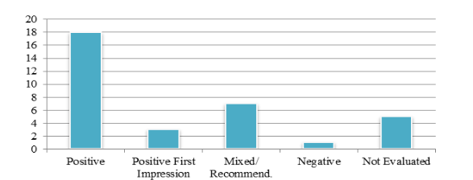
Darina Dicheva et al carried out a mapping study into gamification of education. In this paper they corroborate the study carried out by Fiona Fui-Hoon Nah as the summary shows that the majority of implementations of gamification have experienced positive results⁽¹³⁾.

They found that positives include “significantly higher engagement of students” and “minimizing the gap between the lowest and the top graders”⁽¹³⁾. These results match with the study by Fiona Fui-Hoon Nah et al.
While the authors of the mapping study conclude that gamification “has the potential to improve learning” they claim that “more substantial empirical research is needed” to investigate the “motivating effects of using a single game element”⁽¹³⁾. This is a gap in the current research as the implementations of gamification use multiple game design elements at once. It is unclear how effective each game element is on its own or if the only effective implementation is a mix of game design elements.

2.3.3 Effect of Gamification on Motivation
In 2017 Darina Dicheva et al published a paper following up their mapping study with a critical review on the current known facts of gamification in an attempt to provide a more factual perspective of gamification rather than potentialities⁽¹⁵⁾. This paper further backs up the point made in their previous paper that traditional schooling is perceived as ineffective and explains that gamification has been given significant attention by researchers because of its potential to motivate students.
After examining further studies Dicheva et al have found that “a growing body of reported results is backed by inconclusive and insufficient evidence for making valid claims about the efficacy of gamification in education”⁽¹⁵⁾. This is an unexpectedly different conclusion seeing as their previous study claimed that the majority of implementations of gamification have experienced positive results⁽¹³⁾, which backed up the study by Fiona Fui-Hoon Nah et al which also found positive results. Dicheva et al theorise that this inconclusiveness may be due to researchers trying to answer a broad research question with limited supportive evidence. Dicheva et al argue that “whether gamification motivates students, improves learning or increases participation, are too broad questions.”⁽¹⁵⁾ Instead, research should narrow the focus down to “whether game design elements G are effective for learners of type L participating in activity of type A”⁽¹⁵⁾. This sheds light on why Fui-Hoon Nah et al’s study gave positive results; they focused on the effectiveness of individual game design elements.
This paper also highlights a limitation of studies which focus on the effects of gamification on motivation. These studies analyse the effects on learning, attainment, and participation, which Dicheva et al say that these observable indicators are not always linked to motivation, which means that that the educational benefits “in terms of increasing student motivation”⁽¹⁵⁾ are not well understood. However, in their previous paper, Dicheva et al found a higher engagement from students when education was gamified which is supported by similar results from Fui-Hoon Nah. So, while the exact link between gamification and motivation in education is unknown at the current understanding, results show a connection between gamification and increased motivation.
In 2021, Ana Manzano-León et al published a paper with different results from Dicheva et al’s research. In their review of the current understanding of gamification, they found that researchers understood the benefits of gamification on motivation. They found “several benefits of the use of gamified learning in students such as an improvement in their motivation, engagement, and academic achievement”⁽¹⁶⁾. Where this differs from Dicheva et al’s paper is that this time they understand why. León et al found that points, badges and leaderboards (PBL) are effective as extrinsic motivation, so students more motivated by reward find PBL to be highly motivating. They also say that there are very few elements of gamification currently used that supports intrinsic motivation, students are being motivated based on rewards instead of a feeling of accomplishment or desire to improve which they found to be better motivators⁽¹⁶⁾. The researchers have found that extrinsic motivation is less effective than intrinsic motivation because students eventually tire of the rewards and they are not seen as worth working for, while intrinsic motivation is always rewarding.
To make gamification more intrinsically motivating León et al suggest using the MDA model to provide a gamified experience that is all encompassing rather than just PBL. The MDA model divides gamification elements into 3 categories:
Mechanics: Actions and controls offered to users within a game context (e.g. attack, compete, cooperate, trade)⁽¹⁶⁾
Dynamics: Behaviours that are performed while interacting with the mechanics (e.g. socialising, bluffing, reflecting)⁽¹⁶⁾
Aesthetics: Emotional responses by the user when interacting with the gamified system. (e.g. sensation, narrative, challenge, discovery, expression, entertainment)⁽¹⁶⁾
The researchers argue that current PBL systems are having a negative effect on intrinsic motivation and that gamified systems designed around having a variety of MDA elements will improve intrinsic motivation: “it is important to advance to other systems of deeper gamification integrating different dynamics, mechanics, and aesthetics that can act as reinforcers of intrinsic motivation of the students”⁽¹⁶⁾.
Other than providing an understanding of how gamification elements link to motivation, the results of this study also support the use of gamification in education saying “the results suggest that gamification can have positive effects on student motivation, engagement, and academic performance at different educational levels. These findings provide evidence that educational gamification could be an effective educational strategy.”⁽¹⁶⁾

2.3.4 Gamification at Elementary and Secondary Levels
Mohammad Alshammari evaluated gamification of learning specifically for elementary school students. The gamified elements used included points, badges and leaderboards along with levels, feedback, and time pressure. Alshammari found that gamified learning “yields significantly better learning outcomes”⁽¹⁷⁾ when compared to traditional teaching. This result confirmed 4 out of 6 of Alshammari’s hypothses:
- Gamification enhances the learning outcomes of the students.
- Gamification improves the relevance level of students.
- Gamification improves the satisfaction level of students.
- Gamification improves the overall learning motivation of students.
However, no improvement was found regarding the student’s level of attention or confidence. Alshammari found that the reason for the higher level of attention in traditional teaching may be due to the teacher demanding everyone’s attention as they teach. He also found that the reason for there being no difference in confidence may be due to the students being unfamiliar with using a computer to learn and they required time to adapt to the new style of learning⁽¹⁷⁾.
Alshammari concludes saying “learning using the gamified learning system yields significantly better overall motivation than when learning in a traditional classroom”⁽¹⁷⁾ and that the results obtained were mostly positive in terms of learning outcome.
Goh Yung Hong et al studied gamification of learning for secondary level students. They found that students who participated in the gamified lesson were generally “displaying and were experiencing a higher motivation level to learn compared with participants who went through the CTM [conventional teaching method] lesson”⁽¹⁸⁾.
Along with this, the students who participated in the gamified lesson were also reporting “higher interest and enjoyment in learning, perceived themselves more competent and perceived the gamified activity of value and usefulness more so than the participants of CTM”⁽¹⁸⁾. This is almost exactly the same result that Alshammari found with gamified elementary learning. The biggest difference is that at the secondary level students were gaining confidence which the elementary level students were not. This may be because at the secondary level students are likely to be more familiar with learning using a computer and so will not need to adapt like the elementary students did in Alshammari’s study. If true, then confidence from gamified learning increases based on IT literacy and is not impacted by the education level.
Hong et al found that the gamified learning students reported increased pressure and tension compared to the participants of CTM, indicating that the competitive elements of gamification may contribute to a negative participant experience. While this was reported, the students also reported higher levels of motivation.⁽¹⁸⁾
Hong et al conclude saying gamification showed “better potential in raising a student’s engagement in the classroom when compared to conventional teaching methods”⁽¹⁸⁾. However, they warn that more research into the negative effects of competition need to be carried out in case gamification promotes anti-social behaviour.

Existing Tools

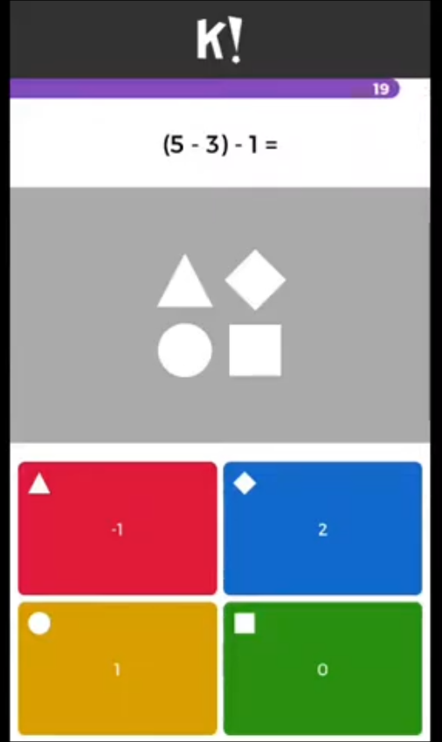
2.4.1 Kahoot!
Kahoot⁽¹⁹⁾ presents questions as a quiz where students gain points for correct answer and gain a bonus for consecutive correct answers. At the end of the quiz the top three scorers are placed on a podium in 1st, 2^{nd,} and 3rd positions. Kahoot uses points and leaderboards, two game design elements to engage users in a friendly competition. Kahoot is one of the most popular gamified learning platforms with over 70 million monthly active users⁽²⁰⁾. Studies show that “Kahoot can have a positive effect on learning”⁽²⁰⁾. Kahoot requires a quiz to be made manually by a teacher. Which means the app is only useful to students for as long as a teacher supports it.

2.4.2 Knowre
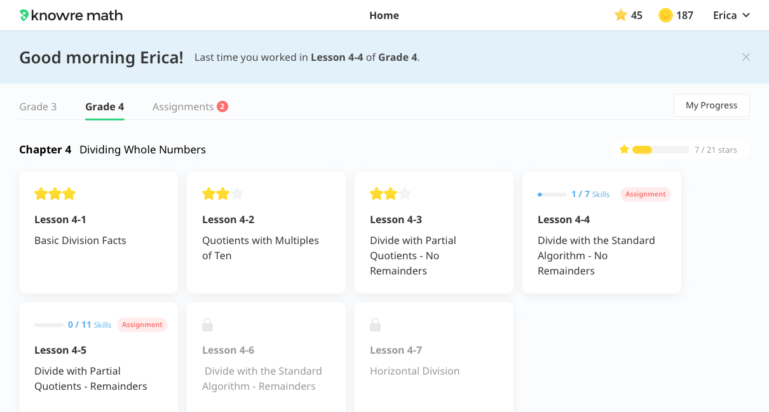
Knowre⁽²¹⁾ is an app that breaks down maths into individual concepts. Students are then assessed to see which of the concepts they are struggling with. Then Knowre will create a learning path tailored to that student’s strengths and weaknesses⁽²²⁾. Knowre uses multiple game design elements including points, badges/achievements as stars to show how well a task was completed, and branching pathways that give students autonomy over how they progress through Knowre’s map. Knowre includes a dashboard that allows teachers to assign homework, monitor students individually and monitor the progress, strengths, and weaknesses of the class as a collective.

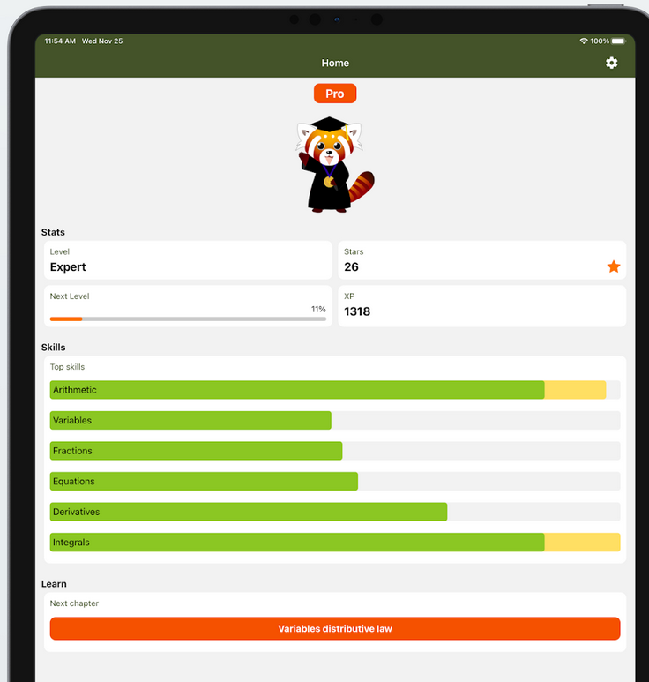
2.4.3 Maphi
Maphi⁽²³⁾ breaks down maths into individual concepts, like Knowre, and rates a learner’s skill in each concept, showing where they need practice. Maphi also uses game design concepts to increase engagement. It uses levelling up and experience points, levels in the form of chapters and stars that rank how well learners achieved on each chapter. Maphi also offers autonomy by using a difficulty selection so students of each skill level can be challenged. Unlike Knowre, Maphi is designed for personal use instead of classroom use. As such it lacks the classroom features present in Knowre such as allowing teachers to monitor progress and set homework.

Primary Research Findings
Out of the 8 users who participated in interviews all of them preferred using the app to normal classes. The biggest reasons for why they preferred using the app were because it was “more fun than normal classes” and it “Doesn’t feel like you’re learning but you are”. Every question answered correctly resulted in a point earned for the user and an incorrect answer resulted in a game over. The first score for each participant was recorded along with their final score before conducting the interview. Every participant had a score increase of at least 17 points and the average score increase overall was 24.25.
Participants were also asked if they were motivated to learn when using the app and 100% of them responded with yes and patterns can be identified for the motivating elements of the app. Out of the 8 participants 6 said ranked the leaderboard as the most motivating part of the app. The remaining 2 participants listed the leaderboard as a motivator, but it was not as effective to these participants as other motivators. The users’ reasons for finding the leaderboard motivating were all similar and related to getting to the top of the leaderboard or beating their friends.
The next most motivating part of the application was the XP and levelling system, which was mentioned as the top motivator for 2 participants but was still listed as a motivator for 4 out of the 6 remaining participants. The remaining 2 participants criticised this gamification element saying “XP and levelling were not motivating because there was no reward for levelling up”. These users are more motivated by extrinsic rewards and the levelling system did not provide anything for them. This means that the implementation of the XP and levelling system has more in common with intrinsic motivation as the levels are only a measurement of how many questions the user has answered correctly which shows them how far they have come. Presenting this information to users is satisfying and intrinsically motivating. The effectiveness of leaderboards and experience points matches with the findings from the literature review as they were the top motivators from both primary and secondary sources.
Some users claimed that they were motivated by seeing their personal high score increase regardless of their place on the leaderboard. This removes the competitive element as a motivator for them and is a truly intrinsic motivator. As their personal high score increased, these users felt more capable with math and that reward was motivating for them. This is surprising as the paper by Ana Manzano-Leon et al found that intrinsic motivation was poorly supported in gamified learning apps as they often use points, badges and leaderboards. But it appears that when points are used to record the user’s personal high score it acts as a personal target for the user, intrinsically motivating them to improve their mathematical ability to beat their record.
Users were asked about changes or additions they would make to the app to get an understanding of what users look for in a gamified learning app that was not met by the developed prototype. The first thing is variety, this was mentioned by multiple participants who asked for more variety to the games on offer so they avoid getting bored and practice math for longer. In addition to this they also mentioned more math concepts to practice such as including games about decimal or negative numbers.
The second thing mentioned by many users were bugfixes. Multiple participants encountered, were frustrated by, and criticised the bugs they encountered. The frustration felt when losing because of a bug is a huge demotivator and is likely to cause play sessions to come to an end earlier.
A third addition was the inclusion of a progression path. This was brought up by the participants who were unsatisfied that levelling up did not unlock anything. Levelling up or achieving a certain score can reward users with extra game types, math concepts, difficulty modes or cosmetic items that give them reason to keep playing.

Research Findings
To summarise the research findings, the average score for students in maths is below 40 points which is below a C grade. These troubles in mathematics come from misunderstanding basic arithmetic concepts, so the app focussed primarily on these basic concepts in order to be successful at assisting students. As the research has shown that learning styles are not effective at improving student learning, the app forwent utilising different learning styles. Instead, the app included elements of gamification as the research has shown that gamified elements increase a student’s motivation to study and can improve their grades.
There is a conflict over whether there is a sufficient understanding on how gamification affects motivation. Some sources claim that not enough research has been conducted on individual gamification elements to truly understand their effect on motivation. While other sources say that points, badges, leaderboards experience points and levelling up are all effective game elements that motivate users. The primary research backs up this point as leaderboards and experience points were the most effective motivators for the participants of the study. Some sources say that each element either offers intrinsic or extrinsic motivation. With intrinsic motivation lasting longer and being more effective and that not enough game elements used motivate students intrinsically.
Gamification, when applied at elementary learning levels, yields significantly better overall motivation than when learning in a traditional classroom. When gamification was applied to learning at the secondary level, students displayed a higher motivation to learn, and the learning outcomes were enhanced. This is also supported by the primary research, every participant of the primary research preferred learning with the app over normal classes. When using the app participants went from answering an average of 2 questions correctly before a game over to answering an average of 26 questions correctly before a game over.
The learning app followed the example set by existing tools. A scoring system and leaderboard were used because they are present in Kahoot which is widely popular and successful. An XP and levelling system was be taken from Knowre and Maphi because it personalises the app so non-competitive learners who lack interest in scores and leaderboards can still feel accomplished. Including these elements should have made the app more appealing to learners, increasing their motivation to use it and improving their experience when learning maths.

Methodologies

Research Methodology

3.1.1 Philosophy
Phenomenology is the philosophy to be used as it focuses on studying people’s experiences and perspective on a particular phenomenon⁽²⁴⁾. This focus on people’s experiences can be applied to this project by focusing on student’s experiences and motivation while using gamified learning tools. This knowledge can be used to improve the tool and evaluate its success. A disadvantage of phenomenology is that analysis may lead to misinterpretation⁽²⁵⁾. This can be overcome if information is gathered in person so that the participant can be asked to elaborate and clarify responses.

3.1.2 Approach
A deductive approach will be used because this project has been approached with the following theory “Gamification improves the learning experience of students”. A deductive approach allows for the research to be more focused as only that which is relevant to proving or disproving the theory is necessary⁽²⁶⁾. A negative of a deductive approach is that it does not encourage divergent thinking as research focuses on the theory. This is not a disadvantage for this project however, because the project scope is already limited due to the restricted time allocated to complete the project.

3.1.3 Strategy
A case study will be used for this project. This case study will investigate the use of gamification in learning tools. Several studies have already been carried out into specific implementations of gamification in education, which allows this case study to research these sources in depth. A disadvantage of using case studies is that the researchers own views may influence the research⁽²⁷⁾. This can be mitigated as the primary research will focus on the views of others and not the researcher.

3.1.4 Time Horizon
The time horizon which will be used is cross-sectional. Making the study focus on a single point in time will allow the project to be completed in the given timeframe. “Longitudinal studies collect data repeatedly over a long period of time”⁽²⁸⁾, this is not suitable for completing the project by the set deadlines. Cross sectional is also suitable to prove or disprove assumptions⁽²⁹⁾. This makes it suitable for a deductive approach as it can prove or disprove the theory.

3.1.5 Data Collection Method
The data will be collected using interviews. This has a disadvantage of a limited sample size as it is not possible for the interview to reach hundreds of people like a questionnaire can⁽³⁰⁾. However, interviews allow for more in-depth responses as the interviewer can press for more detailed responses and ask extra questions on interesting responses⁽³⁰⁾. This will be especially useful for obtaining responses related to the participant’s experiences and perspective’s which assists in the phenomenological research philosophy.

3.1.6 Evaluation Criteria
- The application must include math questions to be answered.
- Users should be able to register and account.
- The user’s high scores should be tracked in the app giving them a personal target to aim for.
- The stats of the user must be saved so they can track their overall progress.
- The application must load the user’s stats upon login allowing them to continue their progress.
- Elements of gamification must be included in the design of the app.
- A competitive element must exist within the app to motivate user through the competition with others.
- The application must be easy to use as it is aimed at children.
- Multiple math concepts must be included to provide users with a variety of concepts to learn.
- The application must be as bug-free as possible.

3.1.7 Methods of Testing
The first method of testing is unit testing, where the app is tested in parts or units to ensure that it works as intended⁽³¹⁾. To do this, the app will be broken down into its features and each feature will be tested to ensure that it is functioning correctly. Doing this will reduce the number of defects present in the final app and ensure that features added later do not cause bugs in features implemented earlier⁽³¹⁾.
The next testing method to be used is system testing. This tests how each component interacts with one another⁽³²⁾. To do this the application will be tested again once each unit is complete. This will test if features implemented later affects earlier features. Passing this test means that the whole app functioning as intended.
Usability testing is another testing method which will be used. To do this the app will be given to others to use and these participants will be asked to perform tasks using the app⁽³³⁾. They will then report on their experience using the app and how effectively they found they were able to perform the given tasks⁽³³⁾. This feedback will be used to evaluate the usability of the app and improvements will be identified and implemented.
The final testing method which will be used is acceptance testing. This test will determine how users view and use the app⁽³⁴⁾. If users are not accepting of the app then they will not use it and the app will fail in its purpose to help practice maths. If users are not accepting of the app, the reasons why will provide an effective list of changes/additions which need to be made to improve the app and bring it to an acceptable standard. Conversely, if users accept the app, then it will provide evidence of the app’s success.

Development Methodology

Feature Driven
The methodology to be used to develop the application is Feature Driven Development (FDD). FDD focuses the development process on the development of features and consists of 5 stages⁽³⁵⁾:
- Develop an overall model. – The scope of the app and the problem that it needs to solve are defined⁽³⁵⁾.
- Create a list of features. – A list of features that solve the defined problem is created⁽³⁵⁾.
- Create a plan. – Features are ordered based on importance, which features are derived from other features and the risks involved during development⁽³⁵⁾.
- Create the designs for each feature. – Designs are created including screen mock-ups, flow charts and pseudocode⁽³⁵⁾.
- Build by feature. – The feature is developed based on the designs. The feature is then tested before another feature is developed⁽³⁵⁾.
Feature Driven Development was chosen as it reduces the risks during development as the scope of the development is clearly defined and features are prioritised⁽³⁵⁾. Defining the scope for a gamification app limits what gamified elements will and will not be included. Low priority features on the list can be removed from the project, helping it remain on schedule. Another advantage which led to FDD being chosen was that the feature list acts as clear stages/milestones during the development which aids the planning as each feature/milestone can be plotted on a Gantt Chart timeline. Developing and testing one feature at a time assists in tracking and fixing bugs in the code. FDD is typically considered unsuitable for projects with only one developer as each member of a team takes ownership of and develops a feature, spreading out the workload⁽³⁵⁾. This should not be an issue for this project, however, because its prototypical nature means that it is very small in scope meaning the developer will not be overburdened with the workload.

Software
- Game Maker Studio 2 – The application will be created using this game engine. Using a game engine will expedite the implementation of gamified concepts.
- Windows 10 – Game Maker Studio 2 (GMS2) is a Windows compatible software, whose updates focus on Windows compatibility first⁽³⁶⁾. Because of this, Windows 10 is the operating system required to complete this project as it is the most up to date version of Windows.
- Notepad – In order to save data in GMS2, a .sav file is required in order to store the data. Notepad will be needed to open and read this .sav file to check/test that the save and load feature is working correctly.

Hardware
The following are the recommended hardware requirements needed to run and use Game Maker Studio 2⁽³⁶⁾:
- Quad Core CPU
- 8GB Ram
- Dedicated Graphics Card
- HDD or SSD (at least 3GB of free disk space)

Materials and Tools
- Tom’s Planner – This is required as the Gantt Chart created to plan the project steps over a length of time was created and stored in this tool. Tom’s Planner is still required to access and amend this Gantt Chart.

Design & Implementation

Design

Project Requirements
ID | User Requirements | Required
1.1 | Register themselves on the app. | Imperative – Unregistered users cannot be placed on a leaderboard and cannot save their progress.
1.2 | Be able to practice multiple maths concepts. | Nice to have – only one concept is required to be implemented as this is a prototype.
1.3 | Compete with others for high math scores. | Imperative – The leaderboard is one of the gamification elements to be researched.
1.4 | Be able to login again and continue without losing progress. | Imperative – XP/Levels are being researched for their motivating effects.
1.5 | Easy to use. | Nice to have – Usability can be improved in future iterations. If users encounter issues in usability, they can be given outside direction to overcome them.

ID | System Requirements | Required
2.1 | Store User Login Details in Users.sav file. | Imperative – Details must be stored to allow users to login.
2.2 | Setup Starting stats for new users. | Imperative – Users need these stats or there is no levelling up.
2.3 | Random question generation. | Nice to have – Random generation would prevent memorisation of question order.
2.4 | Increase stats when user practices maths. | Imperative – XP/Levelling is an element under research.
2.5 | Save updated stats is Users.sav. | Imperative – New stats must be saved or users will never progress.
2.6 | Insert user score into leaderboard. | Imperative – User must see where they rank among their peers for the competitive element.
2.7 | Save new leaderboard positions. | Imperative – New leaderboard must be saved so subsequent users can compete for higher scores.

System Models

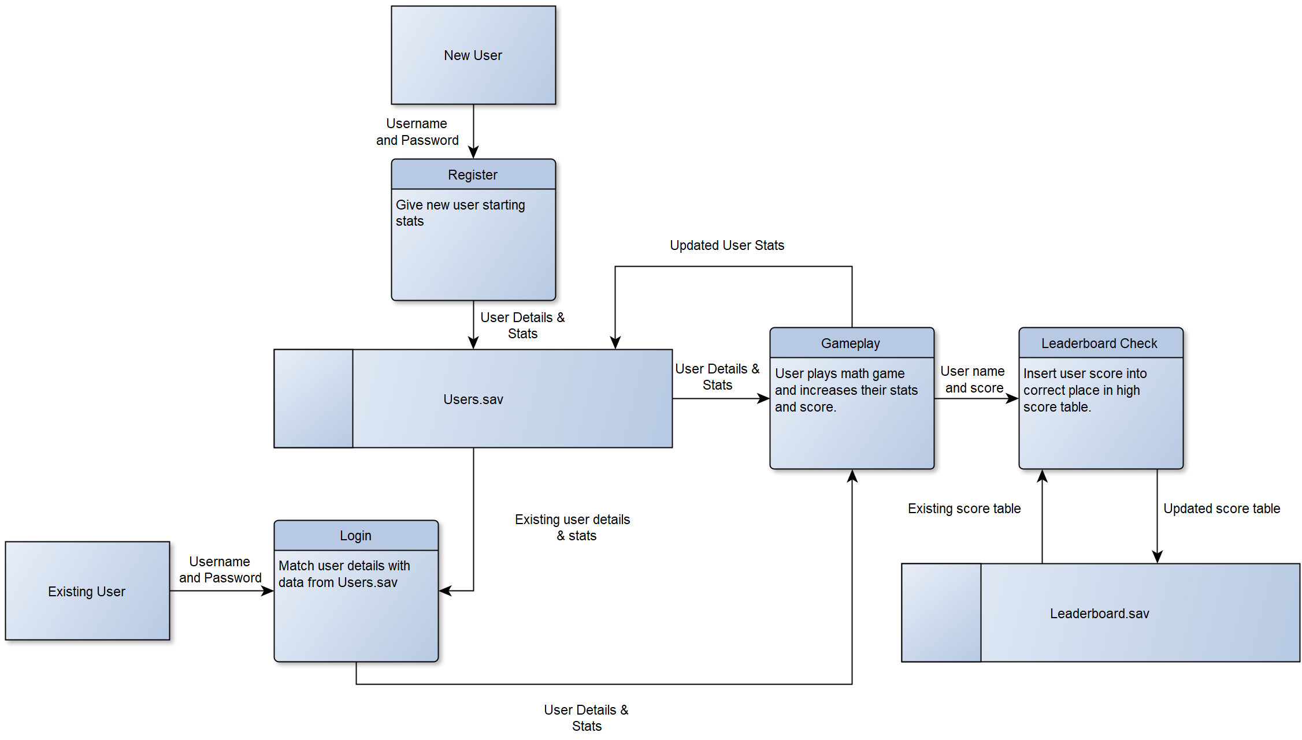
Data Flow Diagram

A DFD was created to help visualise the flow of data to aid in the development. The created app can follow the DFD to ensure that the data usage is correct. The DFD shows that new users provide their username and password, the system then provides the starting stats, and all of these details are stored in Users.sav. Existing users enter their username and password, and they are matched with the data pulled from Users.sav. When the user plays the math game their Level and XP increases, these new stats overwrite the existing stats in Users.sav. The user’s score is then compared to other users scores from leaderboard.sav, the user is placed in the rankings and then leaderboard.sav is updated.

Application Flowchart
A flowchart was created to plan the logic of the math game and leaderboard. The flowchart plans the algorithm to be used when coding the app. This is useful as the steps have already been planned, the build just needs to translate them into code. The flowchart below starts with the generation of a question and then obstacles. When the player collides with the obstacle a check is performed to see if they answered the question correctly. If so, their score increases and a new question is generated. Otherwise, the game is over and the user’s score is used to calculate their new stats which are then saved. The leaderboard is displayed and the user score is compared to each existing position to see where the user is placed on the leaderboard. The leaderboard is then updated and the new rankings are saved.
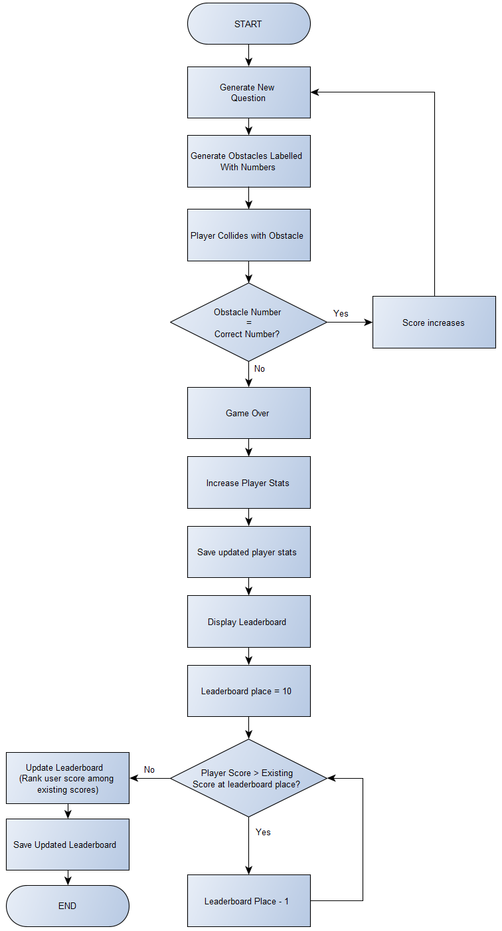

File setups
Users details will be stored in a file called Users.sav. This file will store:

Username – This is the unique identifier as users cannot have the same username.
Password – The password required to login as that user.
Divscore – Their score for the division practice.
Multiscore – Their score for the multiplication practice.
Subscore – Their score for the subtraction practice.
Addscore – Their score for the addition practice.
Exp – The user’s current experience points.
Expthreshold – The experience points required to level up.
Level – The user’s current level.

A second file called Leaderboard.sav will be required to save the high scores:

Place – 1st to 10th
Score – The score that earned them that place.
Name – The name of the user who achieved that score.

4.1.3 System Interfaces
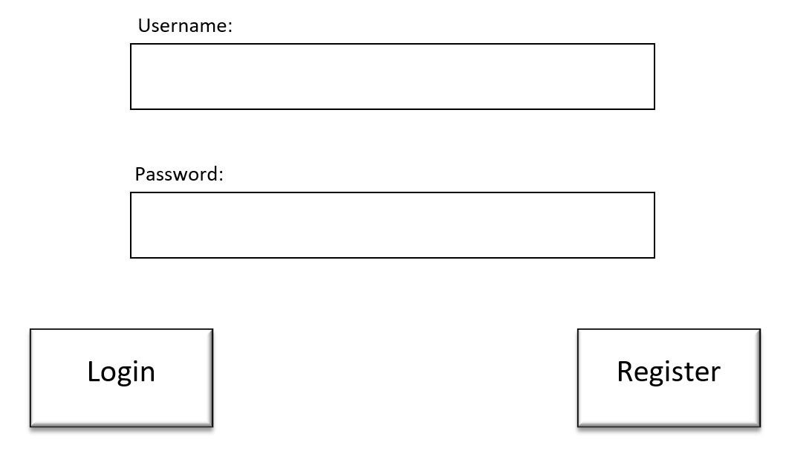
Mockups of the system interface were created to plan how each screen would look and provide a guide for how the users will interact with the app. The first screen planned was the login screen. Users would enter their username and password then click register if they are new to have these details saved. Existing users would click login and the details they entered will be matched with their details in Users.sav to log them in.
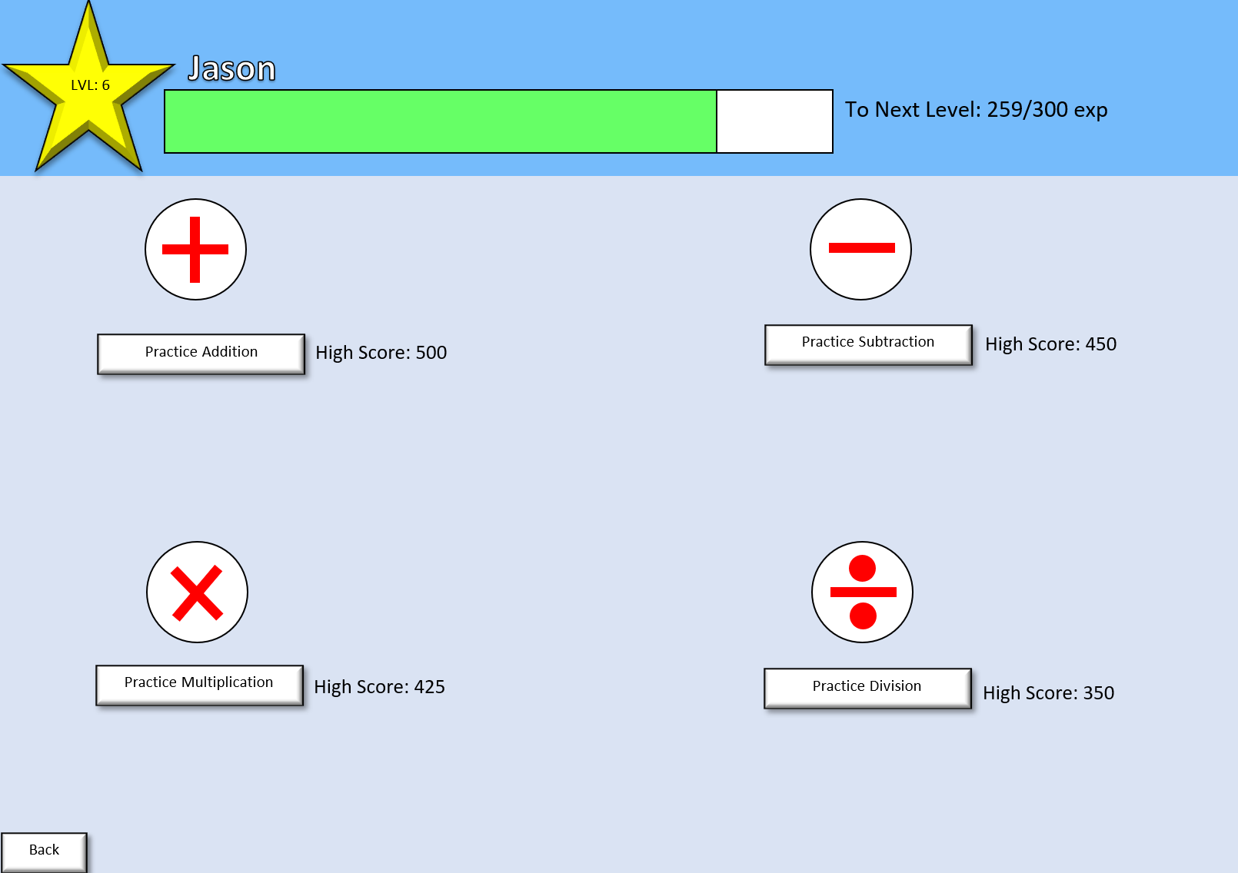
Once users have logged in, they are presented with this screen which shows them their stats including their level, number of experience points they have and the amount they need to level up. It also provides them with options for what math concept they want to practice and their high score for each concept. A progress bar is included to show users how close they are to levelling up, users who see the bar near full may practice math longer than usual to see the level up.
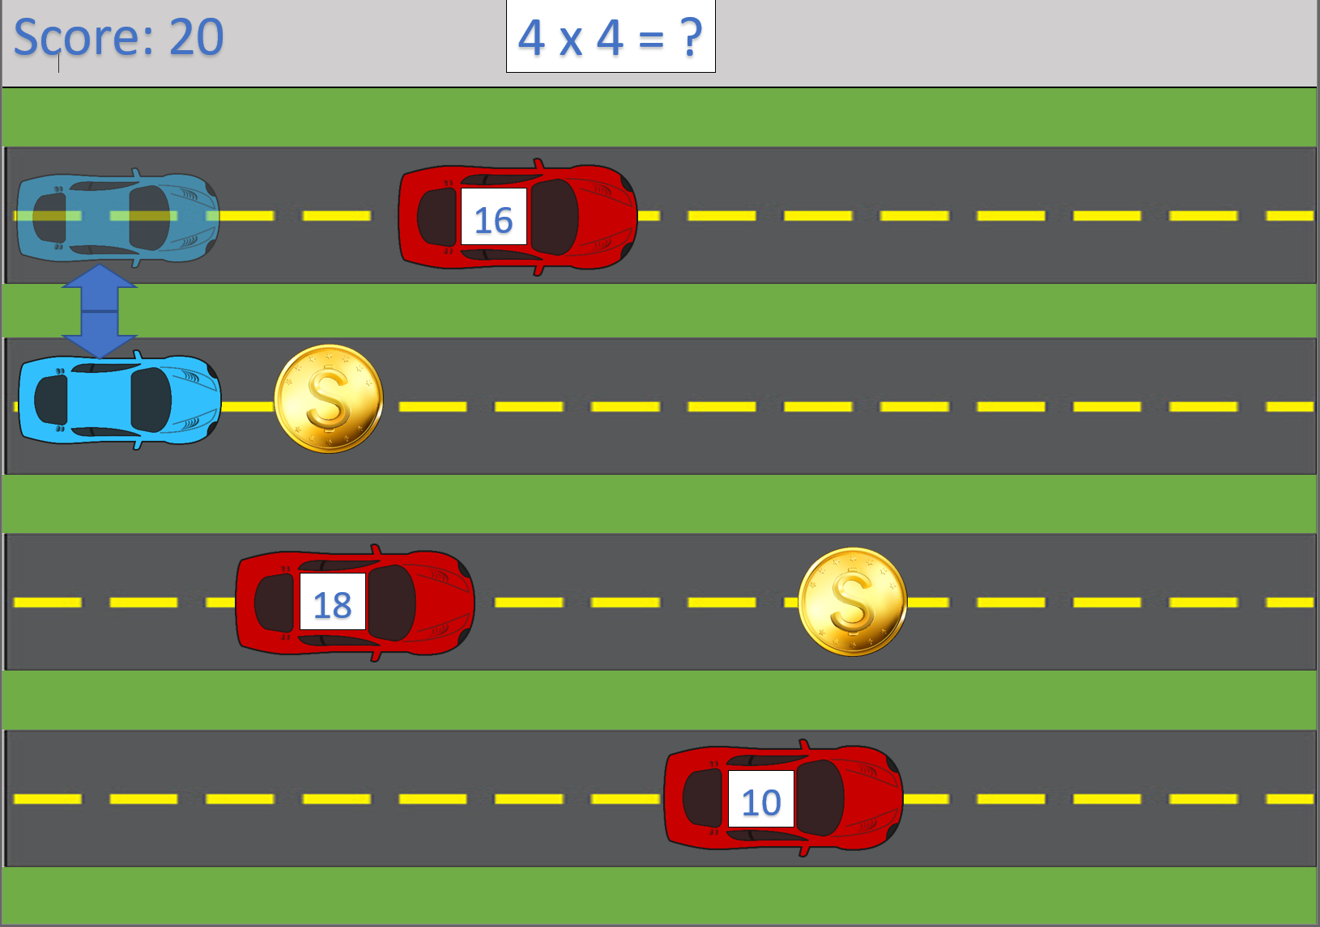
This is the practice screen where users can play the math game. Users control the blue car using the arrow keys to move up and down between lanes. Their goal is to earn points by colliding with the obstacle which has the correct number to answer the question at the top of the screen. Coins are included in the design to add a risk vs reward decision to make the interaction more engaging. Users can risk missing the answer or colliding with an obstacle by going out of their way to collect a coin but are rewarded with more points for doing so.

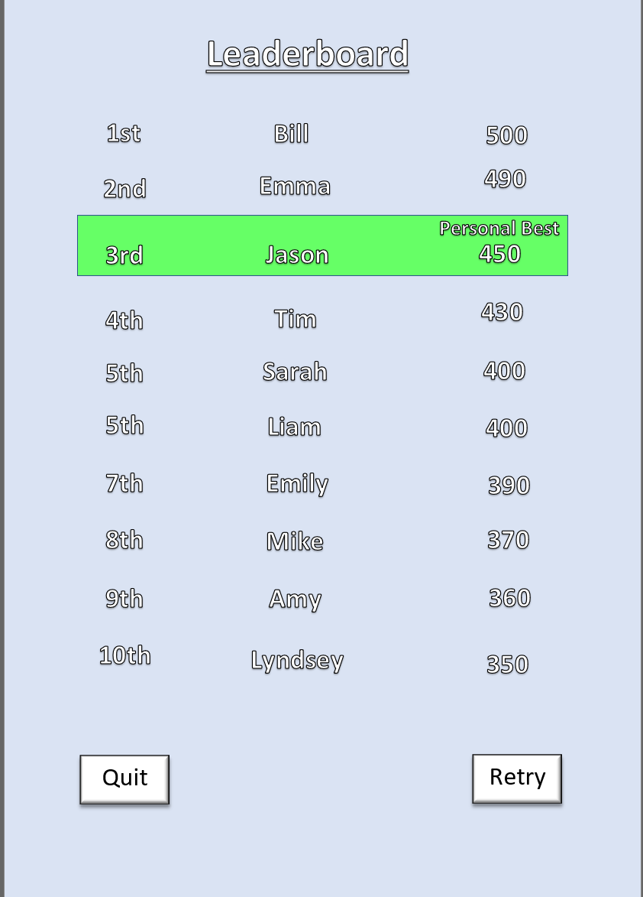
The leaderboard screen displays once the user gets a game over. This screen will display the user’s score and show them the top 10 scores of other registered users. The leaderboard was limited to the top 10 scores to prevent users from getting demotivated if they see themselves appear close to last place.

Implementation

Problems and Successes
The first problem came from a design oversight. The math game was designed so players can earn extra points by collecting the coins. This was supposed to provide a risk vs reward decision, players would risk crashing into an obstacle for the reward of extra points. When this design was created it was not considered that users can abuse this system to get to the top of the leaderboard without answering any math questions. The initial solution to this problem was to change how coins work, instead of just giving points they would instead double the points received by answering the next question correctly. This solution was scrapped because one user can be ranked above another while being weaker at maths by doubling the score for every question. Because of this, coins were removed so the user rankings truly reflect their mathematic ability.
Another issue was found when showing the progress of the app to the project supervisor, at this point the player was set up and able to move and car obstacles were generated for the player to avoid. The project supervisor thought the obstacles were driving backwards towards the player and was confused. To solve this the background was animated to give the impression that all cars are driving forward, and the player car is overtaking the obstacle cars. This solved any confusion as to what was happening in the gameplay screen.
A third solution encountered was the offsetting of the UI which occurred on every screen after the user first reaches the leaderboard. This meant that labels were not just offset but the question and score was completely offscreen when playing the math game. This was caused by code in the draw event of the leaderboard. The vertical and horizontal alignment was changed for the leaderboard, but this code did not just apply to the leaderboard but to every single draw event in the application, which was what caused the offset. This was resolved by adding code to the buttons so that when users leave the leaderboard screen, the vertical and horizontal alignment would be reset.

4.2.2 Software Testing

4.2.2.1 Unit Testing
Unit testing was carried out during the development after each feature in the feature driven methodology was completed. To carry out unit testing a table was created (see appendix 1) which documented the test number, name, testing method, expected outcome and the actual outcome. If the actual outcome matched the expected outcome the test was considered a success and development proceeded to the next feature. Otherwise, changes were made to overcome the problem that caused the expected and actual results to differ, and the feature was retested.

4.2.2.2 System Testing
After all features were implemented and individually tested, they were all retested to ensure that the implementation of later features did not cause bugs to appear in earlier features. This test was carried out using the same table setup as previous and if one part failed, the entire feature list would be retested from the start after bugfixes were implemented to guarantee that the new bugfixes did not nullify previous tests.

4.2.2.3 Usability Testing
Usability testing was split into two halves. Firstly, the testing table was used to test that every control in the app did what it was intended to. Where expected and actual results differed, bugfixes were implemented. The second part of usability testing came from the participants in the primary research. They were questioned on how easy the app was to use and to provide feedback on what would make it easier to understand. This was done because these participants would be using the app for the first time and have no previous knowledge on how to use it unlike the developer whose knowledge from developing the app would hinder his ability to fairly evaluate its usability.

4.2.2.4 Acceptance Testing
Acceptance testing was carried out entirely based on participant feedback. They were asked if they would continue to use the app to practice maths. If the answer was no, then they were asked to give reasons why and recommend improvements that would make them change their view. If the answer was yes then the app was accepted by that user but they were still asked for improvements.

Evaluation
The math learning app was a success as 100% of the interview participants preferred learning with the app over normal classes. Also, over the course of using the app every user increased their score (number of questions answered) showing an improvement in their mathematical ability. Users scores increased from an average of 2 points before a game over to 26. Not only can the user’s improvement be seen in the score, but the users also felt themselves improving saying “it helps and is fun” and “it helped me learn”.
While the app was successful in this regard it was not perfect. Some users found issue with encountering bugs that frustrated them such as a question with an undefined answer because the question generated as ÷ by 0. Another issue is that there is a possibility for users to game over on a correct answer. These issues must be addressed in future iterations of the build. While some users found levelling up to be motivating others disliked the system because it offered no rewards. In a future build levelling up would offer rewards to users to reward the users who found the lack of reward disappointing and to further reward those who like levelling up.
Even though these parts of the application were criticised it was successful at motivating users to continue using the app and practice their maths. The leaderboards were successfully implemented as it was the biggest motivator for the users. The XP and levelling system was also a successful at motivating users to continue playing but not as much as the leaderboard. If the levelling up included some form of reward it might have been received as well as the leaderboards. Because these elements were fun and motivating, 100% of the users said that would like to continue using the app.
The project is also a success as all objectives and the aim has been met. The first objective was met as the research has identified that most effective gamification elements to include in an educational tool were points, badges and leaderboards closely followed by XP and levelling. The second and third objectives were met in chapter 4 which documented the designs, development and testing of the app. The fourth objective was met as the user feedback was gathered about the application. This feedback was used to draw comparisons to the findings of the literature review, and it was also used to determine whether the application was successful at assisting user’s to learn maths. Because all 4 objectives were met, the project was successful at meeting the aim set out in the proposal.

Conclusions & Recommendations
From the literature review and the primary research, it can be concluded that gamified apps can assist users in learning maths. Multiple research studies have found an increase in attendance, engagement, motivation and achievement. The primary research conducted can corroborate part of the conclusions of those studies as the users of the created math app were motivated to learn and demonstrated an improvement in their recorded math scores. The literature review does not support learning styles as an effective method to improve math learning and so should be ignored when gamifying learning.
Commonly identified effective game elements from the literature review were points, badges and leaderboards, which were called the most effective and then XP and levelling systems were identified as the next most effective elements. Participants in the interview were able to back up that points and leaderboards were the most effective gamification element as it was the most motivating, encouraging them to continue playing the game and practicing for longer. XP and levelling up was also a successful motivator but not as effective as leaderboards.
There are some issues brought up in the literature review that were not addressed. Darina Dicheva argued that whether game elements improved motivation or achievement are too broad questions, and that each element should be researched with more focus. They say we should ask whether “elements G are effective for learners type L participating in activity type A”. This research project did not focus on elements that specifically and so it remains a gap in the current knowledge. Another gap that has the potential to completely change the results is brought up by Goh Yung Hong, who found that students who used a gamified application which included a competitive element felt more pressure than those who did not. This means that there are possible negative effects to using competition as a motivator which this research failed to identify. Further research should investigate these gaps as they could lead to major changes in what are currently viewed as effective gamification elements in a learning app. Until then it is recommended that gamified learning apps include points, badges and leaderboards along with an XP and levelling system as these are the most effective at increasing the motivation and achievements of the users.

Reflection
The reflection will be carried out following Gibbs reflective cycle as it is one of the most famous cyclical models of reflection which gives structure to learning from experiences⁽³⁷⁾.
The literature review is part of the project that I believe went well. I was able to find plenty of academic sources on the related topics and sub-topics and I believe I was able to analyse them effectively to extract the main points out of them and draw comparisons. Where I think the literature review could be improved is with how some important points were brought up in the literature review but never expanded or researched further. The avenue of research that I wish I investigated more was whether there were any negative effects of using a competitive element in the app as this was brought up by Guh Yung Hong and never explored further. Answering this could have completely changed the results if I found that there were negative effects of competition. This is a missed opportunity to expand the research to answer gaps in knowledge. If I were to do this again, I would focus the research on trying to answer these gaps in knowledge.
The development of the app was the smoothest part of the project. I was able to complete the app and fully test it in approximately 2 weeks. As this project is under time constraints, I am pleased with the app but I would have liked to include more elements of gamification so that can be evaluated in the primary research. I only included the elements that the literature review found to be effective. If I included other elements, then I may have found ways to effectively motivate users using elements that have been declared by others as less effective or my research would corroborate the current findings. If I were to do another build of the app, I would use the current build as a base and include extra gamification elements based on the feedback gained from interviews. For example, some users wanted levelling up to give them more of a reward, so I would include an in-game store where levelling up rewards users with coins that they can use to customise their cars or buy upgrades so levelling up offers a more rewarding experience to users who are more extrinsically motivated. I also would have included different levels as one participant suggested so users feel a sense of progress when they unlock a new stage.
I believe the primary research is the weakest part of the project. Due to the pandemic, I could not conduct interviews in person, so I was unable to make notes about the user’s facial expressions and body language that may have provided me with more information to their thoughts and feelings about the app. Instead, the interviews were conducted over a voice chat and I was unable to properly observe the user as they used the app; I was only able to see their screen when using the app. As a result of this, my notes for each talking point in the interview were significantly less than I expected or wanted. I was able to get a good response from each user enough to find patterns in their responses, but I feel like I received the bare minimum required to properly analyse how users feel about a gamified application. If I were to conduct the primary research again I would do it when conditions are safe enough for a face-to-face interview and get more of a discussion going to obtain more data.

References
- Welsh Government. Gov.wales 2020 [Accessed: 10/11/2020] Available From: https://gov.wales/sites/default/files/statistics-and-research/2020-01/examination-results-september-2018-august-2019-revised-477.pdf

- Welsh Government. Gov.wales 2020 [Accessed: 12/12/2020] Available From: https://gov.wales/sites/default/files/statistics-and-research/2020-12/examination-results-september-2019-august-2020-502.pdf

- Opitz E, et al. ResearchGate.net 2016 [Accessed: 11/11/2020] Available From: https://www.researchgate.net/publication/307945552_Remediation_for_Students_With_Mathematics_Difficulties_An_Intervention_Study_in_Middle_Schools

- Nelson G, et al. ResearchGate.net 2016 [Accessed: 11/11/2020] Available From: https://www.researchgate.net/publication/298898367_Is_Mathematical_Representation_of_Problems_an_Evidence-Based_Strategy_for_Students_With_Mathematics_Difficulties

- Stocker, J. ResearchGate.net 2016 [Accessed: 12/11/2020] Available From: https://www.researchgate.net/publication/305042959_Impact_of_Cover_Copy_and_Compare_on_fluency_outcomes_for_students_with_disabilities_and_math_deficits_A_review_of_the_literature

- Jaleel S & Thomas A. HRPub.org 2019 [Accessed: 30/11/2020] Available From: http://www.hrpub.org/download/book16-978-1-943484-20-1.pdf

- Ellington S & Benders D. ResearchGate.net 2012 [Accessed: 30/11/2020] Available From: https://www.researchgate.net/publication/256022625_Learning_Style_and_it%27s_importance_in_Education

- Pearson. Pearson.com 2016 [Accessed: 30/11/2020] Available From: https://www.pearson.com/content/dam/one-dot-com/one-dot-com/us/en/pearson-ed/downloads/Learning-Styles.pdf

- Awla H. ResearchGate.net 2014 [Accessed: 01/12/2020] Available From: https://www.researchgate.net/publication/275567766_Learning_Styles_and_Their_Relation_to_Teaching_Styles

- Newton P & Miah M. Frontiersin.org 2017 [Accessed: 01/12/2020] Available From: https://www.frontiersin.org/articles/10.3389/fpsyg.2017.00444/full

- Deterding S, et al. ResearchGate.net 2011 [Accessed: 13/11/2020] Available From: https://www.researchgate.net/publication/230854710_From_Game_Design_Elements_to_Gamefulness_Defining_Gamification

- Deterding S. ResearchGate.net 2013 [Accessed: 13/11/2020] Available From: https://www.researchgate.net/publication/298489865_Gameful_design_for_learning

- Dicheva D, et al. JSTOR.org 2014 [Accessed: 13/11/2020] Available From: https://www.jstor.org/stable/pdf/jeductechsoci.18.3.75.pdf

- Nah F, et al. ResearchGate.net 2014 [Accessed: 15/11/2020] Available From: https://www.researchgate.net/publication/300588016_Gamification_of_Education_A_Review_of_Literature

- Dichev C & Dicheva D. SpringerOpen.com 2017 [Accessed: 01/02/2021] Available From: https://educationaltechnologyjournal.springeropen.com/articles/10.1186/s41239-017-0042-5

- Manzano-León A, et al. MDPI.com 2021 [Accessed: 22/02/2021] Available From: https://www.mdpi.com/2071-1050/13/4/2247/htm

- Alshammari M. TemJournal.com 2020 [Accessed: 08/02/2021] Available From: https://www.temjournal.com/content/92/TEMJournalMay2020_806_813.pdf

- Yung Hong G & Masood M. waset.org 2014 [Accessed: 08/02/2021] Available From: https://publications.waset.org/9999788/effects-of-gamification-on-lower-secondary-school-students-motivation-and-engagement

- Kahoot!. Kahoot.com 2013 [Accessed: 13/12/2020] Available From: https://kahoot.com/

- Wang A & Tahir R. ScienceDirect.com 2020 [Accessed: 13/12/2020] Available From: https://www.sciencedirect.com/science/article/pii/S0360131520300208

- Knowre. Knowre.com [Accessed: 14/12/2020] Available From: https://www.knowre.com/about-us

- Joo D. YouTube.com 2013 [Accessed: 14/12/2020] Available From: https://www.youtube.com/watch?v=1A9ZVDfLTWk&ab_channel=SparkLabsKorea

- Edutapps GmbH. Maphi.app [Accessed: 15/12/2020] Available From: https://maphi.app/

- Neubauer B. link.springer.com 2019 [Accessed: 30/11/2020] Available From: https://link.springer.com/article/10.1007/s40037-019-0509-2

- Dudovskiy J. research-methodology.net 2018 [Accessed: 30/11/2020] Available From: https://research-methodology.net/research-philosophy/phenomenology/

- Dudovskiy J. research-methodology.net 2018 [Accessed: 30/11/2020] Available From: https://research-methodology.net/research-methodology/research-approach/deductive-approach-2/

- McLeod S. SimplyPsychology.org 2019 [Accessed: 01/12/2020] Available From: https://www.simplypsychology.org/case-study.html

- Melnikovas A. JFSDigital.org 2018 [Accessed: 02/12/2020] Available From: https://jfsdigital.org/wp-content/uploads/2019/01/03-Melnikovas-Onion-Research-Model.pdf

- Rivers J. Study.com [Accessed: 02/12/2020] Available From: https://study.com/academy/lesson/cross-sectional-study-definition-advantages-disadvantages-example.html

- Marshall C. LinkedIn.com 2016 [Accessed: 02/12/2020] Available From: https://www.linkedin.com/pulse/face-to-face-interviews-advantages-disadvantages-charlie-marshall

- TutorialsPoint. TutorialsPoint.com [Accessed: 15/02/2021] Available From: https://www.tutorialspoint.com/software_testing_dictionary/unit_testing.htm

- Guru99. Guru99.com [Accessed: 15/02/2021] Available From: https://www.guru99.com/system-testing.html

- Moran K. nngroup.com 2019 [Accessed: 16/02/2021] Available From: https://www.nngroup.com/articles/usability-testing-101/

- STF. SoftwareTestingFundamentals.com 2020 [Accessed: 16/02/2021] Available From: https://softwaretestingfundamentals.com/acceptance-testing/

- LucidChart Content Team. LucidChart.com [Accessed: 16/02/2021] Available From: https://www.lucidchart.com/blog/why-use-feature-driven-development

- YoyoGames. YoyoGames.com [Accessed: 16/02/2021] Available From: https://www.yoyogames.com/en/get

- The University of Edinburgh. ed.ac.uk 2020 [Accessed: 09/04/2021] Available From: https://www.ed.ac.uk/reflection/reflectors-toolkit/reflecting-on-experience/gibbs-reflective-cycle

DEMONSTRATION FILE
https://www.youtube.com/watch?v=K-xlDZrON_w – A short video demonstration which shows the functionality of the math learning app.

Appendices

Appendix 1: Test Case Table
Below are the first four tests carried out. This is used as an example of how test cases were used during unit and system testing.
Test No. | Test Name | Test Method | Expected Results | Actual Result | Remedial Action
1 | User Registration | Enter a username & password, click register. | Confirmation message saying user is registered. User details saved in Users.sav file. | Failed | Added an extra ini_write function to store the user’s current level which was missing.
2 | User Registration Retest | Enter a username & password, click register. | Confirmation message saying user is registered. User details saved in Users.sav file. | Passed
3 | Login | Enter the same username and password, click login | Welcome back message appears, user’s stats are displayed on screen. | Passed
4 | Register Validation | Click register with blank spaces. | User is not registered. Message appears telling users to not leave spaces blank. | Passed

Appendix 2: Blank Interview Sheet
- Did you prefer learning with the app rather than the normal classes?

- What about the app did you like/dislike?

- Were you motivated to learn?

- Were your scores getting better over time?

- How easy was the game?

- Was the app easy to use?

- What would you like changed/added to the app?

- Would you continue using the app?

Appendix 3: Participant 1 Interview
- Did you prefer learning with the app rather than the normal classes?

User preferred the app saying, it “Gives a competitive edge and doesn’t feel like learning”.

- What about the app did you like/dislike?

The user praised the presentation of the app saying “It looks like a website game”. When asked to clarify what they meant by that, they actually mean that it looks like a flash game that you can play on websites like coolmathgames.com

The user identified a balance issue as their main dislike of the app. When cars passed the player they still crashed into them even though only a few pixels of the car were visible because the rest of the car was off screen. Screenshot below replicating the issue.
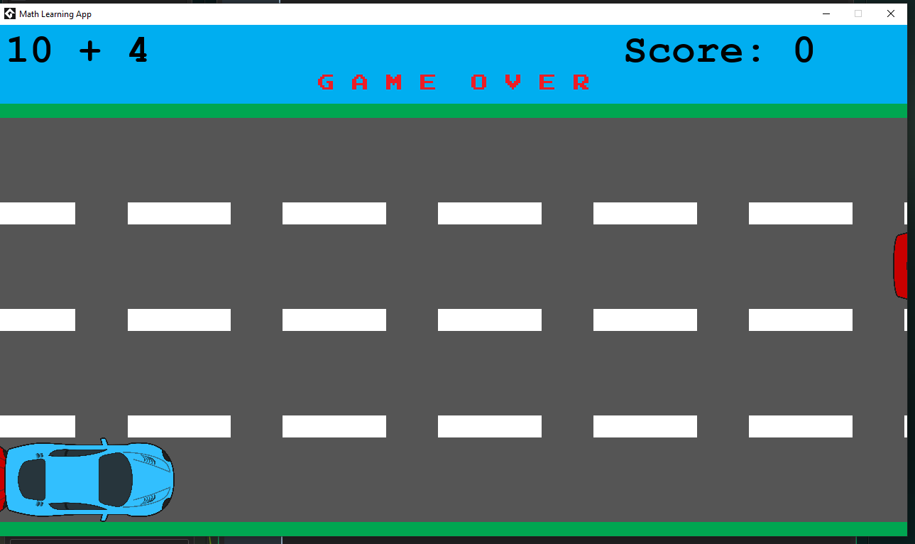

- Were you motivated to learn?

The user found levelling up motivating saying “I wanted to get higher levels”.
They also said “I want to be at the top of the scoreboard”, showing they are also motivated by the competitive element.
When asked which was more motivating the participant said that the competitive element was more motivating.

- Were your scores getting better over time?

Yes. The user’s score increased over time from 4 to 23.

- How easy was the game?

The user said that the game was “Easy but not too easy”. They were positive when saying this so the balance was just right, excluding the balance issue they mentioned earlier.

- Was the app easy to use?

Yes – all instructions and messages they needed were provided except user had to ask how to control the car.

- What would you like changed/added to the app?

The participant wanted the cars to disappear off screen quicker and to add an instruction on how to move the car.

- Would you continue using the app?

“Yes, I want to beat Bill and get the top score” – The user wants to continue to use the app so they can beat the existing high scorer.

Appendix 4: Participant 2 Interview
- Did you prefer learning with the app rather than the normal classes?

The participant preferred using the app because it was “More fun” and “Doesn’t feel like you’re learning but you are”.

- What about the app did you like/dislike?

The participant stated that they like the Competition
They also liked Levelling up.

The participant disliked that “Cars moved too quick and were blurry”. – This can lead to frustration and balance issues which may demotivate the participant.

- Were you motivated to learn?

Yes – “Playing the game is engaging, I want to reach the top of the leaderboard”. The participant stated they “want to get new high scores” and “get bigger levels”, showing that they were also motivated by getting a personal best and the XP/levelling system. The participant found reaching the top of the leaderboard to be the most motivating element followed by achieving a personal best score.

Surprisingly, the blurred cars did not demotivate them or cause them frustration, however it is still a negative point raised against the app as it may demotivate and frustrate other users who may feel the same.

- Were your scores getting better over time?

Yes. The participant’s score increased from 1 to 18 over the course of their time using the app.

- How easy was the game?

“It wasn’t that hard but wasn’t too easy”. The difficulty seems to be just right.

- Was the app easy to use?

Yes. “getting around the app (navigation) was easy” but it “Doesn’t explain what to do to play the game”.

- What would you like changed/added to the app?

“More types of games”. The participant wanted more variety in the math games available, doing this would likely motivate users to use the app for longer as once they get tired of playing one game type they can try another game type and continue learning maths.

“Add instructions” – This addition was directed at the lack of instructions on how to play the game.

- Would you continue using the app?

Yes
(Participant said “Sure” in an apathetic manner, they spoke with enthusiasm for earlier questions though. They could be tired of the interview, but they may also be unsure of whether they truly would continue using the app).

Appendix 5: Participant 3 Interview
- Did you prefer learning with the app rather than the normal classes?

Yes “It was more fun than normal classes”

- What about the app did you like/dislike?

The user praised the usability and the presentation saying “it was easy to get (understand) and brightly coloured”.

“One question broke” – A question appeared that was divided by 0 which gave an infinite answer. This was displayed on the correct answer car as NaN.

“can crash into a car that is already behind me”. – This is the same issue highlighted by participant 1.

- Were you motivated to learn?

Yes.

The participant was motivated most by levelling up saying “I liked seeing the (XP) bar fill up”. They also said that they were motivated “To get a higher score” – they made a distinction that this was about their personal high score instead of the leaderboard.

While the user was motivated by the leaderboard they said this was motivating “but not as much as my own high scores and levelling up”. When asked why that is they said that the leaderboard did not change much so there was no need to keep checking it.

- Were your scores getting better over time?

Yes. The participant’s score increased from 0 to 21.

- How easy was the game?

The participant said that the game was “easy to understand and control.” And then said a “tutorial would be nice”. This appears to be a contradiction so the participant was asked: if the game was easy to understand and control what would the tutorial be for.

They responded saying that what they were supposed to do to earn points was clear, but they didn’t immediately know how to control the car. They tried using WASD to move the car first but when that didn’t work they knew to use the arrow keys. Once they understood this is when they said controlling the car was easy.

- Was the app easy to use?

The user found registering and logging in to be simple and it was easy to select what math concept they wanted to learn. This is positive for the usability of the app outside of the math game screen.

- What would you like changed/added to the app?

The user wants the app to expand on the available types of math concepts such as “negative numbers or decimal numbers”.

They also want “more game modes so the app doesn’t get boring”.

- Would you continue using the app?

Yes – “It helped me learn”.

Appendix 6: Participant 4 Interview
- Did you prefer learning with the app rather than the normal classes?

Yes “it mixed math and games so it was fun”.

- What about the app did you like/dislike?

Participant likes the scoring system used in the app - “I like seeing my scores improve”.

“The questions were easy to answer”. – They said this as something they liked about the app but as the developer, I wanted the questions to test the user so I will take this as a negative against the app because if the questions are too easy the user is not learning.

“The road markings made my eyes bleed”. – Note: the user’s eyes didn’t actually bleed it was a figure of speech for how bad it looked, which is understandable. The road only has 5 frames of animation and can look rather choppy.

- Were you motivated to learn?

Yes
“Getting high on the leaderboard was most motivating”. – The participant is most motivated by the competitive element.

“I wanted to improve my scores”. – The second most motivating element to the participant is seeing their own personal scores improve.

“XP and levelling were not motivating because there was no reward for levelling up” – This is a good point to make against the XP and levelling system, once participants realise the only thing they get from levelling up is a higher number attached to their name they may lose interest as there is not much in terms of extrinsic rewards to motivate them.

- Were your scores getting better over time?

Yes. The user’s score increased from 0 to 32.

- How easy was the game?

“Too easy” – User noticed that incorrect answers were commonly high numbers (over 40) while correct answers were never higher than 40 (except for multiplication).

- Was the app easy to use?

“Yes it was easy to use” – The user was asked to expand on their answer but said that there was nothing wrong with the app that they can talk about. NOT ENTIRELY TRUE SEE QUESTION 7.

- What would you like changed/added to the app?

“A little how to play, maybe like a date for the leaderboard so it shows you when you got your scores. Better graphics or interesting backgrounds and rewards for levelling up.”

Because the user said that they wanted a how to play section but also said the app was easy to use they were asked to provide more information because I viewed this as a contradiction. They said they had no issues using the app but others might be confused because there is no instructions. – However this is not entirely true. The user got a score of 0 on their first attempt because they didn’t move the car out of the way of an obstacle, it was on their second attempt when they used the arrow keys. I don’t believe the participant was being untruthful when they said the had no issues with it because when reminded of this fact they said “oh yeah I did do that”, so it seems they just forgot.

TLDR – there needs to be better instructions in the app to inform users on how to play.

Rewards for levelling up would be an extra layer of extrinsic motivation that could keep users coming back to the app to learn. This is something that can be implemented in a future iteration. When asked for what types of reward they are looking for the user said “maybe you can unlock new cars or earn money to spend on upgrades or paintjobs”.

- Would you continue using the app?

“Yes because I want to keep improving my score”.

Appendix 7: Participant 5 Interview
- Did you prefer learning with the app rather than the normal classes?

Yes Because it was fun.

- What about the app did you like/dislike?

“I like the XP bar and the leaderboard because it showed my progress.”

“I answered a question correctly but I got a game over” – The game generates two types of obstacle correct car and incorrect car. Incorrect cars carry the incorrect answer while correct cars carry the correct car. The participant answered a question after a car with the number 4 was generated. The next question generated as 2 + 2 which was 4 but the car currently carrying the number 4 is marked as incorrect because it was generated as incorrect because it was incorrect at the time it was generated.

“I kept crashing into cars trying to switch lanes because the gap was too narrow” – This is the same issue highlighted by participant 1.

“Some answers showed up as NaN and I didn’t know what it meant”. – This is the divide by zero bug that participant 3 experienced.

- Were you motivated to learn?

“Yes because it was more fun than just writing answers.”
“XP and levels were good because I could see that I was improving”. – most motivating gamification element.
“I can see how well I did on my last turn and I want to try and beat it”. Second most motivating gamification element.
“I liked to beat my friends on the score table”. – least motivating gamification element.

- Were your scores getting better over time?

Yes. Improved from 7 – 53.

- How easy was the game?

“Wasn’t too easy because I had to think quick.” – the participant found the difficulty to be just right.

- Was the app easy to use?

Yes. The participant gave no further expansion to this as they could not think of anything that would make it easier to use.

- What would you like changed/added to the app?

“A date for the scores” – The user wanted to check back on previous scores so they can see how long it took them to beat their high score.

“Start with addition and when you hit level 2 or 3 you unlock the next one so you progress because they get harder”. – User wanted the extra concepts to be unlocked as they levelled up to act as a difficulty curve.

- Would you continue using the app?

“Yes it was a more fun way of learning”.

Appendix 8: Participant 6 Interview
- Did you prefer learning with the app rather than the normal classes?

Yes “it was fun to play against my friends”.

- What about the app did you like/dislike?

“I like that it’s a game and that there are scores to show my mates”. – Participant likes that the learning feels like a game rather than a chore and likes when others see him at the top of the leaderboard.

“Sometimes the right answer takes a while to get there”. – Due to the random generation there is a chance that the correct answer won’t appear for a long time.

“obvious what answers are wrong”. – Same point made by participant 4.

- Were you motivated to learn?

Yes “So I can get better at the game and get a better score than my friends”.

“Not really motivated by levelling up because they do not do anything”. – Same point as participant 4.

“Getting a higher score was to compete with my mates.” – Response to whether the reward for getting a high score was to better themselves or to compete with others.

- Were your scores getting better over time?

Yes. Scores increased from 2 to 27

- How easy was the game?

“adding and take away were too easy”. – The user found that the addition and subtraction questions were too easy because the highest possible question was 20 + 20.

“multiply and divide was hard” – User said they find multiplication and division hard even when it’s not a game and that they can’t comment on the games balance here. They did say that it “wasn’t so hard that it made me angry”. – So at the very least the extra challenge was not frustrating.

- Was the app easy to use?

“Mostly, a tutorial would be good”. – The participant’s “mostly” was only given because they did not know how to control the car at first.

- What would you like changed/added to the app?

“extra difficulties” – Added difficulty options would make the questions more satisfying by matching the participant’s skill level.

“Better graphics” – User wanted the game to be 3d because it “doesn’t look as good as games I play”. – This is a simple game to practice maths not a AAA blockbuster so the extent that the game can look good is limited by the need for it to be playable on as low spec devices as possible. While I cannot make the game 3d and as visually appealing to match the user’s expectations the art included in the game is very lifeless so maybe a stronger art style can solve this criticism.

“Rewards for levels”. – Again, this is something that participant 4 brought up. Levelling becomes less motivating to some users when they realise that the only reward is a higher number.

- Would you continue using the app?

Yes “To stay at the top of the leaderboard”.

Appendix 9: Participant 7 Interview
- Did you prefer learning with the app rather than the normal classes?

Yes – “Adds more fun to learning”.

- What about the app did you like/dislike?

“I liked that it was easy to understand”. – User thought the app was easy to use.
“I had to think about what the answers were”. – User liked the challenge.

“crashing into cars that I thought was off screen”. – Same as participant 1.

User expected the register button to take them to a separate page to enter their details, however they said that it made sense once the instruction appeared on screen when trying to click register with empty fields.

- Were you motivated to learn?

Yes – “I liked the competitiveness of the game. I wanted to stay on top of the leaderboard”. – Most motivating to the user.

“I liked seeing my high score get higher because I could see that I was getting better”. – Second most motivating.

“I thought I really want to be level 2 now and progress in the game”. – Third most motivating.

- Were your scores getting better over time?

Yes. Score increased from 2 to 19.

- How easy was the game?

“Difficulty was just right”
“The right answer didn’t always appear straight away so I had to think about the answer and not just guess”.

- Was the app easy to use?

“Very Easy” – The user mentioned that the layout was simple and easy to follow. NOTE: In an earlier question they talked about their expectation of the register button. Because the app was very easy to use it shows that this may not have taken away from the ease of use. E.g it was easy but not quite what they are used to.

- What would you like changed/added to the app?

User would like a dedicated register page to match their expectations.

“move car forward and back so I can get to the answers quicker”. – Speed is dictated by the game. Allowing users to score points at their own speed may make for a more fun and therefore motivating game.

“I want rewards for levelling up because you don’t get anything for it”. – Same as participant 4.

- Would you continue using the app?

Yes – “I can learn more for fun”.

Appendix 10: Participant 8 Interview
- Did you prefer learning with the app rather than the normal classes?

Yes “It’s fun and easy to understand”.

- What about the app did you like/dislike?

The user praised part the presentation saying it was “Very colourful”
The participant found it “Fun using cars to do math”.

No smooth animation. – The user criticised the animation of the road similar to participant 4

- Were you motivated to learn?

“Yes”
They said “Most of all I wanted to get to the top of the scoreboard. After that I kept wanting to fill the xp bar.”

The competitive element was most motivating followed by the xp and levelling.

- Were your scores getting better over time?

Yes score increased from 1 to 18.

- How easy was the game?

“mostly easy, sometimes unfair” – user is referring to crashing into cars that they can’t see as not being off screen similar to participant 1.

- Was the app easy to use?

“Yes everything was clearly labelled and tells me what it’s doing”.

- What would you like changed/added to the app?

Difficulty options, Increased digits (triple digit), More math concepts “like solving the radius of a shape”.
“More game types, maybe a fishing game or a platforming game”.
This participant values extra challenge and variety in the app.

- Would you continue using the app?

“Yes because it helps and is fun”.

Appendix 11: Average and Total Scores


