Assignment Title: Mid-Term Formative Assessment and End of Term Assessment



Group 2
Hasina Akhter
Student Id: 1711896
Module Code: BMSW 5006
Module: Knowledge and Information Management Skills for the Workplace
Lecturer: Domnan Miri

Assignment no 1.
Midterm formative assessment.

Question 1: Explain why the same set of data can be considered as useful information by some and useless data by others. Further, could this useful information be termed as “knowledge”? Why?
Answer: Data can be defined as some numbers, symbols, facts etc that have little meaning or not meaningful at all. For example: 8 hours. These data are not completely meaningful that’s why useless to some people. But when these data are processed and become completely meaningful is known as information. For example: an employee works 8 hours per day. These are meaningful now that’s why become useful to others. According to French, C (1996), data is the term used to describe basic facts about the activities of a business. And the information is obtained by assembling items of data into a meaningful form. So, the data are raw facts that are collected thorough observation or research which don’t have complete meaning, than this data are processed to create meaningful to the users which are known as information. To make it clearer this process is presented as below figure 1.1 by providing example.

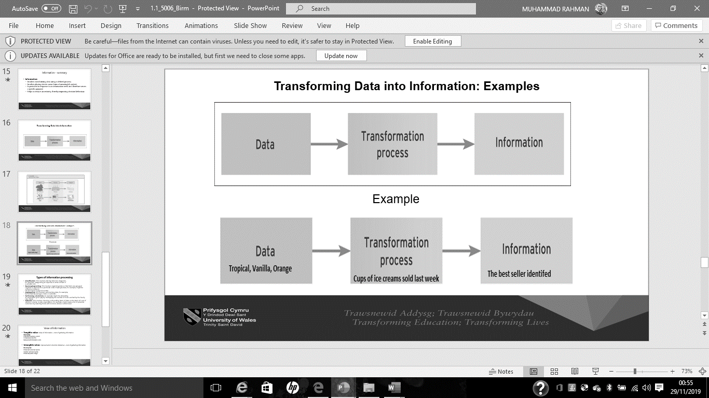
Figure 1.1: Transforming Data into information; Examples. Source, UWTSD (2019).
In above figure the data tropical, vanilla, orange don’t create a complete meaningful word that’s why these are useless to some. When this data are under transformation process like cups of ice cream sold last week become the information and useful to others. That’s why it is reasonable to say the same set of data can be considered as useful information by some and useless data by others.
Moreover, these information also can be termed as knowledge. Because, the knowledge is something that we acquired by experiencing previously. So, the knowledge can be defined as our beliefs, assumption, familiarity that we gained from our past experiences. According to The Oxford Dictionary (1998) knowledge is the range of information that a person has, also a person’s awareness or familiarity that is gained by experiencing things or facts. So, when we experienced something or acquired a information we recognised it next time as we know about it. That’s the useful information can be termed as knowledge.
Question 2: Describe the ways in which “knowledge” differs from “data” and “information.” Justify your answer with a relevant diagram.
Answer: The knowledge differs from the data and information as we have seen in above discussion that data are raw facts, information are processed data and knowledge is our awareness and familiarity. The DIKW model shows how the knowledge differs from data and information. According to Carayannis, E. Pirzadeh, A (2013) DIKW hierarchy model refers to a class of model for representing purported structural and/or functional relationships between data, information, knowledge and wisdom. Below figure 1.2 represents the DIKW model.
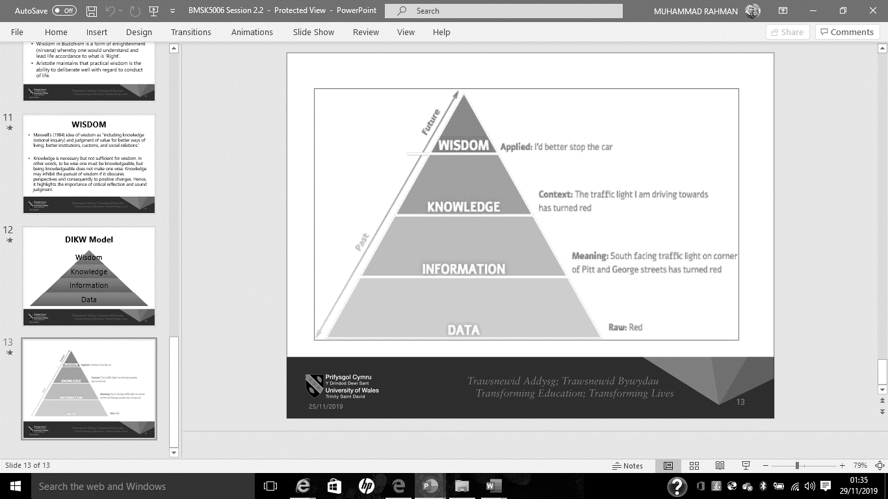

Figure 1.2; DIKW model. Source; UWTSD (2019)

The above figure shows that on the first stage data are raw and not completely meaningful like: Red. In the second stage data transformed to information which is meaningful like; South facing traffic light on the corner of Pitt and George streets has turned red. On the third stage a situation or context where we acquired our knowledge Like: the traffic light I am driving towards has turned red. At last stage is wisdom where we must react on the basis of our knowledge like: I’d batter stop the car. So, the knowledge differs from the data and information in a hierarchical way.
Question 3: Does a player in a card game use tacit or explicit knowledge? Explain why. Define and explain the difference between the two.
Answer: In general when a player plays card game, he/she used her experiences, expertise, assumption but its only possible for an experienced player. However, what about an un-experienced or new player. That’s why the commonly knowledge is categorised as tacit and explicit knowledge. According to Coakes, E (2003) ‘Tacit knowledge is hard to formalize and highly personal that’s why difficult to communicate with others. Because tacit knowledge is being practical, personal, and likeliness. On the other hand, explicit knowledge is seen being independent, hypothetical and digital. can be easily communicated with others, because it is formal and systematic. That’s why there are various differences between tacit and explicit knowledge such as:
- Explicit knowledge is Objective, theoretical and digital. But the Tacit knowledge is Subjective, practical and analog.
- Explicit knowledge is systematic and formal. On the other hand, Tacit knowledge is hard to formalize and highly personal.
- Explicit knowledge can be easily shared and communicated with others, where tacit knowledge difficult to communicate.
- Explicit knowledge is easy to capture and can be easily documented, but tacit knowledge can’t be documented as hard to capture.
- Explicit knowledge is documented in books, memo, invoices that’s transferable through teaching and training. On the other hand tacit knowledge is not documented that’s why it is transferable through coaching, mentoring, face to face or one to one session.
Furthermore, according to the theory of organizational knowledge creation developed by Nonaka, I (1994) discussed four patterns for the knowledge creation such as: socialization, combination, internalization and externalization through continuous dialogue between tacit and explicit knowledge. Which are presented in below figure 1.3.
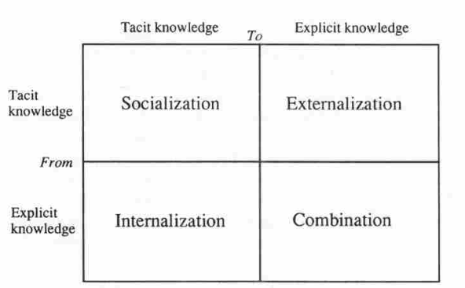

Figure 2: Modes of knowledge creation. Source Nonaka, I (1994)
So, the above discussion made it clear that in a card game an tacit knowledge is used by an experience player as being expertise. But, a unexperienced player use the explicit knowledge as play by following rules from the books.
Question 4: Consider five decisions you have made today (they could be simple such as taking a turn while driving or even choosing a soda at a convenience store). In each case determine the data, information, or knowledge that were involved in the decision.
Answer: To make a decision we always use available data, information and our knowledge. Following five decisions that I have made today were based on available data, information and my knowledge.
1. I took my house recycle bins out today and kept in the collection area by segregated the waste for tomorrow collection. In here council provided us the information by letter that recycle bins waste must be segregated before the collection otherwise they will not take the bins. Also, I have knowledge of what should be recycled from the past experiences.
2. I bought salt from ASDA today where I have used the information provided in the packaging like the price and weight to decide the amount and packets I need to buy.
3. I went to the town today with the bus number 60. Where I used the information was given in bus stop that number 60 goes to town and my knowledge as used the bus before. To avoid being late to reach in town.
4. I bought dish washing liquid today for the house. Where I have used the information on the packaging to know the price. And I have used my knowledge to buy the fairy brand liquid as I know it is good quality.
5. I have posted a letter today by using recorded delivery. Where I have used the information provided in the post office for the price and when it will be reached to the destination.
Question 5: Now consider how those decisions would have been influenced by the lack of pre-existing data, information, or knowledge.
Answer: It will be very hard to make decisions without the pre-existing information or knowledge even some time it will be impossible to decide. So, not only in personal life but also for the organisation decisions making purpose pre-existing information and knowledge are vital. According to Murugan, A. Asokan, A. Srinivasan A. C. (2012) Information turn out to be essential for the organization’s stability and progress, that’s why the organisation must efficiently use the intangible resources like, data, information and knowledge. If we look in to above 5 decision I have taken today all of them was based on pre-existing information and knowledge. If I dint have those information I would have been confused, wasting my time by wondering or asking people, and might take wrong decisions in some case the consequence would have been terrible. For example, first decision I have taken to segregate the recycle bins before putting in the collection area, if the council didn’t give me the information what to recycle, when the bins will be collected, or the policy to segregate the bins. I would of not know the proper policy for bin collection and the result would have been council not taking my bins. Similarly with second decision I would not be able to buy the correct amount of salt and stuck with the price if there was no information available. Also, for third decision I would of catch wrong bus and reach wrong destination if I didn’t have the information that bus number 60 goes to town. Again, for fourth decision without the information and knowledge I would of buy the wrong liquid which would have been dangerous for health. And the last decision I would of used wrong stamp and the letter wouldn’t of reach on time. So, without the pre-existing information and knowledge the decision may become risky for the organisation.
Question 6: You have recently invented a new product. Collect demographic data from a sample population, determine how you would use this data, and convert it into information and possibly knowledge for promoting the product.
Answer: Selling craft items that represents the Bangladeshi cultures and useable by any age group male or female. So, I need to collect data for Bangladeshi ethnic back ground people leaving in Birmingham. According to the census (2011) that 32,532 Bangladeshi, 64,621 Indian, 144,627 Pakistani and others ethnic group people live in Birmingham including various age group. In here the data 32,532 and Bangladesh been transformed in to the whole information as 32,532 Bangladeshi people live in Birmingham. Where I need only need that information to promote my product. So, my target market is all the Bangladeshi people and age doesn’t matter as the product is useable by all age groups and by both male and female. So, I will not produce excess number of products that may goes waste as I know the maximum number of target customer living in Birmingham.

References:
- Carayannis, E. Pirzadeh, A (2013), The Knowledge of Culture and the Culture of Knowledge: Implications for Theory, Policy and Practice Springer.
- Coakes, E (2003), Knowledge Management: Current Issues and Challenges, Idea Group Inc.
- French, C (1996), Data Processing and Information Technology. 10th Edition. Cengage Learning.
- Murugan, A. Asokan, A. Srinivasan A. C. (2012), Business Intelligence Techniques: A Perspective from Accounting and Finance, Springer Science & Business Media, 2012.
- Nonaka, I (1994), A dynamic theory of organisational knowledge creation. The Institute of management science. Vol.5 no.1. February 1994.
- The census (2011), 2011 ethnic group by age ward, https://www.birmingham.gov.uk/downloads/file/9839/2011_ethnic_group_by_age_ward
- UWTSD (2019), Lecture slides for the course: Knowledge and Information Management Skills for the Workplace, BMSK5006, week 1, session 1.
- UWTSD (2019), Lecture slides for the course: Knowledge and Information Management Skills for the Workplace, BMSK5006, week 2, session 4.

Assignment no 2.
End of Term Assessment.
Part 1: case study

1: Describe how the overall approach adopted by American Airlines incorporated the basic competitive strategies of cost leadership and product differentiation
Any business organisation always will look to take competitive advantages over other competitors in all possible ways. That’s why it is essential for a business organisation to find the competitive strategies. Michael E. Porter developed three strategies that a business can achieve for competitive advantages over rivals such as: Overall cost leadership, differentiation, and focus (Neil, B. John, M. 1999). Following graph 2.1 presents the Porter’s competitive strategies.
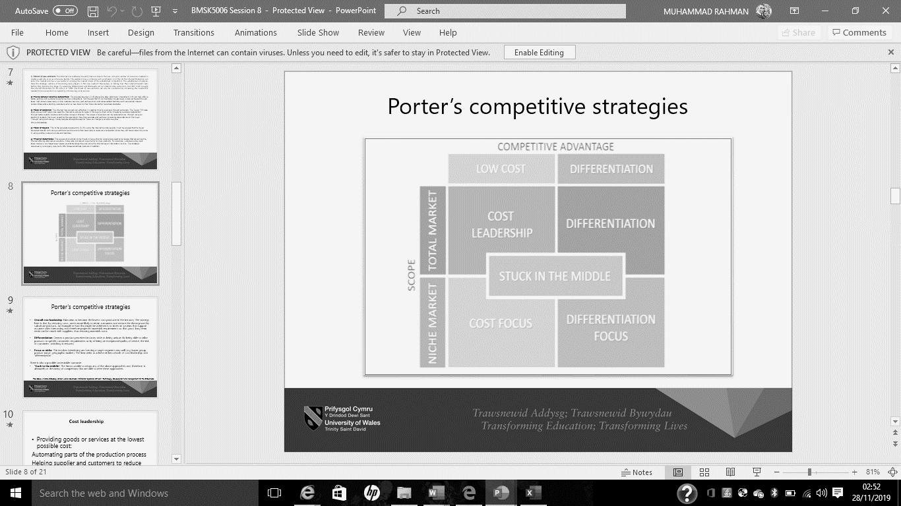

Graph 2.1: Porter’s competitive strategies. Source, UWTSD (2019).

In here the approach by the American airlines company was cost leadership strategy and the strategy of differentiate its product from the competitors to take competitive advantages over its rivals. So, the question is how the company approached to Cost leadership and differentiation. Following discussion will find that answer:
- Cost leadership: Cost leader ship refer to a firm wants to reduce the production cost by saving money on buying raw material as a bulk amount, increasing productivity by reducing the human labour like introducing new technology. In the case study with the help of SABRE the American airline was able to reduce its 30% investment cost, which they could of offer reservation at 30% less price than usual and over other competitors.
- Differentiation: Company produces an exclusive or unique product that is superior from the competitors products by offering extraordinary quality product or excellent service that exceeds the customer expectation. In the case study American airline was offering to its customer additional service like hotel booking, rental cars and looking for low price through agent exceeded the customer expectation and made the company service as unique than its competitors.
2: In what ways did SABRE provide American Airlines with a competitive advantage? Your analysis should refer to concepts related to the strategic use of information systems, for example, entry barriers.
The thought of information systems and technology strengthened the chances for the firm to be more efficient and competence for lowering the production cost and improving the quality of products and services. It will become barriers for a newcomer in the competition if an existing firm attain the competitive advantages in the industry. By analysing the five forces developed by Porter’s the way SABRE gave the American airline such competitive advantages can be identified. Where, the information system also influences the porter five forces.
The threat of new entrants: A new entrance business will make the competition more higher in the industry that’s why the new entrants are seen as threat for the existing company. Also, a new entrants will try to established in the industry by attracting the existing company’s customer through providing various facilities like; reducing the price at lowest level, giving more quality product than existing company as the new comer will not look at the profit in the first place rather to establish the business in the customer mind. That’s why an existing company must create barriers for the new entrance. Where heavily investing in technology or information system is crucial to innovate a unique service or product that can increase the start up investment higher for the new entrance.
Threat of substitutes: As the industry is highly competitive all the firms will try to provide similar product to the customers that can attract the competitors customer. This kind of similar products are known as substitutes. That’s why the firm must look in to the way to stop its competitors to create substitute product. This can be done by continuous innovation to reduce the price and increased the quality that the competitors may find it hard to create substitute.
The power of buyers: The buyers can always bargain on the price and quality if the industry is dominated by handful of customers and availability of the products is higher. A firms can’t stop the customer from bargaining but investing in information technology the firm can widen its geographic selling are for the product even by not opening more outlets. Like: customer can by Amazon products for various places in the world.
The power of suppliers: A firm can’t increase the profitability by increasing the sales rather controlling its cost and quality. If there are only limited supplier available for a firm to buy raw materials the price of raw materials will be high even the quality may be low. Because, the firm has no other option available to get raw materials rather than those handful suppliers. But by investing in web-based purchase the firm can increased its suppliers there fore will have the chance choose the best quality and cheapest possible price.
Rivalry between existing competitors: In a highly competitive industry like airlines services there are always rivalry between existing competitors will be present. Only way to take advantages by choosing the competitive strategies.
However, the competitive advantages provided by SABRE to the American airlines created the barriers for new entrance as well made the leader in the industry such as:
However, by investing money to innovate the real time application SEBRE provided the American airlines competitive advantages of cost leader by reducing 30% money on investment. Also, by giving additional facilities such as hotel booking, motor cars booking and available to reserve ticket by agent by choosing the lowest price the company was able to differentiate its product from others. As a result, the customer was happy to reserve the ticket at cheapest price. So, this real time innovation gave the company to strategic competitive advantages over the rivals. Moreover, the company was expanded sales through making the reservation available for the customer from various places than before. That’s mean the bargaining power of customer was reduced. Again, the substitute of its product and services was difficult as the competitors needed to make same kind of innovation through heavy investment. Also, its created the investment high for a new entrance as the new entrance need to innovate same kind of service through heavily investment.
3: Although SABRE was undoubtedly successful, American Airlines was not able to maintain its competitive advantage beyond the late 1980s. What factors played a part in the erosion of the company’s lead over its competitors and how did the company react?
In general, it is more difficult to hold something rather than achieving it. In here the external factors played vital rule for the company couldn’t maintain its success. The external factors are always changeable that why an organisation must act and react to achieve its goal. Marcella, R. Lily W. N. and Isaac, O. (2013) has described some factors that created challenges for the airline industry leaders such as; innovation of products and services, Fragility’ in Reputation, Powerful Customers, Strong Competition, Boosted Costs of operations. The most crucial external factors played for falling down of the American airline was technological factors. Only by inventing something will give initial success but will not last long. Because the technological factors are rapidly changeable as new update and products keep coming through innovation. Where the company was failed to keep it self updated with the technology. That’s why it required heavily and continuous investment on information system to discover new innovation or update on existing one that can suite the technological demand by the customer.
Also, it takes long to build the company good will or reputation but can be lost in a minutes as social media can make anything viral. If the competitors provide more valuable product and service customer will go there. Also, one customer will tell 10 others that’s why the customer power plays crucial role for a firm’s success. Where the company was unable to maintain of holding the customers and its reputation. Furthermore, strong competition paly vital role in the airline industry. Where the American airline company was unable to maintain its competitive advantages as being cost leader and differentiating its product made the company to loose its position in the industry.
Part 2: Information system

1; Define an information System:
Information system can be referred to the application or software that helps a company or an organisation to determine, research and manage the organizational information for the purpose of helping the different level of management to make strategic decision. According to Paul, B. Andrew, G. Simon, H. (2008), An information system is known as a group of interconnected module that work together to transmit input, processing, output, storage and govern the actions in order to translate data in to information products that are useful to support the planning, forecasting, controlling, decision making , coordinating, and operational activities in an organisation. For example: online transaction, recording the sales and manage the inventory, memo or invoices available in web-based system to make decision from any place.
2: Describe the categories of computer-based information systems, providing relevant business examples for each category identified;
There are six categories of computer based information systems that support an organisation to make decision at various level of management such as:
Transaction processing systems: This kind systems deal with recording, analysing, summarizing and controlling the data related to transaction. Like; In ASDA sales are recorded in the till for instore sales and in online for online sales, inventory management in ASDA hrough hand held devices.
Process control systems: Technology has given the opportunities to increase the production in a efficiency way by adding machinery in the production line. And to operate those machinery specific programming are required which control the pressure, temperature these programming are known as process control. Like: In ASDA to make ASDA brand orange juice they used the machine to control the same test every single bottle/cartoon of orange juice.
Office automation systems: Every organisation has to perform administrative task where in the office computer programming like excel, power point help the management to complete those tasks. These programming known as office automation systems. For example: in ASDA absence and attendance are recorded using Microsoft excel, its process the payment of hourly employees work in ASDA.
Decision support systems: Every organisation must need information to make any decision. Where the application or software keep the recoding of data and information that can be used by management to make decision. Like; credit card company check the credit history of an applicant before making the final decision.
Information reporting systems: This kind of systems generate the reports or statements or provide information in a web -based system, where the users can use the information to make decision. This kind system are generally used by the company’s that provide quotation and estimate. Like; insurance company’s provide the quotation if any one search for relevant information in the web-based system like website Gocompare.com
Executive information systems: These kinds of information system hold the vital and key points to provide the summarised information to the executive officers or managers like CEO, are managers to make the decision. Where the information may be presented by various table, chart, graphs, pie, wheels and model etc. Like; CEO of ASAD may see which product are mostly selling in a store or area.
3. Explain how computer-based information systems can support managers at each level of an organisation.
In below graph 2.2 computer based systems are presented that support each level of managers.
Executive information systems
Executive information systems
Information reporting systems and Decision support systems
Office automation systems and Process control systems
Transaction processing systems
Executives
Senior Managers
Middle Managers
Lower level managers/workers
Figure 2.2; Different level of management are supported by six categories of computer-based system
The above graph shows the six categories that support four levels of management to make the decision. Where, transaction processing systems support Lower level managers/workers, Office automation systems and Process control systems support Middle Managers, Information reporting systems and Decision support systems support Senior Managers and finally Executive information systems support executive officers.

References:
- Neil, B. John, M. (1999), Competitive Strategies for Service Organizations, Purdue University Press.
- UWTSD (2019), Lecture slides for the course: Knowledge and Information Management Skills for the Workplace, BMSK5006, week 8, session 16.
- Marcella, R. Lily W. N. and Isaac, O. (2013), Key Success Factors in Airlines: Overcoming the Challenges, European Journal of Business and Management Vol.5, No.30.
- Paul, B. Andrew, G. Simon, H. (2008), Business Information Systems: Technology, Development and Management. Pearson Education.

